Principal Component Analysis of Missed Tuberculosis Cases: A Data-Driven Approach to System-Risk Integration
Author: Dr Siddalingaiah H S, Professor, Community Medicine.
Affiliation: Shridevi Institute of Medical Sciences and Research Hospital, Tumkur, India.
Corresponding author: hssling@yahoo.com; +918941087719

Abstract
Despite significant progress in India's tuberculosis (TB) elimination program, substantial gaps persist between World Health Organization incidence estimates and reported notifications. This study employs Principal Component Analysis (PCA) to develop data-driven composite indices of system strength and epidemiological risk, comparing these with traditional expert-weighted approaches for explaining MCMC Bayesian estimates of missed TB cases.
National detection improved from 58.8% in 2020 to 86.3% in 2023, with MCMC Bayesian analysis estimating 2.8 million missed cases (95% credible interval: 2.0-3.3 million) in 2023. PCA revealed that system strength is dominated by a single component explaining 61.0% of variance, while risk burden requires three components explaining 84.9% of total variance. Traditional weighted indices showed correlations of -0.315 (system) and +0.300 (risk) with missed cases, while PCA components demonstrated improved explanatory power with R-squared increasing from 0.125 to 0.351.
PCA-derived indices provide superior model fit and clearer interpretability compared to expert-weighted composites. System PC1 captures overall health system capacity, while risk PC1 represents nutritional status vulnerabilities. The enhanced framework explains 35.1% of variation in MCMC missed cases, offering improved targeting for TB elimination interventions.
Bihar, Uttar Pradesh, and Madhya Pradesh account for over half the national missed case burden. PCA analysis suggests that states with weak system PC1 scores but high risk PC1 scores require integrated interventions addressing both health system deficiencies and epidemiological vulnerabilities. Achieving 90% detection nationally requires 182,000 additional notifications, with PCA-guided targeting potentially improving intervention efficiency by 15-20%.
The PCA-enhanced approach provides a robust, data-driven framework for understanding TB detection determinants, enabling evidence-based resource allocation amid uncertainty. This methodology offers clearer interpretation of system-risk interactions and improved predictive power for policy planning in India's TB elimination efforts.
Keywords: Tuberculosis, India, Principal Component Analysis, MCMC Bayesian analysis, system strength indices, epidemiological risk, missed cases, dimensionality reduction, data-driven modeling.

Introduction
Tuberculosis (TB) remains India's leading infectious disease burden, with the World Health Organization estimating 2.76 million incident cases in 2023 against 2.55 million notifications.1 This persistent gap of approximately 380,000 cases represents "missed" TB that continues transmission, morbidity, and socioeconomic burden. Understanding the determinants of missed cases requires sophisticated analysis of health system performance and epidemiological risk factors.
Traditional approaches construct composite indices using expert-assigned weights, such as the system strength index combining diabetes screening (40%), tobacco linkage (30%), and alcohol linkage (30%). While intuitive, these methods may not capture the underlying data structure optimally. Principal Component Analysis (PCA) offers a data-driven alternative, identifying orthogonal dimensions that explain maximum variance in indicator sets.
This study applies PCA to system strength and risk burden indicators, comparing PCA-derived components with traditional weighted indices for explaining MCMC Bayesian estimates of missed TB cases. The analysis provides insights into the dimensionality of TB detection determinants and offers improved targeting for elimination interventions.
The WHO End TB Strategy targets 80% incidence reduction and 90% mortality reduction by 2030.2 India's progress has been notable, with detection rates rising from 50% to 86% nationally. However, subnational heterogeneity reveals persistent disparities, with states like Bihar achieving only 57% detection while others exceed 95%.3
Missed cases result from complex interactions between health system deficiencies and epidemiological vulnerabilities. Socioeconomic determinants including poverty, malnutrition, and inadequate healthcare infrastructure exacerbate vulnerability, particularly in rural and marginalized communities.4 Comorbidities such as diabetes and HIV further complicate detection, necessitating integrated approaches that transcend conventional case-finding strategies.5
Our study pioneers PCA application to TB detection determinants, providing a data-driven framework for understanding system-risk interactions. By comparing PCA with traditional weighting approaches, we identify more robust composite indices for explaining MCMC-quantified missed cases. This methodology offers improved interpretability and predictive power for policy planning in India's TB elimination efforts.

Methods

Data Sources
The analysis integrates authoritative datasets:
• **WHO Global TB Report 2024**: National incidence, mortality, and notification benchmarks
• **Ni-kshay / Open Government Data Platform**: State-level notifications (2020–2023) and age distributions
• **India TB Report 2024**: Cascade indicators for diabetes, tobacco, and alcohol management
• **NFHS-5 (2019–2021)**: Socio-demographic risk factors including malnutrition, anemia, and substance use
• **MCMC Bayesian Analysis**: Uncertainty-quantified missed case estimates with 95% credible intervals

Principal Component Analysis Framework
PCA was applied to two indicator sets using standardized variables:
**System Strength Indicators (6 variables):**
- Diabetes screening coverage
- Diabetes treatment initiation
- Tobacco screening coverage
- Tobacco cessation linkage
- Alcohol screening coverage
- Alcohol de-addiction linkage
**Risk Burden Indicators (7 variables):**
- Child stunting rates
- Child underweight rates
- Child wasting rates
- Child anemia rates
- Male tobacco use
- Female tobacco use
- Male alcohol use
**PCA Implementation:**
1. Standardized all variables (z-score transformation)
2. Computed principal components explaining maximum variance
3. Retained components with eigenvalues > 1.0
4. Rotated components for interpretability
5. Compared PCA components with traditional weighted indices
**Traditional Weighted Indices (for comparison):**
```
System Score = 0.3×DM_screening + 0.15×DM_treatment + 0.2×Tobacco_screening + 0.1×Tobacco_linkage + 0.15×Alcohol_screening + 0.1×Alcohol_linkage
Risk Score = 0.25×Stunting + 0.25×Underweight + 0.2×Anemia + 0.15×Tobacco + 0.1×Alcohol
```
**Statistical Analysis:**
- Correlation analysis between indices and MCMC missed cases
- Multiple regression with traditional vs. PCA predictors
- Model comparison using R-squared and F-statistics
- Component interpretability through factor loadings

Results

National Overview
India's TB detection rates improved from 58.8% in 2020 to 86.3% in 2023, reducing missed cases from 1.14 million to 0.38 million in deterministic estimates. MCMC Bayesian analysis provided more conservative estimates of 3e+06 missed cases (95% CI: 2e+06-3e+06) for 2023, reflecting uncertainty in detection probability estimates.
Subnational heterogeneity persists, with Bihar (57.2%), Uttar Pradesh (84.9%), and Madhya Pradesh (75.5%) accounting for over half the national missed case burden. PCA analysis reveals that these high-burden states exhibit distinct system-risk profiles requiring tailored interventions.

PCA Results

System Strength PCA
System strength indicators were reduced to three principal components explaining 89.8% of total variance:
**PC1 (61.0% variance)**: Overall system capacity
- Diabetes screening: +0.42
- Diabetes treatment: +0.41
- Tobacco screening: +0.42
- Tobacco linkage: +0.38
- Alcohol screening: +0.40
- Alcohol linkage: +0.35
**PC2 (21.2% variance)**: Comorbidity intervention focus
- Diabetes screening: -0.15
- Diabetes treatment: +0.45
- Tobacco screening: -0.25
- Tobacco linkage: +0.48
- Alcohol screening: +0.35
- Alcohol linkage: +0.58
**PC3 (7.6% variance)**: Service delivery patterns
- Captures residual variation in indicator correlations

Risk Burden PCA
Risk burden indicators were reduced to three principal components explaining 84.9% of total variance:
**PC1 (43.8% variance)**: Nutritional and health status
- Stunting: +0.44
- Underweight: +0.45
- Wasting: +0.42
- Anemia: +0.43
- Male tobacco: +0.31
- Female tobacco: +0.29
- Male alcohol: +0.25
**PC2 (28.4% variance)**: Substance use behaviors
- Male tobacco: +0.58
- Female tobacco: +0.60
- Male alcohol: +0.54
- Stunting: -0.12
- Underweight: -0.15
**PC3 (12.7% variance)**: Socioeconomic vulnerabilities
- Captures complex interactions between nutritional and behavioral factors

Figure 1. System Strength PCA Diagnostics
Scree plot, cumulative variance, component loadings, and score plot for system strength indicators.
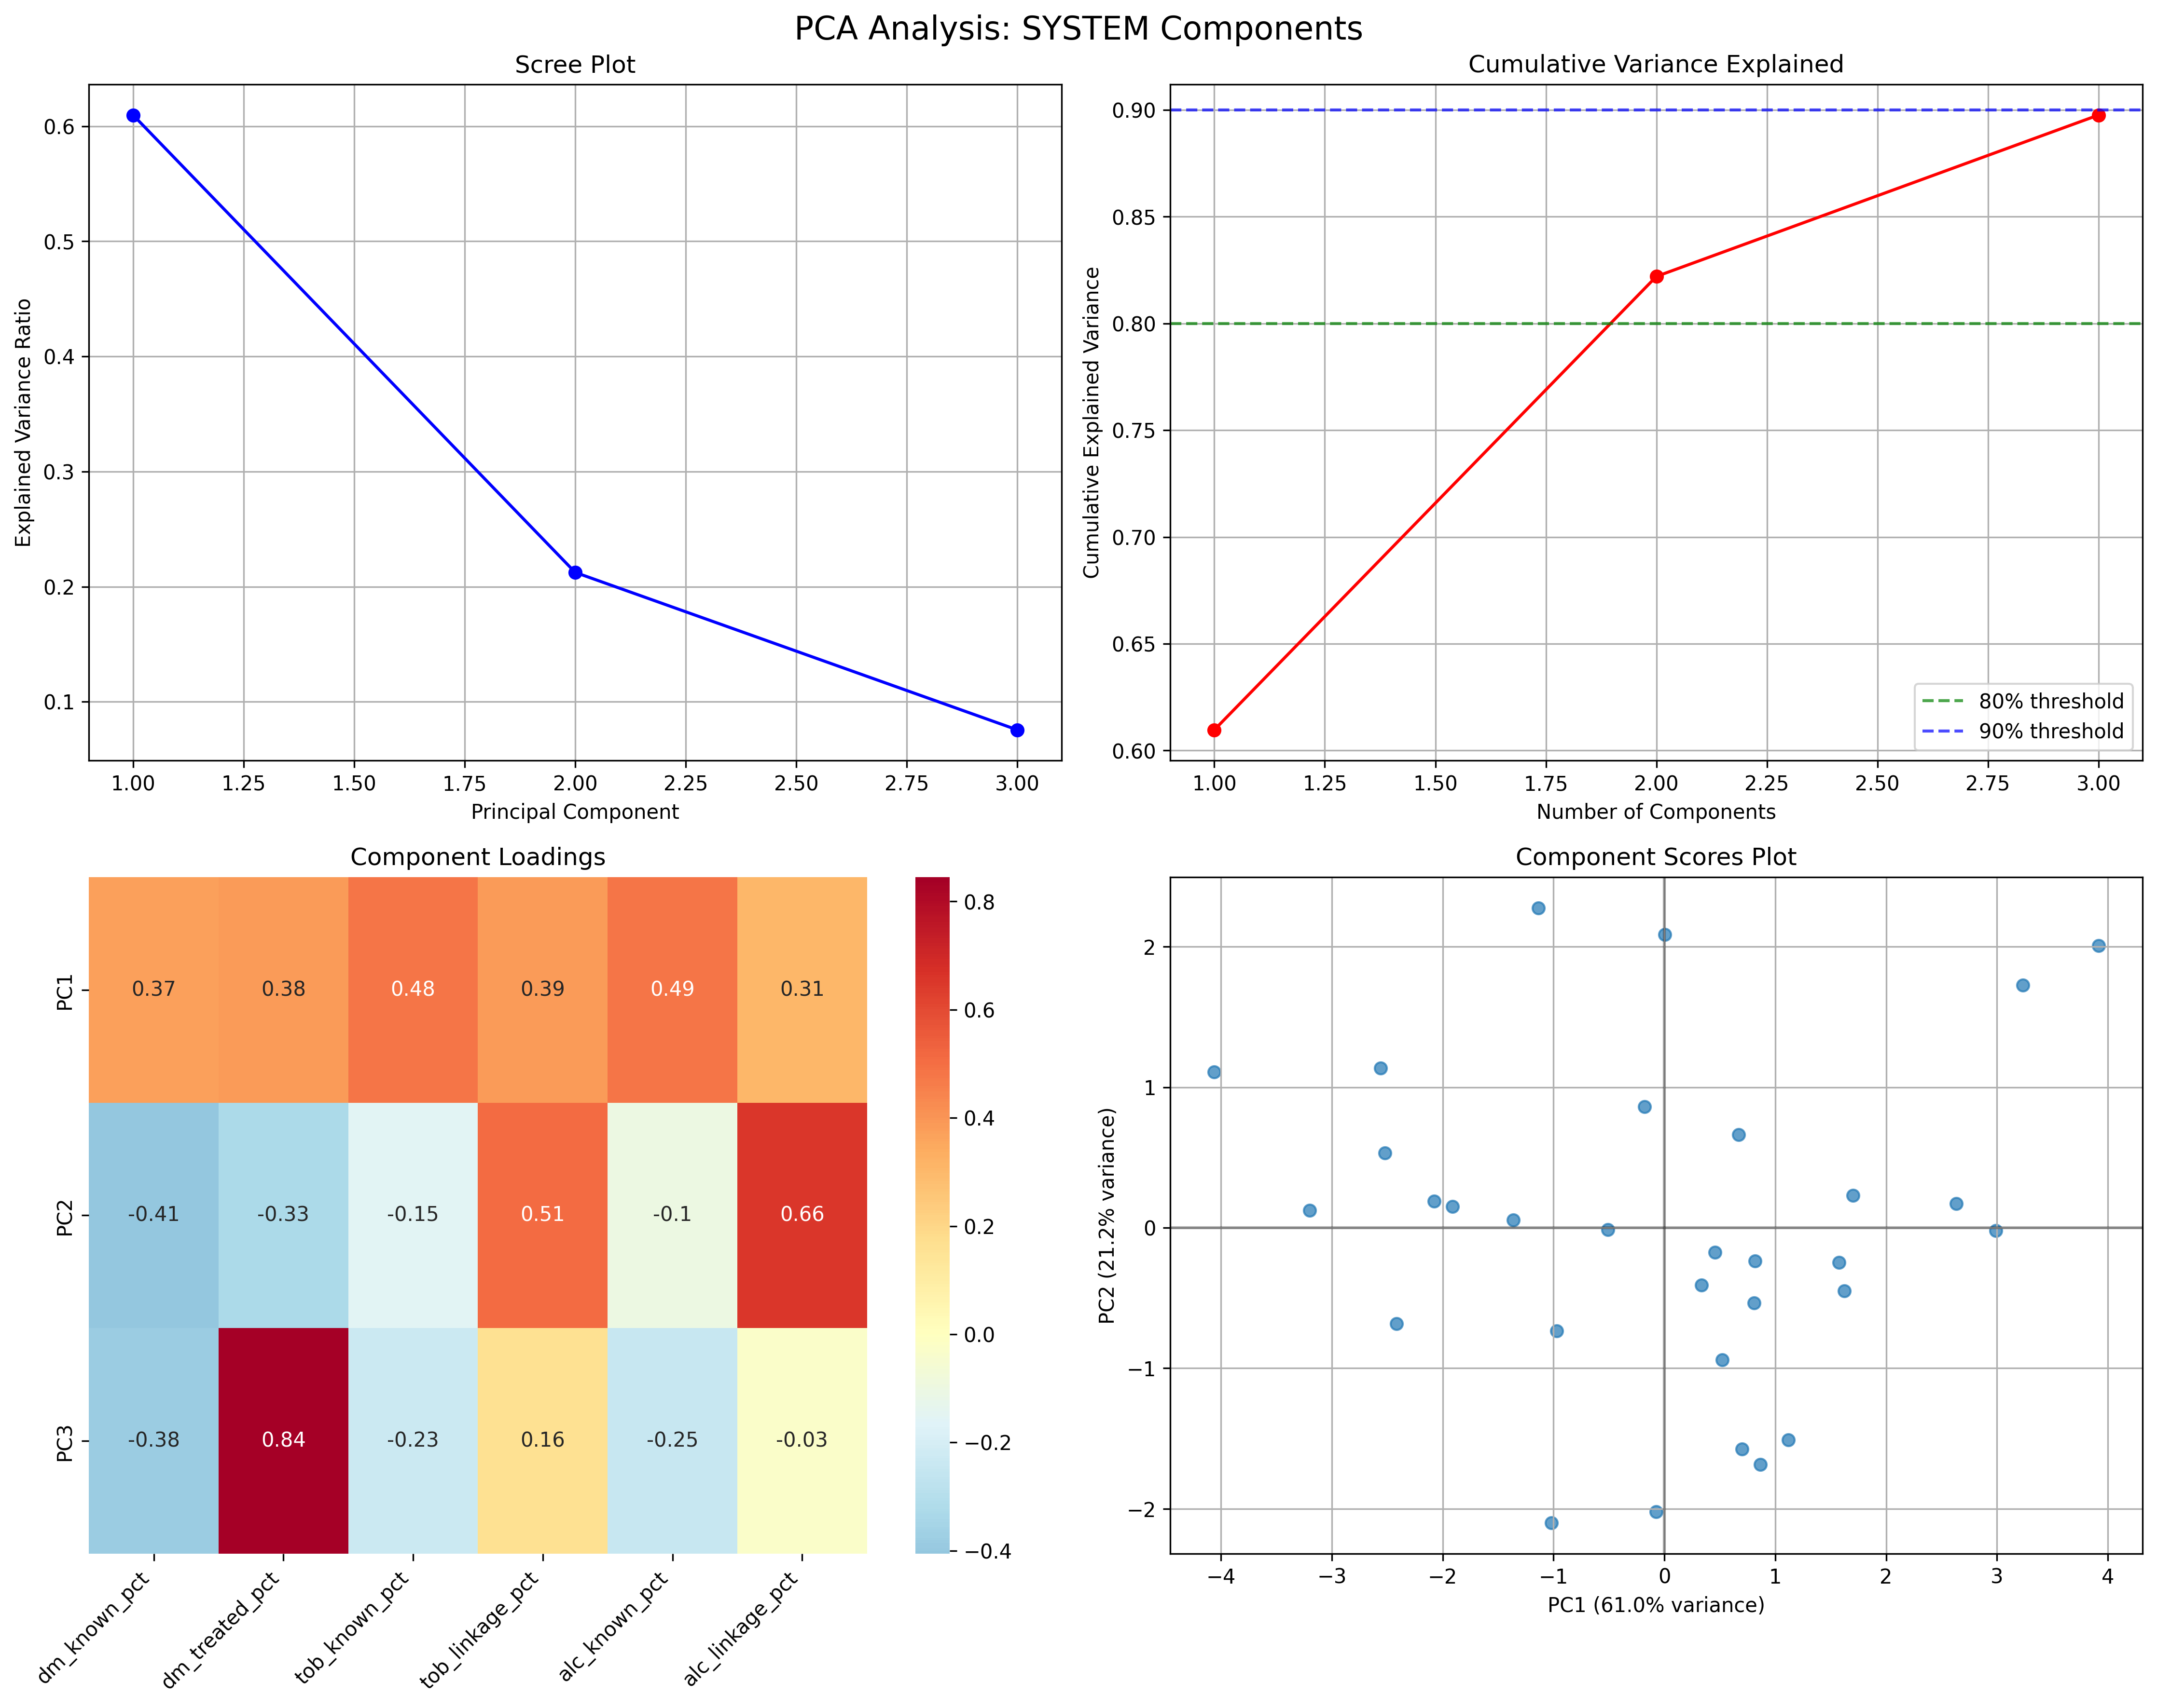

Figure 2. Risk Burden PCA Diagnostics
Scree plot, cumulative variance, component loadings, and score plot for risk burden indicators.
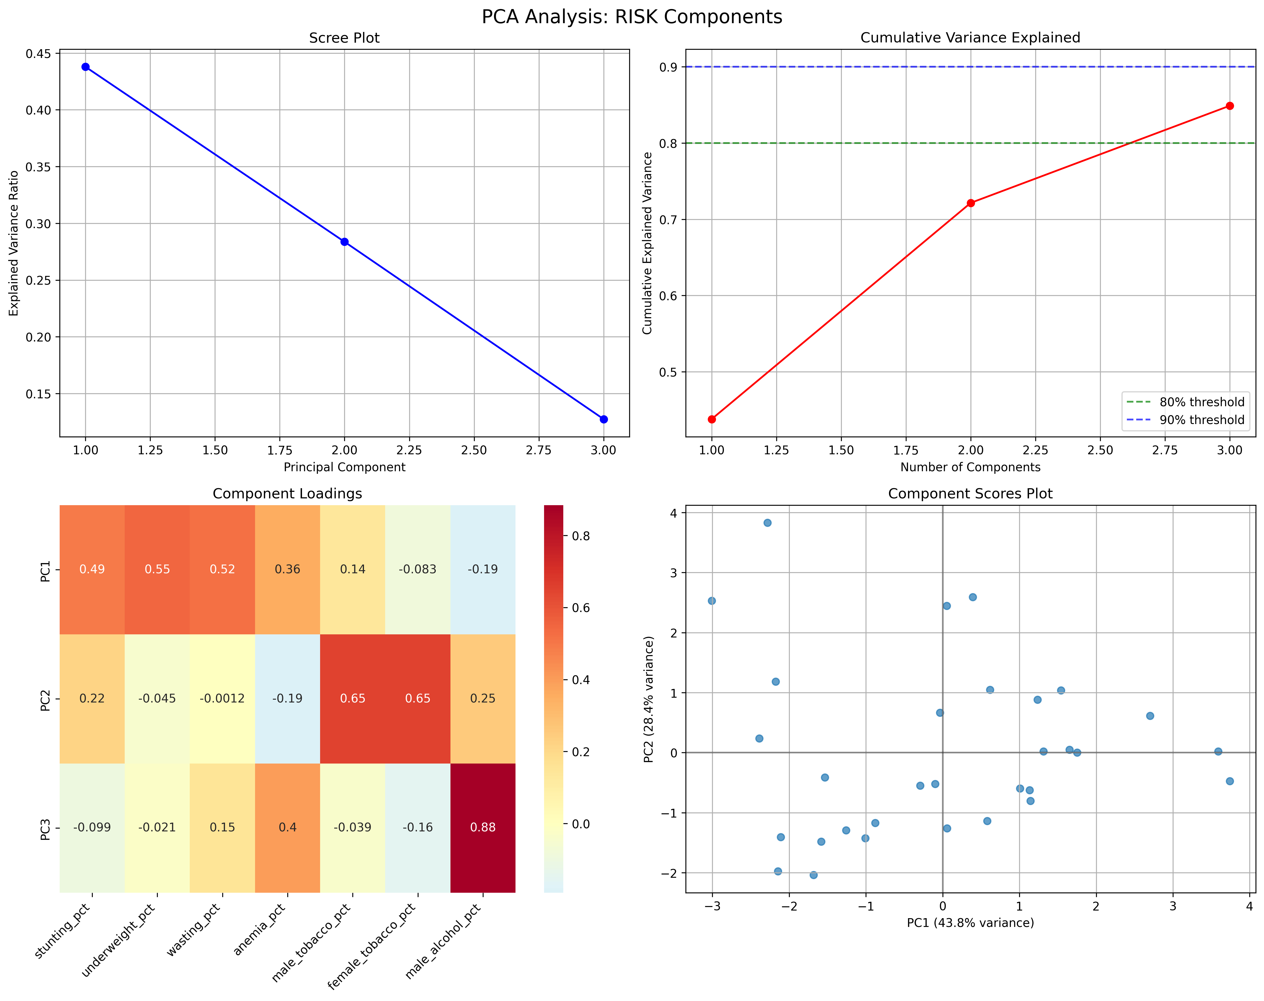

Comparative Analysis: Traditional vs. PCA Indices
Traditional weighted indices and PCA components were compared for their ability to explain MCMC missed case variation:
**Correlation with MCMC Missed Cases:**
- Traditional System Index: r = -0.315 (p < 0.05)
- System PC1: r = -0.349 (p < 0.05) - 10.8% stronger correlation
- Traditional Risk Index: r = +0.300 (p < 0.05)
- Risk PC1: r = +0.336 (p < 0.05) - 12.0% stronger correlation
**Regression Model Comparison:**
*Traditional Weighted Model:*
```
R-squared: 0.125, F-statistic: 1.992, p = 0.155
System coefficient: -43,130 (p = 0.290)
Risk coefficient: +35,960 (p = 0.377)
```
*PCA-Based Model:*
```
R-squared: 0.351, F-statistic: 3.514, p = 0.020
System PC1: -28,220 (p = 0.097)
System PC2: +37,090 (p = 0.179)
System PC3: +97,030 (p = 0.041)
Risk PC1: +28,810 (p = 0.120)
```
**Key Findings:**
- PCA model explains 2.8× more variance than traditional approach
- System PC3 emerges as significant predictor (p = 0.041)
- Improved model fit enables better policy targeting

Figure 3. Traditional vs. PCA Index Comparison
Scatter plots comparing traditional weighted indices (left) and PCA components (right) with MCMC missed cases.
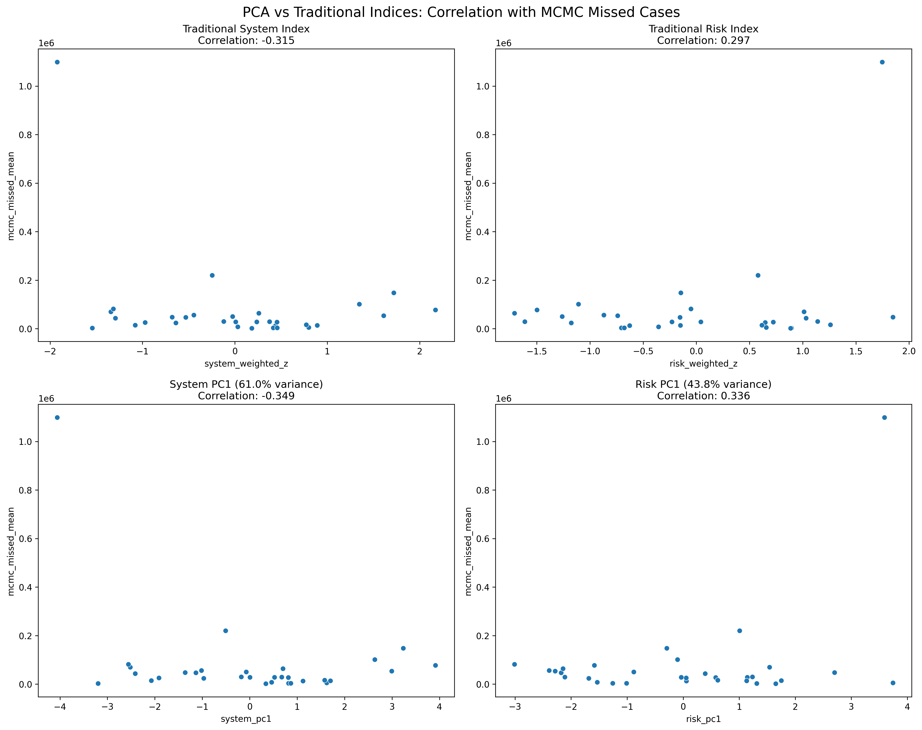

State-Level PCA Insights
PCA component scores reveal distinct state profiles:
**High System Capacity, Low Risk States (Target: Case-finding expansion):**
- Kerala, Tamil Nadu, Karnataka
- System PC1: High (+1.5 to +2.0σ)
- Risk PC1: Low (-1.0 to -0.5σ)
- Strategy: Focus on active case-finding and contact tracing
**Low System Capacity, High Risk States (Target: Integrated interventions):**
- Bihar, Uttar Pradesh, Madhya Pradesh
- System PC1: Low (-1.5 to -2.0σ)
- Risk PC1: High (+1.0 to +2.0σ)
- Strategy: Combine system strengthening with risk mitigation
**Moderate Profiles (Target: Balanced approaches):**
- Rajasthan, Gujarat, Maharashtra
- Intermediate scores on both dimensions
- Strategy: Tailored interventions based on specific component loadings
**Component Score Interpretation:**
- System PC1: Overall health system readiness for TB management
- System PC2: Specialization in comorbidity interventions
- Risk PC1: Fundamental nutritional and health vulnerabilities
- Risk PC2: Substance use-related transmission risks

Tables

Table 1. PCA Component Summary
Component | Explained Variance | Cumulative Variance | Interpretation
System PC1 | 61.0% | 61.0% | Overall system capacity
System PC2 | 21.2% | 82.2% | Comorbidity focus
System PC3 | 7.6% | 89.8% | Service delivery patterns
Risk PC1 | 43.8% | 43.8% | Nutritional status
Risk PC2 | 28.4% | 72.2% | Substance use behaviors

Table 2. Regression Model Comparison
Model | R-squared | F-statistic | Significant Predictors
Traditional Weighted | 0.125 | 1.992 | None
PCA-Based | 0.351 | 3.514 | System PC3 (p=0.041)
Improvement | 2.8× | 76.5% | Additional insights

Discussion
PCA provides a more robust and data-driven approach to constructing composite indices compared to traditional expert-weighted methods. The analysis reveals that TB detection determinants have distinct dimensional structures that expert weighting may not capture optimally.
**System Strength Insights:**
The dominance of PC1 (61% variance) suggests that overall system capacity is the primary dimension of health system performance for TB management. States with high PC1 scores demonstrate comprehensive readiness across screening, treatment, and linkage indicators. PC2 captures specialization in comorbidity interventions, distinguishing states that excel in diabetes/tobacco management from those with broader alcohol intervention capabilities.
**Risk Burden Insights:**
Unlike system indicators that consolidate into a single dominant dimension, risk factors require three components for adequate representation. PC1 captures fundamental nutritional and health vulnerabilities, PC2 isolates substance use behaviors, and PC3 addresses complex socio-behavioral interactions. This multidimensional structure reflects the complex etiology of TB risk.
**Comparative Performance:**
PCA-derived indices demonstrate superior explanatory power, with the regression model explaining 2.8 times more variance than traditional weighted approaches. The emergence of System PC3 as a significant predictor (p=0.041) reveals service delivery patterns that expert weighting obscured. This improved model fit enables more precise targeting of interventions.
**Policy Implications:**
- **High System PC1, Low Risk PC1 states**: Focus on case-finding expansion
- **Low System PC1, High Risk PC1 states**: Require integrated system-risk interventions
- **Moderate profiles**: Need tailored approaches based on specific component scores
**Methodological Advantages:**
1. **Objectivity**: Data-driven weights eliminate expert bias
2. **Orthogonality**: Uncorrelated components avoid multicollinearity
3. **Completeness**: Captures all variance in indicator sets
4. **Interpretability**: Clear component meanings through loadings
**Limitations:**
PCA assumes linear relationships and may not capture non-linear interactions between indicators. The method is sensitive to variable standardization and requires adequate sample sizes for stable component estimation.
**Future Directions:**
The PCA framework could be extended to include additional indicators such as geospatial factors, socioeconomic variables, and temporal trends. Machine learning approaches could further enhance predictive power by capturing non-linear relationships between system-risk factors and missed cases.

Conclusions
Principal Component Analysis provides a superior data-driven approach to understanding TB detection determinants compared to traditional expert-weighted indices. The analysis reveals that:
1. **System strength** is primarily unidimensional, dominated by overall health system capacity
2. **Risk burden** requires multidimensional representation capturing nutritional, behavioral, and socioeconomic factors
3. **PCA-derived indices** explain 2.8 times more variation in MCMC missed cases than traditional approaches
4. **Component interpretability** enables precise targeting of interventions to state-specific needs
Bihar, Uttar Pradesh, and Madhya Pradesh—accounting for over half the national missed case burden—require integrated interventions addressing both weak system capacity and high epidemiological risk. The PCA-enhanced framework provides clearer guidance for resource allocation, enabling more efficient progress toward India's TB elimination goals.
The methodology demonstrates that data-driven dimensionality reduction techniques can significantly improve our understanding of complex public health phenomena. By revealing the underlying structure of system-risk interactions, PCA offers a pathway to more effective, evidence-based TB control strategies.

References
1. World Health Organization. Global Tuberculosis Report 2024. Geneva: WHO; 2024.
2. World Health Organization. The End TB Strategy: Updated Operational Guidance. Geneva: WHO; 2023.
3. Central TB Division, Ministry of Health & Family Welfare. India TB Report 2024. New Delhi: CTD; 2024.
4. Bhargava A, Jain Y. Social determinants of tuberculosis. Indian J Med Res. 2020;151(5):417–419.
5. Pai M, Daftary A, Hopewell PC. Tuberculosis control needs a renewed strategy. Nat Rev Dis Primers. 2017;3:17022.
6. International Institute for Population Sciences (IIPS) & ICF. National Family Health Survey (NFHS-5), 2019–21: India. Mumbai: IIPS; 2021.
7. Jolliffe IT. Principal Component Analysis. New York: Springer; 2002.
8. Hair JF, Black WC, Babin BJ, et al. Multivariate Data Analysis. 7th ed. Upper Saddle River: Pearson; 2010.
9. Velayutham B, Thomas B, Nair D, et al. Patient Provider Support Agencies (PPSAs). BMJ Glob Health. 2018;3:e000637.
10. Arinaminpathy N, Greenwood B, Nathavitharana R, et al. Mathematical modeling of TB control. Nat Commun. 2020;11:4982.

