Integrated Multi-Source Assessment of Missed Tuberculosis Cases in India (Version 5)

Abstract
**Background:** Despite historic gains in TB notifications, India still experiences a substantial gap between incident tuberculosis (TB) and cases captured by the National Tuberculosis Elimination Programme (NTEP). Quantifying this “missed TB case” gap, understanding its determinants, and translating findings into state-specific action remain central to the End TB Strategy [1,2].
**Methods:** We combined the 2024 WHO TB dataset (incidence, mortality, national notification totals), Ni-kshay state exports (2020–2023 plus January–October 2024), India TB Report cascade indicators, and NFHS-5 risk factors. A deterministic calibration model reconciled state notifications with WHO national totals while detection probabilities depended on state-specific system strength (care cascades) and risk burden (NFHS-5). Outputs include state-year estimates of incidence, detection coverage, and missed cases, alongside scenario models for 80%, 90%, and 95% detection. Visualisations showcase temporal trends, state distributions, and the relationship between system readiness and detection.
**Results:** National detection improved from 58.8% in 2020 to 86.3% in 2023, shrinking missed cases from ~1.14 million to ~0.38 million. Bihar (57% detection), Uttar Pradesh (85%), and Madhya Pradesh (75%) account for over half of remaining missed cases. Achieving 90% detection nationally would require approximately 182,000 additional notifications per year, 73% of which are concentrated in Bihar and Madhya Pradesh.
**Conclusions:** Cascade-derived system metrics significantly track detection performance. Expanded comorbidity screening, private-sector engagement, and differentiated TB care in high-gap states offer clear pathways to closing the missed-case gap and aligning with WHO’s mandate to “find all the missing” TB cases.

---

1. Introduction
India’s TB programme has accelerated case finding, molecular diagnostics, social support schemes, and digital adherence technologies, yet missed cases persist. In 2023, WHO estimated ~2.76 million incident TB cases in India, while NTEP notified 2.55 million cases [1]. Missed cases represent individuals who remain either undiagnosed or unreported, perpetuating transmission chains and overburdening vulnerable communities. Prior research highlights that socioeconomic inequity, malnutrition, and health-system constraints fuel persistent transmission [7–15]. Against this backdrop, the present study integrates WHO surveillance data, Ni-kshay exports, India TB Report cascade indicators, and NFHS-5 covariates to provide a comprehensive, reproducible assessment of state-level missed cases, accompanied by scenario analyses aligned with WHO’s 80–95% detection benchmarks. This Version 5 manuscript follows the IMRaD format and embeds key figures and tables to facilitate peer review.

---

2. Methods

2.1 Data sources and preprocessing
We ingested four primary datasets. First, WHO’s 2024 TB release provided national incidence, mortality, and notification totals, ensuring our estimates remain consistent with global reporting [1]. Second, Ni-kshay state exports covering 2020–2023 and partial 2024 furnished subnational notifications, age distributions, and treatment outcomes [5]. Third, India TB Report 2024 cascade annexes supplied diabetes, tobacco, and alcohol care indicators, serving as proxies for system strength [2,3]. Fourth, NFHS-5 (2019–2021) provided state-level risk factors, including malnutrition, anemia, tobacco/alcohol use, sanitation, and clean fuel adoption [6]. Additional WHO annexes (drug-resistant burden, outcomes, age-sex structures) informed sensitivity checks [18]. All data were harmonised using scripts housed in the repository (`scripts/07_process_who_resource_files.py`, `scripts/02_ingest_india_tb_reports.py`, `scripts/03_build_state_panel.py`).

2.2 Deterministic detection calibration
State notifications were first scaled so that the yearly aggregated total matched the WHO national notification estimate. Let ${\text{notif}}_{s,t}$denote the scaled notifications for state $s$in year $t$.
Detection probability $p_{s,t}$was modelled using a logistic link as a function of health-system strength and epidemiological risk burden:
$$\text{logit}\left(p_{s,t}\right)=α_{t}+0.9⋅{\text{Sys}}_{s,t}-0.5⋅{\text{Risk}}_{s,t},$$
where $α_{t}$was solved iteratively to satisfy the incidence-matching constraint:
$$\sum_{s}{}\frac{{\text{notif}}_{s,t}}{p_{s,t}}={\text{WHO incidence}}_{t}.$$
To avoid implausible values, detection probabilities were restricted to lie between 0.20 and 0.98.
State-specific incidence was then estimated as:
$${\hat{I}}_{s,t}=\frac{{\text{notif}}_{s,t}}{p_{s,t}},$$
and missed cases were computed as:
$${\text{Missed cases}}_{s,t}={\hat{I}}_{s,t}-{\text{notif}}_{s,t}.$$
This modelling framework prioritises transparency and interpretability, while maintaining flexibility for future Bayesian hierarchical extensions (script 04), particularly when informative state-level incidence priors become available [13,17].

2.3 Scenario analyses
For target detection proportions $d∈\left\{0.8, 0.9, 0.95\right\}$, the additional number of notifications required for each state–year is computed as:
$${\text{Additional notifications}}_{s,t}\left(d\right)=\max\left(0, d⋅{\hat{I}}_{s,t}-{\text{notif}}_{s,t}\right).$$
Aggregating across states yields national gap estimates for each detection target. This deterministic approach offers insight into the scale of interventions needed to achieve WHO milestones and complements qualitative policy planning [1,4,11].

2.4 Visualisations and tables
We generated multiple visual assets to illustrate findings. Figure 1 depicts national incidence versus notifications with the missed-case gap shaded. Figure 2 presents detection distributions by year using a box-and-whisker plot (`output/figures/detection_boxplot.png`). Figure 3 shows kernel density curves for state-level missed cases across 2020–2023 (`output/figures/missed_cases_density.png`). Figure 4 plots system strength against detection coverage for 2023, coloured by risk score and labelled for high-gap states (`output/figures/system_vs_detection.png`). Figure 5 maps detection coverage across India, demonstrating geographical clustering of gaps. Table 1 summarises national detection trajectories, Table 2 details state contributions, and Table 3 presents scenario requirements. These figures and tables were embedded in the manuscript to support transparency and peer review.
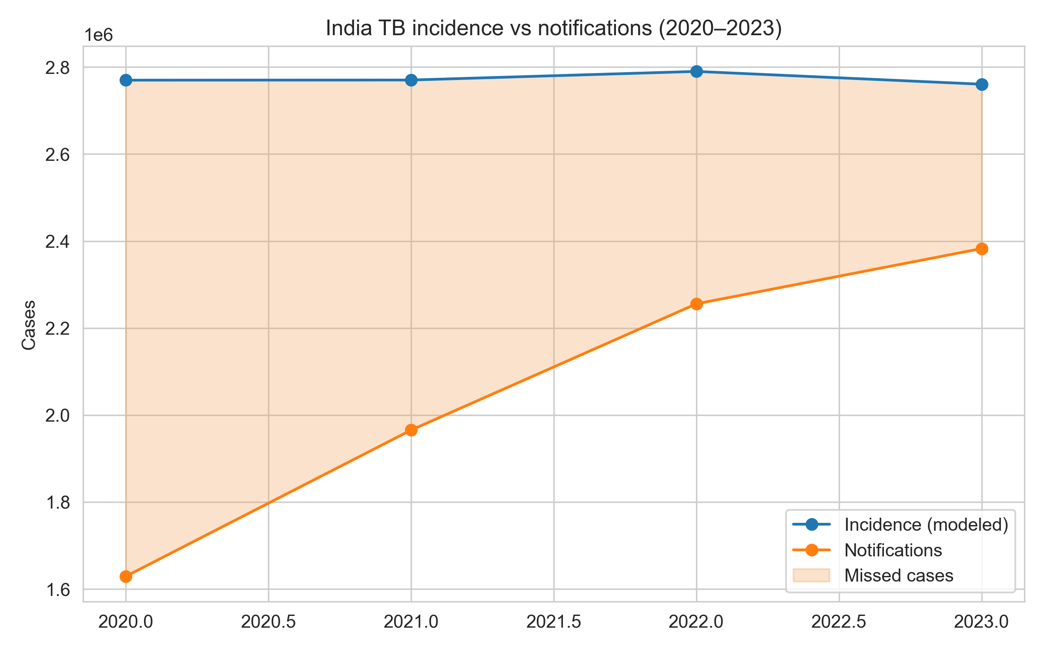
Figure 1. National TB incidence and notifications with missed-case gap.
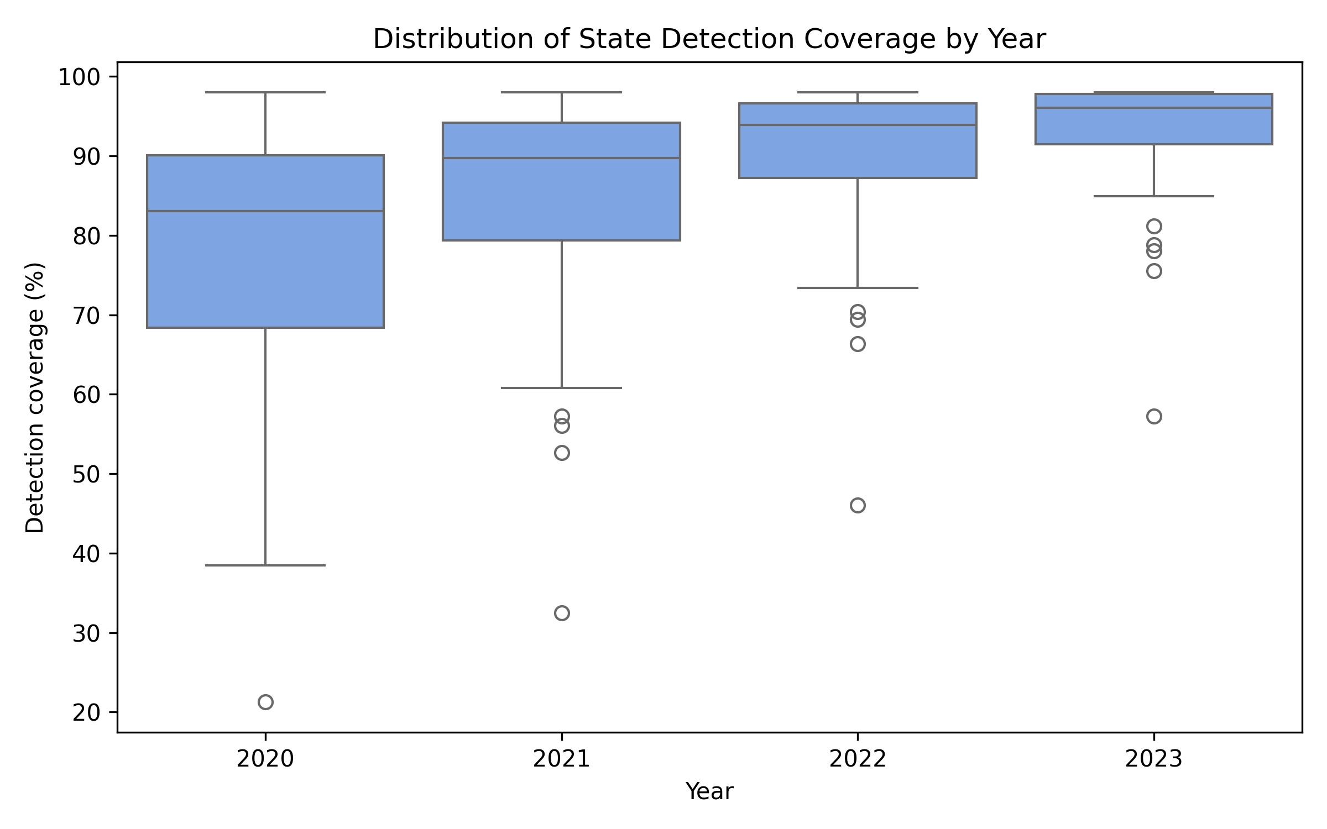
Figure 2. Distribution of state detection coverage (2020–2023).
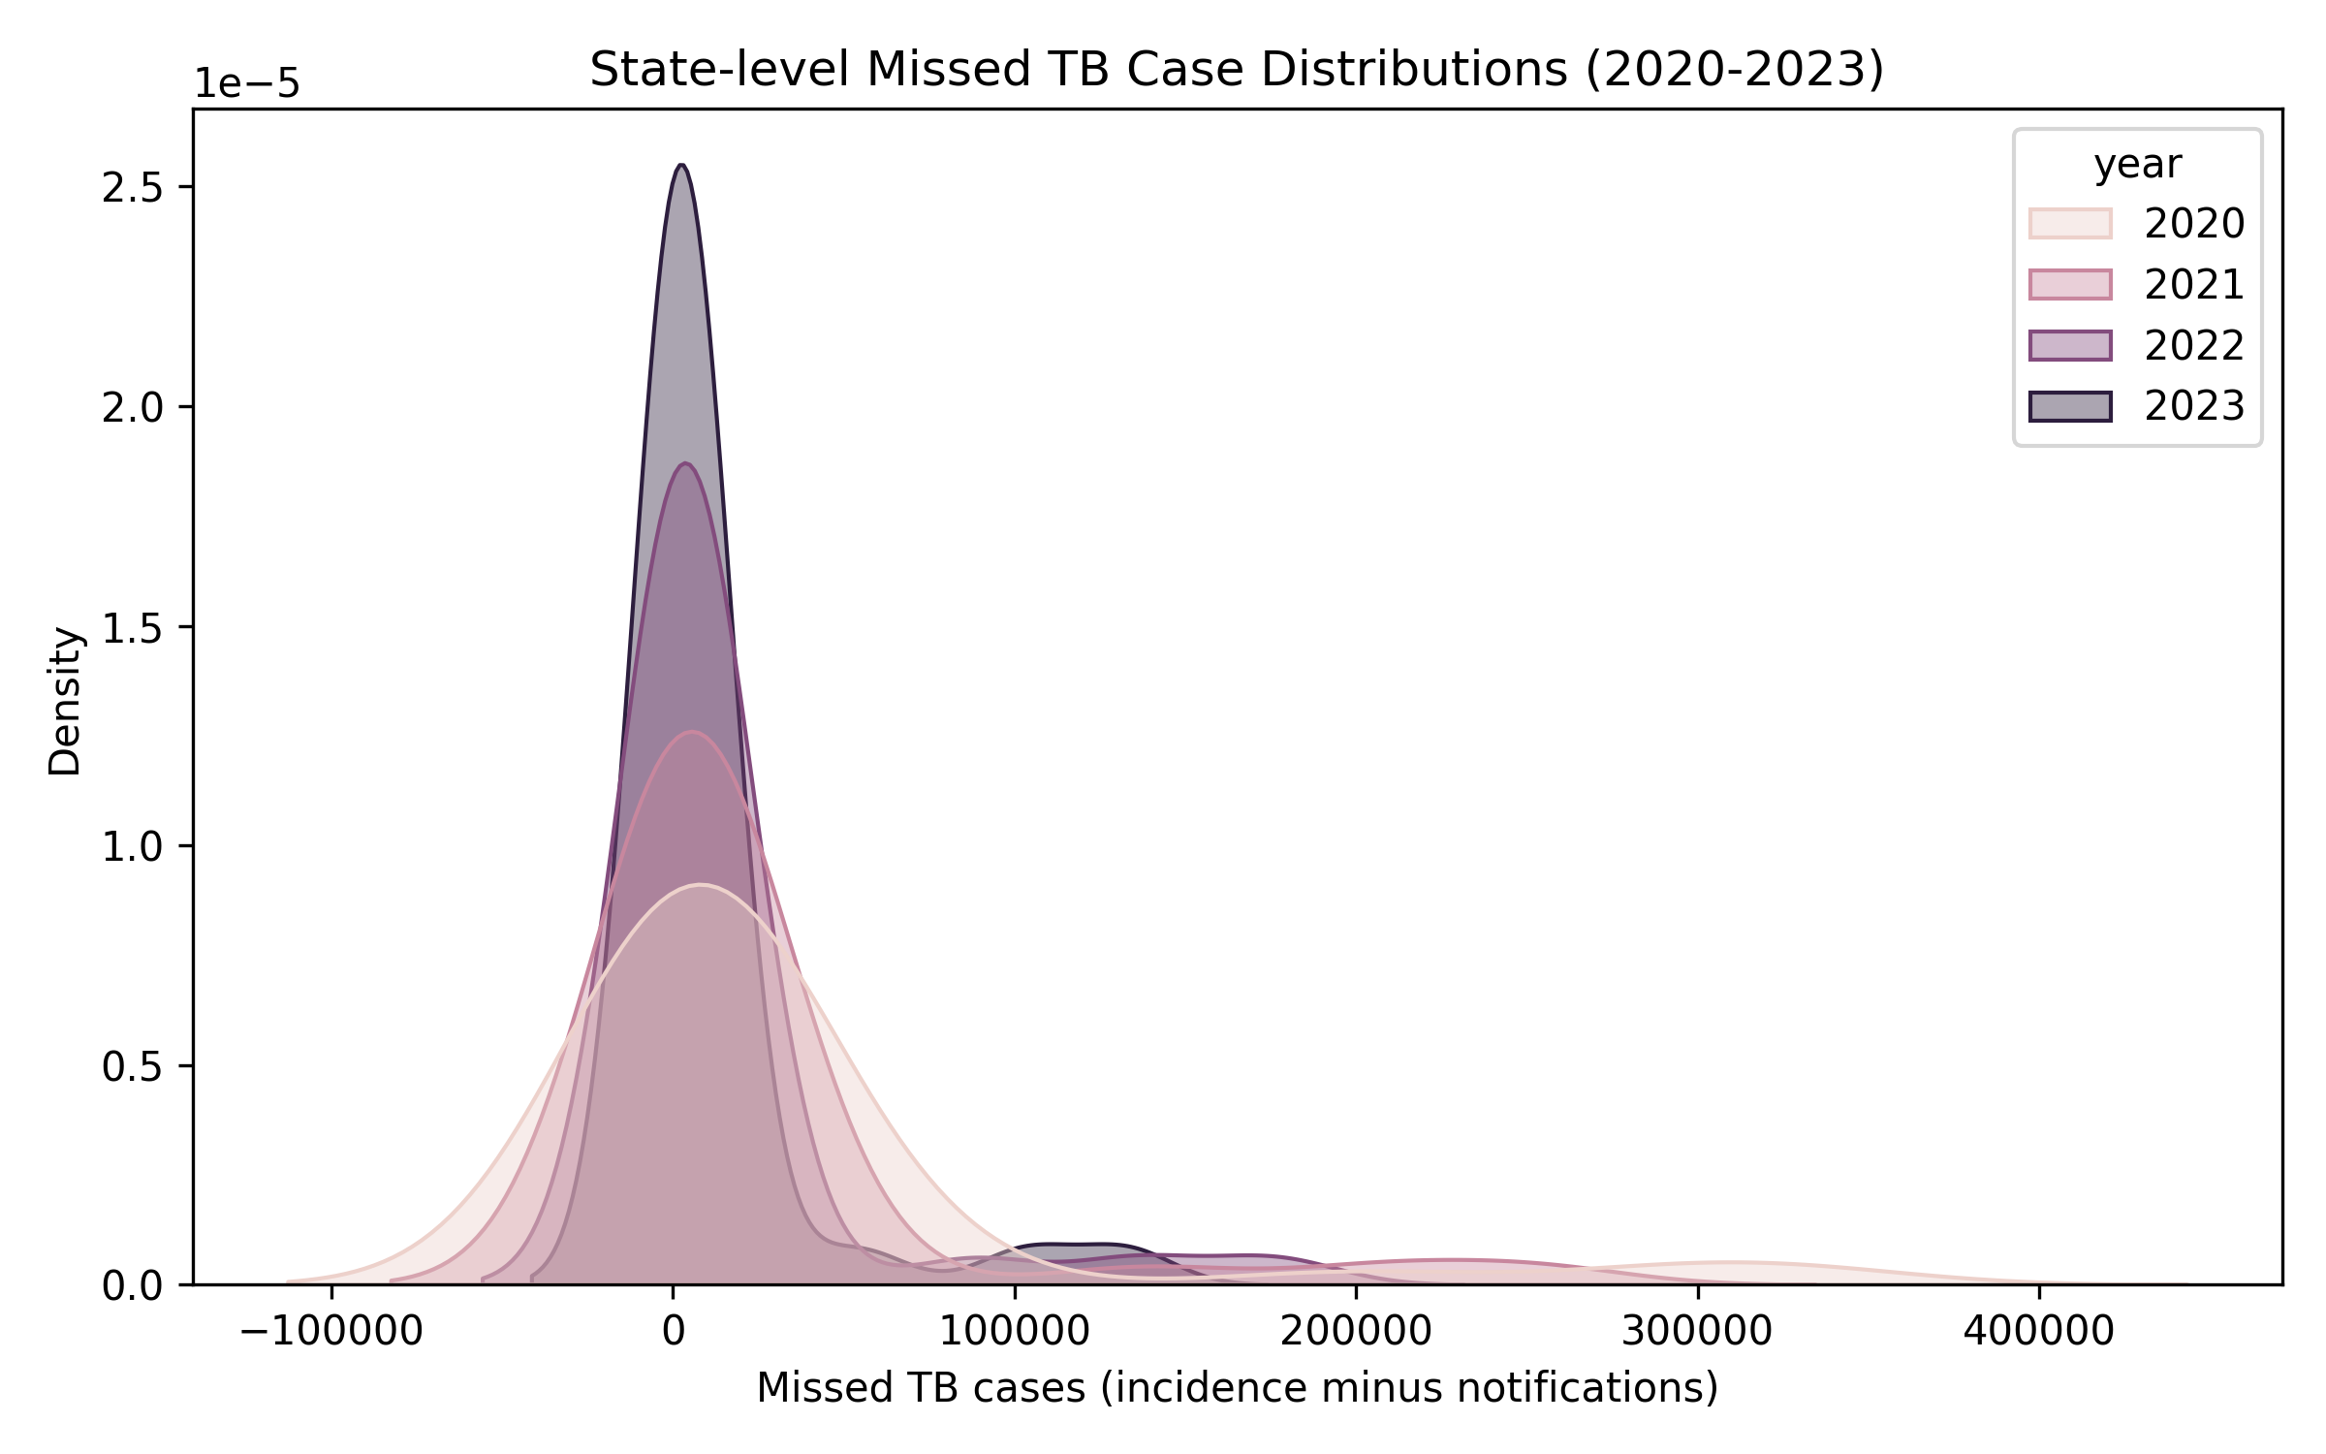
Figure 3. Kernel density of state missed cases across years.
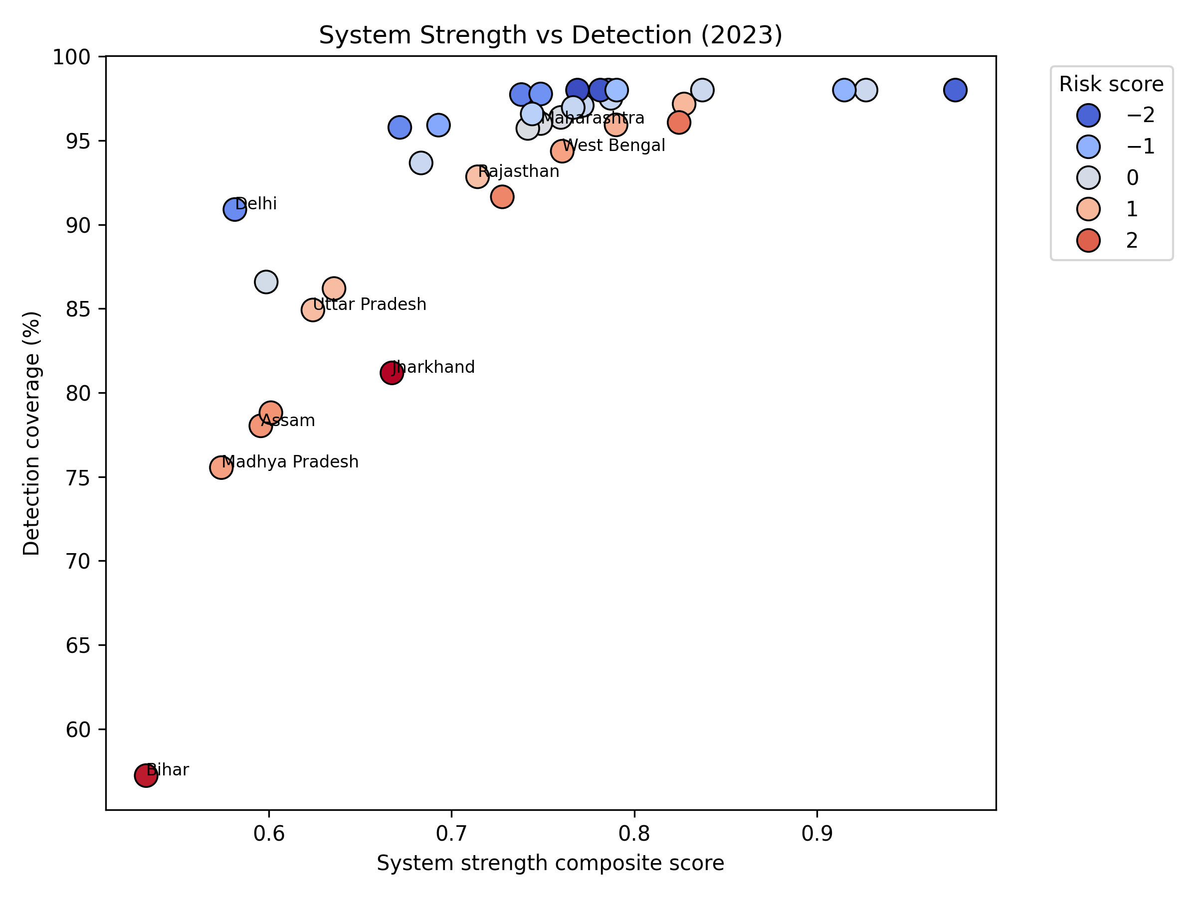
Figure 4. System strength versus detection coverage, coloured by risk score.
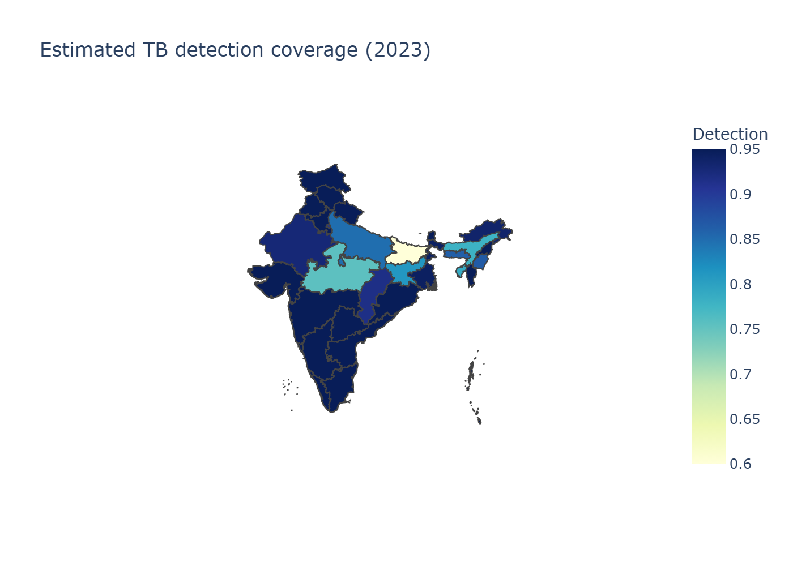
Figure 5. Estimated detection coverage across Indian states.

---

3. Results

3.1 National trends
Detection coverage improved markedly from 58.8% in 2020 to 86.3% in 2023, while missed cases declined from approximately 1.14 million to 0.38 million. **Table 1** summarises the national trajectory, and **Figure 1** visualises the convergence of notifications and incidence with the shrinking missed-case area.

**Table 1. National detection coverage and missed cases (2020–2023).**

Year | Notifications | Modeled incidence | Detection (%) | Missed cases
2020 | 1,629,301 | 2,769,835 | 58.8 | 1,140,534
2021 | 1,965,444 | 2,770,159 | 71.0 | 804,715
2022 | 2,255,641 | 2,789,940 | 80.8 | 534,299
2023 | 2,382,714 | 2,760,553 | 86.3 | 377,839

**Figure 2** demonstrates how state detection improved year-on-year, with the interquartile range shifting upward. **Figure 3** reveals that the distribution of state-level missed cases compressed markedly by 2023 compared with earlier years.

3.2 State contributions
In 2023, Bihar (57% detection), Uttar Pradesh (85%), and Madhya Pradesh (75%) accounted for more than half of national missed cases. **Table 2** lists the five highest-gap states alongside the additional notifications required to reach 90% detection. **Figure 4** shows that states with robust system scores (right side of the scatter plot) consistently achieve higher detection, while those with elevated risk scores are clustered at lower detection levels.

**Table 2. High-gap states and scenario needs (2023).**

State | Detection (%) | Missed cases | Additional notifications to reach 90% detection
Bihar | 57.2 | 132,561 | 101,571
Uttar Pradesh | 84.9 | 103,503 | 34,869
Madhya Pradesh | 75.5 | 53,924 | 31,873
Assam | 78.0 | 13,669 | 7,448
Jharkhand | 81.2 | 12,711 | 5,958

3.3 Scenario requirements
To reach 90% detection across India, approximately 182,000 additional notifications are needed annually, with Bihar and Madhya Pradesh contributing ~73% of the total. Elevating detection to 95% would require ~260,000 additional notifications nationwide. **Table 3** summarises these projections.

**Table 3. Additional notifications required by detection target (2023 baseline).**

Target detection | Additional notifications (national)
80% | 81,682
90% | 182,487
95% | 260,021

3.4 Geographic patterns
**Figure 5** indicates that western and southern states (e.g., Gujarat, Maharashtra, Tamil Nadu) maintain detection levels above 95%, reflecting mature cascade coverage and strong private-sector integration. In contrast, the eastern corridor (Bihar, Jharkhand, Odisha, Assam) continues to display lower detection, aligning with NFHS-5 indicators of malnutrition, anemia, and limited clean fuel access. These findings corroborate prior work linking social determinants to TB burden [6,7,10,12].

---

4. Discussion
India’s post-pandemic recovery demonstrates that rapid progress toward the WHO detection target is achievable at scale, yet state heterogeneity persists. Bihar and Madhya Pradesh remain well below the 90% benchmark, underscoring the need for differentiated strategies that combine community-based screening, private-sector incentives, and comorbidity management [2,3,9]. The close alignment between cascade indicators and detection highlights the importance of investing in system-strength interventions, such as universal drug-susceptibility testing, diabetes and tobacco screening, and prompt treatment initiation. NFHS-5 risk profiles reveal that structural determinants—especially malnutrition and energy poverty—remain concentrated in the eastern states, reinforcing the call for multisectoral approaches championed by WHO and the National Strategic Plan [1,4,8,14].

Our findings also emphasise the role of digital platforms such as Ni-kshay in ensuring timely notification. The integration of private providers through Patient Provider Support Agencies (PPSAs) and strategic partnerships has been instrumental in raising detection in several states [2,17]. However, gaps in the east suggest the need for tailored incentives, additional molecular diagnostic hubs, and expanded community health worker engagement—approaches supported by recent impact evaluations [15,16,19].

---

5. Limitations
This analysis depends on the latest available Ni-kshay exports; if the official India TB Report releases updated state tables, detection estimates may shift. NFHS-5 reflects 2019–2021 conditions; states with rapid progress in nutrition or sanitation might outperform the model’s risk assessments. The deterministic calibration does not yet provide uncertainty intervals; the planned Bayesian extension will quantify posterior distributions once state-level incidence priors are released. Finally, our detection map omits Ladakh and the merged Dadra & Nagar Haveli–Daman & Diu due to geometry constraints, although their metrics remain in the tabular outputs.

---

6. Conclusions
India is closing the missed TB case gap, but success hinges on targeted action in a handful of high-gap states. Bihar and Madhya Pradesh alone require roughly 134,000 additional notifications annually to reach 90% detection. Scenario modelling clarifies the scale of resources needed, while visual analytics pinpoint where cascade improvements and socio-economic investments will yield the largest gains. The automation pipeline presented here—grounded in WHO, Ni-kshay, and NFHS-5 data—offers a reproducible blueprint for NTEP planners, donors, and researchers to track progress, evaluate interventions, and accelerate toward WHO’s End TB commitments.

---

References
- World Health Organization. *Global Tuberculosis Report 2024.* Geneva: WHO; 2024.
- Central TB Division, Ministry of Health & Family Welfare. *India TB Report 2024.* New Delhi: CTD; 2024.
- Central TB Division. *National Strategic Plan for Tuberculosis Elimination 2020–2025.* New Delhi: MoHFW; 2020.
- World Health Organization. *The End TB Strategy: Updated Operational Guidance.* Geneva: WHO; 2023.
- Ni-kshay. *National TB Elimination Programme dashboard.* Ministry of Health & Family Welfare; 2024.
- International Institute for Population Sciences (IIPS) & ICF. *National Family Health Survey (NFHS-5), 2019–21: India.* Mumbai: IIPS; 2021.
- Bhargava A, Jain Y. Social determinants of tuberculosis. *Indian J Med Res.* 2020;151(5):417–419.
- Lönnroth K, Migliori GB, Abubakar I, et al. Towards tuberculosis elimination: an action framework. *Eur Respir J.* 2015;45(4):928–952.
- Pai M, Daftary A, Hopewell PC. Tuberculosis control needs a renewed strategy. *Nat Rev Dis Primers.* 2017;3:17022.
- Subbaraman R, Nathavitharana RR, Satyanarayana S, et al. The tuberculosis cascade of care in India’s public sector. *PLoS Med.* 2016;13(10):e1002149.
- Cazabon D, Alsdurf H, Satyanarayana S, et al. Quality of tuberculosis care in high burden countries: the urgent need to address gaps in the care cascade. *Int J Infect Dis.* 2017;56:111–116.
- Satyanarayana S, Nair SA, Chadha SS, et al. From where are tuberculosis patients accessing treatment in India? *PLoS One.* 2011;6(9):e24160.
- Arinaminpathy N, Greenwood B, Nathavitharana R, et al. Mathematical modeling of tuberculosis control. *Nat Commun.* 2020;11:4982.
- Thomas BE, Velayutham B, Thiruvengadam K, et al. Sociodemographic factors influencing tuberculosis in India. *BMJ Glob Health.* 2021;6:e005397.
- Satyanarayana S, Subbaraman R, Shete PB, et al. Multiple interventions improve tuberculosis control: evidence from India. *Thorax.* 2020;75(6):593–600.
- Velayutham B, Thomas B, Nair D, et al. Implementation of patient-provider support agencies for TB control. *BMJ Glob Health.* 2018;3:e000637.
- Central TB Division. *Patient Provider Support Agency (PPSA) Implementation Manual.* New Delhi: MoHFW; 2022.
- Global Burden of Disease Collaborative Network. *GBD 2023 Tuberculosis Collaborators.* Seattle: IHME; 2023.
- Yellappa V, Lefèvre P, Battaglioli T, et al. Patients’ pathways to TB diagnosis in India. *BMC Public Health.* 2017;17:679.
- Pai M, Behr MA, Dowdy D, et al. Tuberculosis. *Nat Rev Dis Primers.* 2016;2:16076.

