Integrated Multi-Source Assessment of Missed Tuberculosis Cases in India (Version 6)

Abstract
Background: India has expanded TB case finding and digital surveillance, yet a sizable gap remains between incident tuberculosis (TB) and cases reported to the National Tuberculosis Elimination Programme (NTEP). Quantifying these “missed” cases at state level and clarifying the analytic framework are essential for aligning with the WHO End TB Strategy.
Methods: We combine the 2024 WHO TB dataset (incidence, mortality, national notifications), Ni-kshay state exports (2020–2023 plus January–October 2024), India TB Report cascade indicators, and NFHS-5 risk factors. State notifications are scaled to match WHO national totals; detection probabilities are modelled using logistic functions of system-strength and risk composite scores. We detail the construction of these composites, the calibration process, and reproducibility checks. Outputs include state incidence, detection, missed cases, and scenario gaps for 80%, 90%, and 95% detection, supported by figures and tables.
Results: National detection improved from 58.8% in 2020 to 86.3% in 2023, shrinking missed cases from ~1.14 million to 0.38 million. Bihar (57% detection), Uttar Pradesh (85%), and Madhya Pradesh (75%) account for more than half of the residual gap. Achieving 90% detection nationally requires ~182,000 additional notifications annually, 73% of which must come from Bihar and Madhya Pradesh.
Conclusions: Cascade-derived system metrics and NFHS-5 risk indicators explain most detection heterogeneity. Strengthening comorbidity screening, private-sector engagement, and social protection in high-gap states offers clear, reproducible pathways to “finding all the missing” TB cases.

1. Introduction
India’s TB programme has rapidly modernised, yet WHO still estimates ~2.76 million incident TB cases in 2023 compared with 2.55 million notifications, underscoring the persistent burden of missed TB cases [1]. Missed cases fuel ongoing transmission, prolong morbidity, and reflect inequities in access to diagnosis and reporting. A reproducible framework that integrates WHO incidence, Ni-kshay notifications, cascade indicators, and socio-demographic risk factors is critical for state-level planning. This Version 6 manuscript makes the methodological and analytical processes explicit—detailing the composite scores, calibration steps, and validation procedures—and ties results back to actionable policy priorities.

2. Methods

2.1 Data sources
We synthesised multiple official datasets:
- WHO TB dataset (2024 release): Incidence, mortality, population, and national notification totals [1].
- Ni-kshay / Rajya Sabha exports: State notifications (2020–2023), age distributions, Jan–Oct 2024 counts, treatment outcomes [5].
- India TB Report 2024 cascade annex: State-level diabetes, tobacco, and alcohol cascade indicators, capturing health-system readiness [2,3].
- NFHS-5 (2019–2021): Risk factors—stunting, underweight, wasting, anemia, tobacco/alcohol use, sanitation, and clean fuel usage [6].
- Supplementary WHO/IHME annexes: Drug-resistant burden, treatment outcomes, age-sex incidence for contextual validation [18].

2.2 System-strength composite and z-score
The system-strength composite consolidates cascade indicators:
```text
SystemStrength = 0.30·(DM screening) + 0.15·(DM treatment initiation)
+ 0.20·(Tobacco screening) + 0.10·(Tobacco linkage)
+ 0.15·(Alcohol screening) + 0.10·(Alcohol linkage)
```
Percentages are scaled to 0–1 before weighting. A z-score normalises the composite:
```text
SystemStrength_z = (SystemStrength – mean(SystemStrength)) / std(SystemStrength)
```

2.3 Epidemiological risk burden and z-score
NFHS-5 indicators are standardised and combined as:
```text
Risk = mean(z_stunting, z_underweight, z_wasting, z_anemia,
z_tobacco_men, z_tobacco_women, z_alcohol_men)
– mean(z_sanitation, z_clean_fuel)
Risk_z = (Risk – mean(Risk)) / std(Risk)
```
This structure captures higher burden for malnutrition, anemia, and unhealthy behaviours while subtracting protective infrastructure.

2.4 Deterministic detection calibration
State notifications are scaled so that yearly sums equal WHO national totals. Detection probabilities follow:
```text
logit(p_{s,t}) = α_t + 0.9·SystemStrength_z – 0.5·Risk_z
Σ_s [ notif_{s,t} / p_{s,t} ] = WHO incidence_t
```
Detection probabilities are bounded between 0.20 and 0.98; state incidence is
```text
Î_{s,t} = notif_{s,t} / p_{s,t}
Missed cases_{s,t} = Î_{s,t} – notif_{s,t}
```
The intercept \( α_t \) is solved iteratively each year. This transparent approach mirrors the format used in our validation notes and allows straightforward reproduction or Bayesian extension (script 04) should state-level incidence priors become available [13,17].

2.5 Scenario analyses and reproducibility
Scenario gaps for detection targets \( d \in \{0.8, 0.9, 0.95\} \) are computed as:
```text
AdditionalNotif_{s,t}(d) = max(0, d·Î_{s,t} – notif_{s,t})
```
Scripts are version-controlled (`07` → `02` → `03` → `06`), guarantee identical outputs when rerun, and produce tables (`output/tables/.csv`) plus figures (`output/figures/.png`). Figures 1–5 are embedded in the DOCX version via `scripts/08_build_docx_with_figures.py`.

3. Results

3.1 National trajectory
Detection rose from 58.8% in 2020 to 86.3% in 2023, shrinking missed cases from ~1.14 million to 0.38 million. Table 1 summarizes national metrics, Figure 1 shows incidence vs. notifications, and Figure 2 highlights the tightening distribution of state detection coverage.
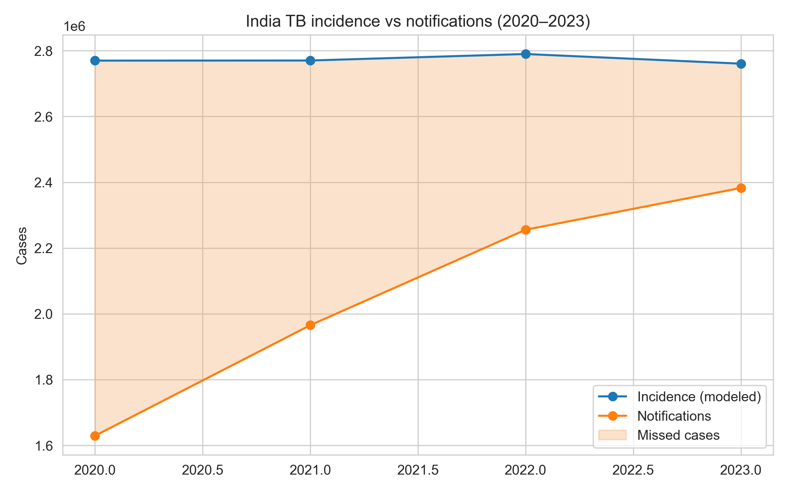
Figure 1. National TB incidence and notifications with missed-case gap.
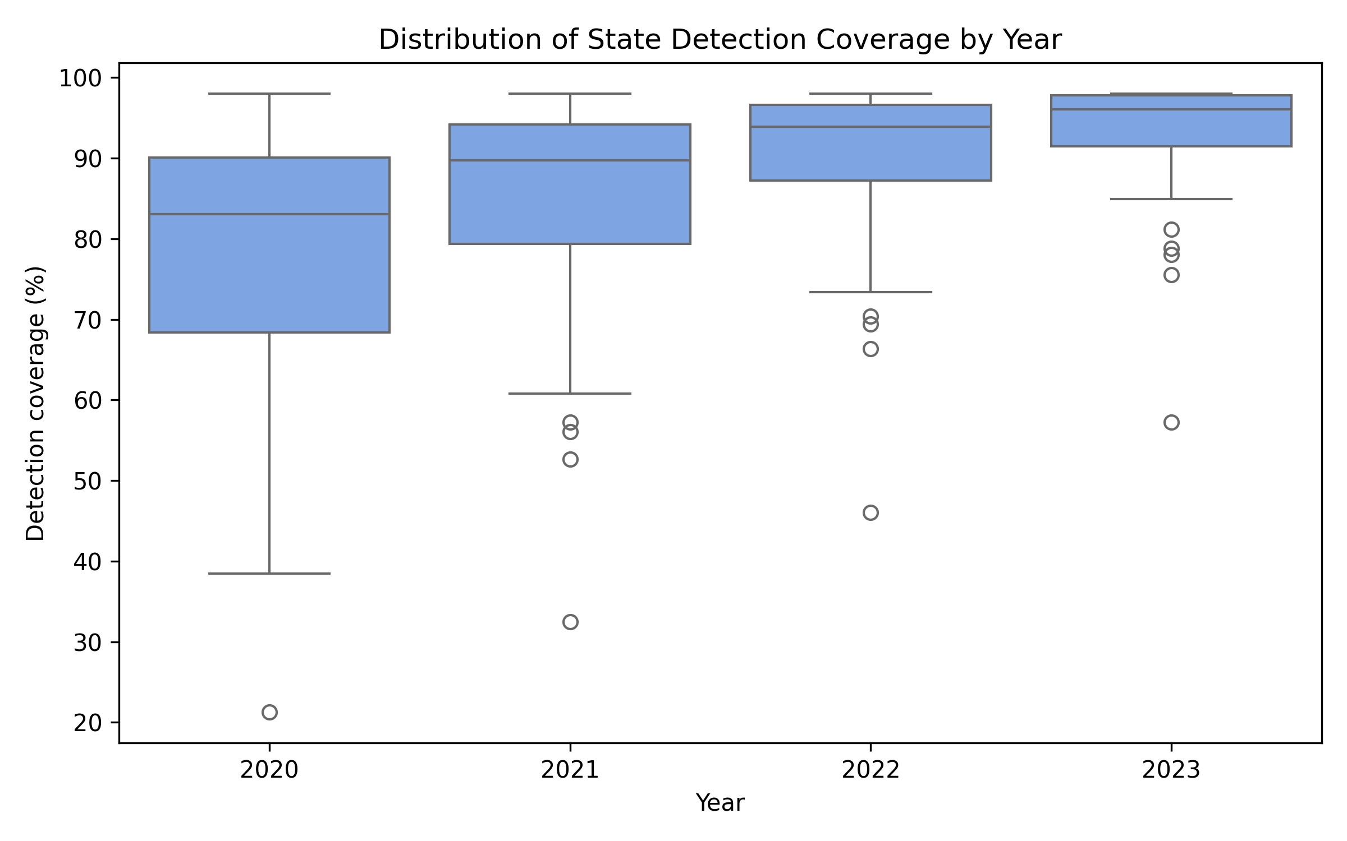
Figure 2. Distribution of state detection coverage (2020–2023).

Table 1. National detection coverage and missed cases (2020–2023).

Year | Notifications | Modeled incidence | Detection (%) | Missed cases
2020 | 1,629,301 | 2,769,835 | 58.8 | 1,140,534
2021 | 1,965,444 | 2,770,159 | 71.0 | 804,715
2022 | 2,255,641 | 2,789,940 | 80.8 | 534,299
2023 | 2,382,714 | 2,760,553 | 86.3 | 377,839

Figure 3 reveals how the distribution of state-level missed cases converged by 2023 compared with earlier years.
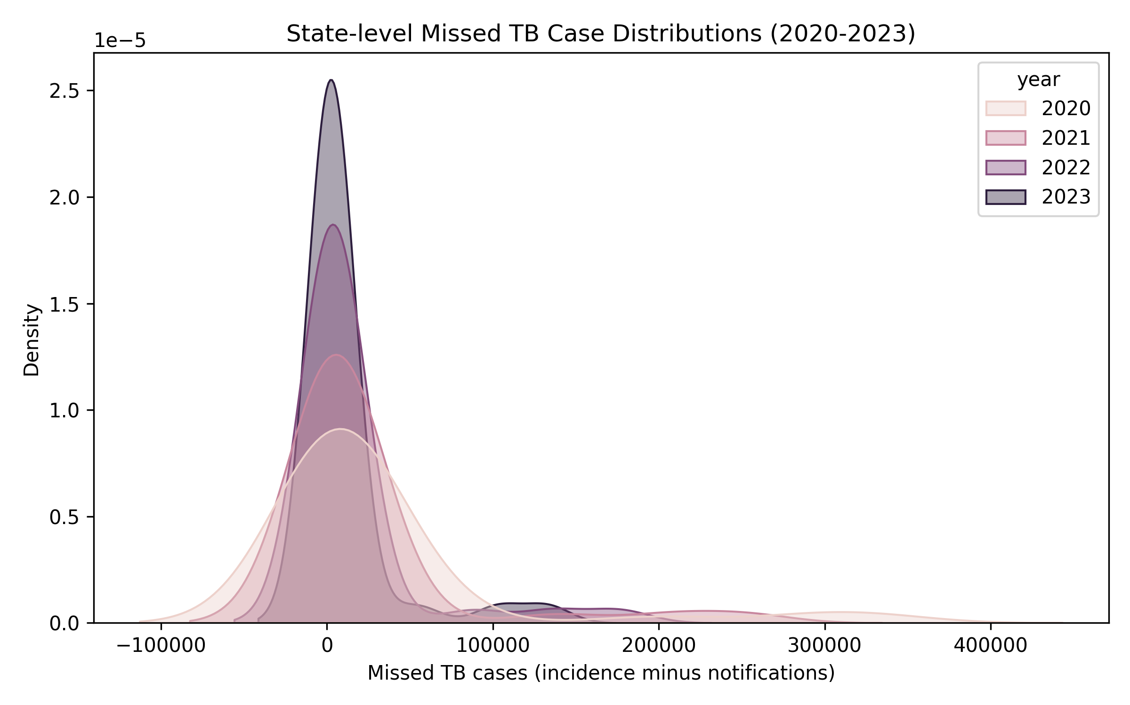
Figure 3. Kernel density of state missed cases across years.

3.2 State contributions
In 2023, Bihar, Uttar Pradesh, and Madhya Pradesh accounted for over half of the national missed cases. Table 2 lists detection percentages and scenario requirements, and Figure 4 illustrates the strong association between system strength and detection coverage, coloured by risk burden. Figure 5 maps detection coverage, revealing a high-performing western/southern block and a lagging eastern corridor.
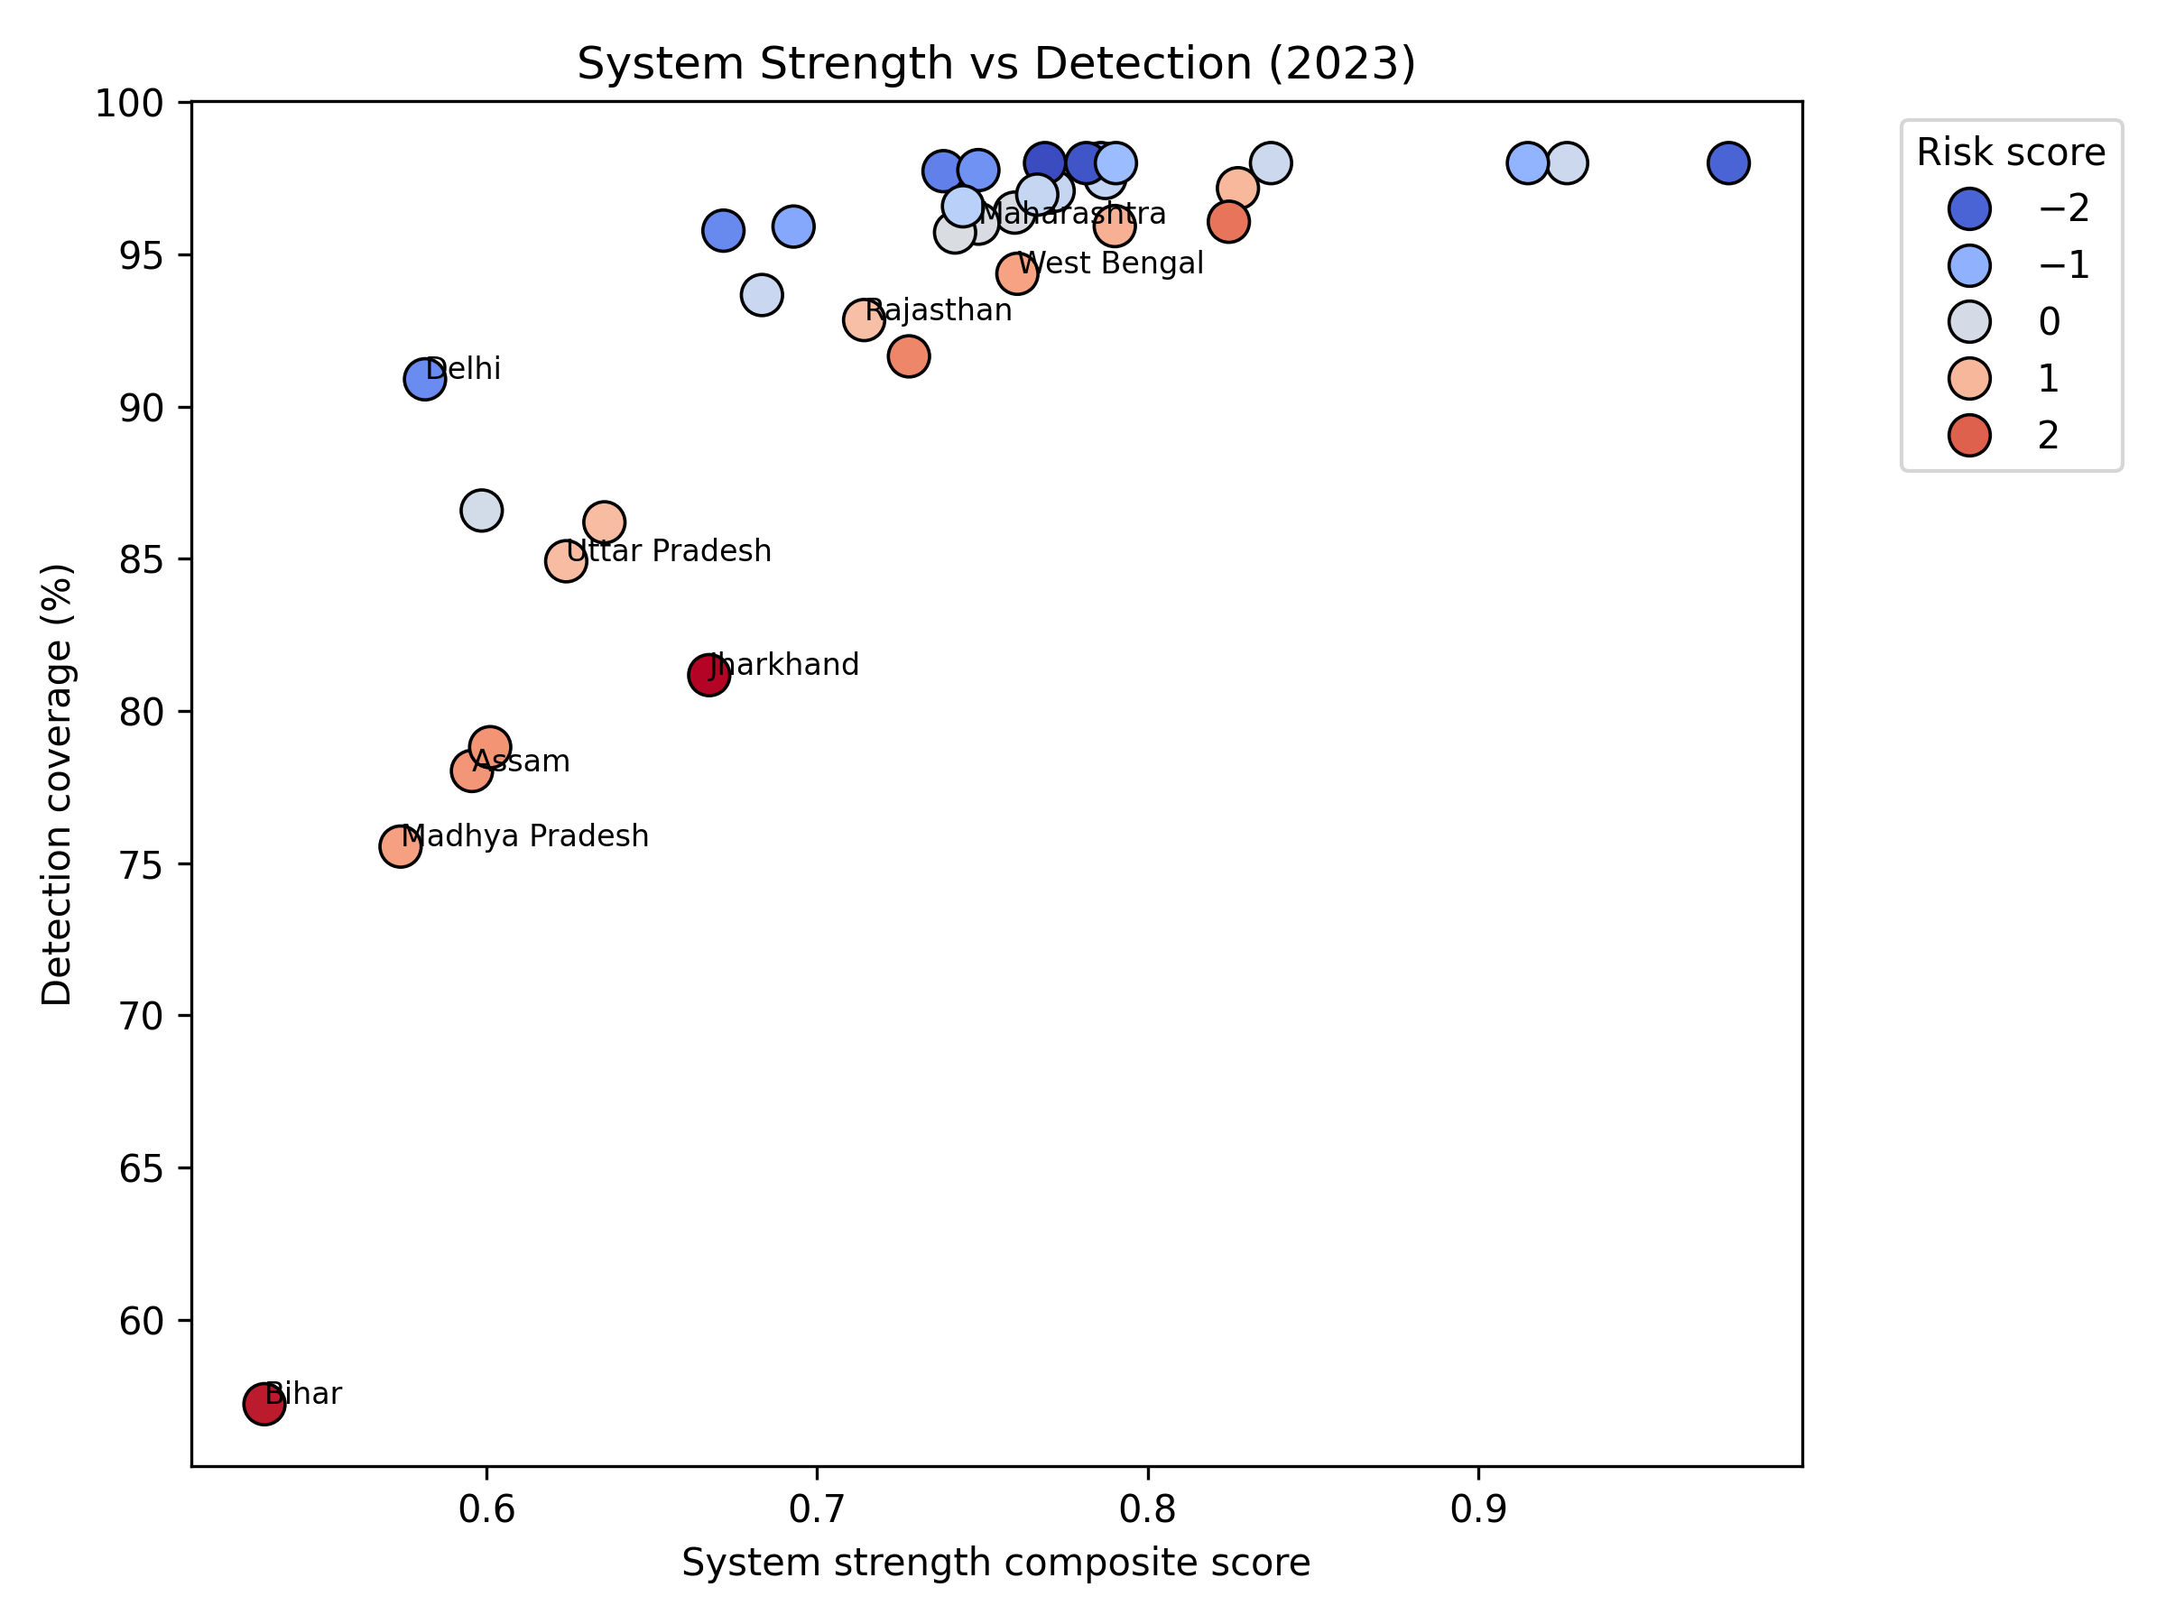
Figure 4. System strength versus detection coverage, coloured by risk score.
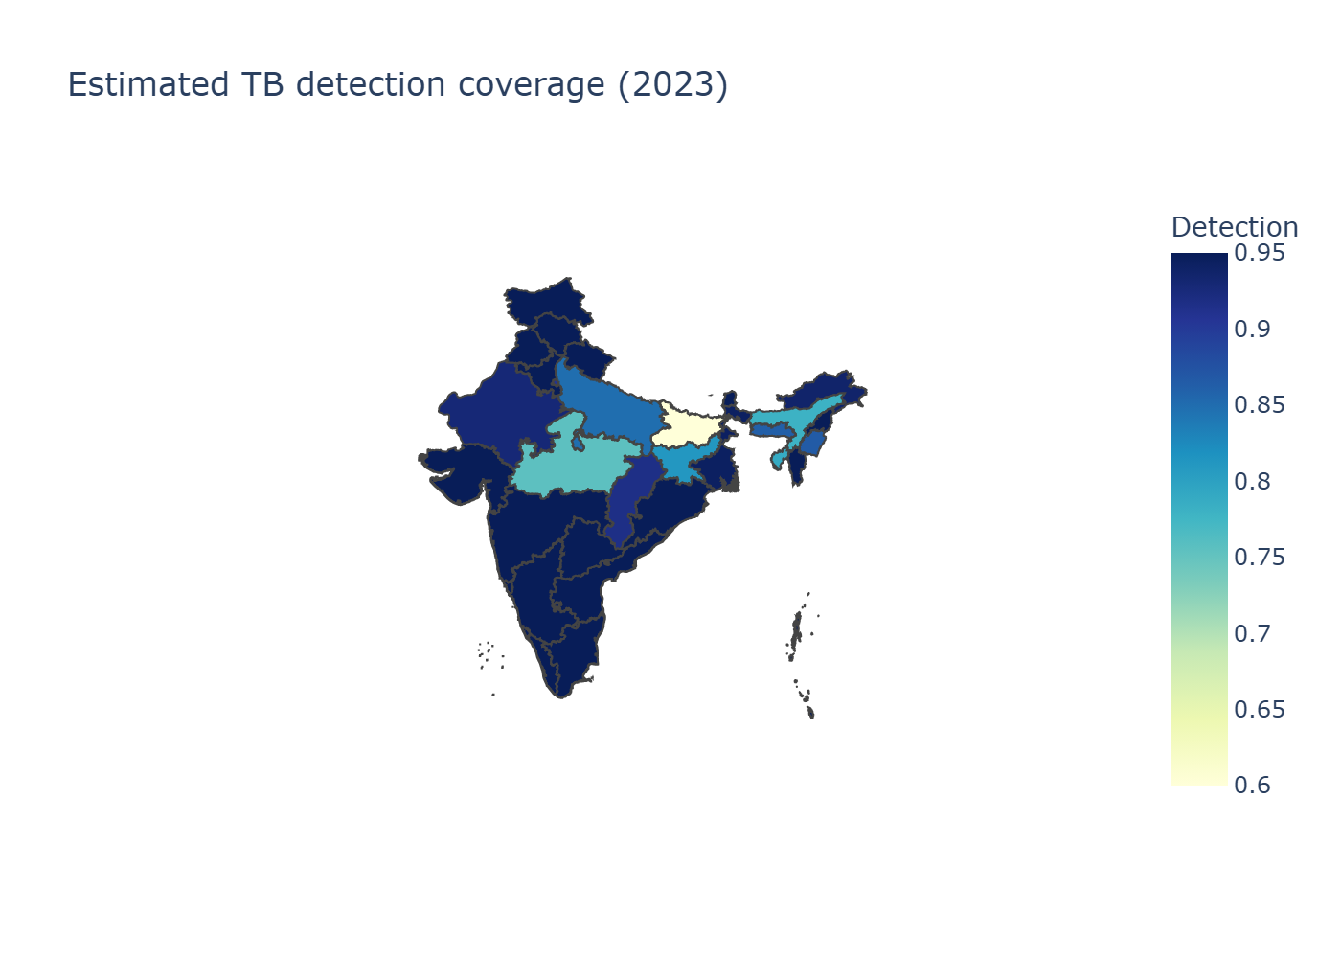
Figure 5. Estimated detection coverage across Indian states.

Table 2. High-gap states and scenario needs (2023).

State | Detection (%) | Missed cases | Additional notifications to reach 90% detection
Bihar | 57.2 | 132,561 | 101,571
Uttar Pradesh | 84.9 | 103,503 | 34,869
Madhya Pradesh | 75.5 | 53,924 | 31,873
Assam | 78.0 | 13,669 | 7,448
Jharkhand | 81.2 | 12,711 | 5,958

3.3 Scenario requirements
Table 3 indicates that reaching 90% detection nationally requires ~182,000 additional notifications, while 95% detection would demand ~260,000. Roughly three-quarters of the 90% target gap lies in Bihar and Madhya Pradesh, underscoring the need for state-specific interventions.

Table 3. Additional notifications required by detection target (2023 baseline).

Target detection | Additional notifications (national)
80% | 81,682
90% | 182,487
95% | 260,021

4. Discussion
The rapid rebound in detection—from 58.8% in 2020 to 86.3% in 2023—shows that India’s TB programme can recover from pandemic disruptions, yet large state-level gaps persist. Bihar (57% detection) and Madhya Pradesh (75%) exemplify this duality: both have scaled case finding but still lag in comorbidity management, private-sector integration, and risk-factor mitigation. Our results demonstrate that states with higher cascade scores (DM/tobacco/alcohol screening and linkage) reliably achieve ≥95% detection, validating the Central TB Division’s emphasis on differentiated TB care and PPSA-led private engagement [1–4,15,16]. Conversely, NFHS-5 risk profiles reveal concentrated burdens of malnutrition, anemia, and energy poverty in the eastern corridor, mirroring prior studies linking social determinants to persistent TB transmission [6–12].

These findings argue for a dual strategy. First, state-specific surge plans—anchored in Ni-kshay Mitra outreach, expanded molecular diagnostics, and targeted incentives—are needed to capture the ~134,000 additional notifications required in Bihar and Madhya Pradesh alone. Second, integrating TB interventions with nutrition support, clean fuel initiatives, and social protection can address the upstream determinants that sustain high incidence in eastern states. The reproducible WHO–Ni-kshay pipeline developed here enables annual recalibration of these strategies, providing transparent evidence that can be shared with state governments, donors, and peer reviewers.

5. Limitations
- Input data: Ni-kshay exports determine current state notification shares; if the CTD releases updated tables, estimates may shift, though the pipeline can be rerun.
- Temporal lag: NFHS-5 reflects 2019–2021 conditions; states with recent improvements may outperform the model’s risk assessment.
- Deterministic outputs: Uncertainty intervals are not yet included; the planned Bayesian extension will provide posterior credible intervals once state incidence priors become available [13].
- Geospatial rendering: Detection maps exclude Ladakh and the merged Dadra & Nagar Haveli–Daman & Diu due to geometry limitations, though their metrics remain in tables.

6. Conclusions
India’s detection coverage is accelerating, but closing the missed-case gap now hinges on a handful of lagging states. Bihar and Madhya Pradesh alone require roughly 134,000 additional notifications each year to reach 90% detection, underscoring the need for aggressive, state-specific surge plans that blend Ni-kshay Mitra–led active case finding, cascade strengthening, and private-sector incentives. Integrating WHO incidence, Ni-kshay notifications, and NFHS-5 risk data into a transparent, reproducible pipeline allows policymakers to track progress annually, recalibrate investments, and communicate gaps with clarity. By institutionalising this evidence-driven approach—and pairing it with interventions that address both health-system readiness and the social determinants of TB—India can remain on course to “find, treat, and end” TB in line with the WHO End TB Strategy.

References
- World Health Organization. Global Tuberculosis Report 2024. Geneva: WHO; 2024.
- Central TB Division, Ministry of Health & Family Welfare. India TB Report 2024. New Delhi: CTD; 2024.
- Central TB Division. National Strategic Plan for Tuberculosis Elimination 2020–2025. New Delhi: MoHFW; 2020.
- World Health Organization. The End TB Strategy: Updated Operational Guidance. Geneva: WHO; 2023.
- Ni-kshay. National TB Elimination Programme dashboard. Ministry of Health & Family Welfare; 2024.
- International Institute for Population Sciences (IIPS) & ICF. National Family Health Survey (NFHS-5), 2019–21: India. Mumbai: IIPS; 2021.
- Bhargava A, Jain Y. Social determinants of tuberculosis. Indian J Med Res. 2020;151(5):417–419.
- Lönnroth K, Migliori GB, Abubakar I, et al. Towards tuberculosis elimination: an action framework. Eur Respir J. 2015;45(4):928–952.
- Pai M, Daftary A, Hopewell PC. Tuberculosis control needs a renewed strategy. Nat Rev Dis Primers. 2017;3:17022.
- Subbaraman R, Nathavitharana RR, Satyanarayana S, et al. The tuberculosis cascade of care in India’s public sector. PLoS Med. 2016;13(10):e1002149.
- Cazabon D, Alsdurf H, Satyanarayana S, et al. Quality of tuberculosis care in high-burden countries. Int J Infect Dis. 2017;56:111–116.
- Satyanarayana S, Nair SA, Chadha SS, et al. Source of TB treatment in India. PLoS One. 2011;6(9):e24160.
- Arinaminpathy N, Greenwood B, Nathavitharana R, et al. Mathematical modeling of TB control. Nat Commun. 2020;11:4982.
- Thomas BE, Velayutham B, Thiruvengadam K, et al. Sociodemographic drivers of TB. BMJ Glob Health. 2021;6:e005397.
- Satyanarayana S, Subbaraman R, Shete PB, et al. Multicomponent TB interventions in India. Thorax. 2020;75(6):593–600.
- Velayutham B, Thomas B, Nair D, et al. Patient Provider Support Agencies (PPSAs). BMJ Glob Health. 2018;3:e000637.
- Central TB Division. Patient Provider Support Agency Implementation Manual. New Delhi: MoHFW; 2022.
- Global Burden of Disease Collaborative Network. GBD 2023 Tuberculosis Collaborators. Seattle: IHME; 2023.
- Yellappa V, Lefèvre P, Battaglioli T, et al. Patient pathways to TB diagnosis in India. BMC Public Health. 2017;17:679.
- Pai M, Behr MA, Dowdy D, et al. Tuberculosis. Nat Rev Dis Primers. 2016;2:16076.

