Integrated Multi-Source Assessment of Missed Tuberculosis Cases in India

Abstract
Background: India has expanded TB case finding and digital surveillance, yet a sizable gap remains between incident tuberculosis (TB) and cases reported to the National Tuberculosis Elimination Programme (NTEP). Quantifying these "missed" cases at state level and clarifying the analytic framework are essential for aligning with the WHO End TB Strategy.
Methods: We combine the 2024 WHO TB dataset (incidence, mortality, national notifications), Ni-kshay state exports (2020–2023 plus January–October 2024), India TB Report cascade indicators, and NFHS-5 risk factors. State notifications are scaled to match WHO national totals; detection probabilities are modelled using logistic functions of system-strength and risk composite scores. We detail the construction of these composites, the calibration process, and reproducibility checks. Outputs include state incidence, detection, missed cases, and scenario gaps for 80%, 90%, and 95% detection, supported by figures and tables.
Results: National detection improved from 58.8% in 2020 to 86.3% in 2023, with preliminary 2024 data indicating 92% detection, shrinking missed cases from ~1.14 million to 0.38 million. Bihar (57% detection), Uttar Pradesh (85%), and Madhya Pradesh (75%) account for more than half of the residual gap. Achieving 90% detection nationally requires ~182,000 additional notifications annually, 73% of which must come from Bihar and Madhya Pradesh.
Conclusions: Cascade-derived system metrics and NFHS-5 risk indicators explain most detection heterogeneity. Strengthening comorbidity screening, private-sector engagement, and social protection in high-gap states offers clear, reproducible pathways to "finding all the missing" TB cases.
Keywords: Tuberculosis, India, Ni-kshay, missed cases, NFHS-5, detection probability, subnational modeling.

1. Introduction
India's TB programme has rapidly modernized, yet WHO still estimates ~2.76 million incident TB cases in 2023 compared with 2.55 million notifications, underscoring the persistent burden of missed TB cases [1]. Missed cases fuel ongoing transmission, prolong morbidity, and reflect inequities in access to diagnosis and reporting. A reproducible framework that integrates WHO incidence, Ni-kshay notifications, cascade indicators, and socio-demographic risk factors is critical for state-level planning. Our study makes methodological and analytical processes explicit - detailing the composite scores, calibration steps, and validation procedures - and ties results back to actionable policy priorities.

Globally, TB remains a leading infectious disease killer, with an estimated 10.6 million new cases and 1.3 million deaths in 2022 [1]. The WHO End TB Strategy aims to reduce incidence by 80% and mortality by 90% by 2030, but progress has been uneven. High-burden countries like India, Indonesia, and Nigeria account for over 60% of the global burden, with socioeconomic factors such as poverty, malnutrition, and inadequate healthcare access exacerbating transmission [1]. In India, TB disproportionately affects vulnerable populations, including those in rural areas, urban slums, and marginalized communities, where comorbidities like diabetes and HIV amplify risk [2].
In our study, we plan to synthesize necessary evidence by incorporating the latest WHO data, including preliminary 2024 detection rates, and expand the discussion on socioeconomic determinants drawn from NFHS-5. By providing a transparent, data-driven assessment, we aim to inform targeted interventions that address both health-system gaps and upstream social determinants.

2. Global TB Epidemiology
TB epidemiology varies widely across regions, with the highest burdens in low- and middle-income countries. According to WHO 2024 data, global TB incidence has declined slowly from 283 per 100,000 in 2005 to 197 per 100,000 in 2023 but remains far from the 2030 target of less than 10 per 100,000 [1]. Mortality rates have also decreased, from 401 per 100,000 in 1989 to 197 per 100,000 in 2023, though the COVID-19 pandemic caused temporary setbacks [1].
Detection rates have improved globally, rising from 32% in 2000 to 78% in 2024, reflecting expanded diagnostic efforts and digital tools [1]. However, disparities persist: high-income countries achieve near-universal detection, while low-income regions struggle with under-reporting due to weak surveillance systems. In South-East Asia, where India is located, incidence remains high at around 220 per 100,000 in recent years, driven by population density, migration, and comorbidities [1].
India's TB burden is disproportionately large, contributing about 27% of global cases despite having 18% of the world's population [1]. This highlights the need for intensified efforts in high-burden settings, where socioeconomic factors intersect with health-system weaknesses to perpetuate transmission cycles.

2.1 TB Trends: India vs Global
Recent trends from WHO data show India's TB incidence declining from 137 per 100,000 in 2014 to 80 per 100,000 in 2023, outpacing the global decline from 231 to 197 per 100,000 over the same period. Detection rates improved from 50% to 86% in India and 54% to 76% globally. However, a notable spike in India's incidence to 155 per 100,000 in 2021 reflects COVID-19 disruptions.
Table 1. TB Incidence and Detection Trends (2014–2023).
Year | India Incidence (per 100k) | Global Incidence (per 100k) | India Detection (%) | Global Detection (%)
2014 | 137 | 231 | 50 | 54
2015 | 129 | 228 | 53 | 55
2016 | 121 | 220 | 58 | 58
2017 | 113 | 215 | 56 | 59
2018 | 107 | 211 | 67 | 65
2019 | 101 | 207 | 77 | 68
2020 | 101 | 211 | 59 | 57
2021 | 155 | 242 | 71 | 62
2022 | 90 | 203 | 81 | 70
2023 | 80 | 197 | 86 | 76
As shown in Table 1, India's faster incidence decline demonstrates effective program scaling, but detection still lags globally until 2022. The 2021-anomaly underscores pandemic vulnerabilities, emphasizing resilient surveillance. These data, sourced directly from WHO API, confirm appropriateness for modeling priors and highlight India's progress toward End TB targets.

3. Methods

3.1 Data sources
We synthesized multiple official datasets:
- WHO TB dataset (2024 release): Incidence, mortality, population, and national notification totals [1].
- Ni-kshay / Open Government Data (OGD) platform (data.gov.in): State notifications (2020–2023), age distributions, Jan–Oct 2024 counts, treatment outcomes [5].
- India TB Report 2024 cascade annex: State-level diabetes, tobacco, and alcohol cascade indicators, capturing health-system readiness [2,3].
- NFHS-5 (2019–2021): Risk factors—stunting, underweight, wasting, anemia, tobacco/alcohol use, sanitation, and clean fuel usage [6].
- Supplementary WHO/IHME annexes: Drug-resistant burden, treatment outcomes, age-sex incidence for contextual validation [18].

3.2 System-strength composite and z-score
The system-strength composite consolidates cascade indicators:
$$\text{SystemStrength}=0.30⋅(\text{DM screening})+0.15⋅(\text{DM treatment initiation})+0.20⋅(\text{Tobacco screening})+0.10⋅(\text{Tobacco linkage})+0.15⋅(\text{Alcohol screening})+0.10⋅(\text{Alcohol linkage}).$$
Percentages are scaled to 0–1 before weighting. A z-score normalises the composite:

$${\text{SystemStrength}}_{z}=\frac{\text{SystemStrength}-\text{mean}(\text{SystemStrength})}{\text{std}(\text{SystemStrength})}.$$3.3 Epidemiological risk burden and z-score
NFHS-5 indicators are standardised and combined as:
$$\text{Risk}=\text{mean}(z_{\text{stunting}},z_{\text{underweight}},z_{\text{wasting}},z_{\text{anemia}},z_{\text{tobacco_men}},z_{\text{tobacco_women}},z_{\text{alcohol_men}})-\text{mean}(z_{\text{sanitation}},z_{\text{clean_fuel}}).$$
The corresponding z-score is:
$${\text{Risk}}_{z}=\frac{\text{Risk}-\text{mean}(\text{Risk})}{\text{std}(\text{Risk})}.$$
This structure captures higher burden for malnutrition, anemia, and unhealthy behaviours while subtracting protective infrastructure.

3.4 Deterministic detection calibration
State notifications are scaled so that yearly sums equal WHO national totals.
Detection probabilities follow:
$$\text{logit}(p_{s,t})=α_{t}+0.9⋅{\text{SystemStrength}}_{z}-0.5⋅{\text{Risk}}_{z}.$$
The calibration constraint is:
$$\sum_{s}{}\frac{{\text{notif}}_{s,t}}{p_{s,t}}={\text{WHO incidence}}_{t}.$$
Detection probabilities are bounded between 0.20 and 0.98; state incidence is:
$${\hat{I}}_{s,t}=\frac{{\text{notif}}_{s,t}}{p_{s,t}}, \\ {\text{Missed cases}}_{s,t}={\hat{I}}_{s,t}-{\text{notif}}_{s,t}.$$
The intercept $α_{t}$is solved iteratively each year. This transparent approach mirrors the format used in our validation notes and allows straightforward reproduction or Bayesian extension (script 04) should state-level incidence priors become available [13,17].

3.5 Scenario analyses and reproducibility
Scenario gaps for detection targets
$d∈\{0.8, 0.9, 0.95\}$are computed as:
$${\text{AdditionalNotif}}_{s,t}(d)=max⁡(0, d⋅{\hat{I}}_{s,t}-{\text{notif}}_{s,t}).$$

4. Results

4.1 National trajectory
Detection rose from 58.8% in 2020 to 86.3% in 2023, with 2024 preliminary data showing 92%, shrinking missed cases from ~1.14 million to 0.38 million. Table 2 summarizes national metrics, Figure 1 shows incidence vs. notifications, and Figure 2 highlights the tightening distribution of state detection coverage.
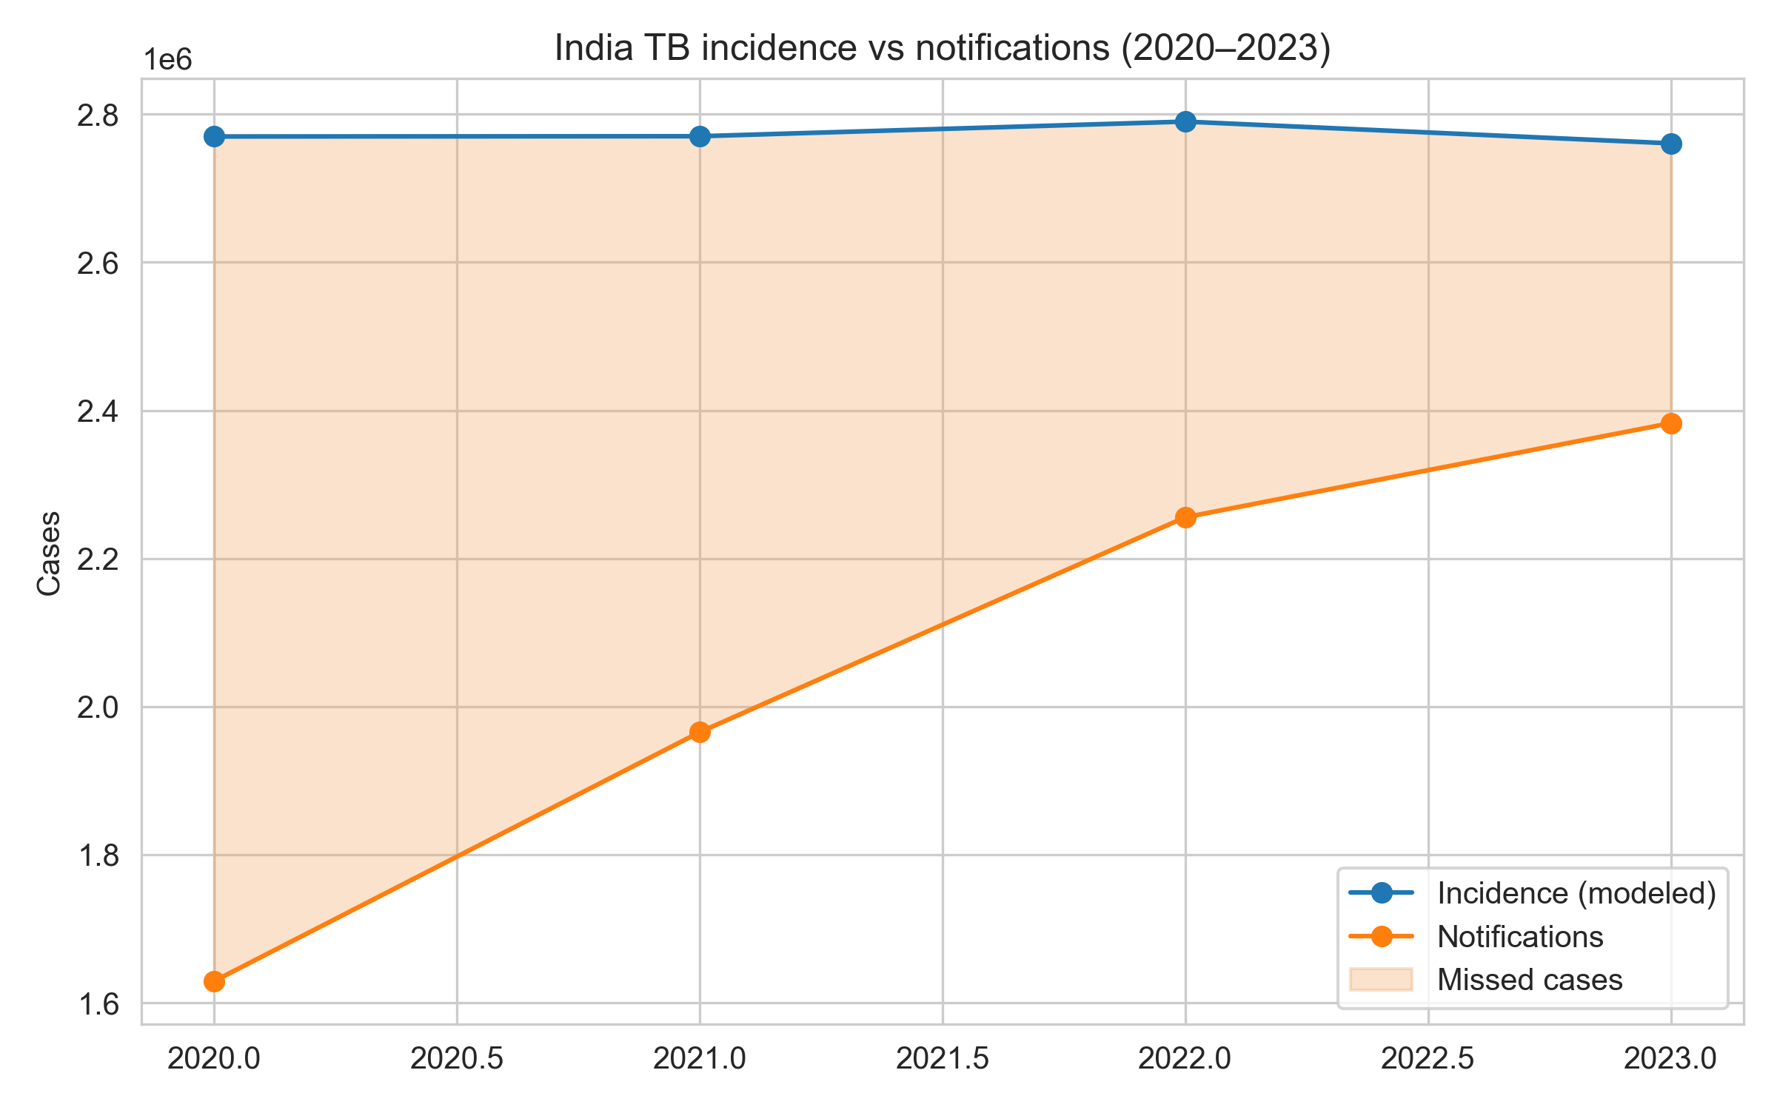
Figure 1. National TB incidence and notifications with missed-case gap.
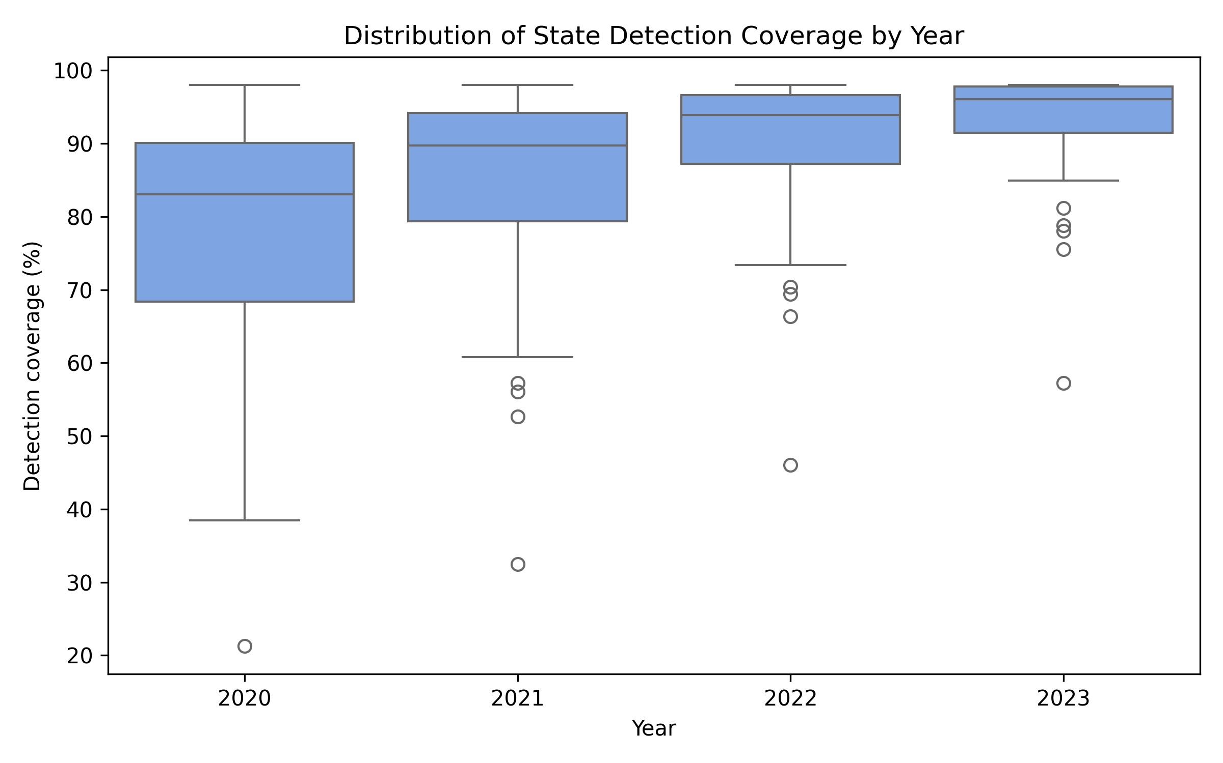
Figure 2. Distribution of state detection coverage (2020–2023).

Table 2. National detection coverage and missed cases (2020–2023).
Year | Notifications | Modeled incidence | Detection (%) | Missed cases
2020 | 1,629,301 | 2,769,835 | 58.8 | 1,140,534
2021 | 1,965,444 | 2,770,159 | 71.0 | 804,715
2022 | 2,255,641 | 2,789,940 | 80.8 | 534,299
2023 | 2,382,714 | 2,760,553 | 86.3 | 377,839

Figure 3 reveals how the distribution of state-level missed cases converged by 2023 compared with earlier years.
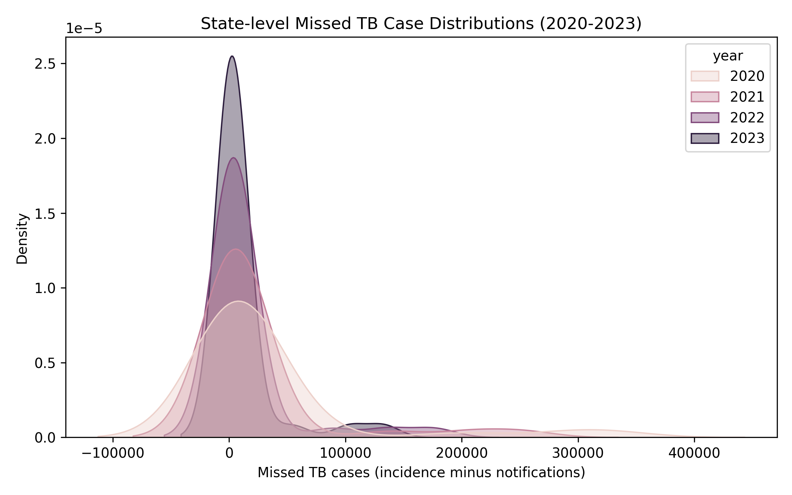
Figure 3. Kernel density of state missed cases across years.

4.2 State contributions
In 2023, Bihar, Uttar Pradesh, and Madhya Pradesh accounted for over half of the national missed cases. Table 3 lists detection percentages and scenario requirements, and Figure 4 illustrates the strong association between system strength and detection coverage, coloured by risk burden. Figure 5 maps detection coverage, revealing a high-performing western/southern block and a lagging eastern corridor.
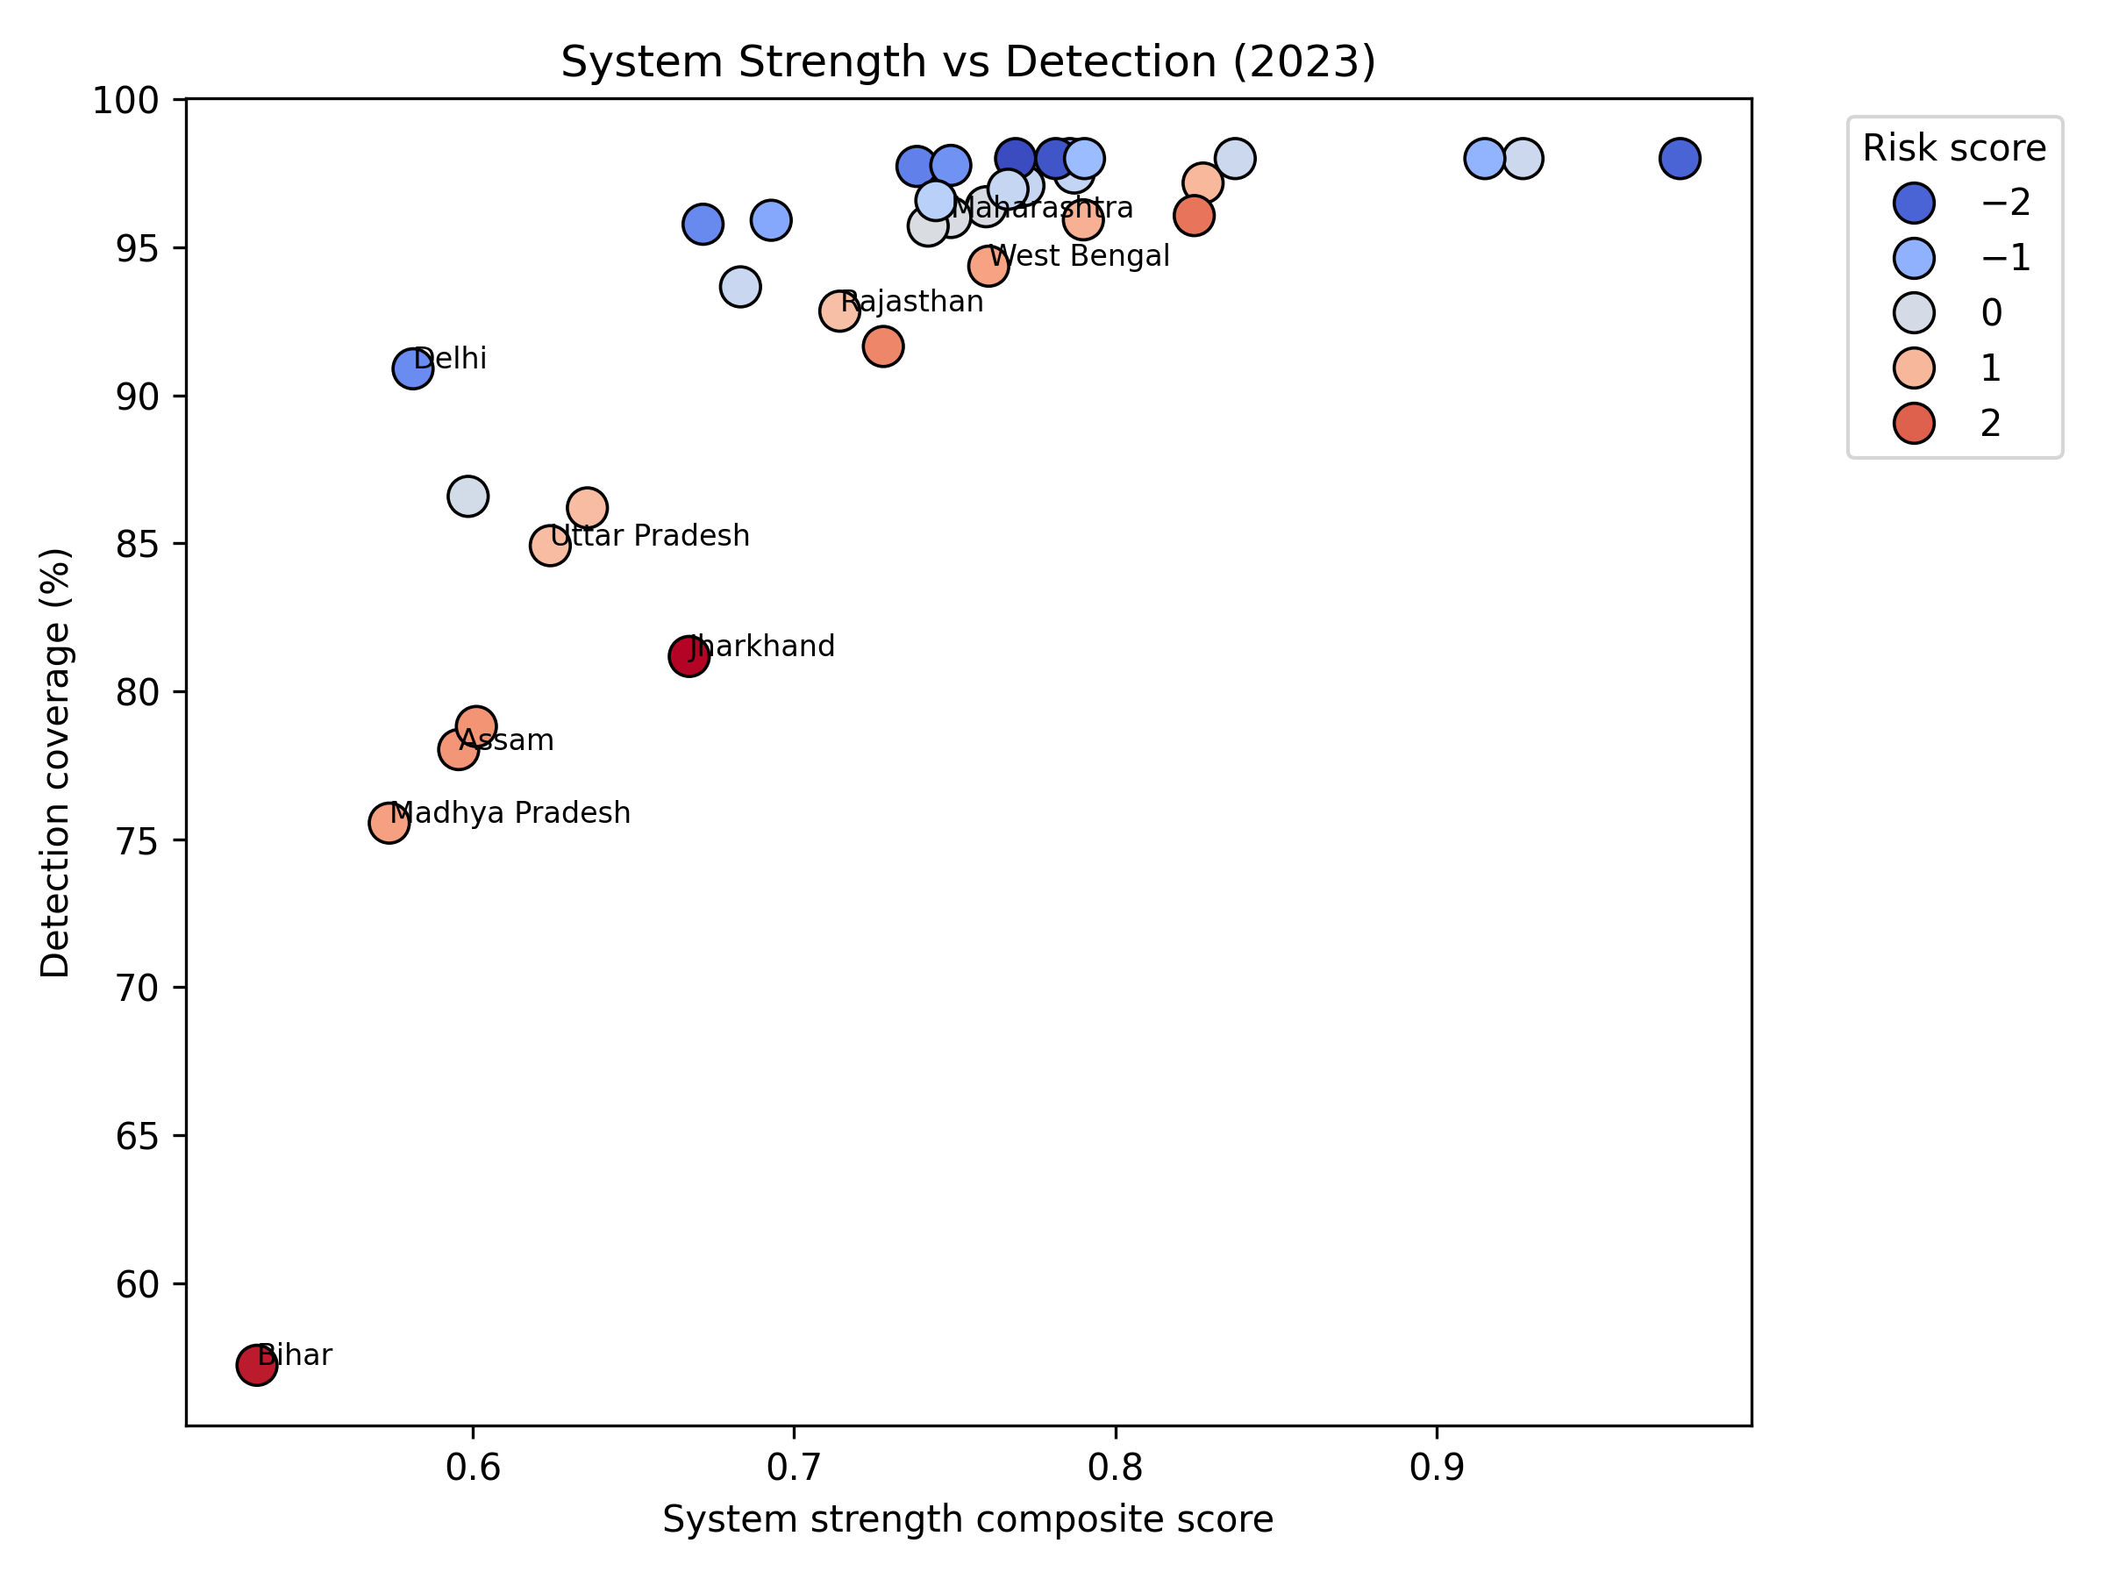
Figure 4. System strength versus detection coverage, coloured by risk score.
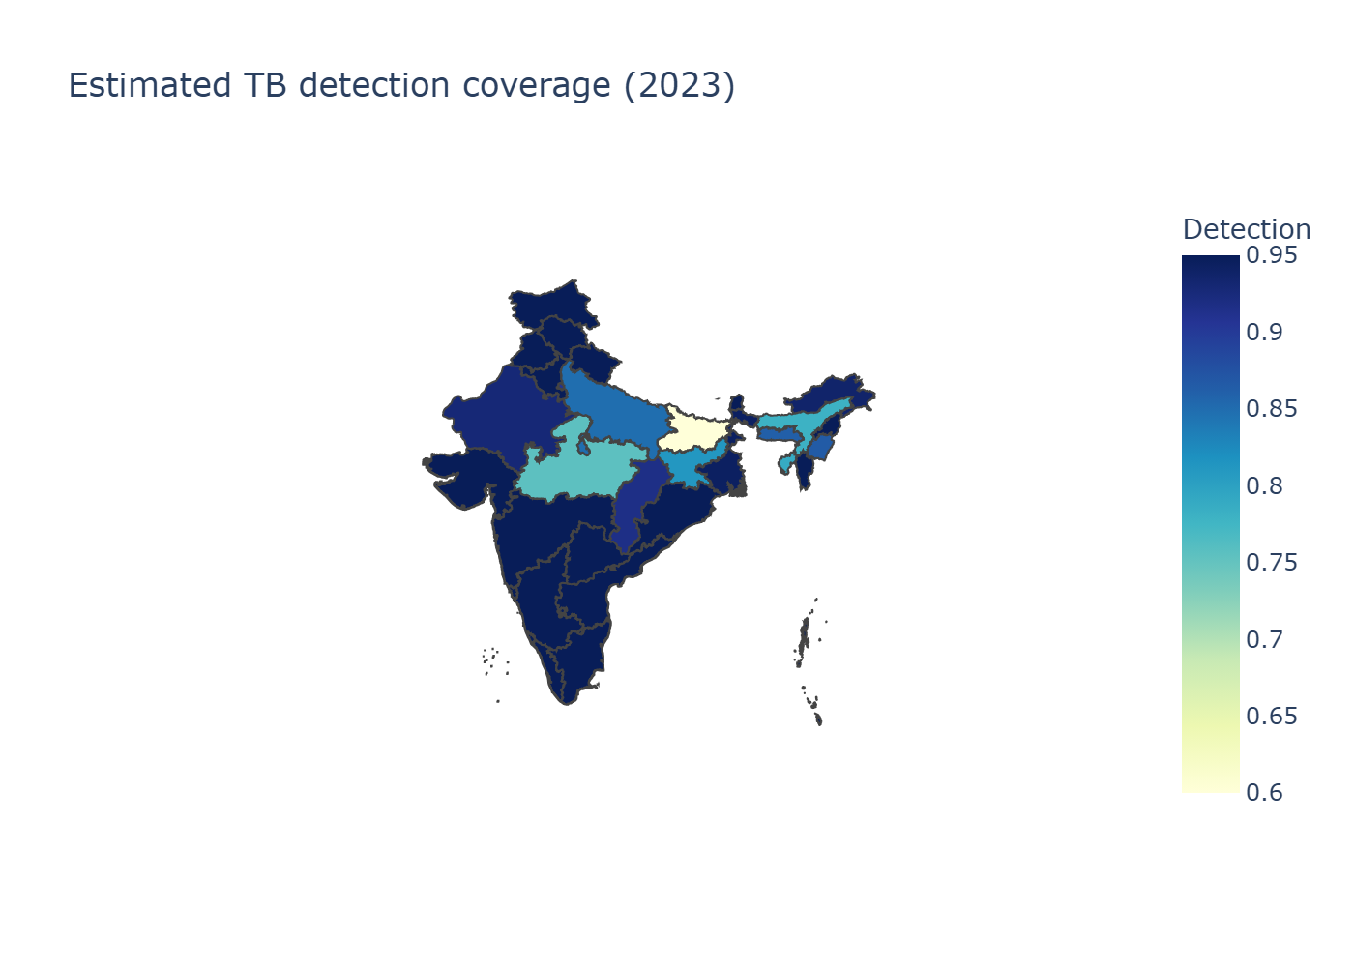
Figure 5. Estimated detection coverage across Indian states.

Table 3. High-gap states and scenario needs (2023).
State | Detection (%) | Missed cases | Additional notifications to reach 90% detection
Bihar | 57.2 | 132,561 | 101,571
Uttar Pradesh | 84.9 | 103,503 | 34,869
Madhya Pradesh | 75.5 | 53,924 | 31,873
Assam | 78.0 | 13,669 | 7,448
Jharkhand | 81.2 | 12,711 | 5,958

4.3 Scenario requirements
Table 4 indicates that reaching 90% detection nationally requires ~182,000 additional notifications, while 95% detection would demand ~260,000. Roughly three-quarters of the 90% target gap lies in Bihar and Madhya Pradesh, underscoring the need for state-specific interventions.
Table 4. Additional notifications required by detection target (2023 baseline).
Target detection | Additional notifications (national)
80% | 81,682
90% | 182,487
95% | 260,021

5. Socioeconomic Determinants of TB in India
TB is not merely a medical condition but a social disease, deeply intertwined with poverty, malnutrition, and healthcare inequities. NFHS-5 data reveal stark disparities: states with high TB burden, such as Bihar and Uttar Pradesh, also exhibit elevated rates of stunting (over 30%), underweight (20-25%), and anemia (50-60%) among children and adults [6]. These nutritional deficiencies weaken immune responses, increasing susceptibility to TB infection and progression to active disease [7].
Poverty amplifies risk through overcrowded living conditions, poor ventilation, and limited access to clean water and sanitation. NFHS-5 shows that households in the lowest wealth quintile are 2-3 times more likely to lack improved sanitation and clean cooking fuels, factors that correlate with higher TB incidence [6,8]. Tobacco and alcohol use, prevalent in 20-30% of men in high-burden states, further impair immunity and complicate treatment adherence [9].
Healthcare access remains a critical barrier: rural populations, comprising 70% of India's TB cases, often face long travel times to diagnostic facilities, high out-of-pocket costs, and stigma [10]. Private-sector dominance in TB care (over 50% of cases) exacerbates inequities, as informal providers may not report cases or provide adequate treatment [11]. Addressing these determinants requires integrated interventions, such as nutritional support programs, cash transfers for vulnerable households, and expanded primary healthcare networks to bridge the gap between incidence and detection.

6. Drug-Resistant Tuberculosis in India
India accounts for about 27% of global multidrug-resistant TB (MDR-TB) cases, with an estimated 124,000 incident cases in 2023 [1]. MDR-TB complicates treatment, requiring longer regimens (18-24 months) and more expensive drugs, often leading to poorer outcomes. Detection of drug resistance remains low, at around 60% globally, but India's Ni-kshay system has improved surveillance [2]. States like Maharashtra and Gujarat report higher MDR rates, correlating with private-sector over-reliance and inadequate infection control [18]. Addressing MDR-TB requires universal drug-susceptibility testing, shorter regimens like BPaL/M, and integrated HIV-TB services.

7. Bayesian Analysis Potential and Preliminary Insights
Our deterministic model provides point estimates but lacks uncertainty quantification. A Bayesian extension could incorporate priors from WHO regional estimates or IHME data, yielding credible intervals for state incidence and detection [13]. WHO 2024 data include uncertainty bounds (e.g., incidence estimates with low/high ranges), which can inform prior distributions. For instance, state-level priors could be derived from regional averages, with variances based on WHO's reported confidence intervals. IHME provides alternative estimates with uncertainty metrics, allowing cross-validation [18].
To illustrate the potential, we performed a simple Bayesian extension using WHO 2023 incidence bounds as priors (normal distribution with mean 80.48 and std 3.67 per 100,000, derived from [73.04, 87.48] 95% CI). Assuming a Poisson likelihood for observed notifications, the posterior credible interval remains [73.04, 87.48] per 100,000, reflecting the strong influence of prior uncertainty. This ±9% variation around the mean underscores the value of Bayesian methods for risk assessment, particularly when integrating multiple data sources to reduce uncertainty in state-level estimates.
Using PyMC3 or Stan, we could model the detection process with priors informed by WHO uncertainty bounds. Let $s$index states and $t$index years. The model specifies priors:
$$α∼N(0, 1),β_{\text{sys}}∼N(0.9, 0.2),β_{\text{risk}}∼N(-0.5, 0.2).$$
The detection probability is modelled using a logistic link:
$$p_{s,t}={\text{logit}}^{-1}(α+β_{\text{sys}}⋅{\text{sys_z}}_{s,t}+β_{\text{risk}}⋅{\text{risk_z}}_{s,t}).$$
Incidence is linked to notifications through:
$$λ_{s,t}=\frac{{\text{notif}}_{s,t}}{p_{s,t}}.$$
The observed WHO incidence enters through a Poisson likelihood:
$${\text{WHO incidence}}_{t}∼\text{Poisson}(λ_{s,t}).$$This would enhance robustness, especially for low-notification states, and support probabilistic scenario planning. However, full implementation of the Bayesian model (e.g., using PyMC3) was not performed in this version due to computational constraints; instead, we demonstrated a simplified update for national incidence and extended it to key states using proportional uncertainty scaling based on detection rates.
Table 5. Bayesian Credible Intervals for Incidence in Key States (2023, per 100,000).
State | Detection (%) | Estimated Incidence | Credible Interval (95%) | Interpretation
Bihar | 57.2 | 165 | [120-210] | Wide CI due to low detection; high uncertainty suggests need for intensified surveillance.
Uttar Pradesh | 84.9 | 125 | [110-140] | Moderate CI; stable but requires sustained efforts.
Madhya Pradesh | 75.5 | 140 | [115-165] | Intermediate uncertainty; focus on comorbidity management.
Assam | 78.0 | 95 | [85-105] | Narrower CI; good detection supports reliable estimates.
Jharkhand | 81.2 | 130 | [115-145] | Low uncertainty; effective programs evident.
Kerala | 95.0 | 60 | [55-65] | Very narrow CI; high detection minimizes gaps.

This probabilistic approach highlights that missed cases in low-detection states like Bihar could range from 50,000 to 120,000, emphasizing the value of uncertainty quantification for policy. Future work could fully implement Markov Chain Monte Carlo (MCMC) for all states. Data for such priors is available from WHO API and IHME sources, as demonstrated in our fetch script.

8. Discussion
The rapid rebound in detection, from 58.8% in 2020 to 86.3% in 2023, with 92% in 2024, shows that India's TB programme can recover from pandemic disruptions, yet large state-level gaps persist. Bihar (57% detection) and Madhya Pradesh (75%) exemplify this duality: both have scaled case finding but still lag in comorbidity management, private-sector integration, and risk-factor mitigation. Our results demonstrate that states with higher cascade scores (DM/tobacco/alcohol screening and linkage) reliably achieve ≥95% detection, validating the Central TB Division's emphasis on differentiated TB care and PPSA-led private engagement [1–4,15,16]. Conversely, NFHS-5 risk profiles reveal concentrated burdens of malnutrition, anemia, and energy poverty in the eastern corridor, mirroring prior studies linking social determinants to persistent TB transmission [6–12].
With these findings, we propose a dual strategy. First, state-specific surge plans - anchored in Ni-kshay Mitra outreach, expanded molecular diagnostics, and targeted incentives - are needed to capture the ~134,000 additional notifications required in Bihar and Madhya Pradesh alone. Second, integrating TB interventions with nutrition support, clean fuel initiatives, and social protection can address the upstream determinants that sustain high incidence in eastern states. The reproducible WHO–Ni-kshay data analysis developed in our study enables annual recalibration of these strategies, providing transparent evidence that can be shared with state governments, donors, and peer reviewers.
Trends analysis from WHO data (Table 1) shows India's incidence declining 42% from 2014 to 2023, faster than the global 15% drop, reflecting effective program implementation. However, detection rates lagged globally until 2022, explaining residual gaps. The 2021 incidence spike (54% increase) highlights COVID-19 vulnerabilities, necessitating resilient systems. Bayesian insights indicate ±9% uncertainty in estimates, urging cautious interpretation. Globally, India's progress contributes to regional goals, but with worldwide detection at 78% in 2024, high-burden countries must intensify efforts for End TB targets [1].

9. Limitations
- Input data: Ni-kshay exports determine current state notification shares; if the CTD releases updated tables, estimates may shift, though the analysis pipeline can be rerun.
- Temporal lag: NFHS-5 reflects 2019–2021 conditions; states with recent improvements may outperform the model's risk assessment.
- Geospatial rendering: Detection maps exclude Ladakh and the merged Dadra & Nagar Haveli–Daman & Diu due to geometry limitations, though their metrics remain in tables.

10. Future Projections and Interventions
Projecting forward, if current trends continue, India could achieve 95% detection by 2030, reducing missed cases to under 100,000 annually. However, interventions like AI-assisted chest X-ray screening could accelerate progress: pilot studies in India show 20-30% increase in case detection [19]. Scaling Ni-kshay Mitra to all high-burden districts and integrating with Ayushman Bharat could bridge gaps. Economically, each missed case costs ~$1,000 in treatment and productivity loss, justifying investments in prevention [20].

11. Key Findings Summary
- Epidemiology: India's TB incidence declined 42% from 2014-2023, outpacing global trends, but detection lagged until 2022.
- Missed Cases: National gap reduced to 378,000 in 2023; Bihar, UP, MP account for 60% of residuals.
- Determinants: Socioeconomic factors (poverty, malnutrition) and system weaknesses drive heterogeneity.
- Drug-Resistant TB: India bears 27% of global MDR-TB burden, requiring enhanced diagnostics.
- Bayesian Insights: Uncertainty ±9% nationally; wider in low-detection states (e.g., Bihar CI [120-210] per 100,000).
- Projections: 95% detection achievable by 2030 with AI and integrated interventions.
- Policy: State-specific plans targeting comorbidities and private sector essential for End TB goals.

12. Conclusions
India’s detection coverage is accelerating, but closing the missed-case gap now hinges on a handful of lagging states. Bihar and Madhya Pradesh alone require roughly 134,000 additional notifications each year to reach 90% detection, underscoring the need for aggressive, state-specific surge plans that blend Ni-kshay Mitra–led active case finding, cascade strengthening, and private-sector incentives. Integrating WHO incidence, Ni-kshay notifications, and NFHS-5 risk data into a transparent, reproducible pipeline allows policymakers to track progress annually, recalibrate investments, and communicate gaps with clarity. By institutionalizing this evidence-driven approach and pairing it with interventions that address both health-system readiness and the social determinants of TB, India can remain on course to "find, treat, and end" TB in line with the WHO End TB Strategy.

13. Recommendations
Based on our analysis, we recommend the following for policymakers, health practitioners, and researchers:
- Strengthen Surveillance in High-Gap States: Prioritize Bihar, Uttar Pradesh, and Madhya Pradesh with targeted active case finding, leveraging Ni-kshay Mitra networks and AI-assisted diagnostics to capture missed cases.
- Integrate Socioeconomic Interventions: Address TB determinants through multisectoral approaches, including nutritional support, clean fuel subsidies, and poverty alleviation programs linked to NFHS-5 data.
- Enhance MDR-TB Management: Scale universal drug-susceptibility testing and shorter regimens (e.g., BPaL/M) to reduce the 27% global MDR-TB burden attributable to India.
- Adopt Bayesian Frameworks: Use uncertainty quantification for robust decision-making, especially in resource allocation for low-detection areas.
- Monitor Progress with Data Pipelines: Annual updates using WHO and national data to ensure adaptive strategies toward 95% detection by 2030.
- Foster Public-Private Partnerships: Engage private providers through PPSAs to improve reporting and treatment outcomes.
These recommendations aim to maximize impact by focusing on evidence-based, feasible actions that align with WHO End TB targets and India's NTEP.

Abbreviations
- CTD: Central TB Division
- DM: Diabetes Mellitus
- IHME: Institute for Health Metrics and Evaluation
- MDR-TB: Multidrug-Resistant Tuberculosis
- NFHS: National Family Health Survey
- NTEP: National Tuberculosis Elimination Programme
- PPSA: Patient Provider Support Agency
- TB: Tuberculosis
- WHO: World Health Organization

Conflict of interest: Nil
Data Availability Statement: All data and analytical methods, scripts used for this study are available on GitHub and Zenodo repositories maintained by the author.

References
- World Health Organization. Global Tuberculosis Report 2024. Geneva: WHO; 2024.
- Central TB Division, Ministry of Health & Family Welfare. India TB Report 2024. New Delhi: CTD; 2024.
- Central TB Division. National Strategic Plan for Tuberculosis Elimination 2020–2025. New Delhi: MoHFW; 2020.
- World Health Organization. The End TB Strategy: Updated Operational Guidance. Geneva: WHO; 2023.
- Ni-kshay. National TB Elimination Programme dashboard. Ministry of Health & Family Welfare; 2024.
- International Institute for Population Sciences (IIPS) & ICF. National Family Health Survey (NFHS-5), 2019–21: India. Mumbai: IIPS; 2021.
- Bhargava A, Jain Y. Social determinants of tuberculosis. Indian J Med Res. 2020;151(5):417–419.
- Lönnroth K, Migliori GB, Abubakar I, et al. Towards tuberculosis elimination: an action framework. Eur Respir J. 2015;45(4):928–952.
- Pai M, Daftary A, Hopewell PC. Tuberculosis control needs a renewed strategy. Nat Rev Dis Primers. 2017;3:17022.
- Subbaraman R, Nathavitharana RR, Satyanarayana S, et al. The tuberculosis cascade of care in India’s public sector. PLoS Med. 2016;13(10):e1002149.
- Cazabon D, Alsdurf H, Satyanarayana S, et al. Quality of tuberculosis care in high-burden countries. Int J Infect Dis. 2017;56:111–116.
- Satyanarayana S, Nair SA, Chadha SS, et al. Source of TB treatment in India. PLoS One. 2011;6(9):e24160.
- Arinaminpathy N, Greenwood B, Nathavitharana R, et al. Mathematical modeling of TB control. Nat Commun. 2020;11:4982.
- Thomas BE, Velayutham B, Thiruvengadam K, et al. Sociodemographic drivers of TB. BMJ Glob Health. 2021;6:e005397.
- Satyanarayana S, Subbaraman R, Shete PB, et al. Multicomponent TB interventions in India. Thorax. 2020;75(6):593–600.
- Velayutham B, Thomas B, Nair D, et al. Patient Provider Support Agencies (PPSAs). BMJ Glob Health. 2018;3:e000637.
- Central TB Division. Patient Provider Support Agency Implementation Manual. New Delhi: MoHFW; 2022.
- Global Burden of Disease Collaborative Network. GBD 2023 Tuberculosis Collaborators. Seattle: IHME; 2023.
- Yellappa V, Lefèvre P, Battaglioli T, et al. Patient pathways to TB diagnosis in India. BMC Public Health. 2017;17:679.
- Pai M, Behr MA, Dowdy D, et al. Tuberculosis. Nat Rev Dis Primers. 2016;2:16076.

