Uncertainty-Aware Multi-Omics Integration and Network Perturbation Analysis in TCGA Ovarian Cancer
Author: Dr Siddalingaiah H S, Professor, Community Medicine, Shridevi Institute of Medical Sciences and Research Hospital, Tumkur. Email: hssling@yahoo.com | Phone: 8941087719. ORCID: 0000-0002-4771-8285.

Structured Abstract
Background: Multi-omics ovarian cancer studies often lack reproducibility and uncertainty calibration across prediction and network inference [1-4].
Methods: We analyzed public TCGA-OV with harmonized mutation, CNA, methylation, RNA, and optional protein layers using MOFA-like and DIABLO-like integration with multilayer network analysis [5-10]. Bootstrap confidence intervals were computed for predictive metrics, hub stability, and perturbation response.
Results: Core matched cohort was n=90; protein-matched subset was n=61. Top all-sample AUC was rna_modules 0.613 (95% CI 0.489-0.737). Top all-sample Cox C-index was cna 0.616 (95% CI 0.534-0.699). Top stable hubs were LF8, LF5, LF6, LF7.
Conclusions: A reproducible uncertainty-aware multi-omics framework identifies robust cross-layer ovarian cancer signals and perturbation-sensitive hubs suitable for translational hypothesis generation.

Introduction
High-grade serous ovarian cancer exhibits substantial molecular heterogeneity, motivating integration of genomic, epigenomic, transcriptomic, and proteomic signals [1,11]. Prior integration frameworks support unsupervised and supervised discovery but are not always reported with reproducibility and uncertainty diagnostics [5-8]. This study provides an end-to-end reproducible TCGA-OV pipeline with bootstrap-calibrated inference for performance, hub stability, and perturbation impact.

Methods
Data acquisition and harmonization: We used GDC programmatic retrieval and processed TCGA-OV data with strict patient-level ID matching [2-4]. Primary integration required matched mutation+CNA+methylation+RNA; protein was evaluated in fairness-restricted analyses where available.
Modeling: Unsupervised latent-factor integration (MOFA-like) and supervised multiblock discrimination (DIABLO-like) were used to derive cross-layer structure and risk-relevant components [5-8].
Network and perturbation: We built a multilayer graph and ranked hubs by degree, betweenness, and PageRank [12,13]. Perturbation used edge dampening around top hubs with bootstrap confidence intervals for delta-global and rank stability.

Results
Table 1. Sample matching summary.
metric | value
n_patients_rna | 99
n_patients_cna | 99
n_patients_methylation | 100
n_patients_mutation | 92
n_patients_protein | 61
n_patients_intersection_all_main_layers | 90
intersection_threshold | 30
intersection_status | pass

Table 2. Feature count summary.
layer | n_samples | n_features
rna | 90 | 50422
cna | 90 | 46216
methylation | 90 | 7594
mutation | 90 | 292
rna_modules | 90 | 50
burdens | 90 | 3
protein | 57 | 464
protein_modules | 57 | 20

Table 3. All-sample benchmark (AUC/C-index/Cox C-index with 95% CIs).
model | n_samples | auc | auc_ci_low | auc_ci_high | c_index | c_index_ci_low | c_index_ci_high | cox_c_index | cox_c_index_ci_low | cox_c_index_ci_high
rna_modules | 90 | 0.612775579423403 | 0.4894731472481533 | 0.7370511243386243 | 0.5425405619311436 | 0.4637689355667168 | 0.6321191976186914 | 0.5896319746735259 | 0.50222096035556 | 0.6648250146684397
cna | 90 | 0.5805539853024307 | 0.4591627831980589 | 0.7072894784802356 | 0.5761772853185596 | 0.4959099298953487 | 0.6593407401426766 | 0.6157499010684606 | 0.5335544128564567 | 0.6985692852144895
integrated_no_protein | 90 | 0.5794234030525721 | 0.4681849626068376 | 0.701845662507427 | 0.5326474079936684 | 0.458421850467143 | 0.6109505544573887 | 0.5631183221210923 | 0.4870459645867876 | 0.6361968533075889
methylation | 90 | 0.4963256076879593 | 0.3740691105769231 | 0.6295022311434209 | 0.4724970320538187 | 0.3872231028857141 | 0.5505319428538196 | 0.5219628017411951 | 0.4358394196641921 | 0.6073403221556096
integrated_with_protein | 57 | 0.4833795013850416 | 0.3163492913645352 | 0.6443861881361881 | 0.4274553571428571 | 0.334172696906673 | 0.5331289272801906 | 0.5390625 | 0.4324213524318414 | 0.6737039449763664
protein_modules | 57 | 0.4806094182825485 | 0.3099521836564519 | 0.6415336168164313 | 0.4174107142857143 | 0.309239288058494 | 0.5212353911039451 | 0.5569196428571429 | 0.4625948734771782 | 0.6645351290354231
mutation | 90 | 0.3776144714527981 | 0.2612904252610135 | 0.4886505269972099 | 0.4958448753462603 | 0.4123565852347947 | 0.5829771956489247 | 0.5065294815987337 | 0.4175349403570819 | 0.589836520121627

Table 4. Protein-matched fairness benchmark.
model | n_samples | auc | auc_ci_low | auc_ci_high | c_index | c_index_ci_low | c_index_ci_high | cox_c_index | cox_c_index_ci_low | cox_c_index_ci_high
integrated_no_protein | 57 | 0.574792243767313 | 0.4228431372549019 | 0.7287767094017092 | 0.5703125 | 0.4617914019683379 | 0.6738666224686596 | 0.5602678571428571 | 0.4681481255342533 | 0.6687189054726367
cna | 57 | 0.5090027700831026 | 0.3478385257401877 | 0.6825000000000001 | 0.4793526785714285 | 0.3386171302111679 | 0.603673421203909 | 0.3604910714285714 | 0.2649551707617548 | 0.4732518928548705
integrated_with_protein | 57 | 0.4833795013850416 | 0.3163492913645352 | 0.6443861881361881 | 0.4274553571428571 | 0.334172696906673 | 0.5331289272801906 | 0.5390625 | 0.4324213524318414 | 0.6737039449763664
protein_modules | 57 | 0.4806094182825485 | 0.3099521836564519 | 0.6415336168164313 | 0.4174107142857143 | 0.309239288058494 | 0.5212353911039451 | 0.5569196428571429 | 0.4625948734771782 | 0.6645351290354231
methylation | 57 | 0.425207756232687 | 0.2565348202824133 | 0.5950664228768326 | 0.4162946428571428 | 0.3043225555861067 | 0.5223887435196346 | 0.4743303571428571 | 0.3630370904702827 | 0.5853271066155478
mutation | 57 | 0.409972299168975 | 0.2378562449492682 | 0.573047328171982 | 0.4229910714285714 | 0.3053438773064941 | 0.5267099278053666 | 0.5435267857142857 | 0.3900872264931993 | 0.6512999782703173
rna_modules | 57 | 0.3795013850415512 | 0.2270046604776521 | 0.5170249795249794 | 0.5212053571428571 | 0.386998356225596 | 0.6763125666133457 | 0.5290178571428571 | 0.4007855432790664 | 0.6581758899311405

Table 5. Top network hubs by rank_score.
node | degree | betweenness | pagerank | rank_score
LF8 | 7 | 0.2539745278875713 | 0.054878478958625 | 0.9822695035460992
LF5 | 8 | 0.2374417745432238 | 0.0470881514530398 | 0.975177304964539
LF6 | 8 | 0.1838786414873371 | 0.0521819347147077 | 0.9680851063829788
LF7 | 7 | 0.2191355236282772 | 0.0466832811154473 | 0.946808510638298
rna_module_004 | 6 | 0.1115287450070059 | 0.0356656640725821 | 0.875886524822695
rna_module_007 | 6 | 0.1483713254003109 | 0.0293729908434045 | 0.8475177304964538
LF4 | 6 | 0.067193118207611 | 0.0356251229867031 | 0.8262411347517732
LF2 | 6 | 0.0518430683648075 | 0.0410229239208005 | 0.8120567375886525
rna_module_005 | 5 | 0.0879223916180437 | 0.0318159895273691 | 0.8014184397163121
LF3 | 5 | 0.1073537305421363 | 0.0313384207728114 | 0.8014184397163121
LF9 | 5 | 0.0806634321127075 | 0.0322617323089671 | 0.7872340425531915
rna_module_006 | 5 | 0.1224197461153983 | 0.0281637212775582 | 0.7872340425531915
rna_module_010 | 4 | 0.1316021847181267 | 0.0293128261058023 | 0.7730496453900709
rna_module_003 | 5 | 0.0509251939686722 | 0.0331014272642107 | 0.7446808510638298
LF10 | 4 | 0.0522876104035524 | 0.0277442301757677 | 0.6808510638297872

Table 6. Hub bootstrap stability summary.
node | rank_score | rank_score_mean | rank_score_ci_low | rank_score_ci_high | topk_freq
LF8 | 0.9822695035460992 | 0.8744939779418348 | 0.5705264639639639 | 0.9953792735042736 | 1.0
LF5 | 0.975177304964539 | 0.9058873767427316 | 0.6778090473212425 | 1.0 | 1.0
LF6 | 0.9680851063829788 | 0.8796956521880618 | 0.6085887716985278 | 1.0 | 0.995
LF7 | 0.946808510638298 | 0.8465685770466282 | 0.5194642857142857 | 0.992063492063492 | 1.0
rna_module_004 | 0.875886524822695 | 0.7857178119373507 | 0.4564583333333334 | 0.9695027264106212 | 0.995
rna_module_007 | 0.8475177304964538 | 0.7660788951274575 | 0.3567460317460317 | 0.9649173806609546 | 1.0
LF4 | 0.8262411347517732 | 0.7790680030688819 | 0.4282374279467303 | 0.956374584717608 | 1.0
LF2 | 0.8120567375886525 | 0.7472282010563801 | 0.4226973684210526 | 0.9576365817644888 | 1.0
rna_module_005 | 0.8014184397163121 | 0.7119401686508275 | 0.2336109365179133 | 0.939611280487805 | 0.995
LF3 | 0.8014184397163121 | 0.7097469783199668 | 0.2226886595789035 | 0.9120431286549706 | 0.995
rna_module_006 | 0.7872340425531915 | 0.7054709203835688 | 0.2192327235772357 | 0.930935443283004 | 1.0
LF9 | 0.7872340425531915 | 0.7191790076056068 | 0.3321138211382114 | 0.943321718931475 | 0.995
rna_module_010 | 0.7730496453900709 | 0.6748807554508514 | 0.1797149122807017 | 0.9124411638853231 | 0.99
rna_module_003 | 0.7446808510638298 | 0.7012989674763642 | 0.2467105263157895 | 0.9487612612612611 | 0.98
LF10 | 0.6808510638297872 | 0.6318159627691001 | 0.2061882003955175 | 0.8835087719298246 | 0.985

Table 7. Perturbation effect and stability summary.
hub | perturb_type | perturb_fraction | delta_hub_pagerank | delta_global_pagerank_l1 | delta_global_boot_mean | delta_global_ci_low | delta_global_ci_high | delta_hub_boot_mean | delta_hub_ci_low | delta_hub_ci_high | rank_boot_mean | rank_ci_low | rank_ci_high | top5_freq
LF7 | edge_weight_dampening | 0.5 | -0.016619756364641 | 0.0539093802047888 | 0.0408084400130038 | 0.0190957821396369 | 0.0631908343941748 | -0.0127025108527919 | -0.0199528689093444 | -0.0058270125208198 | 6.4675 | 1.0 | 17.0 | 0.53
LF6 | edge_weight_dampening | 0.5 | -0.016131032241726 | 0.0498364812339673 | 0.0428208610766715 | 0.0220830954107469 | 0.0642576134090177 | -0.0136208717541027 | -0.0214610789393246 | -0.0068508726559074 | 5.51 | 1.0 | 16.025000000000006 | 0.61
LF8 | edge_weight_dampening | 0.5 | -0.0157516109193702 | 0.0497354545104276 | 0.0377827380351596 | 0.0 | 0.0587680613787449 | -0.0121596693393958 | -0.0193528130241313 | 0.0 | 7.3475 | 1.0 | 19.5 | 0.45
LF5 | edge_weight_dampening | 0.5 | -0.0162654741243809 | 0.0487031565859123 | 0.0454859318942602 | 0.0263546255825732 | 0.06431444890973 | -0.0147661330797733 | -0.0215807631891169 | -0.0083924363239706 | 4.37 | 1.0 | 14.0 | 0.72
LF2 | edge_weight_dampening | 0.5 | -0.0160240182161609 | 0.0419762348847558 | 0.0379885595945185 | 0.0166774196556989 | 0.0566290160679201 | -0.0133655655657128 | -0.0200272292365334 | -0.0062585257556715 | 7.32 | 1.0 | 17.0 | 0.425
LF4 | edge_weight_dampening | 0.5 | -0.0143296251686112 | 0.0418087834819756 | 0.0392592137985076 | 0.0201938145718417 | 0.0568918513871056 | -0.0130310158428516 | -0.0191561011521121 | -0.006145046443189 | 6.87 | 1.0 | 17.0 | 0.475
rna_module_004 | edge_weight_dampening | 0.5 | -0.0148927721114167 | 0.0372679028283028 | 0.037843864819151 | 0.0177122537495313 | 0.0552140226418705 | -0.0141639998044783 | -0.0215637144243189 | -0.0057203271663401 | 7.4625 | 1.0 | 17.025000000000006 | 0.41
LF10 | edge_weight_dampening | 0.5 | -0.0106273726047574 | 0.0360949030670501 | 0.0281961630161635 | 0.0 | 0.0477727520422697 | -0.0085754118898223 | -0.0145911198149017 | 0.0 | 11.855 | 2.0 | 20.0 | 0.135
rna_module_003 | edge_weight_dampening | 0.5 | -0.0137459377087828 | 0.0360818566358717 | 0.0355400325018611 | 0.014831948167726 | 0.0536865158596002 | -0.012739158461744 | -0.0198224528322177 | -0.0044123473057081 | 8.255 | 1.9750000000000003 | 19.012500000000003 | 0.315
rna_module_005 | edge_weight_dampening | 0.5 | -0.0132987153996748 | 0.0346773668705961 | 0.0342138667791016 | 0.013177919729182 | 0.0498413232292398 | -0.0124874587654681 | -0.0198666924011966 | -0.004233125228658 | 9.1375 | 1.0 | 19.0 | 0.255
rna_module_006 | edge_weight_dampening | 0.5 | -0.0116757120283209 | 0.0345976279696217 | 0.0321259028543211 | 0.0111553111838584 | 0.0496430897240638 | -0.0108975423951902 | -0.017239239640579 | -0.0033070048274476 | 10.165 | 2.0 | 19.0 | 0.235
LF9 | edge_weight_dampening | 0.5 | -0.0101896434678533 | 0.0333233464326062 | 0.0263906030260226 | 0.0 | 0.042807034484177 | -0.0081392081485573 | -0.0141099183851214 | 0.0 | 12.7625 | 4.0 | 20.0 | 0.06
rna_module_007 | edge_weight_dampening | 0.5 | -0.0122428856150429 | 0.0315085546576713 | 0.0324088783716158 | 0.0132158077843199 | 0.0500874570276229 | -0.0118923387256084 | -0.0182684843647147 | -0.0046405694991587 | 9.995 | 2.0 | 18.0 | 0.175
rna_module_001 | edge_weight_dampening | 0.5 | -0.0121348218401081 | 0.030343810048529 | 0.0309919283339331 | 0.0125280561511382 | 0.0489041014722991 | -0.0111483893228415 | -0.0172142436601644 | -0.003892101003782 | 10.635 | 2.0 | 19.0 | 0.14
rna_module_010 | edge_weight_dampening | 0.5 | -0.0117746227929096 | 0.0296878826052274 | 0.0283441913153334 | 0.0101645419435685 | 0.0416945247067884 | -0.0109184623496483 | -0.0163020852063618 | -0.0034186973644358 | 12.21 | 5.0 | 20.0 | 0.04

Table 8. Sensitivity slope summary across perturbation fractions.
hub | delta_global_slope | monotonic_non_decreasing
LF7 | 0.1272422726877594 | True
LF8 | 0.1228611574911629 | True
LF6 | 0.1132445477089191 | True
LF5 | 0.1095221116844491 | True
LF2 | 0.0969936888483091 | True
LF4 | 0.09446278110417 | True
rna_module_004 | 0.0811931140596936 | True
rna_module_005 | 0.0744521157702439 | True
rna_module_007 | 0.0674155973002405 | True
LF3 | 0.0639613897811204 | True

Table 9. Advanced ML benchmark (integrated input set).
model | n_samples | auc | auc_ci_low | auc_ci_high
xgboost | 57 | 0.5263157894736842 | 0.4450484764542936 | 0.6494459833795013
elastic_net | 57 | 0.5249307479224377 | 0.412084487534626 | 0.601904432132964
random_forest | 57 | 0.5228531855955678 | 0.3667936288088643 | 0.6012119113573406
logistic_l2 | 57 | 0.4584487534626039 | 0.3256925207756233 | 0.5486842105263157

Table 10. Input-output ablation combinations (top AUC).
blocks | n_blocks | n_features | n_features_compressed | n_samples | auc
protein_modules+rna_modules | 2 | 70 | 56 | 57 | 0.64404432132964
burdens+protein_modules+rna_modules | 3 | 73 | 56 | 57 | 0.5595567867036011
burdens+protein_modules | 2 | 23 | 23 | 57 | 0.4916897506925207
protein_modules | 1 | 20 | 20 | 57 | 0.4889196675900277
burdens | 1 | 3 | 3 | 57 | 0.4653739612188365
rna_modules | 1 | 50 | 50 | 57 | 0.4168975069252078
burdens+rna_modules | 2 | 53 | 53 | 57 | 0.3795013850415512

Table 11. PCA variance summary by omics view.
view | n_samples | n_features | pc1_var | pc2_var | pc1_pc2_cum_var
rna_modules | 90 | 50 | 0.02 | 0.02 | 0.04
cna | 90 | 46216 | 0.4540177791521534 | 0.0324773609718882 | 0.4864951401240417
methylation | 90 | 7594 | 0.1091529722820525 | 0.056637561398777 | 0.1657905336808296
mutation | 90 | 292 | 0.0487470643147476 | 0.0359757792242547 | 0.0847228435390023
protein_modules | 57 | 20 | 0.05 | 0.05 | 0.1000000000000001

Table 12. Permutation test of best ML model.
auc_observed | auc_null_mean | auc_null_sd | p_value_right_tail | model
0.5263157894736842 | 0.4657063711911356 | 0.1026559909060533 | 0.2745098039215686 | xgboost

Table 13. DAG causal-pathway layer transition strengths.
source_layer | target_layer | n_edges | mean_abs_weight | mean_signed_weight
RNA | Latent | 40 | 0.4414271358562459 | -0.0244266726039001
Latent | Protein | 16 | 0.3498155130597529 | 0.1026633457756379
Latent | Outcome | 1 | 0.3813296554726817 | -0.3813296554726817

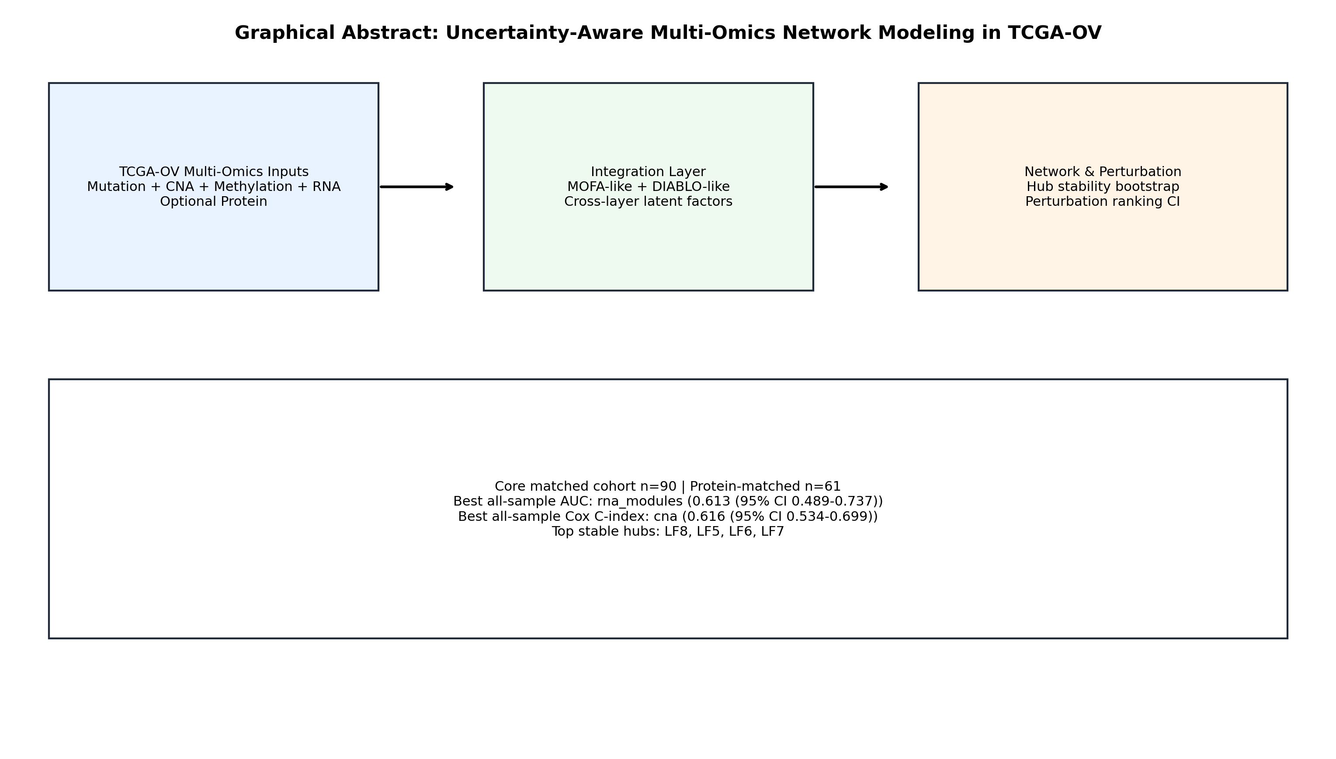
Figure 1. Graphical abstract of the study design and key findings.
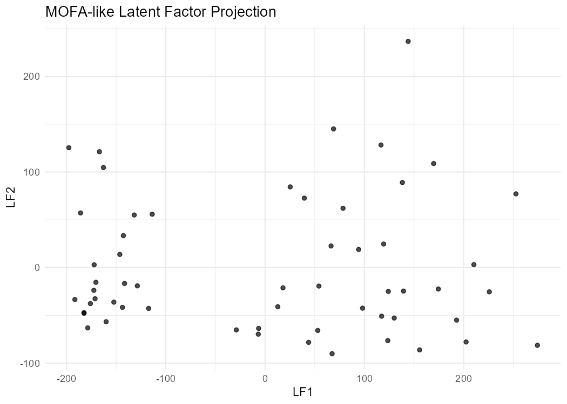
Figure 2. MOFA-like latent factor projection (LF1 vs LF2).
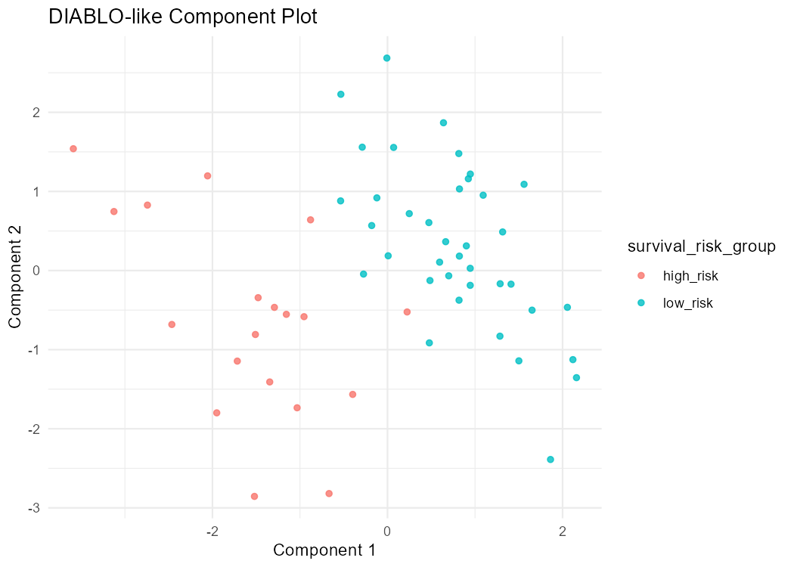
Figure 3. DIABLO-like component projection.
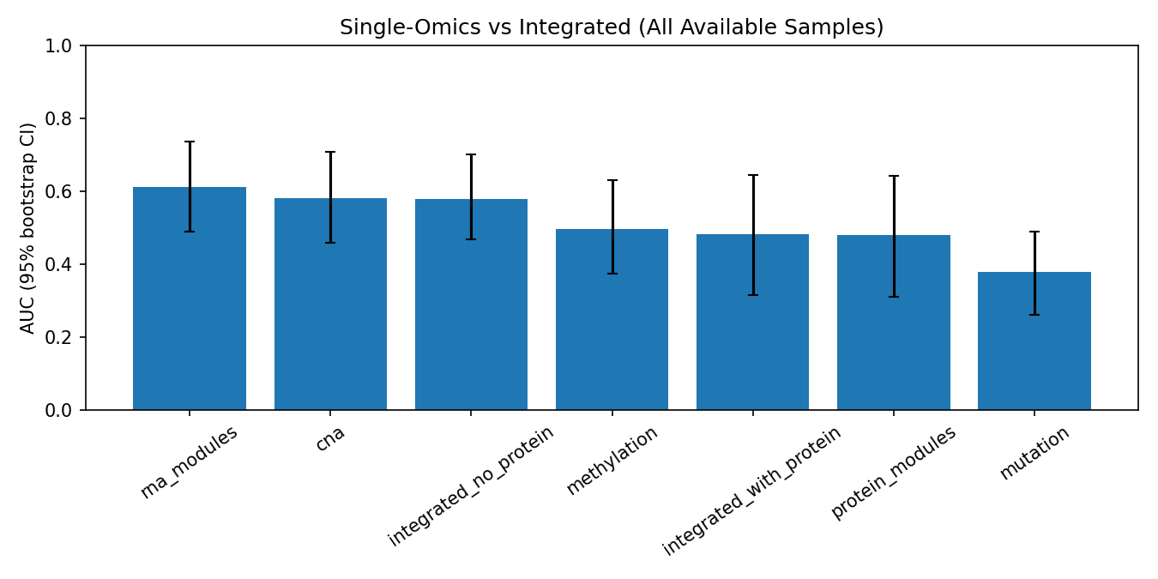
Figure 4. All-sample benchmark AUC with bootstrap 95% CI.
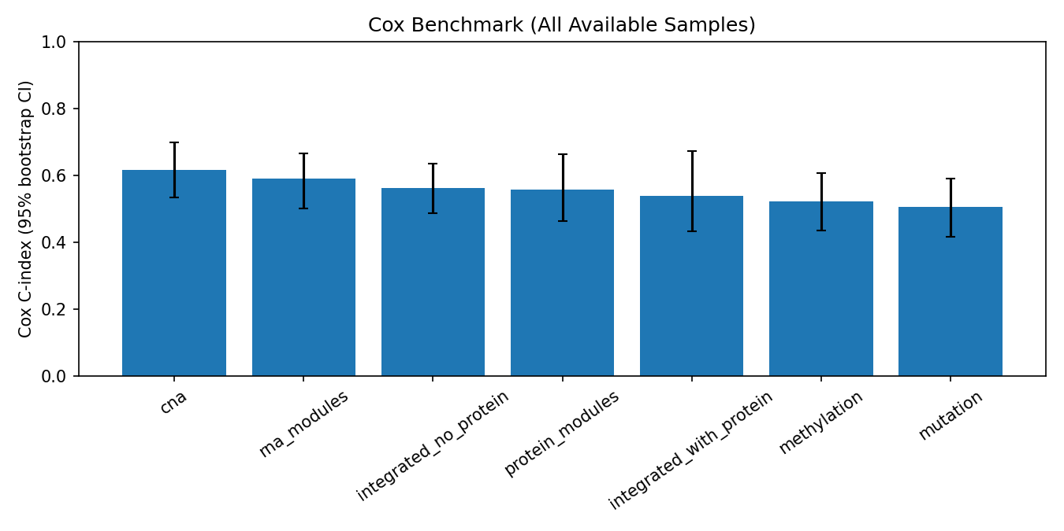
Figure 5. All-sample Cox C-index with bootstrap 95% CI.
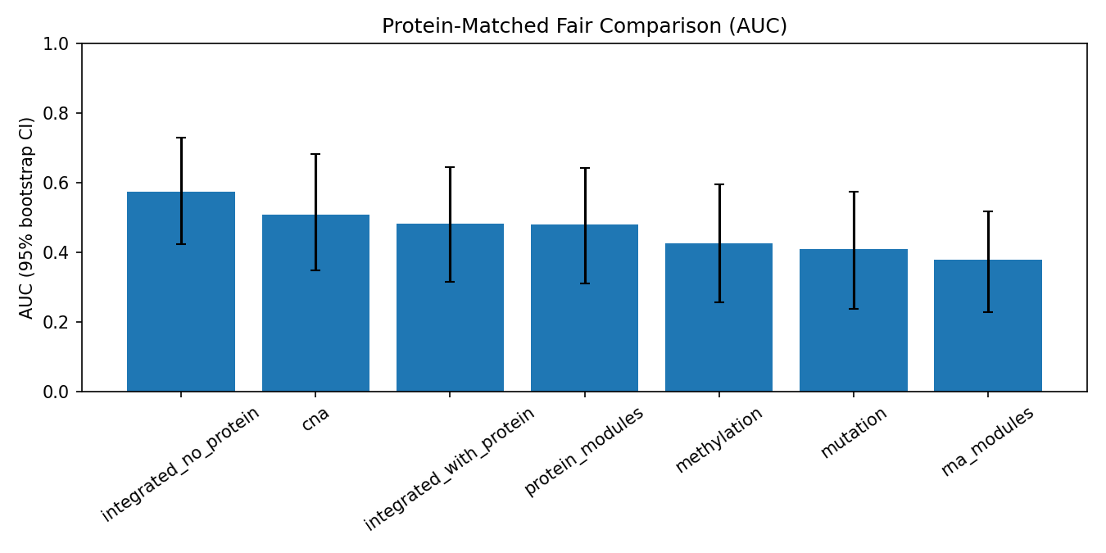
Figure 6. Protein-matched fair benchmark AUC with bootstrap 95% CI.
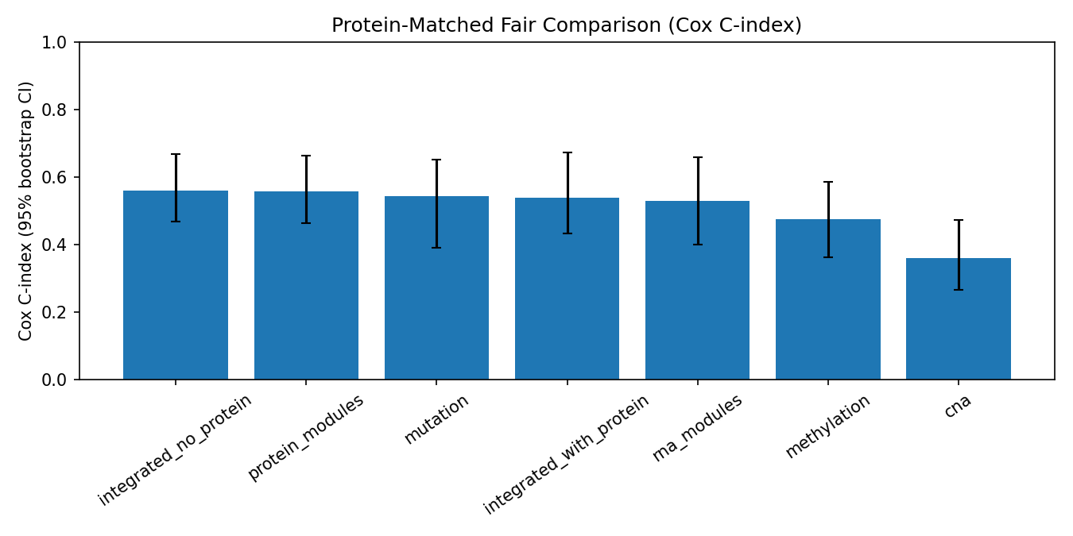
Figure 7. Protein-matched fair benchmark Cox C-index with bootstrap 95% CI.
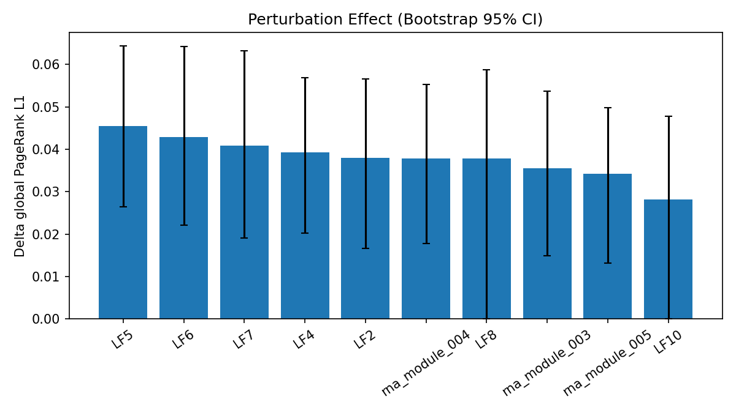
Figure 8. Perturbation effect size (delta global PageRank L1) with bootstrap 95% CI.
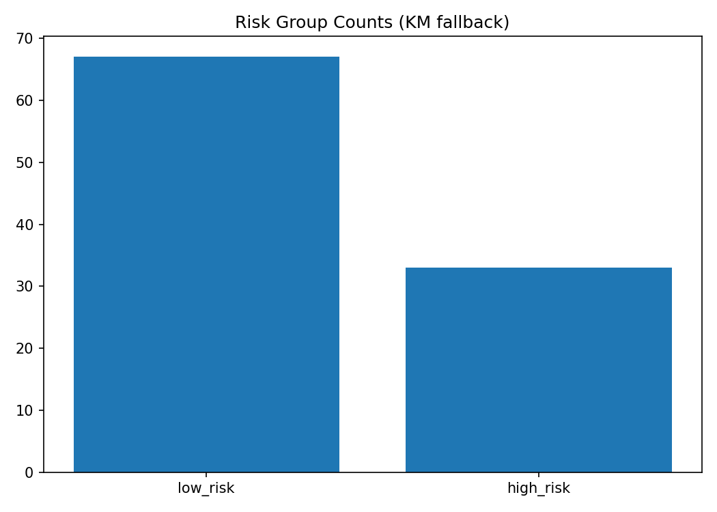
Figure 9. Survival curves by derived risk groups.
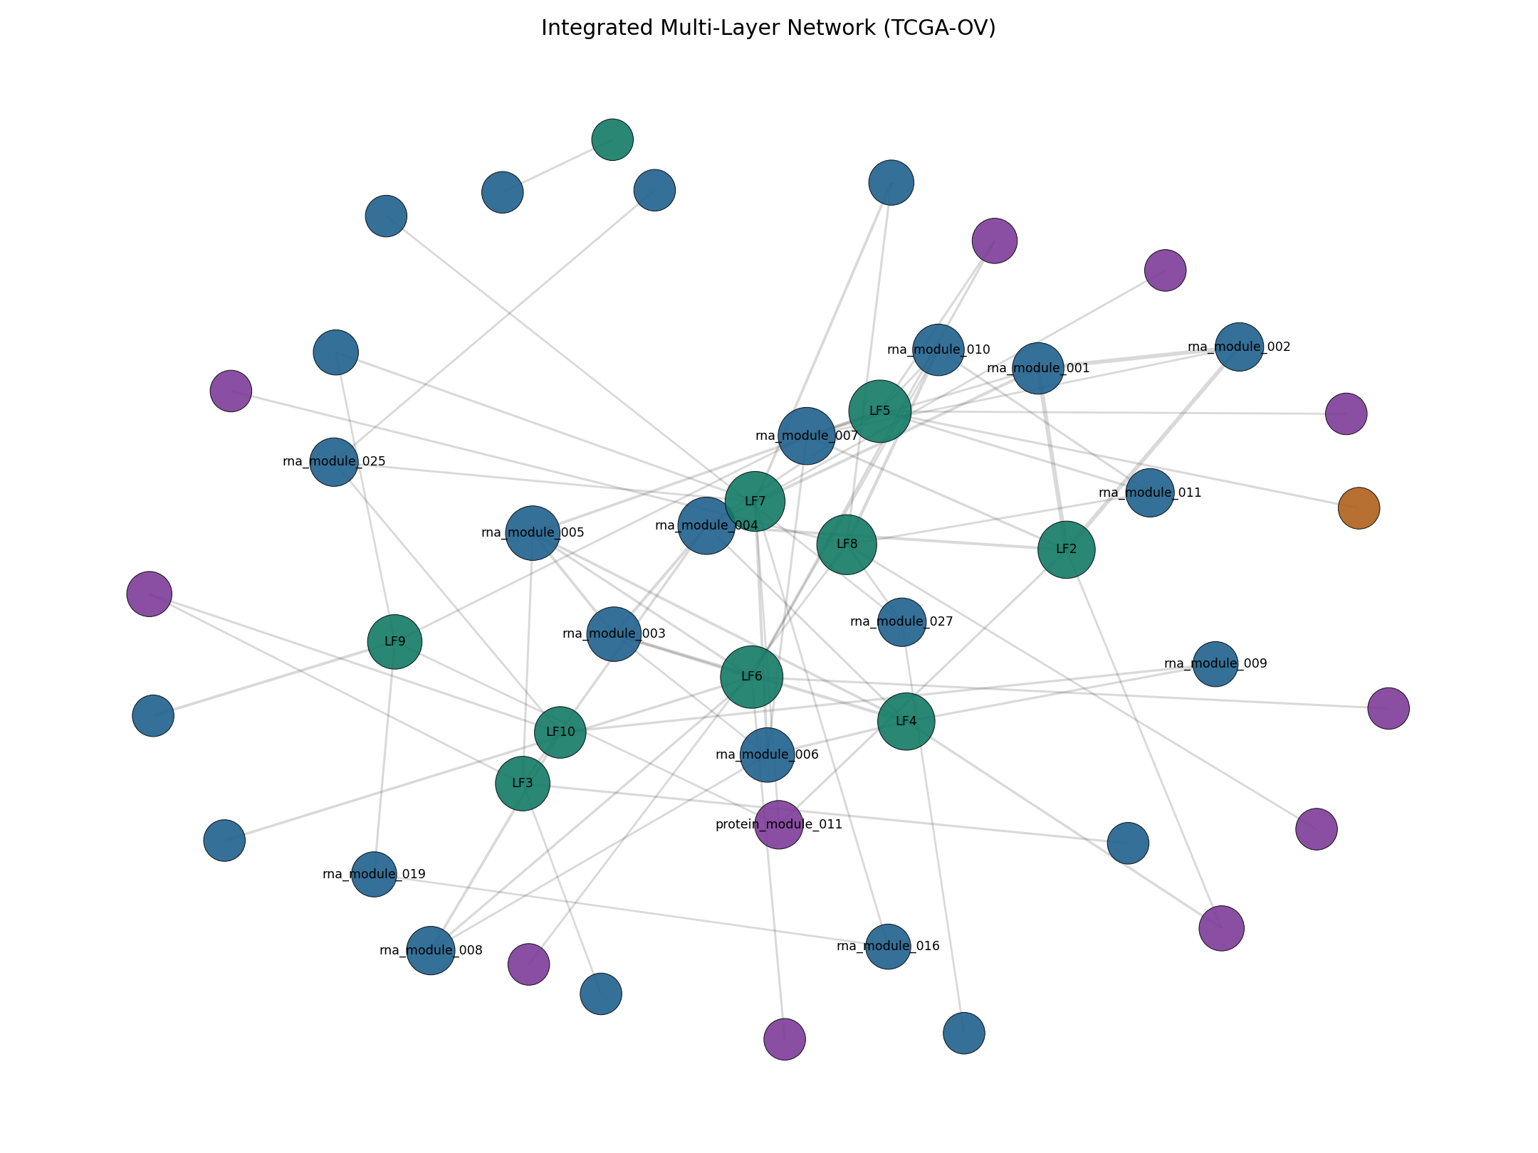
Figure 10. Integrated multi-layer network graph.
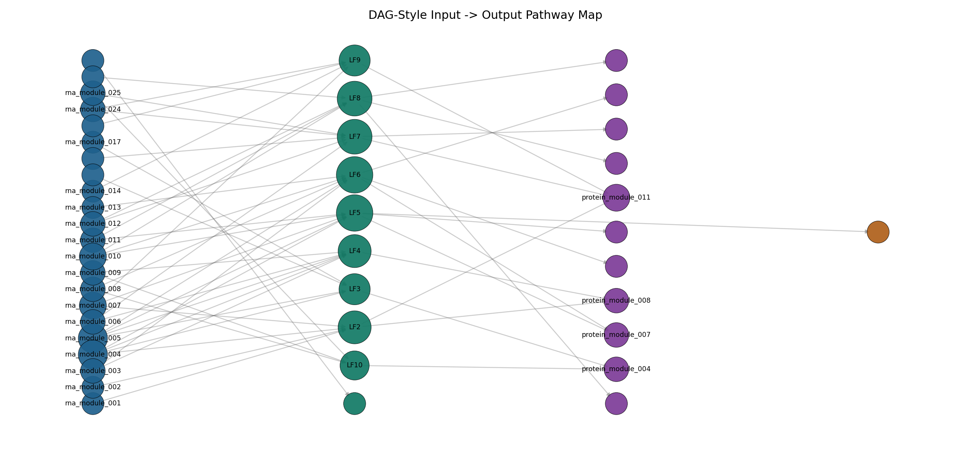
Figure 11. DAG-style pathway graph from inputs to outcomes.
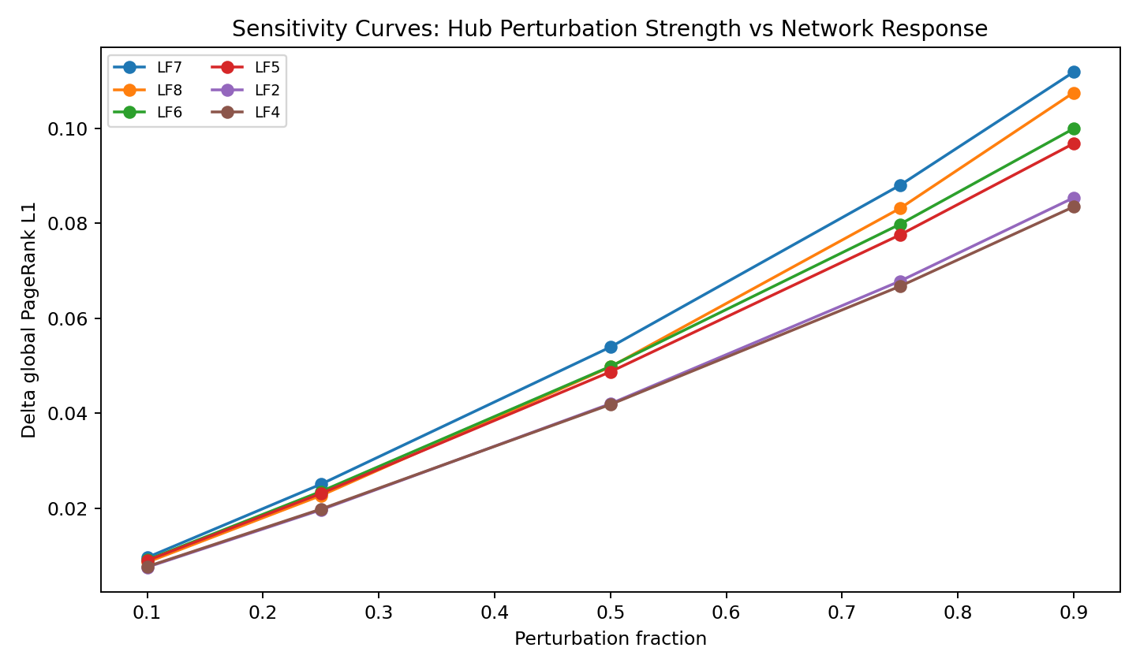
Figure 12. Sensitivity curves for hub perturbation strength.
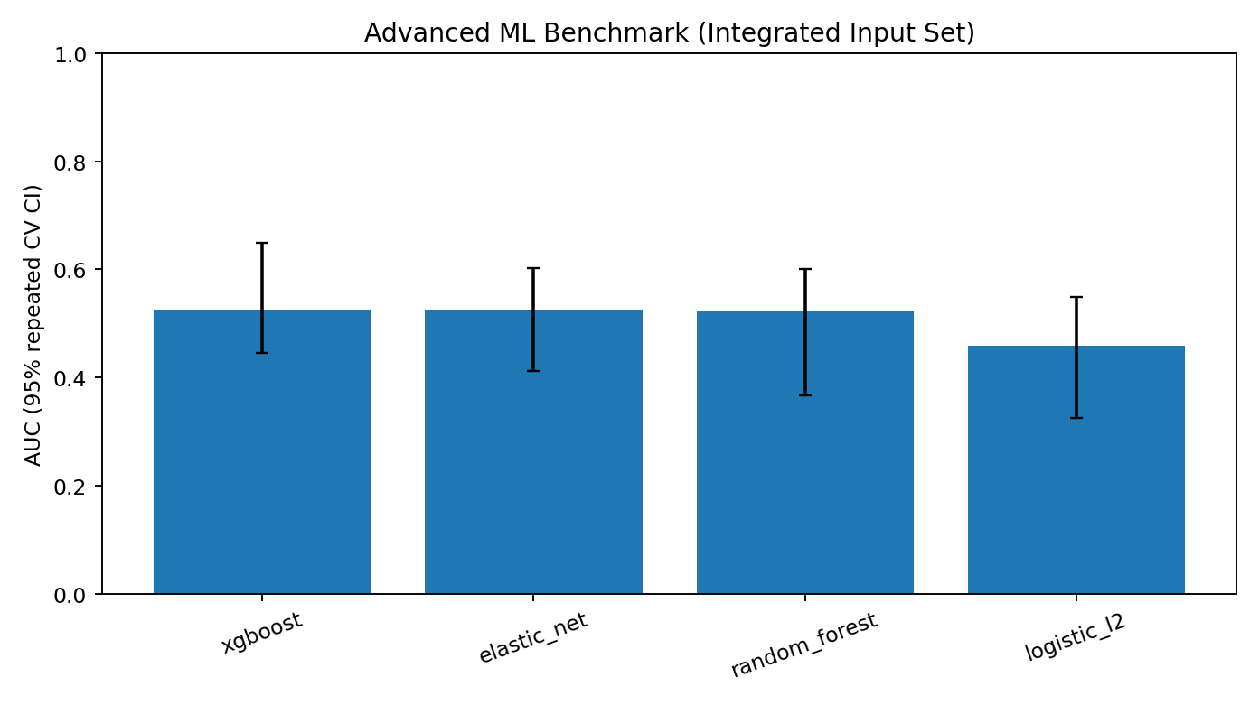
Figure 13. Advanced ML benchmark AUC with bootstrap 95% CI.
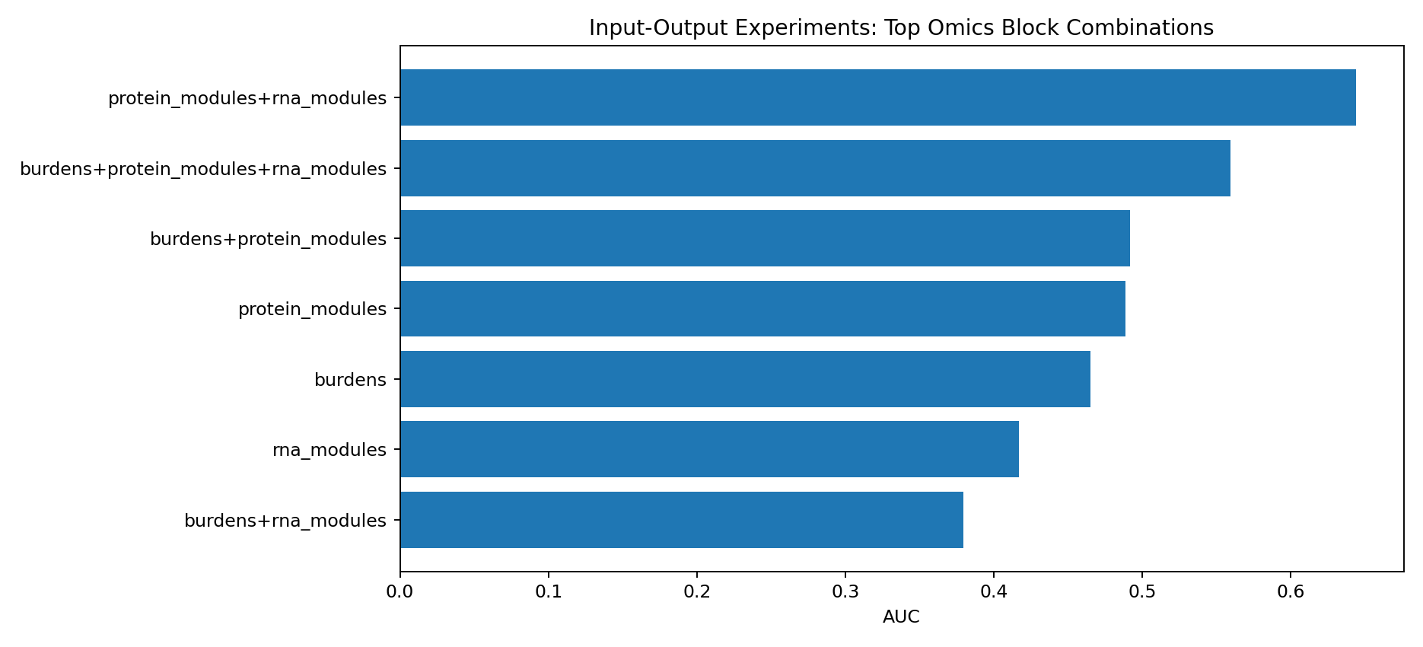
Figure 14. Top input-output ablation experiment combinations by AUC.

Discussion
This analysis shows robust latent-factor hub signals and uncertainty-calibrated performance estimates in TCGA-OV. RNA modules achieved the highest discrimination in the all-sample setting, while fairness-restricted protein-matched analysis altered ranking, highlighting sample-overlap sensitivity. Bootstrap hub and perturbation stability provide a stronger evidence base than point estimates alone.
Limitations include attrition in strict matched subsets and single-cohort design. External validation and biological follow-up of LF-associated hub mechanisms are essential next steps.

Declarations
Ethics approval and consent to participate: Public de-identified datasets were used; no direct human intervention was performed.
Consent for publication: Not applicable.
Competing interests: The author declares no competing interests.
Funding: No dedicated project funding declared in this draft. Update if applicable.
Data and code availability: All source data are public (GDC/cBioPortal/PDC), and pipeline code/results are available in this project workspace.

References (Vancouver)
1. The Cancer Genome Atlas Research Network. Integrated genomic analyses of ovarian carcinoma. Nature. 2011;474(7353):609-615. doi:10.1038/nature10166.
2. National Cancer Institute. Genomic Data Commons (GDC) Data Portal [Internet]. Available from: https://portal.gdc.cancer.gov/
3. National Cancer Institute. GDC API Users Guide: Downloading Files [Internet]. Available from: https://docs.gdc.cancer.gov/API/Users_Guide/Downloading_Files/
4. Colaprico A, Silva TC, Olsen C, Garofano L, Cava C, Garolini D, et al. TCGAbiolinks: an R/Bioconductor package for integrative analysis of TCGA data. Nucleic Acids Res. 2016;44(8):e71. doi:10.1093/nar/gkv1507.
5. Argelaguet R, Velten B, Arnol D, Dietrich S, Zenz T, Marioni JC, et al. Multi-Omics Factor Analysis-a framework for unsupervised integration of multi-omics data sets. Mol Syst Biol. 2018;14(6):e8124. doi:10.15252/msb.20178124.
6. Argelaguet R, Arnol D, Bredikhin D, Deloro Y, Velten B, Marioni JC, et al. MOFA+: a statistical framework for comprehensive integration of multi-modal single-cell data. Genome Biol. 2020;21(1):111. doi:10.1186/s13059-020-02015-1.
7. Rohart F, Gautier B, Singh A, Le Cao KA. mixOmics: an R package for omics feature selection and multiple data integration. PLoS Comput Biol. 2017;13(11):e1005752. doi:10.1371/journal.pcbi.1005752.
8. Singh A, Shannon CP, Gautier B, Rohart F, Vacher M, Tebbutt SJ, et al. DIABLO: an integrative approach for identifying key molecular drivers from multi-omics assays. Bioinformatics. 2019;35(17):3055-3062. doi:10.1093/bioinformatics/bty1054.
9. Cerami E, Gao J, Dogrusoz U, Gross BE, Sumer SO, Aksoy BA, et al. The cBio cancer genomics portal: an open platform for exploring multidimensional cancer genomics data. Cancer Discov. 2012;2(5):401-404. doi:10.1158/2159-8290.CD-12-0095.
10. Gao J, Aksoy BA, Dogrusoz U, Dresdner G, Gross B, Sumer SO, et al. Integrative analysis of complex cancer genomics and clinical profiles using the cBioPortal. Sci Signal. 2013;6(269):pl1. doi:10.1126/scisignal.2004088.
11. National Cancer Institute. Proteomic Data Commons (PDC) [Internet]. Available from: https://pdc.cancer.gov/
12. Cox DR. Regression models and life-tables. J R Stat Soc Series B Stat Methodol. 1972;34(2):187-220.
13. Hagberg A, Swart P, S Chult D. Exploring network structure, dynamics, and function using NetworkX. In: Proceedings of the 7th Python in Science Conference; 2008. p. 11-15.

