Supplementary Appendix
Manuscript: Uncertainty-Aware Multi-Omics Integration and Network Perturbation Analysis in TCGA Ovarian Cancer
Author: Dr Siddalingaiah H S (ORCID: 0000-0002-4771-8285)
Generated: 2026-04-20

Supplementary Methods
S1. Data processing and harmonization details: strict patient-level matching across layers; optional protein extension retained for fairness-controlled analyses.
S2. Bootstrap settings: network/perturbation and predictive analyses were bootstrap-calibrated with script-level fixed seeds; current advanced benchmark run used reduced bootstrap iterations for computational stability.
S3. Cox benchmarking strategy: penalized Cox primary fold fit with PHReg/linear fallback for numerical robustness.

Supplementary Tables
Supplementary Table S1. All-sample benchmark full table.
model | n_samples | auc | auc_ci_low | auc_ci_high | c_index | c_index_ci_low | c_index_ci_high | cox_c_index | cox_c_index_ci_low | cox_c_index_ci_high
rna_modules | 90 | 0.612775579423403 | 0.4894731472481533 | 0.7370511243386243 | 0.5425405619311436 | 0.4637689355667168 | 0.6321191976186914 | 0.5896319746735259 | 0.50222096035556 | 0.6648250146684397
cna | 90 | 0.5805539853024307 | 0.4591627831980589 | 0.7072894784802356 | 0.5761772853185596 | 0.4959099298953487 | 0.6593407401426766 | 0.6157499010684606 | 0.5335544128564567 | 0.6985692852144895
integrated_no_protein | 90 | 0.5794234030525721 | 0.4681849626068376 | 0.701845662507427 | 0.5326474079936684 | 0.458421850467143 | 0.6109505544573887 | 0.5631183221210923 | 0.4870459645867876 | 0.6361968533075889
methylation | 90 | 0.4963256076879593 | 0.3740691105769231 | 0.6295022311434209 | 0.4724970320538187 | 0.3872231028857141 | 0.5505319428538196 | 0.5219628017411951 | 0.4358394196641921 | 0.6073403221556096
integrated_with_protein | 57 | 0.4833795013850416 | 0.3163492913645352 | 0.6443861881361881 | 0.4274553571428571 | 0.334172696906673 | 0.5331289272801906 | 0.5390625 | 0.4324213524318414 | 0.6737039449763664
protein_modules | 57 | 0.4806094182825485 | 0.3099521836564519 | 0.6415336168164313 | 0.4174107142857143 | 0.309239288058494 | 0.5212353911039451 | 0.5569196428571429 | 0.4625948734771782 | 0.6645351290354231
mutation | 90 | 0.3776144714527981 | 0.2612904252610135 | 0.4886505269972099 | 0.4958448753462603 | 0.4123565852347947 | 0.5829771956489247 | 0.5065294815987337 | 0.4175349403570819 | 0.589836520121627

Supplementary Table S2. Protein-matched benchmark full table.
model | n_samples | auc | auc_ci_low | auc_ci_high | c_index | c_index_ci_low | c_index_ci_high | cox_c_index | cox_c_index_ci_low | cox_c_index_ci_high
integrated_no_protein | 57 | 0.574792243767313 | 0.4228431372549019 | 0.7287767094017092 | 0.5703125 | 0.4617914019683379 | 0.6738666224686596 | 0.5602678571428571 | 0.4681481255342533 | 0.6687189054726367
cna | 57 | 0.5090027700831026 | 0.3478385257401877 | 0.6825000000000001 | 0.4793526785714285 | 0.3386171302111679 | 0.603673421203909 | 0.3604910714285714 | 0.2649551707617548 | 0.4732518928548705
integrated_with_protein | 57 | 0.4833795013850416 | 0.3163492913645352 | 0.6443861881361881 | 0.4274553571428571 | 0.334172696906673 | 0.5331289272801906 | 0.5390625 | 0.4324213524318414 | 0.6737039449763664
protein_modules | 57 | 0.4806094182825485 | 0.3099521836564519 | 0.6415336168164313 | 0.4174107142857143 | 0.309239288058494 | 0.5212353911039451 | 0.5569196428571429 | 0.4625948734771782 | 0.6645351290354231
methylation | 57 | 0.425207756232687 | 0.2565348202824133 | 0.5950664228768326 | 0.4162946428571428 | 0.3043225555861067 | 0.5223887435196346 | 0.4743303571428571 | 0.3630370904702827 | 0.5853271066155478
mutation | 57 | 0.409972299168975 | 0.2378562449492682 | 0.573047328171982 | 0.4229910714285714 | 0.3053438773064941 | 0.5267099278053666 | 0.5435267857142857 | 0.3900872264931993 | 0.6512999782703173
rna_modules | 57 | 0.3795013850415512 | 0.2270046604776521 | 0.5170249795249794 | 0.5212053571428571 | 0.386998356225596 | 0.6763125666133457 | 0.5290178571428571 | 0.4007855432790664 | 0.6581758899311405

Supplementary Table S3. Hub stability full table.
node | rank_score | rank_score_mean | rank_score_ci_low | rank_score_ci_high | topk_freq
LF8 | 0.9822695035460992 | 0.8744939779418348 | 0.5705264639639639 | 0.9953792735042736 | 1.0
LF5 | 0.975177304964539 | 0.9058873767427316 | 0.6778090473212425 | 1.0 | 1.0
LF6 | 0.9680851063829788 | 0.8796956521880618 | 0.6085887716985278 | 1.0 | 0.995
LF7 | 0.946808510638298 | 0.8465685770466282 | 0.5194642857142857 | 0.992063492063492 | 1.0
rna_module_004 | 0.875886524822695 | 0.7857178119373507 | 0.4564583333333334 | 0.9695027264106212 | 0.995
rna_module_007 | 0.8475177304964538 | 0.7660788951274575 | 0.3567460317460317 | 0.9649173806609546 | 1.0
LF4 | 0.8262411347517732 | 0.7790680030688819 | 0.4282374279467303 | 0.956374584717608 | 1.0
LF2 | 0.8120567375886525 | 0.7472282010563801 | 0.4226973684210526 | 0.9576365817644888 | 1.0
rna_module_005 | 0.8014184397163121 | 0.7119401686508275 | 0.2336109365179133 | 0.939611280487805 | 0.995
LF3 | 0.8014184397163121 | 0.7097469783199668 | 0.2226886595789035 | 0.9120431286549706 | 0.995
rna_module_006 | 0.7872340425531915 | 0.7054709203835688 | 0.2192327235772357 | 0.930935443283004 | 1.0
LF9 | 0.7872340425531915 | 0.7191790076056068 | 0.3321138211382114 | 0.943321718931475 | 0.995
rna_module_010 | 0.7730496453900709 | 0.6748807554508514 | 0.1797149122807017 | 0.9124411638853231 | 0.99
rna_module_003 | 0.7446808510638298 | 0.7012989674763642 | 0.2467105263157895 | 0.9487612612612611 | 0.98
LF10 | 0.6808510638297872 | 0.6318159627691001 | 0.2061882003955175 | 0.8835087719298246 | 0.985
rna_module_027 | 0.6773049645390071 | 0.5362116094215499 | 0.1441119691119691 | 0.7927376485303314 | 0.98
rna_module_001 | 0.6453900709219859 | 0.5978833800034362 | 0.2188160569105691 | 0.8508890469416787 | 0.995
rna_module_025 | 0.6276595744680852 | 0.5132935782250613 | 0.0 | 0.7917214912280701 | 0.97
rna_module_011 | 0.6063829787234042 | 0.4766376821623197 | 0.1497222222222222 | 0.7876589912280701 | 0.98
rna_module_008 | 0.5921985815602837 | 0.5051750519193186 | 0.0 | 0.8336538461538463 | 0.945
rna_module_012 | 0.5851063829787234 | 0.3574132509051625 | 0.0 | 0.7104649292149293 | 0.85
protein_module_011 | 0.5567375886524822 | 0.441171004722388 | 0.0 | 0.7456195175438597 | 0.945
rna_module_002 | 0.4822695035460993 | 0.4233575814220797 | 0.0 | 0.7034111721611724 | 0.935
rna_module_016 | 0.4645390070921986 | 0.3344656704563271 | 0.0 | 0.61843671679198 | 0.87
protein_module_004 | 0.4645390070921986 | 0.3221665090051263 | 0.0 | 0.6624007936507936 | 0.855
protein_module_007 | 0.4574468085106383 | 0.2837008085425282 | 0.0 | 0.6036450924608819 | 0.815
rna_module_019 | 0.450354609929078 | 0.3333011065894283 | 0.0 | 0.6303014905149051 | 0.84
rna_module_009 | 0.450354609929078 | 0.3251075542439918 | 0.0 | 0.6708388157894738 | 0.85
rna_module_024 | 0.4432624113475177 | 0.289563546731898 | 0.0 | 0.6424357284113382 | 0.83
protein_module_008 | 0.400709219858156 | 0.2992059299246039 | 0.0 | 0.6169551282051283 | 0.88
rna_module_040 | 0.3333333333333333 | 0.2228406717073202 | 0.0 | 0.3861788617886179 | 0.63
LF1 | 0.3333333333333333 | 0.2228406717073202 | 0.0 | 0.3861788617886179 | 0.63
rna_module_014 | 0.2375886524822694 | 0.195158307889089 | 0.0 | 0.374157955865273 | 0.705
rna_module_036 | 0.2304964539007092 | 0.1817931787717365 | 0.0 | 0.3708648255813954 | 0.67
rna_module_026 | 0.2234042553191489 | 0.1710978870024811 | 0.0 | 0.3684584937954643 | 0.635
protein_module_016 | 0.2163120567375886 | 0.1412110624784875 | 0.0 | 0.3288346038346039 | 0.6
rna_module_013 | 0.2092198581560283 | 0.1472563889590601 | 0.0 | 0.3251067073170732 | 0.62
rna_module_023 | 0.202127659574468 | 0.1697682993174348 | 0.0 | 0.3632675438596491 | 0.665
protein_module_001 | 0.1950354609929077 | 0.1588504354561767 | 0.0 | 0.3378179824561403 | 0.68
protein_module_012 | 0.1879432624113475 | 0.1501185027499733 | 0.0 | 0.316260162601626 | 0.675
rna_module_017 | 0.1808510638297872 | 0.1563435008406196 | 0.0 | 0.3334349593495935 | 0.665
comp2 | 0.1737588652482269 | 0.1473763111922686 | 0.0 | 0.3089430894308942 | 0.665
protein_module_014 | 0.1666666666666666 | 0.1421391504406302 | 0.0 | 0.3181102166567283 | 0.655
protein_module_013 | 0.1595744680851063 | 0.1217273142066257 | 0.0 | 0.3134094225557641 | 0.555
protein_module_009 | 0.152482269503546 | 0.1245684493591246 | 0.0 | 0.3071271929824561 | 0.6
rna_module_015 | 0.1453900709219858 | 0.1301678002633428 | 0.0 | 0.3255952380952381 | 0.615
protein_module_010 | 0.1382978723404255 | 0.1265165476174764 | 0.0 | 0.2919969512195123 | 0.64

Supplementary Table S4. Perturbation bootstrap and rank-stability full table.
hub | perturb_type | perturb_fraction | delta_hub_pagerank | delta_global_pagerank_l1 | delta_global_boot_mean | delta_global_ci_low | delta_global_ci_high | delta_hub_boot_mean | delta_hub_ci_low | delta_hub_ci_high | rank_boot_mean | rank_ci_low | rank_ci_high | top5_freq
LF7 | edge_weight_dampening | 0.5 | -0.016619756364641 | 0.0539093802047888 | 0.0408084400130038 | 0.0190957821396369 | 0.0631908343941748 | -0.0127025108527919 | -0.0199528689093444 | -0.0058270125208198 | 6.4675 | 1.0 | 17.0 | 0.53
LF6 | edge_weight_dampening | 0.5 | -0.016131032241726 | 0.0498364812339673 | 0.0428208610766715 | 0.0220830954107469 | 0.0642576134090177 | -0.0136208717541027 | -0.0214610789393246 | -0.0068508726559074 | 5.51 | 1.0 | 16.025000000000006 | 0.61
LF8 | edge_weight_dampening | 0.5 | -0.0157516109193702 | 0.0497354545104276 | 0.0377827380351596 | 0.0 | 0.0587680613787449 | -0.0121596693393958 | -0.0193528130241313 | 0.0 | 7.3475 | 1.0 | 19.5 | 0.45
LF5 | edge_weight_dampening | 0.5 | -0.0162654741243809 | 0.0487031565859123 | 0.0454859318942602 | 0.0263546255825732 | 0.06431444890973 | -0.0147661330797733 | -0.0215807631891169 | -0.0083924363239706 | 4.37 | 1.0 | 14.0 | 0.72
LF2 | edge_weight_dampening | 0.5 | -0.0160240182161609 | 0.0419762348847558 | 0.0379885595945185 | 0.0166774196556989 | 0.0566290160679201 | -0.0133655655657128 | -0.0200272292365334 | -0.0062585257556715 | 7.32 | 1.0 | 17.0 | 0.425
LF4 | edge_weight_dampening | 0.5 | -0.0143296251686112 | 0.0418087834819756 | 0.0392592137985076 | 0.0201938145718417 | 0.0568918513871056 | -0.0130310158428516 | -0.0191561011521121 | -0.006145046443189 | 6.87 | 1.0 | 17.0 | 0.475
rna_module_004 | edge_weight_dampening | 0.5 | -0.0148927721114167 | 0.0372679028283028 | 0.037843864819151 | 0.0177122537495313 | 0.0552140226418705 | -0.0141639998044783 | -0.0215637144243189 | -0.0057203271663401 | 7.4625 | 1.0 | 17.025000000000006 | 0.41
LF10 | edge_weight_dampening | 0.5 | -0.0106273726047574 | 0.0360949030670501 | 0.0281961630161635 | 0.0 | 0.0477727520422697 | -0.0085754118898223 | -0.0145911198149017 | 0.0 | 11.855 | 2.0 | 20.0 | 0.135
rna_module_003 | edge_weight_dampening | 0.5 | -0.0137459377087828 | 0.0360818566358717 | 0.0355400325018611 | 0.014831948167726 | 0.0536865158596002 | -0.012739158461744 | -0.0198224528322177 | -0.0044123473057081 | 8.255 | 1.9750000000000003 | 19.012500000000003 | 0.315
rna_module_005 | edge_weight_dampening | 0.5 | -0.0132987153996748 | 0.0346773668705961 | 0.0342138667791016 | 0.013177919729182 | 0.0498413232292398 | -0.0124874587654681 | -0.0198666924011966 | -0.004233125228658 | 9.1375 | 1.0 | 19.0 | 0.255
rna_module_006 | edge_weight_dampening | 0.5 | -0.0116757120283209 | 0.0345976279696217 | 0.0321259028543211 | 0.0111553111838584 | 0.0496430897240638 | -0.0108975423951902 | -0.017239239640579 | -0.0033070048274476 | 10.165 | 2.0 | 19.0 | 0.235
LF9 | edge_weight_dampening | 0.5 | -0.0101896434678533 | 0.0333233464326062 | 0.0263906030260226 | 0.0 | 0.042807034484177 | -0.0081392081485573 | -0.0141099183851214 | 0.0 | 12.7625 | 4.0 | 20.0 | 0.06
rna_module_007 | edge_weight_dampening | 0.5 | -0.0122428856150429 | 0.0315085546576713 | 0.0324088783716158 | 0.0132158077843199 | 0.0500874570276229 | -0.0118923387256084 | -0.0182684843647147 | -0.0046405694991587 | 9.995 | 2.0 | 18.0 | 0.175
rna_module_001 | edge_weight_dampening | 0.5 | -0.0121348218401081 | 0.030343810048529 | 0.0309919283339331 | 0.0125280561511382 | 0.0489041014722991 | -0.0111483893228415 | -0.0172142436601644 | -0.003892101003782 | 10.635 | 2.0 | 19.0 | 0.14
rna_module_010 | edge_weight_dampening | 0.5 | -0.0117746227929096 | 0.0296878826052274 | 0.0283441913153334 | 0.0101645419435685 | 0.0416945247067884 | -0.0109184623496483 | -0.0163020852063618 | -0.0034186973644358 | 12.21 | 5.0 | 20.0 | 0.04
LF3 | edge_weight_dampening | 0.5 | -0.0086293897042604 | 0.0286080260679774 | 0.0255639439427317 | 0.0 | 0.041131644110329 | -0.0078628179552263 | -0.0128987244662729 | 0.0 | 13.24 | 5.9750000000000005 | 19.512500000000003 | 0.025
rna_module_008 | edge_weight_dampening | 0.5 | -0.0079186144670882 | 0.0247301389434208 | 0.0222477622675069 | 0.0 | 0.0363888274821669 | -0.0074798184793949 | -0.0121736168802405 | 0.0 | 14.85 | 7.975 | 20.0 | 0.0
rna_module_011 | edge_weight_dampening | 0.5 | -0.0075822259507502 | 0.0200375534654357 | 0.0193715354659319 | 0.0 | 0.0312858129279454 | -0.0071215254631136 | -0.01159334448139 | 0.0 | 16.25 | 10.0 | 20.0 | 0.0
rna_module_025 | edge_weight_dampening | 0.5 | -0.0060769175435089 | 0.019395159112851 | 0.0166416271894631 | 0.0 | 0.0291970578909186 | -0.005619996049994 | -0.0099822655214914 | 0.0 | 17.1 | 11.0 | 20.0 | 0.0
rna_module_027 | edge_weight_dampening | 0.5 | -0.0050146671906919 | 0.0155819996961283 | 0.011705389727561 | 0.0 | 0.0236146612612914 | -0.0039485250248178 | -0.0077252394337936 | 0.0 | 18.1975 | 14.0 | 20.0 | 0.0

Supplementary Table S5. Advanced ML benchmark.
model | n_samples | auc | auc_ci_low | auc_ci_high
xgboost | 57 | 0.5263157894736842 | 0.4450484764542936 | 0.6494459833795013
elastic_net | 57 | 0.5249307479224377 | 0.412084487534626 | 0.601904432132964
random_forest | 57 | 0.5228531855955678 | 0.3667936288088643 | 0.6012119113573406
logistic_l2 | 57 | 0.4584487534626039 | 0.3256925207756233 | 0.5486842105263157

Supplementary Table S6. Input-output ablation results.
blocks | n_blocks | n_features | n_features_compressed | n_samples | auc
protein_modules+rna_modules | 2 | 70 | 56 | 57 | 0.64404432132964
burdens+protein_modules+rna_modules | 3 | 73 | 56 | 57 | 0.5595567867036011
burdens+protein_modules | 2 | 23 | 23 | 57 | 0.4916897506925207
protein_modules | 1 | 20 | 20 | 57 | 0.4889196675900277
burdens | 1 | 3 | 3 | 57 | 0.4653739612188365
rna_modules | 1 | 50 | 50 | 57 | 0.4168975069252078
burdens+rna_modules | 2 | 53 | 53 | 57 | 0.3795013850415512

Supplementary Table S7. Perturbation sensitivity grid (top rows).
hub | perturb_fraction | delta_hub_pagerank | delta_global_pagerank_l1
LF8 | 0.1 | -0.0027398995259314 | 0.0085990843859299
LF5 | 0.1 | -0.0029963639188266 | 0.0089584095014552
LF6 | 0.1 | -0.0029449183865057 | 0.0090914695031122
LF7 | 0.1 | -0.0029538776920769 | 0.0096103624596197
rna_module_004 | 0.1 | -0.0027964782979481 | 0.0069899768884577
rna_module_007 | 0.1 | -0.0023282635738259 | 0.0059847804250232
LF4 | 0.1 | -0.0026411881280527 | 0.0076764793381242
LF2 | 0.1 | -0.0028705911660992 | 0.0075554946455749
rna_module_005 | 0.1 | -0.0025174195346091 | 0.0065677623179807
LF3 | 0.1 | -0.0016027408950787 | 0.005306995428474
LF8 | 0.25 | -0.007199223238185 | 0.0226356410650775
LF5 | 0.25 | -0.0077153884354697 | 0.0230789184042747
LF6 | 0.25 | -0.0076080597163559 | 0.0234933515878144
LF7 | 0.25 | -0.0077004269217092 | 0.0250280921062552
rna_module_004 | 0.25 | -0.0071544723313345 | 0.0178910083636079
rna_module_007 | 0.25 | -0.005929789609901 | 0.015249793277028
LF4 | 0.25 | -0.0067998237119409 | 0.0197871520607264
LF2 | 0.25 | -0.0074655661671898 | 0.0196182434512632
rna_module_005 | 0.25 | -0.0064222252497225 | 0.0167541405300987
LF3 | 0.25 | -0.0041133257712475 | 0.0136254102642265
LF8 | 0.5 | -0.0157516109193702 | 0.0497354545104276
LF5 | 0.5 | -0.0162654741243809 | 0.0487031565859123
LF6 | 0.5 | -0.016131032241726 | 0.0498364812339673
LF7 | 0.5 | -0.016619756364641 | 0.0539093802047888
rna_module_004 | 0.5 | -0.0148927721114167 | 0.0372679028283028
rna_module_007 | 0.5 | -0.0122428856150429 | 0.0315085546576713
LF4 | 0.5 | -0.0143296251686112 | 0.0418087834819756
LF2 | 0.5 | -0.0160240182161609 | 0.0419762348847558
rna_module_005 | 0.5 | -0.0132987153996748 | 0.0346773668705961
LF3 | 0.5 | -0.0086293897042604 | 0.0286080260679774

Supplementary Figures
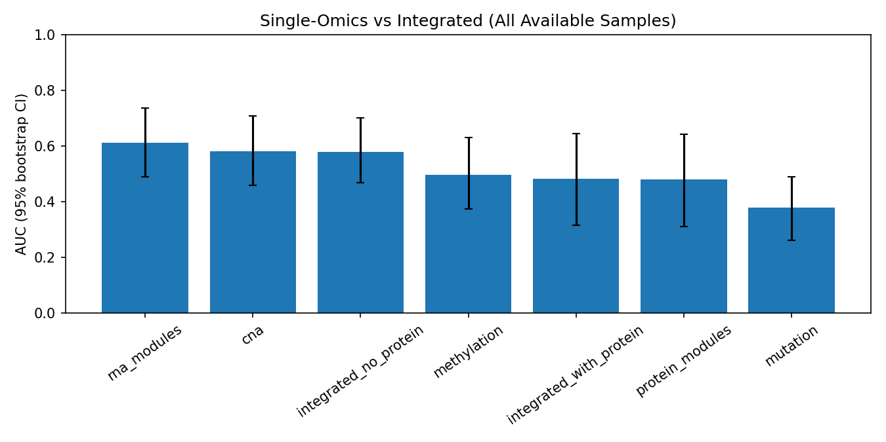
Supplementary Figure S1. All-sample AUC CI.
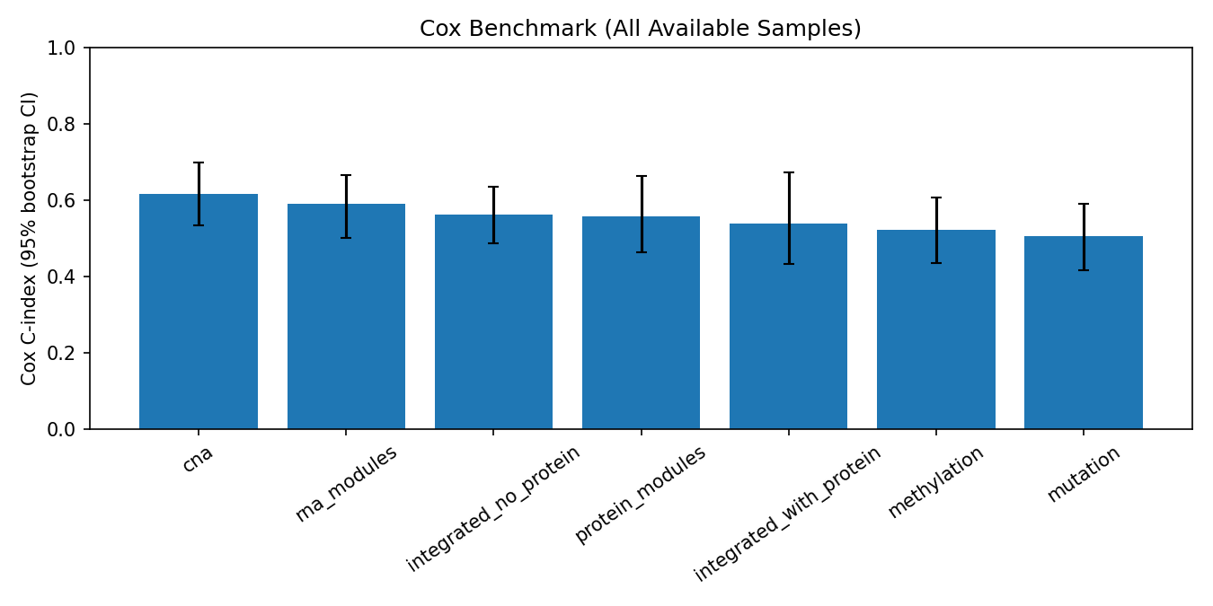
Supplementary Figure S2. All-sample Cox C-index CI.
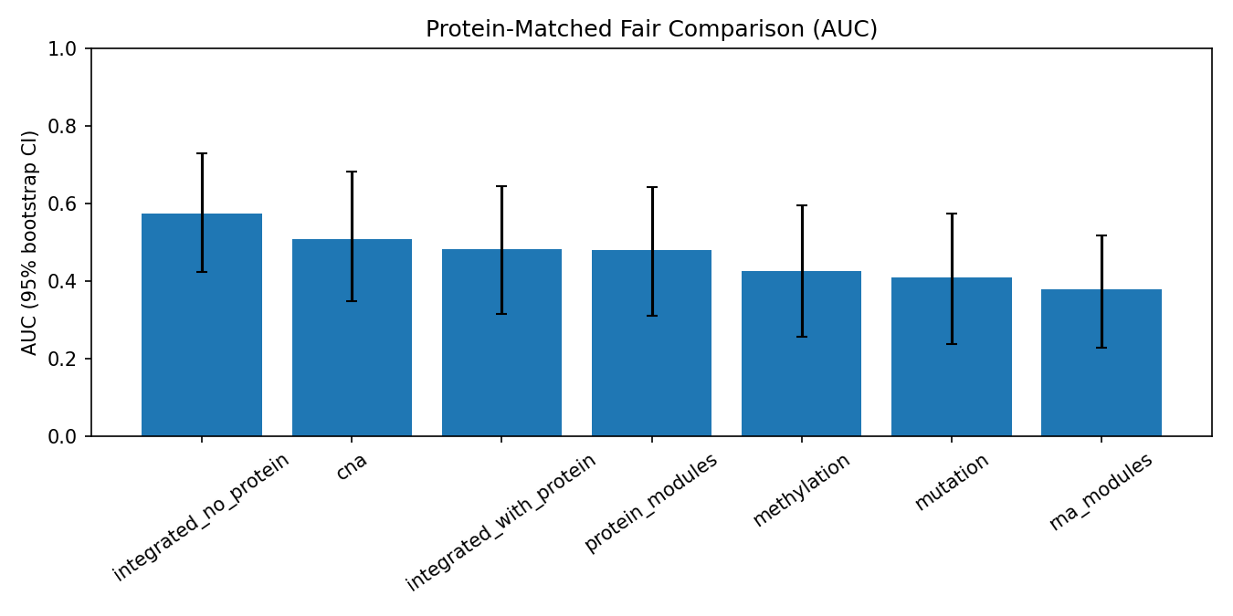
Supplementary Figure S3. Protein-matched AUC CI.
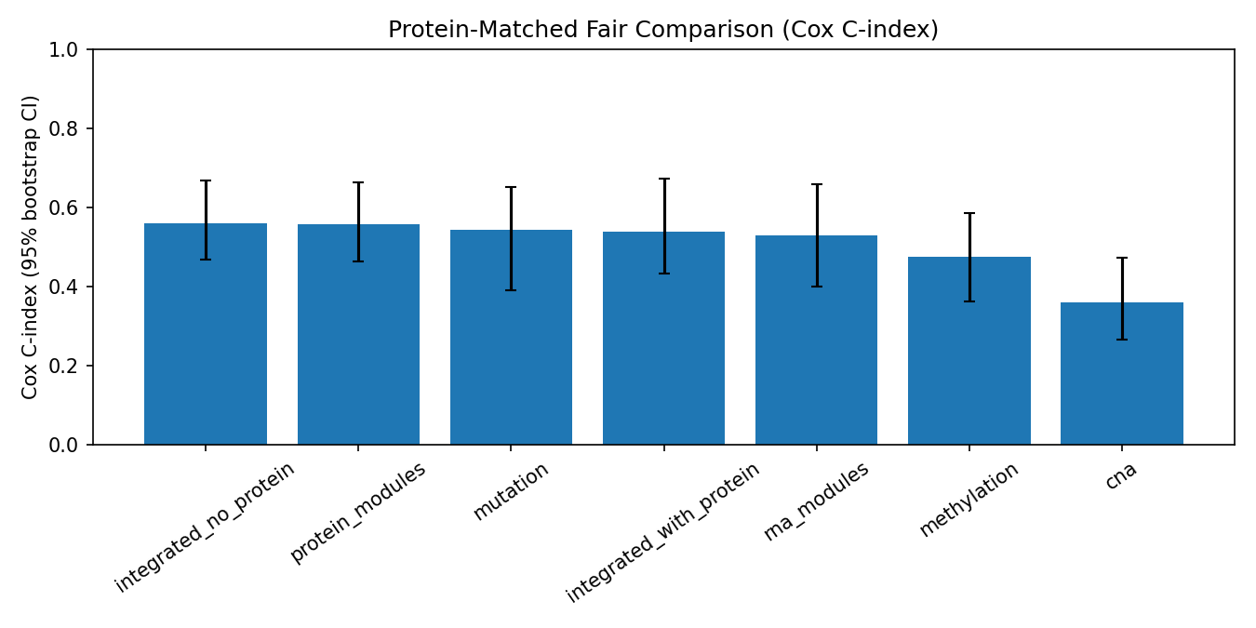
Supplementary Figure S4. Protein-matched Cox C-index CI.
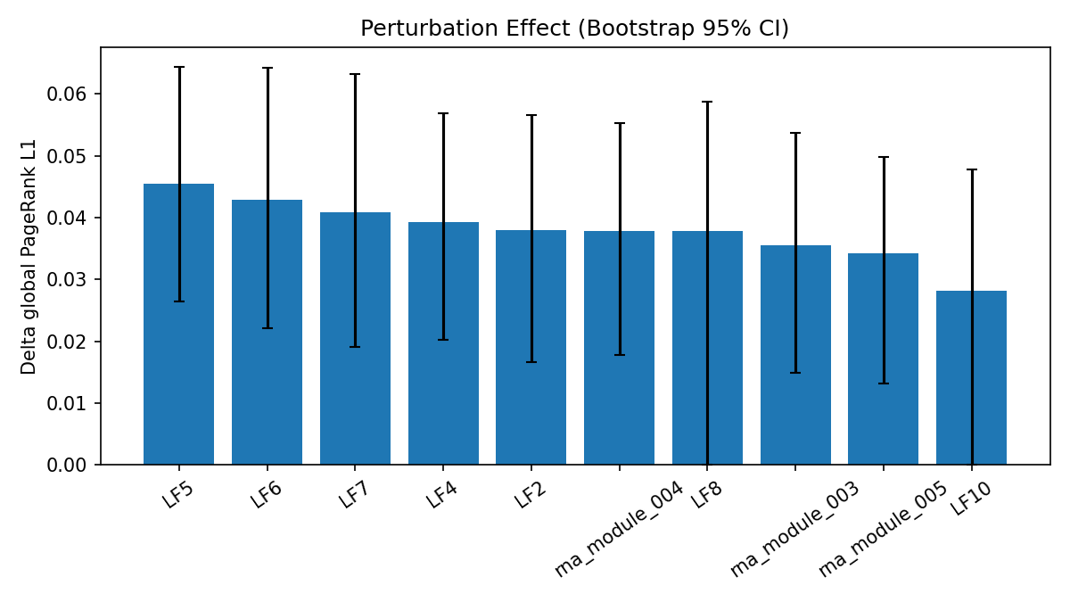
Supplementary Figure S5. Perturbation CI.
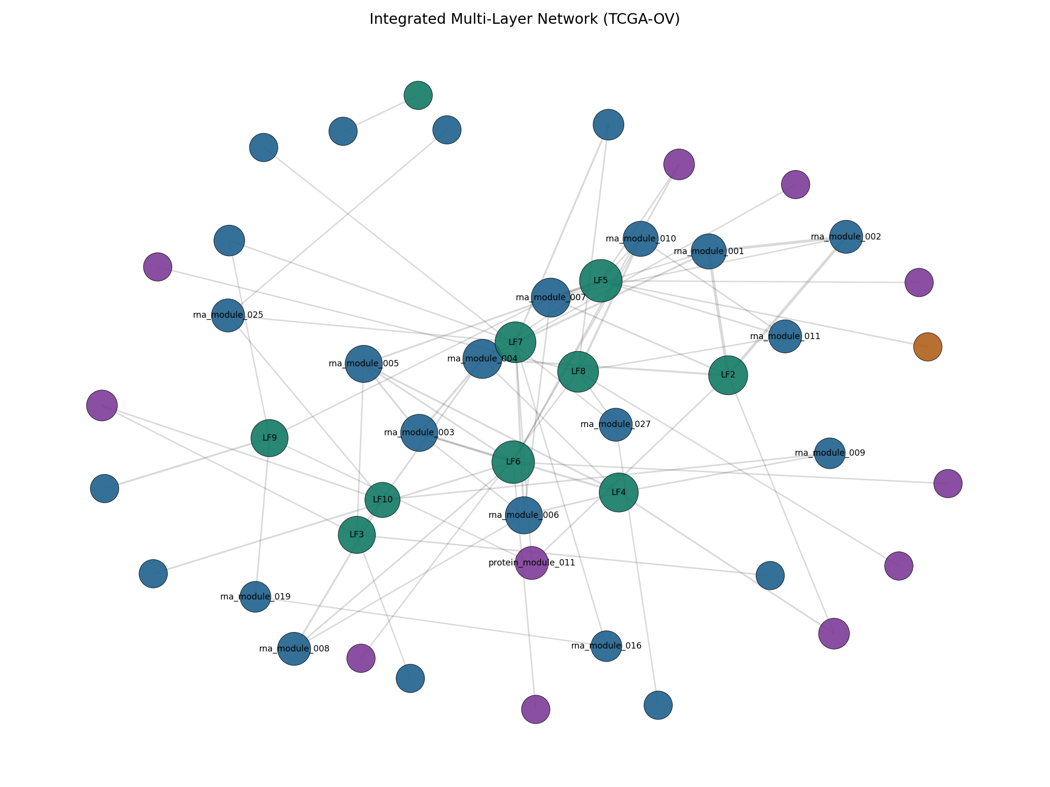
Supplementary Figure S6. Integrated network graph.
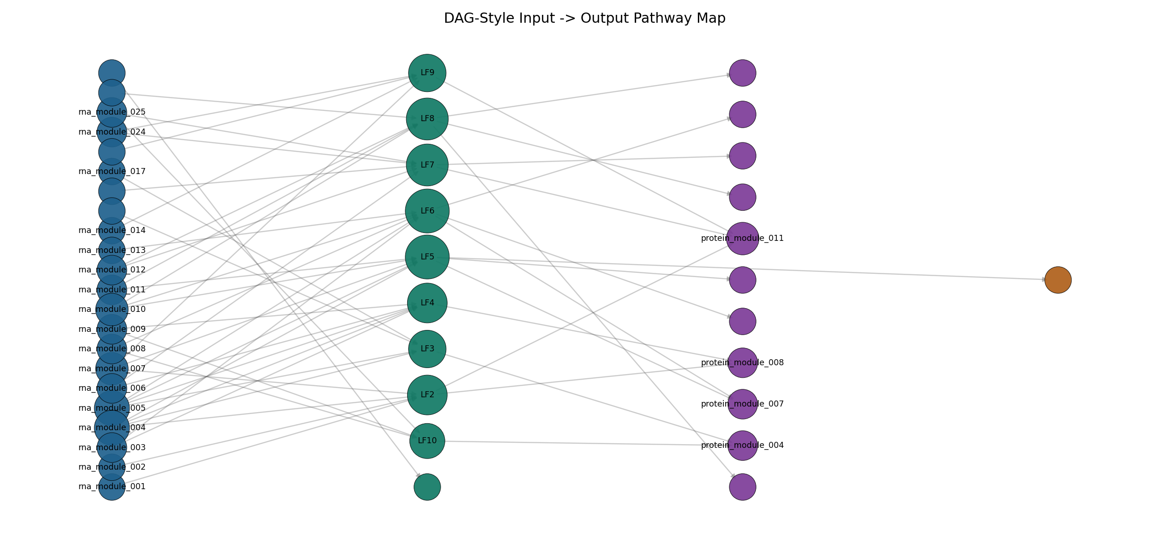
Supplementary Figure S7. DAG pathway graph.
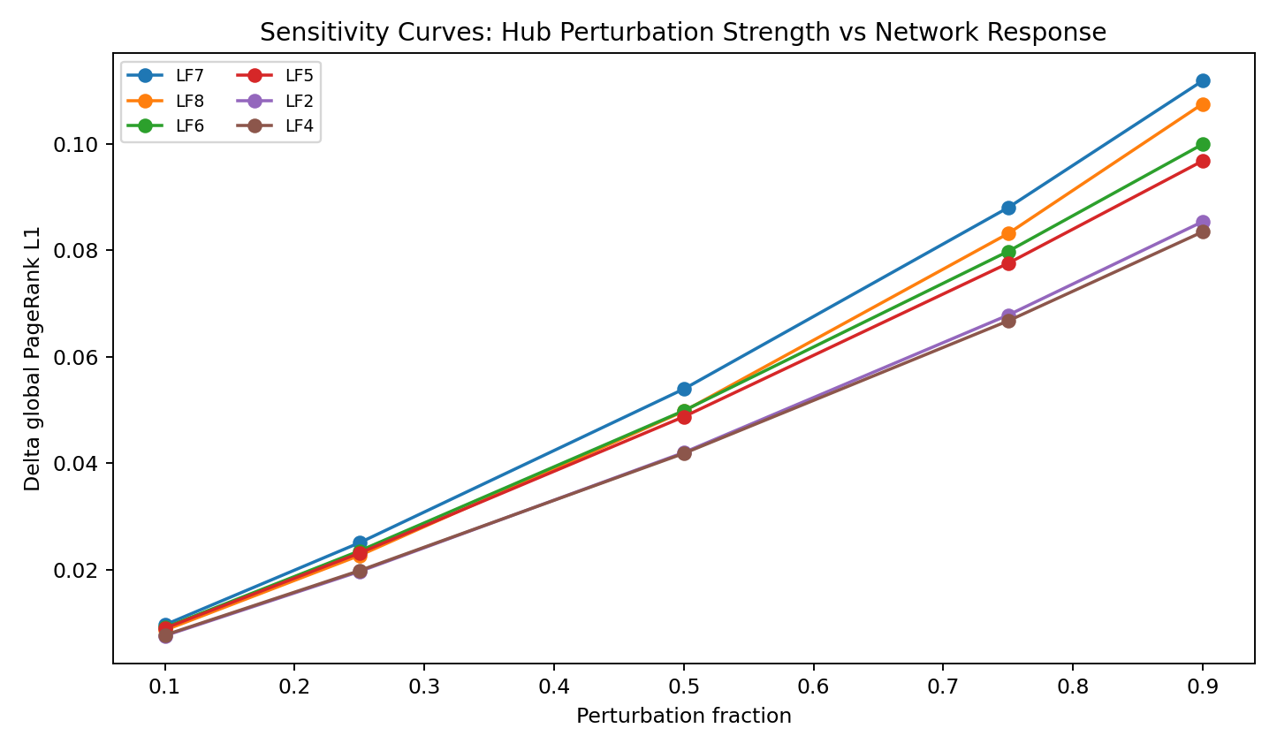
Supplementary Figure S8. Sensitivity curves.
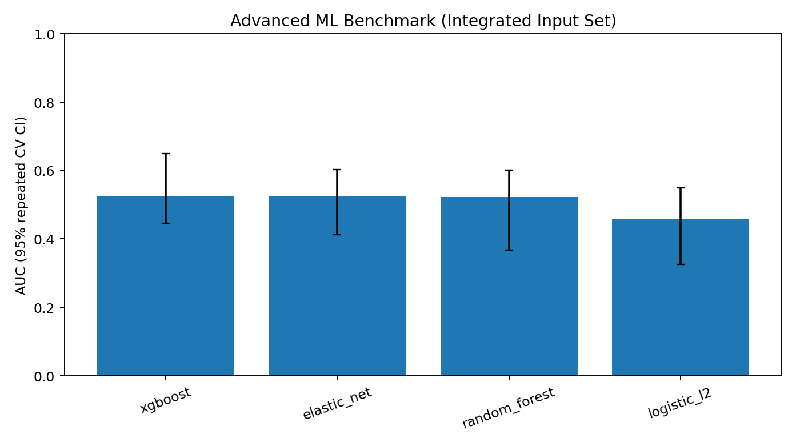
Supplementary Figure S9. Advanced ML benchmark.
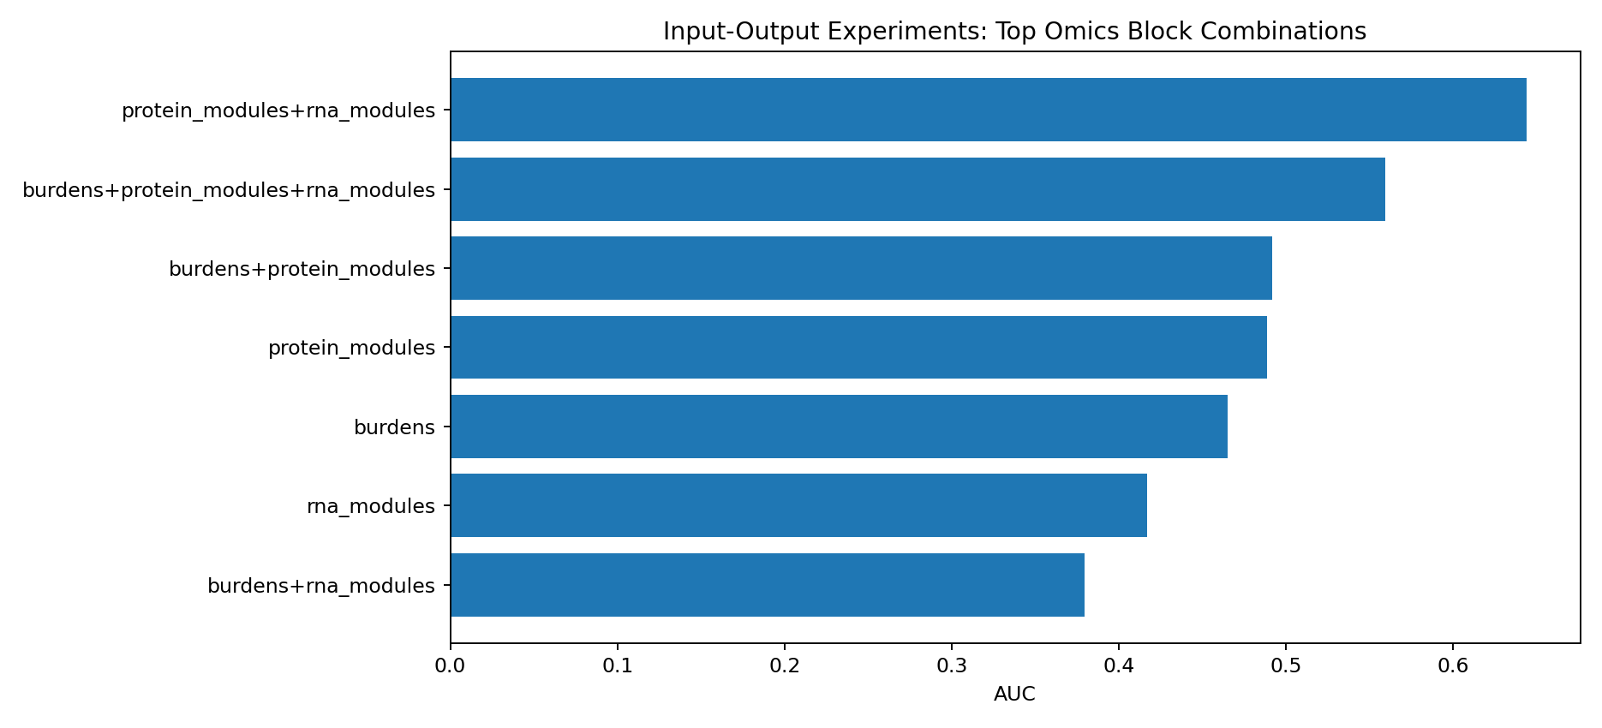
Supplementary Figure S10. Input-output ablation ranking.

