Journal of Biomedical Informatics Supplementary Appendix
Generated: 2026-04-20
Author: Dr Siddalingaiah H S
Supplementary Table S1. All-sample benchmark.
model | n_samples | auc | auc_ci_low | auc_ci_high | c_index | c_index_ci_low | c_index_ci_high | cox_c_index | cox_c_index_ci_low | cox_c_index_ci_high
rna_modules | 90 | 0.612775579423403 | 0.4894731472481533 | 0.7370511243386243 | 0.5425405619311436 | 0.4637689355667168 | 0.6321191976186914 | 0.5896319746735259 | 0.50222096035556 | 0.6648250146684397
cna | 90 | 0.5805539853024307 | 0.4591627831980589 | 0.7072894784802356 | 0.5761772853185596 | 0.4959099298953487 | 0.6593407401426766 | 0.6157499010684606 | 0.5335544128564567 | 0.6985692852144895
integrated_no_protein | 90 | 0.5794234030525721 | 0.4681849626068376 | 0.701845662507427 | 0.5326474079936684 | 0.458421850467143 | 0.6109505544573887 | 0.5631183221210923 | 0.4870459645867876 | 0.6361968533075889
methylation | 90 | 0.4963256076879593 | 0.3740691105769231 | 0.6295022311434209 | 0.4724970320538187 | 0.3872231028857141 | 0.5505319428538196 | 0.5219628017411951 | 0.4358394196641921 | 0.6073403221556096
integrated_with_protein | 57 | 0.4833795013850416 | 0.3163492913645352 | 0.6443861881361881 | 0.4274553571428571 | 0.334172696906673 | 0.5331289272801906 | 0.5390625 | 0.4324213524318414 | 0.6737039449763664
protein_modules | 57 | 0.4806094182825485 | 0.3099521836564519 | 0.6415336168164313 | 0.4174107142857143 | 0.309239288058494 | 0.5212353911039451 | 0.5569196428571429 | 0.4625948734771782 | 0.6645351290354231
mutation | 90 | 0.3776144714527981 | 0.2612904252610135 | 0.4886505269972099 | 0.4958448753462603 | 0.4123565852347947 | 0.5829771956489247 | 0.5065294815987337 | 0.4175349403570819 | 0.589836520121627

Supplementary Table S2. Protein-matched benchmark.
model | n_samples | auc | auc_ci_low | auc_ci_high | c_index | c_index_ci_low | c_index_ci_high | cox_c_index | cox_c_index_ci_low | cox_c_index_ci_high
integrated_no_protein | 57 | 0.574792243767313 | 0.4228431372549019 | 0.7287767094017092 | 0.5703125 | 0.4617914019683379 | 0.6738666224686596 | 0.5602678571428571 | 0.4681481255342533 | 0.6687189054726367
cna | 57 | 0.5090027700831026 | 0.3478385257401877 | 0.6825000000000001 | 0.4793526785714285 | 0.3386171302111679 | 0.603673421203909 | 0.3604910714285714 | 0.2649551707617548 | 0.4732518928548705
integrated_with_protein | 57 | 0.4833795013850416 | 0.3163492913645352 | 0.6443861881361881 | 0.4274553571428571 | 0.334172696906673 | 0.5331289272801906 | 0.5390625 | 0.4324213524318414 | 0.6737039449763664
protein_modules | 57 | 0.4806094182825485 | 0.3099521836564519 | 0.6415336168164313 | 0.4174107142857143 | 0.309239288058494 | 0.5212353911039451 | 0.5569196428571429 | 0.4625948734771782 | 0.6645351290354231
methylation | 57 | 0.425207756232687 | 0.2565348202824133 | 0.5950664228768326 | 0.4162946428571428 | 0.3043225555861067 | 0.5223887435196346 | 0.4743303571428571 | 0.3630370904702827 | 0.5853271066155478
mutation | 57 | 0.409972299168975 | 0.2378562449492682 | 0.573047328171982 | 0.4229910714285714 | 0.3053438773064941 | 0.5267099278053666 | 0.5435267857142857 | 0.3900872264931993 | 0.6512999782703173
rna_modules | 57 | 0.3795013850415512 | 0.2270046604776521 | 0.5170249795249794 | 0.5212053571428571 | 0.386998356225596 | 0.6763125666133457 | 0.5290178571428571 | 0.4007855432790664 | 0.6581758899311405

Supplementary Table S3. Full hub stability table.
node | rank_score | rank_score_mean | rank_score_ci_low | rank_score_ci_high | topk_freq
LF8 | 0.9822695035460992 | 0.8744939779418348 | 0.5705264639639639 | 0.9953792735042736 | 1.0
LF5 | 0.975177304964539 | 0.9058873767427316 | 0.6778090473212425 | 1.0 | 1.0
LF6 | 0.9680851063829788 | 0.8796956521880618 | 0.6085887716985278 | 1.0 | 0.995
LF7 | 0.946808510638298 | 0.8465685770466282 | 0.5194642857142857 | 0.992063492063492 | 1.0
rna_module_004 | 0.875886524822695 | 0.7857178119373507 | 0.4564583333333334 | 0.9695027264106212 | 0.995
rna_module_007 | 0.8475177304964538 | 0.7660788951274575 | 0.3567460317460317 | 0.9649173806609546 | 1.0
LF4 | 0.8262411347517732 | 0.7790680030688819 | 0.4282374279467303 | 0.956374584717608 | 1.0
LF2 | 0.8120567375886525 | 0.7472282010563801 | 0.4226973684210526 | 0.9576365817644888 | 1.0
rna_module_005 | 0.8014184397163121 | 0.7119401686508275 | 0.2336109365179133 | 0.939611280487805 | 0.995
LF3 | 0.8014184397163121 | 0.7097469783199668 | 0.2226886595789035 | 0.9120431286549706 | 0.995
rna_module_006 | 0.7872340425531915 | 0.7054709203835688 | 0.2192327235772357 | 0.930935443283004 | 1.0
LF9 | 0.7872340425531915 | 0.7191790076056068 | 0.3321138211382114 | 0.943321718931475 | 0.995
rna_module_010 | 0.7730496453900709 | 0.6748807554508514 | 0.1797149122807017 | 0.9124411638853231 | 0.99
rna_module_003 | 0.7446808510638298 | 0.7012989674763642 | 0.2467105263157895 | 0.9487612612612611 | 0.98
LF10 | 0.6808510638297872 | 0.6318159627691001 | 0.2061882003955175 | 0.8835087719298246 | 0.985
rna_module_027 | 0.6773049645390071 | 0.5362116094215499 | 0.1441119691119691 | 0.7927376485303314 | 0.98
rna_module_001 | 0.6453900709219859 | 0.5978833800034362 | 0.2188160569105691 | 0.8508890469416787 | 0.995
rna_module_025 | 0.6276595744680852 | 0.5132935782250613 | 0.0 | 0.7917214912280701 | 0.97
rna_module_011 | 0.6063829787234042 | 0.4766376821623197 | 0.1497222222222222 | 0.7876589912280701 | 0.98
rna_module_008 | 0.5921985815602837 | 0.5051750519193186 | 0.0 | 0.8336538461538463 | 0.945

Supplementary Table S4. Perturbation delta table.
hub | perturb_type | perturb_fraction | delta_hub_pagerank | delta_global_pagerank_l1 | delta_global_boot_mean | delta_global_ci_low | delta_global_ci_high | delta_hub_boot_mean | delta_hub_ci_low | delta_hub_ci_high | rank_boot_mean | rank_ci_low | rank_ci_high | top5_freq
LF7 | edge_weight_dampening | 0.5 | -0.016619756364641 | 0.0539093802047888 | 0.0408084400130038 | 0.0190957821396369 | 0.0631908343941748 | -0.0127025108527919 | -0.0199528689093444 | -0.0058270125208198 | 6.4675 | 1.0 | 17.0 | 0.53
LF6 | edge_weight_dampening | 0.5 | -0.016131032241726 | 0.0498364812339673 | 0.0428208610766715 | 0.0220830954107469 | 0.0642576134090177 | -0.0136208717541027 | -0.0214610789393246 | -0.0068508726559074 | 5.51 | 1.0 | 16.025000000000006 | 0.61
LF8 | edge_weight_dampening | 0.5 | -0.0157516109193702 | 0.0497354545104276 | 0.0377827380351596 | 0.0 | 0.0587680613787449 | -0.0121596693393958 | -0.0193528130241313 | 0.0 | 7.3475 | 1.0 | 19.5 | 0.45
LF5 | edge_weight_dampening | 0.5 | -0.0162654741243809 | 0.0487031565859123 | 0.0454859318942602 | 0.0263546255825732 | 0.06431444890973 | -0.0147661330797733 | -0.0215807631891169 | -0.0083924363239706 | 4.37 | 1.0 | 14.0 | 0.72
LF2 | edge_weight_dampening | 0.5 | -0.0160240182161609 | 0.0419762348847558 | 0.0379885595945185 | 0.0166774196556989 | 0.0566290160679201 | -0.0133655655657128 | -0.0200272292365334 | -0.0062585257556715 | 7.32 | 1.0 | 17.0 | 0.425
LF4 | edge_weight_dampening | 0.5 | -0.0143296251686112 | 0.0418087834819756 | 0.0392592137985076 | 0.0201938145718417 | 0.0568918513871056 | -0.0130310158428516 | -0.0191561011521121 | -0.006145046443189 | 6.87 | 1.0 | 17.0 | 0.475
rna_module_004 | edge_weight_dampening | 0.5 | -0.0148927721114167 | 0.0372679028283028 | 0.037843864819151 | 0.0177122537495313 | 0.0552140226418705 | -0.0141639998044783 | -0.0215637144243189 | -0.0057203271663401 | 7.4625 | 1.0 | 17.025000000000006 | 0.41
LF10 | edge_weight_dampening | 0.5 | -0.0106273726047574 | 0.0360949030670501 | 0.0281961630161635 | 0.0 | 0.0477727520422697 | -0.0085754118898223 | -0.0145911198149017 | 0.0 | 11.855 | 2.0 | 20.0 | 0.135
rna_module_003 | edge_weight_dampening | 0.5 | -0.0137459377087828 | 0.0360818566358717 | 0.0355400325018611 | 0.014831948167726 | 0.0536865158596002 | -0.012739158461744 | -0.0198224528322177 | -0.0044123473057081 | 8.255 | 1.9750000000000003 | 19.012500000000003 | 0.315
rna_module_005 | edge_weight_dampening | 0.5 | -0.0132987153996748 | 0.0346773668705961 | 0.0342138667791016 | 0.013177919729182 | 0.0498413232292398 | -0.0124874587654681 | -0.0198666924011966 | -0.004233125228658 | 9.1375 | 1.0 | 19.0 | 0.255
rna_module_006 | edge_weight_dampening | 0.5 | -0.0116757120283209 | 0.0345976279696217 | 0.0321259028543211 | 0.0111553111838584 | 0.0496430897240638 | -0.0108975423951902 | -0.017239239640579 | -0.0033070048274476 | 10.165 | 2.0 | 19.0 | 0.235
LF9 | edge_weight_dampening | 0.5 | -0.0101896434678533 | 0.0333233464326062 | 0.0263906030260226 | 0.0 | 0.042807034484177 | -0.0081392081485573 | -0.0141099183851214 | 0.0 | 12.7625 | 4.0 | 20.0 | 0.06
rna_module_007 | edge_weight_dampening | 0.5 | -0.0122428856150429 | 0.0315085546576713 | 0.0324088783716158 | 0.0132158077843199 | 0.0500874570276229 | -0.0118923387256084 | -0.0182684843647147 | -0.0046405694991587 | 9.995 | 2.0 | 18.0 | 0.175
rna_module_001 | edge_weight_dampening | 0.5 | -0.0121348218401081 | 0.030343810048529 | 0.0309919283339331 | 0.0125280561511382 | 0.0489041014722991 | -0.0111483893228415 | -0.0172142436601644 | -0.003892101003782 | 10.635 | 2.0 | 19.0 | 0.14
rna_module_010 | edge_weight_dampening | 0.5 | -0.0117746227929096 | 0.0296878826052274 | 0.0283441913153334 | 0.0101645419435685 | 0.0416945247067884 | -0.0109184623496483 | -0.0163020852063618 | -0.0034186973644358 | 12.21 | 5.0 | 20.0 | 0.04
LF3 | edge_weight_dampening | 0.5 | -0.0086293897042604 | 0.0286080260679774 | 0.0255639439427317 | 0.0 | 0.041131644110329 | -0.0078628179552263 | -0.0128987244662729 | 0.0 | 13.24 | 5.9750000000000005 | 19.512500000000003 | 0.025
rna_module_008 | edge_weight_dampening | 0.5 | -0.0079186144670882 | 0.0247301389434208 | 0.0222477622675069 | 0.0 | 0.0363888274821669 | -0.0074798184793949 | -0.0121736168802405 | 0.0 | 14.85 | 7.975 | 20.0 | 0.0
rna_module_011 | edge_weight_dampening | 0.5 | -0.0075822259507502 | 0.0200375534654357 | 0.0193715354659319 | 0.0 | 0.0312858129279454 | -0.0071215254631136 | -0.01159334448139 | 0.0 | 16.25 | 10.0 | 20.0 | 0.0
rna_module_025 | edge_weight_dampening | 0.5 | -0.0060769175435089 | 0.019395159112851 | 0.0166416271894631 | 0.0 | 0.0291970578909186 | -0.005619996049994 | -0.0099822655214914 | 0.0 | 17.1 | 11.0 | 20.0 | 0.0
rna_module_027 | edge_weight_dampening | 0.5 | -0.0050146671906919 | 0.0155819996961283 | 0.011705389727561 | 0.0 | 0.0236146612612914 | -0.0039485250248178 | -0.0077252394337936 | 0.0 | 18.1975 | 14.0 | 20.0 | 0.0

Supplementary Table S5. Advanced ML benchmark.
model | n_samples | auc | auc_ci_low | auc_ci_high
xgboost | 57 | 0.5263157894736842 | 0.4450484764542936 | 0.6494459833795013
elastic_net | 57 | 0.5249307479224377 | 0.412084487534626 | 0.601904432132964
random_forest | 57 | 0.5228531855955678 | 0.3667936288088643 | 0.6012119113573406
logistic_l2 | 57 | 0.4584487534626039 | 0.3256925207756233 | 0.5486842105263157

Supplementary Table S6. Input-output ablation summary.
blocks | n_blocks | n_features | n_features_compressed | n_samples | auc
protein_modules+rna_modules | 2 | 70 | 56 | 57 | 0.64404432132964
burdens+protein_modules+rna_modules | 3 | 73 | 56 | 57 | 0.5595567867036011
burdens+protein_modules | 2 | 23 | 23 | 57 | 0.4916897506925207
protein_modules | 1 | 20 | 20 | 57 | 0.4889196675900277
burdens | 1 | 3 | 3 | 57 | 0.4653739612188365
rna_modules | 1 | 50 | 50 | 57 | 0.4168975069252078
burdens+rna_modules | 2 | 53 | 53 | 57 | 0.3795013850415512

Supplementary Table S7. TCGA-OV immune proxy summary.
score | genes_requested | genes_found | genes_found_list | mean_score | sd_score | high_minus_low_mean | p_value_mannwhitney
tcr_core_score | 10 | 10 | PTPRC;CD3D;CD3E;CD3G;TRAC;TRBC1;TRBC2;LCK;LAT;ZAP70 | 2.960594732333751e-17 | 0.8643248200978272 | 0.1301087623003559 | 0.517281866030325
cytolytic_score | 6 | 6 | NKG7;PRF1;GZMB;GNLY;CTSW;CCL5 | -5.551115123125783e-18 | 0.8701419251678787 | 0.2388413950821075 | 0.9174815811426862
ifn_antigen_presentation_score | 9 | 9 | IFNG;CXCL9;CXCL10;STAT1;IRF1;B2M;HLA-A;HLA-B;HLA-C | -4.749287383118725e-17 | 0.7703979440461373 | 0.0104847697401066 | 0.6472429748247976
exhaustion_regulatory_score | 5 | 5 | PDCD1;LAG3;TIGIT;HAVCR2;CTLA4 | 2.4671622769447924e-18 | 0.8864643591214423 | 0.1603760974974521 | 0.6976278514750239
bcr_plasma_score | 6 | 6 | CD79A;MS4A1;CD74;MZB1;JCHAIN;CD27 | -2.906625557525584e-17 | 0.7328782786470586 | 0.1359249376285969 | 0.8833088597088012

Supplementary Table S8. External ovarian immune validation summary.
score | sample_group | n_samples | mean_score | sd_score
tcr_core_score | CD137+ PD-1high CD39+ CD8 T cells | 3 | 3036.5875054020667 | 647.1136521294537
tcr_core_score | CD137- PD-1high CD39+ CD8 T cells | 3 | 3662.2347346154406 | 619.2340864636759
tcr_core_score | PD-1+ CD39- CD8 T cells | 3 | 3458.827566521298 | 716.5610861731622
cytolytic_score | CD137+ PD-1high CD39+ CD8 T cells | 3 | 6324.778465761101 | 815.0184958619468
cytolytic_score | CD137- PD-1high CD39+ CD8 T cells | 3 | 6930.24257443758 | 806.0753141604278
cytolytic_score | PD-1+ CD39- CD8 T cells | 3 | 5964.215042810854 | 2839.5228819323884
ifn_antigen_presentation_score | CD137+ PD-1high CD39+ CD8 T cells | 3 | 4644.515257636313 | 369.4798456392368
ifn_antigen_presentation_score | CD137- PD-1high CD39+ CD8 T cells | 3 | 5225.049838791853 | 590.1216847068634
ifn_antigen_presentation_score | PD-1+ CD39- CD8 T cells | 3 | 5409.363351365272 | 662.708747627236
exhaustion_regulatory_score | CD137+ PD-1high CD39+ CD8 T cells | 3 | 2162.0020511105918 | 285.913202844285
exhaustion_regulatory_score | CD137- PD-1high CD39+ CD8 T cells | 3 | 2135.974446937015 | 329.9448740499404
exhaustion_regulatory_score | PD-1+ CD39- CD8 T cells | 3 | 832.6125274898068 | 619.0382497862622
bcr_plasma_score | CD137+ PD-1high CD39+ CD8 T cells | 3 | 2031.2076775337075 | 551.1595963081668
bcr_plasma_score | CD137- PD-1high CD39+ CD8 T cells | 3 | 2046.7898210808908 | 603.4744266792442
bcr_plasma_score | PD-1+ CD39- CD8 T cells | 3 | 1717.0093162465134 | 1017.5788870010962

Supplementary Table S9. Direct CAR-product FASTQ benchmark QC.
file | sampled_reads | mean_read_length | sd_read_length | gc_fraction | n_fraction | compressed_size_bytes
data\raw\external_validation\car_benchmark\SRR31001810\SRR31001810_1.fastq.gz | 50000 | 75.5212 | 1.2291096615029924 | 0.4802185346631145 | 0.000595594349666 | 1594117031
data\raw\external_validation\car_benchmark\SRR31001810\SRR31001810_2.fastq.gz | 50000 | 75.48648 | 1.0998805433318657 | 0.4856257703366218 | 0.0015557752858525 | 1747874203

Supplementary Table S10. Public CAR architecture metadata.
source_type | title | target_antigen | construct_identifier | scfv_or_binding_domain | hinge_spacer | transmembrane_domain | costimulatory_domain | signaling_domain | sequence_access_level | recommended_project_use | public_access_route | source_url
Addgene | pSLCAR-CD19-BBz | CD19 | pSLCAR-CD19-BBz / Addgene 135992 | not explicitly stated | not explicitly stated | not explicitly stated | 4-1BB | CD3-zeta | direct public construct/metadata access | cataloguing/reference design only | Addgene plasmid page and developer/API ecosystem | https://www.addgene.org/135992/
Addgene | Addgene Developers Portal | general/unspecified | API and sequence-data access portal | not explicitly stated | not explicitly stated | not explicitly stated | not explicitly stated | not explicitly stated | metadata only | cataloguing/reference design only | Developer/API access | https://developers.addgene.org/
FreeGenes | CD19CAR-CD28z | CD19 | BBF10K_000527 / pOpen-CD19CAR-CD28z | not explicitly stated | not explicitly stated | not explicitly stated | CD28 | CD3-zeta | direct public construct/metadata access | cataloguing/reference design only | FreeGenes plasmid page with GenBank link | https://freegenes.github.io/genes/BBF10K_000527.html
Patent | WO2020261231A1 | general/unspecified | WO2020261231A1 | not explicitly stated | CD8 hinge | not explicitly stated | 4-1BB | not explicitly stated | patent-disclosed sequence identifiers | cataloguing/reference design only | Google Patents | https://patents.google.com/patent/WO2020261231A1/en
Patent | US20190106492A1 | CD19 | LTG2050 and related anti-CD19 CAR variants | LTG2050 | not explicitly stated | CD8 transmembrane | not explicitly stated | CD3-zeta | patent-disclosed sequence identifiers | cataloguing/reference design only | Google Patents | https://patents.google.com/patent/US20190106492A1/en
Patent | US20220324967A1 | CD19/CD22 | CAR 22-19 / LTG2681 family | not explicitly stated | not explicitly stated | not explicitly stated | not explicitly stated | not explicitly stated | patent-disclosed sequence identifiers | cataloguing/reference design only | Google Patents | https://patents.google.com/patent/US20220324967A1/en
Patent | EP4190804A1 | CD19 | h19BBz / FMC63-based CD19 CAR | FMC63-related | not explicitly stated | not explicitly stated | 4-1BB | CD3-zeta | patent-disclosed sequence identifiers | cataloguing/reference design only | European Patent Office PDF | https://data.epo.org/publication-server/rest/v1.0/publication-dates/20230607/patents/EP4190804NWA1/document.pdf
Paper | Affordable academic anti-CD19 CAR development | CD19 | ARI-0001 | ARI-0001 academic construct | not explicitly stated | not explicitly stated | not explicitly stated | not explicitly stated | paper-level construct description | cataloguing/reference design only | Peer-reviewed paper/PMC record | https://pmc.ncbi.nlm.nih.gov/articles/PMC6319086/

Supplementary Table S11. Heuristic CAR motif benchmark.
file | sampled_reads | wpre_core | cd3zeta_motif | cd8a_hinge_like | fmc63_like_seed | sampled_bases | motif_total_hits | all_zero_flag
data\raw\external_validation\car_benchmark\SRR31001810\SRR31001810_1.fastq.gz | 150000 | 0 | 0 | 0 | 0 | 11329035 | 0 | 1
data\raw\external_validation\car_benchmark\SRR31001810\SRR31001810_2.fastq.gz | 150000 | 0 | 0 | 0 | 0 | 11323275 | 0 | 1

Supplementary Table S12. CAR reference alignment readiness audit.
component | status | detail
reference_panel_fasta | missing | references\car_t\public_car_panel.fasta not found
reference_panel_readme | ready | references\car_t\README.md
reference_panel_metadata | ready | results\tables\car_t_architecture_metadata.csv
raw_fastq_inventory | ready | 2 FASTQ files discovered across configured roots
tool:bwa | ready | /home/devcontainers/miniconda3/envs/cartalign/bin/bwa
tool:samtools | ready | /home/devcontainers/miniconda3/envs/cartalign/bin/samtools
tool:minimap2 | ready | /home/devcontainers/miniconda3/envs/cartalign/bin/minimap2

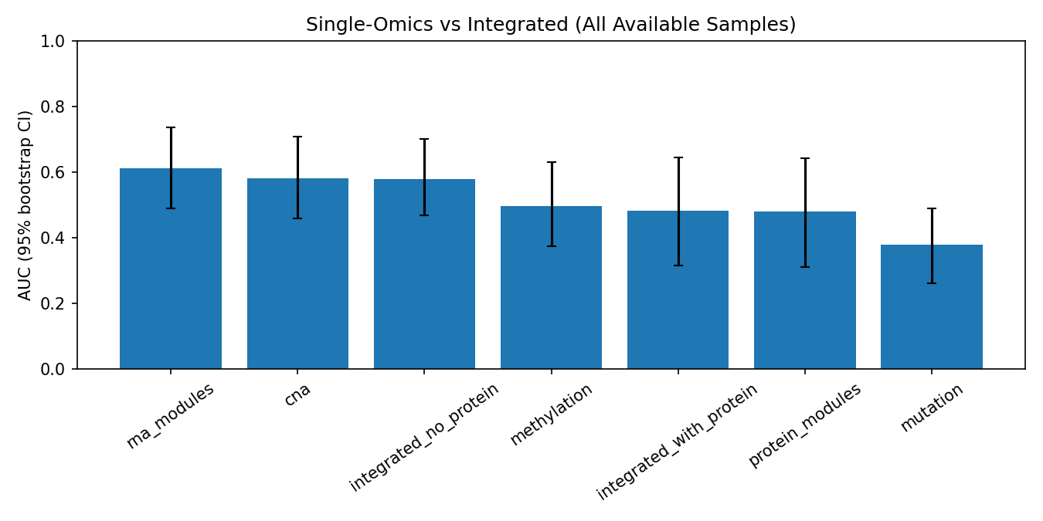
Supplementary Figure S1. Core benchmark AUC intervals.
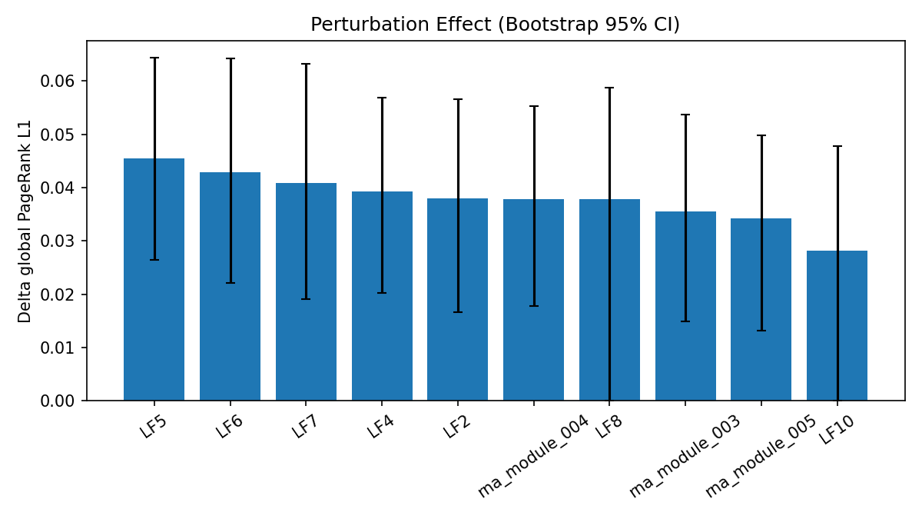
Supplementary Figure S2. Perturbation confidence intervals.
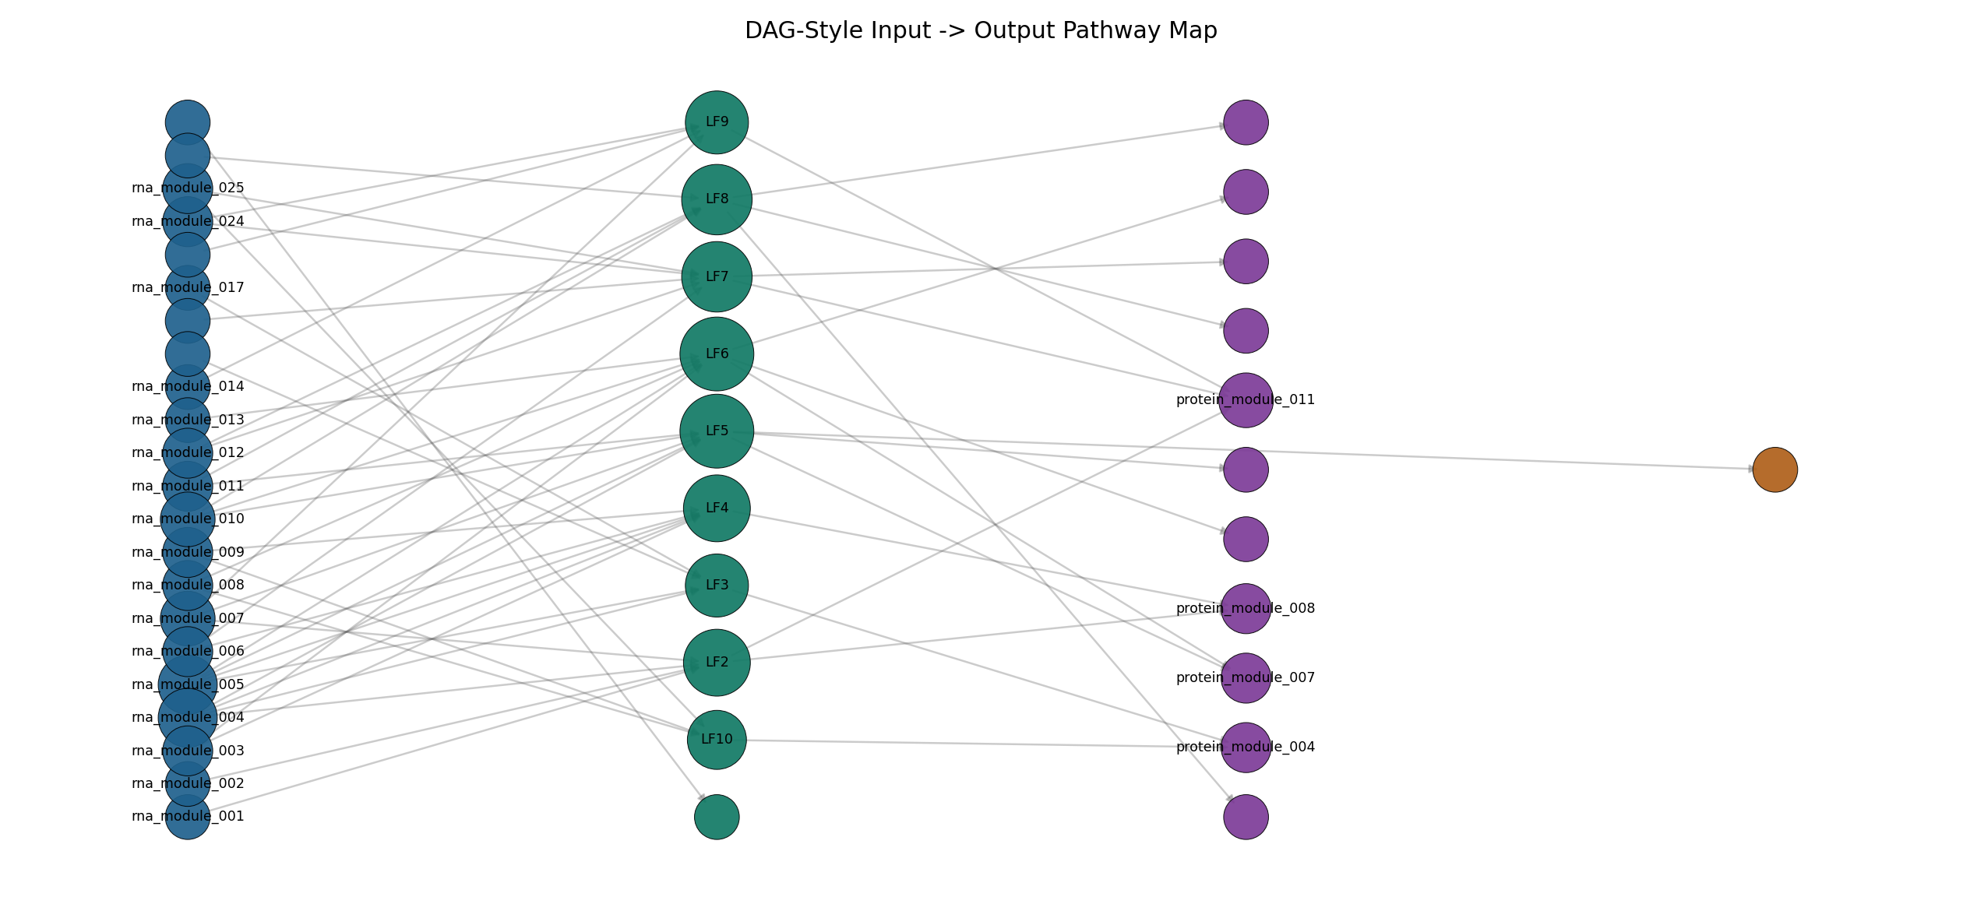
Supplementary Figure S3. Directed pathway aggregation graph.
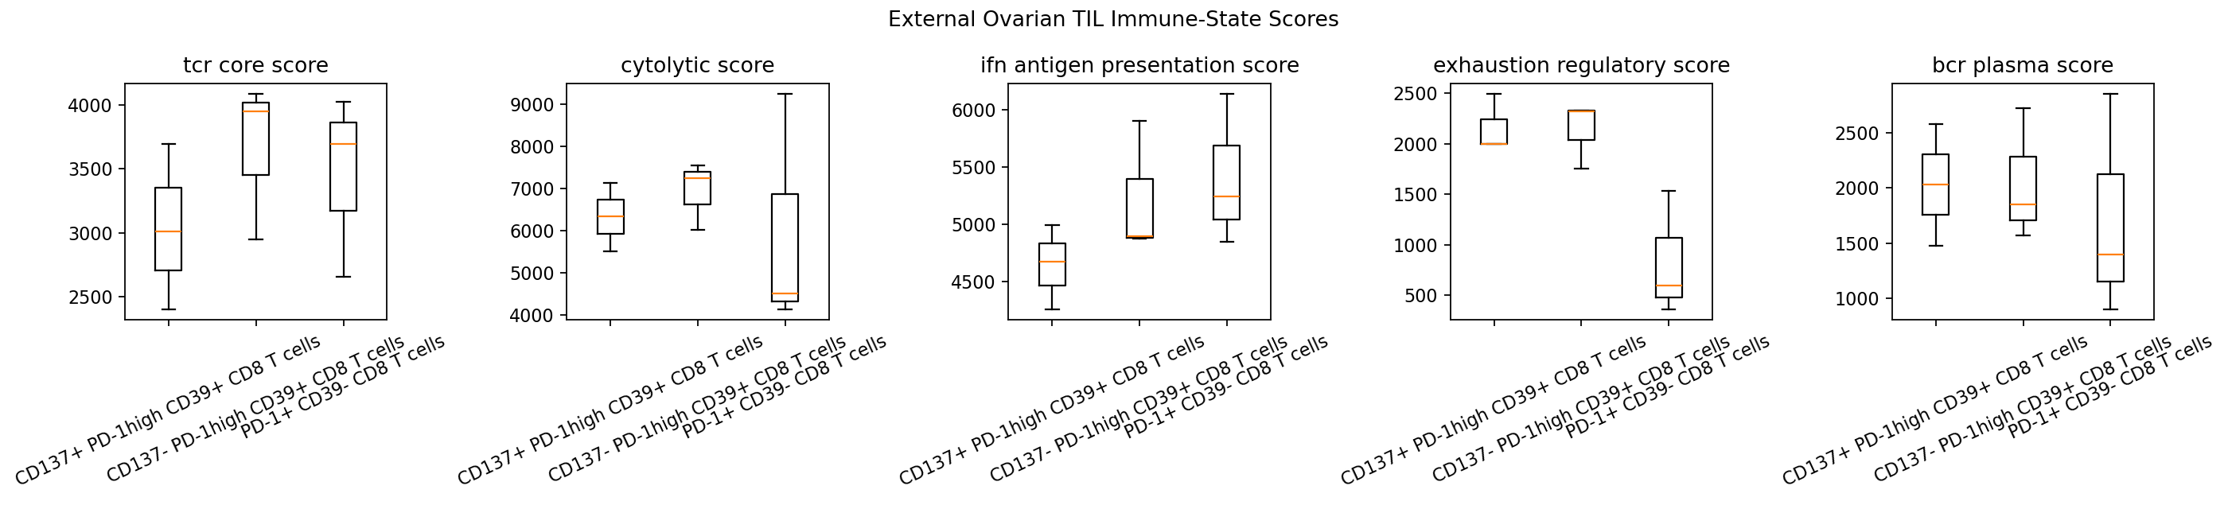
Supplementary Figure S4. External ovarian immune-state score distributions.
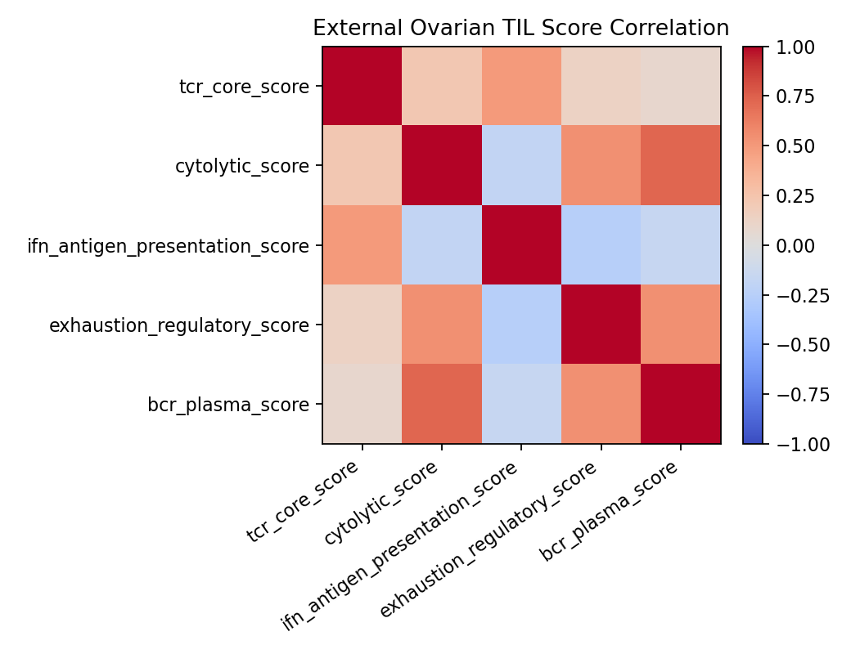
Supplementary Figure S5. External ovarian immune-state score correlation.
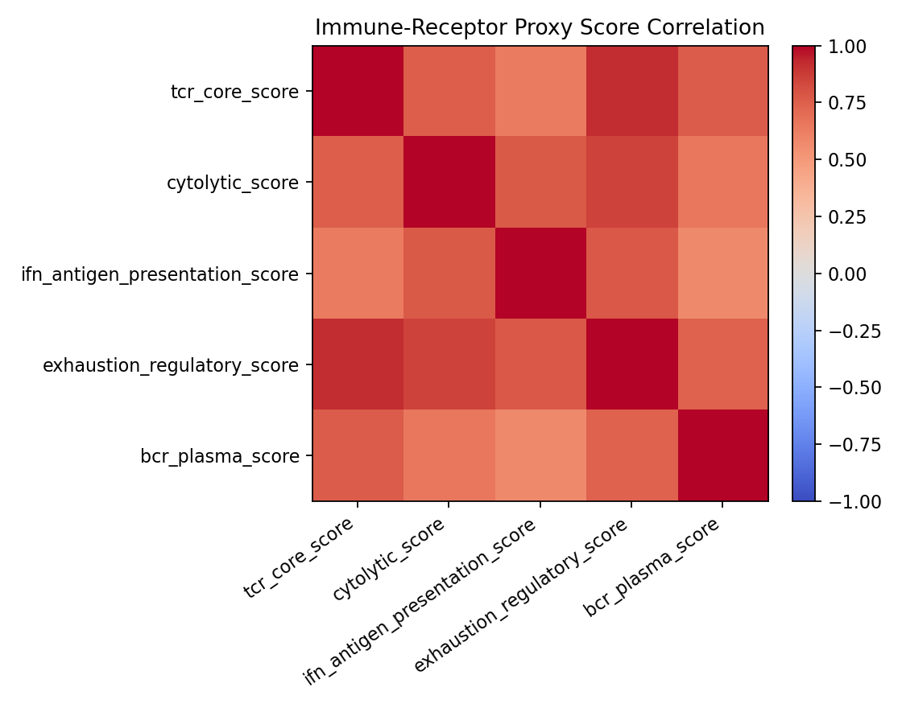
Supplementary Figure S6. TCGA-OV immune proxy correlation.
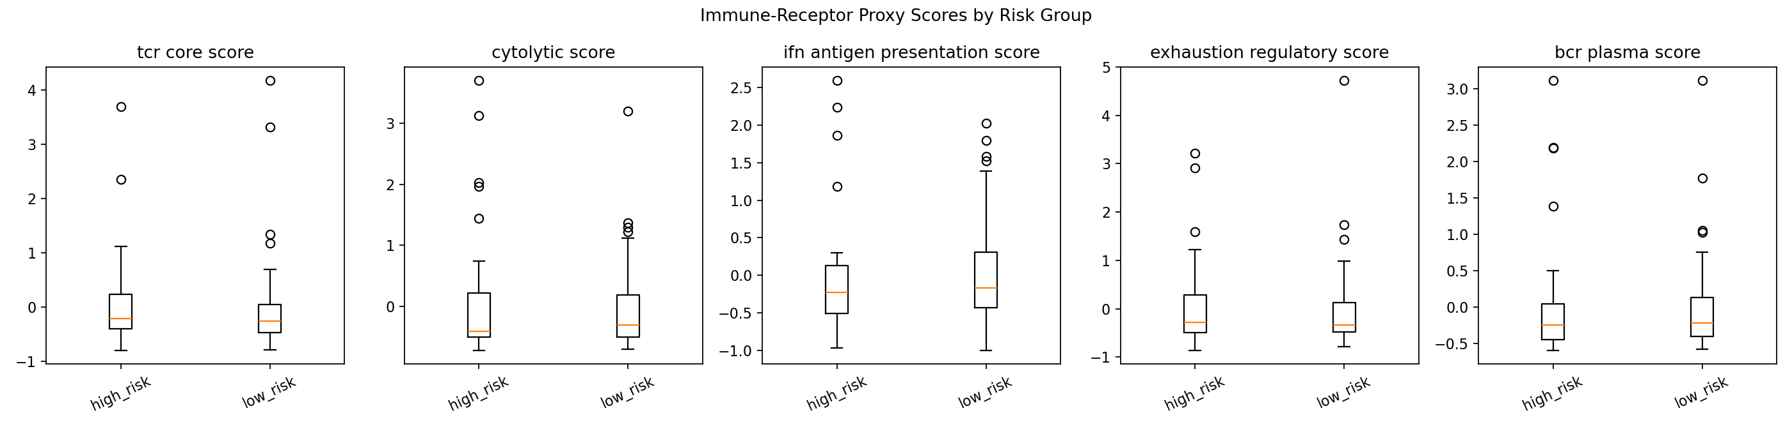
Supplementary Figure S7. TCGA-OV immune proxy by risk group.

