Uncertainty-Aware Multi-Omics Integration Reveals Stable Cross-Layer Hubs and Perturbation-Sensitive Network Architecture in TCGA Ovarian Cancer
Dr Siddalingaiah H S, Professor, Community Medicine, Shridevi Institute of Medical Sciences and Research Hospital, Tumkur. Email: hssling@yahoo.com | ORCID: 0000-0002-4771-8285

Structured Abstract
Background: Integrated ovarian cancer multi-omics studies often report performance without clarifying which signals remain stable across methods and uncertainty checks.
Methods: Public TCGA-OV multi-omics data were harmonized and analyzed with latent integration, supervised multiblock modeling, network analysis, perturbation, pathway aggregation, ablation, and predictive calibration.
Results: RNA modules gave the highest AUC (0.613), CNA the highest Cox C-index (0.616), and the most stable hubs were LF8, LF5, LF6, LF7. Perturbation prioritized LF7, LF6, LF8, LF5.
Conclusions: Stable cross-layer hubs and perturbation-sensitive architecture were more robust than direct predictive claims and provide the strongest translational signal.

Introduction
Ovarian cancer is biologically heterogeneous across genomic, epigenomic, transcriptomic, and proteomic layers. In deeply matched public cohorts, the key question is not whether integration can produce a single favorable model, but which conclusions remain stable after uncertainty-aware stress testing.
This study therefore prioritizes reproducible systems evidence over isolated point estimates. We used TCGA-OV to identify cross-layer hubs that remain stable across latent integration, network centrality, perturbation analysis, and pathway-oriented interpretation.

Methods
Public TCGA-OV data were harmonized at patient level. Core analyses required matched mutation, CNA, methylation, and RNA data; protein was evaluated in a fairness-restricted subset. MOFA-like latent factors, DIABLO-like supervised components, a multilayer network, perturbation experiments, ablation tests, and repeated-CV ML benchmarking were performed.

Results
RNA modules had the strongest discriminative signal (AUC 0.613; 95% CI 0.489-0.737), whereas CNA had the strongest survival-ordering signal (Cox C-index 0.616; 95% CI 0.534-0.699).
Hub stability analysis consistently prioritized LF8, LF5, LF6, LF7. Perturbation ranked LF7, LF6, LF8, LF5 among the highest-impact nodes, and the strongest ablation combination was RNA modules plus protein modules.
Enrichment analysis linked LF6 to Epithelial Mesenchymal Transition (adjusted P=0.00432), reinforcing a stromal/extracellular-matrix interpretation.
LF8 showed enrichment for Positive Regulation Of Axon Extension (GO:0045773) (adjusted P=0.0253), supporting a neural-lineage and cell-junction related signal.
Table 1. Benchmark summary.
model | auc | auc_ci_low | auc_ci_high | cox_c_index | cox_c_index_ci_low | cox_c_index_ci_high
rna_modules | 0.612775579423403 | 0.4894731472481533 | 0.7370511243386243 | 0.5896319746735259 | 0.50222096035556 | 0.6648250146684397
cna | 0.5805539853024307 | 0.4591627831980589 | 0.7072894784802356 | 0.6157499010684606 | 0.5335544128564567 | 0.6985692852144895
integrated_no_protein | 0.5794234030525721 | 0.4681849626068376 | 0.701845662507427 | 0.5631183221210923 | 0.4870459645867876 | 0.6361968533075889
methylation | 0.4963256076879593 | 0.3740691105769231 | 0.6295022311434209 | 0.5219628017411951 | 0.4358394196641921 | 0.6073403221556096
integrated_with_protein | 0.4833795013850416 | 0.3163492913645352 | 0.6443861881361881 | 0.5390625 | 0.4324213524318414 | 0.6737039449763664
protein_modules | 0.4806094182825485 | 0.3099521836564519 | 0.6415336168164313 | 0.5569196428571429 | 0.4625948734771782 | 0.6645351290354231
mutation | 0.3776144714527981 | 0.2612904252610135 | 0.4886505269972099 | 0.5065294815987337 | 0.4175349403570819 | 0.589836520121627

Table 2. Hub stability summary.
node | rank_score_mean | rank_score_ci_low | rank_score_ci_high | topk_freq
LF8 | 0.8744939779418348 | 0.5705264639639639 | 0.9953792735042736 | 1.0
LF5 | 0.9058873767427316 | 0.6778090473212425 | 1.0 | 1.0
LF6 | 0.8796956521880618 | 0.6085887716985278 | 1.0 | 0.995
LF7 | 0.8465685770466282 | 0.5194642857142857 | 0.992063492063492 | 1.0
rna_module_004 | 0.7857178119373507 | 0.4564583333333334 | 0.9695027264106212 | 0.995
rna_module_007 | 0.7660788951274575 | 0.3567460317460317 | 0.9649173806609546 | 1.0
LF4 | 0.7790680030688819 | 0.4282374279467303 | 0.956374584717608 | 1.0
LF2 | 0.7472282010563801 | 0.4226973684210526 | 0.9576365817644888 | 1.0

Table 3. Selected hub pathway enrichment results.
hub | library | Term | Adjusted P-value | Genes
LF8 | MSigDB_Hallmark_2020 | Hedgehog Signaling | 0.1555364244777396 | L1CAM
LF8 | MSigDB_Hallmark_2020 | Apical Surface | 0.1555364244777396 | AFAP1L2
LF8 | MSigDB_Hallmark_2020 | UV Response Up | 0.1655503660358053 | ONECUT1
LF8 | MSigDB_Hallmark_2020 | KRAS Signaling Dn | 0.1655503660358053 | PKP1
LF8 | MSigDB_Hallmark_2020 | Hypoxia | 0.1655503660358053 | PKP1
LF8 | MSigDB_Hallmark_2020 | Complement | 0.1655503660358053 | ADRA2B
LF8 | MSigDB_Hallmark_2020 | Estrogen Response Early | 0.1655503660358053 | MAPT
LF8 | MSigDB_Hallmark_2020 | Estrogen Response Late | 0.1655503660358053 | MAPT
LF8 | KEGG_2021_Human | Maturity onset diabetes of the young | 0.2698378178450243 | ONECUT1
LF8 | KEGG_2021_Human | Pathways of neurodegeneration | 0.2698378178450243 | MAPT;PRPH
LF8 | KEGG_2021_Human | TGF-beta signaling pathway | 0.2698378178450243 | GDF6
LF8 | KEGG_2021_Human | Signaling pathways regulating pluripotency of stem cells | 0.2698378178450243 | ONECUT1

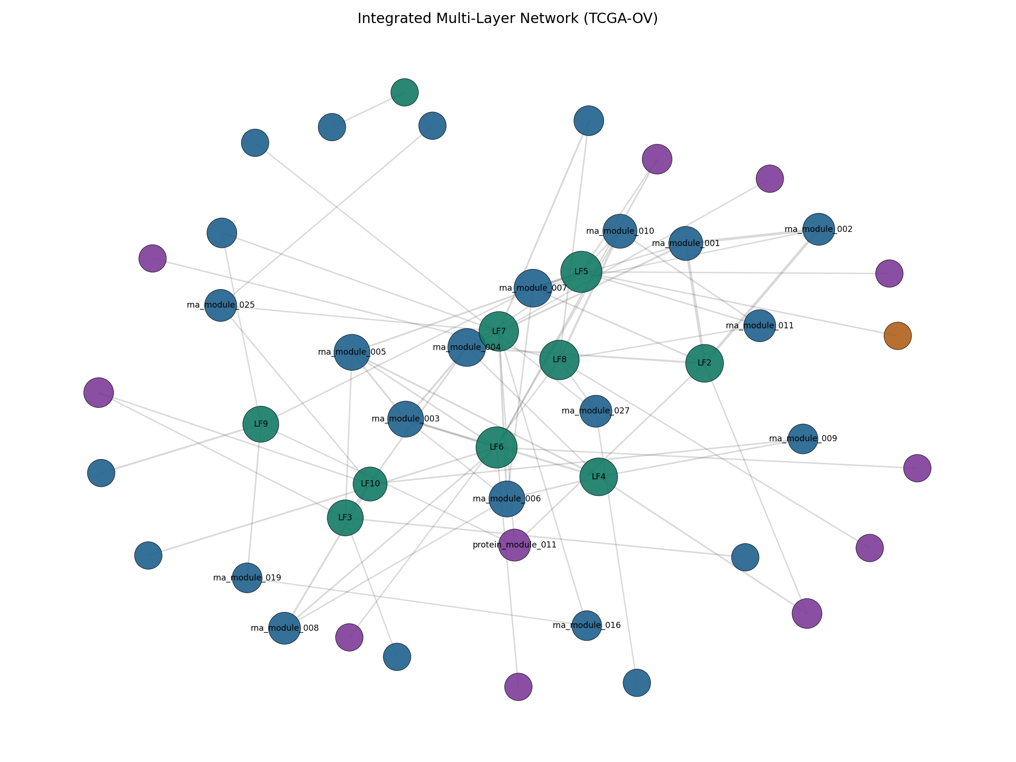
Figure 1. Integrated multilayer network graph.
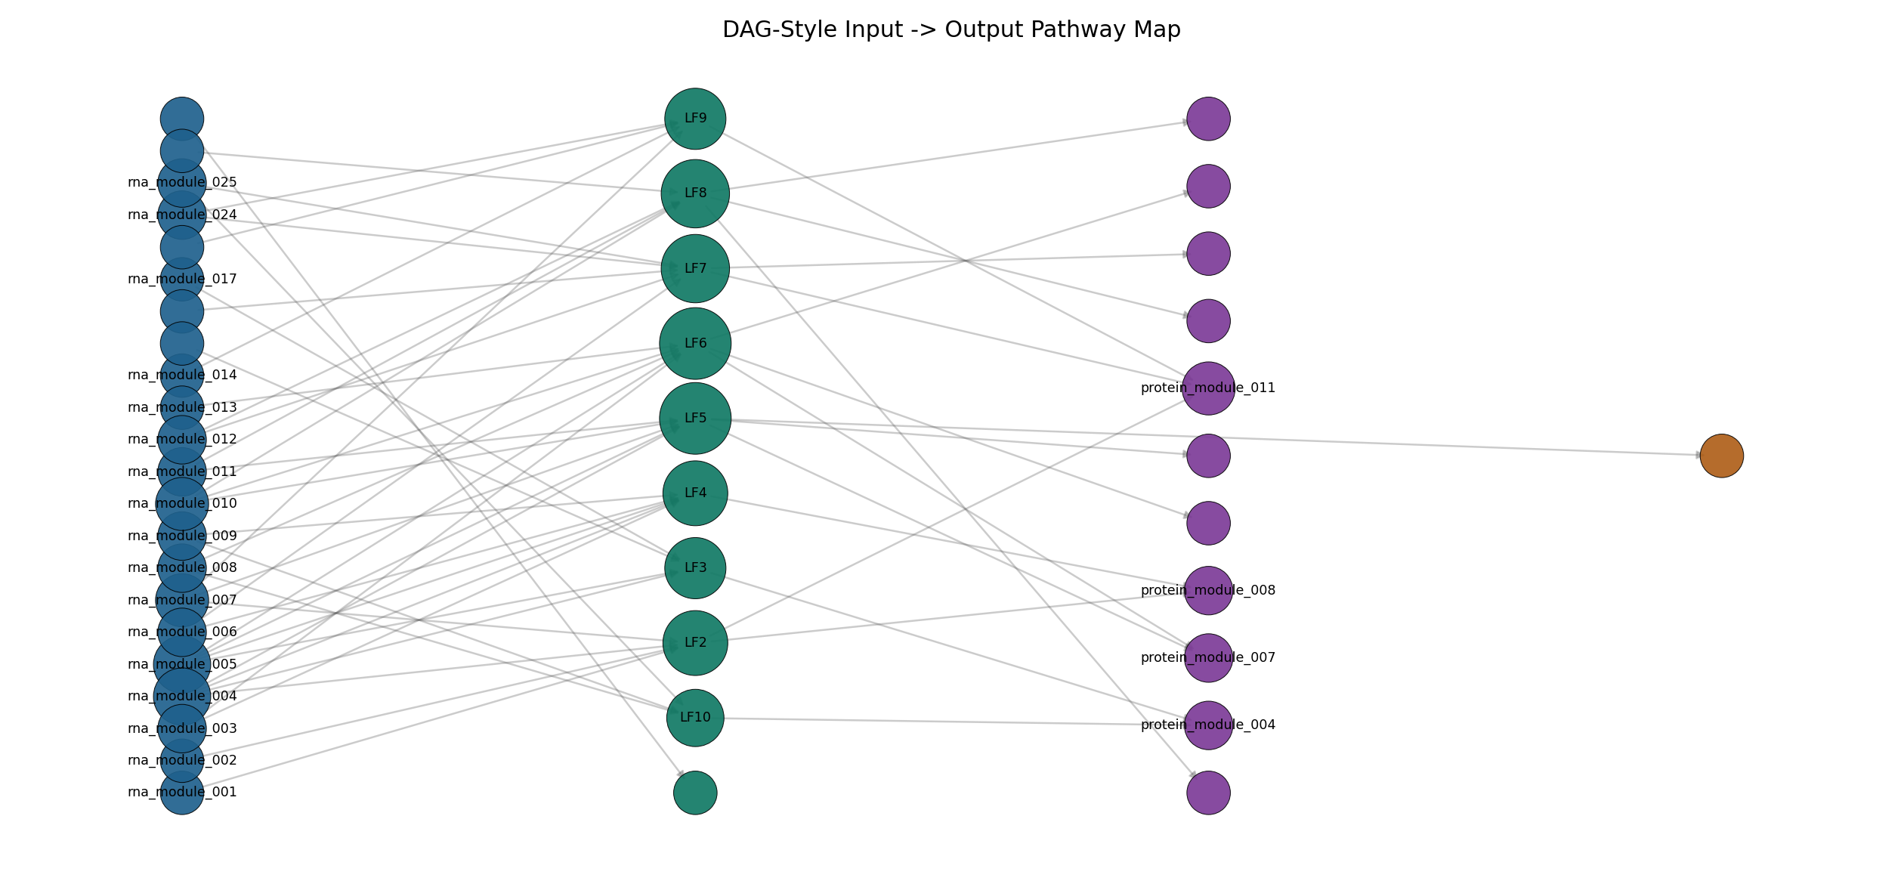
Figure 2. DAG-style pathway graph.
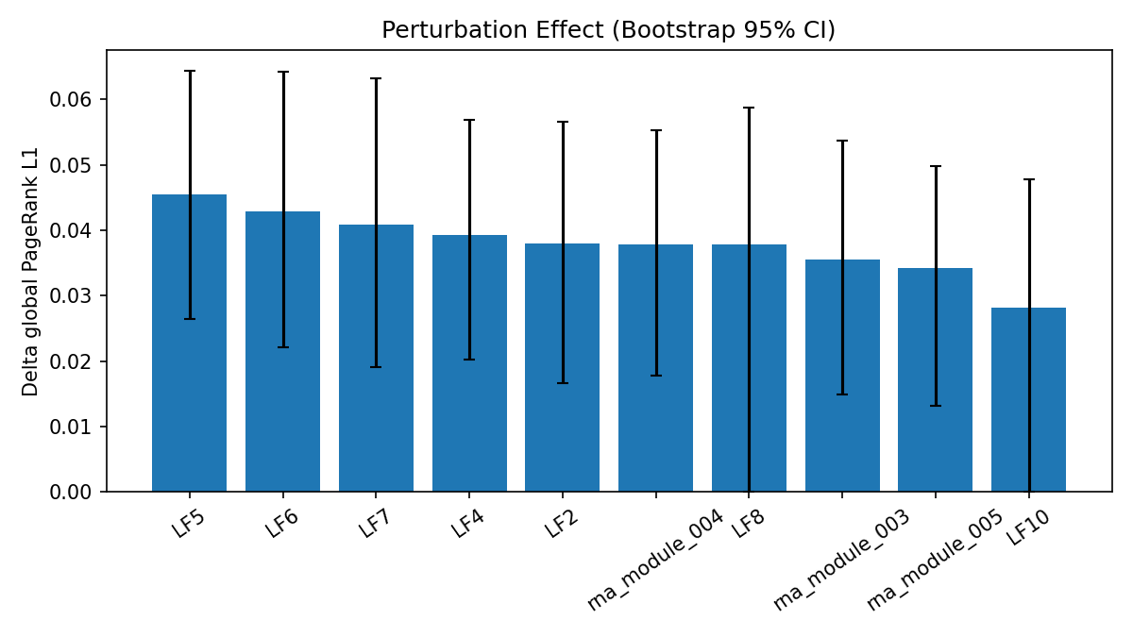
Figure 3. Perturbation effect sizes with bootstrap intervals.
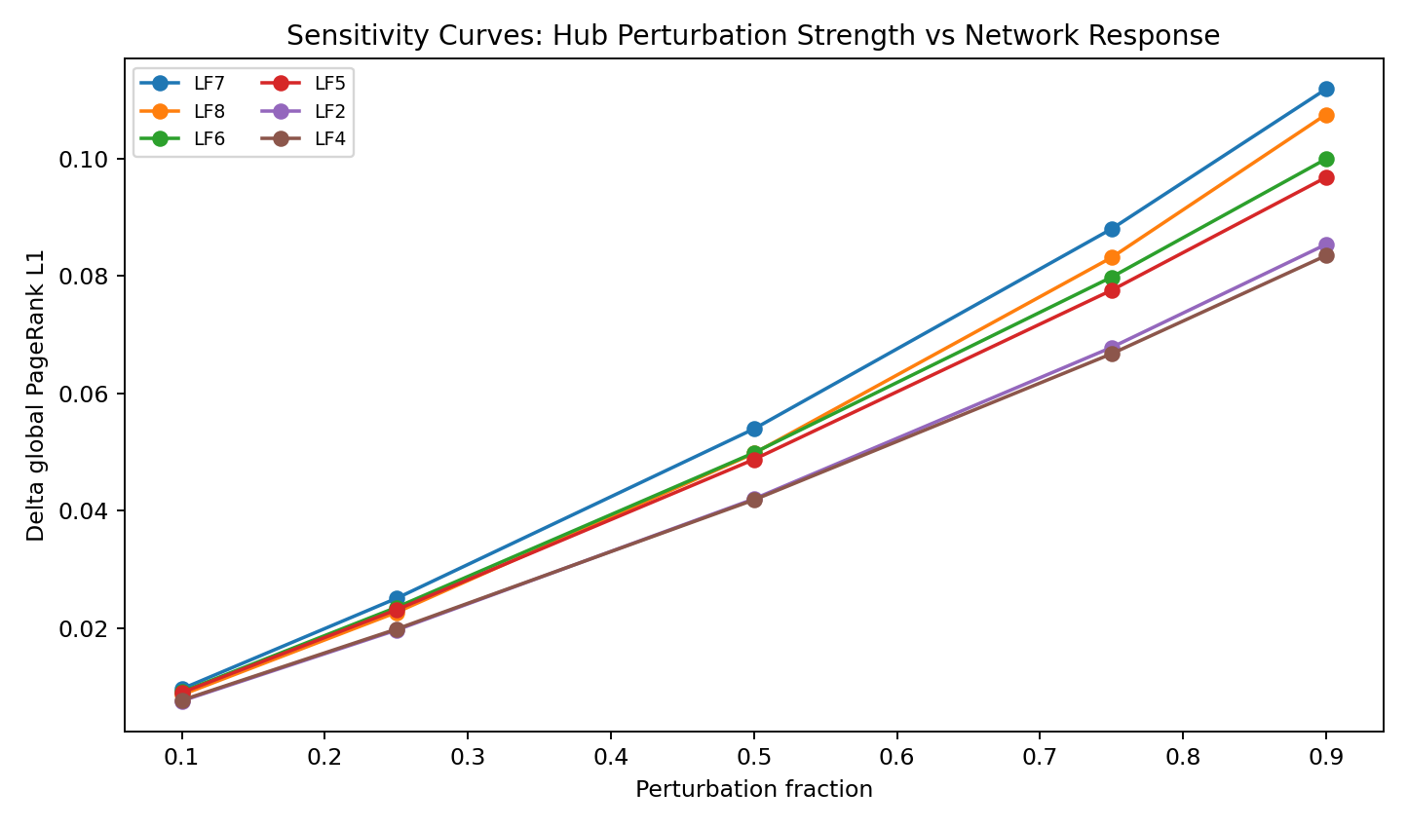
Figure 4. Hub sensitivity curves across perturbation fractions.
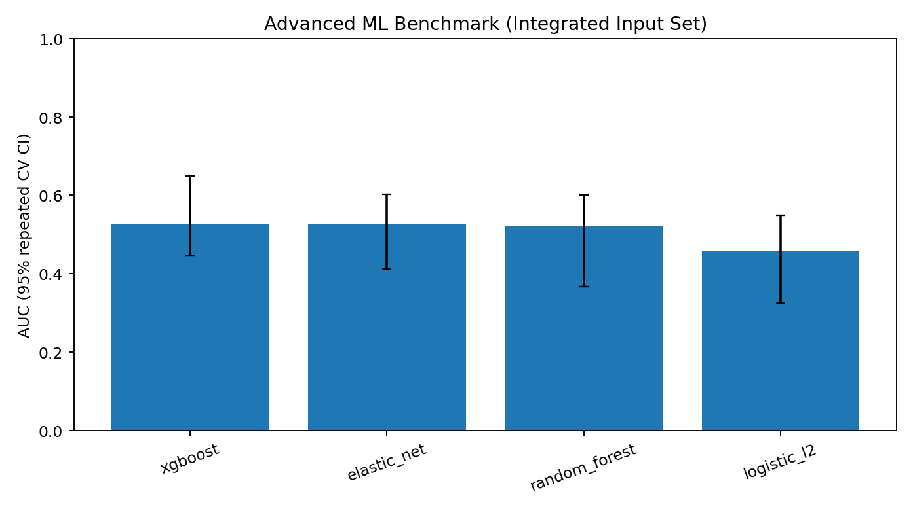
Figure 5. Advanced ML benchmark AUC with repeated-CV confidence intervals.
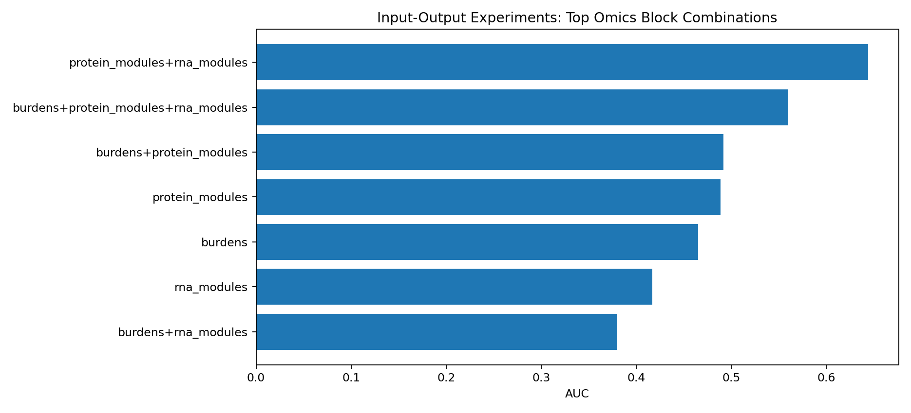
Figure 6. Top input-output ablation combinations.

Discussion
The central result is a stable hub-centric network architecture rather than a high-accuracy classifier. Transcript-level features carried the clearest discriminative signal, CNA best preserved survival ranking, and a small set of latent hubs dominated the perturbation and stability analyses.
The enrichment layer sharpened the biological interpretation of those hubs, especially LF6 as an extracellular-matrix or EMT-linked state and LF8 as a neural-lineage or cell-junction associated state. Advanced ML remained modest and served primarily as calibration against overstatement.

Additional Information
Acknowledgements: Public de-identified resources from GDC, cBioPortal, and PDC were used.
Authors' contributions: Dr Siddalingaiah H S conceived the work, interpreted the results, and prepared the manuscript.
Ethics approval and consent to participate: Secondary analysis of public de-identified data; no new ethics approval required.
Consent for publication: Not applicable.
Data availability: Derived artifacts and reproducibility outputs are available in the workspace and release bundles.
Competing interests: The author declares no competing interests.
Funding information: The author received no specific funding for this work.

