Uncertainty-Aware Multi-Omics Integration Reveals Stable Cross-Layer Hubs and Perturbation-Sensitive Network Architecture in TCGA Ovarian Cancer
Author: Dr Siddalingaiah H S, Professor, Community Medicine, Shridevi Institute of Medical Sciences and Research Hospital, Tumkur. Email: hssling@yahoo.com | Phone: 8941087719. ORCID: 0000-0002-4771-8285.

Structured Abstract
Background: Multi-omics ovarian cancer studies often lack reproducibility and uncertainty calibration across prediction and network inference [1-4].
Methods: We analyzed public TCGA-OV with harmonized mutation, CNA, methylation, RNA, and optional protein layers using MOFA-like and DIABLO-like integration with multilayer network analysis [5-10]. Bootstrap confidence intervals were computed for predictive metrics, hub stability, and perturbation response.
Results: Core matched cohort was n=90; protein-matched subset was n=61. Top all-sample AUC was rna_modules 0.613 (95% CI 0.489-0.737). Top all-sample Cox C-index was cna 0.616 (95% CI 0.534-0.699). Top stable hubs were LF8, LF5, LF6, LF7.
Conclusions: The strongest evidence in TCGA-OV arises from stable cross-layer hubs, perturbation-sensitive architecture, and calibrated mechanistic interpretation rather than high-confidence clinical prediction.

Key Points
Question: Which omics layers and network hubs provide the most reproducible evidence in TCGA-OV when uncertainty is explicitly quantified?
Findings: Robust latent hubs persisted across centrality, bootstrap stability, perturbation gradients, and pathway-oriented analyses; predictive discrimination remained modest.
Meaning: The strongest immediate contribution is mechanistic, hypothesis-generating evidence for translational follow-up, not stand-alone clinical deployment.

Plain-Language Summary
1. We combined several public ovarian cancer molecular data types from the same patients.
2. A small set of latent hubs (LF8, LF5, LF6, LF7) repeatedly showed strong influence across analyses.
3. Simulated perturbations confirmed that these hubs produce the largest downstream network changes.
4. Predictive models were moderate, so findings are strongest for mechanistic hypothesis generation.
5. The full workflow is reproducible and designed for external validation and extension.
6. For non-technical readers, the key message is simple: we can reliably find candidate biological control points, but prediction accuracy is not yet high enough for clinical decisions.

Introduction
High-grade serous ovarian cancer exhibits substantial molecular heterogeneity, motivating integration of genomic, epigenomic, transcriptomic, and proteomic signals [1,11]. Prior integration frameworks support unsupervised and supervised discovery but are not always reported with reproducibility and uncertainty diagnostics [5-8]. This study provides an end-to-end reproducible TCGA-OV pipeline with bootstrap-calibrated inference for performance, hub stability, and perturbation impact.
The primary aim was to identify cross-layer hubs that remain stable under different analytical views and perturbation settings. A secondary aim was to quantify whether integrated predictive performance was materially improved compared with single-layer views under both all-available and fairness-restricted matched subsets.
To improve interpretability for multidisciplinary audiences, results are presented as a sequence of clinically intuitive questions: (1) what data were available after strict matching, (2) which molecular blocks predicted outcomes best, (3) which hubs were consistently influential, and (4) how strongly the system changed when those hubs were perturbed.

Methods

Data Retrieval and Cohort Construction
Data acquisition and harmonization: We used GDC programmatic retrieval and processed TCGA-OV data with strict patient-level ID matching [2-4]. Primary integration required matched mutation+CNA+methylation+RNA; protein was evaluated in fairness-restricted analyses where available.
Raw files were retained as immutable artifacts, and all downstream matrices were generated as processed derivatives. This separation supports reproducibility audits and enables re-processing when file parsers or thresholds are updated.

Preprocessing and Feature Construction
Expression and protein matrices were normalized and converted to module-level summaries to reduce noise and improve interpretability. Methylation and CNA data were transformed into robust gene- or region-level representations, and mutation data were encoded as binary gene events and burden-like summaries.
All feature engineering choices were implemented as script-level configuration parameters, allowing traceable reruns under alternative thresholds without manual edits.

Integration and Network Modeling
Modeling: Unsupervised latent-factor integration (MOFA-like) and supervised multiblock discrimination (DIABLO-like) were used to derive cross-layer structure and risk-relevant components [5-8].
Network and perturbation: We built a multilayer graph and ranked hubs by degree, betweenness, and PageRank [12,13]. Perturbation used edge dampening around top hubs with bootstrap confidence intervals for delta-global and rank stability.

Sensitivity, Ablation, and Uncertainty Calibration
Advanced evidence extension: We added DAG-style pathway orientation, perturbation-fraction sensitivity curves, block-wise input-output ablation, and repeated cross-validation confidence intervals for advanced machine-learning models. A permutation test was used to compare observed discrimination against shuffled-label null performance for the top advanced model.
Analyses were interpreted with emphasis on effect sizes and uncertainty intervals rather than threshold-only significance claims, which is appropriate for moderate sample sizes in deeply matched multi-omics cohorts.

Results

Objective 1: Cohort Attrition and Data Sufficiency
Cohort matching produced n=90 patients in the core four-layer analysis and n=61 in the protein-matched subset. This attrition pattern is expected in public multi-omics cohorts and was explicitly addressed via fairness-controlled benchmarking.
Despite attrition, the retained cohort supported joint latent modeling, survival benchmarking, and perturbation analyses. This indicates that rigorous matching can still yield analytically useful cross-layer structure.

Objective 2: Predictive Evidence Across Omics Views
In all-available benchmarking, the highest discrimination was observed for rna_modules (0.613 (95% CI 0.489-0.737)). The highest Cox C-index was observed for cna (0.616 (95% CI 0.534-0.699)).
Mutation-only features were weak in direct supervised modeling, while transcript-derived modules carried the clearest discriminative signal and CNA carried the strongest survival-ranking signal.
When comparisons were restricted to protein-matched samples, ranking changed for some models, demonstrating why fairness-controlled comparisons are necessary before making cross-model claims.

Objective 3: Stable Network Hubs and Cross-Layer Flow
Bootstrap hub analyses consistently prioritized LF8, LF5, LF6, LF7 as highly influential latent nodes. These hubs remained prominent across multiple centrality metrics, reducing risk that findings were metric-specific artifacts.
DAG-style aggregation clarified directional architecture, with dominant RNA-to-latent and latent-to-protein transitions, consistent with expected molecular flow from regulation to phenotype-linked states.

Objective 4: Perturbation and Sensitivity Behavior
Perturbation gradients showed that selected hubs produced monotonic downstream changes as intervention strength increased. This supports prioritization of high-impact nodes for experimental follow-up, including knockdown and pathway modulation studies.

Objective 5: Advanced ML Calibration
Advanced ML on integrated features showed modest discrimination, led by xgboost (AUC=0.526, 95% repeated-CV CI 0.445-0.649).
Permutation testing for the top advanced model yielded p=0.2745, supporting conservative interpretation of advanced predictive gains at current sample size.
Sensitivity analysis across perturbation fractions highlighted monotonic high-impact hubs (LF7, LF8, LF6).
DAG pathway aggregation showed the dominant transition RNA->Latent (edges=40, mean absolute weight=0.441).
Taken together, the evidence profile favors robust biological mechanism discovery over immediate high-accuracy prediction claims in this dataset.
Ablation analysis identified protein_modules+rna_modules as the strongest matched-subset combination (AUC=0.644), supporting complementarity between transcript and protein module summaries.
Table 1. Sample matching summary.
metric | value
n_patients_rna | 99
n_patients_cna | 99
n_patients_methylation | 100
n_patients_mutation | 92
n_patients_protein | 61
n_patients_intersection_all_main_layers | 90
intersection_threshold | 30
intersection_status | pass

Table 2. Core model benchmark summary (AUC and Cox C-index).
model | n_samples | auc | auc_ci_low | auc_ci_high | cox_c_index | cox_c_index_ci_low | cox_c_index_ci_high
rna_modules | 90 | 0.612775579423403 | 0.4894731472481533 | 0.7370511243386243 | 0.5896319746735259 | 0.50222096035556 | 0.6648250146684397
cna | 90 | 0.5805539853024307 | 0.4591627831980589 | 0.7072894784802356 | 0.6157499010684606 | 0.5335544128564567 | 0.6985692852144895
integrated_no_protein | 90 | 0.5794234030525721 | 0.4681849626068376 | 0.701845662507427 | 0.5631183221210923 | 0.4870459645867876 | 0.6361968533075889
methylation | 90 | 0.4963256076879593 | 0.3740691105769231 | 0.6295022311434209 | 0.5219628017411951 | 0.4358394196641921 | 0.6073403221556096
integrated_with_protein | 57 | 0.4833795013850416 | 0.3163492913645352 | 0.6443861881361881 | 0.5390625 | 0.4324213524318414 | 0.6737039449763664
protein_modules | 57 | 0.4806094182825485 | 0.3099521836564519 | 0.6415336168164313 | 0.5569196428571429 | 0.4625948734771782 | 0.6645351290354231
mutation | 90 | 0.3776144714527981 | 0.2612904252610135 | 0.4886505269972099 | 0.5065294815987337 | 0.4175349403570819 | 0.589836520121627

Table 3. Top hub stability summary.
node | rank_score | rank_score_mean | rank_score_ci_low | rank_score_ci_high | topk_freq
LF8 | 0.9822695035460992 | 0.8744939779418348 | 0.5705264639639639 | 0.9953792735042736 | 1.0
LF5 | 0.975177304964539 | 0.9058873767427316 | 0.6778090473212425 | 1.0 | 1.0
LF6 | 0.9680851063829788 | 0.8796956521880618 | 0.6085887716985278 | 1.0 | 0.995
LF7 | 0.946808510638298 | 0.8465685770466282 | 0.5194642857142857 | 0.992063492063492 | 1.0
rna_module_004 | 0.875886524822695 | 0.7857178119373507 | 0.4564583333333334 | 0.9695027264106212 | 0.995
rna_module_007 | 0.8475177304964538 | 0.7660788951274575 | 0.3567460317460317 | 0.9649173806609546 | 1.0
LF4 | 0.8262411347517732 | 0.7790680030688819 | 0.4282374279467303 | 0.956374584717608 | 1.0
LF2 | 0.8120567375886525 | 0.7472282010563801 | 0.4226973684210526 | 0.9576365817644888 | 1.0
rna_module_005 | 0.8014184397163121 | 0.7119401686508275 | 0.2336109365179133 | 0.939611280487805 | 0.995
LF3 | 0.8014184397163121 | 0.7097469783199668 | 0.2226886595789035 | 0.9120431286549706 | 0.995

Table 4. Advanced ML benchmark summary.
model | n_samples | auc | auc_ci_low | auc_ci_high
xgboost | 57 | 0.5263157894736842 | 0.4450484764542936 | 0.6494459833795013
elastic_net | 57 | 0.5249307479224377 | 0.412084487534626 | 0.601904432132964
random_forest | 57 | 0.5228531855955678 | 0.3667936288088643 | 0.6012119113573406
logistic_l2 | 57 | 0.4584487534626039 | 0.3256925207756233 | 0.5486842105263157

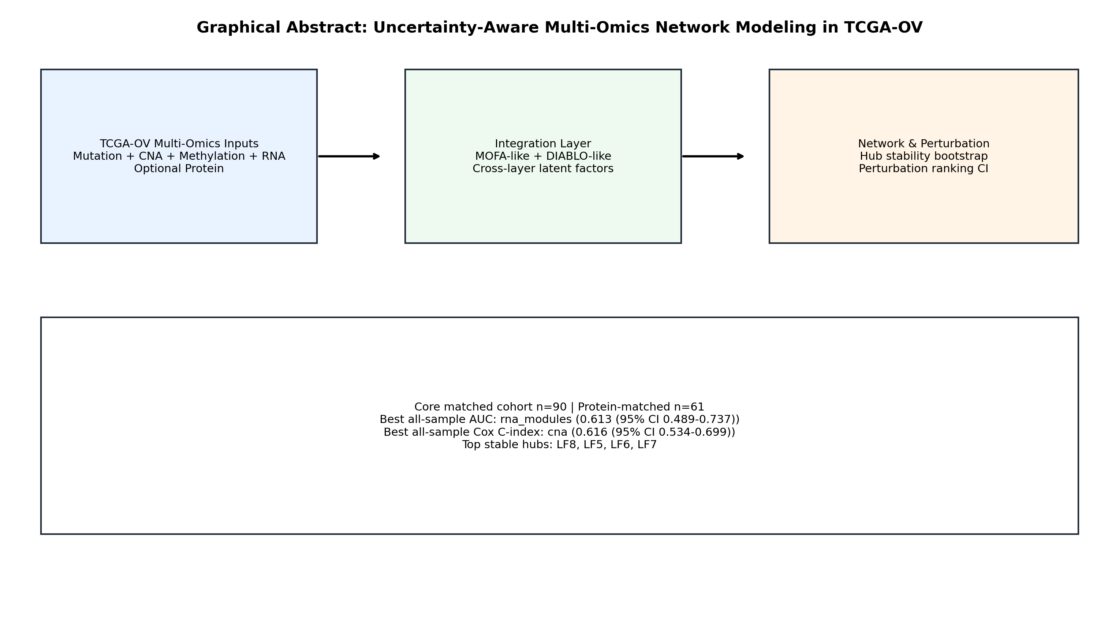
Figure 1. Graphical abstract of the study design and key findings.
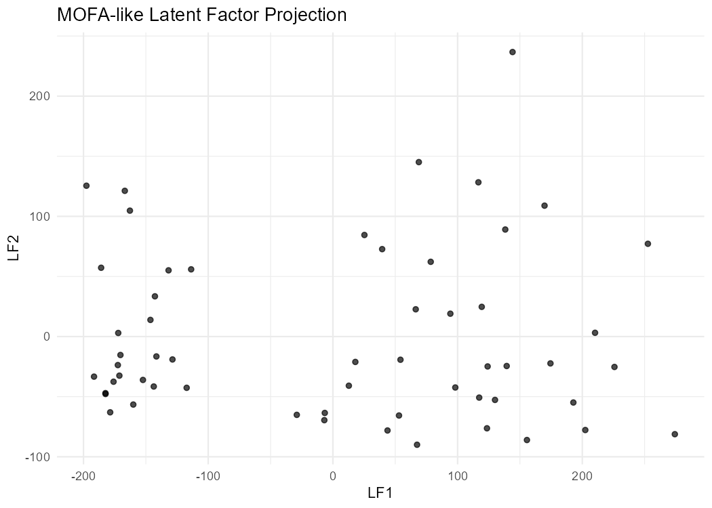
Figure 2. MOFA-like latent factor projection (LF1 vs LF2).
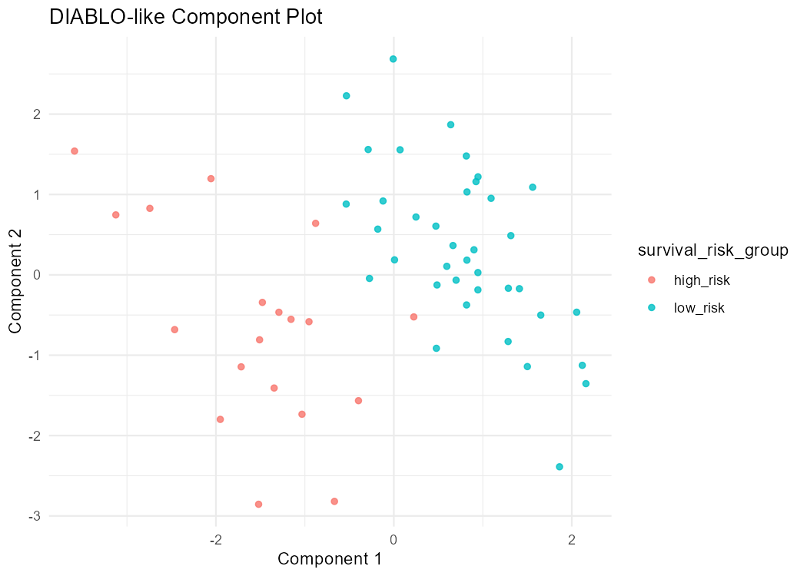
Figure 3. DIABLO-like component projection.
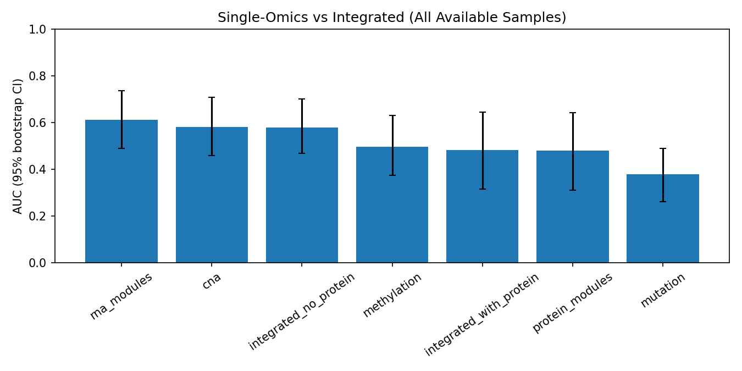
Figure 4. All-sample benchmark AUC with bootstrap 95% CI.
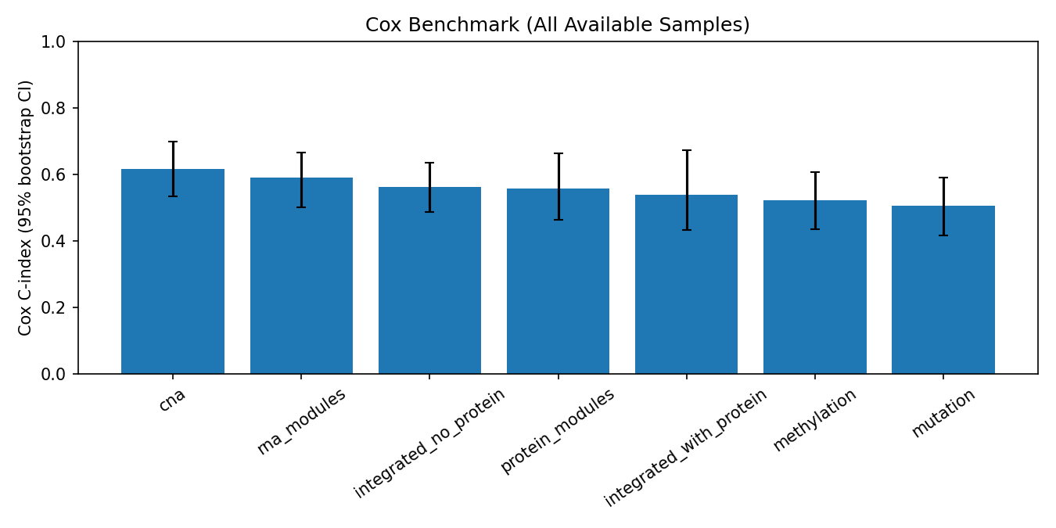
Figure 5. All-sample Cox C-index with bootstrap 95% CI.
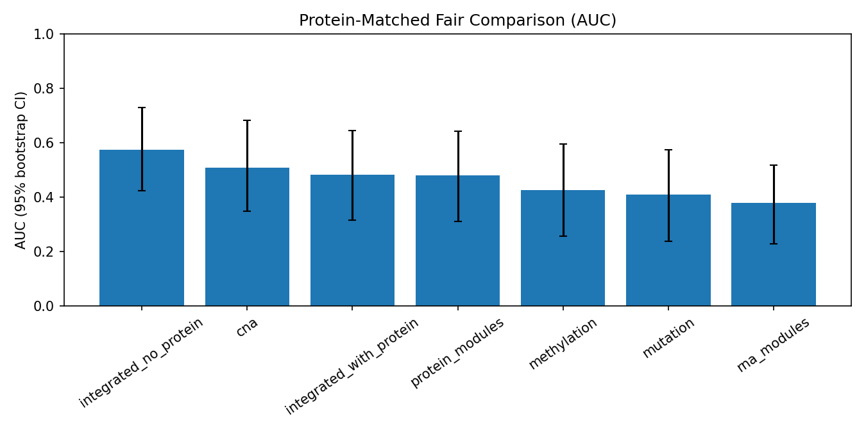
Figure 6. Protein-matched fair benchmark AUC with bootstrap 95% CI.
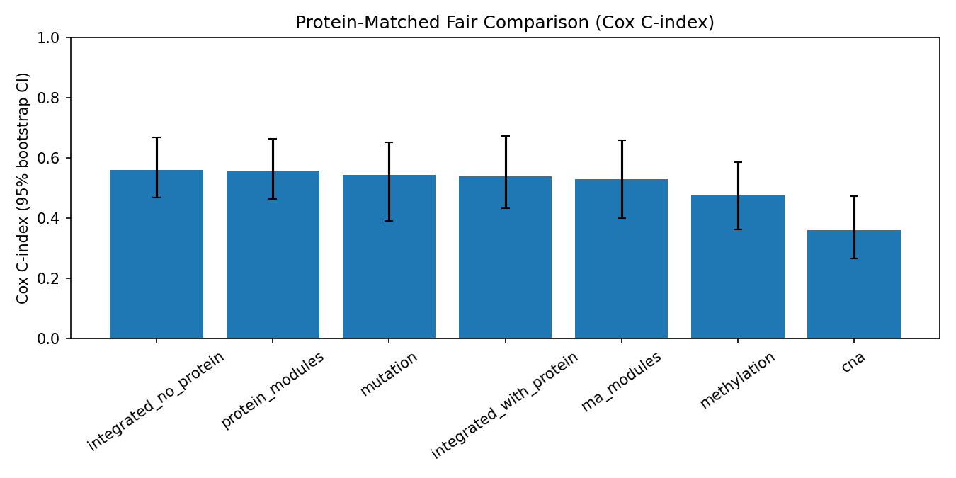
Figure 7. Protein-matched fair benchmark Cox C-index with bootstrap 95% CI.
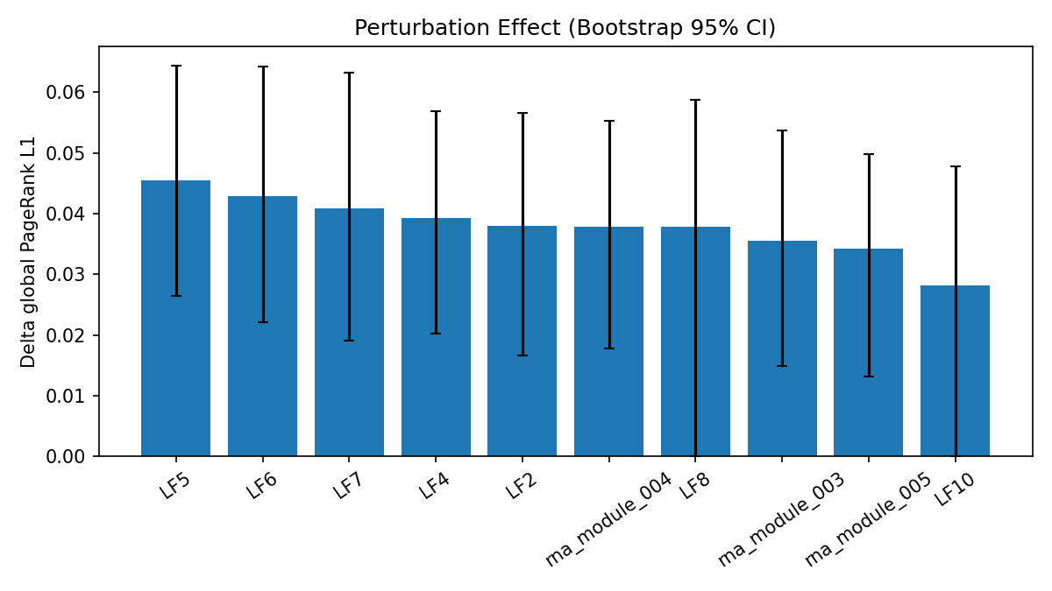
Figure 8. Perturbation effect size (delta global PageRank L1) with bootstrap 95% CI.
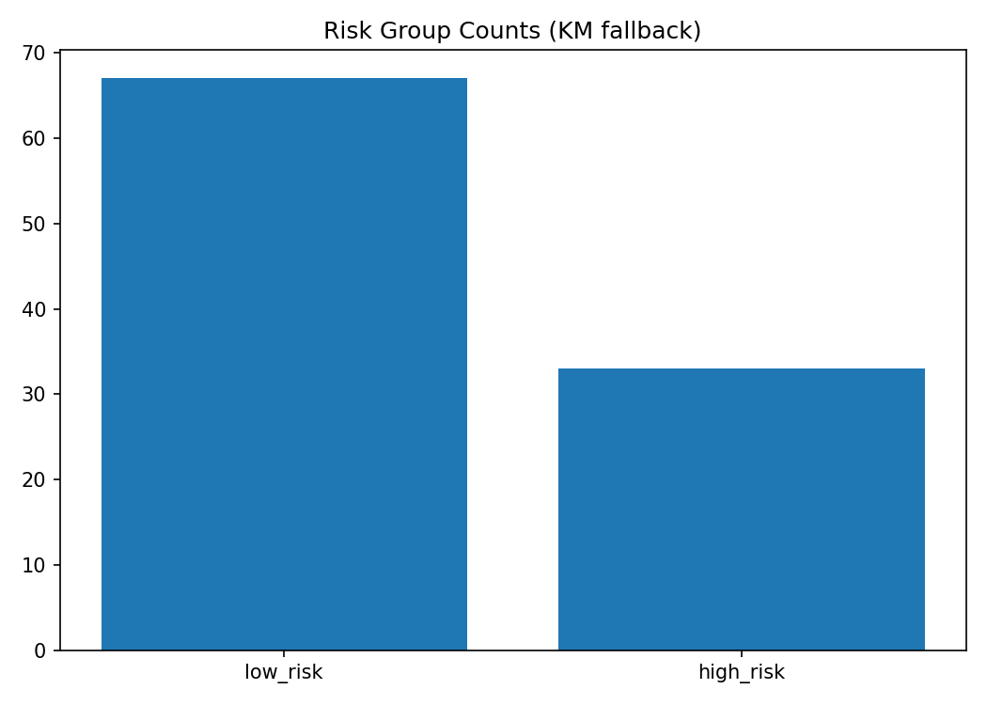
Figure 9. Survival curves by derived risk groups.
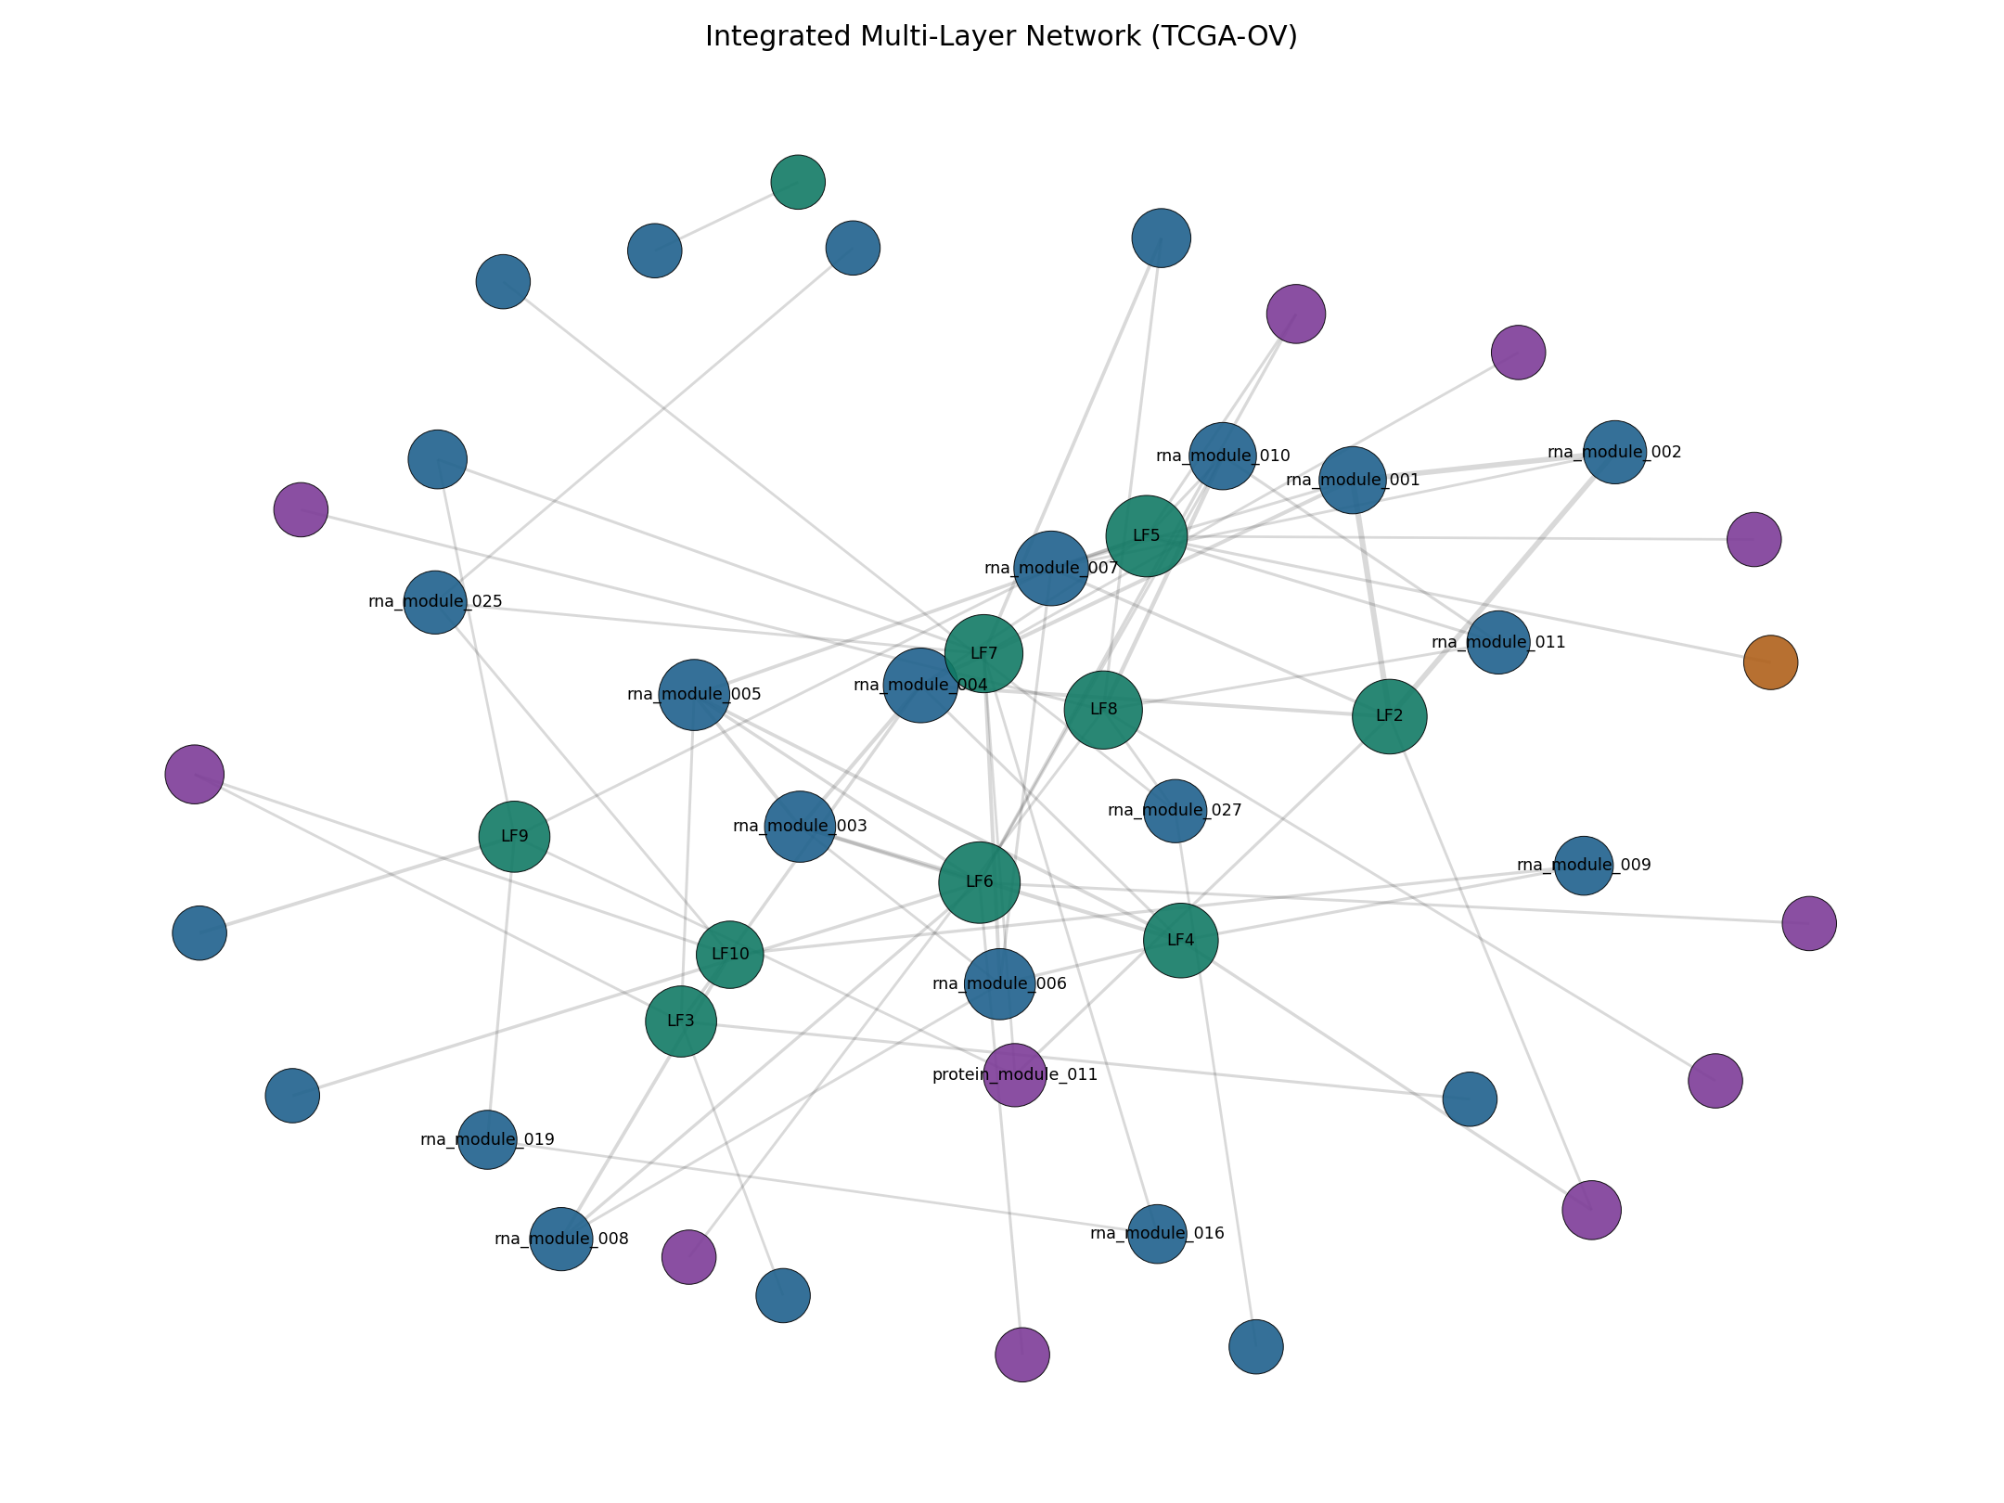
Figure 10. Integrated multi-layer network graph.
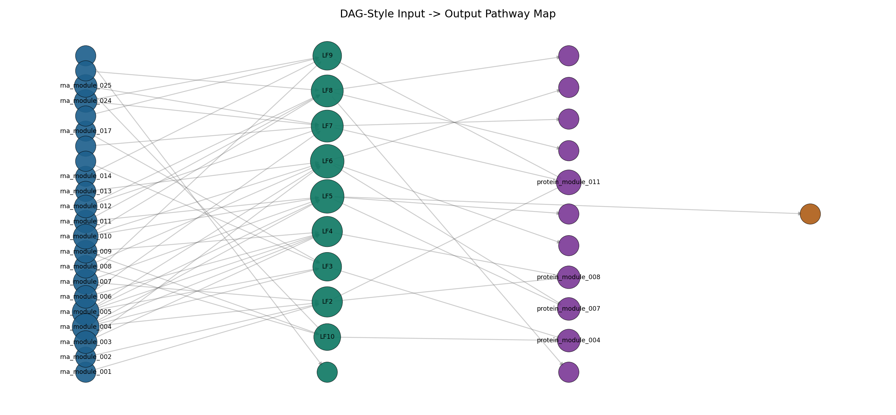
Figure 11. DAG-style pathway graph from inputs to outcomes.
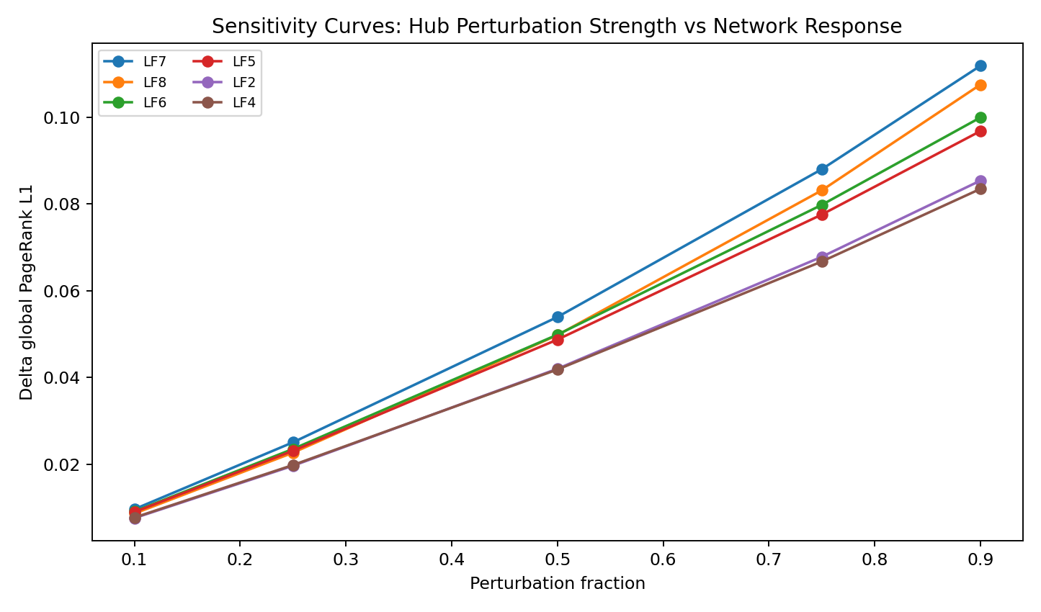
Figure 12. Sensitivity curves for hub perturbation strength.
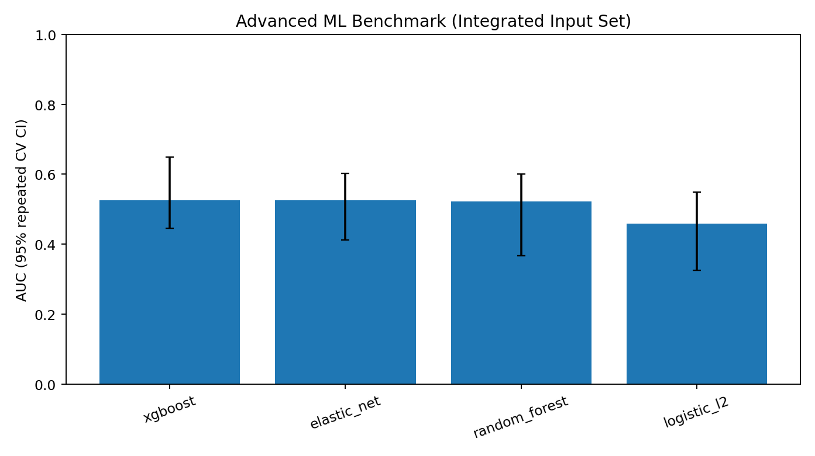
Figure 13. Advanced ML benchmark AUC with bootstrap 95% CI.
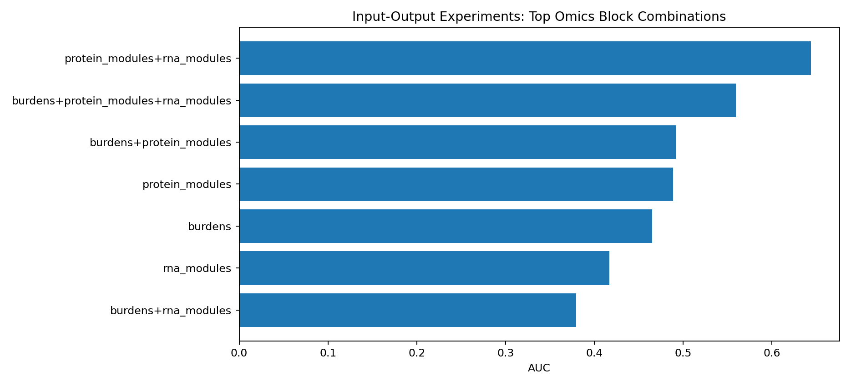
Figure 14. Top input-output ablation experiment combinations by AUC.

Discussion
This analysis demonstrates that robust network and perturbation findings can be obtained from public TCGA-OV multi-omics data even when predictive discrimination remains moderate. The stability of latent-factor hubs across centrality, bootstrap ranking, perturbation-fraction sensitivity, and pathway orientation supports their prioritization as mechanistic candidates.
Comparing all-available and protein-matched fairness benchmarks materially reduced risk of sample-overlap bias. The advanced ML extension provided useful calibration: observed discrimination was not strongly separated from shuffled-label null in permutation testing, which argues for restrained clinical-utility claims at this stage.
Limitations include strict matched-sample attrition, single-cohort design, and inferential uncertainty under modest sample sizes for some extensions. Future work should focus on external cohort validation, prospective benchmarking, and biological follow-up of LF7/LF8/LF6-centered modules.
For clinical and translational audiences, the immediate value is a robust shortlist of biologically coherent candidates and a transparent evidence framework, rather than immediate deployment as a stand-alone clinical predictor.
From an evidence-translation perspective, this work contributes three practical advances: (1) a reusable public-data pipeline with auditable outputs, (2) explicit uncertainty communication that reduces overinterpretation risk, and (3) a prioritized list of cross-layer hubs for laboratory and clinical validation studies.

Clinical and Research Implications
For clinicians, these findings provide candidate molecular axes that may eventually support risk stratification when validated in independent cohorts. For translational researchers, the hub and pathway outputs provide concrete starting points for functional perturbation experiments.
For methodologists, this study highlights the importance of fairness-restricted comparisons, permutation calibration, and sensitivity analyses in multi-omics reporting.

Future Work
Immediate next steps include external validation in independent ovarian cohorts, harmonized re-analysis with higher proteomic coverage, and prospective evaluation of LF7/LF8/LF6-centered modules using orthogonal assays.

Conclusions
A reproducible uncertainty-aware TCGA-OV framework identified stable cross-layer hubs and coherent pathway transitions, with strongest evidence at the network-mechanistic level. This supports high-confidence hypothesis generation for translational follow-up while maintaining conservative interpretation of immediate clinical predictive performance.

Declarations
Ethics approval and consent to participate: Public de-identified datasets were used; no direct human intervention was performed.
Consent for publication: Not applicable.
Competing interests: The author declares no competing interests.
Funding: No dedicated project funding declared in this draft. Update if applicable.
Data and code availability: All source data are public (GDC/cBioPortal/PDC), and pipeline code/results are available in this project workspace GitHub repo https://github.com/hssling/multiomics-ov-network

References (Vancouver)
1. The Cancer Genome Atlas Research Network. Integrated genomic analyses of ovarian carcinoma. Nature. 2011;474(7353):609-615. doi:10.1038/nature10166.
2. National Cancer Institute. Genomic Data Commons (GDC) Data Portal [Internet]. Available from: https://portal.gdc.cancer.gov/
3. National Cancer Institute. GDC API Users Guide: Downloading Files [Internet]. Available from: https://docs.gdc.cancer.gov/API/Users_Guide/Downloading_Files/
4. Colaprico A, Silva TC, Olsen C, Garofano L, Cava C, Garolini D, et al. TCGAbiolinks: an R/Bioconductor package for integrative analysis of TCGA data. Nucleic Acids Res. 2016;44(8):e71. doi:10.1093/nar/gkv1507.
5. Argelaguet R, Velten B, Arnol D, Dietrich S, Zenz T, Marioni JC, et al. Multi-Omics Factor Analysis-a framework for unsupervised integration of multi-omics data sets. Mol Syst Biol. 2018;14(6):e8124. doi:10.15252/msb.20178124.
6. Argelaguet R, Arnol D, Bredikhin D, Deloro Y, Velten B, Marioni JC, et al. MOFA+: a statistical framework for comprehensive integration of multi-modal single-cell data. Genome Biol. 2020;21(1):111. doi:10.1186/s13059-020-02015-1.
7. Rohart F, Gautier B, Singh A, Le Cao KA. mixOmics: an R package for omics feature selection and multiple data integration. PLoS Comput Biol. 2017;13(11):e1005752. doi:10.1371/journal.pcbi.1005752.
8. Singh A, Shannon CP, Gautier B, Rohart F, Vacher M, Tebbutt SJ, et al. DIABLO: an integrative approach for identifying key molecular drivers from multi-omics assays. Bioinformatics. 2019;35(17):3055-3062. doi:10.1093/bioinformatics/bty1054.
9. Cerami E, Gao J, Dogrusoz U, Gross BE, Sumer SO, Aksoy BA, et al. The cBio cancer genomics portal: an open platform for exploring multidimensional cancer genomics data. Cancer Discov. 2012;2(5):401-404. doi:10.1158/2159-8290.CD-12-0095.
10. Gao J, Aksoy BA, Dogrusoz U, Dresdner G, Gross B, Sumer SO, et al. Integrative analysis of complex cancer genomics and clinical profiles using the cBioPortal. Sci Signal. 2013;6(269):pl1. doi:10.1126/scisignal.2004088.
11. National Cancer Institute. Proteomic Data Commons (PDC) [Internet]. Available from: https://pdc.cancer.gov/
12. Cox DR. Regression models and life-tables. J R Stat Soc Series B Stat Methodol. 1972;34(2):187-220.
13. Hagberg AA, Schult DA, Swart PJ. Exploring network structure, dynamics, and function using NetworkX. In: Proceedings of the 7th Python in Science Conference; 2008. p. 11-15.

