Supplementary Material

Supplementary Figure Legends
Supplementary Figure 1. Final translational priority framework. Weighted scores classifying candidates into high-priority, promising, and lower-confidence groups.
Supplementary Figure 2. Pathway validation and actionability matrix. Pathway modules scored across human evidence, mechanistic plausibility, genetics or omics support, clinical actionability, safety or feasibility, and public-health relevance.
Supplementary Figure 3. Gene Ontology biological-process enrichment dotplot. Enrichment of the top-ranked 500 genes from GSE72267.
Supplementary Figure 4. Exploratory Reactome enrichment dotplot. Reactome pathway enrichment of the top-ranked 500 genes from GSE72267; results are exploratory because adjusted p values did not remain below 0.05.
Supplementary Figure 5. Evidence-aligned individual and public-health prevention measures. Low-risk measures framed as risk-reduction and health-promotion actions rather than guaranteed prevention.
Supplementary Figure 6. Benchmark target ranking. Downstream consensus ranking of validation-ready targets integrating pathway evidence, tractability, model relevance, and assayability.
Supplementary Figure 7. Benchmark evidence matrix. Heat-map view of evidence and tractability components contributing to downstream target ranking.
Supplementary Figure 8. Multi-dataset pathway recurrence. Recurrent pathway signals across GSE72267, GSE7621, and GSE20163.
Supplementary Figure 9. Benchmark knowledge graph. Graph representation linking targets, pathways, compounds, model systems, and evidence categories.

Supplementary Notes
The supplementary figures provide additional detail for readers interested in pathway scoring, exploratory enrichment, prevention framing, target benchmarking, and multi-dataset recurrence. They are intended to support, not replace, the main findings of the manuscript.

Embedded Supplementary Figures
Supplementary Figure 1
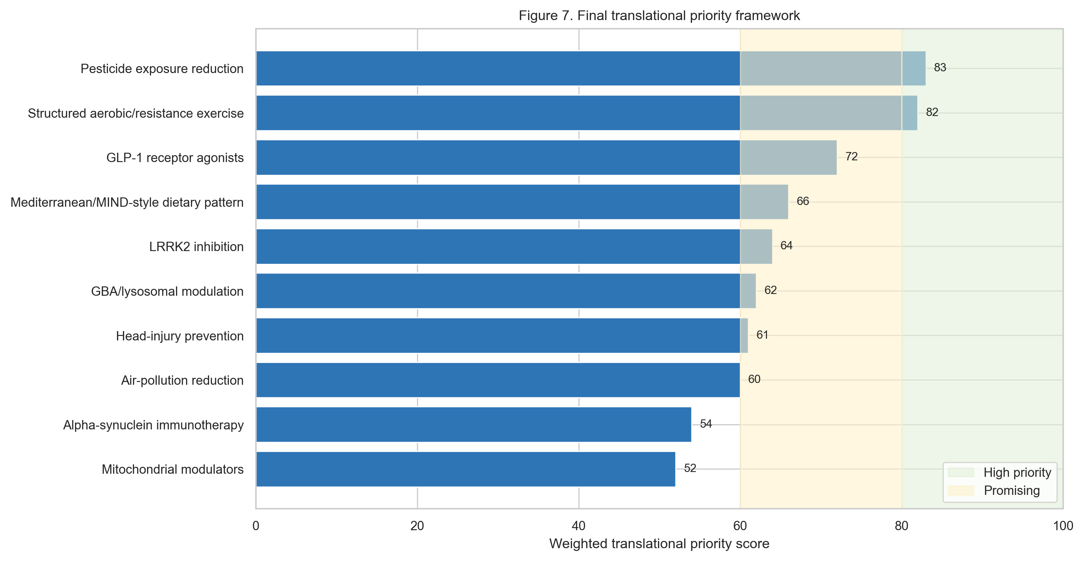

Supplementary Figure 2
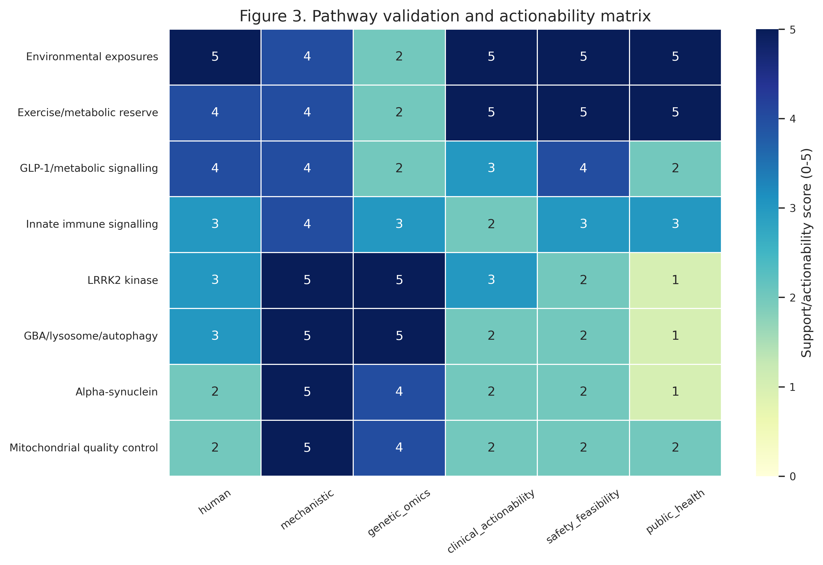

Supplementary Figure 3
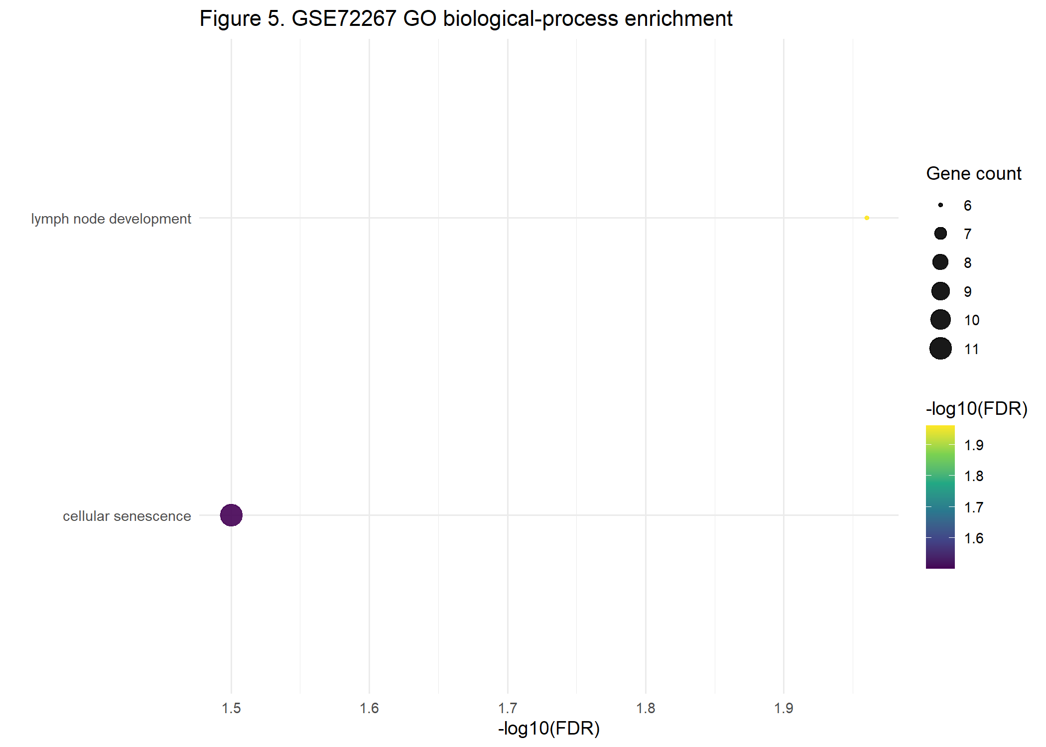

Supplementary Figure 4
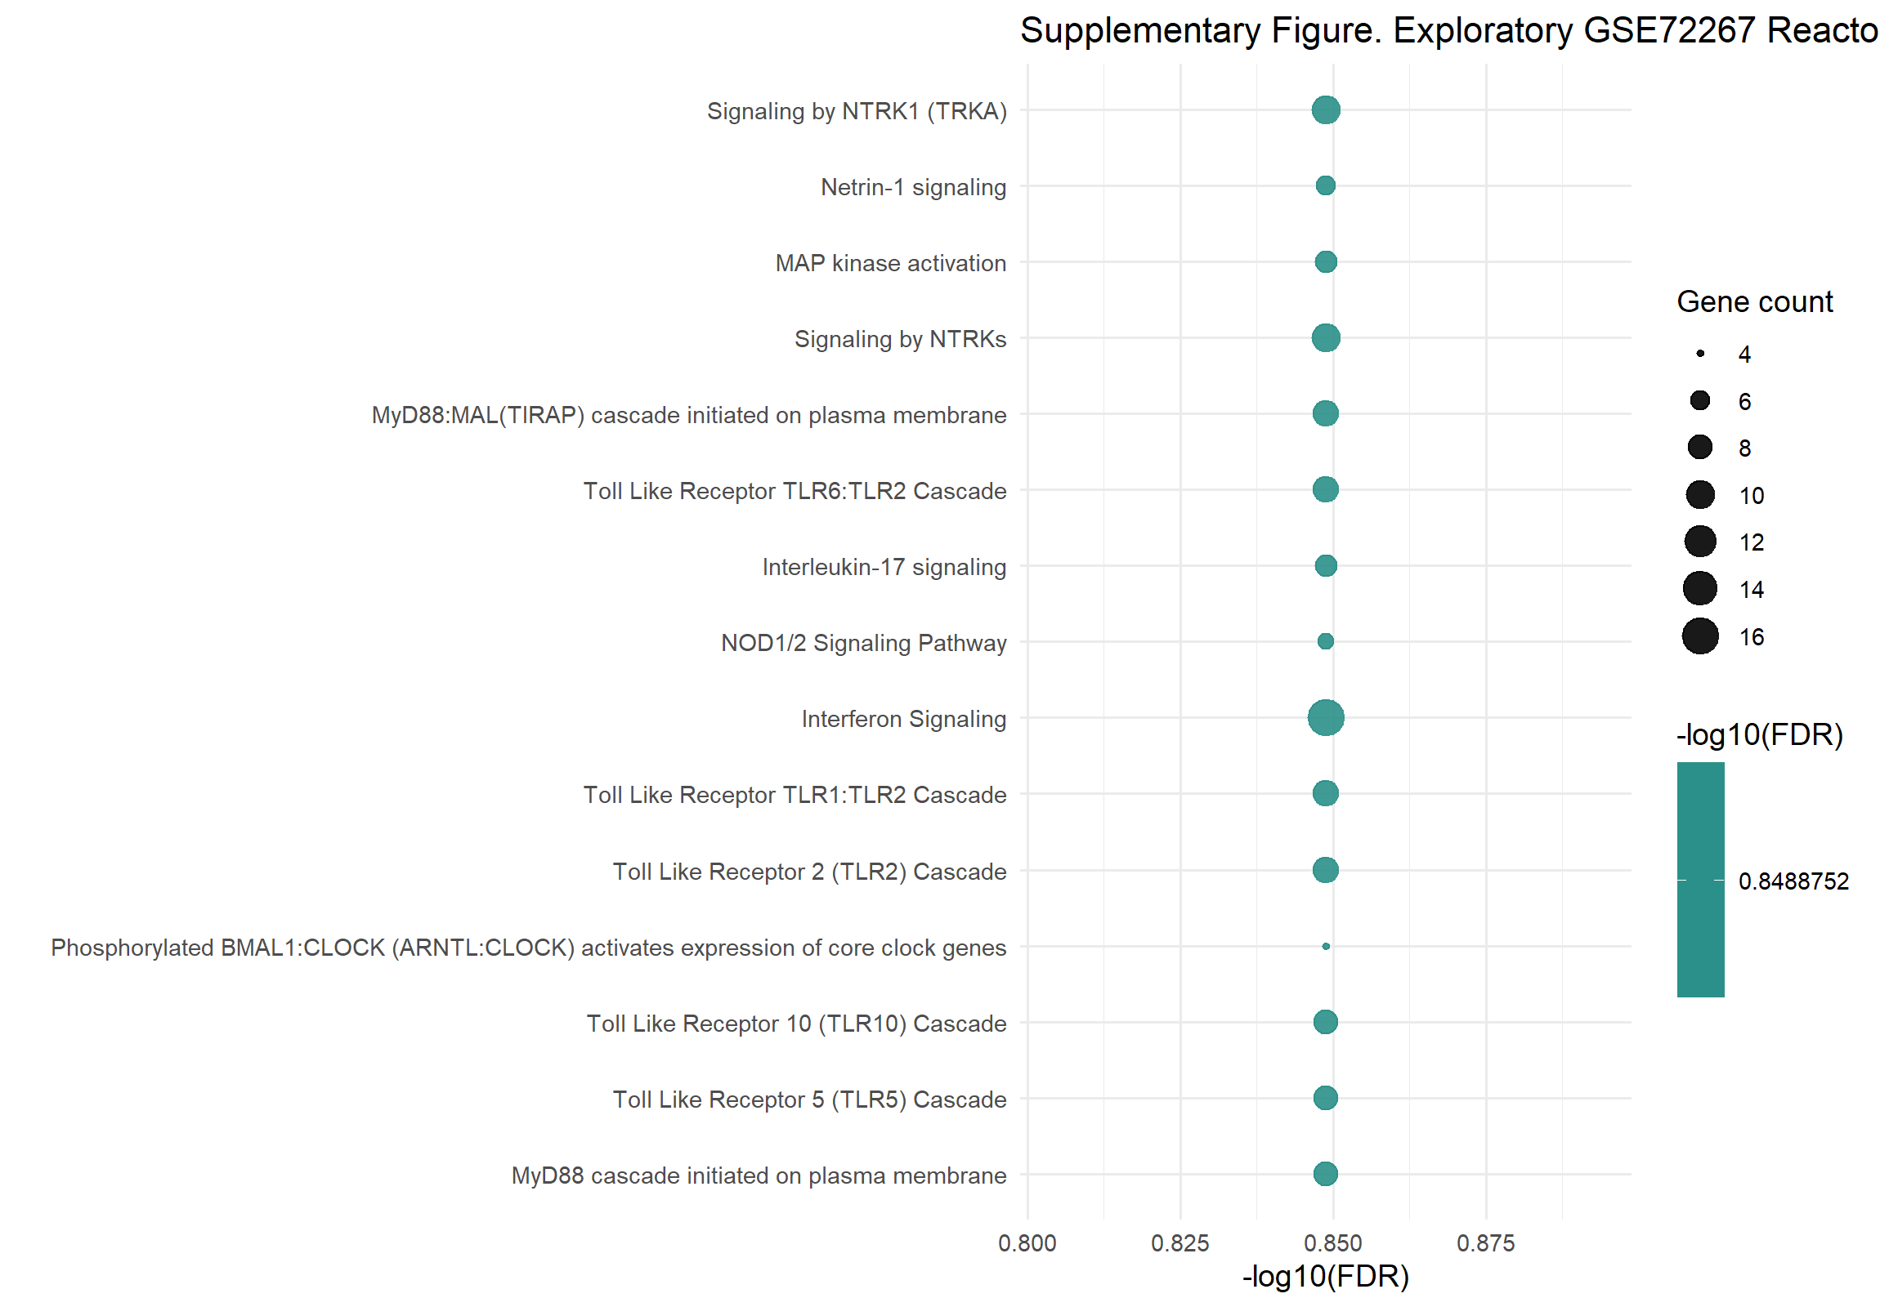

Supplementary Figure 5
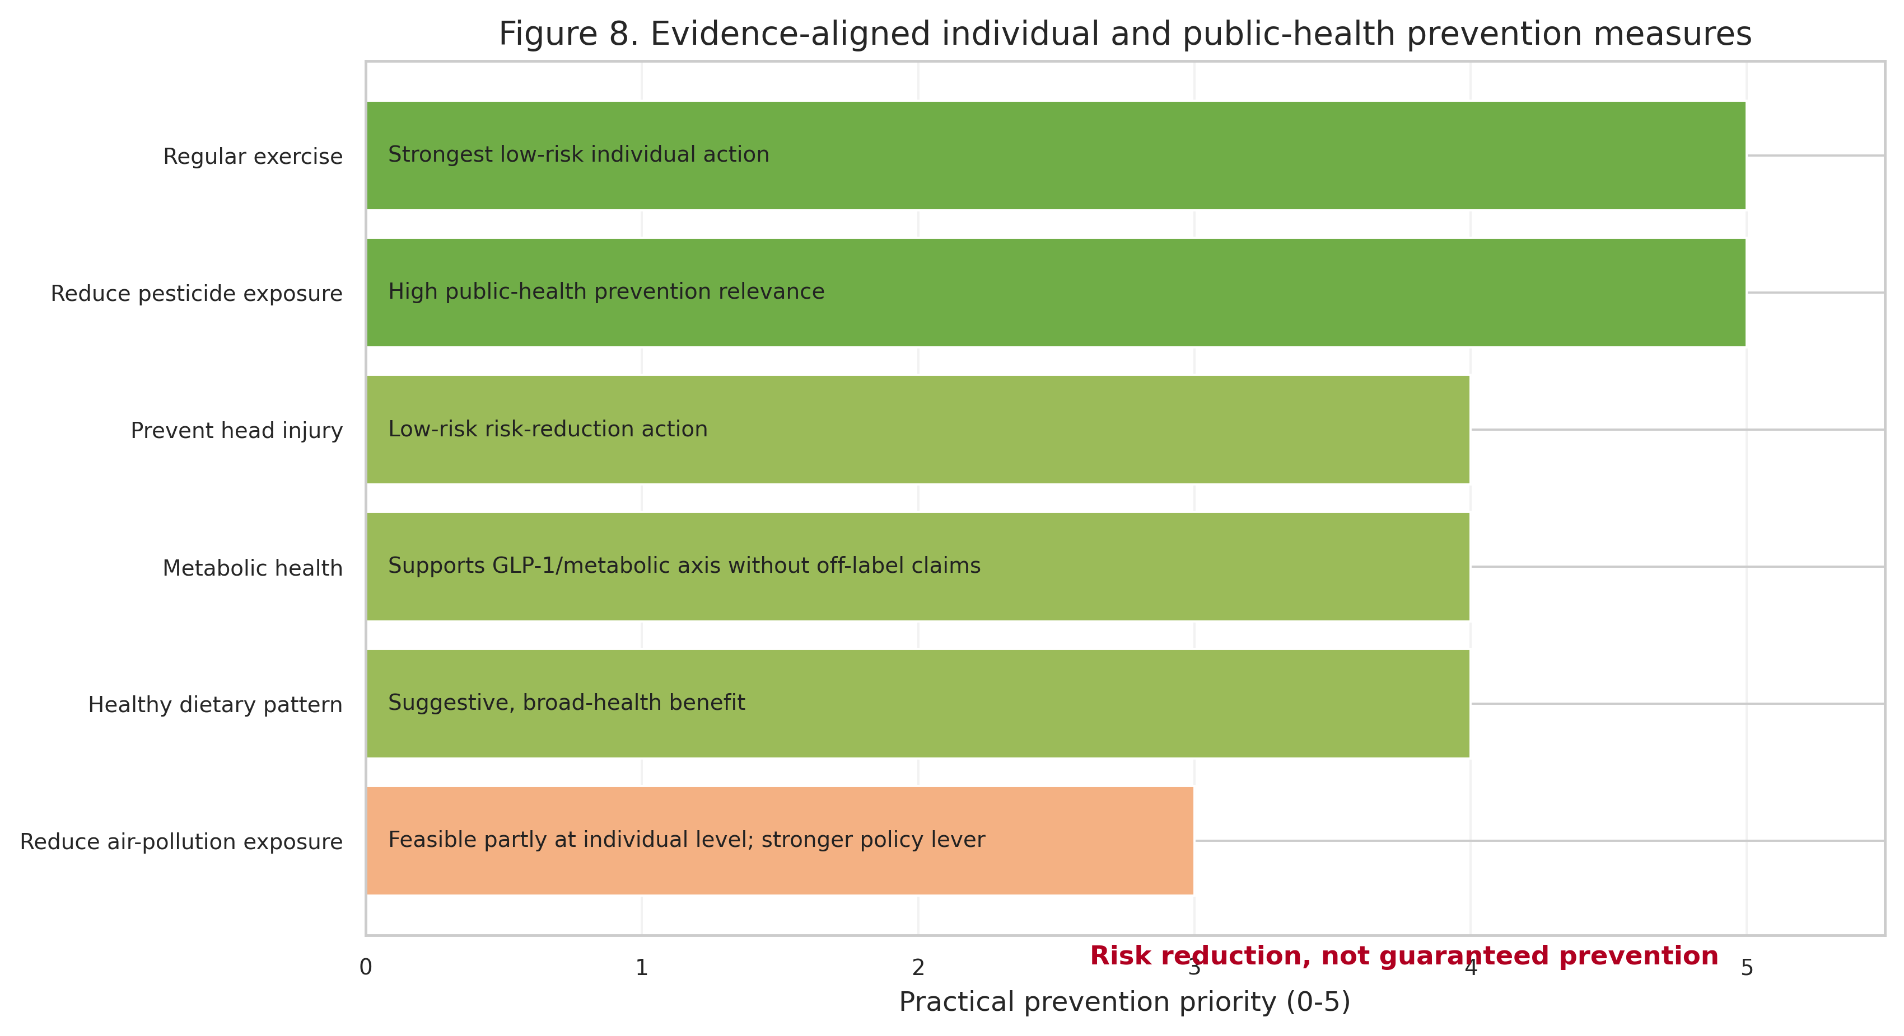

Supplementary Figure 6
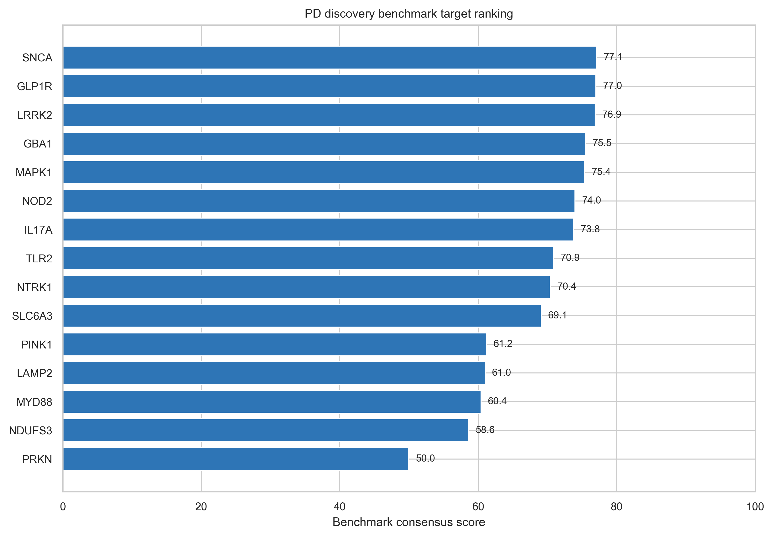

Supplementary Figure 7
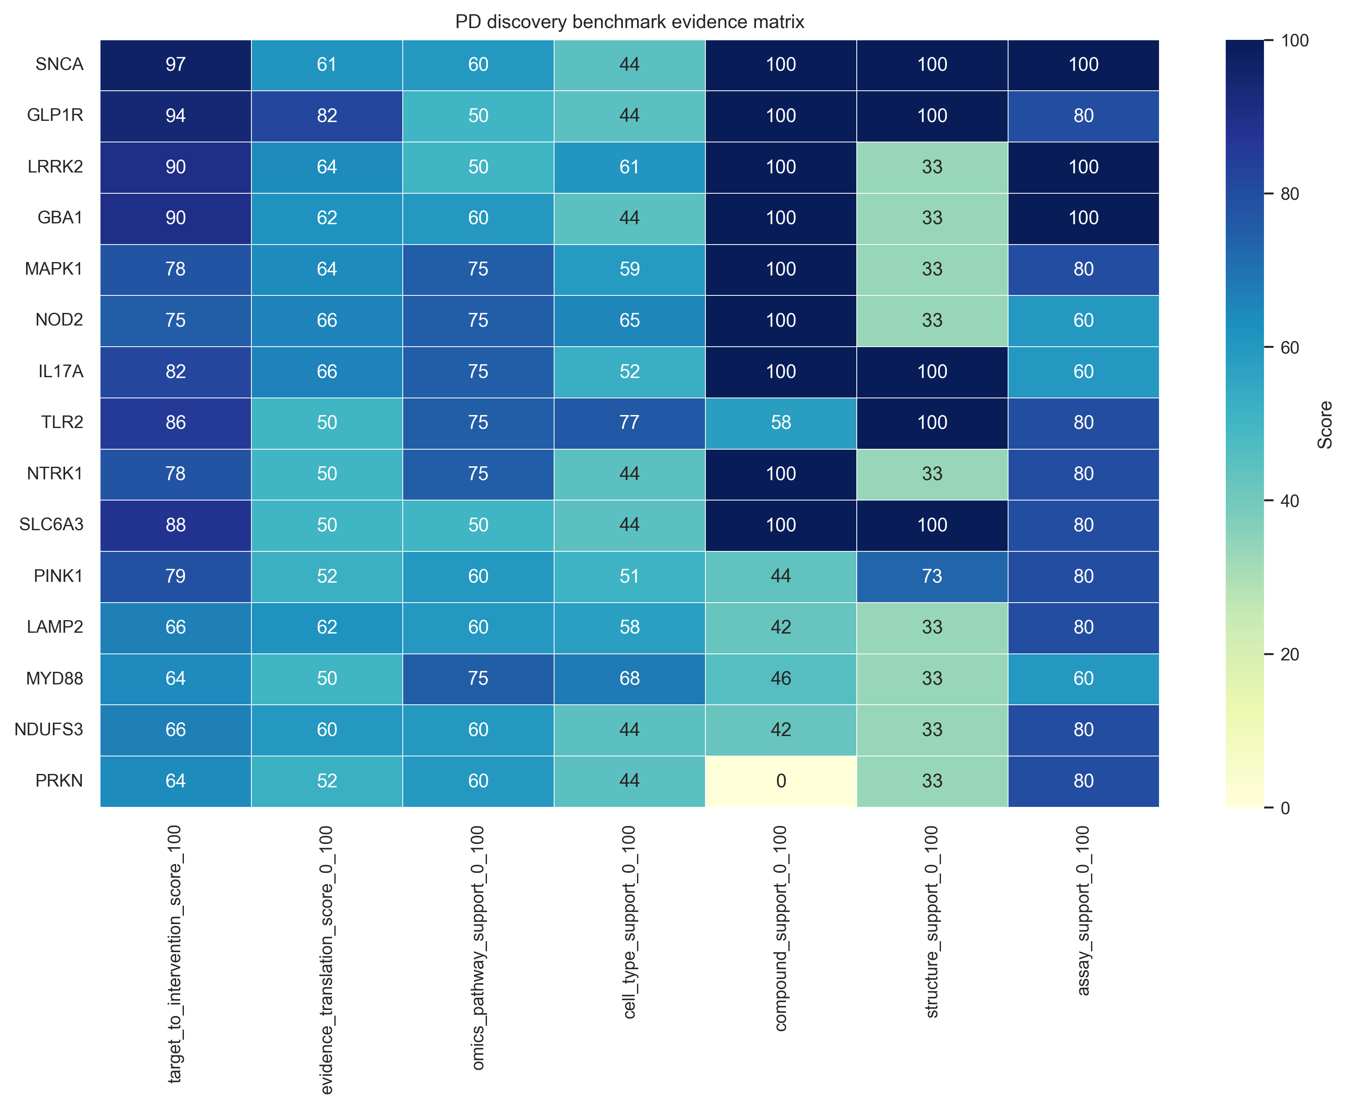

Supplementary Figure 8
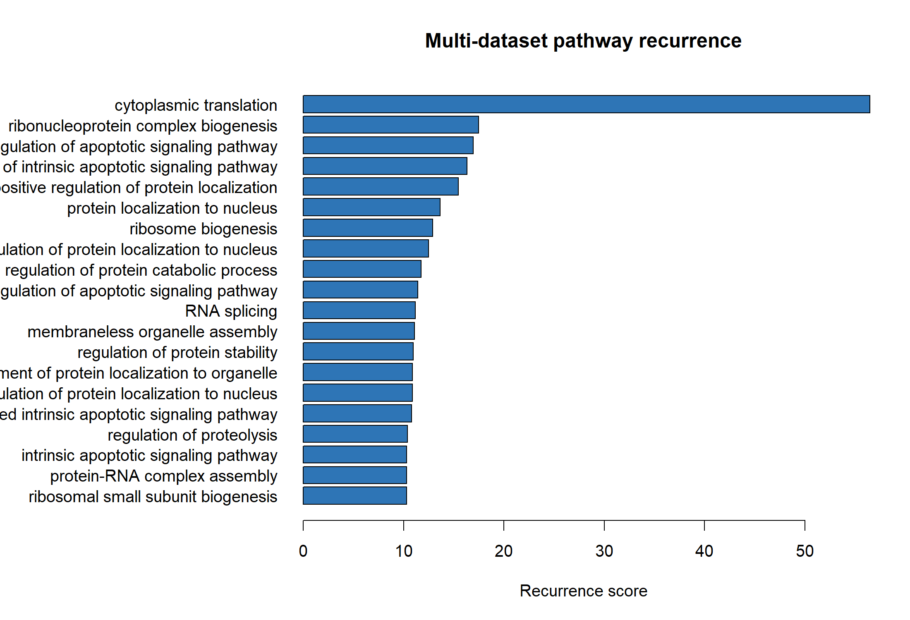

Supplementary Figure 9
