Figures
Manuscript. What a tuberculosis budget cannot see: fiscal invisibility and the limits of the WHO funding-gap indicator in India, 2017–2025
Figures are supplied separately as 600 dpi TIFF files for production; PNG previews are embedded below.

Figure 1
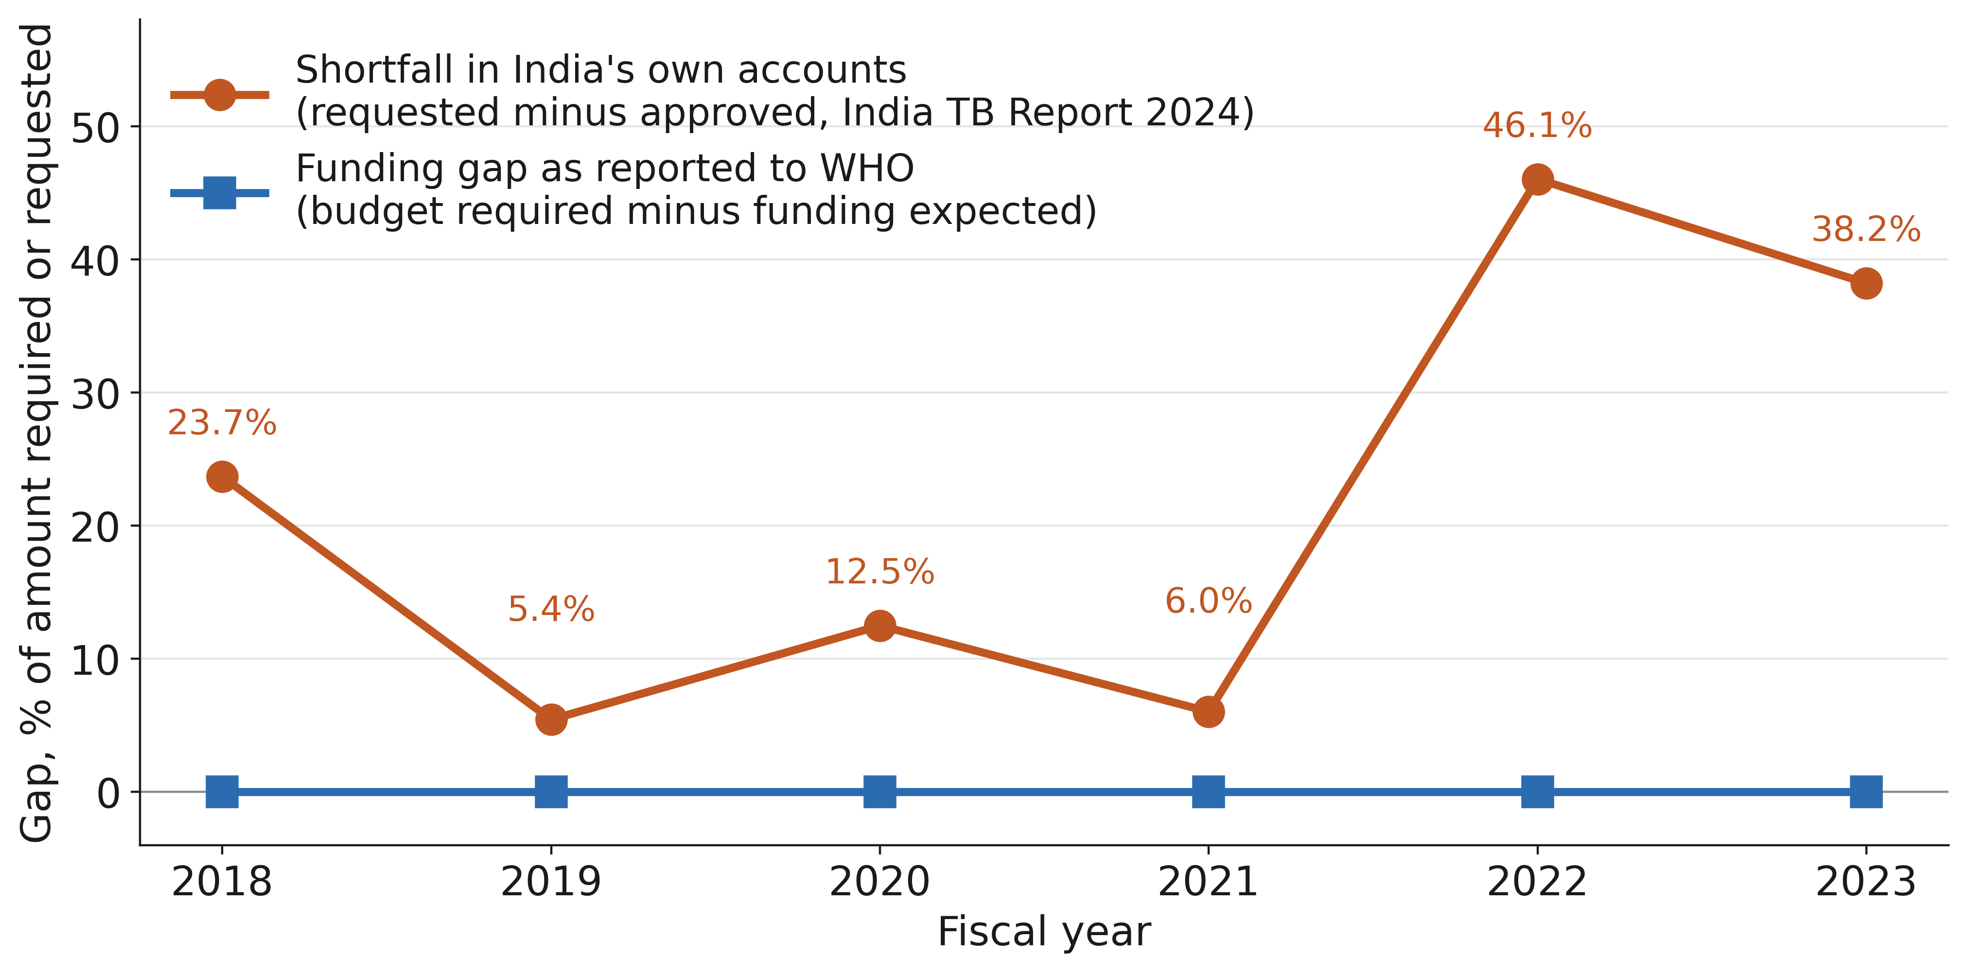
Figure 1. Two accounts of the same years. India’s funding gap as reported to WHO, against the shortfall recorded in India’s own programme accounts, 2018–2023. The WHO-reported gap is zero in every year because expected funding is reported equal to budget required; over the same years the national accounts record approvals falling short of requests by 5.4% to 46.1%. Values are percentages of the amount required (WHO) or requested (national accounts). National years are the first year of India’s April–March fiscal year (2018 denotes 2018–19); the WHO series is plotted by reporting year. Sources: WHO TB budget dataset [7] and India TB Report 2024, report table 16.1 [2].

Figure 2
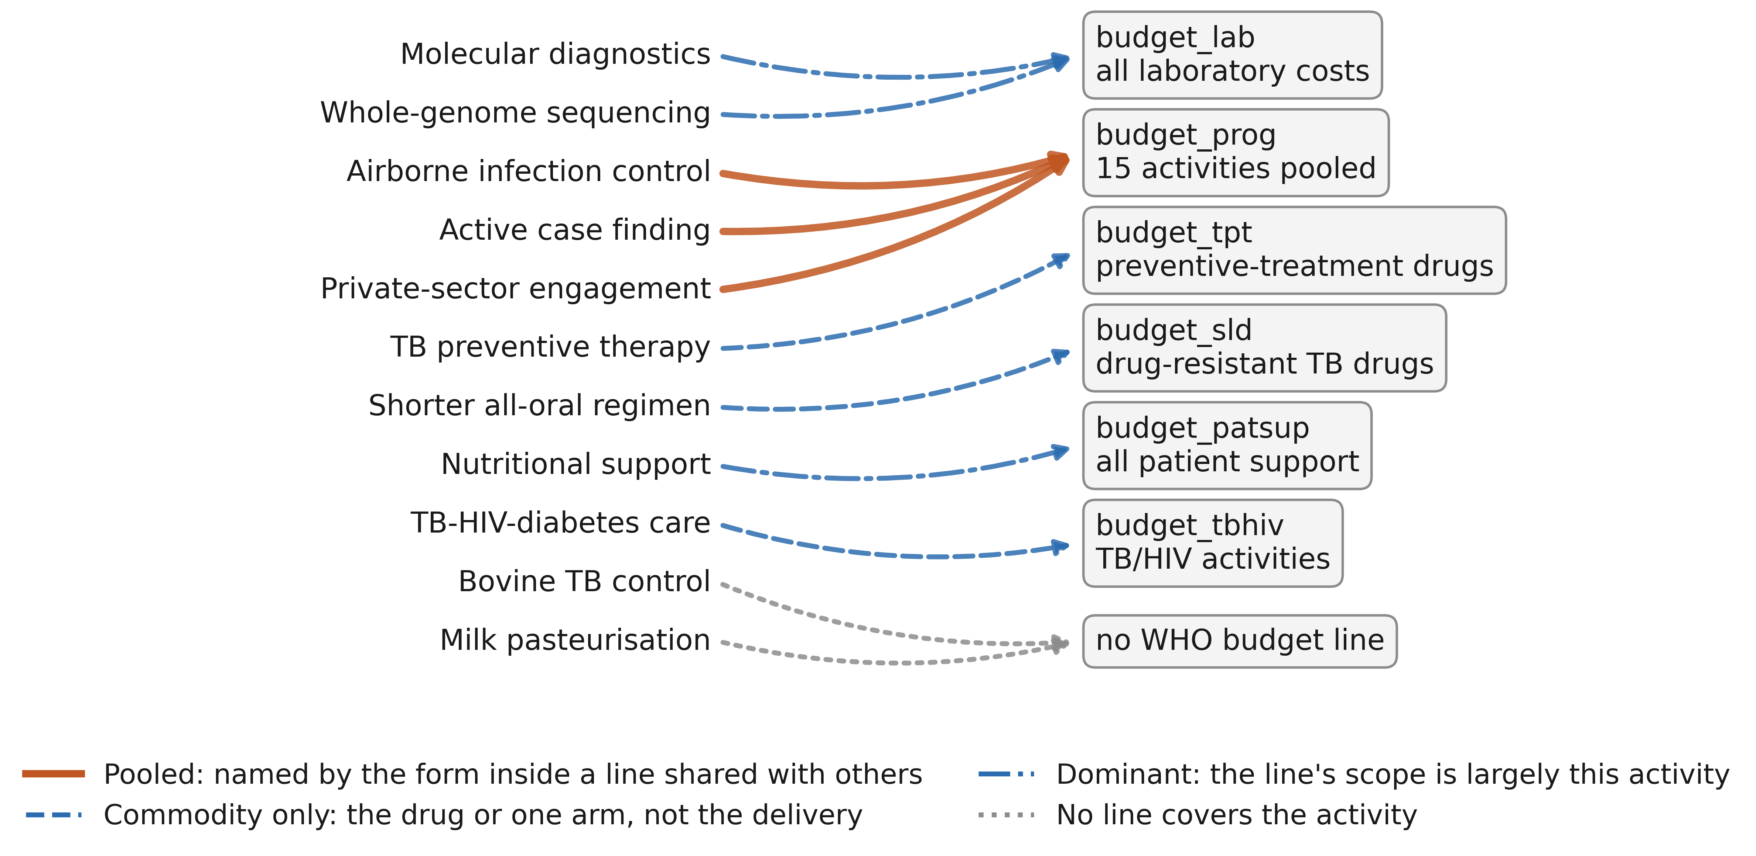
Figure 2. Where each intervention falls in WHO’s budget classification. Eleven TB interventions, in the order of Table 2, joined to the WHO budget line that covers them as judged against the data collection form [9]. Line style marks the condition of that coverage: pooled, where the form names the activity inside a line shared with many others; commodity only, where the line covers the drug or one arm but not the delivery; dominant, where the line is largely the activity though still shared; and no line. Three interventions converge on budget_prog, one figure pooling fifteen activities. No arrow ends at a line specific to its own intervention.

