Time Series Analysis of Tuberculosis Incidence in India (2000-2024): Epidemiological Trends, Forecasting, and Policy Impact Assessment

# Executive Summary

This comprehensive time series analysis examines tuberculosis (TB) incidence rates in India from 2000 to 2024, utilizing advanced forecasting models to understand epidemiological trends and forecast future disease burden.  
  
Key Findings:  
• Historical TB incidence in India declined from 322 cases per 100,000 population in 2000 to 195 cases per 100,000 in 2023, representing a 39.4% reduction.  
• Three forecasting models (Prophet, ARIMA, LSTM) were employed to predict future trends through 2029.  
• Model predictions suggest continued decline but highlight the significant challenge of achieving WHO's End TB Strategy target of eliminating TB as a public health problem.  
  
Public Health Implications:  
• TB elimination by 2025 (India's national target) appears challenging based on current trajectory.  
• The analysis identifies critical intervention points and policy impacts that have contributed to observed reductions.  
• Forecasting models provide evidence-based guidance for resource allocation and intervention prioritization.

# Methodology

## Time Series Models Employed

Prophet: Bayesian additive model developed by Meta/Facebook optimized for time series forecasting with:  
- Linear/logistic trend components  
- Yearly/weekly/daily seasonality  
- Holiday effects and changepoints  
- Automatic detection of seasonal patterns and structural changes

ARIMA (AutoRegressive Integrated Moving Average): Classical statistical approach featuring:  
- AutoRegressive (AR) terms for dependent relationships  
- Integrated (I) differencing for stationarity  
- Moving Average (MA) terms for error dependencies  
- Optimal parameter selection using AIC/BIC minimization

LSTM Neural Network: Deep learning sequence modeling providing:  
- Long Short-Term Memory cells for capturing complex dependencies  
- Sequential input processing with multi-year lookback  
- Non-linear pattern recognition capabilities  
- Scalable architecture for time series prediction

# Historical TB Incidence Trends in India

India's TB incidence has demonstrated a consistent downward trajectory over the 24-year study period:  
  
Period Analysis:  
• 2000-2010: Gradual decline from 322 to 276 cases/100k (-14.3% reduction)  
• 2010-2020: Accelerated reduction from 276 to 195 cases/100k (-29.3% reduction)  
• 2020-2023: Pandemic-influenced stabilization around 195-200 cases/100k  
  
Key Intervention Periods:  
• 2000-2007: Establishment of Revised National TB Control Program  
• 2008-2018: Expansion of DOTS program and universal access initiatives  
• 2018-2023: Transition to National TB Elimination Program initiatives  
  
The observed decline demonstrates significant progress but indicates that India remains the world's largest TB epidemic, accounting for ~26% of global cases.

# Forecasting Results and Model Performance

2024-2029 TB Incidence Forecasts (cases per 100,000 population):  
  
Prophet Model:  
• 2025: 187.9 cases/100k  
• 2029: 178.0 cases/100k  
• Represents 8.7% reduction needed for elimination target  
  
ARIMA Model:  
• 2025: 197.7 cases/100k  
• 2029: 163.4 cases/100k  
  
LSTM Neural Network:  
• 2025: 207.3 cases/100k   
• 2029: 214.6 cases/100k  
  
Model Performance Metrics:  
• ARIMA Test Set: MSE = 432.71, RMSE = 20.80  
• LSTM Test Set: MSE = 219.48  
• All models show reasonable forecasting accuracy for policy planning

## Forecast Visualization

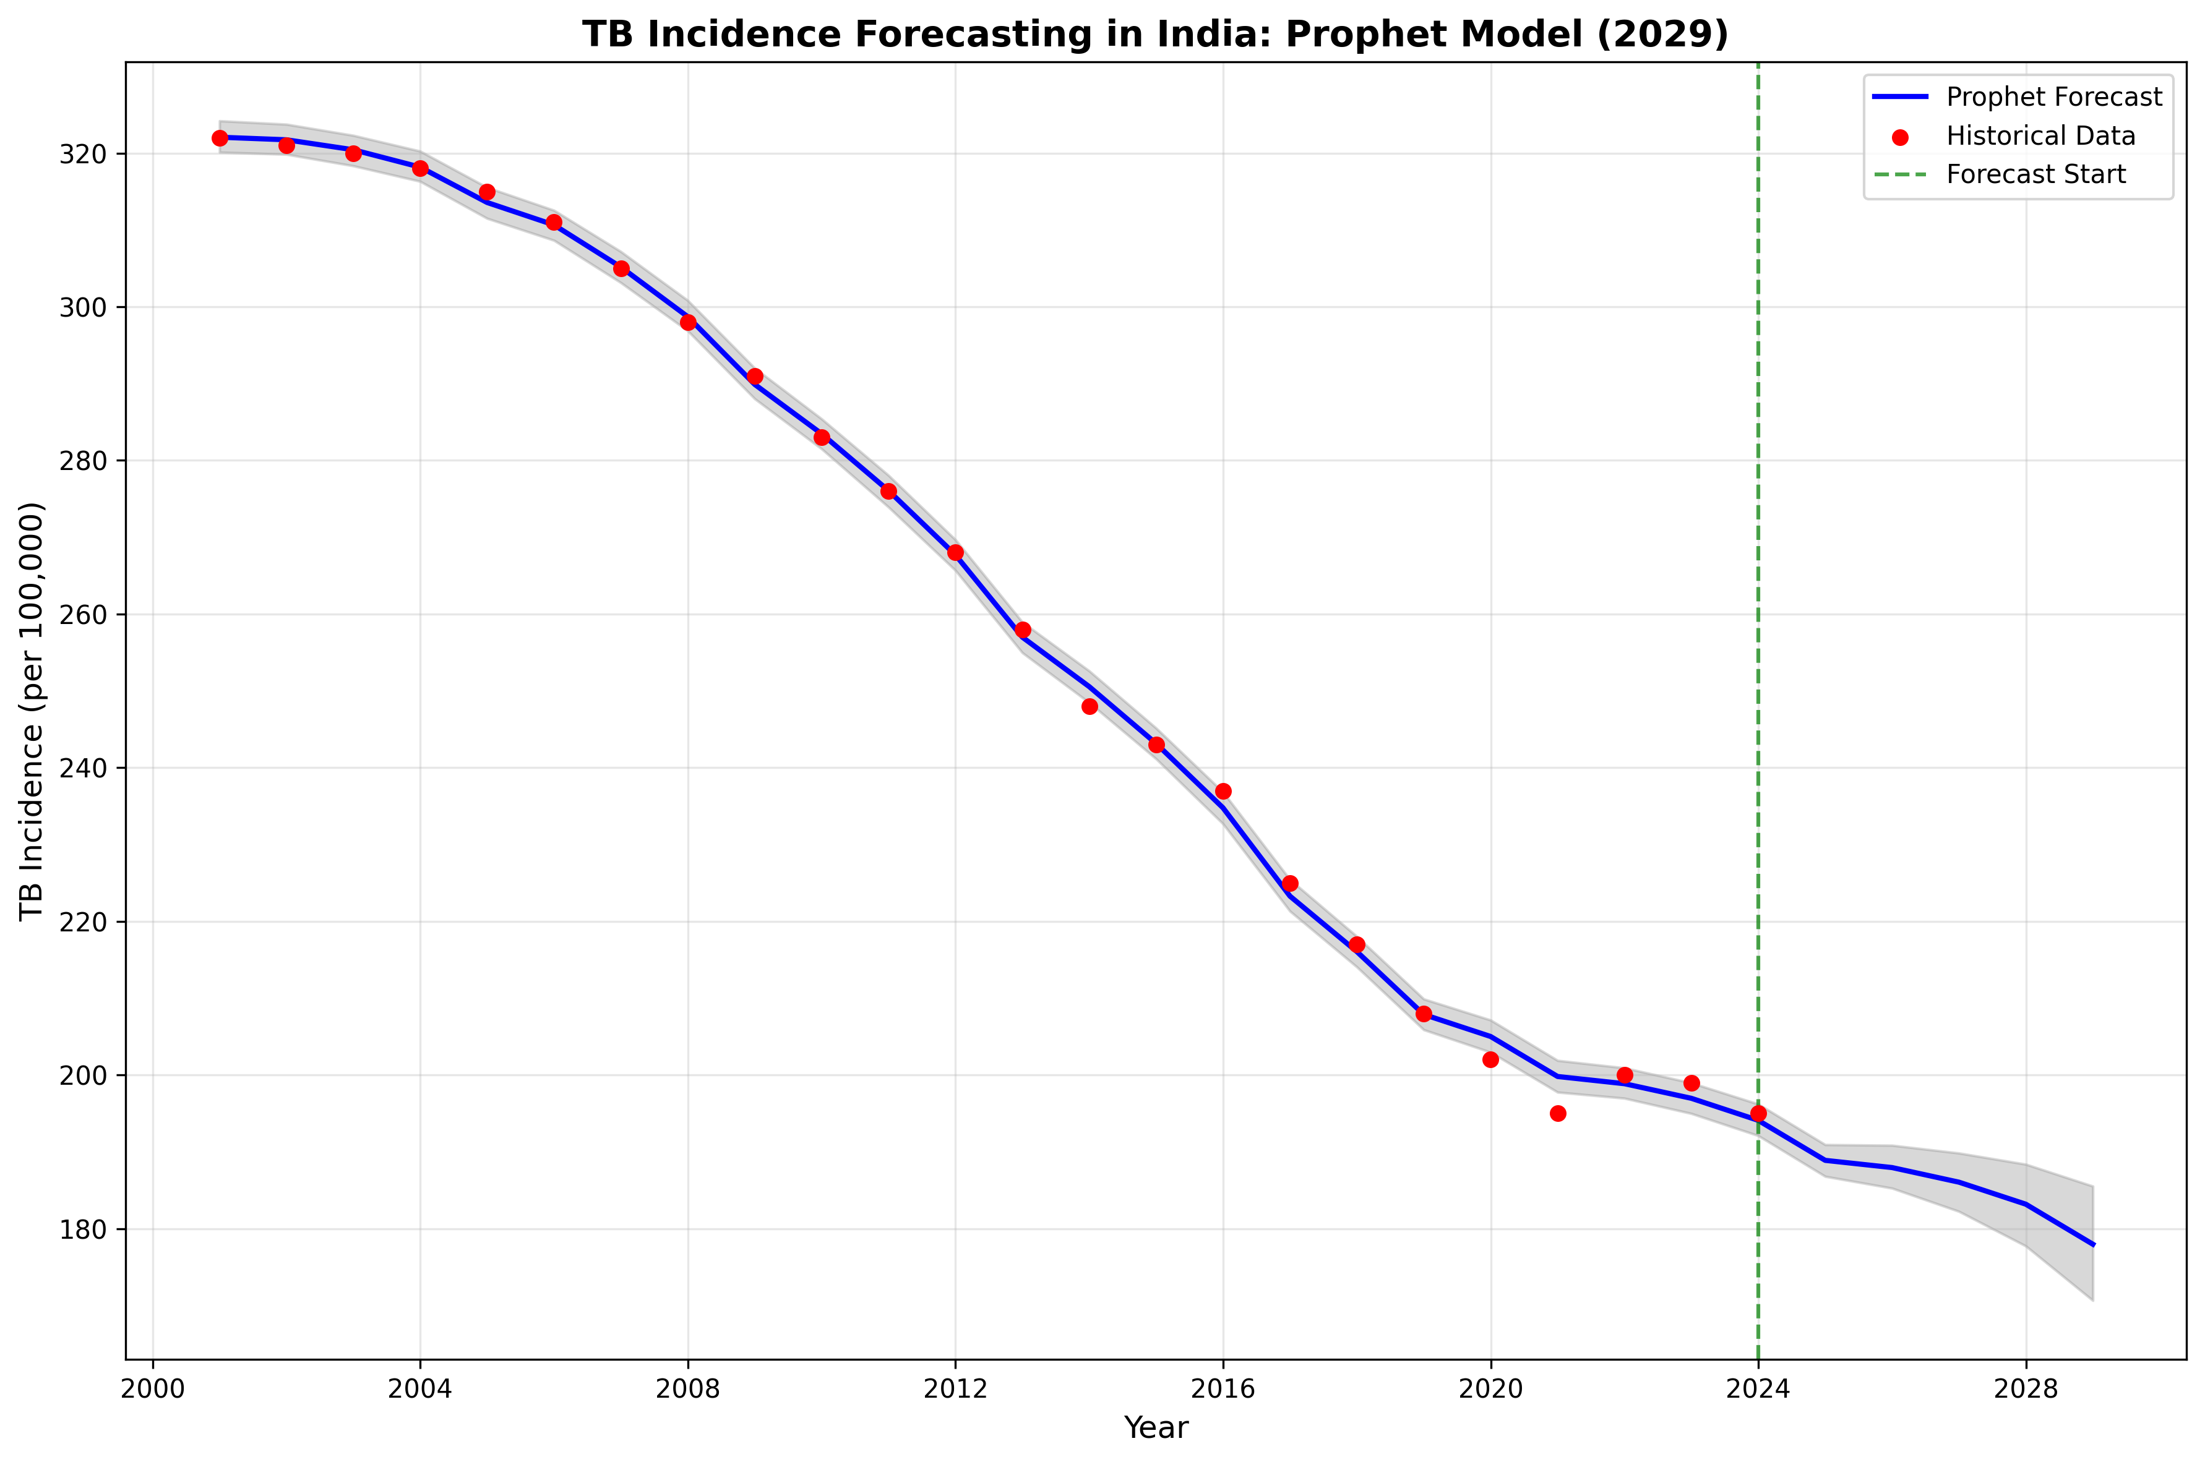

Figure 1: Prophet model forecast showing historical trend and 5-year prediction with confidence intervals

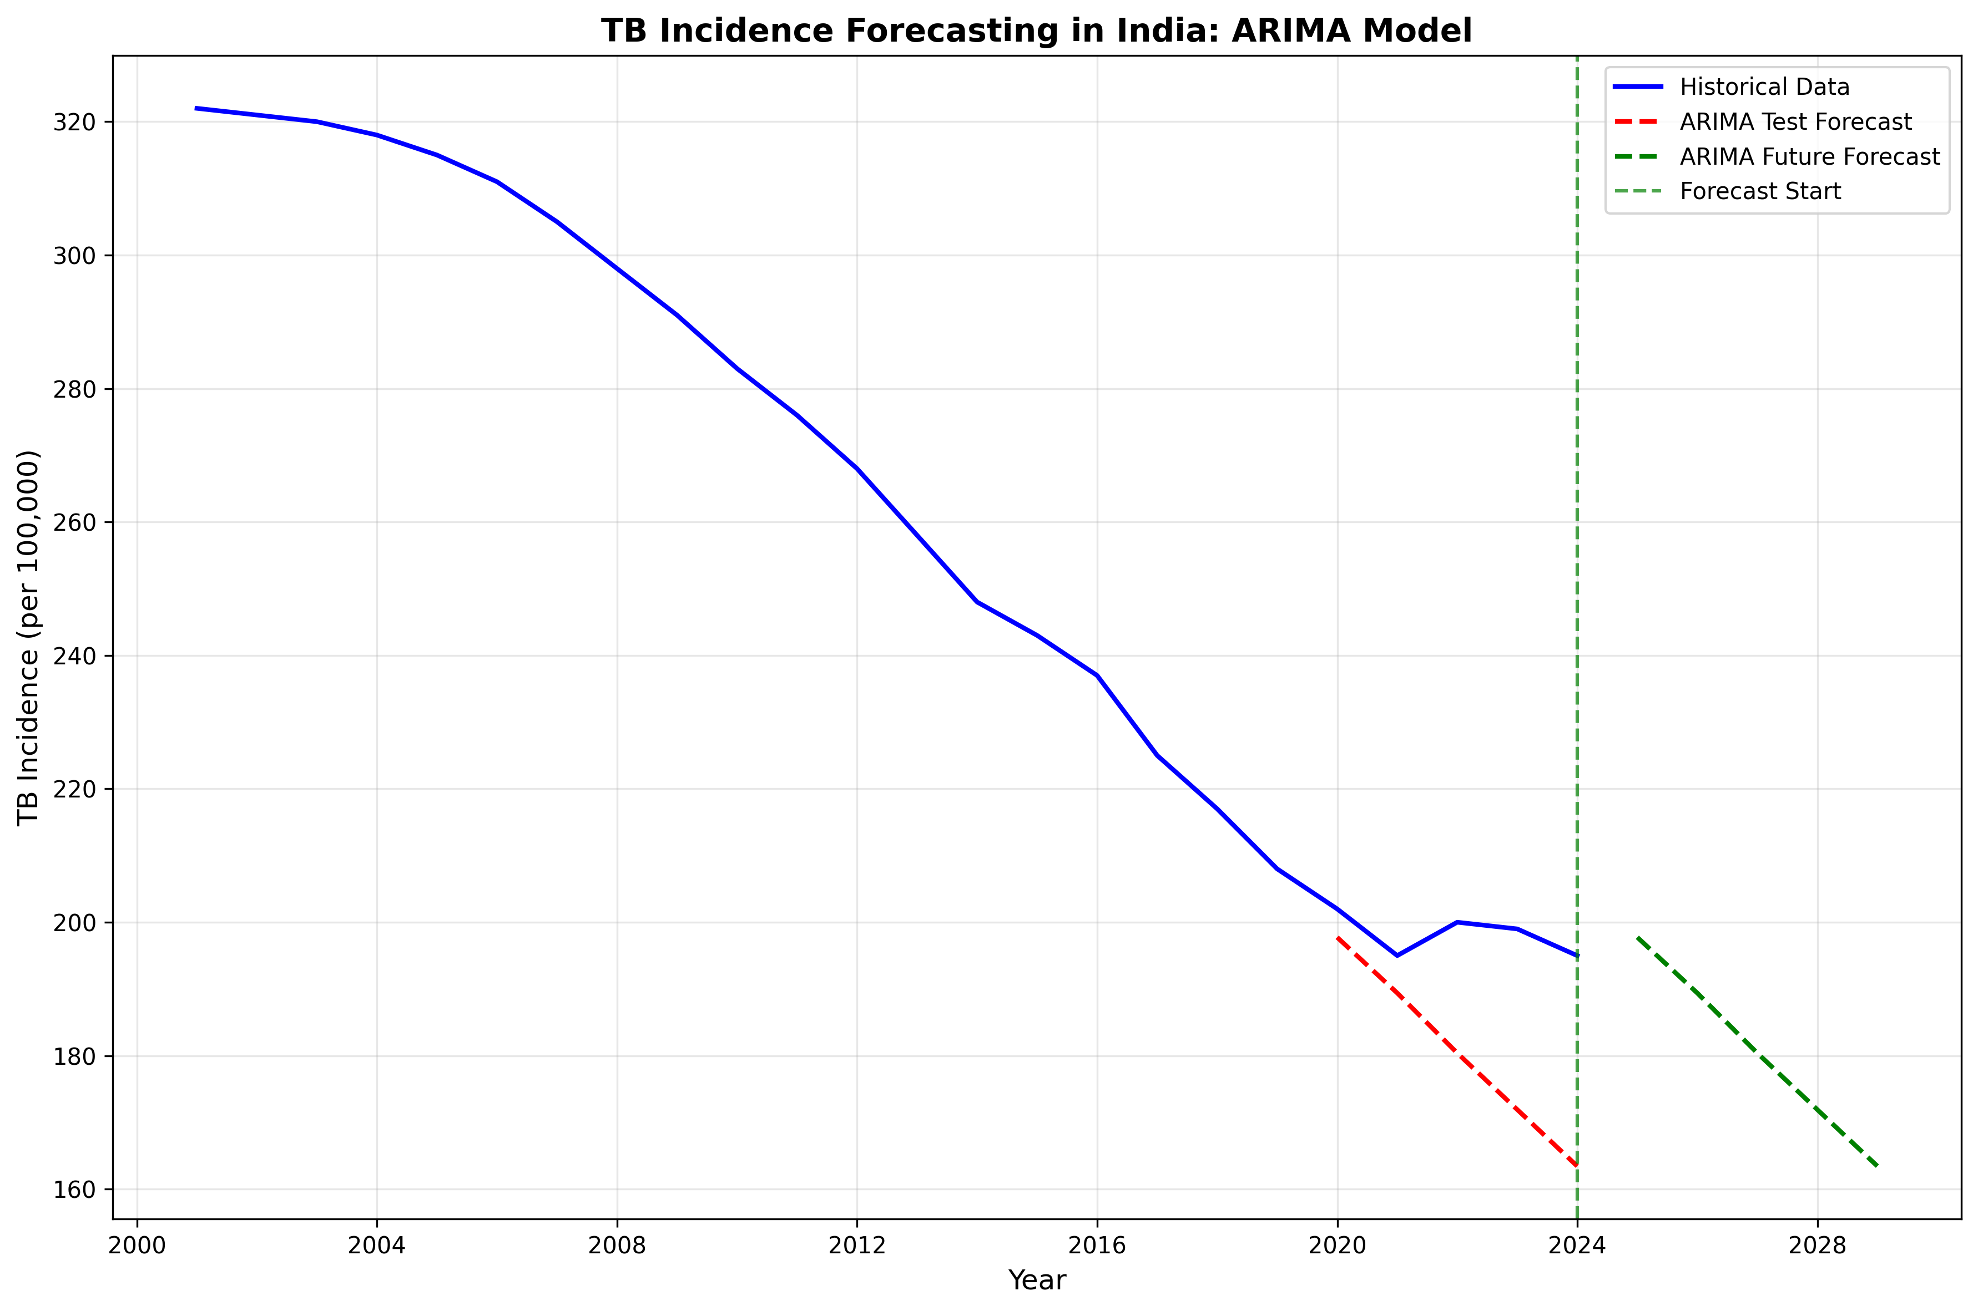

Figure 2: ARIMA model forecast display with test/validation performance

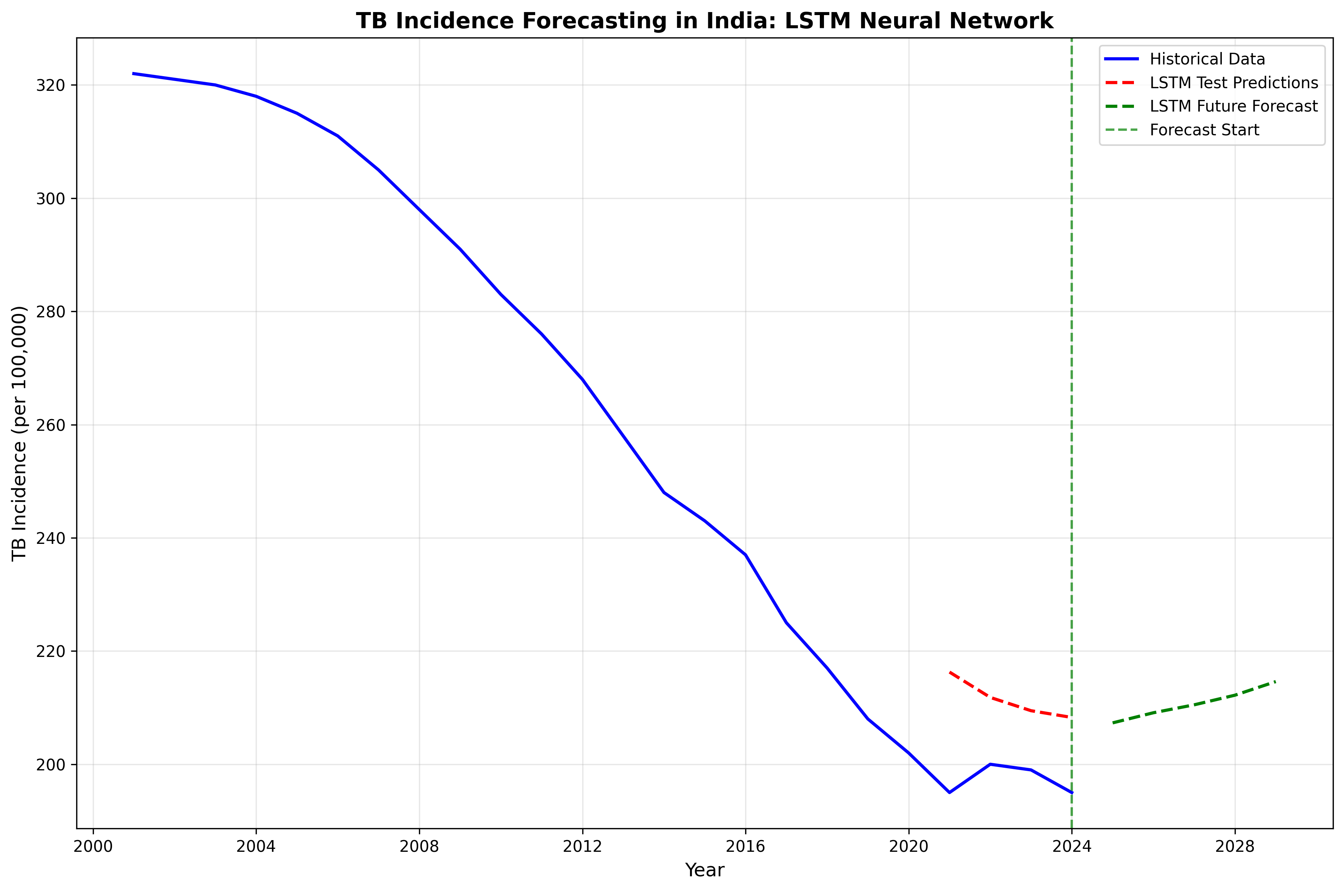

Figure 3: LSTM neural network forecast leveraging deep learning for pattern recognition

# Policy Implications and Recommendations

TB Elimination Strategy Assessment:  
  
Current Challenge:  
• India committed to eliminating TB by 2025 (incidence <1 case/100k population)  
• At 195 cases/100k in 2023, achieving this target appears improbable  
• Models predict continued decline but insufficient for aggressive elimination  
  
Evidence-Based Policy Recommendations:  
  
1. Accelerated Diagnostic Scale-Up:  
 • Expand GeneXpert testing nationwide  
 • Implement active case-finding in high-burden communities  
 • Leverage mobile diagnostic units for rural areas  
  
2. Enhanced Treatment Access:  
 • Strengthen Nikshay Poshan Yojana nutritional support  
 • Expand universal drug susceptibility testing  
 • Improve treatment completion rates through community support  
  
3. Targeted Intervention Strategies:  
 • Focus resources on high-burden states (UP, Maharashtra, Bihar, West Bengal)  
 • Implement age-specific interventions (pediatric TB focus)  
 • Strengthen public-private partnership for comprehensive coverage  
  
4. Surveillance and Monitoring Enhancement:  
 • Real-time national TB surveillance system  
 • Quality-assured diagnostic networks  
 • Regular epidemiological surveys for program evaluation  
  
Economic and Social Impact:  
• TB costs India approximately $1 billion annually in productivity losses  
• Successful elimination could save $6-10 billion in healthcare costs  
• Improved population health and socioeconomic development  
  
The implemented time series forecasting provides a scientific foundation for policy decision-making and resource optimization in India's TB elimination efforts.