Time Series Forecasting Report

This report presents automated time series analysis and forecasting using Prophet, ARIMA, and LSTM models.

Dataset length: 98 observations

ARIMA Mean Squared Error: 594.25

# Prophet Forecast

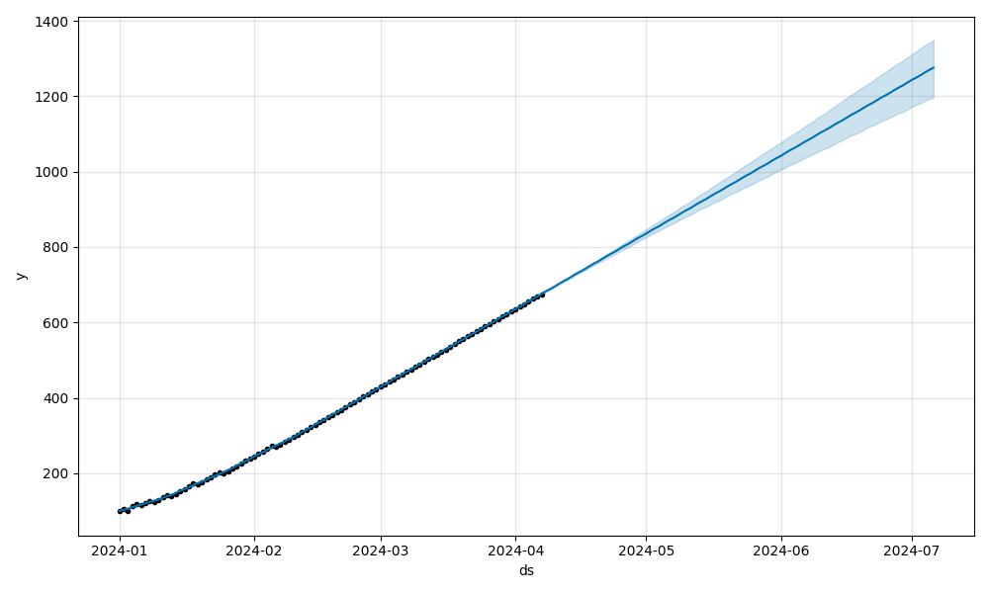

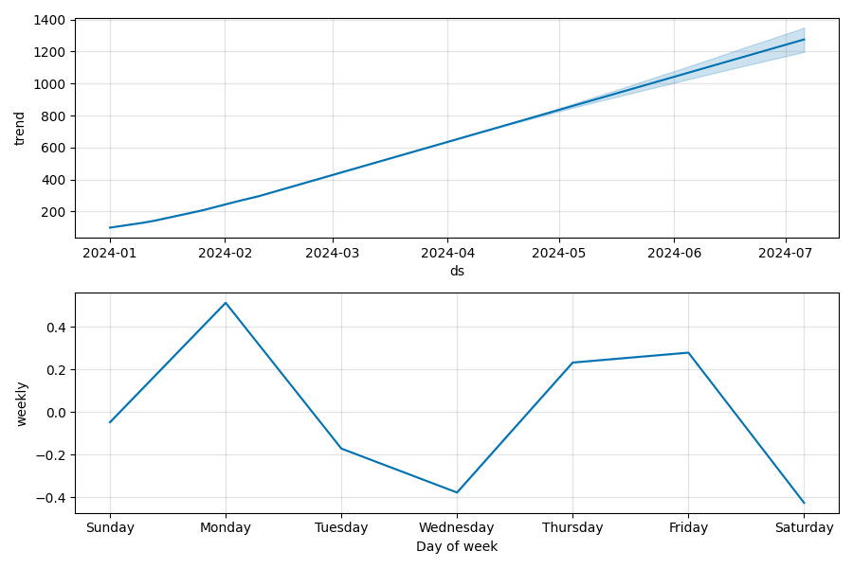

# ARIMA Forecast

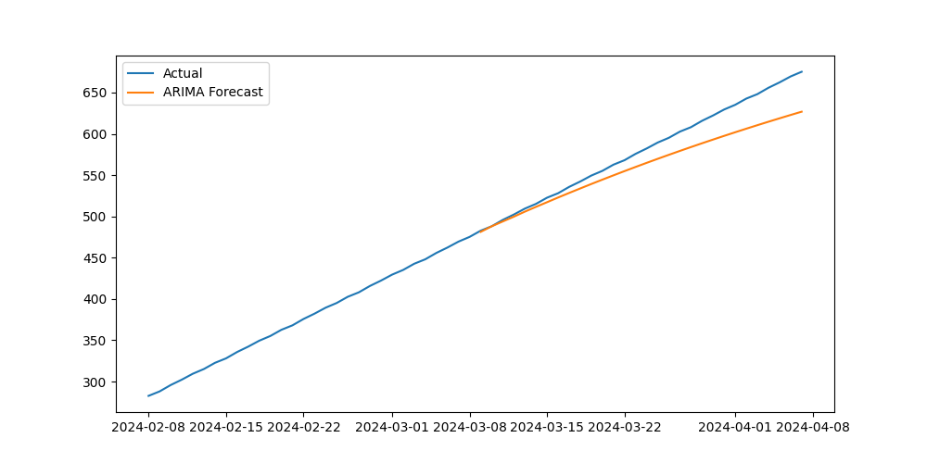

# LSTM Forecast

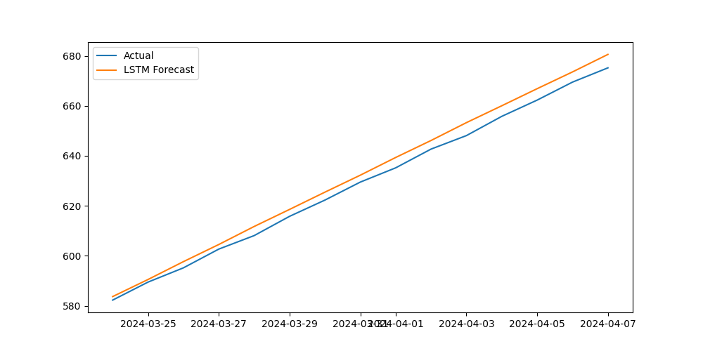

# Interpretation

The Prophet model captures trend and seasonality effectively. ARIMA provides a strong baseline for short-term forecasting, while the LSTM model adapts to complex nonlinear patterns. Comparison of MSE suggests ARIMA is useful for stable series, while LSTM may outperform when long-term dependencies exist. Prophet is highly interpretable and well-suited for business/health forecasting.