Figures and legends

Figure 1
Federated operating model for patient safety surveillance in India.
The surveillance model is organized across facility, state, and national layers. Daily operational surveillance and event-level learning cases originate at facility level. State surveillance cells perform aggregation, signal review, and escalation. National governance functions synthesize trends, policy implications, and benchmarking outputs. 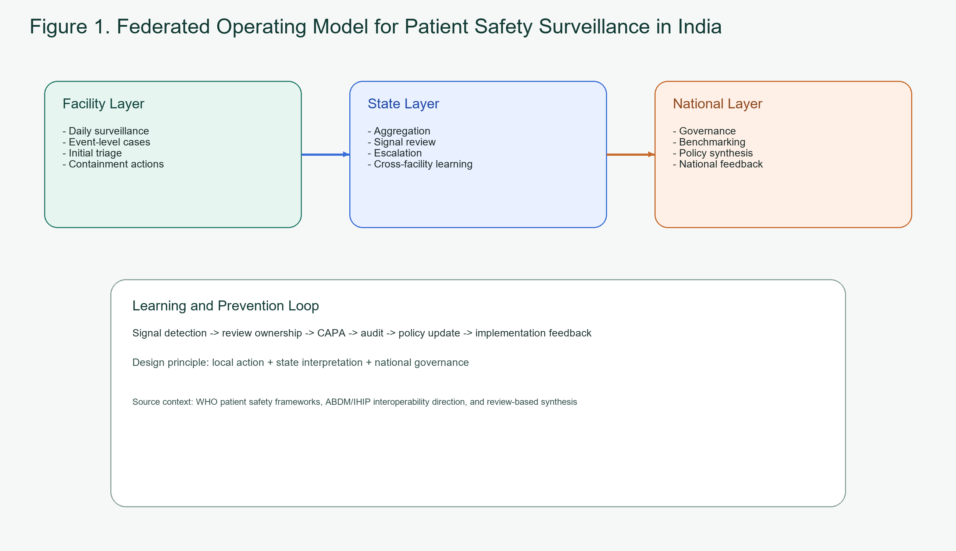

Figure 2
Unified data and learning flow.
Manual submissions, digital system events, and future machine-detected signals flow into a common safety intelligence layer. Triage, investigation, CAPA, analytics, AI assistance, and governance review operate on the normalized event stream, allowing both local action and system-level learning. 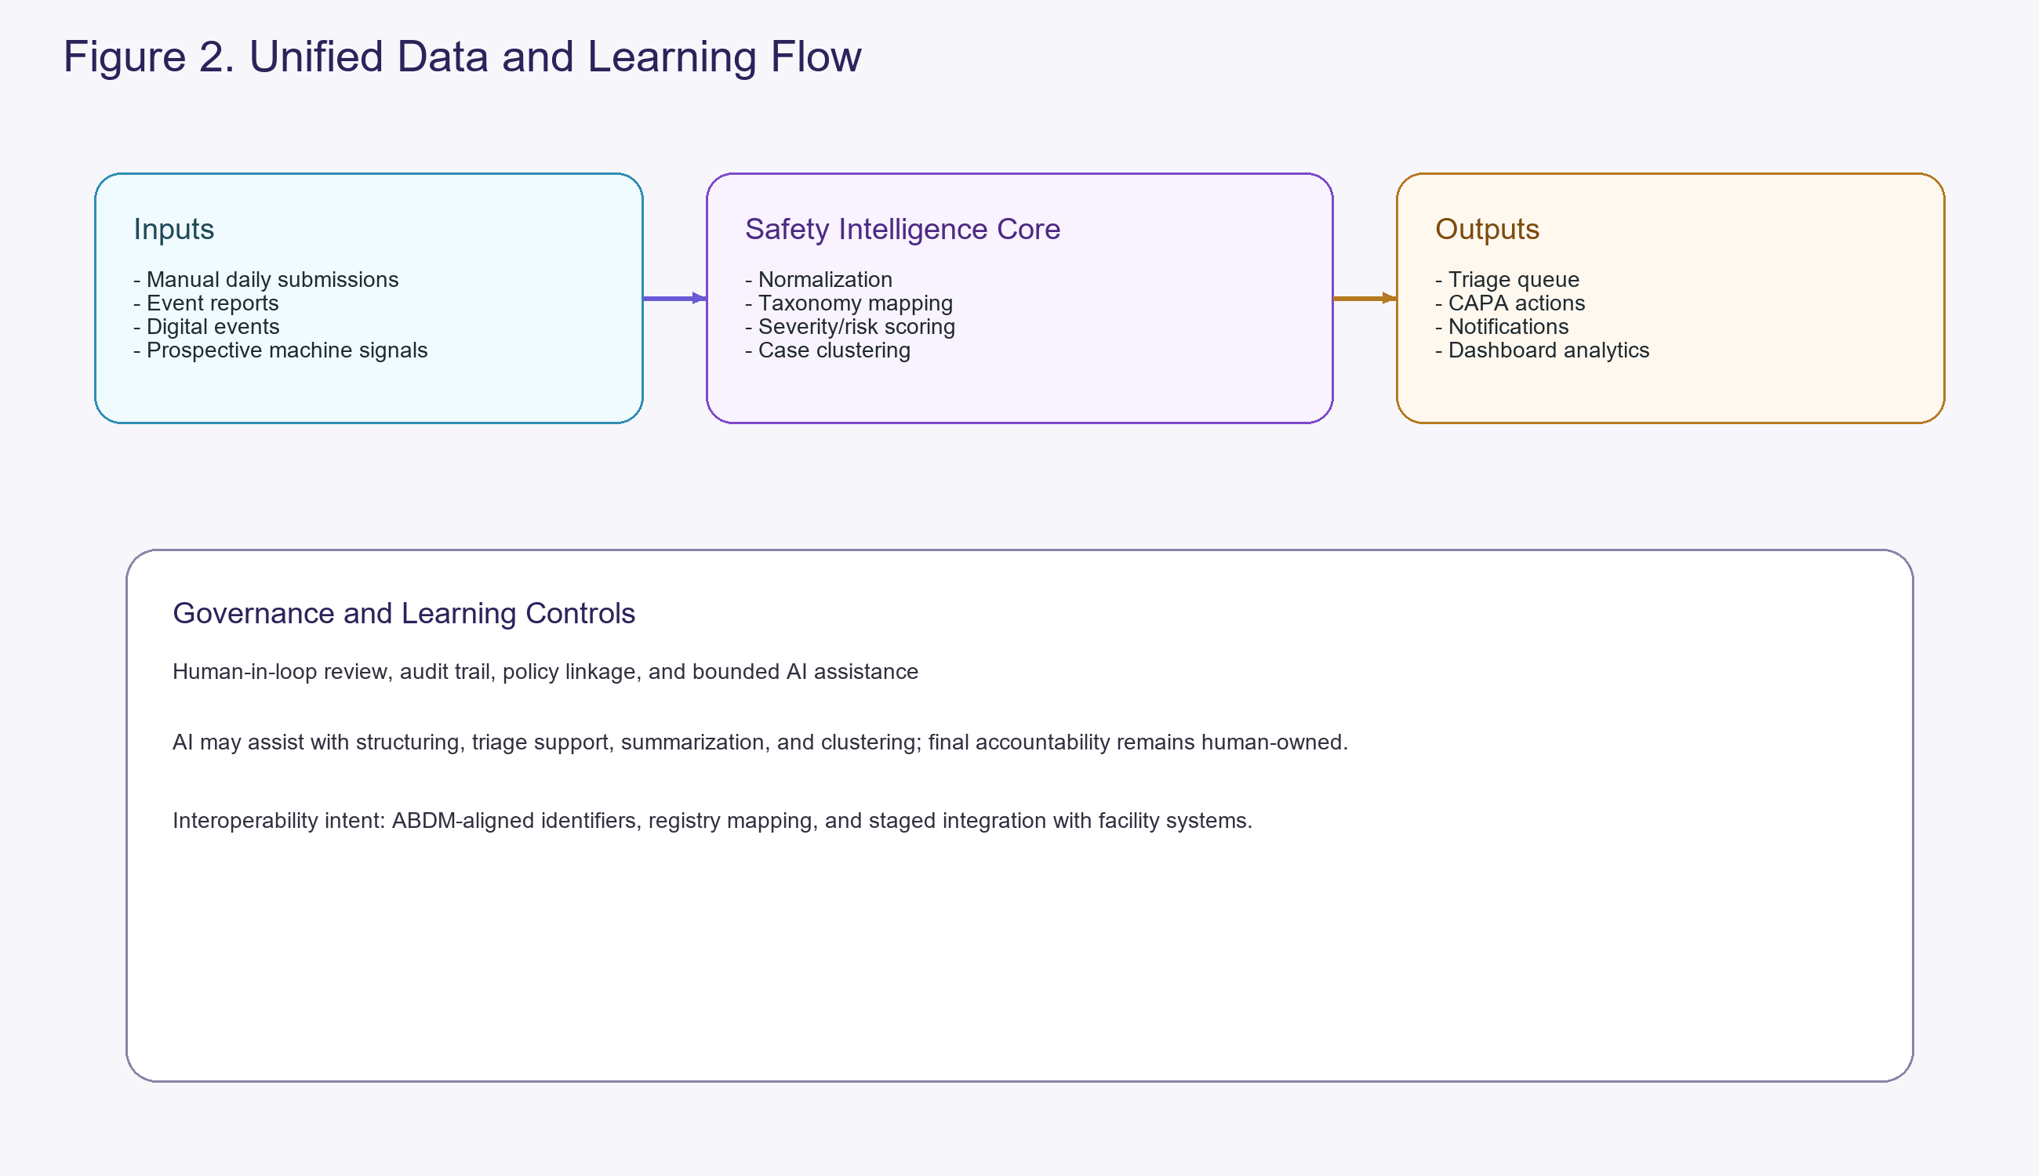

Graphical abstract
Integrated report-review-learn-govern cycle for federated patient safety surveillance in India.
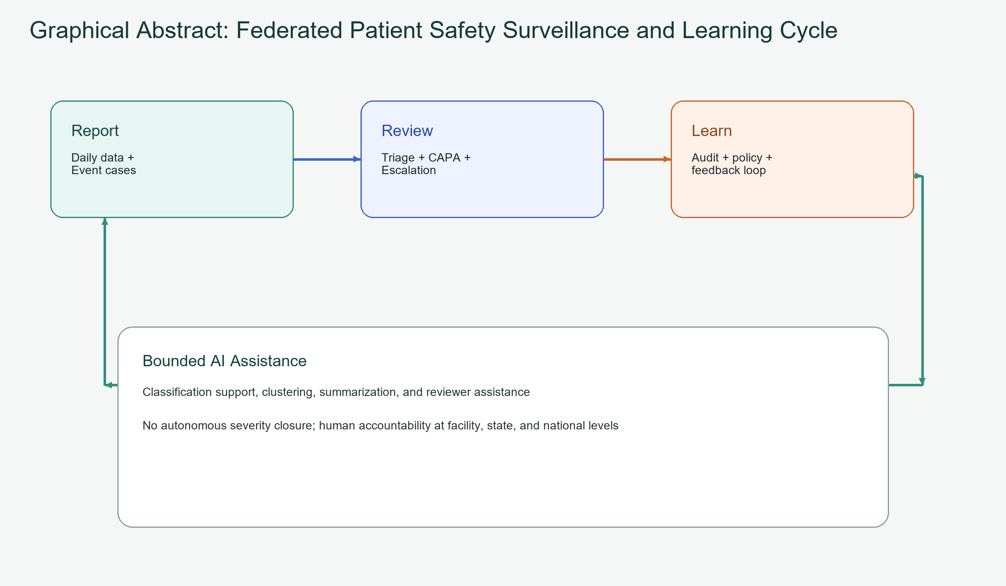
Graphical abstract. Federated patient safety surveillance and learning cycle

