OmicsClaw-Informed Extension Analyses
This supplement summarizes two additional analysis layers inspired by OmicsClaw bulk-RNA workflows: marker-based NNLS deconvolution and WGCNA-style coexpression analysis.
These outputs are intended to add biological context to the advanced tuberculosis progression manuscript. They should be interpreted as supportive analyses rather than stand-alone validation of mechanism.

Immune Deconvolution
A conservative NNLS framework was applied using canonical blood-cell marker genes present in the shared-gene matrix. The resulting coefficients are best interpreted as relative composition proxies.
Supplementary Table A1. NNLS-derived cell-type score summary.
Cell type | Mean progressor | Mean non-progressor | Delta | p value
Monocyte | 0.183 | 0.148 | 0.035 | 0.0
T_cell | 0.156 | 0.19 | -0.034 | 0.0
Platelet | 0.177 | 0.144 | 0.033 | 0.0
B_cell | 0.163 | 0.19 | -0.027 | 0.0
NK_cell | 0.138 | 0.169 | -0.03 | 0.0
Neutrophil | 0.183 | 0.16 | 0.023 | 0.0

Supplementary Figure A1. Mean NNLS cell-type scores by progressor status.
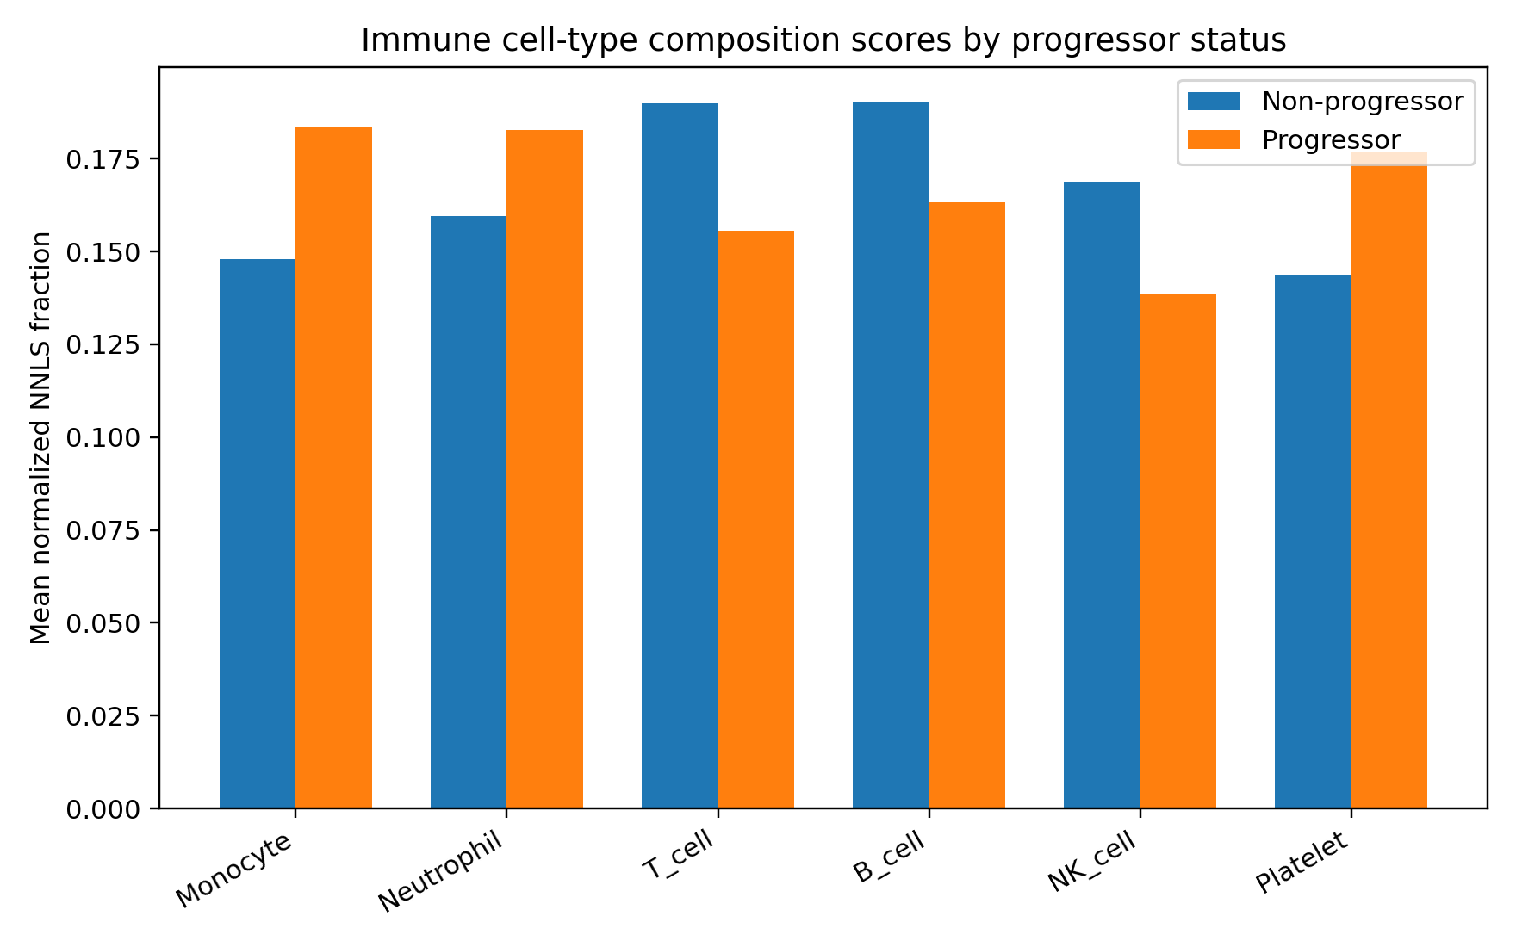

Supplementary Figure A2. Distribution of NNLS cell-type scores across progressors and non-progressors.
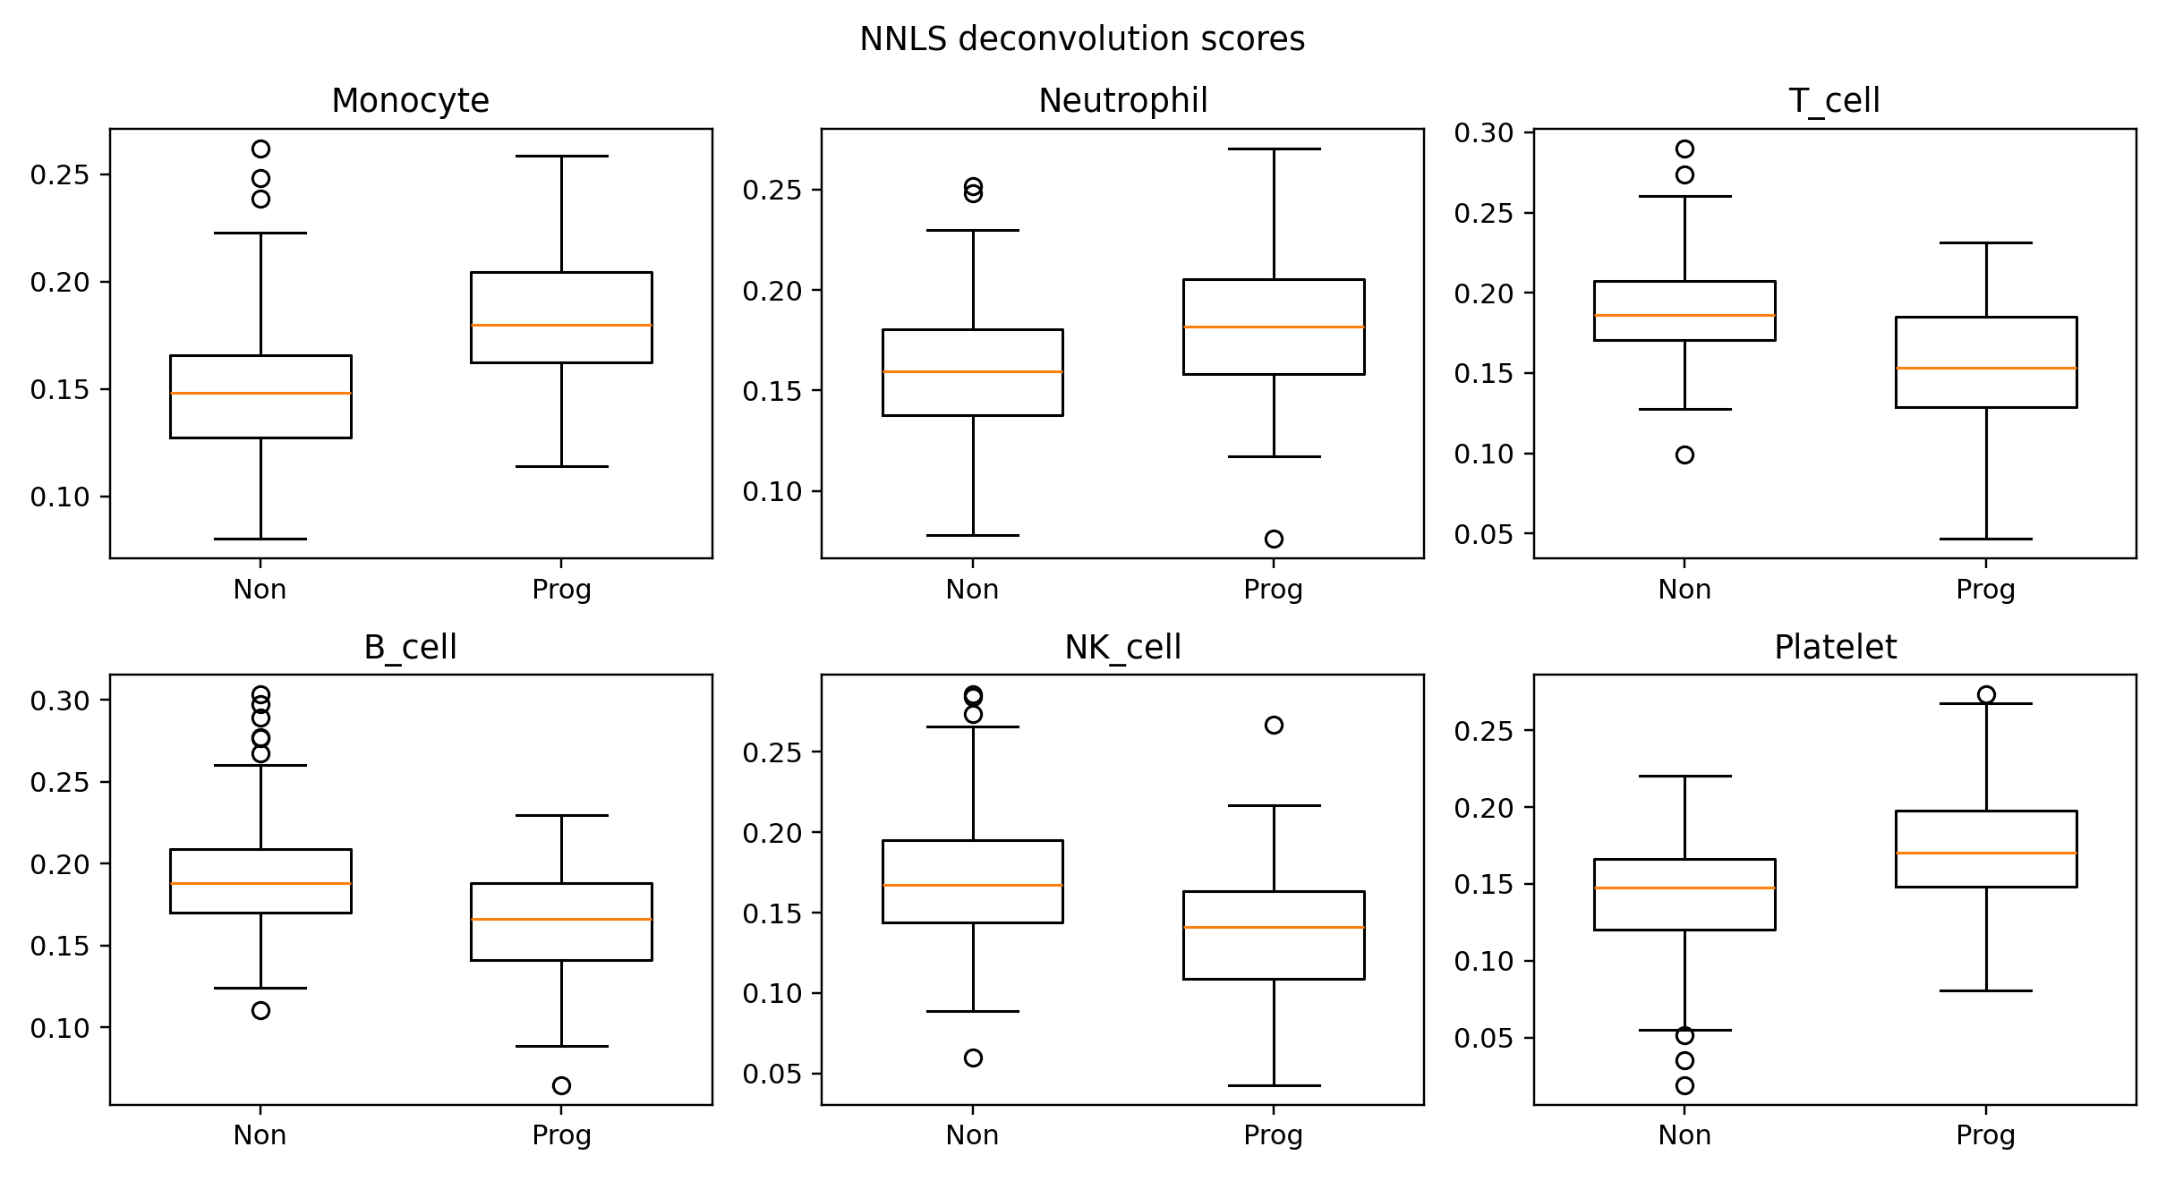

Coexpression Modules
A WGCNA-style unsigned coexpression analysis was performed on the most variable shared genes after cohort centering. Modules were summarized by eigengenes and compared by progressor status.
Supplementary Table A2. Coexpression module-trait summary.
Module | Genes | Mean progressor | Mean non-progressor | Delta | p value
M6 | 854 | 12.035 | -4.893 | 16.928 | 0.0
M5 | 2113 | -6.571 | 2.671 | -9.243 | 0.001

Supplementary Table A3. Overlap between coexpression modules and top Bayesian genes.
Module | Bayesian signature overlap | Overlapping genes
M5 | 1 | IRAK3
M6 | 10 | ANKRD9; CD36; ERMAP; FAM20C; GLB1; HAUS4; LOXL1; PLBD1; SPTB; VSIG4

Supplementary Figure A3. Coexpression module eigengene differences by progressor status.
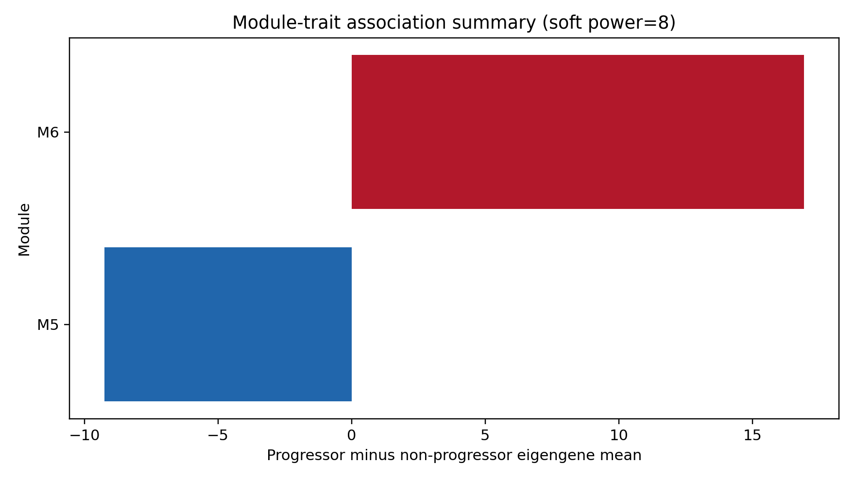

Supplementary Figure A4. Top module eigengene distributions in progressors and non-progressors.
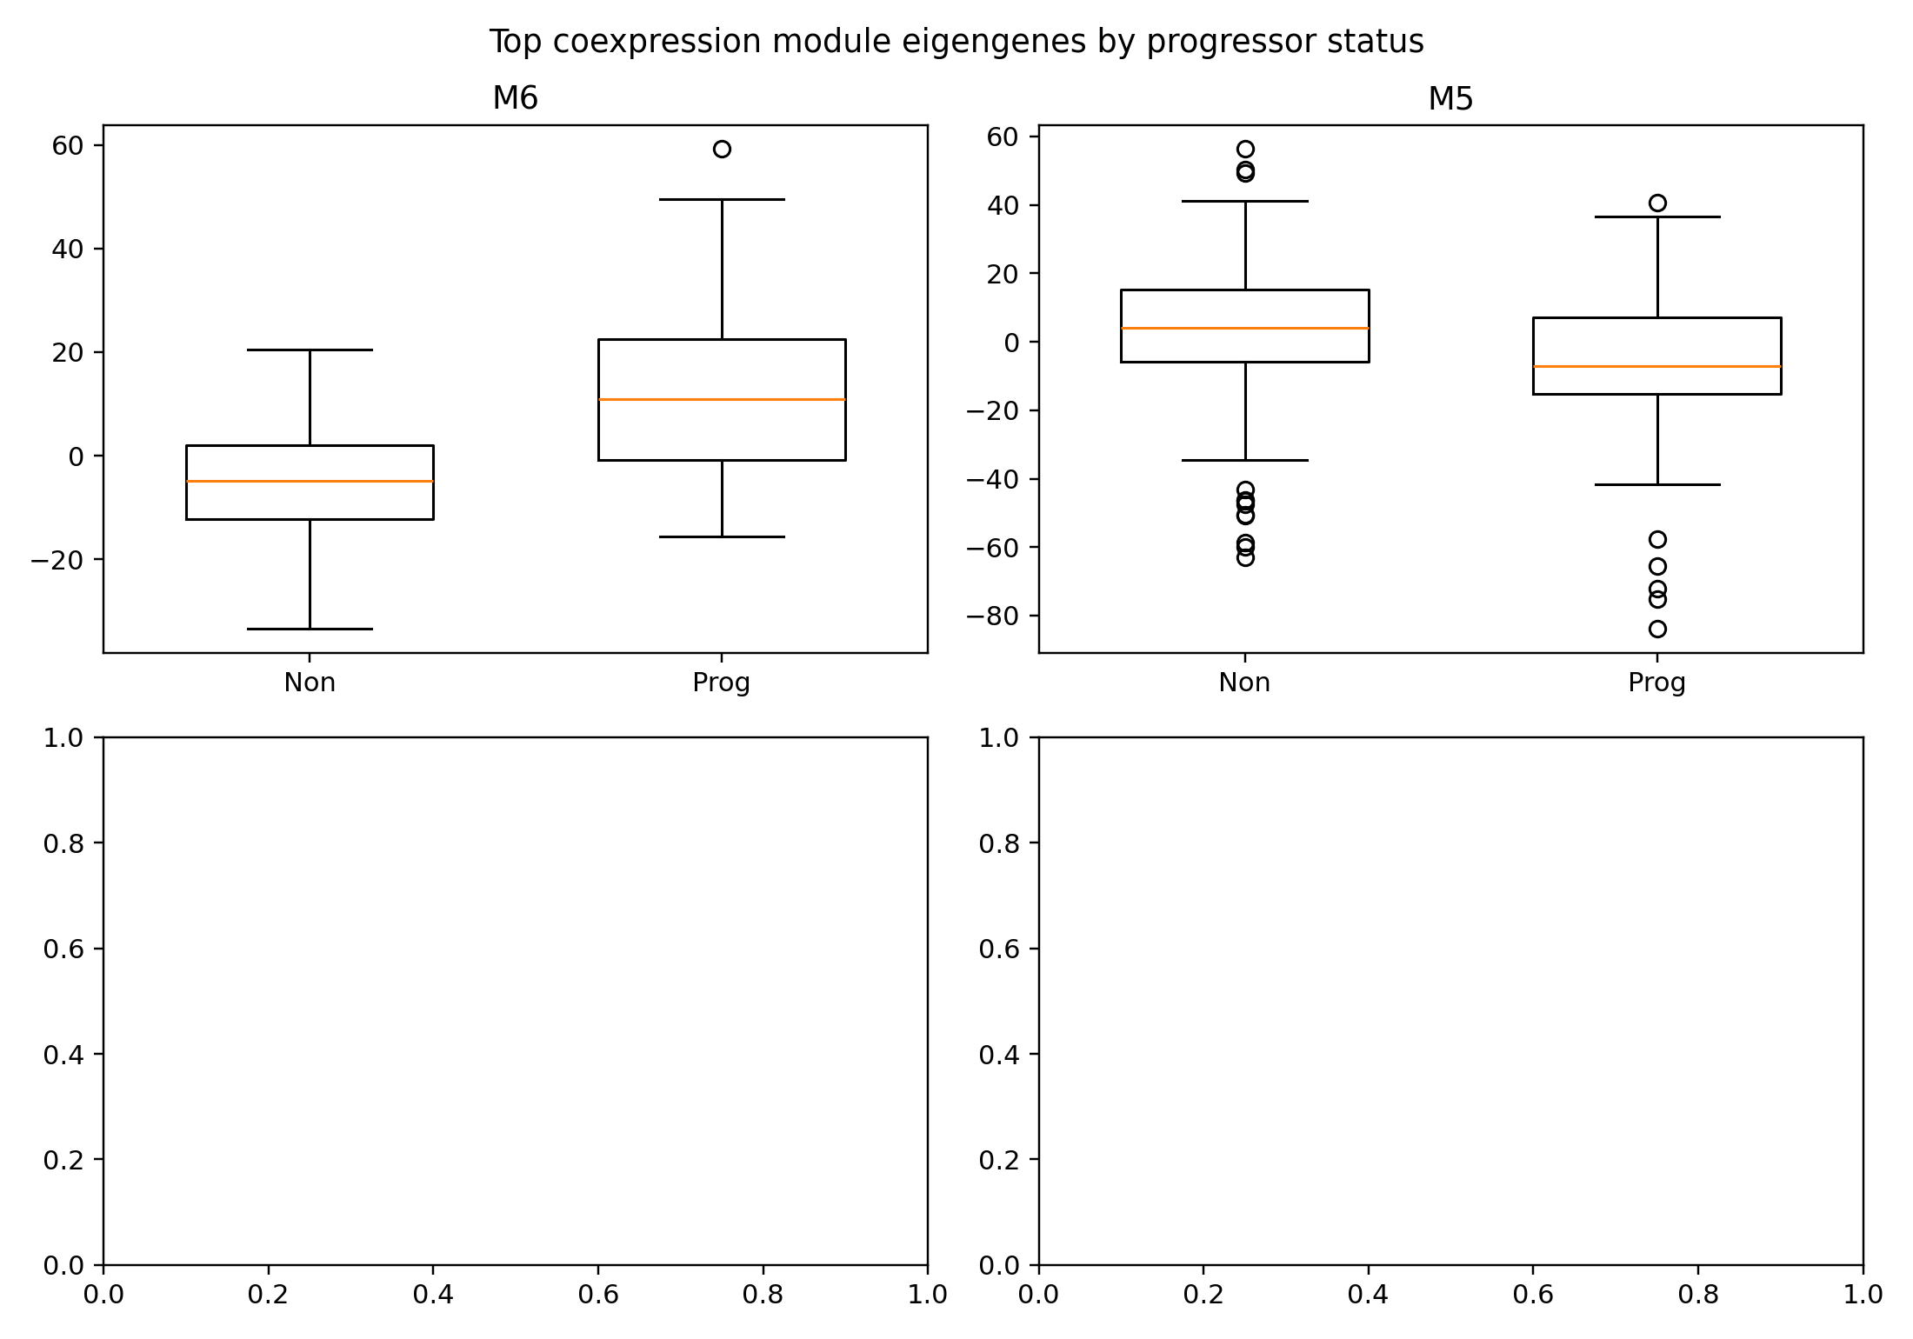

Cohort Expansion Note
This extension layer was motivated by OmicsClaw bulk-RNA resources for deconvolution, coexpression, enrichment, and literature support.
The present repository already contained pathway enrichment and the new Bayesian/PCA/factor analysis layer, so the main additive analyses were deconvolution and coexpression.
- GSE79362: prospectively validated adolescent risk-signature cohort and still the highest-value target for full shared-gene remapping.
- GSE107993: paired Leicester non-progressor companion dataset from the same phenotypic heterogeneity study and potentially useful for expansion once harmonization details are checked carefully.
- GSE117435: single-cell supportive resource that may help interpret monocyte-T-cell interface biology, but not a direct replacement for bulk progression validation.
- Deconvolution helps test whether the progression signal partly reflects shifts in myeloid and lymphoid composition.
- Coexpression modules help move the interpretation from isolated genes to coordinated biological programs.
- Literature-led cohort expansion is the main requirement for stronger generalization claims.

