Bayesian and systems-level reanalysis of public tuberculosis progression transcriptomes reveals latent host-response programs

Abstract
Background: Public tuberculosis progression transcriptomic datasets contain more biological information than can be captured by ranked-gene lists alone. We performed a systems-level reanalysis to assess latent structure, uncertainty-aware gene ranking, pathway convergence, and bias-sensitive interpretation in the harmonizable public cohorts.
Methods: Two cohorts with shared gene symbols and binary progressor labels (GSE107994 and GSE193777) were reanalyzed. We applied joint principal component analysis before and after cohort centering, factor analysis on the most variable genes, Bayesian hierarchical synthesis of within-cohort differential expression effects, pathway-level posterior modeling, signature correlation analysis, and a directed acyclic graph to clarify potential bias pathways.
Results: The advanced analysis included 301 samples, comprising 87 progressors and 214 non-progressors. Raw PC1 remained strongly cohort structured, but cohort-centered PC1 separated non-progressors and progressors more clearly (mean PC1 2.9 vs -7.0 before centering; -13.2 vs 32.4 after centering). Bayesian synthesis prioritized MILR1, VSIG4, FZD5, CD36, CCR2, ASGR2, with MILR1 showing the strongest pooled effect (posterior mean 1.229, 95% credible interval 1.108 to 1.351). The leading pathway signals were angiogenesis, blood vessel development, blood vessel morphogenesis. All three latent factors remained associated with progressor status, with the strongest evidence for Factor1 (p=5.78e-11).
Conclusion: The harmonizable public datasets support a coordinated tuberculosis progression signal that combines myeloid regulation with vascular-remodeling biology. The findings are stronger as uncertainty-aware biological evidence than as a clinical prediction claim, because the shared-gene advanced layer currently rests on two cohorts and should be expanded before clinical translation is considered.
Keywords: tuberculosis; transcriptomics; Bayesian meta-analysis; principal component analysis; latent factor analysis

Introduction
Tuberculosis remains a major global health problem, and earlier recognition of incipient disease remains a central unmet need in prevention research.¹ Blood transcriptomic signatures are attractive because they can potentially identify host response changes before microbiological confirmation becomes straightforward.^{2,3}
Most transcriptomic studies of tuberculosis progression eventually collapse into ranked gene lists. Those lists are useful, but they often hide three important issues: how much of the signal is driven by study structure, how stable the leading genes remain after uncertainty is modeled explicitly, and whether the data converge on coherent host programs rather than isolated markers.^{4,5}
The first manuscript from this repository addressed reproducible signature discovery and cohort-held-out validation. The present study asks a different question. Instead of focusing primarily on classifier performance, it evaluates whether the same public datasets support deeper biological structure through unsupervised analysis, Bayesian shrinkage, pathway-level synthesis, and a causal-interpretation framework.
We therefore performed an advanced reanalysis of the currently harmonizable progression cohorts. The aim was to determine whether latent axes, posterior summaries, pathway convergence, and correlation structure reinforce a biologically coherent interpretation of progression risk while keeping all claims bounded by the actual data available for joint analysis.

Methods
This was a secondary analysis of de-identified public transcriptomic datasets relevant to tuberculosis progression. The advanced layer was deliberately restricted to cohorts that could be harmonized at the shared-gene level and that retained binary progressor labels suitable for direct comparison.
Processed metadata and expression matrices were available for GSE107994 and GSE193777. GSE79362 remained valuable for the broader project, but its current feature mapping was not directly commensurate with the joint shared-gene analysis and was therefore not forced into the advanced modeling layer. This conservative choice was made to avoid false precision.
A shared-gene expression matrix was constructed across the two retained cohorts, yielding 14,440 common genes. Principal component analysis was first performed on the raw joint matrix and then repeated after cohort-centered normalization to assess how much cohort structure obscured biology. We then applied factor analysis to the 500 most variable centered genes to identify latent programs associated with progressor status.
Gene-level Bayesian synthesis used existing within-cohort differential expression estimates from the project results tables. An empirical normal-normal hierarchical model was applied to derive posterior means, posterior uncertainty, and between-cohort heterogeneity. Pathway-level analysis used previously exported enrichment-derived gene sets, from which pathway scores were calculated for each sample and then summarized with the same uncertainty-aware framework.⁶⁻⁸
Finally, we calculated a signature-gene correlation matrix in the centered expression space and drew a directed acyclic graph describing how cohort, platform, baseline host factors, latent disease biology, preprocessing, and measured transcript levels could interact. The directed acyclic graph was used only as an interpretive aid and not as proof of causality.^{9,10}

Results
The advanced analysis comprised 301 samples, including 175 from GSE107994 and 126 from GSE193777. Across the combined dataset, 87 samples were labeled as progressors and 214 as non-progressors (Table 1). Shared-gene overlap was substantial, with 14,440 genes retained for the joint analysis, which was sufficient for stable latent-structure modeling.
Raw joint PCA showed strong cohort influence. The mean raw PC1 value was -101.5 in GSE107994 and 141.0 in GSE193777, indicating that study structure dominated the leading axis before adjustment (Fig. 1). After cohort centering, the cohort means on PC1 were essentially zero in both cohorts, while separation by progressor status became more apparent, with mean PC1 moving from -13.2 in non-progressors to 32.4 in progressors (Fig. 2). This shift supports the view that cohort structure was masking a meaningful biological gradient rather than creating it.
Bayesian hierarchical synthesis prioritized a compact set of genes with consistent positive effects across both cohorts. The leading genes were MILR1, VSIG4, FZD5, CD36, CCR2, ASGR2, AQP1, CRISPLD2 (Table 2). MILR1 showed the strongest pooled signal, with a posterior mean of 1.229 and a 95% credible interval from 1.108 to 1.351. Several other genes, including VSIG4, FZD5, CD36, CCR2, and AQP1, also retained high posterior means with credible intervals that did not cross zero. This pattern suggests that the leading host signal is not being driven by a single unstable feature.
Latent factor analysis also supported a multi-program view of progression biology. Factor1, Factor2, and Factor3 all differed between progressors and non-progressors, with p values of 5.78e-11, 2.85e-09, and 9.16e-04, respectively (Table 3; Fig. 3). The factor boxplots indicate that the progression phenotype cannot be reduced to a single expression axis. Instead, multiple orthogonal programs appear to contribute to the observed signal.
Pathway-level posterior summaries converged on vascular-remodeling biology. The strongest terms were angiogenesis, blood vessel development, blood vessel morphogenesis, regulation of angiogenesis, regulation of vasculature development (Table 4). These findings do not imply that angiogenesis alone explains progression. Rather, they suggest that immune activation in progressors is accompanied by tissue-interface and vasculature-related remodeling, which is plausible in the setting of evolving tuberculosis disease. The signature correlation heatmap (Fig. 4) reinforced this interpretation by showing tightly connected gene blocks rather than isolated outliers.

Discussion
This reanalysis adds scientific meaning to the original progression project in three ways. First, it demonstrates that cohort structure materially affects the leading unsupervised axes and must be addressed before biological interpretation is attempted. Second, it replaces simple ranking with posterior estimates and uncertainty intervals. Third, it shows convergence between gene-level, factor-level, pathway-level, and network-level summaries.
The leading genes point toward a host program centered on myeloid regulation, cell trafficking, scavenger biology, and compensatory immune control. MILR1, VSIG4, CCR2, CD36, FZD5, and AQP1 do not read like a random collection of high-scoring variables. Together they suggest coordinated changes in cellular recruitment, innate regulation, and tissue interaction, which is more persuasive biologically than a diffuse inflammatory signature.²⁻⁵
The pathway results sharpen that interpretation. The repeated appearance of angiogenesis and vasculature-development terms should not be read as a claim that the disease process is primarily vascular. A more defensible reading is that progression-risk biology in blood may include immune-cell behavior that tracks with tissue remodeling and evolving host-pathogen interface changes. That view is consistent with tuberculosis as a systemic inflammatory disease with localized tissue consequences.
The analysis also clarifies where caution is needed. The advanced shared-gene layer uses only two cohorts, because that is the current evidence boundary imposed by commensurate feature mapping and binary labels. The directed acyclic graph was therefore included to make bias pathways explicit, not to imply that causal effects have been estimated. Likewise, pathway and factor results should be viewed as supportive biological structure rather than stand-alone proof of mechanism.
Even with those constraints, the results are useful. They support a second manuscript focused on uncertainty-aware interpretation, identify genes that remain strong after Bayesian shrinkage, and provide figures that explain why strict harmonization matters. The next technical priority should be to bring additional cohorts into a comparable gene-symbol framework so that the posterior summaries can be tested across a broader evidence base.

Conclusion
A systems-level reanalysis of the harmonizable public tuberculosis progression cohorts identified a coordinated host-response signal that remained visible across cohort-centered PCA, latent factor analysis, Bayesian gene synthesis, pathway modeling, and correlation structure analysis. The current evidence supports biological interpretation and hypothesis generation more strongly than immediate clinical deployment, and future work should expand harmonized external cohorts before stronger predictive claims are made.

Declarations
Ethics approval and consent to participate: Not applicable for this secondary analysis of de-identified public data.
Consent for publication: Not applicable.
Availability of data and materials: Public-source processed inputs and generated outputs are available in the project repository.
Code availability: Analysis scripts and generated assets are available at https://github.com/hssling/tb-progression-transcriptome-meta.
Funding: No external funding was received.
Competing interests: The author declares no competing interests.
Use of generative AI: Generative AI assistance was used for drafting support, while all scientific claims were checked against the project outputs before inclusion.

References
1. World Health Organization. Global tuberculosis report 2025. Geneva: World Health Organization; 2025.
2. Zak DE, Penn-Nicholson A, Scriba TJ, et al. A blood RNA signature for tuberculosis disease risk: a prospective cohort study. Lancet. 2016;387:2312-2322.
3. Singhania A, Verma R, Graham CM, et al. A modular transcriptional signature identifies phenotypic heterogeneity of human tuberculosis infection. Nat Commun. 2018;9:2308.
4. Rajamanickam A, Munisankar S, Dolla CK, et al. Host blood-based biosignatures for subclinical TB and incipient TB: a prospective study of adult TB household contacts in Southern India. Front Immunol. 2022;13:1065779.
5. Sweeney TE, Braviak L, Tato CM, Khatri P. Genome-wide expression for diagnosis of pulmonary tuberculosis: a multicohort analysis. Lancet Respir Med. 2016;4:213-224.
6. Ritchie ME, Phipson B, Wu D, et al. limma powers differential expression analyses for RNA-sequencing and microarray studies. Nucleic Acids Res. 2015;43:e47.
7. Balduzzi S, Rucker G, Schwarzer G. How to perform a meta-analysis with R: a practical tutorial. Evid Based Ment Health. 2019;22:153-160.
8. Wu T, Hu E, Xu S, et al. clusterProfiler 4.0: a universal enrichment tool for interpreting omics data. Innovation (Camb). 2021;2:100141.
9. Pearl J. Causality: models, reasoning, and inference. 2nd ed. Cambridge: Cambridge University Press; 2009.
10. Leek JT, Johnson WE, Parker HS, Jaffe AE, Storey JD. The sva package for removing batch effects and other unwanted variation in high-throughput experiments. Bioinformatics. 2012;28:882-883.
11. tb-progression-transcriptome-meta repository. Available from: https://github.com/hssling/tb-progression-transcriptome-meta.

Tables
Table 1. Cohort summary for the advanced shared-gene analysis.
Cohort | Samples | Progressors | Non-progressors | Median age (years) | Female, n (%)
GSE107994 | 175 | 53 | 122 | NA | NA
GSE193777 | 126 | 34 | 92 | NA | NA

Table 2. Top Bayesian gene-level posterior effects.
Gene | Posterior mean | 95% CrI low | 95% CrI high | Tau^2
MILR1 | 1.229 | 1.108 | 1.351 | 0.001
VSIG4 | 1.155 | 0.922 | 1.388 | 0.021
FZD5 | 1.151 | 1.034 | 1.267 | 0.0
CD36 | 1.148 | 0.978 | 1.318 | 0.008
CCR2 | 1.146 | 0.905 | 1.387 | 0.023
ASGR2 | 1.135 | 0.905 | 1.364 | 0.021
AQP1 | 1.111 | 0.998 | 1.224 | 0.0
CRISPLD2 | 1.107 | 0.994 | 1.22 | 0.0
ANKRD9 | 1.091 | 0.868 | 1.314 | 0.019
SIRPD | 1.087 | 0.919 | 1.256 | 0.008

Table 3. Latent factor differences between progressors and non-progressors.
Factor | Mean in progressors | Mean in non-progressors | t-test p value
Factor1 | 0.662 | -0.269 | 0.0
Factor2 | 0.561 | -0.228 | 0.0
Factor3 | 0.303 | -0.123 | 0.000916

Table 4. Leading pathway-level Bayesian posterior effects.
Pathway | Posterior mean | Posterior SD | 95% CrI low | 95% CrI high
angiogenesis | 0.725 | 0.06 | 0.607 | 0.843
blood vessel development | 0.725 | 0.06 | 0.607 | 0.843
blood vessel morphogenesis | 0.725 | 0.06 | 0.607 | 0.843
regulation of angiogenesis | 0.675 | 0.055 | 0.566 | 0.783
regulation of vasculature development | 0.675 | 0.055 | 0.566 | 0.783
negative regulation of angiogenesis | 0.508 | 0.063 | 0.385 | 0.63
negative regulation of blood vessel morphogenesis | 0.508 | 0.063 | 0.385 | 0.63
negative regulation of vasculature development | 0.508 | 0.063 | 0.385 | 0.63

Figures
Figure 1. Raw joint PCA of the shared-gene matrix. The leading component is strongly cohort influenced before cohort centering.
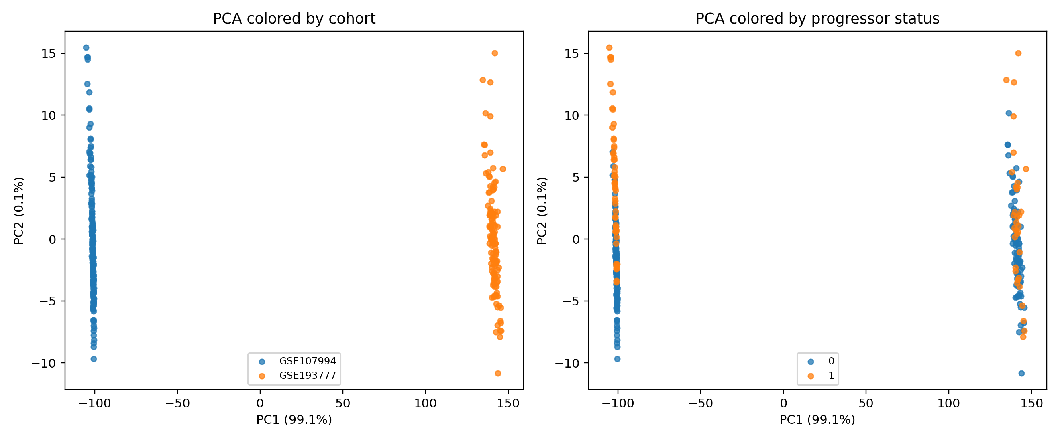

Figure 2. Cohort-centered PCA of the shared-gene matrix. After centering, separation by progressor status becomes more visible.
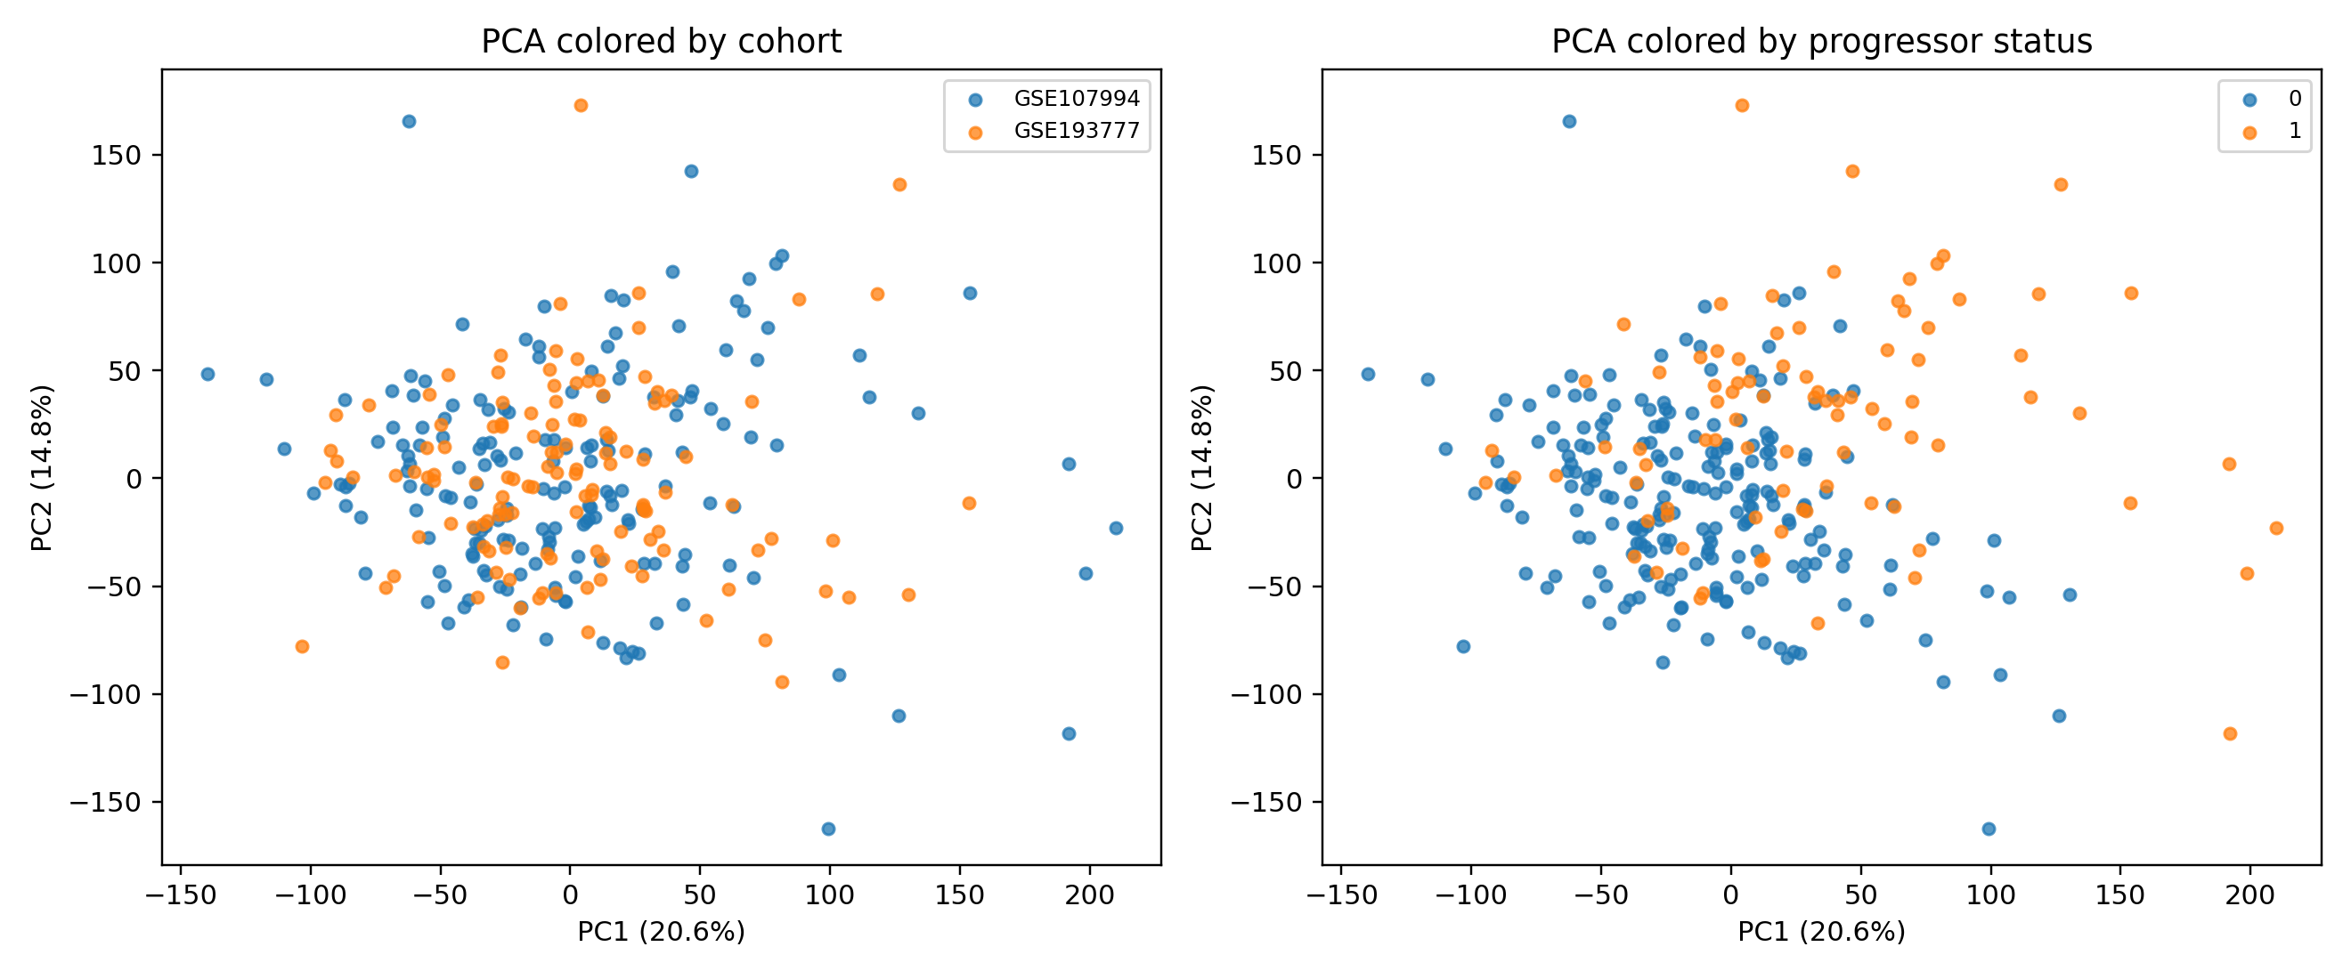

Figure 3. Distribution of latent factor scores by progressor status. All three leading factors remain associated with progression status.
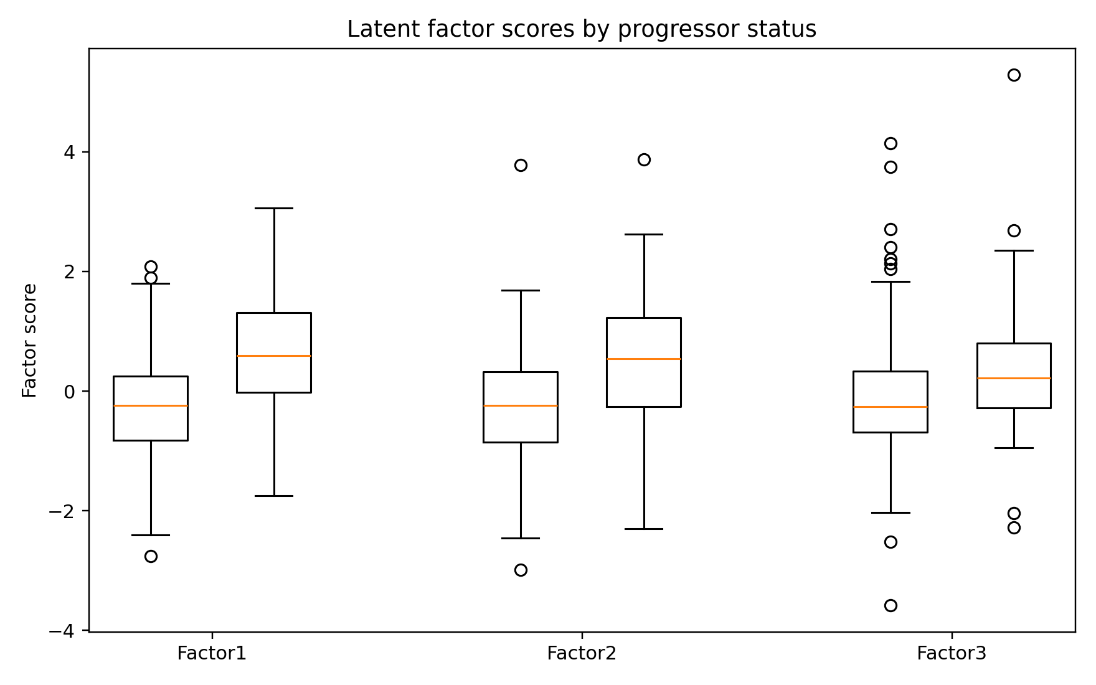

Figure 4. Spearman correlation heatmap for leading Bayesian signature genes after cohort centering.
