Longitudinal reanalysis of a prospective tuberculosis blood RNA-sequencing cohort suggests follow-up dynamics in coordinated host-response programs

Abstract
Background: Most blood transcriptomic studies of tuberculosis progression summarize baseline discrimination, but prospective cohorts with repeated samples can also clarify whether host-response programs change differently over follow-up in progressors and non-progressors. We reanalyzed a remapped public longitudinal RNA-sequencing cohort to test that question.
Methods: The GSE79362 cohort was remapped from junction-level counts to a gene-level matrix and linked to subject identifiers and follow-up labels. Primary models used 248 scheduled samples with numeric follow-up months from 107 subjects. Prespecified scores represented an existing 25-gene signature, a compact Bayesian core, a remap-sensitive myeloid set, vascular and coexpression proxies, and marker-based cell-state proxies. Random-intercept mixed-effects or subject-clustered longitudinal models estimated month, progressor, and progressor-by-month effects. IC samples were analyzed separately as a sensitivity layer.
Results: The cohort contained 264 samples from 107 subjects, including 33 progressors and 74 non-progressors. The strongest progressor-by-month interactions were observed for vascular_proxy5 (coefficient -0.0218, p=0.0092, FDR=0.0587), remap_myeloid5 (-0.0295, p=0.0125, FDR=0.0587), neutrophil proxy (-0.0026, p=0.0177, FDR=0.0587), platelet proxy (0.0035, p=0.0196, FDR=0.0587), and module_M6_proxy (-0.0222, p=0.0366, FDR=0.0878). No individual gene interaction survived multiple-testing correction, although ACSL1, FCGR3B, and VSIG4 showed the strongest nominal trends.
Conclusion: In this longitudinal cohort, temporal differences between progressors and non-progressors were more coherent at the level of coordinated host-response programs than at the level of single transcripts. These findings support a dynamics-oriented interpretation of progression biology, but they should not be read as direct time-to-disease forecasting because scheduled follow-up months and IC samples are not equivalent clinical states.
Keywords: tuberculosis; transcriptomics; longitudinal analysis; mixed-effects modeling; host-response programs

Introduction
Tuberculosis remains a major global health problem, and host blood transcriptomic signatures continue to attract attention as potential tools for identifying people at increased risk of future disease.¹⁻⁴ Most published work has emphasized cross-sectional or baseline discrimination, often asking whether one blood sample can distinguish progressors from non-progressors or active disease from other states.²⁻⁶
That work has been valuable, but it leaves a second question less well developed: how the host signal behaves over repeated follow-up within the same individual. A progression-associated signature may be biologically real even if no single transcript remains uniformly dominant across all visits. Conversely, some apparently strong baseline genes may weaken once repeated sampling and within-subject variation are considered.
Longitudinal reanalysis is particularly relevant in public tuberculosis cohorts because some datasets include scheduled follow-up visits, unscheduled or intermediate collections, and additional samples close to clinically important transitions. Those features can add biological meaning, but only if they are handled conservatively rather than collapsed into one pseudo-time variable without scrutiny.
A longitudinal framework is also useful for a practical reason. If serial blood testing is ever to contribute to tuberculosis prevention or early recognition, the biomarker cannot be judged only by cross-sectional separation. It must also show interpretable behavior across repeated visits, because real implementation would almost certainly involve follow-up measurements rather than one isolated sample.
At the same time, longitudinal public-data analysis is technically demanding. Repeated collections create within-subject dependence, intermediate or unscheduled samples complicate the visit structure, and RNA-sequencing data released at exon or junction level require additional preprocessing before biologically meaningful gene-level interpretation becomes possible. These challenges make conservative remapping and model specification essential.
This issue is especially important in tuberculosis because the biological window preceding overt disease is unlikely to be uniform. Some individuals may move gradually through a detectable host-response transition, whereas others may show sharper changes nearer to diagnosis. A longitudinal analysis cannot fully resolve that heterogeneity, but it can test whether there is enough directional structure in repeated blood measurements to justify a dynamic interpretation at all.
It is also useful to separate two different scientific objectives that are often blurred together. One objective is prediction: whether a biomarker can forecast future disease with clinically useful accuracy. The other is biological interpretation: whether repeated transcriptomic measurements reveal coordinated host programs that differ between progressors and non-progressors. The present study is aimed more strongly at the second objective than at the first.
The present analysis therefore takes a prespecified program-based approach. Instead of deriving a new single-cohort classifier, it evaluates whether host-response programs already highlighted by earlier harmonized public-data analyses show different temporal behavior in a remapped prospective RNA-sequencing cohort. This approach was chosen to reduce overfitting and to ask a more mechanistic question.
Our aim was to determine whether scheduled follow-up in the remapped GSE79362 cohort reveals reproducible progressor-specific dynamics at the level of coordinated programs, including myeloid, vascular-remodeling, coexpression, and marker-based cell-state signals, while keeping IC samples and time interpretation within conservative limits.

Methods
This was a secondary analysis of de-identified public transcriptomic data from GSE79362.^{2,11} The locally remapped gene-level matrix linked each sample to a subject identifier, progressor status, and a parsed follow-up label. Scheduled visits included DAY0, DAY180, DAY360, and DAY540, while an additional OTHER group represented intermediate early collections. IC samples were retained but not forced onto the same numeric follow-up scale.
Gene-level remapping aggregated junction-level counts to gene symbols and then linked the resulting matrix to subject and visit information already curated in the local processed metadata. This step was necessary because direct use of junction identifiers would have prevented biologically interpretable program scoring and would have made comparison with prior gene-symbol analyses unnecessarily unstable.
To avoid deriving another unstable cohort-specific signature, we used prespecified score families. These included: a 25-gene progression signature proxy based on genes present after remapping; a compact Bayesian core based on leading genes recovered in the earlier two-cohort harmonized analysis; a remap-sensitive myeloid score based on FCGR3B, HP, ACSL1, ANXA5, and SERINC2; vascular and coexpression proxy scores; and marker-based cell-state scores for monocyte, neutrophil, platelet, T-cell, B-cell, and NK-cell biology.⁸⁻¹⁰
Gene-level expression values were standardized within the remapped cohort before score construction. Program scores were calculated as the mean standardized expression of the genes in each prespecified set. Marker-based cell-state scores were estimated with a non-negative least squares approach using canonical blood-cell marker genes, and these were interpreted as relative composition proxies rather than measured cell fractions.⁹
The primary longitudinal models used samples with numeric scheduled follow-up months. For each score or gene, we fit a model with fixed effects for follow-up month, progressor status, and a progressor-by-month interaction. Random-intercept mixed-effects models were used when estimation was stable; otherwise, subject-clustered regression was used as a conservative fallback.⁷ The interaction term was the main parameter of interest because it captured whether the temporal slope differed by progression status.
This design was chosen deliberately. A positive progressor coefficient could reflect higher early values in progressors, whereas a negative interaction could reflect a steeper later decline; the two effects therefore answer different biological questions. By fitting them together, the analysis could distinguish initial separation from divergence in temporal behavior rather than conflating both into one summary score.
IC samples were not included in the primary month-scale models because they are not naturally ordered alongside the scheduled visit structure in the remapped metadata. Instead, we compared IC samples with scheduled progressor samples in a sensitivity analysis. Multiple-testing correction used the Benjamini-Hochberg method within the program-level and gene-level model families.
The primary interpretation was prespecified before manuscript drafting. Program-level findings were considered stronger than gene-level findings if they remained directionally coherent, survived false-discovery control, and aligned with the descriptive time-course plots. This rule was intended to avoid overstating isolated nominal p values from individual transcripts.
We treated the scheduled visit scale as a follow-up framework rather than as a surrogate for exact biological staging. That distinction matters because scheduled month does not necessarily equal distance from microbiologically confirmed disease in a simple linear way. The longitudinal coefficients are therefore best interpreted as differences in follow-up behavior within this cohort design, not as universal temporal constants of tuberculosis progression.
No attempt was made to estimate causal effects from these longitudinal models. The random-intercept or clustered regressions summarize within-cohort temporal association structure, while the prespecified scoring strategy constrains the feature space to biologically plausible programs already supported by the broader project. Together, these design choices were intended to favor robustness of interpretation over maximal model complexity.

Results
The remapped longitudinal cohort contained 264 samples from 107 subjects, including 33 progressors and 74 non-progressors. Scheduled follow-up months were available for 248 samples, which formed the primary longitudinal modeling set (Table 1). Repeat sampling was common enough to justify subject-level trajectory analysis, and there were no duplicated subject-timepoint combinations after remapping.
Program-level modeling produced a clearer signal than single-gene modeling. The strongest progressor-by-month interactions were observed for vascular_proxy5, remap_myeloid5, Neutrophil, Platelet, module_M6_proxy (Table 2; Fig. 3). At a false-discovery threshold below 0.10, the retained program-level features were vascular_proxy5, remap_myeloid5, Neutrophil, Platelet, module_M6_proxy. The negative interaction coefficients for vascular_proxy5, remap_myeloid5, and module_M6_proxy indicate steeper decline over follow-up in progressors than in non-progressors, whereas platelet showed a modest positive interaction.
Descriptive mean trajectories supported the same interpretation. In progressors, remap_myeloid5 rose between OTHER or DAY0 and DAY180, then decreased by DAY540, while the vascular proxy also shifted from early positive values toward negative values later in follow-up (Fig. 2). Non-progressors showed flatter or smaller changes over the same scheduled visits. For example, the progressor mean for remap_myeloid5 moved from 0.605 at DAY180 to 0.006 at DAY540, whereas the non-progressor means remained closer to -0.115 and -0.047, respectively.
The cell-state proxy layer added a complementary view. Neutrophil and platelet-associated proxies both showed progressor-by-month interactions that remained within the program-level false-discovery-supported set, while monocyte-associated scores were directionally compatible with the broader myeloid signal but did not show the same level of longitudinal interaction strength. This pattern suggests that the observed temporal behavior is not reducible to one simple composition shift.
The sign pattern of the coefficients is also informative. For remap_myeloid5, a positive progressor main effect together with a negative interaction indicates that progressors tended to start from a higher level but then changed more sharply over subsequent follow-up. Vascular_proxy5 showed a similar negative interaction without requiring a dominant single-gene driver, which supports the view that temporal restructuring occurs at the level of coordinated biology rather than one isolated marker.
Module_M6_proxy behaved similarly to the remap-sensitive myeloid and vascular scores, linking the longitudinal result back to the earlier coexpression analysis. That continuity matters because it suggests that the temporal signal is not simply a new artifact introduced by remapping or mixed-effects modeling. Instead, it connects the repeated-measures cohort to a broader progressor-associated expression program already visible in the cross-cohort analyses.
Gene-level models were less decisive. No individual gene trajectory survived multiple-testing correction, although ACSL1, FCGR3B, VSIG4 showed the strongest nominal progressor-by-month trends (Table 3; Fig. 4). This pattern argues that the longitudinal signal is more stable at the level of coordinated programs than at the level of isolated genes.
The existing 25-gene signature proxy and the compact Bayesian core both trended in the same overall direction, but neither reached the same level of statistical support as the higher-order program scores. This further suggests that repeated follow-up captures shifting composite biology better than it captures one persistent dominant transcript.
The subject-level trajectory plot reinforces that interpretation. Individual trajectories were heterogeneous, which is expected in prospective host-response data, yet the overlaid mean curves still separated enough to support model-based program differences. In other words, the longitudinal signal was not driven by one or two extreme subjects but emerged from directional structure across the cohort.
IC sensitivity analyses did not identify a strong separate IC effect in this run (Table 4). The largest numerical contrasts were seen for HP, ACSL1, and FCGR3B, but none survived multiple-testing correction. These observations support keeping IC samples as a descriptive sensitivity layer rather than merging them into the primary numeric follow-up model.
Taken together, the results support three linked inferences. First, longitudinal differences exist within this remapped cohort. Second, those differences are better captured by grouped biology than by single genes. Third, the strongest longitudinal story involves myeloid-weighted and vascular-linked programs that change over follow-up rather than remaining fixed at one elevated level.

Discussion
This reanalysis suggests that longitudinal progression biology in this cohort is easier to detect at the level of coordinated host programs than at the level of individual genes. That is an important distinction. It implies that repeated measurements may capture dynamic reweighting of related pathways, cell states, and modules even when no one transcript provides a universally stable trajectory marker.
The strongest supported programs were not random. The remap-sensitive myeloid set and the vascular proxy both showed steeper temporal shifts in progressors, and the M6 coexpression proxy moved in the same broad direction. Together, these findings are compatible with a model in which progression risk is associated with evolving myeloid activity and tissue-interface remodeling rather than with one static baseline inflammatory state.
This is also the point at which the longitudinal paper adds something genuinely different to the cross-sectional literature. Many prior transcriptomic studies already established that a blood signature can perform above chance at one time point. The present analysis suggests that when repeated sampling is available, the more stable biological story may reside in the way related programs move together across follow-up rather than in whether one gene remains consistently highest at every visit.
The marker-based neutrophil and platelet results also add meaning, but they require careful interpretation. These scores are relative composition proxies derived from canonical marker genes, not measured leukocyte or platelet fractions. Their value lies in supporting the biological direction of change, not in providing exact cell counts.⁹
The weaker gene-level results are equally informative. ACSL1, FCGR3B, and VSIG4 showed the strongest nominal interaction trends, all biologically plausible in a myeloid-weighted host-response setting, but none remained significant after multiple-testing correction. That argues against overclaiming any single transcript as the dominant longitudinal driver in this cohort.
The analysis also clarifies the importance of separating scheduled follow-up from IC samples. The remapped metadata support a clear visit structure at approximately 0, 6, 12, and 18 months, but IC samples do not sit naturally on that same timeline. Treating them as ordinary late follow-up points would risk imposing an interpretation that the data do not warrant.
These results fit the broader tuberculosis biomarker literature while adding a different layer of meaning. Prior work established that blood RNA signatures can identify short-term risk and can retain prognostic value across cohorts.²⁻⁶ The present longitudinal analysis adds that, within one prospective RNA-sequencing cohort, the stronger reproducible signal lies in coordinated program dynamics rather than in any one gene's time slope.
From a study-design perspective, the results also argue for a more disciplined way of using public longitudinal data. Remapping, subject linkage, and explicit handling of unscheduled collections are not merely technical preliminaries; they change what can be claimed biologically. The present workflow therefore offers a practical template for future reanalyses of TB transcriptomic cohorts with mixed visit structures.
This distinction matters for translation. A clinically useful serial biomarker may ultimately need to summarize multidimensional host-response programs rather than rely on a single repeatedly measured transcript. Longitudinal program behavior could therefore become a complementary criterion for selecting robust candidate panels, alongside cross-sectional discrimination and cross-platform stability.
Several limitations remain. The primary longitudinal evidence currently rests on one remapped cohort, follow-up month is not equivalent to exact time-to-disease, and the program definitions were prespecified from the present analytical framework rather than from an externally published longitudinal framework. These constraints support biological interpretation and hypothesis generation more strongly than immediate clinical forecasting.
Future work should therefore proceed in two linked directions. The first is analytical: extending the same trajectory logic to other cohorts once remapping and subject-level linkage are feasible. The second is translational: asking whether the most stable longitudinal programs can be compressed into assay-friendly panels without losing interpretability across repeated measurements.
A further implication is methodological. Public-data transcriptomic studies often emphasize discovery of the best-ranked genes because those are easy to tabulate and compare. The current results suggest that for repeated-measures designs, ranking alone may be an incomplete summary. A program may carry meaningful longitudinal information even if its constituent genes trade prominence across visits. That possibility deserves more attention in future TB biomarker work.
The present manuscript also helps define what would count as a stronger next study. A more definitive longitudinal paper would need at least one additional subject-linked cohort, clearer anchoring to time-to-disease or clinical transition, and ideally an orthogonal cell-state reference such as flow cytometry or single-cell profiling. Those elements are not available here, but the current results establish a rational basis for pursuing them.

Conclusion
A longitudinal reanalysis of the remapped GSE79362 blood RNA-sequencing cohort suggests that progressor-specific temporal differences are more coherent at the level of coordinated host-response programs than at the level of individual genes. The strongest supported signals involved remap-sensitive myeloid biology, vascular-remodeling proxies, neutrophil or platelet proxy shifts, and a progressor-associated coexpression program. These findings support a longitudinal systems-biology interpretation of tuberculosis progression, while also showing that scheduled follow-up and IC samples must be handled as distinct analytical states.

Declarations
Ethics approval and consent to participate: Not applicable for this secondary analysis of de-identified public data.
Consent for publication: Not applicable.
Availability of data and materials: The remapped GSE79362-derived metadata, generated analysis tables, and manuscript assets are available in the project repository.
Code availability: Analysis scripts and generated assets are available at https://github.com/hssling/tb-progression-transcriptome-meta.
Funding: No external funding was received.
Competing interests: The author declares no competing interests.
Use of generative AI: Generative AI assistance was used for drafting support, while all scientific claims were checked against the project outputs before inclusion.

References
1. World Health Organization. Global tuberculosis report 2025. Geneva: World Health Organization; 2025.
2. Zak DE, Penn-Nicholson A, Scriba TJ, et al. A blood RNA signature for tuberculosis disease risk: a prospective cohort study. Lancet. 2016;387:2312-2322.
3. Penn-Nicholson A, Mbandi SK, Thompson E, et al. RISK6, a 6-gene transcriptomic signature of TB disease risk, diagnosis and treatment response. Sci Rep. 2020;10:8629.
4. Gupta RK, Turner CT, Venturini C, et al. Concise whole blood transcriptional signatures for incipient tuberculosis: a systematic review and patient-level pooled meta-analysis. Lancet Respir Med. 2020;8:395-406.
5. De Groote MA, Gupta RK, Hellwig SM, et al. Prospective multicentre head-to-head validation of host blood transcriptomic biomarkers for pulmonary tuberculosis by real-time PCR. Commun Med (Lond). 2022;2:26.
6. Andrews JR, Nemes E, Tameris M, et al. Transcriptomic signatures of progression to tuberculosis disease among close contacts in Brazil. Clin Infect Dis. 2024;78:1672-1681.
7. Laird NM, Ware JH. Random-effects models for longitudinal data. Biometrics. 1982;38:963-974.
8. Leek JT, Johnson WE, Parker HS, Jaffe AE, Storey JD. The sva package for removing batch effects and other unwanted variation in high-throughput experiments. Bioinformatics. 2012;28:882-883.
9. Newman AM, Liu CL, Green MR, et al. Robust enumeration of cell subsets from tissue expression profiles. Nat Methods. 2015;12:453-457.
10. Langfelder P, Horvath S. WGCNA: an R package for weighted correlation network analysis. BMC Bioinformatics. 2008;9:559.
11. National Center for Biotechnology Information. Gene Expression Omnibus: GSE79362. https://www.ncbi.nlm.nih.gov/geo/query/acc.cgi?acc=GSE79362. Accessed 18 Mar 2026.
12. Siddalingaiah HS. tb-progression-transcriptome-meta. GitHub. https://github.com/hssling/tb-progression-transcriptome-meta. Accessed 18 Mar 2026.

Tables
Table 1. Longitudinal cohort summary after gene-level remapping and subject linkage.
Measure | Value
Total samples | 264
Subjects | 107
Progressor subjects | 33
Non-progressor subjects | 74
Samples with numeric scheduled follow-up | 248
IC samples | 16

Table 2. Program-level progressor-by-month interaction estimates from the primary longitudinal models.
Feature | Interaction coef | 95% CI low | 95% CI high | p value | FDR
vascular_proxy5 | -0.0218 | -0.0381 | -0.0054 | 0.0092 | 0.0587
remap_myeloid5 | -0.0295 | -0.0527 | -0.0064 | 0.0125 | 0.0587
Neutrophil | -0.0026 | -0.0047 | -0.0004 | 0.0177 | 0.0587
Platelet | 0.0035 | 0.0006 | 0.0065 | 0.0196 | 0.0587
module_M6_proxy | -0.0222 | -0.043 | -0.0014 | 0.0366 | 0.0878
signature25_proxy | -0.0123 | -0.0277 | 0.0031 | 0.1163 | 0.2327
bayesian_core8 | -0.0178 | -0.044 | 0.0083 | 0.1816 | 0.3113
NK_cell | -0.0008 | -0.0025 | 0.0009 | 0.3702 | 0.5365

Table 3. Gene-level progressor-by-month interaction estimates. No gene-level interaction survived multiple-testing correction.
Gene | Interaction coef | 95% CI low | 95% CI high | p value | FDR
ACSL1 | -0.033 | -0.0669 | 0.0009 | 0.0567 | 0.176
FCGR3B | -0.0299 | -0.0621 | 0.0023 | 0.0689 | 0.176
VSIG4 | -0.0303 | -0.0637 | 0.0031 | 0.0754 | 0.176
IRAK3 | -0.023 | -0.0561 | 0.0102 | 0.1742 | 0.3048
CCR2 | -0.0193 | -0.0614 | 0.0228 | 0.3694 | 0.5171
HP | -0.012 | -0.0466 | 0.0227 | 0.4989 | 0.582
CD36 | 0.0056 | -0.0291 | 0.0403 | 0.7511 | 0.7511

Table 4. Progressor-only IC sensitivity contrasts. These results are descriptive and do not support merging IC samples into the scheduled visit scale.
Feature | IC minus scheduled delta | p value | FDR
HP | -0.3337 | 0.1383 | 0.709
ACSL1 | -0.331 | 0.1441 | 0.709
FCGR3B | -0.2721 | 0.2213 | 0.709
IRAK3 | -0.3255 | 0.2687 | 0.709
remap_myeloid5 | -0.1788 | 0.3302 | 0.709
signature25_proxy | -0.1164 | 0.3873 | 0.709
module_M6_proxy | -0.1211 | 0.4799 | 0.709
bayesian_core8 | -0.1732 | 0.5421 | 0.709
VSIG4 | -0.1985 | 0.5941 | 0.709
CCR2 | -0.1673 | 0.6445 | 0.709
CD36 | -0.1031 | 0.7456 | 0.7456

Figures
Figure 1. Subject-level and mean trajectories for the 25-gene signature proxy across scheduled follow-up visits.
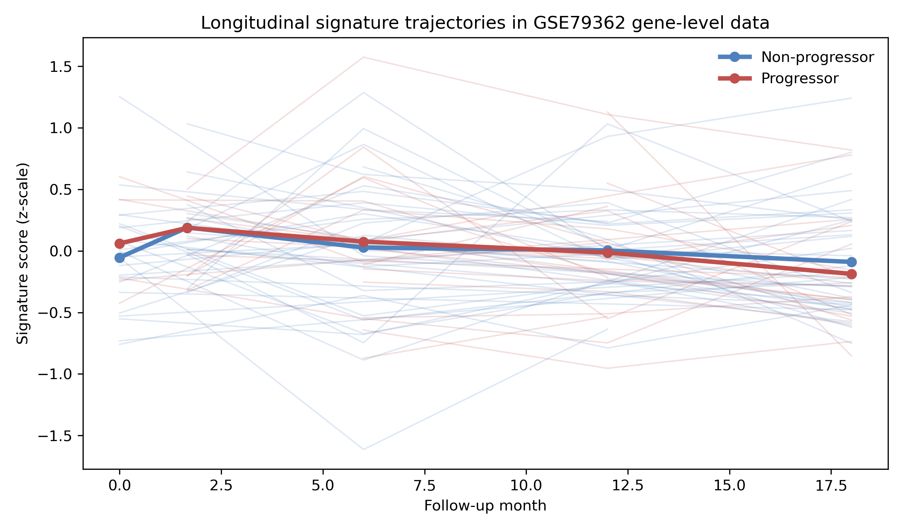

Figure 2. Mean trajectories for selected prespecified programs, including the remap-sensitive myeloid score, M6 module proxy, and monocyte-related proxy.
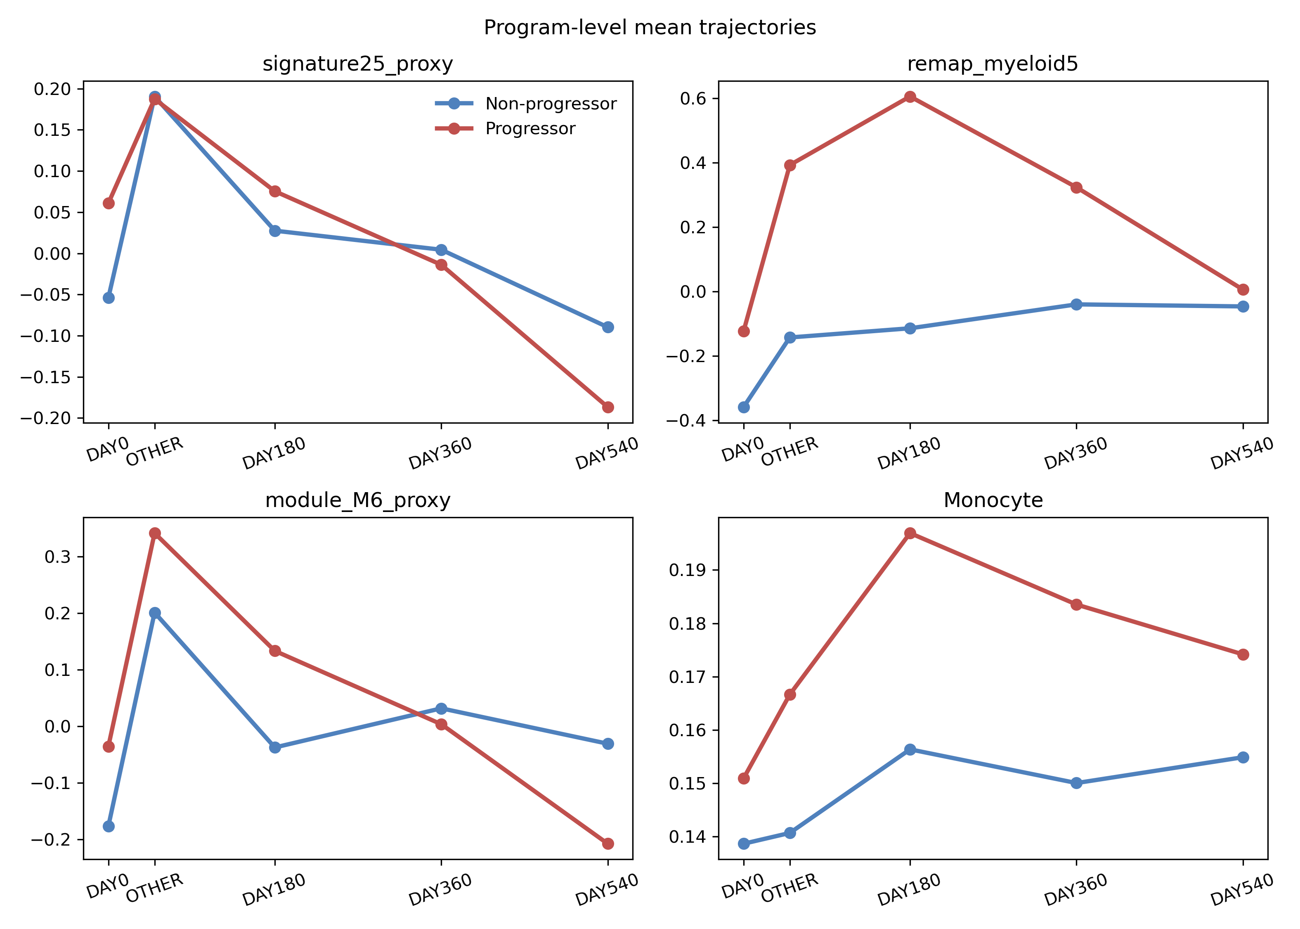

Figure 3. Program-level progressor-by-month interaction estimates with 95% confidence intervals.
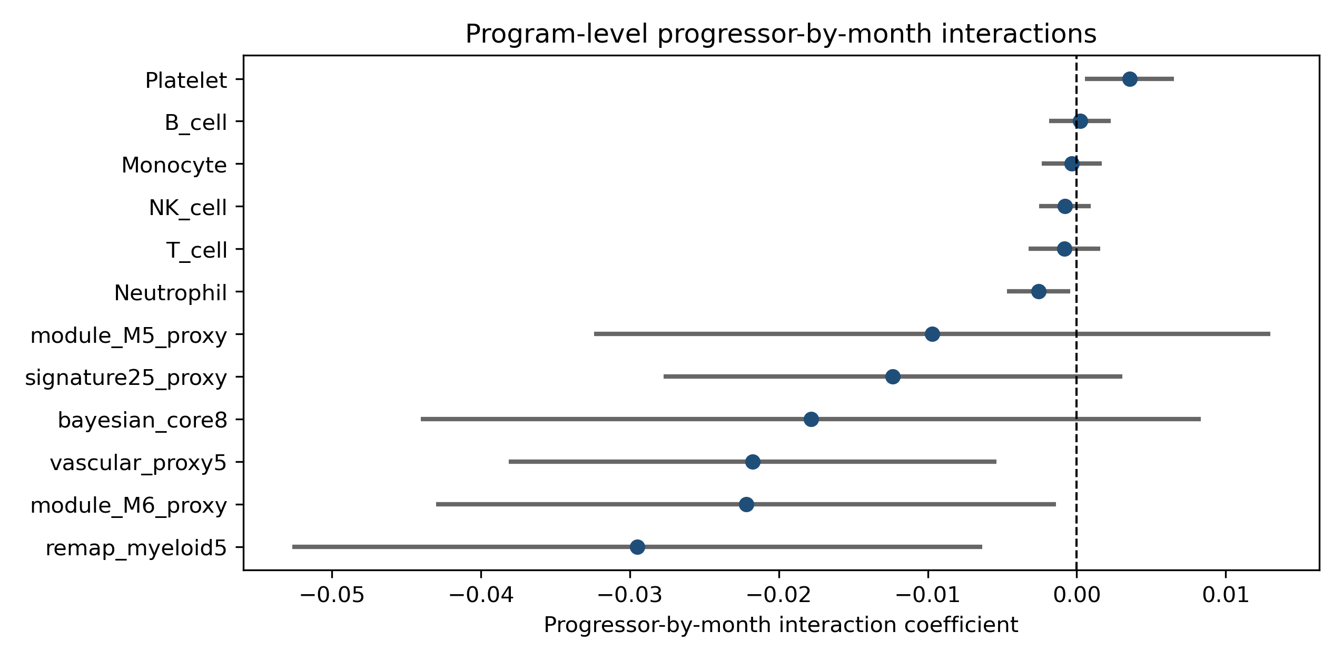

Figure 4. Gene-level progressor-by-month interaction estimates with 95% confidence intervals.
