Supplementary Methods and Notes

Supplementary Methods
The advanced analysis used the processed cohort matrices already generated within the repository. Only GSE107994 and GSE193777 entered the shared-gene layer because both cohorts retained gene-symbol expression matrices and binary progressor labels. The overlap across those cohorts was 14,440 genes.
The Bayesian gene model summarized existing within-cohort effect sizes using a normal-normal hierarchical framework. The objective was not to prove mechanism, but to stabilize ranking and provide posterior uncertainty intervals that are easier to interpret than raw point estimates alone.
The pathway-level analysis derived sample-level scores from the exported enrichment gene sets. Because the enrichment source was itself downstream of the project pipeline, the pathway results should be viewed as structured biological corroboration rather than an independent discovery layer.
The OmicsClaw-inspired deconvolution extension used canonical blood-cell marker genes with a non-negative least squares framework. These outputs are relative composition proxies and should not be interpreted as absolute leukocyte fractions. The coexpression extension was used to summarize coordinated programs and hub genes, but not to claim causal regulatory networks.

Supplementary Figure
Supplementary Figure 1. Directed acyclic graph showing the conceptual relationships among cohort, platform, host baseline factors, latent progression biology, preprocessing, and observed transcriptomic measurements.
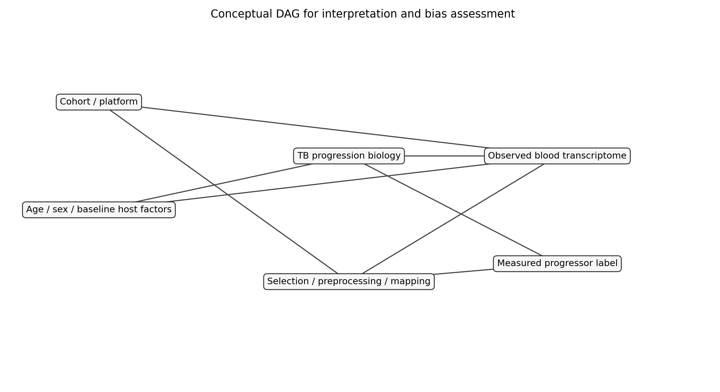

Supplementary Table
Supplementary Table 1. Top 20 Bayesian gene-level posterior effects.
Gene | Posterior mean | 95% CrI low | 95% CrI high
MILR1 | 1.229 | 1.108 | 1.351
VSIG4 | 1.155 | 0.922 | 1.388
FZD5 | 1.151 | 1.034 | 1.267
CD36 | 1.148 | 0.978 | 1.318
CCR2 | 1.146 | 0.905 | 1.387
ASGR2 | 1.135 | 0.905 | 1.364
AQP1 | 1.111 | 0.998 | 1.224
CRISPLD2 | 1.107 | 0.994 | 1.22
ANKRD9 | 1.091 | 0.868 | 1.314
SIRPD | 1.087 | 0.919 | 1.256
PLBD1 | 1.079 | 0.93 | 1.228
PLXDC2 | 1.066 | 0.823 | 1.309
NCSTN | 1.063 | 0.856 | 1.27
FAM20C | 1.058 | 0.945 | 1.171
USP3 | 1.036 | 0.857 | 1.215
CPVL | 1.025 | 0.851 | 1.2
MYOF | 1.012 | 0.866 | 1.157
ERMAP | 1.009 | 0.857 | 1.161
IRAK3 | 1.007 | 0.894 | 1.12
PROS1 | 0.998 | 0.839 | 1.157

