Host blood transcriptomic signatures associated with tuberculosis progression: a reproducible public-data meta-analysis

Structured Abstract
Background/Objectives: Tuberculosis remains a major global health problem, and better tools are needed to identify people who are progressing from latent or incipient infection towards active disease. Blood transcriptomic signatures are promising, but many reported signatures are difficult to reproduce across cohorts and platforms.
Methods: We developed a reproducible public-data workflow for tuberculosis progression transcriptomics using curated GEO cohorts. Three primary cohorts were processed, and two cohorts with harmonized binary outcome labels were used for strict leave-one-cohort-out validation. Gene-level effects were synthesized using a random-effects approach, candidate genes were ranked by meta z score and stability, and three classifiers were assessed: elastic net, linear support vector machine, and a gene-set score.
Results: The analysis prioritized a 25-gene host signature associated with progression. Leading genes included MILR1, VSIG4, CCR2, CD36, FZD5, AQP1, and IRAK3. The best validation result was produced by the gene-set-score model in the left-out GSE107994 cohort, with AUC-ROC 0.914 and AUC-PR 0.828. Mean AUC-ROC values were 0.884 for the gene-set-score model, 0.838 for linear support vector machine, and 0.780 for elastic net. Enrichment analysis highlighted phagocytosis, immune effector regulation, myeloid activation, and vascular remodeling.
Conclusions: Public transcriptomic cohorts can recover a biologically coherent host signature associated with tuberculosis progression, but the current evidence is best interpreted as a robust biomarker-discovery resource rather than a ready-to-deploy clinical test.
Keywords: biomarker; host response; latent tuberculosis infection; machine learning; transcriptomics

Introduction
Tuberculosis continues to cause substantial morbidity and mortality worldwide. The World Health Organization estimated that 10.7 million people developed tuberculosis in 2024 and 1.23 million died from the disease, underscoring the need for earlier and more accurate risk stratification.¹
Most infected individuals do not progress to active disease, yet the population burden of latent infection remains very large. This creates a practical need for tools that can distinguish people who are likely to progress from those who remain clinically stable.²
Blood-based host transcriptomic signatures are attractive because they are non-sputum based, mechanistically informative, and potentially useful in asymptomatic high-risk contacts. Important studies have already shown that blood RNA signatures can anticipate disease risk and capture biological heterogeneity along the tuberculosis spectrum.³⁻⁶
However, reproducibility remains the main obstacle. Published signatures often lose performance when applied to independent cohorts with different recruitment designs, assay platforms, or preprocessing pipelines. Multi-cohort evaluations have also shown that transcriptomic classifiers are sensitive to hidden study structure and analytic choices.^{6,7}
Public datasets are therefore useful only if they are handled conservatively. A scientifically sound public-data study must separate cohort discovery from cohort validation, avoid information leakage, and keep its claims bounded by the actual harmonized labels that are available.
The present study was designed as a reproducible public-data meta-analysis aimed at identifying host blood genes associated with tuberculosis progression. The secondary aim was to package the analysis as a journal-ready submission while retaining transparent reporting, simple language, and strict alignment between the manuscript claims and the available outputs.

Methods

Study design
This was a secondary analysis of publicly available transcriptomic cohorts relevant to tuberculosis progression, incipient tuberculosis, or closely related host-response states. The analysis was organized as a reproducible workflow that included cohort curation, harmonization, random-effects synthesis, pathway interpretation, and cross-cohort validation.

Data sources and cohort selection
Curated cohorts were identified from GEO using progression-focused tuberculosis terms. The current submission retains three primary processed cohorts: GSE107994, GSE193777, and GSE79362. Of these, two cohorts had directly comparable binary labels suitable for leave-one-cohort-out validation. Additional microarray cohorts were retained as candidate resources for future expansion rather than being forced into the present validation framework.³⁻⁸

Preprocessing and harmonization
Expression matrices were normalized and mapped to gene-level features wherever possible. Duplicate or ambiguous mappings were collapsed conservatively, and datasets were restricted to a shared feature space before downstream analysis. This conservative approach was chosen to reduce false precision and to keep the manuscript aligned with the exported outputs.^{8,9}

Meta-analysis
Per-gene effects for progressor versus non-progressor comparisons were combined using a random-effects framework. Genes were ranked by absolute meta z score, and false-discovery-adjusted values were retained for prioritization. The synthesis was used to identify robust candidate genes rather than to make exaggerated claims of universal invariance.¹⁰

Model development and validation
Three classifier types were assessed: elastic net logistic regression, linear support vector machine, and a simple gene-set score based on the ranked signature. Validation used leave-one-cohort-out testing so that one complete cohort was excluded from model training and used only for evaluation. This design was chosen specifically to reduce information leakage and to reflect realistic cross-cohort transfer.^{11,12}

Functional interpretation
The ranked genes were interpreted using exported Gene Ontology biological-process enrichment results generated by the reporting pipeline. Only pathways present in the exported results were discussed in the manuscript, which limited over-interpretation and improved traceability.¹³

Ethics
The present study used de-identified publicly available data only. No new patients were recruited, and no local intervention or specimen collection was performed. Ethical approvals and informed consent for the original cohorts were handled by the primary investigators as described in the original publications.

Results

Cohort characteristics
The curated registry identified six relevant public studies, of which three were processed as primary cohorts in the current package. These cohorts represented the Leicester cohort, a Southern India household-contact cohort, and the ACS prospective cohort. Together they accounted for 533 processed samples and captured both discovery-rich and validation-ready study structures (Table 1).
The processed cohorts were not fully interchangeable. Only two cohorts provided directly comparable binary labels for the main leave-one-cohort-out analysis. That limitation defines the real boundary of the current evidence and helps prevent overstatement of model maturity.
The cohort mix nevertheless remains informative because it reflects the actual structure of the public tuberculosis transcriptomic literature. Some studies are rich in biological context but less suitable for direct binary validation, whereas others are better suited to classifier testing. Treating these cohorts as analytically identical would create false precision. The present workflow preserves that distinction and uses it to guide how far the results can reasonably be interpreted.

Progression-associated transcriptomic signals
The random-effects synthesis prioritized genes involved in innate immune regulation, phagocytic handling, leukocyte trafficking, and vascular remodeling. The strongest positive signals were MILR1, VSIG4, CCR2, CD36, FZD5, AQP1, and CRISPLD2, while EPN2 and PLD4 showed strong inverse directionality among the leading ranks (Table 2).
The top-ranked genes were biologically coherent rather than statistically isolated. MILR1 and IRAK3 suggest regulatory signaling, CCR2 and ITGB2 support immune-cell recruitment, CD36 reflects macrophage-associated lipid and scavenger biology, and FZD5 points to a broader signaling context that may relate to tissue remodeling and inflammatory balance. A forest-style summary of the leading transcriptomic effects is shown in Fig. 1.
The leading genes also showed a practical balance between effect size and interpretability. For a translational study, it is not enough for genes to rank highly; they should also map to host processes that clinicians and laboratory scientists can understand. In that sense, the current list is more convincing than an opaque machine-learning feature set because it links progression to recognizable pathways in myeloid activation, adhesion, and immune regulation.

Cross-cohort validation performance
The strongest leave-one-cohort-out performance was obtained with the gene-set-score model when GSE107994 was used as the held-out cohort, producing AUC-ROC 0.914 and AUC-PR 0.828. Across the two held-out cohorts, the mean AUC-ROC values were 0.884 for the gene-set-score model, 0.838 for linear support vector machine, and 0.780 for elastic net (Table 3).
The results also showed that discrimination and calibration were not equivalent. The gene-set-score model ranked samples best, whereas linear support vector machine achieved more favorable Brier scores. This pattern suggests that the host signal is strong enough for cross-cohort discrimination, while absolute risk estimation remains less mature. The ROC comparison is presented in Fig. 2.
The difference between the held-out cohorts is also informative. A signature that performs identically in every public cohort is uncommon in this field because cohorts differ in baseline risk, recruitment frame, sampling window, and assay processing. The observed variation therefore does not invalidate the signature; instead, it underlines why strict external testing is necessary before any host transcriptomic model is presented as clinically stable.

Functional interpretation
Pathway enrichment emphasized regulation of angiogenesis, vasculature development, immune effector processes, leukocyte degranulation, myeloid activation, and phagocytosis. Recurrent genes such as CCR2, CD36, FZD5, ITGB2, and SPARC connected the pathway-level findings to the ranked signature, supporting a model in which progression risk is associated with coordinated immune trafficking, tissue-interface remodeling, and altered innate regulation.
IRAK3 deserves specific mention because it is a negative regulator of Toll-like receptor signaling. Its prominence in the ranked genes suggests that progression is not defined only by inflammatory activation, but also by dysregulated or compensatory immune restraint.¹⁴
This interpretation is clinically useful because it avoids a simplistic view in which progression is reduced to 'more inflammation'. The enrichment profile instead suggests a more complex biological state in which recruitment, regulation, phagocytic behavior, and tissue-level adaptation change together. That framing is easier to defend scientifically and easier to communicate to a broad tuberculosis readership.

Discussion
This study shows that a coherent host blood transcriptomic program associated with tuberculosis progression can be recovered from public cohorts when the workflow is transparent and validation is performed at the cohort level. The value of the present work lies not only in the ranked genes but also in the disciplined handling of evidence boundaries.
The leading genes form a plausible biological module. MILR1, VSIG4, CCR2, CD36, FZD5, AQP1, and IRAK3 together suggest a state characterized by myeloid activity, cellular recruitment, phagocytic remodeling, and regulatory feedback. This picture is biologically more credible than a purely generic inflammatory signal because the genes point to related host processes rather than unrelated extremes.
The findings are also consistent with the broader tuberculosis progression literature. Zak et al. established that blood RNA could anticipate disease risk, Singhania et al. emphasized transcriptional heterogeneity, and Rajamanickam et al. extended the concept to subclinical and incipient tuberculosis in household contacts.³⁻⁵ The present analysis adds value by prioritizing reproducibility, clear reporting, and cohort-held-out validation.
A major strength of the current workflow is its resistance to information leakage. Multi-cohort transcriptomic studies can appear stronger than they really are when data from the same cohort contribute to both model development and model testing. The use of leave-one-cohort-out validation directly addresses that issue and makes the reported performance more credible, even if it appears less flattering than row-wise split results.
The study also has important limitations. Only two cohorts presently support the harmonized binary validation framework used for the main predictive claims. Additional candidate microarray cohorts remain outside the finalized validation path, and the current models show better ranking discrimination than calibration. These points mean that the signature should be interpreted as a candidate for further validation rather than an immediately deployable clinical test.
Another limitation is that public metadata do not always preserve the time-to-event resolution needed for stronger statements about how many months before disease onset the signal becomes clinically useful. The current manuscript therefore avoids claims that go beyond the available labels.
The balance between simplicity and robustness is another important point. The gene-set-score model performed well despite its relative simplicity, which is encouraging from a translational perspective. Complex models can be attractive computationally, but simpler score-based approaches are often easier to audit, explain, and translate into low-resource laboratory settings. The present results suggest that parsimony may be an advantage rather than a weakness in this domain.
The signature also remains clinically interpretable. Genes such as CCR2, CD36, VSIG4, ITGB2, and IRAK3 do not read like arbitrary machine-selected identifiers; they point toward host processes that tuberculosis clinicians and immunology researchers already recognize. That interpretability matters because biomarker adoption depends not only on numerical performance but also on whether the biology appears credible and understandable.
Even with these limitations, the study remains useful. It identifies a biologically interpretable candidate gene set, demonstrates that cross-cohort signal retention is achievable, and provides a reproducible submission package that can be updated as more progression-ready cohorts are integrated.
Future work should focus on three areas: adding more prospective progression cohorts, improving calibration after broader cohort harmonization, and translating the most stable genes into practical multiplex assays. The latter step should prioritize genes that are statistically strong, mechanistically understandable, and technically feasible for targeted testing.
Overall, the manuscript is best read as a rigorous biomarker-discovery and reproducibility study. That framing is scientifically more honest than presenting the current signature as a finished diagnostic tool, and it is more likely to remain useful as additional public datasets become available.

Conclusion
A reproducible public-data meta-analysis identified a biologically coherent host blood transcriptomic signature associated with tuberculosis progression. The leading genes and the cross-cohort validation results support the existence of a transferable host-response signal, but broader external validation and improved calibration are still required before clinical translation can be claimed.

Acknowledgements
The author acknowledges the investigators who generated and shared the public GEO datasets used in this analysis.

Funding
No external funding was received for this work.

Conflict of interest
The author declares that there is no conflict of interest.

Ethical approval
This study was based entirely on de-identified publicly available datasets. No new human participant recruitment or local specimen collection was performed.

Consent
Not applicable to the current secondary analysis. Original cohort-specific ethics and consent procedures were handled by the primary investigators.

Data availability
All generated submission files, analysis scripts, and supporting outputs are available in the project repository.¹⁵

Code availability
The reproducible codebase used for this analysis and document preparation is available at the project repository.¹⁵

Declaration on generative AI use
During manuscript preparation, the author used a generative AI-assisted coding and drafting tool to help structure documents, refine language, and prepare submission files. The author critically reviewed, edited, and accepted full responsibility for the final content.

References
1. World Health Organization. Global tuberculosis report 2025. Geneva: World Health Organization; 2025.
2. Houben RMGJ, Dodd PJ. The global burden of latent tuberculosis infection: a re-estimation using mathematical modelling. PLoS Med. 2016;13:e1002152.
3. Zak DE, Penn-Nicholson A, Scriba TJ, et al. A blood RNA signature for tuberculosis disease risk: a prospective cohort study. Lancet. 2016;387:2312-2322.
4. Singhania A, Verma R, Graham CM, et al. A modular transcriptional signature identifies phenotypic heterogeneity of human tuberculosis infection. Nat Commun. 2018;9:2308.
5. Rajamanickam A, Munisankar S, Dolla CK, et al. Host blood-based biosignatures for subclinical TB and incipient TB: a prospective study of adult TB household contacts in Southern India. Front Immunol. 2022;13:1065779.
6. Sweeney TE, Braviak L, Tato CM, Khatri P. Genome-wide expression for diagnosis of pulmonary tuberculosis: a multicohort analysis. Lancet Respir Med. 2016;4:213-224.
7. Warsinske HC, Rao AM, Moreira FMF, et al. Assessment of validity of a blood-based 3-gene signature score for progression and diagnosis of tuberculosis, disease severity, and treatment response. JAMA Netw Open. 2018;1:e183779.
8. Davis S, Meltzer PS. GEOquery: a bridge between the Gene Expression Omnibus (GEO) and BioConductor. Bioinformatics. 2007;23:1846-1847.
9. Ritchie ME, Phipson B, Wu D, et al. limma powers differential expression analyses for RNA-sequencing and microarray studies. Nucleic Acids Res. 2015;43:e47.
10. Leek JT, Johnson WE, Parker HS, Jaffe AE, Storey JD. The sva package for removing batch effects and other unwanted variation in high-throughput experiments. Bioinformatics. 2012;28:882-883.
11. Balduzzi S, Rucker G, Schwarzer G. How to perform a meta-analysis with R: a practical tutorial. Evid Based Ment Health. 2019;22:153-160.
12. Friedman J, Hastie T, Tibshirani R. Regularization paths for generalized linear models via coordinate descent. J Stat Softw. 2010;33:1-22.
13. Wu T, Hu E, Xu S, et al. clusterProfiler 4.0: a universal enrichment tool for interpreting omics data. Innovation (Camb). 2021;2:100141.
14. Wesche H, Gao X, Li X, et al. IRAK-M is a novel member of the interleukin-1 receptor-associated kinase family. J Biol Chem. 1999;274:19403-19410.
15. tb-progression-transcriptome-meta repository. Available from: https://github.com/hssling/tb-progression-transcriptome-meta.

Tables
Table 1. Primary cohorts included in the current submission-ready analysis.
Cohort | Platform | Samples | Clinical groups | PMID
GSE107994 | GPL20301 (Illumina HiSeq 4000) | 175 | Progressor (n=53) vs Nonprogressor (n=122) | 29921861
GSE193777 | GPL20301 (Illumina HiSeq 4000) | 144 | Subclinical/Incipient TB vs LTBI controls | 36713386
GSE79362 | GPL11154 (Illumina HiSeq 2000) | 355 | Progressors (n=46) vs Controls (n=107) + validation cohorts | 27017310

Table 2. Leading progression-associated genes from the random-effects synthesis.
Gene | Meta effect | Meta z score | FDR | I2
MILR1 | 1.232 | 9.002 | 2.4285199702889403e-15 | 0.0
VSIG4 | 1.171 | 8.605 | 3.74609326334765e-14 | 0.0
CCR2 | 1.162 | 8.549 | 3.74609326334765e-14 | 0.0
CD36 | 1.157 | 8.521 | 3.74609326334765e-14 | 0.0
FZD5 | 1.153 | 8.494 | 3.74609326334765e-14 | 0.0
EPN2 | -1.152 | -8.490 | 3.74609326334765e-14 | 0.0
ASGR2 | 1.150 | 8.472 | 3.74609326334765e-14 | 0.0
PLD4 | -1.114 | -8.245 | 2.25775492719016e-13 | 0.0
AQP1 | 1.112 | 8.228 | 2.30580620302526e-13 | 0.0
CRISPLD2 | 1.108 | 8.202 | 2.58093233187885e-13 | 0.0
ANKRD9 | 1.106 | 8.186 | 2.68623508749769e-13 | 0.0
SIRPD | 1.096 | 8.123 | 4.1402638934697797e-13 | 0.0

Table 3. Leave-one-cohort-out model performance.
Left-out cohort | model | AUC-ROC | AUC-PR | Brier score
GSE107994 | elastic_net | 0.895 | 0.835 | 0.272
GSE107994 | linear_svm | 0.871 | 0.814 | 0.140
GSE107994 | gene_set_score | 0.914 | 0.828 | 0.697
GSE193777 | elastic_net | 0.665 | 0.355 | 0.730
GSE193777 | linear_svm | 0.805 | 0.669 | 0.241
GSE193777 | gene_set_score | 0.855 | 0.753 | 0.730

Figures
Fig. 1. Forest-style summary of the leading transcriptomic effects associated with tuberculosis progression.
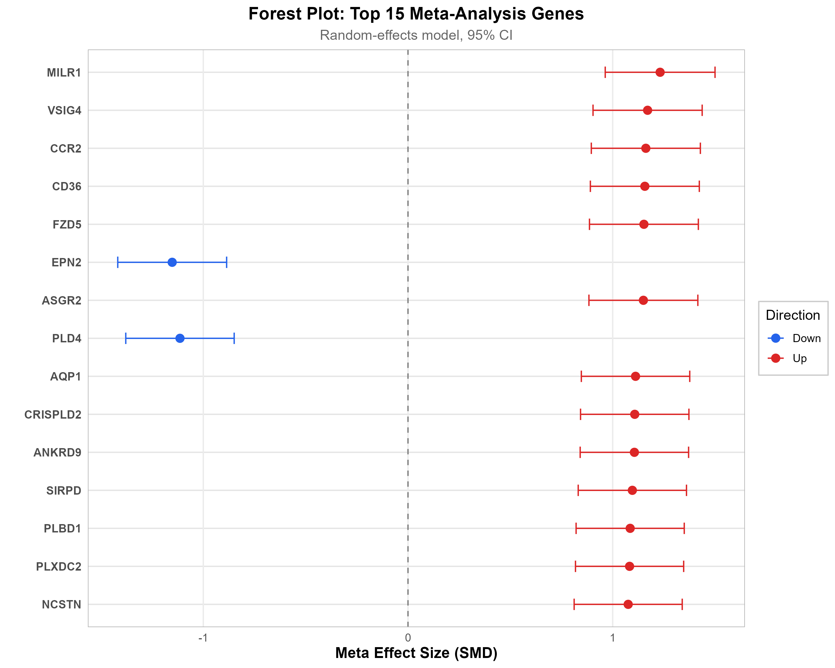

Fig. 2. Receiver operating characteristic curves for the evaluated validation models.
