Bayesian and systems-level reanalysis of public tuberculosis progression transcriptomes reveals latent host-response programs

Abstract
Background: Public tuberculosis progression transcriptomic datasets contain more biological information than can be captured by ranked-gene lists alone. We performed a systems-level reanalysis to assess latent structure, uncertainty-aware gene ranking, pathway convergence, and bias-sensitive interpretation in the harmonizable public cohorts.
Methods: Two cohorts with shared gene symbols and binary progressor labels (GSE107994 and GSE193777) were reanalyzed. We applied joint principal component analysis before and after cohort centering, factor analysis on the most variable genes, Bayesian hierarchical synthesis of within-cohort differential expression effects, pathway-level posterior modeling, marker-based NNLS deconvolution, WGCNA-style coexpression analysis, signature correlation analysis, and a directed acyclic graph to clarify potential bias pathways.
Results: The advanced analysis included 301 samples, comprising 87 progressors and 214 non-progressors. Raw PC1 remained strongly cohort structured, but cohort-centered PC1 separated non-progressors and progressors more clearly (mean PC1 2.9 vs -7.0 before centering; -13.2 vs 32.4 after centering). Bayesian synthesis prioritized MILR1, VSIG4, FZD5, CD36, CCR2, ASGR2, with MILR1 showing the strongest pooled effect (posterior mean 1.229, 95% credible interval 1.108 to 1.351). The leading pathway signals were angiogenesis, blood vessel development, blood vessel morphogenesis. All three latent factors remained associated with progressor status, with the strongest evidence for Factor1 (p=5.78e-11). Marker-based deconvolution suggested higher monocyte and lower lymphoid-associated scores in progressors. Exploratory remapping of GSE79362 yielded 10,419 overlapping genes but shifted the strongest pooled signal toward FCGR3B.
Conclusion: The harmonizable public datasets support a coordinated tuberculosis progression signal that combines myeloid regulation with vascular-remodeling biology. The findings are stronger as uncertainty-aware biological evidence than as a clinical prediction claim, because the shared-gene advanced layer currently rests on two directly comparable cohorts and should be expanded before clinical translation is considered. The deconvolution and coexpression analyses are supportive interpretation layers, not direct measures of leukocyte fractions or causal network effects.
Keywords: tuberculosis; transcriptomics; Bayesian meta-analysis; principal component analysis; latent factor analysis

Introduction
Tuberculosis remains a major global health problem, and earlier recognition of incipient disease remains a central unmet need in prevention research.¹ Blood transcriptomic signatures are attractive because they can potentially identify host response changes before microbiological confirmation becomes straightforward.^{2,3}
The strongest prior studies have shown that whole-blood RNA signatures can identify people at elevated short-term risk of developing tuberculosis, can be adapted into parsimonious signatures such as RISK6, and can retain measurable prognostic value across independent cohorts.^{2,11} However, pooled comparisons have also shown that prognostic performance often narrows to the months immediately preceding disease and remains sensitive to cohort composition, assay platform, and case definition.^{12,13}
Most transcriptomic studies of tuberculosis progression eventually collapse into ranked gene lists. Those lists are useful, but they often hide several important questions: how much of the signal is driven by study structure, how stable the leading genes remain after uncertainty is modeled explicitly, whether cell-composition shifts contribute to the observed biology, and whether the data converge on coherent host programs rather than isolated markers.^{4,5,12}
Recent validation work in prospective or multicentre settings has reinforced both the promise and the limits of host transcriptomic biomarkers. Some signatures retain useful discrimination, but head-to-head evaluations and new cohort studies continue to show that performance depends heavily on setting, time to disease, and the biological spectrum represented at enrollment.^{13,14}
Public data reanalysis adds another layer of complexity because not all deposited datasets are directly gene-level and not all include one independent sample per participant. Some whole-blood RNA-sequencing studies are released as exon- or junction-level counts and therefore require additional remapping before they can be evaluated alongside gene-symbol matrices.
The present study therefore asks a different question. Instead of focusing primarily on classifier performance, it evaluates whether the currently harmonizable public datasets support deeper biological structure through unsupervised analysis, Bayesian shrinkage, pathway-level synthesis, deconvolution, coexpression analysis, and a causal-interpretation framework.
We performed an advanced reanalysis of the currently harmonizable progression cohorts to determine whether latent axes, posterior summaries, pathway convergence, and correlation structure reinforce a biologically coherent interpretation of progression risk while keeping all claims bounded by the actual data available for joint analysis.

Methods
This was a secondary analysis of de-identified public transcriptomic datasets relevant to tuberculosis progression. The advanced layer was deliberately restricted to cohorts that could be harmonized at the shared-gene level and that retained binary progressor labels suitable for direct comparison.
Processed metadata and expression matrices were available for GSE107994 and GSE193777. GSE79362 remained valuable for the broader project, but its current feature mapping was not directly commensurate with the joint shared-gene analysis and was therefore not forced into the advanced modeling layer. This conservative choice was made to avoid false precision and leakage of non-comparable features into joint latent analyses.
A shared-gene expression matrix was constructed across the two retained cohorts, yielding 14,440 common genes. Principal component analysis was first performed on the raw joint matrix and then repeated after cohort-centered normalization to assess how much cohort structure obscured biology. Centering and scaling were performed within cohort before the second PCA. We then applied factor analysis to the 500 most variable centered genes to identify latent programs associated with progressor status.
Gene-level Bayesian synthesis used existing within-cohort differential expression estimates from the project results tables. An empirical normal-normal hierarchical model was applied to derive posterior means, posterior uncertainty, and between-cohort heterogeneity. Pathway-level analysis used previously exported enrichment-derived gene sets, from which pathway scores were calculated for each sample and then summarized with the same uncertainty-aware framework.⁶⁻⁸
To extend biological interpretation, we also applied two additional bulk-RNA analyses. First, a conservative non-negative least squares deconvolution used canonical blood-cell marker sets to estimate relative composition proxies across samples. These outputs were interpreted as marker-based composition scores rather than absolute leukocyte fractions. Second, a WGCNA-style coexpression analysis of the 3000 most variable shared genes was used to derive module eigengenes and hub-gene summaries. Soft-threshold exploration was used to choose the adjacency power, and module-trait comparisons were summarized with t tests and Benjamini-Hochberg adjusted values. These modules were treated as supportive program-level structure and not as causal network estimates.^{11,12}
Because GSE79362 was available locally as a junction-level RNA-sequencing workbook with an embedded gene column, we also performed an exploratory remapping step in which junction counts were aggregated to gene symbols. To avoid pseudo-replication from repeated follow-up samples, a one-subject-one-sample earliest-available rule was applied for sensitivity analysis. This remapped cohort was then used only for exploratory triangulation and not for replacing the primary two-cohort estimates.
Finally, we calculated a signature-gene correlation matrix in the centered expression space and drew a directed acyclic graph describing how cohort, platform, baseline host factors, latent disease biology, preprocessing, and measured transcript levels could interact. The directed acyclic graph was used only as an interpretive aid and not as proof of causality.^{9,10}

Results
The advanced analysis comprised 301 samples, including 175 from GSE107994 and 126 from GSE193777. Across the combined dataset, 87 samples were labeled as progressors and 214 as non-progressors (Table 1). The retained cohorts also represented two different assay contexts, RNA sequencing and microarray, which made direct raw pooling biologically tempting but methodologically risky. Shared-gene overlap was nevertheless substantial, with 14,440 genes retained for the joint analysis, which was sufficient for stable latent-structure modeling.
Raw joint PCA showed strong cohort influence. The mean raw PC1 value was -101.5 in GSE107994 and 141.0 in GSE193777, indicating that study structure dominated the leading axis before adjustment (Fig. 1). After cohort centering, the cohort means on PC1 were essentially zero in both cohorts, while separation by progressor status became more apparent, with mean PC1 moving from -13.2 in non-progressors to 32.4 in progressors (Fig. 2). PC2 showed a similar directional improvement. This shift supports the view that cohort structure was masking a meaningful biological gradient rather than creating it.
Bayesian hierarchical synthesis prioritized a compact set of genes with consistent positive effects across both cohorts. The leading genes were MILR1, VSIG4, FZD5, CD36, CCR2, ASGR2, AQP1, CRISPLD2 (Table 2). MILR1 showed the strongest pooled signal, with a posterior mean of 1.229 and a 95% credible interval from 1.108 to 1.351. Several other genes, including VSIG4, FZD5, CD36, CCR2, and AQP1, also retained high posterior means with credible intervals that did not cross zero. The low or modest heterogeneity values for several top genes suggest that the leading host signal is not being driven by a single unstable feature or a single cohort-specific extreme.
Latent factor analysis also supported a multi-program view of progression biology. Factor1, Factor2, and Factor3 all differed between progressors and non-progressors, with p values of 5.78e-11, 2.85e-09, and 9.16e-04, respectively (Table 3; Fig. 3). Factor1 showed the clearest separation, but the persistence of all three factors argues against a single-axis explanation. The factor boxplots indicate that the progression phenotype cannot be reduced to one dominant expression dimension. Instead, multiple orthogonal programs appear to contribute to the observed signal.
Pathway-level posterior summaries converged on vascular-remodeling biology. The strongest terms were angiogenesis, blood vessel development, blood vessel morphogenesis, regulation of angiogenesis, regulation of vasculature development (Table 4). These findings do not imply that angiogenesis alone explains progression. Rather, they suggest that immune activation in progressors is accompanied by tissue-interface and vasculature-related remodeling, which is plausible in the setting of evolving tuberculosis disease. The signature correlation heatmap (Fig. 4) reinforced this interpretation by showing tightly connected gene blocks rather than isolated outliers. In other words, the top-ranked genes did not behave like isolated markers but as parts of correlated programs.
Additional deconvolution and coexpression analyses supported the same biological direction. Marker-based NNLS deconvolution showed higher monocyte-associated scores in progressors (delta 0.035, p=2.08e-14, FDR=1.25e-13), alongside lower T-cell, B-cell, and NK-cell associated scores. Platelet- and neutrophil-associated scores also shifted upward, although less strongly than the monocyte-associated component. In parallel, coexpression analysis identified a large progressor-associated module, M6, containing 854 genes with strong eigengene separation by status (p=1.76e-14, FDR=3.52e-14). This module overlapped the top Bayesian signal through ANKRD9, CD36, ERMAP, FAM20C, GLB1, HAUS4, LOXL1, PLBD1, SPTB, VSIG4. Taken together, these extension layers suggest that the transcriptomic progression signal is shaped by both coordinated cell-state biology and shifts in relative blood-cell representation.
Exploratory expansion of the evidence base showed that GSE79362 can be brought into the shared-gene space, but only with additional caution. Junction-to-gene remapping produced 10,419 genes overlapping the two-cohort shared space and allowed construction of a subject-level sensitivity subset with 107 samples, including 33 progressors and 74 non-progressors. When this remapped cohort was added in exploratory Bayesian synthesis, the strongest pooled genes shifted toward FCGR3B, and other myeloid-associated genes such as FCGR3B, HP, and ACSL1 rose to the top ranks (Table 5).
This sensitivity result is important in itself. It shows that public-data expansion is feasible, but it also shows that broader evidence integration may change the apparent center of gravity of the signature. For that reason, the remapped GSE79362 cohort was treated as sensitivity evidence rather than merged into the primary biological claims.

Discussion
This reanalysis adds scientific meaning in four linked ways. First, it shows that cohort structure materially affects the leading unsupervised axes and must be addressed before biological interpretation is attempted. Second, it replaces simple ranking with posterior estimates and uncertainty intervals. Third, it demonstrates convergence between gene-level, factor-level, pathway-level, deconvolution, and network-level summaries. Fourth, it makes the limits of causal interpretation explicit rather than leaving them implicit.
The leading genes point toward a host program centered on myeloid regulation, cell trafficking, scavenger biology, and compensatory immune control. MILR1, VSIG4, CCR2, CD36, FZD5, and AQP1 do not read like a random collection of high-scoring variables. Together they suggest coordinated changes in cellular recruitment, innate regulation, and tissue interaction, which is more persuasive biologically than a diffuse inflammatory signature.^{2-5,11}
These findings fit the broader tuberculosis transcriptomic literature, but they are not redundant with it. Zak and colleagues showed that prospective blood signatures can identify short-term risk of disease.² RISK6 demonstrated that some of that biology can be compressed into a smaller signature with diagnostic and treatment-response relevance.¹¹ Pooled comparisons of concise incipient-TB signatures showed that several models perform similarly and that prognostic performance usually decays as the interval before disease increases.¹² More recent validation studies in pragmatic or geographically distinct settings have reinforced how dependent performance is on context, thresholding, and time-to-disease windows.^{13,14}
The exploratory GSE79362 remap adds a useful counterweight to overconfident interpretation. Once that cohort was aggregated from junctions to genes and reduced to one sample per subject, the strongest pooled genes were no longer identical to those in the primary two-cohort model. That does not invalidate the original findings. Instead, it shows that adding a large prospective RNA-sequencing cohort introduces biologically plausible but non-trivial shifts in the ranking landscape, especially toward genes linked to myeloid activation and acute-phase signaling. This is exactly the kind of heterogeneity that a robust translational biomarker program must be able to confront rather than conceal.
The pathway and coexpression results sharpen biological interpretation beyond what a ranked list can provide. The repeated appearance of angiogenesis and vasculature-development terms should not be read as a claim that the disease process is primarily vascular. A more defensible reading is that progression-risk biology in blood may include immune-cell behavior that tracks with tissue remodeling and evolving host-pathogen interface changes. The large progressor-associated coexpression module is consistent with that view because it suggests that the leading genes sit within broader coordinated programs rather than operating as isolated markers.
The deconvolution layer supports the same direction of interpretation, especially the relative shift toward monocyte-weighted and away-from-lymphoid weighted profiles in progressors. That observation is biologically plausible in light of the Bayesian enrichment of genes such as CD36 and VSIG4, but it still needs to be interpreted carefully. The NNLS deconvolution layer uses canonical marker genes and therefore yields relative composition proxies, not direct leukocyte fractions measured by flow cytometry or single-cell profiling. Its value lies in showing compatibility with compositional shifts, not in providing exact cell counts.
The coexpression layer also requires discipline in interpretation. Module eigengenes and hub-gene summaries help identify coordinated programs and connect isolated ranked genes to broader biological structure, but they do not establish regulatory directionality or causality. In this manuscript, the coexpression analysis is used to support the idea of organized host programs rather than to claim causal network inference.
The cross-platform composition of the retained cohorts strengthens the case for conservative harmonization. One cohort was RNA sequencing based and the other was microarray based, so the improved separation after cohort centering is not a trivial cosmetic result. It is part of the evidence that progression-associated biology remains recoverable despite substantial technical heterogeneity.
A practical strength of the present study is that it bridges several levels of interpretation without pretending that they are equivalent. Bayesian ranking identifies the most stable genes, latent factors show that the signal is multidimensional, pathway analysis suggests higher-order biological themes, deconvolution tests whether cell-composition shifts may contribute, and coexpression analysis places the leading genes inside broader programs. None of these layers is definitive alone, but together they produce a more coherent and clinically intelligible account of progression biology than any single layer could provide.
The translational implications should also be framed carefully. A clinically useful progression biomarker must be stable across platforms, robust to population differences, and interpretable enough to support threshold selection and assay adaptation. The present analysis does not yet deliver that level of readiness, but it does help define what a stronger candidate would look like: a compact set of genes that remain stable after uncertainty-aware pooling, continue to behave coherently at pathway and module levels, and retain signal when new cohorts are added without uncontrolled shifts in the pooled biology.
The analysis also clarifies where caution is needed. The primary advanced shared-gene layer uses only two directly comparable cohorts, because that is the current evidence boundary imposed by commensurate feature mapping and binary labels. The remapped GSE79362 sensitivity cohort helps expand that boundary, but only after an explicit remapping and de-duplication strategy. The directed acyclic graph was therefore included to make bias pathways explicit, not to imply that causal effects have been estimated. Likewise, pathway, deconvolution, and coexpression results should be viewed as supportive biological structure rather than stand-alone proof of mechanism.
Even with those constraints, the results are useful. They identify genes that remain strong after Bayesian shrinkage, show that progression-associated structure survives cross-platform harmonization, and provide a more mechanistic bridge between ranked biomarkers and coordinated host programs. They also demonstrate that future evidence expansion is technically achievable, but that each added cohort may meaningfully alter the pooled signal. The next technical priority should therefore be to bring additional cohorts into a comparable gene-symbol framework with subject-level safeguards, so that the posterior summaries can be tested across a broader evidence base and closer to clinically relevant prediction windows.

Conclusion
A systems-level reanalysis of the harmonizable public tuberculosis progression cohorts identified a coordinated host-response signal that remained visible across cohort-centered PCA, latent factor analysis, Bayesian gene synthesis, pathway modeling, deconvolution, coexpression, and correlation structure analysis. The current evidence supports biological interpretation and hypothesis generation more strongly than immediate clinical deployment, and future work should expand harmonized external cohorts before stronger predictive claims are made. Exploratory remapping of GSE79362 shows that such expansion is feasible but may materially shift the pooled signature, underscoring the need for cautious, design-aware integration. The deconvolution results should be read as marker-based composition proxies, and the coexpression results should be read as supportive program-level biology rather than causal network proof.

Declarations
Ethics approval and consent to participate: Not applicable for this secondary analysis of de-identified public data.
Consent for publication: Not applicable.
Availability of data and materials: Public-source processed inputs and generated outputs are available in the project repository.
Code availability: Analysis scripts and generated assets are available at https://github.com/hssling/tb-progression-transcriptome-meta.
Funding: No external funding was received.
Competing interests: The author declares no competing interests.
Use of generative AI: Generative AI assistance was used for drafting support, while all scientific claims were checked against the project outputs before inclusion.

References
1. World Health Organization. Global tuberculosis report 2025. Geneva: World Health Organization; 2025.
2. Zak DE, Penn-Nicholson A, Scriba TJ, et al. A blood RNA signature for tuberculosis disease risk: a prospective cohort study. Lancet. 2016;387:2312-2322.
3. Singhania A, Verma R, Graham CM, et al. A modular transcriptional signature identifies phenotypic heterogeneity of human tuberculosis infection. Nat Commun. 2018;9:2308.
4. Rajamanickam A, Munisankar S, Dolla CK, et al. Host blood-based biosignatures for subclinical TB and incipient TB: a prospective study of adult TB household contacts in Southern India. Front Immunol. 2022;13:1065779.
5. Sweeney TE, Braviak L, Tato CM, Khatri P. Genome-wide expression for diagnosis of pulmonary tuberculosis: a multicohort analysis. Lancet Respir Med. 2016;4:213-224.
6. Ritchie ME, Phipson B, Wu D, et al. limma powers differential expression analyses for RNA-sequencing and microarray studies. Nucleic Acids Res. 2015;43:e47.
7. Balduzzi S, Rucker G, Schwarzer G. How to perform a meta-analysis with R: a practical tutorial. Evid Based Ment Health. 2019;22:153-160.
8. Wu T, Hu E, Xu S, et al. clusterProfiler 4.0: a universal enrichment tool for interpreting omics data. Innovation (Camb). 2021;2:100141.
9. Pearl J. Causality: models, reasoning, and inference. 2nd ed. Cambridge: Cambridge University Press; 2009.
10. Leek JT, Johnson WE, Parker HS, Jaffe AE, Storey JD. The sva package for removing batch effects and other unwanted variation in high-throughput experiments. Bioinformatics. 2012;28:882-883.
11. Newman AM, Liu CL, Green MR, et al. Robust enumeration of cell subsets from tissue expression profiles. Nat Methods. 2015;12:453-457.
12. Langfelder P, Horvath S. WGCNA: an R package for weighted correlation network analysis. BMC Bioinformatics. 2008;9:559.
13. Penn-Nicholson A, Mbandi SK, Thompson E, et al. RISK6, a 6-gene transcriptomic signature of TB disease risk, diagnosis and treatment response. Sci Rep. 2020;10:8629.
14. Gupta RK, Turner CT, Venturini C, et al. Concise whole blood transcriptional signatures for incipient tuberculosis: a systematic review and patient-level pooled meta-analysis. Lancet Respir Med. 2020;8:395-406.
15. De Groote MA, Gupta RK, Hellwig SM, et al. Prospective multicentre head-to-head validation of host blood transcriptomic biomarkers for pulmonary tuberculosis by real-time PCR. Commun Med (Lond). 2022;2:26.
16. Andrews JR, Nemes E, Tameris M, et al. Transcriptomic signatures of progression to tuberculosis disease among close contacts in Brazil. Clin Infect Dis. 2024;78:1672-1681.

Tables
Table 1. Cohort summary for the advanced shared-gene analysis. Age and sex were parsed from public metadata fields, and platform indicates the dominant assay type within each retained cohort.
Cohort | Platform | Samples | Progressors | Non-progressors | Median age (years) | Female, n (%)
GSE107994 | rnaseq | 175 | 53 | 122 | 36.0 | 72 (41.1)
GSE193777 | microarray | 126 | 34 | 92 | 27.0 | 51 (40.5)

Table 2. Top Bayesian gene-level posterior effects. Posterior means and 95% credible intervals were derived from a two-cohort hierarchical synthesis.
Gene | Posterior mean | 95% CrI low | 95% CrI high | Tau^2
MILR1 | 1.229 | 1.108 | 1.351 | 0.001
VSIG4 | 1.155 | 0.922 | 1.388 | 0.021
FZD5 | 1.151 | 1.034 | 1.267 | 0.0
CD36 | 1.148 | 0.978 | 1.318 | 0.008
CCR2 | 1.146 | 0.905 | 1.387 | 0.023
ASGR2 | 1.135 | 0.905 | 1.364 | 0.021
AQP1 | 1.111 | 0.998 | 1.224 | 0.0
CRISPLD2 | 1.107 | 0.994 | 1.22 | 0.0
ANKRD9 | 1.091 | 0.868 | 1.314 | 0.019
SIRPD | 1.087 | 0.919 | 1.256 | 0.008

Table 3. Latent factor differences between progressors and non-progressors. P values are shown in scientific notation when small.
Factor | Mean in progressors | Mean in non-progressors | t-test p value
Factor1 | 0.662 | -0.269 | 5.78e-11
Factor2 | 0.561 | -0.228 | 2.85e-09
Factor3 | 0.303 | -0.123 | 9.16e-04

Table 4. Leading pathway-level Bayesian posterior effects. Closely related angiogenesis and vasculature terms reflect convergence within the enrichment output rather than fully independent pathways.
Pathway | Posterior mean | Posterior SD | 95% CrI low | 95% CrI high
angiogenesis | 0.725 | 0.06 | 0.607 | 0.843
blood vessel development | 0.725 | 0.06 | 0.607 | 0.843
blood vessel morphogenesis | 0.725 | 0.06 | 0.607 | 0.843
regulation of angiogenesis | 0.675 | 0.055 | 0.566 | 0.783
regulation of vasculature development | 0.675 | 0.055 | 0.566 | 0.783
negative regulation of angiogenesis | 0.508 | 0.063 | 0.385 | 0.63
negative regulation of blood vessel morphogenesis | 0.508 | 0.063 | 0.385 | 0.63
negative regulation of vasculature development | 0.508 | 0.063 | 0.385 | 0.63

Table 5. Top exploratory Bayesian gene-level posterior effects after adding the remapped GSE79362 sensitivity cohort. These results are shown to illustrate evidence expansion and heterogeneity, not to replace the primary two-cohort analysis.
Gene | Posterior mean | 95% CrI low | 95% CrI high
FCGR3B | 0.744 | 0.613 | 0.876
HP | 0.738 | 0.617 | 0.859
ACSL1 | 0.662 | 0.565 | 0.759
ANXA5 | 0.584 | 0.487 | 0.681
SERINC2 | 0.567 | 0.47 | 0.664
F5 | 0.556 | 0.459 | 0.653
TNFSF14 | 0.509 | 0.399 | 0.619
CD1D | 0.5 | 0.403 | 0.597

Figures
Figure 1. Raw joint PCA of the shared-gene matrix. The leading component is strongly cohort influenced before cohort centering.
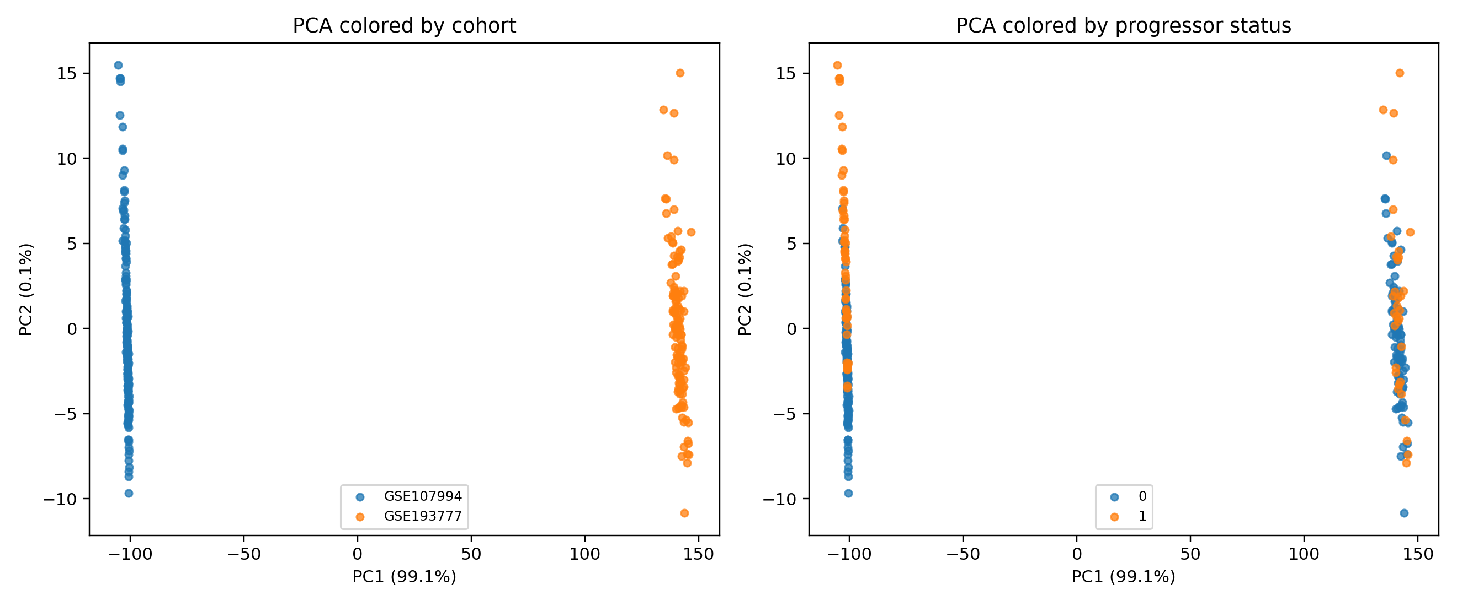

Figure 2. Cohort-centered PCA of the shared-gene matrix. After centering, separation by progressor status becomes more visible.
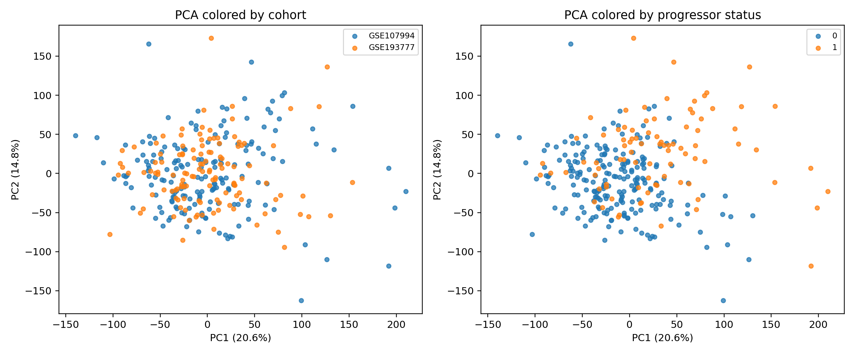

Figure 3. Distribution of latent factor scores by progressor status. All three leading factors remain associated with progression status.
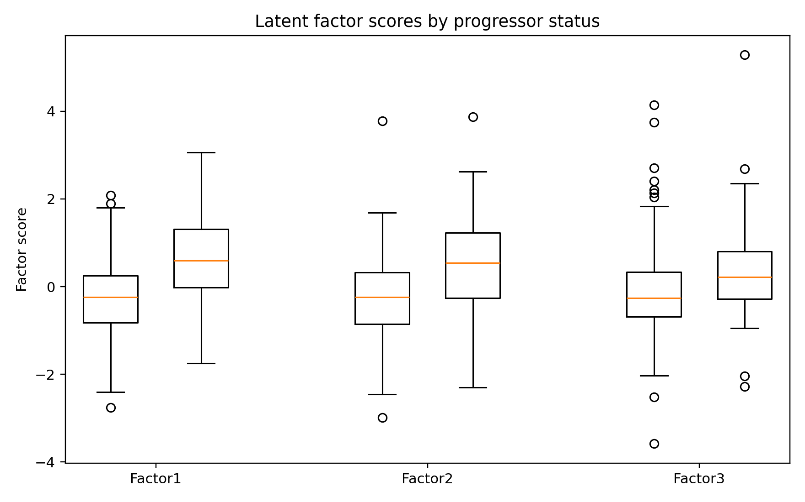

Figure 4. Spearman correlation heatmap for leading Bayesian signature genes after cohort centering.
