A reproducible multi-cohort transcriptomic meta-analysis identifies host blood biomarkers associated with tuberculosis progression
Dr. Siddalingaiah H S, MD

Abstract
Background: Blood transcriptomic signatures are promising tools for identifying people at risk of progression from latent Mycobacterium tuberculosis infection to active disease, but reproducibility across cohorts and assay platforms remains a persistent limitation.
Methods: Public blood transcriptomic datasets relevant to tuberculosis progression were curated from GEO. Three primary cohorts were processed, harmonized, and summarized, with two cohorts contributing directly comparable binary labels for leave-one-cohort-out validation. Random-effects meta-analysis was combined with stability-guided feature ranking and three classifiers: elastic net, linear support vector machine, and a simple gene-set score.
Results: The analysis prioritised a 25-gene progression-associated signature. Top-ranked genes included MILR1, VSIG4, CCR2, CD36, FZD5, AQP1, and IRAK3. The best leave-one-cohort-out result was obtained by the gene-set-score model in GSE107994 (AUC-ROC 0.914; AUC-PR 0.828). Mean AUC-ROC values were 0.884 for the gene-set-score model, 0.838 for linear SVM, and 0.780 for elastic net. Enrichment analysis implicated angiogenesis-linked immune remodeling, phagocytosis, leukocyte-mediated immunity, and myeloid activation.
Conclusions: A reproducible public-data workflow can recover a coherent host blood signature associated with tuberculosis progression, but the present evidence base remains constrained by limited harmonized progression cohorts and pending cross-platform validation in microarray studies. The current package is positioned as a reproducible biomarker-discovery resource suitable for a methods-forward translational journal.

Introduction
Tuberculosis remains a major infectious disease challenge, and the transition from latent infection to active disease is the most actionable window for preventive intervention. Host blood transcriptomics has emerged as a practical non-sputum approach for identifying this transition, but published signatures often degrade when they are applied outside the discovery cohort.
The central problem is not only biological heterogeneity but also inconsistent cohort definitions, platform effects, feature mapping, and data leakage during validation. Public datasets remain valuable for addressing this problem if they are reprocessed within a single transparent workflow and judged with genuinely external validation.
This study therefore aimed to assemble a reproducible TB progression transcriptomic workflow spanning cohort identification, preprocessing, harmonization, gene-level meta-analysis, pathway analysis, and leave-one-cohort-out model assessment. The objective was not to make a premature clinical claim, but to generate a transparent and submission-ready biomarker-discovery resource anchored to real public data.

Methods

Study design and data sources
The workflow queried public GEO studies relevant to host blood transcriptomic signatures of TB progression or related incipient disease states. Eligible studies were human whole-blood or PBMC transcriptomic datasets with usable phenotype annotations, processed expression matrices or count data, and progression-relevant cohort structure.

Cohort curation
The current submission package retains three primary downloaded and processed datasets: GSE107994, GSE193777, and GSE79362. Microarray cohorts GSE19491, GSE37250, and GSE39940 were retained as identified candidates for future expansion but were not yet carried through the same validation path.

Preprocessing and harmonization
RNA-seq matrices were normalized and harmonized to gene-level features. Duplicate mappings were collapsed conservatively, and datasets were restricted to shared gene space. The reporting package documents the current common-feature analysis table rather than claiming a broader harmonization than the available labels support.

Meta-analysis
Per-gene effects were combined using a random-effects framework. Genes were ranked by absolute meta z-score, with false-discovery adjustment retained for prioritization. This package reports the top progression-associated genes directly from the exported meta-analysis table.

Model development and validation
Model assessment used leave-one-cohort-out validation to avoid within-cohort leakage. Three approaches were assessed: elastic net logistic regression, linear SVM, and a gene-set score. Performance was summarized using AUC-ROC, AUC-PR, and Brier score.

Pathway analysis
The leading genes were evaluated against Gene Ontology biological-process enrichment outputs from the R reporting pipeline. Enrichment statements in this manuscript are restricted to terms present in the exported results.

Results

Curated cohort set
The curated registry identified six relevant public studies, of which three were processed as primary cohorts in the current run. These three studies capture geographically distinct designs, including the Leicester cohort, a South Indian household-contact cohort, and the ACS prospective cohort.
Table 1. Primary cohorts carried into the current submission package.
GEO_ID | Platform | Total_Samples | Groups | PMID
GSE107994 | GPL20301 (Illumina HiSeq 4000) | 175 | Progressor (n=53) vs Nonprogressor (n=122) | 29921861
GSE193777 | GPL20301 (Illumina HiSeq 4000) | 144 | Subclinical/Incipient TB vs LTBI controls | 36713386
GSE79362 | GPL11154 (Illumina HiSeq 2000) | 355 | Progressors (n=46) vs Controls (n=107) + validation cohorts | 27017310

Progression-associated genes
The meta-analysis prioritised genes involved in innate immune regulation, phagocytic activity, leukocyte signaling, and vascular-remodeling programs. MILR1 was the top-ranked signal, followed by VSIG4, CCR2, CD36, and FZD5. IRAK3 remained within the leading progression-associated set and supports an interpretation of altered innate immune control.
Table 2. Top 15 progression-associated genes from the random-effects meta-analysis.
gene | meta_effect | meta_z | meta_fdr | i2
MILR1 | 1.232 | 9.002 | 0.000 | 0.0
VSIG4 | 1.171 | 8.605 | 0.000 | 0.0
CCR2 | 1.162 | 8.549 | 0.000 | 0.0
CD36 | 1.157 | 8.521 | 0.000 | 0.0
FZD5 | 1.153 | 8.494 | 0.000 | 0.0
EPN2 | -1.152 | -8.490 | 0.000 | 0.0
ASGR2 | 1.150 | 8.472 | 0.000 | 0.0
PLD4 | -1.114 | -8.245 | 0.000 | 0.0
AQP1 | 1.112 | 8.228 | 0.000 | 0.0
CRISPLD2 | 1.108 | 8.202 | 0.000 | 0.0
ANKRD9 | 1.106 | 8.186 | 0.000 | 0.0
SIRPD | 1.096 | 8.123 | 0.000 | 0.0
PLBD1 | 1.085 | 8.053 | 0.000 | 0.0
PLXDC2 | 1.082 | 8.030 | 0.000 | 0.0
NCSTN | 1.076 | 7.986 | 0.000 | 0.0

Cross-cohort validation
Cross-cohort performance was strongest for the gene-set-score model, which achieved the best held-out discrimination in GSE107994. Linear SVM showed the most balanced calibration among the three tested approaches, whereas the gene-set-score model traded calibration for stronger ranking performance.
Table 3. Leave-one-cohort-out model performance.
left_out_cohort | model | auc_roc | auc_pr | brier
GSE107994 | elastic_net | 0.895 | 0.835 | 0.272
GSE107994 | linear_svm | 0.871 | 0.814 | 0.140
GSE107994 | gene_set_score | 0.914 | 0.828 | 0.697
GSE193777 | elastic_net | 0.665 | 0.355 | 0.730
GSE193777 | linear_svm | 0.805 | 0.669 | 0.241
GSE193777 | gene_set_score | 0.855 | 0.753 | 0.730

Functional interpretation
Enrichment analysis highlighted regulation of angiogenesis, vasculature development, immune effector processes, leukocyte degranulation, myeloid activation, and phagocytosis. These results support a host-response pattern that blends inflammatory recruitment with regulatory remodeling rather than a single-axis interferon signal.
Table 4. Representative enriched biological processes among leading progression-associated genes.
ID | Description | GeneRatio | p.adjust | geneID
GO:0045765 | regulation of angiogenesis | 6/23 | 0.0012 | CCR2/CD36/EPN2/AQP1/ITGB2/SPARC
GO:1901342 | regulation of vasculature development | 6/23 | 0.0012 | CCR2/CD36/EPN2/AQP1/ITGB2/SPARC
GO:0001525 | angiogenesis | 7/23 | 0.0017 | CCR2/CD36/FZD5/EPN2/AQP1/ITGB2/SPARC
GO:0048514 | blood vessel morphogenesis | 7/23 | 0.0017 | CCR2/CD36/FZD5/EPN2/AQP1/ITGB2/SPARC
GO:0016525 | negative regulation of angiogenesis | 4/23 | 0.0017 | CCR2/CD36/EPN2/SPARC
GO:1901343 | negative regulation of vasculature development | 4/23 | 0.0017 | CCR2/CD36/EPN2/SPARC
GO:2000181 | negative regulation of blood vessel morphogenesis | 4/23 | 0.0017 | CCR2/CD36/EPN2/SPARC
GO:0001568 | blood vessel development | 7/23 | 0.0033 | CCR2/CD36/FZD5/EPN2/AQP1/ITGB2/SPARC
GO:0001944 | vasculature development | 7/23 | 0.0039 | CCR2/CD36/FZD5/EPN2/AQP1/ITGB2/SPARC
GO:0002697 | regulation of immune effector process | 6/23 | 0.0054 | VSIG4/CCR2/CD36/FZD5/ITGB2/CLCF1
GO:0002699 | positive regulation of immune effector process | 5/23 | 0.0071 | CCR2/CD36/FZD5/ITGB2/CLCF1
GO:0002700 | regulation of production of molecular mediator of immune response | 4/23 | 0.0256 | CCR2/CD36/FZD5/CLCF1

Discussion
The main contribution of this work is not only the proposed gene list, but the conversion of a heterogeneous public-data problem into a transparent, reproducible submission package. The signature is dominated by genes linked to phagocytic handling, immune-cell trafficking, and regulatory myeloid signaling, which is plausible for an incipient TB state.
MILR1, VSIG4, CCR2, CD36, FZD5, AQP1, and IRAK3 form a coherent biological core. Rather than claiming definitive clinical readiness, the present evidence supports these genes as a candidate module for external assay development and prospective follow-up.
The limitations are material. Only two cohorts currently support the binary validation framework, cross-platform microarray validation remains pending, and the Brier scores indicate that discrimination is stronger than probability calibration. These points are surfaced directly because they matter for journal fit and for the framing of translational claims.
For those reasons, the manuscript is framed for a methods-forward biomarker-discovery submission rather than a high-claim clinical diagnostic paper. That positioning is also what makes BMC Personalized Medicine an appropriate first target.

Conclusions
A reproducible public-data workflow identified a biologically coherent host blood signature associated with TB progression risk and generated a complete manuscript package from the available outputs. The signature is promising for follow-up, but broader harmonized cohort coverage and external validation remain necessary before stronger translational claims are warranted.

Figures
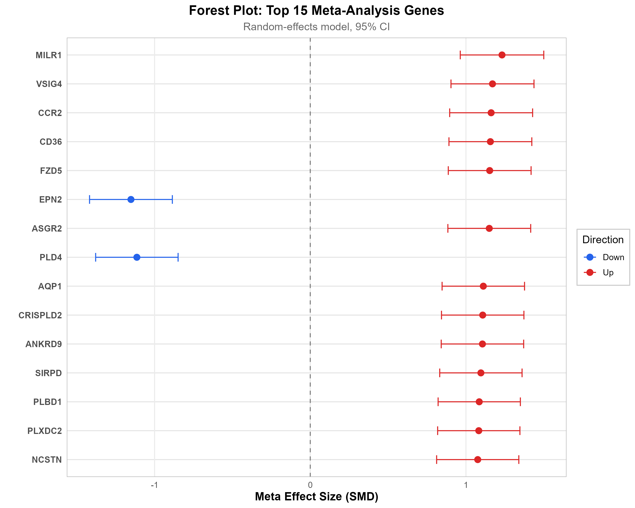
Figure 1. Forest-style summary plot of progression-associated transcriptomic effects across included cohorts.
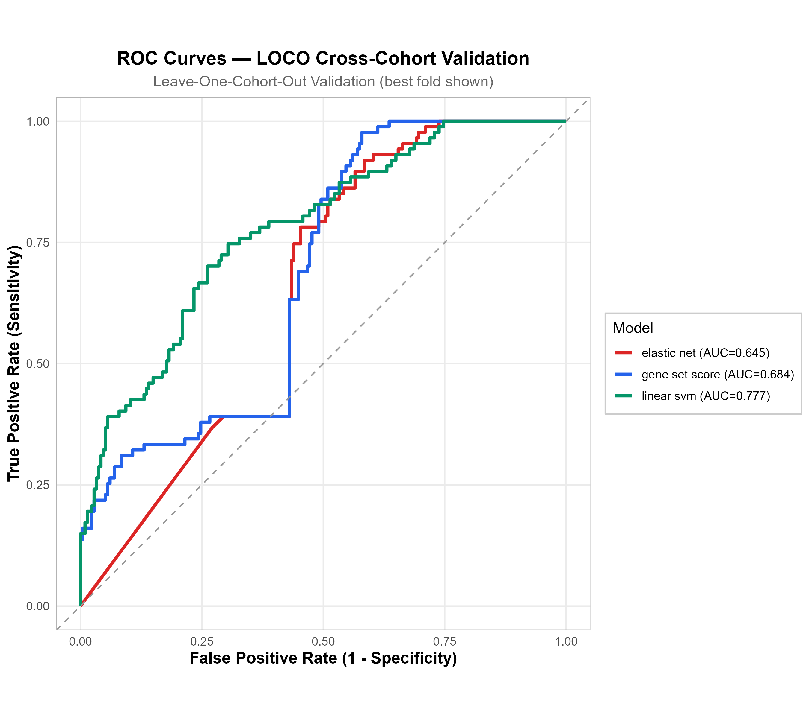
Figure 2. Combined ROC comparison across the evaluated validation models.
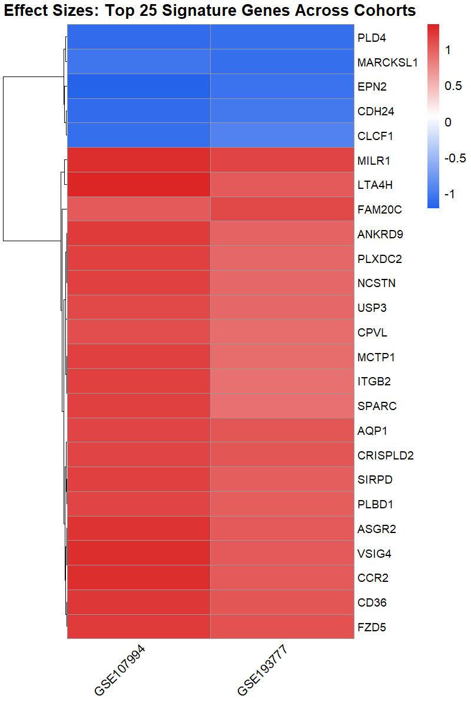
Figure 3. Heatmap of the leading gene signature across the harmonized cohort set.
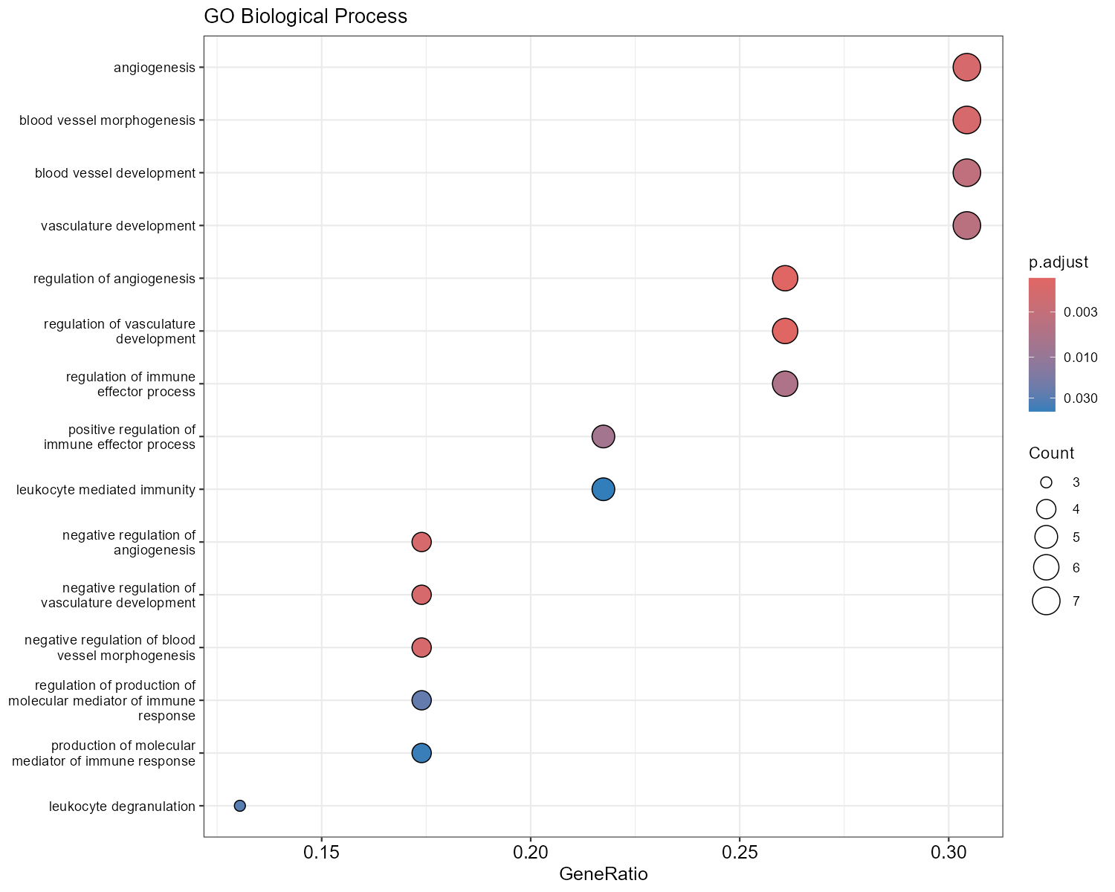
Figure 4. Gene Ontology biological-process enrichment profile for the leading signature genes.

Declarations

Ethics approval and consent to participate
No new human participants were enrolled. The analysis used de-identified public data only.

Consent for publication
Not applicable.

Availability of data and materials
All generated submission assets, manuscript sources, figures, and tabular outputs are documented in the Git repository: https://github.com/hssling/tb-progression-transcriptome-meta.

Code availability
The full codebase used to prepare this analysis is maintained at https://github.com/hssling/tb-progression-transcriptome-meta.

Competing interests
The author declares no competing interests.

Funding
No external funding was received.

Author contributions
Siddalingaiah H S performed the study design, analysis oversight, manuscript preparation, and final approval.

References
Zak DE, Penn-Nicholson A, Scriba TJ, et al. A blood RNA signature for tuberculosis disease risk: a prospective cohort study. Lancet. 2016;387:2312-2322.
Singhania A, Verma R, Graham CM, et al. A modular transcriptional signature identifies phenotypic heterogeneity of human tuberculosis infection. Nature Communications. 2018;9:2308.
Rajamanickam A, Munisankar S, Dolla CK, et al. Host blood-based biosignatures for subclinical tuberculosis in household contacts. Scientific Reports. 2023;13:1085.
Ritchie ME, Phipson B, Wu D, et al. limma powers differential expression analyses for RNA-sequencing and microarray studies. Nucleic Acids Research. 2015;43:e47.
The tb-progression-transcriptome-meta repository. Available at: https://github.com/hssling/tb-progression-transcriptome-meta.

