**機率 HW2**

**通訊二**

**姓名：洪士庭**

**學號：107503514**

1. **程式流程說明**

**Homework 2.1**

**(1)、定義 time.h**

**(2)、進入主程式並用 srand() 函數**

**(3)、令a、b、c2-c12為整數且初值為0**

**(4)、進入for迴圈，重複以下動作10000次。**

**a= (rand() % 6) + 1;**

**b = (rand() % 6) + 1;**

**丟兩粒骰子，進入switch選擇丟到點數之和的case，**

**並使得c(數字和)的值+1**

**(5)、分別印出點數和為2、3、4、…….、12各幾次**

**(6)、程式結束**

**Homework 2.2**

**(1)、引入 #include <stdio.h>**

**#include<stdlib.h>**

**#include <iostream>**

**#include <random>**

**#include<math.h>**

**(2)、定義unsigned long long factorial(int)函數 :**

**進入for迴圈 (int g = 1; g <= f; g++) : r = r * g (引入數為f )**

**return r到主函數**

**(3)、進入主程式**

**(4)、printf印出輸入alpha ; scanf輸入alpha(令為int a)**

**(5)、引用函式庫(passion 分布)，並產生結果x**

**random_device rd**

**mt19937 generator(rd())**

**poisson_distribution<int> poisson(a) //a為alpha**

**int x = poisson(generator)**

**(6)、宣告int 陣列cal1[21] 及cal2[21] 並設初值為0**

**宣告float陣列 pmf1[21]、pmf2[21]**、**cdf1[21]、 cdf2[21]、**

**the[21] 並設初值為0**

**(7)、進入for迴圈 (int i = 0; i < 100; i++)**

**產生poisson分布的int x = poisson(generator)**

**如果x < 21，則cal1[x] += 1 ; x > 21 continue**

**(將x的值存到cal1[x]中)**

**以上重複100次**

**(8)、進入for (int ii = 0; ii < 21; ii++)**

**pmf1[ii] = (float)cal1[ii] / 100;**

**分別對cal1中計算出PMF，並將值一一存入pmf1[ii]中**

**重複21次(x從0到20)**

**(9)、for (int iii = 0; iii < 21; iii++)**

**for (int c1 = 0; c1 < iii; c1++)**

**cdf1[iii] += pmf1[c1];**

**進入巢狀迴圈(因為累加)，算CDF**

**(10)、重複(7)-(9) x改做10000次，將值分別存到cal2[21]、**

**pmf2[21]和cdf2[21]中**

**(11)、進入for (int k = 0; k < 21; k++)**

**the[k] = pow(a, k) * exp(-a) / factorial(k);**

**(引入pow、exp，並進入factorial函式)**

**算poisson分布的PMF的理論值**

**(12)、printf印出做幾次實驗、理論值**

**進入for迴圈，印出x=0-20的PMF、CDF**

**(13)、程式結束**

1. **流程圖**

**Homework 3.1**

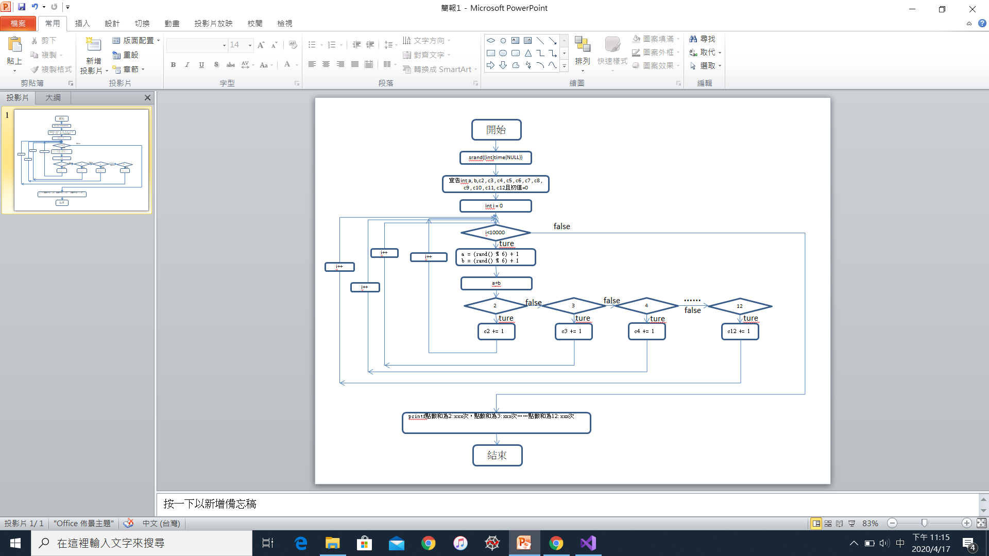

**Homework 3.2**

開始

宣告int a

print f: 輸入alpha

input a

產生poisson分布x

宣告int : cal1[21]、cal1[21] 並設初值為0

宣告float : pmf1[21]、pmf1[21]、cdf1[21]、cdf1[21]、the[21] 並設初值為0

i=0

i<100

int x = poisson(generator)

i++

x<21

cal1[x] += 1

ii=0

ii<100

ii++

pmf1[ii] = (float)cal1[ii] / 100

ii=0

iii<100

iii++

c1=0

c1 < iii

c1++

cdf1[iii] += pmf1[c1]

j=0

j<10000

int x = poisson(generator)

j++

x<21

cal2[x] += 1

jj=0

jj<10000

jj++

pmf2[jj] = (float)cal2[jj] / 10000

jj=0

jjj<100

jjj++

c2=0

c2 < jjj

c2++

Cdf2[jjj] += pmf2[c2]

k=0

k<21

the[k] = pow(a, k) * exp(-a) / factorial(k)

k++

用for迴圈印出實驗結果

結束

1. **實驗結果**

**Homework 3.1**

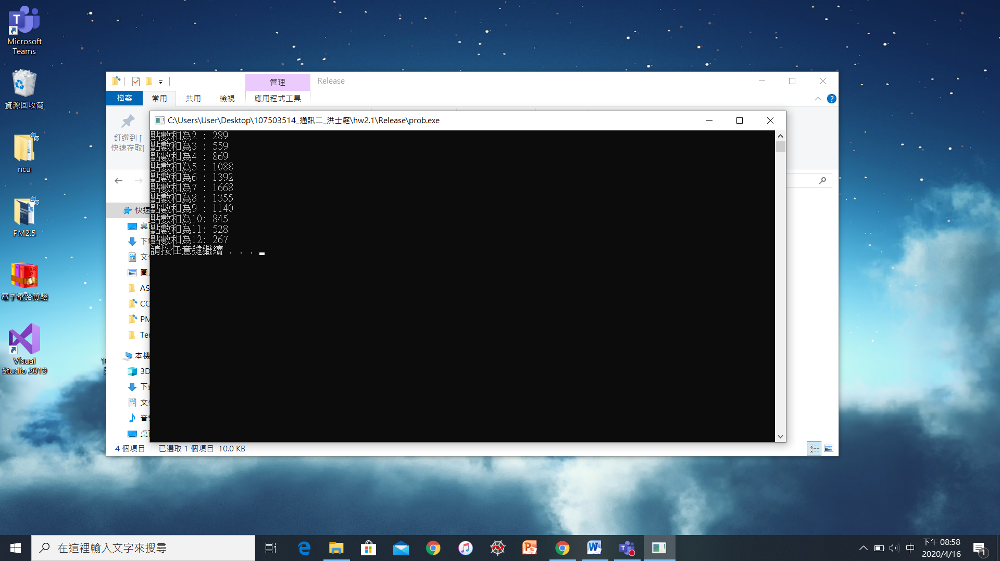

**Matlab:**

x = [2,3,4,5,6,7,8,9,10,11,12];

y=[289/10000,559/10000,869/10000,1088/10000,1392/10000,1668/10000,1355/10000,1140/10000,845/10000,528/10000,267/10000];

bar(x, y);

xlabel('點數和');

ylabel('機率');

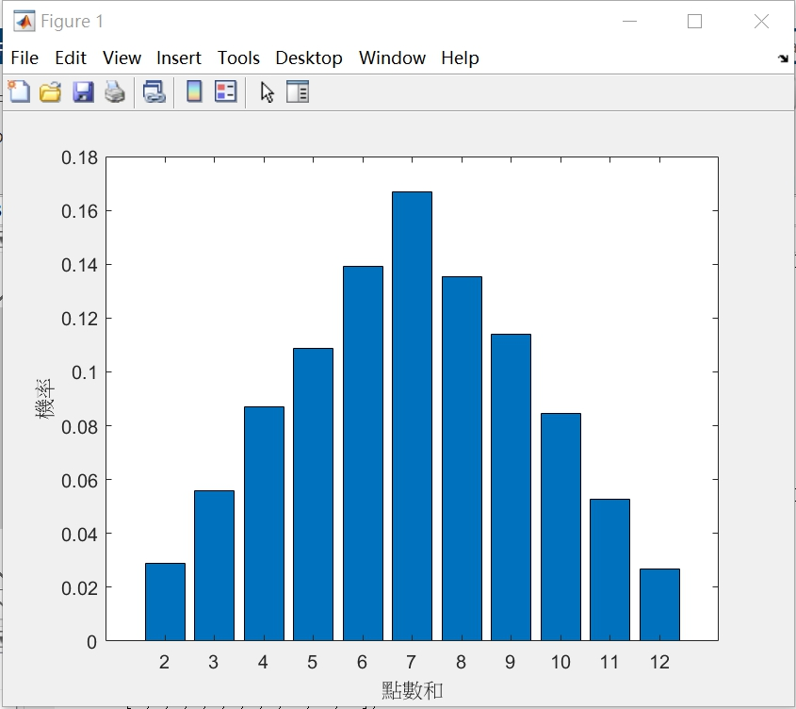

**Homework 3.2**

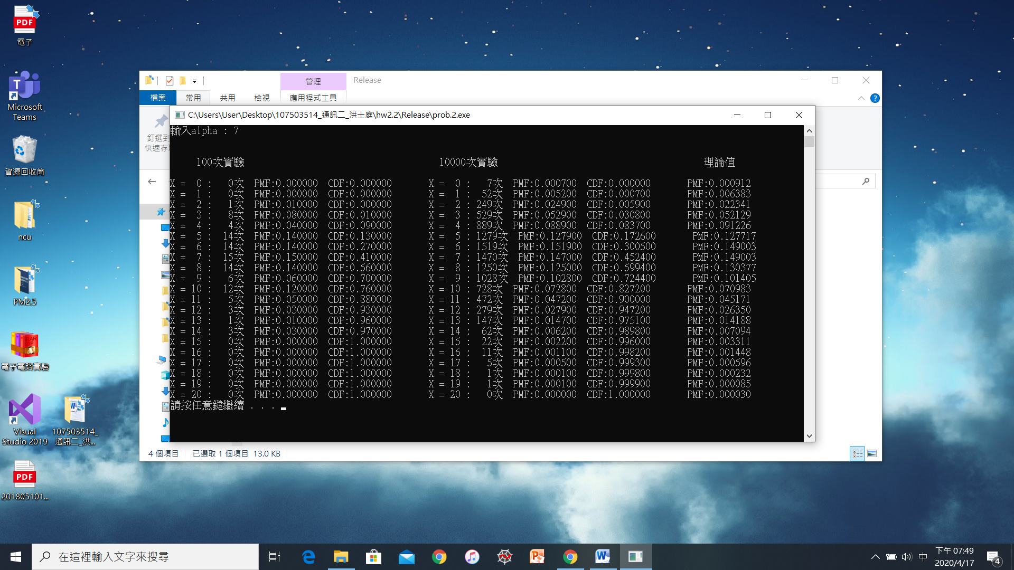

**Matlab:**

x=[0,1,2,3,4,5,6,7,8,9,10,11,12,13,14,15,16,17,18,19,20] ;

y=[0.000000,0.000000,0.010000,0.080000,0.040000,0.140000,0.140000,0.150000,0.140000,0.060000,0.120000,0.050000,0.030000,0.010000,0.030000,0.000000,0.000000,0.000000,0.000000,0.000000,0.000000];

plot(x, y, 'b');

hold on;

x=[0,1,2,3,4,5,6,7,8,9,10,11,12,13,14,15,16,17,18,19,20];

y=[0.000700,0.005200,0.024900,0.052900,0.088900,0.127900,0.151900,0.147000,0.125000,0.102800,0.072800,0.047200,0.027900,0.014700,0.006200,0.002200,0.001100,0.000500,0.000100,0.000100,0.000000];

plot(x, y, 'c');

hold on;

x=[0,1,2,3,4,5,6,7,8,9,10,11,12,13,14,15,16,17,18,19,20] ;

y=[0.000912,0.006383,0.022341,0.052129,0.091226,0.127717,0.149003,0.149003,0.130377,0.101405,0.070983,0.045171,0.026350,0.014188,0.007094,0.003310,0.001448,0.000596,0.000232,0.000085,0.000030];

plot(x, y, 'g');

hold off;

xlabel('x');

ylabel('PMF');

legend('100次實驗','10000次實驗', '理論值');

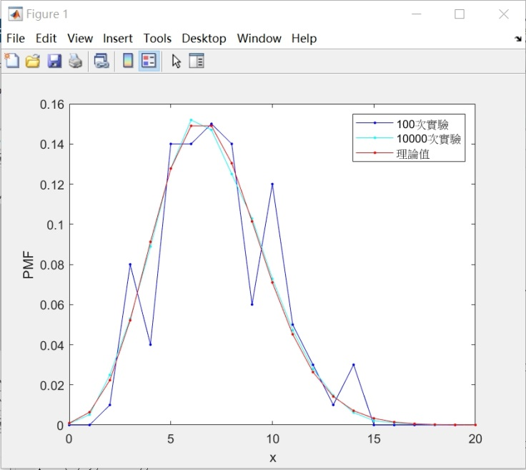

x=[0,1,2,3,4,5,6,7,8,9,10,11,12,13,14,15,16,17,18,19,20] ;

y=[0.000000,0.000000,0.000000,0.010000,0.090000,0.130000,0.270000,0.410000,0.560000,0.700000,0.760000,0.880000,0.930000,0.960000,0.970000,1.000000,1.000000,1.000000,1.000000,1.000000,1.000000];

plot(x, y, 'b.-');

hold on;

x=[0,1,2,3,4,5,6,7,8,9,10,11,12,13,14,15,16,17,18,19,20] ;

y=[0.000000,0.000700,0.005900,0.030800,0.083700,0.172600,0.300500,0.452400,0.599400,0.724400,0.827200,0.900000,0.947200,0.975100,0.989800,0.996000,0.998200,0.999300,0.999800,0.999900,1.000000};

plot(x, y, 'r.-');

hold off;

xlabel('x');

ylabel('CMF');

legend('100次實驗','10000次實驗');

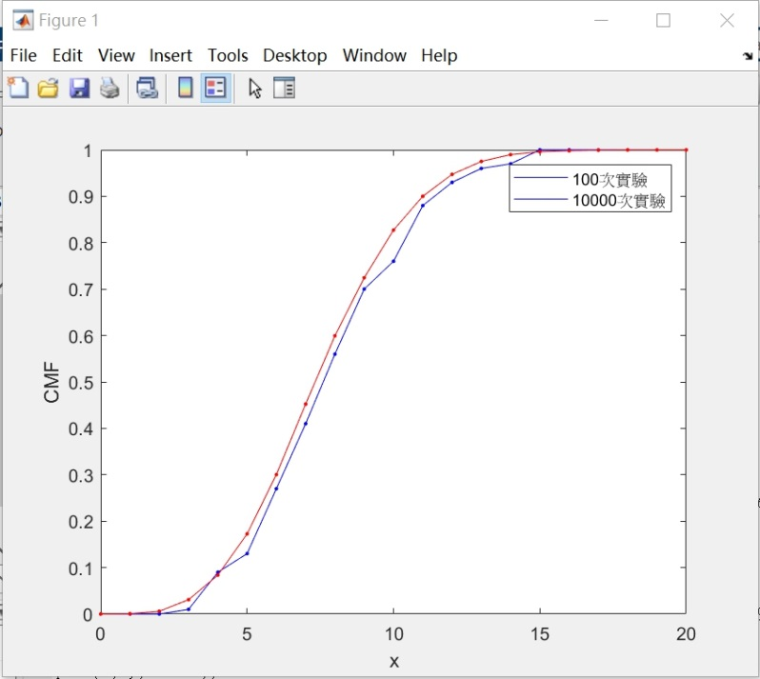

1. **討論**

2.2的poisson分布一開始有想到兩種方法，第一種是用定義去看，藉由binomial的特殊形式去寫，第二種是直接用函式庫引入poisson分布，因為第二種比較簡潔當然就用第二種囉。其中在poisson_distribution<int> poisson(a) 這行程式碼中，<>中一定要是正整數型別，因為要求的是離散而非連續的。

其他的都是比較小的問題，比如說算階乘的時候要用long long否則會溢位還有visual studio 2019的預設編譯器是c++而不是c，要去屬性面板中去改，否則無法編譯。