Vellore Institute of Technology
VIT Vellore
FALL Semester 26–27

PolyGlot

A Compiler for Mixed Syntax
Review 3 Final Project Report
Compiler Design | BCSE307P
Submitted by
Student name | Registration number
Harshit Sharma Thakur | 24BCE0437
Umang Nagaji Vekariya | 24BAI0173
Sarthak Shirish Dhawale | 24BCT0216
Aditya Mayur Khunt | 24BCE2618

Submitted to
Boominathan P, HOD
GitHub Pages
https://hst257.github.io/PolyGlot/
GitHub Repository
https://github.com/hst257/PolyGlot

Table of Contents

1 Abstract 2
2 Introduction 3
3 Literature Survey 3
4 Proposed System 4
5 System Architecture 4
6 System Design 5
7 Technology Stack 6
8 Code and Implementation 6
9 Testing and Validation 8
10 Results and Screenshots 9
11 GitHub Repository and Execution 12
12 Challenges Faced and Solutions 13
13 Conclusion 13
14 Future Scope 13
15 References 14

1 Abstract
PolyGlot compiles a restricted mixture of Python, C, C++, Java, JavaScript and BASIC inspired syntax through one shared implementation. A handwritten lexer and parser produce a common abstract syntax tree. Static analysis checks scopes and types before typed intermediate code is optimized and translated into validated stack bytecode. A custom virtual machine executes the artifact. The project includes a browser workspace for examining real compiler stages, a local Python server, and a GitHub Pages version using Pyodide. Tests and working screenshots demonstrate mixed syntax, arrays, optimization and diagnostics. The scope is an educational structured language, rather than full compatibility with six existing languages.

2 Introduction

Problem and motivation
Most programming tools require one source language at a time. This project asks whether selected familiar syntaxes can share variables, functions and control flow within one program while retaining a single set of type and execution rules. The compiler design course provides the motivation: each stage should produce a real artifact that can be inspected and tested.

Objectives
Accept supported mixed statements in one .poly file; normalize them into one AST; reject lexical, syntax and semantic errors; generate reusable .pbc bytecode; and execute it with a bounded custom VM. The interface should connect source locations to tokens, AST nodes, symbols, IR and bytecode.

3 Literature Survey
The following systems informed the comparison. They are references for compiler exploration and implementation techniques, rather than dependencies of the PolyGlot compiler.
Reference | Useful capability | PolyGlot focus
Compiler Explorer [3] | Interactive compiler and assembly inspection. | Inspect a custom shared pipeline for mixed syntax.
AST Explorer [4] | Explore ASTs produced by different parsers. | Connect the normalized AST to semantics and execution.
Pyodide [5] | Run Python in a browser worker. | Host the same Python compiler in the Pages version.

PolyGlot combines a restricted language implementation with stage inspection in one course project. These references informed inspection and deployment choices; the project implements its own lexer, parser, semantic analyzer, optimizer, code generator and virtual machine.

4 Proposed System
The proposed system uses syntax family parsers as frontends to a common typed language. A C style function can be called from a Python style loop; supported output forms all lower to shared operations. One compiler library serves the CLI, local IDE and hosted IDE.
Implemented features include primitive types, fixed length one dimensional arrays, lexical scopes, annotated functions, recursion, loops, branches, const bindings, source diagnostics, IR optimization and reusable bytecode. The main distinction is shared semantics across syntax forms within one program.

5 System Architecture
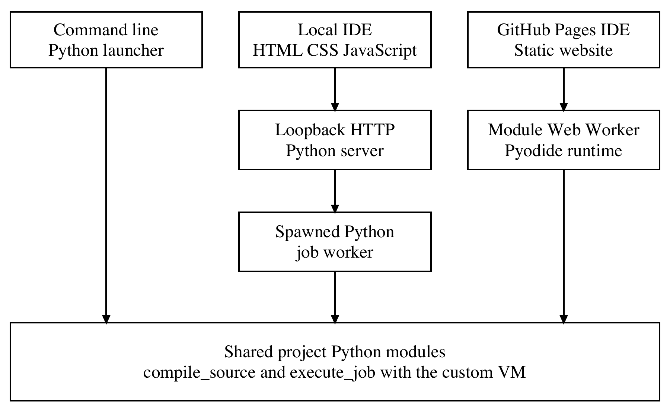
Figure 1 Application architecture and the two browser execution routes
Local route: the browser sends JSON requests to a loopback Python server, which launches a separate job worker. Hosted route: a module Web Worker loads Pyodide and the project Python modules. The hosted route runs in the user’s browser without a remote Python backend. Both routes return compiler stages, diagnostics and output; the CLI calls the shared library directly.

6 System Design
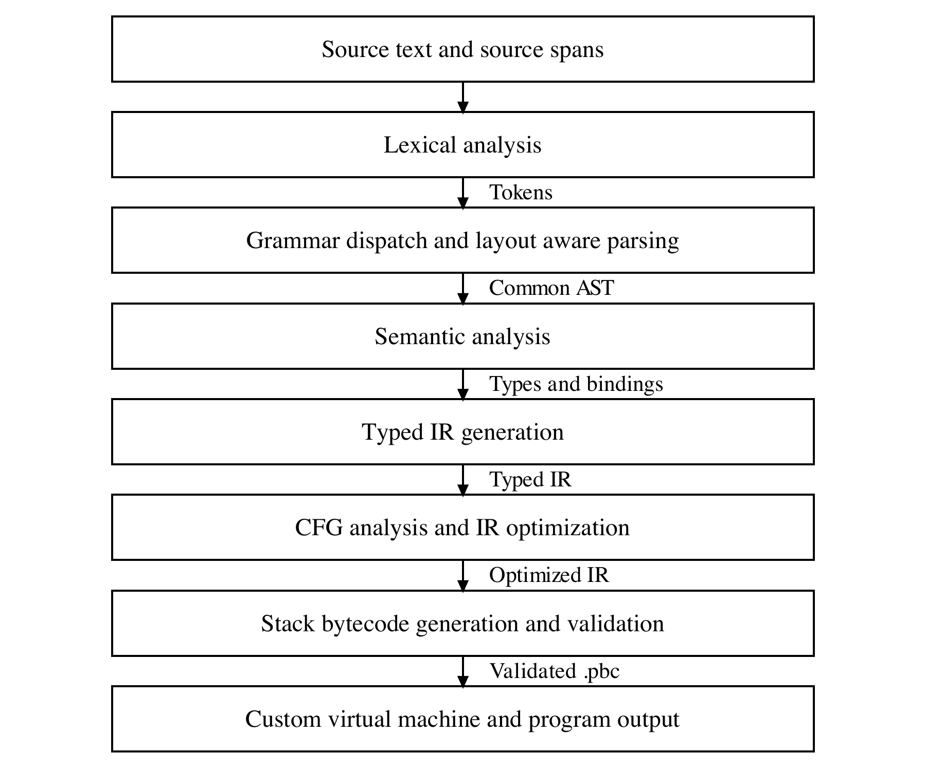
Figure 2 Compiler data flow from source to program output
The parser combines recursive descent for statements with Pratt parsing for expressions. Dispatch examines leading tokens and bounded lookahead; it does not repeatedly run six independent compilers. A declaration such as int x = 3 can remain attributed to several syntax families because the spelling is shared.
AST nodes carry a kind, source span and child data. Semantic analysis annotates them with resolved types and bindings. IR functions hold typed temporaries, labels and instructions. Bytecode functions hold local slot counts and validated operations. A VM frame contains its function, locals, instruction pointer and operand stack; recursive calls receive fresh frames.
There is no database or persistent entity model, so an ER diagram is not applicable. Source files and bytecode artifacts are the main portable inputs and outputs; editor drafts are recovered through browser storage.

7 Technology Stack
Layer | Implementation
Compiler and virtual machine | Python 3.11 or newer; project code and standard library.
Workspace interface | HTML, CSS and JavaScript; bundled Phosphor SVG icons.
Local execution | Python loopback HTTP server and spawned workers.
Hosted execution | GitHub Pages; Pyodide 314.0.7 in a module Web Worker.
Development and testing | Git, GitHub Actions, pytest, Node.js test runner and jsdom.
Storage | Source and JSON bytecode files; browser storage for drafts.

8 Code and Implementation

Frontend and semantic checking
lexer.py creates tokens with positions. parser/dispatch.py selects supported grammar forms; the family parsers normalize them into the AST. semantics.py resolves lexical bindings, checks argument and return types, enforces const and definite assignment, and collects function signatures before checking function bodies.
The shared entry point is compile_source in src/polyglot/compiler.py. The following excerpt shows the actual frontend handoff:
tokens = lex(source)
parser = Parser(source, tokens)
tree = parser.parse()
analyzer = Analyzer(source)
symbols = analyzer.analyze(tree)
Compilation stops at the first error. Its response contains a stable diagnostic and completed earlier stages; the artifact is null. Invalid source therefore cannot continue to bytecode execution.

Intermediate code and optimization
ir.py lowers checked nodes into typed three address instructions. analysis.py builds basic blocks and a control flow graph, then solves backward temporary liveness. optimizer.py uses local constant facts, branch simplification, reachability and definition sensitive next use information.
OUT[B] = union of IN[S] for every successor S
IN[B] = USE[B] union (OUT[B] minus DEF[B])
Safe primitive expressions are folded; known branches become jumps; unreachable blocks and unused constant definitions are removed. Reachable calls, output, stores, arrays and potentially trapping operations are retained. Analysis is bounded, and oversized inputs keep their original IR.
Example print((2 + 3) * 4) | Original | Optimized
Output | 20 | 20
Executed VM instructions | 17 | 5

Bytecode generation and execution
codegen.py maps temporaries to local slots and translates IR to stack operations. This actual excerpt emits a binary operation:
load(inst["left"], loc)
load(inst["right"], loc)
emit("BINARY", [inst["operator"]], loc)
store(inst["dest"], loc)
Labels are recorded while emitting code; pending jump operands are patched to numeric instruction positions afterward. artifact.py validates the .pbc JSON format, version, opcodes, storage, jumps and stack behavior. vm.py executes the result using its own operand stack and activation records. The 17 to 5 result is an instruction count reduction, not a measured elapsed time speedup.

9 Testing and Validation
Verification on 26 October 2026 completed with 298 Python tests and 57 frontend tests passing. The Python run included real loopback HTTP requests and spawned workers. Coverage includes parsing, typing, arrays, recursion, optimization equivalence, malformed artifacts, runtime limits and browser workspace behavior.
Test input or case | Expected result | Result
p1_mixed.poly | total 8; formatted values; BASIC output; 8; done. | Pass
arrays_mixed.poly | 15; 7; [1, 7, 3, 4] 4. | Pass
mixed_nesting.poly | 22. | Pass
recursion.poly | 720. | Pass
print((2 + 3) * 4) | 20 with and without optimization; 17 versus 5 VM steps. | Pass
print(2 + ) | P010 at line 1, column 11; no artifact. | Pass
error_type.poly | S004 at line 2; code generation blocked. | Pass
Division by zero | R004 runtime diagnostic. | Pass
Build then execute .pbc | Same output without requiring the source file. | Pass

Runtime checks also bound execution: the defaults are 1,000,000 instructions, 64 nested calls beyond main, 65,536 output bytes and five seconds of VM execution. The local server adds a parent worker deadline. These limits support controlled demonstrations; they are not a claim of a general public hosting sandbox.
The GitHub Pages URL returned HTTP 200 during report preparation. Previously recorded browser WebAssembly checks cover 26 cases; they are documented separately from the fresh Python and frontend suite results in docs/verification.md.

10 Results and Screenshots

Mixed syntax and arrays
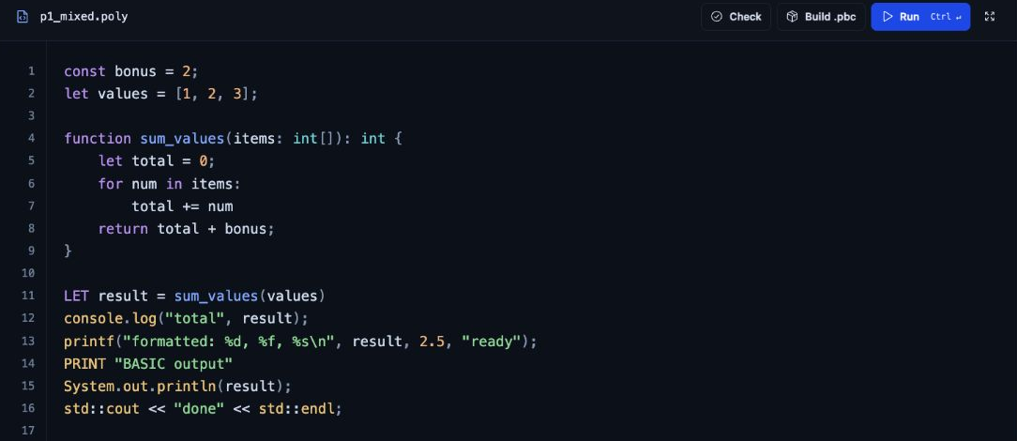
Figure 3 Working mixed syntax source using one shared function and variable environment
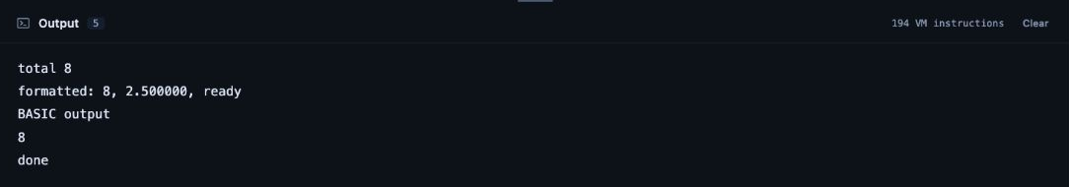
Figure 4 Actual output of p1_mixed.poly
The result demonstrates shared values across function, loop and output spellings. printf produces the formatted decimal line; the other output forms execute through the same VM.
In arrays_mixed.poly, an indexed update changes the second element from 2 to 7. The function then sums the array to 15. The output below confirms the sum, changed element and final array length.
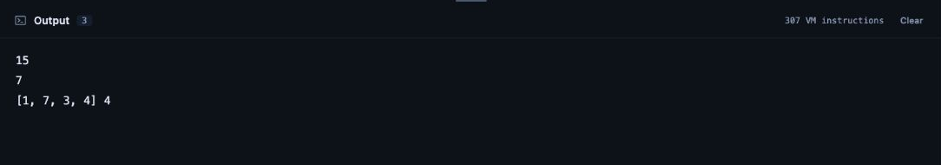
Figure 5 Actual array results including the updated element

Inspecting real compiler data
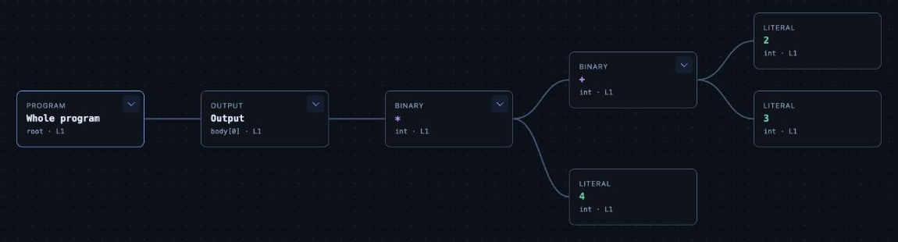
Figure 6 Connected AST for print((2 + 3) * 4)
The AST makes precedence explicit: addition is the left child of multiplication, and multiplication is the output argument. This is an abstract syntax tree, so punctuation and grammar helper productions are omitted.
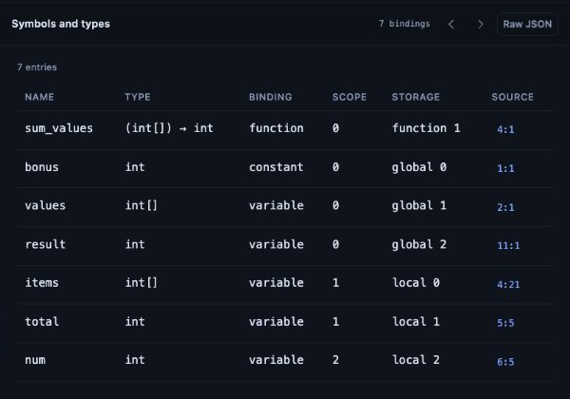
Figure 7 Resolved symbols with their scope and type information
These views display compiler records. They are not independent simulations of the phases. Source locations allow inspection records and diagnostics to lead back to the corresponding source text.

Optimization and error handling
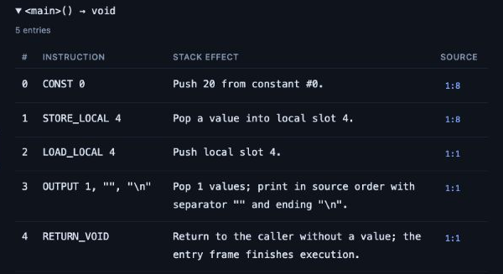
Figure 8 Five emitted instructions for the folded constant expression
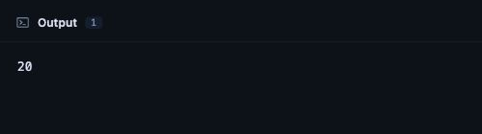
Figure 9 The optimized program still prints 20
Constant folding replaces the arithmetic computation with 20. The remaining instructions load the constant, store and reload its temporary, output it, and return. The source still passes syntax and semantic checking before optimization.
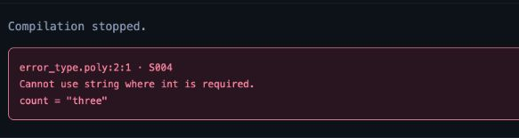
Figure 10 S004 identifies a string assignment to an integer binding
For count = 3 followed by count = "three", the variable retains its inferred integer type. The diagnostic reports line 2, column 1. A syntax error instead fails during parsing; a runtime error, such as division by zero, preserves completed compiler stages and any earlier output.

11 GitHub Repository and Execution
Live GitHub Pages application
https://hst257.github.io/PolyGlot/
Source repository and README
https://github.com/hst257/PolyGlot
README setup and project documentation
The Pages version runs the compiler inside the browser. Its first use downloads the Python WebAssembly runtime, so allow initialization to finish before running an example. The local route uses an installed Python interpreter and works with the bundled interface assets.

Run locally
Install Python 3.11 or newer and Git. Open a terminal and run the following. Changing into the project directory is required before invoking the launcher.
git clone https://github.com/hst257/PolyGlot.git
cd PolyGlot
python3 run_polyglot.py serve --port 8766
Then open the local workspace:
http://127.0.0.1:8766/

Compile and execute a reusable artifact
python3 run_polyglot.py run examples/mixed_demo.poly
python3 run_polyglot.py build examples/mixed_demo.poly \
-o build/mixed_demo.pbc
python3 run_polyglot.py exec build/mixed_demo.pbc
The backslash continues the build command onto its next line in macOS or Linux terminals. Stop the local server with Control+C in its terminal.

Repository organization
src/polyglot contains the compiler and runtime; examples contains programs; tests contains automated checks; docs/compiler contains the language, architecture, grammar, bytecode and diagnostic specifications. presentation/output holds the final slides. The report is stored in report/. Generated builds and caches are ignored by Git.

12 Challenges Faced and Solutions
Mixed block syntax. Indentation cannot be interpreted independently of braces. The parser maintains layout context while reading suites, allowing supported nesting across syntax forms.
Ambiguous spellings. A typed declaration may resemble C, C++ and Java. Recognition records candidate families while the common grammar and semantics determine behavior.
Optimization correctness. Removing or folding operations must preserve evaluation order, output and failures. The pass limits constant facts to safe cases and uses equivalence tests to check output and diagnostics.
Portable execution. GitHub Pages cannot host the local Python server. A Pyodide module worker runs the shared compiler code in the browser, while the local worker route remains available.

13 Conclusion
PolyGlot implements a complete educational compiler path from mixed source syntax to reusable bytecode and custom VM execution. The working examples demonstrate shared semantics, structured control flow, arrays and functions. Its compiler explorer exposes real intermediate results, and the test suite checks both successful programs and failure behavior. The implementation is suitable for explaining concrete compiler design decisions and their limits.

14 Future Scope
Useful next steps are parser recovery for multiple diagnostics, stronger control flow initialization analysis, wider optimization coverage with explicit correctness tests, and systematic performance measurements. Additional syntax should be introduced with matching grammar, semantic, artifact and regression tests.
The present release does not implement full Python, C, C++, Java, JavaScript or BASIC, object oriented features, imports, multidimensional arrays, LLVM code generation or physical register allocation. These boundaries keep the demonstrated implementation precise.

15 References
Project implementation and supporting documents
[1] PolyGlot contributors. PolyGlot source repository and README.
https://github.com/hst257/PolyGlot
[2] PolyGlot compiler specifications and verification record.
Architecture and module interfaces
Language specification and supported syntax
IR and bytecode format
Recorded validation and test coverage
External primary references
[3] Compiler Explorer contributors. Compiler Explorer project documentation. Browser based compiler and assembly inspection.
https://github.com/compiler-explorer/compiler-explorer
[4] Felix Kling and AST Explorer contributors. AST Explorer project documentation. Parser AST exploration.
https://github.com/fkling/astexplorer
[5] Pyodide contributors. Using Pyodide in a web worker. Official documentation.
https://pyodide.org/en/stable/usage/webworker.html
Web resources checked on 26 October 2026. Figures 1 and 2 describe this implementation. Figures 3 through 10 are genuine captures from the working PolyGlot interface; the report retains their original screenshot colors.

