TITLE: CRIMES PREDICTIONS USING CLIMATE COVARIATES

Approach: Fitting general additive models (GAM) to monthly data and predicting crimes (Burglaries, Theft, Drug offence, Miscellaneous Crimes Against Society, Public Order Offences, Robbery, Sexual Offences, Vehicle Offences, Violence Against the Person) using climates characteristics (mean temperature, max temperature, rainfall, rain days, sunshine hours, humidity)

Results:

1. Good predictive models for Burglaries and Theft: e.g.: Theft predictions against sunshine hours.

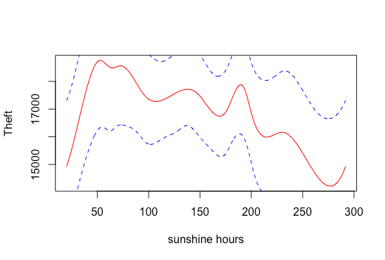

1. Acceptable predictive models with more uncertainty: e.g.: Miscellaneous Crimes Against Society against humidity.

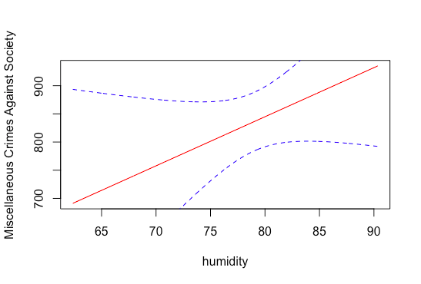

NB: Red line refers to means predictions and dashed blue line refers to confidence intervals.