Report 1
Descriptive Statistics
Hunter Stevens

Stats on Variables
Age FEV Hgt Sex Smoke
count 654.00000 654.0000 654.00000 654.0000 654.0000
mean 9.9311930 2.636780 61.143578 0.513761 0.099388
std 2.9539350 0.867059 5.703513 0.500193 0.299412
min 3.0000000 0.791000 46.000000 0.000000 0.000000
25% 8.0000000 1.981000 57.000000 0.000000 0.000000
50% 10.000000 2.547500 61.500000 1.000000 0.000000
75% 12.000000 3.118500 65.500000 1.000000 0.000000
max 19.000000 5.793000 74.000000 1.000000 1.000000

Histograms of the variables
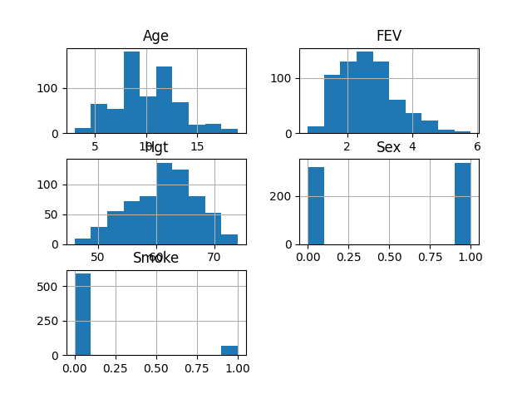

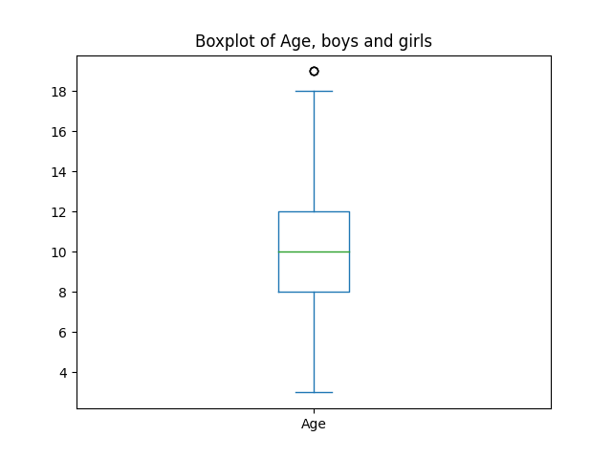

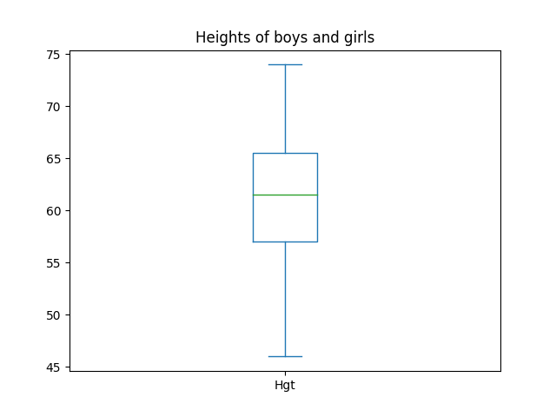

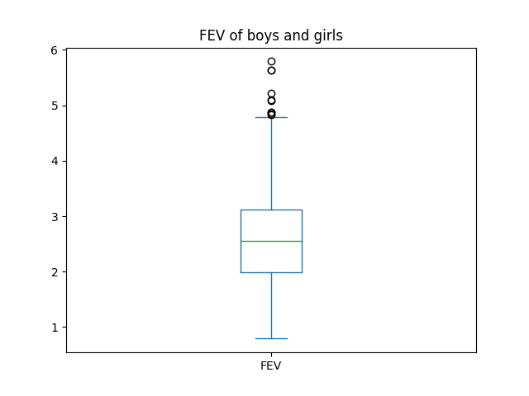

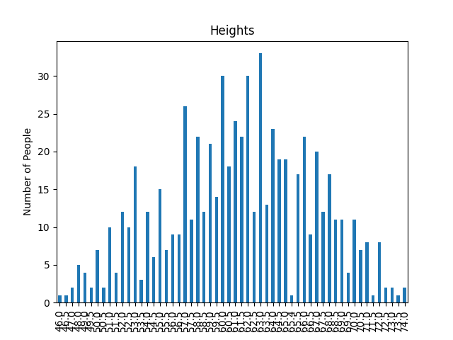

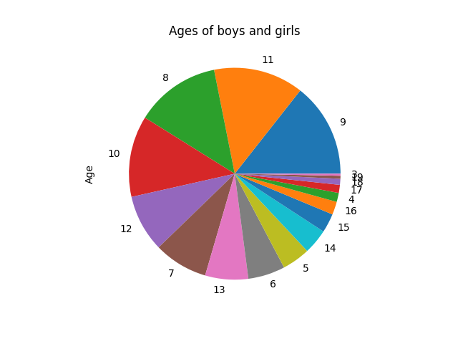

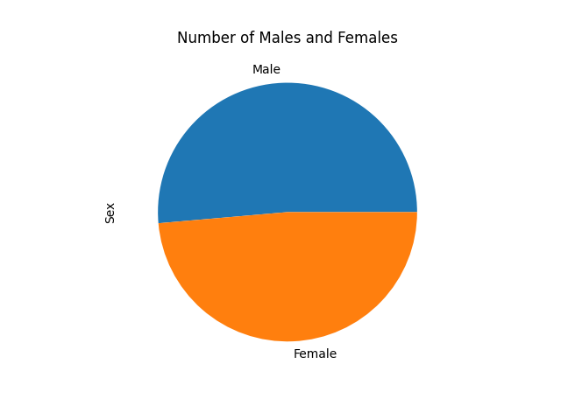

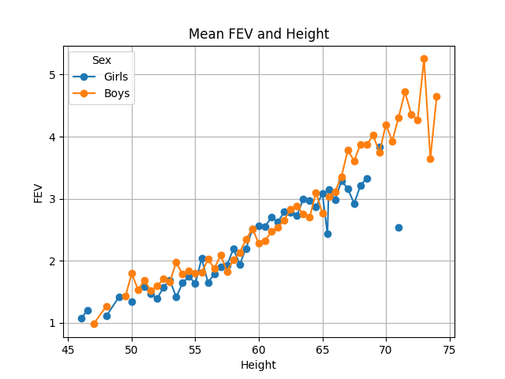
FEV and Height:

FEV and Age:

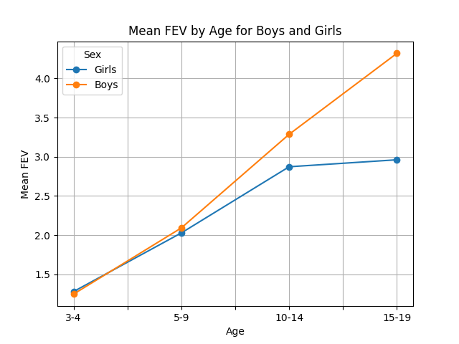

FEV and Smoking

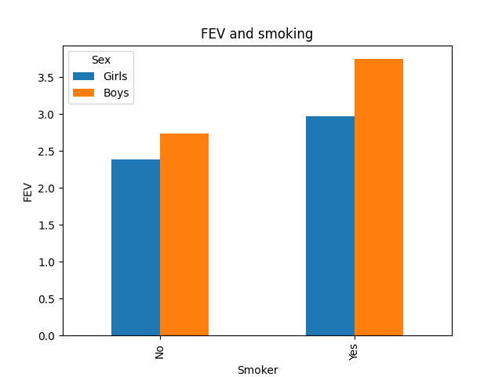

iii.

According to the charts above FEV seems to be directly correlated with age, height and smoking status. As you can see in ‘FEV and Smoking’ among boys and girls FEV is higher among smokers with a bigger jump between boys and girls who smoke vs boys and girls who don’t.
Height also seems to play a role in higher FEV levels. In the ‘Mean FEV and Height’ chart we can see a steady increase in FEV as height increases.
In ‘Mean FEV by age for boys and girls’ FEV increases with each age group, with the biggest jump being between the 5-9 age group and the 10-14 age group. However, this could also be an indicator of smoking affecting FEV considering the average age of smokers among the dataset is 13. See below.

Stats on smokers:
Age FEV Hgt Sex
count 65.000000 65.000000 65.000000 65.00000
mean 13.523077 3.276862 65.953846 0.40000
std 2.339255 0.749986 3.192671 0.49371
min 9.000000 1.694000 58.000000 0.00000
25% 12.000000 2.795000 63.500000 0.00000
50% 13.000000 3.169000 66.000000 0.00000
75% 15.000000 3.751000 68.000000 1.00000
max 19.000000 4.872000 72.000000 1.00000

Part 2

Water potability:

