Final Project

AdUTels

Documentation

Submitted By:

Laserna, Justine Ildefonso

Mbonyingabo Karuta, Christian

Mukamugemanyi, Jolie Josiane

Reomales, Cedric Joel Remolacio

Submitted To:

Engr. Baluyot, Raffaello Manalaysay

December 12, 2018

USE CASE DIAGRAM

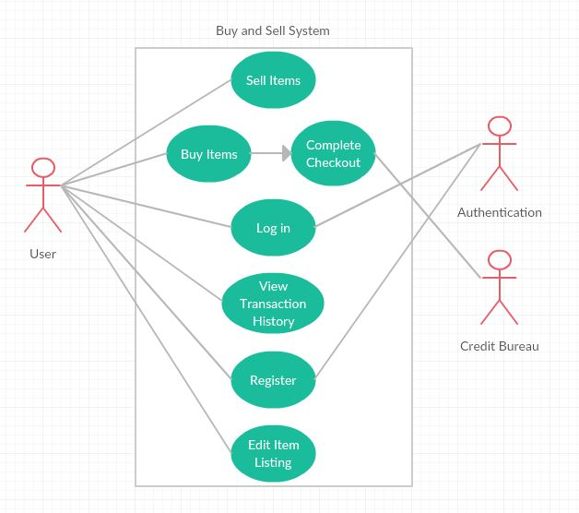

ACTIVITY DIAGRAM

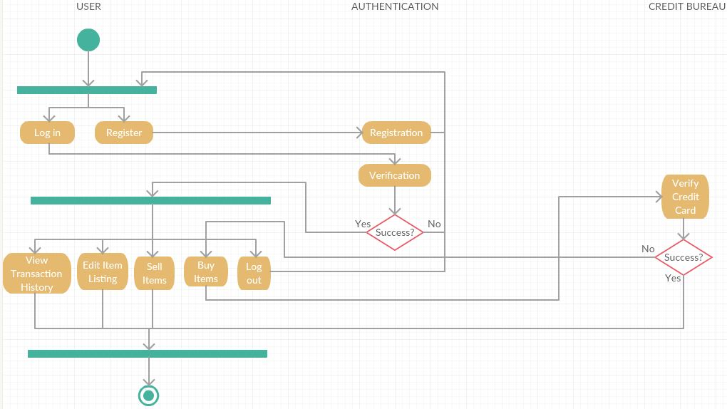

CONCEPTUAL CLASS DIAGRAM

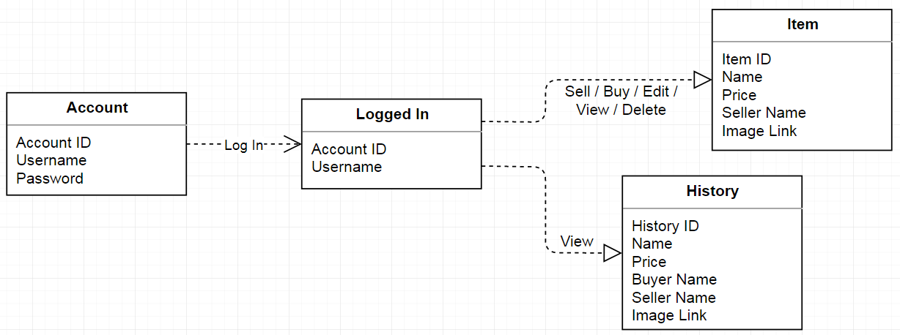

DETAILED CLASS DIAGRAM

