Course: Data Structures (CSE CS203A)
Assignment V: Tree
Student Worksheet Companion

Due date: 2025.12.30 23:59:59

Academic Integrity and AI Usage Statement
In this assignment, you must use AI tools (such as ChatGPT, Gemini, Claude, Grok, M365 Copilot, etc.) as learning assistants, but you must also take full responsibility for understanding and organizing your own work.

Permitted Use of AI Tools
You may use AI to:
- Review or clarify definitions and concepts.
- Compare different tree data structures.
- Get suggestions for report layout or examples.
- Ask for explanations of algorithms (e.g., BST insertion, AVL rotation, heapify process).
You should read, think about, and rewrite the content in your own words.

Not Permitted
- Do not copy/paste AI-generated content directly as your final answer.
- Do not ask AI to draw the final diagrams or directly produce the final tree screenshots.
- Do not ask AI to complete the whole assignment report for you.

Your Responsibility
- You are responsible for understanding the definitions and algorithms.
- You are responsible for verifying whether AI answers are correct or not.
- You must produce your own original explanations and diagrams.

AI Usage Log
- You must record all AI queries related to this assignment.
- At the end of your report, include an AI Usage Log table with: Index, Prompt, AI service name.
By submitting this assignment, you acknowledge that you have used AI tools only as study aids, and that the final content of this assignment represents your own understanding and work.

Section 1. Definitions of Tree Variants
Task: Write your own definitions for each tree type. You may use AI for learning, but rewrite in your own words.
- General Tree
Definition:
- Binary Tree
Definition: 每個節點最大度數為2，每個子節點有明確的方向之分。

- Complete Binary Tree
Definition: 除了最底層外，其餘每一層都必須全滿，且最底層的節點必須由左向右依序填入，中間不能有空缺。

- Binary Search Tree (BST)
Definition: 對於樹中的每個節點，其左子樹內所有節點的值都小於該節點，而其右子樹內所有節點的值都大於該節點。
- AVL Tree
Definition: 對於所有節點 其左子樹與右子樹的高度差小於等於1，確保搜尋的時間複雜度永遠穩定在 O(log n)。
- Red-Black Tree
Definition: 對於每個節點不是黑色就是紅色，Root node和 Leaf node必為黑色，不允許兩個紅色節點相連。從根節點出發，所有路徑的黑色節點數必須相等。

- Max Heap
Definition: 屬於一種Complete Binary Tree，父節點的值永遠大於或等於其子節點的值，最大值在Root node。

- Min Heap
Definition: 屬於一種Complete Binary Tree，父節點的值永遠小於或等於其子節點的值，最小值在Root node。

Section 2. Tree Family Hierarchy and Transformations
Task: Show how these structures are related (general → specialized). Use a simple diagram and explanations of what constraints are added at each step.
2.1 Tree Family Diagram
You may draw this by hand and paste a photo, or use drawing tools.
Suggested chain example (you may extend or adjust):
General Tree → Binary Tree → Complete Binary Tree
Binary Tree → Binary Search Tree → AVL / Red-Black
Binary Tree → Max Heap / Min Heap
Your Diagram:
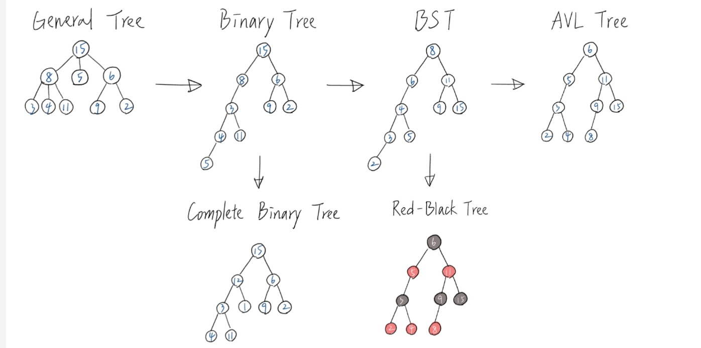
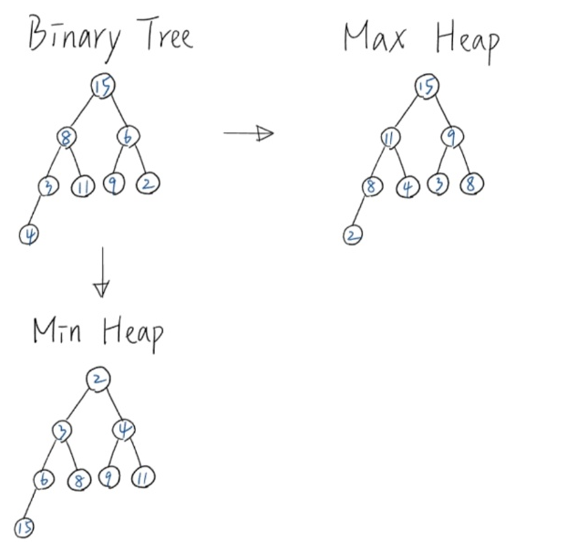

2.2 Explanation of Transformations
Fill in what new property or constraint is added at each step.
From | To | New property / constraint added
General Tree | Binary Tree | 限制節點最多只能有兩個子節點，有左右之分
Binary Tree | Complete Binary Tree | 限制節點須由上而下、由左至右填滿
Binary Tree | Binary Search Tree | 對於所有節點須滿足左子樹 < 父節點 < 右子樹
BST | AVL Tree | 左子樹和右子樹高度差不能超過1
BST | Red-Black Tree | 增加節點顏色，規定從根到葉子的最長路徑不得超過最短路徑的兩倍
Binary Tree | Max Heap | 是完全二元樹，而且滿足父節點大於等於子節點
Binary Tree | Min Heap | 是完全二元樹，而且滿足父節點小於等於子節點

Section 3. Tree Constructions Using Given Integers
Given integers (fixed for all parts):
37, 142, 5, 89, 63, 117, 24, 176, 58, 133, 92, 11, 151, 72, 39, 184, 7, 101, 54, 160
Task: For each tree type below, construct the tree using these integers, take a screenshot of the tree from your chosen tool, record the tool name/URL, and describe the insertion / heap-building procedure.
3.1 Binary Tree
Tool name / URL: https://treeconverter.com/
Construction / insertion description: 依照給定的順序由上至下、由左至右填滿二元樹。
Screenshot of Binary Tree (paste below):
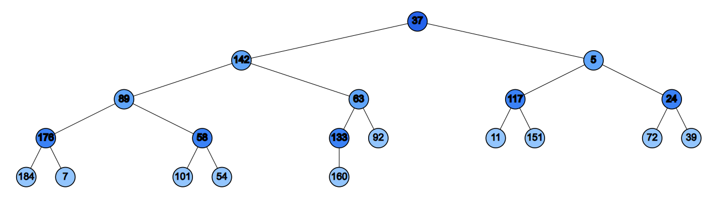

3.2 Complete Binary Tree
Tool name / URL: https://treeconverter.com/

Construction / insertion description: 依照給定的順序由上至下、由左至右填滿完全二元樹。

Screenshot of Complete Binary Tree (paste below):

3.3 Binary Search Tree (BST)
Tool name / URL: https://www.cs.usfca.edu/~galles/visualization/BST.html

Construction / insertion description: 第一個輸入的數字做為根節點，接下來輸入的數字如果比父節點小就往左子樹放，如果大於則往右子樹放。

Screenshot of Complete Binary Tree (paste below):
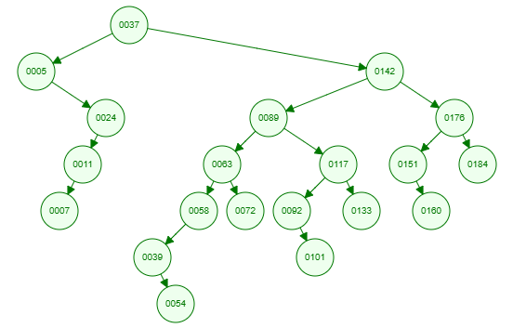

3.4 AVL Tree
Tool name / URL: https://www.cs.usfca.edu/~galles/visualization/AVLtree.html

Insertion & balancing description: 先依照BST插入順序，每當插入的結點使左右子樹高度差超過1時，透過單旋轉或雙旋轉讓樹保持平衡。

Screenshot of AVL Tree (paste below):
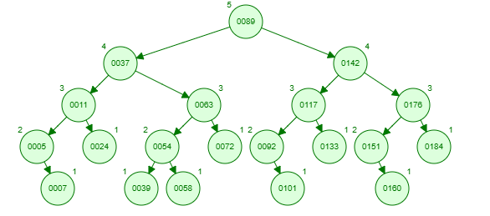

3.5 Red-Black Tree
Tool name / URL: https://www.cs.usfca.edu/~galles/visualization/RedBlack.html

Insertion & balancing description:每個插入的節點先預設為紅色，檢查是否有違反黑紅樹規則，如果有違反，則透過變色或旋轉來維持黑高度一致與樹平衡。

Screenshot of Red-Black Tree (paste below):
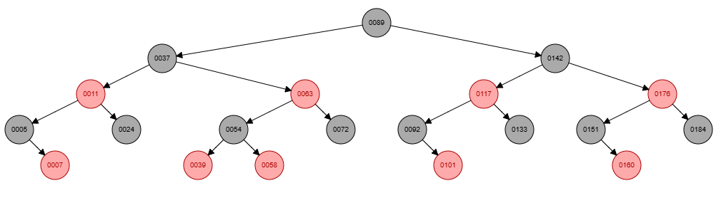

3.6 Max Heap
Tool name / URL: https://sercankulcu.github.io/files/data_structures/slides/Bolum_08_Heap.html

Construction / heap-building description (e.g. heapify, insert-and-sift-up): 使用insert-and-sift-up，將一個數字放入樹的最底層最左的空位，接著將該數字與父節點比較，如果數字比父節點大則和父節點交換，直到該數字小於父節點，再放入下一個數字。

Screenshot of Max Heap (paste below):
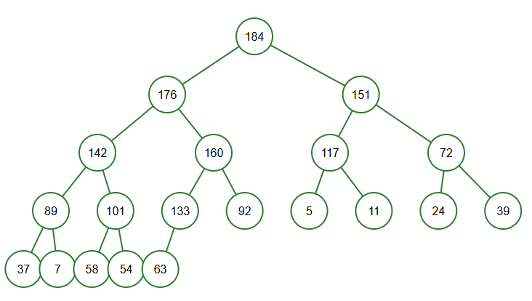

3.7 Min Heap
Tool name / URL: https://www.cs.usfca.edu/~galles/visualization/Heap.html

Construction / heap-building description: 使用insert-and-sift-up，將一個數字放入樹的最底層最左的空位，接著將該數字與父節點比較，如果數字比父節點小則和父節點交換，直到該數字大於父節點，再放入下一個數字。

Screenshot of Min Heap (paste below):
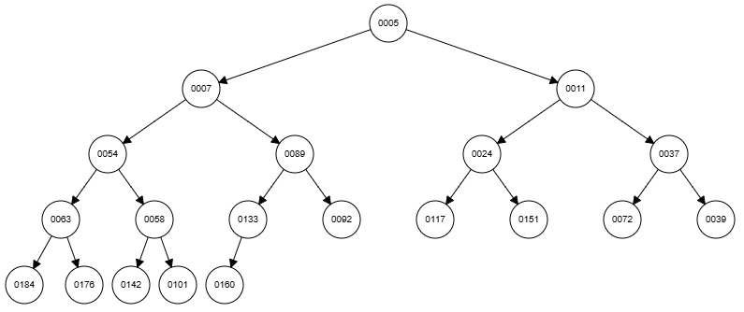

Section 4. Application Examples
Task: For each tree type, choose one application and explain why this tree is suitable.
Tree Type | Application Example (name / context) | Why this tree fits (properties that matter)
Binary Tree | 表示階層式資料 (Expression Tree) | 簡單結構，適合遞迴處理，能表示任意二元關係
Complete Binary Tree | 優化儲存結構 (Heap) | 節點排列緊密，節省空間適合陣列儲存
Binary Search Tree | 資料查找 | 有大小排序，可以快速搜尋、插入、刪除，平均時間複雜度O(log n)
AVL Tree | 資料庫索引 | 嚴格平均，適合多讀取、少更新的檢索系統
Red-Black Tree | 作業系統記憶體管理 (Linux VMA) | 平衡但插入刪除的速度更快，維護成本低於AVL Tree
Max Heap | 排序 / 優先佇列 | 最大值快速取出，完全二元樹結構，O(log n)時間複雜度插入
Min Heap | 排成(Dijkstra最短路徑演算法) | 最小值快速取出，適合優先級任務管理

Section 5. Reflection on Tree Family and Performance (Optional but recommended)
Among BST, AVL, and Red-Black trees, which one would you pick for:
Mostly search (few updates)? Why?
AVL Tree. 因為AVL Tree高度平衡，樹的高度最矮，搜尋時經過的節點最少。

Frequent insertions and deletions? Why?
Red-Black Tree. 插入數字後的平衡成本低，調整結構的速度比AVL Tree快很多

If you must store these 20 integers for static search only (no updates), which structure or representation would you prefer (sorted array + binary search, BST, AVL, etc.)? Why?
Sorted array + binary search. 陣列只需要儲存數字，不需要像二元樹儲存左右子節點的指標，節省記憶體，排序陣列的二元搜尋時間複雜度也是O(log n)，效能跟平衡樹一樣快。

Section 6. AI Usage Log (Required)
Task: Record every time you ask an AI assistant about this assignment.
Index | Date / Time | AI Service (ChatGPT, Gemini, etc.) | Your Full Prompt / Question
1 | 12/22 | Gemini | 解釋黑紅樹
2 | 12/22 | Gemini | AVL Tree如何平衡
3 |  | Gemini | heapify, insert-and-sift-up的差別
4 |  | Gemini | AVL Tree, Red-Black Tree的應用有哪些
5 | 12/28 | M365 Copilot | AVL Tree, Red-Black Tree的應用有哪些
6 | 12/30 | Gemini | BST, AVL, and Red-Black trees差別在哪

