Kyle Smith

CS 444

Scott Burgess

Research Paper

For Better or Worse: The Robotic Divide

In an age of new technologies being released every day, industrial automation may be a factor that drives innovation even further. Successful companies find themselves automating more each year, and with that choice comes the result of more possibilities within automation. The conflict over whether to automate is often debated, mainly since it can leave some companies on the fiscally disadvantaged side. Due to the efficiency of automation, companies can produce more for less, giving them an edge over competitors, thus leaving those people in competition in a difficult position.

Automating is not an all-around simple task, however. Before approaching the effects of automation, it can help to explore the meaning of it first. Jenay Beer, Arthur Fisk, and Wendy Rogers put forth a simple definition of automation that applies to robots (which can also be extended to humans) in their paper “Toward a framework for levels of robot autonomy in human-robot interaction”. They define automation as “the extent to which a robot can sense the environment, plan based on that environment, and act upon that environment, with the intent of reaching some goal (either given to or created by the robot) without external control” (Beer, Fisk, & Rogers, 2014). This encapsulates the essence of automation very well and gives us an idea of why companies might wish to enact automation. If a company can rely fully on a machine to complete tasks, then they don’t have to worry about issues such as wages, overtime, or training. This allows more time for humans to work on other (possibly more important) tasks.

Automation is certainly easier if a company has the resources to enact such implementations. One should ask, however, what sort of standards are there for using robotic automation? The answer is that there are extensive standards that companies must meet if they wish to begin automation. Standards development organizations have been writing and requiring their standards for robotic automation and Human-Robot-Interaction since the early 1990’s (Jacobs, Veneman, Virk, & Haidegger, 2018). Over the years, this has become challenging, and especially so in the last few years. There are several standards development organizations (SDOs), and they each operate slightly differently. The International Electrotechnical Commission (IEC) separates their reviewing of current standards into several Working Groups, each of which review a different area of robotic standards. When it comes to Industrial Safety, the IEC assigns Working Group to create standards to ensure a safe industrial environment. This Working Group oversees topics such as how much force a robot can safely apply, or the instructions for Human-Robot-Interaction in industrial settings (Jacobs, Veneman, Virk, & Haidegger, 2018). Although these standards are interesting, consider the effect that they have on the industrial sector. Meeting these standards is not an easy task, and in fact, complying with standards may cost so much that automation may not seem like a frugal choice (Wachsman, 2018). This leaves the wealthy companies with an advantage once again, since paying for training and installing automation may not be an issue for them. So, less well-off companies are left behind, and thus increasing the robotic divide.

The ability to meet the standards set out by these SDOs is one advantage successful companies have regarding the robotic divide, but one should also consider if these “winning” companies wish to automate. The debate of whether to automate is not only external between separate company entities, but can also exist internally, within a single company or entity (Rotz et al, 2019). Many companies don’t wish to automate any time soon, partly due to the overhead that is required, and partly because of the risk involved. This infographic (Fig. 1) is from a study done (Wachsman, 2018), which found that out of the sample they polled, sixty percent of people polled said they did not have plans to automate any time soon. This is due to budget restrictions,

Figure 1: 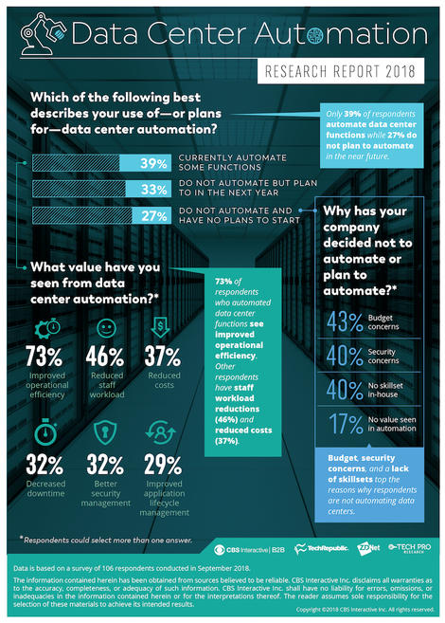

concerns about security, and a general lack of skill to maintain and oversee the automated systems. Although there are concerns and hesitations, many companies do report increases in productivity (Decker, Fischer, & Ott, 2017). Being fearful about a new venture is a normal human behavior though, and once we see each other succeeding more people will follow suit.

Automation is not something to be afraid of or avoided. It should be embraced and engaged. We need to regulate immediately and increase the resources available to SDOs so we can build standards that everyone can follow. The robotic divide due to wealthy companies being the “winners” and taking all the spoils, is an issue that has roots in every economical problem existent today. However, as engineers and scientists, we can embrace change and work towards automation as a desirable goal by focusing our efforts on creating efficient and accessible technologies. Figure 2 shows an estimate of how the division of labor between humans and robotic automation could increase by 2025 (Chowdhry, 2018). We must consider

Figure 2: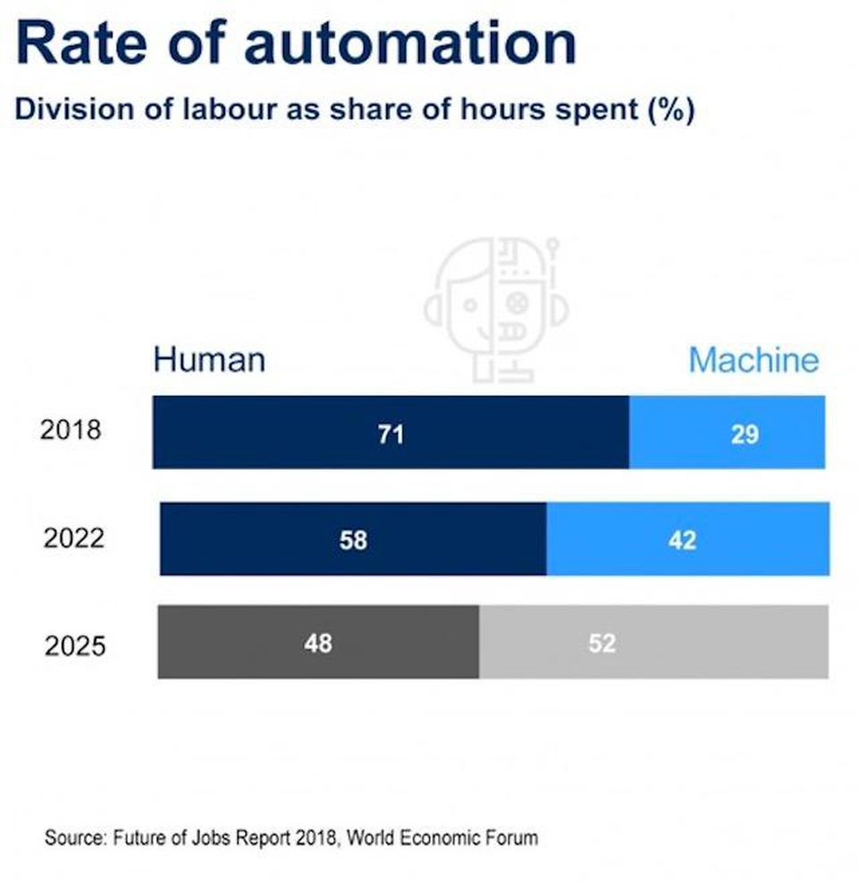

this scenario as likely and gather motivation from the suggestion so we can prepare accordingly.

A final thought to consider is that small “Mom and Pop” stores may not be declining as rapidly as many might claim. As Smith and Anderson point out in their paper, “AI, Robotics, and the Future of Jobs” from 2014, some groups of experts “anticipate that pushback against expanding automation will lead to a revolution in small-scale, artisanal, and handmade modes of production”. This provides hope that people who wish to pursue a small business still have an environment in which to flourish. Only the direct competitors of large-scale companies are in danger of losing business, and small-scale businesses are usually on a local scale anyway and have been found to adapt to changes in the economy (Smith & Anderson, 2014).

So, while some may not gain from the increasing robotic divide, the “Winner-Take-All” idea may be flawed; a more accurate depiction would be “Only-One-Can-Be-On-Top”. This implies one company may take most of the economic spoils, but the hierarchy of business, whether automated or not, will always persist. As Richard Straub points out, large companies have the ability to be role models for other businesses, by providing the technologies and products that we all want and need (Straub, 2015). Thus, as members of a discipline intimately entwined with this ongoing issue, it is up to us to help shape the future of technology and its integration within society. Embracing automation sooner rather than later, and understanding that we can all gain from automation, will set us on a path of defining and creating a new culture, one in which we may all prosper.

References

Beer, J., Fisk, A., & Rogers, W. (2014, July 3). Toward a framework for levels of robot autonomy in human-robot interaction. Retrieved from https://www.ncbi.nlm.nih.gov/pmc/articles/PMC5656240/

Chowdhry, A. (2018, September 18). Artificial Intelligence To Create 58 Million New Jobs By 2022, Says Report. Retrieved from https://www.forbes.com/sites/amitchowdhry/2018/09/18/artificial-intelligence-to-create-58-million-new-jobs-by-2022-says-report/#6d51e38b4d4b

Decker, M., Fischer, M., & Ott, I. (2017, September 17). Service Robotics and Human Labor: A first technology assessment of substitution and cooperation. Retrieved from https://www.sciencedirect.com/science/article/pii/S0921889016306285

Jacobs, T., Veneman, J., Virk, G., & Haidegger, T. (2018, March 12). The Flourishing Landscape of Robot Standardization [Industrial Activities] - IEEE Journals & Magazine. Retrieved from https://ieeexplore.ieee.org/document/8314589

Rotz, S., Gravely, E., Mosby, I., Duncan, E., Finnis, E., Horgan, M., & Fraser, E. (2019, January 20). Automated pastures and the digital divide: How agricultural technologies are shaping labour and rural communities. Retrieved from https://www.sciencedirect.com/science/article/pii/S0743016718307769

Smith, A., & Anderson, J. (2014, August 6). AI, Robotics, and the Future of Jobs. Retrieved from www.pewresearch.org/wp-content/uploads/sites/9/2014/08/Future-of-AI-Robotics-and-Jobs.pdf

Straub, R. (2015, April 7). Managing in an Age of Winner-Take-All. Retrieved from https://hbr.org/2015/04/managing-in-an-age-of-winner-take-all

Wachsman, M. W. (2018, November 1). Survey: Despite increases in data, companies reluctant to automate data center functions. Retrieved from https://www.zdnet.com/article/survey-despite-increases-in-data-companies-reluctant-to-automate-data-center-functions/