MarkItDown Converter
User Guide
Turn Excel, Word and PDF files into something Claude reads easily, with fewer tokens
Version: v1.7.1
The short version
1. Drag a file into the Quick Convert panel. The converted file appears as a card.
2. Drag the card into your Claude conversation. For a big file the card is a small "index"; give Claude just that first.
3. Tokens are saved by uploading less: give Claude the index first, and it will tell you which data file it needs.

1. What this tool does
MarkItDown Converter is built on Microsoft's open-source MarkItDown. It turns documents into Markdown (.md) text files that Claude Desktop or Cowork can read. For PDF, Word, PowerPoint, HTML, CSV, web pages and YouTube transcripts, the result is the same as the original MarkItDown.
Excel files get special treatment. By default they are converted into a compact package for Claude:
- Index (00_索引與邏輯.md): every sheet's columns, with totals, minimums and maximums computed exactly by the program, each column's formula, and how data flows between sheets. Usually only a few thousand tokens.
- Data files: the complete, lossless data. Big workbooks are split into several files by sheet.
- Cell-by-cell check: before writing, the program reads every cell back and compares it with the workbook. If a single cell differs, nothing is produced.
The one thing to remember
Uploading a big file in full costs about as many tokens as uploading the Excel itself: numbers take tokens whatever the format. Tokens are saved by uploading less: give the index first, give only the sheets you need, filter by keyword, or convert only the newest versions. Chapter 4 explains how; chapter 7 walks through a complete example.

2. Download and first run
- Download markitdown.exe from the download page (about 110 MB; nothing to install, no Python needed).
- The first time you run it, Windows may show "Windows protected your PC". The program is not digitally signed. Click More info, then Run anyway.
- Double-click to open the main window. It takes a few seconds to start each time; that is normal.
- Tip: create a desktop shortcut to markitdown.exe, right-click › Properties, and add --panel at the end of Target. Double-clicking the shortcut then opens the Quick Convert panel directly.

3. The Quick Convert panel (recommended)
The Quick Convert panel is a small window that floats above other windows. Put it next to Claude: drag files in, drag results out.

3.1 Opening the panel
- In the main window, choose 「檢視 › 快速轉換面板」 (View › Quick Convert panel), or press Ctrl+Shift+P.
- While the main window's list is empty, click the blue link 「或開啟快速轉換面板」 (or open the Quick Convert panel).
- Use a shortcut with --panel (see chapter 2).

3.2 Converting files
Drag files onto the dashed area at the top of the panel (several at once is fine), or click 「選擇檔案…」 (Choose files…). You can keep dropping files while it converts; they are queued.

Figure 1 The panel when first opened: drop files into the dashed area

3.3 Handing results to Claude
Each result becomes a card. Drag the card straight into your Claude Desktop conversation to attach the file. If dragging is inconvenient, double-click the card to open the file, or right-click for 「複製內容」 (Copy content) to paste into Claude, or 「開啟檔案位置」 (Show in folder) to drag it from File Explorer.

Figure 2 Results (sample files): the index card of a big file on top, a small file's card below

3.4 Reading a card
Text on the card | Meaning
File name | The file you drag into Claude. For a big file this is 00_索引與邏輯.md (the index).
約 1,300 token (about 1,300 tokens) | Roughly how many tokens this file costs (an estimate; the real count can differ by 10–20% depending on the model).
✓ 已逐格核對 (checked cell by cell) | Every Excel cell has been compared with the original.
先拖這張就好，Claude 會說還要哪個檔 (drag just this one; Claude will say which other file it needs) | For a big file, give only the index first; Claude names the data file it needs.
同資料夾另有 N 個資料檔 (N more data files in the same folder) | The data files are in the <name>_md folder; upload a specific one when asked.
⚠ 全部約 N 萬 token，太大，別整包上傳 (too big; don't upload it all) | More than one conversation should take; don't upload the whole folder.
→ 只轉最新一版 · 約 N token (newest version only) | Shown only when the file has a version column (see 3.5). Click to make a small file with the newest version only.
來自 ○○.xlsx (from ○○.xlsx) | The original file. Filtered extracts add 只含最新 1 版 (newest version only).

3.5 Converting only the newest versions (files with a version column)
Some workbooks build up data period by period, for example weekly forecast snapshots or monthly inventory snapshots: every item has a row in every period, and one column holds the date of the period. The program finds this "version column" automatically.
If the file is big (over about 30,000 tokens in total), the card offers 「只轉最新一版」 (newest version only) and 「只轉最新 2 版」 (newest 2 versions) links with their approximate token counts. Clicking one creates a separate small file (named with _最新1版, "newest 1 version"); the full package is not overwritten. When you only need the latest period, or want to compare the last two, the small file is enough.
Date columns such as order or ship dates, whose rows per day vary a lot, are never taken as a version column, and files without a version column never show these links. See chapter 7 for a worked example.

3.6 The bottom of the panel
- Settings line: how Excel files are currently converted and where results are saved.
- 「浮在其他視窗上方」 (Float above other windows): on by default, so cards are easy to drag into Claude; turn it off if you don't need it.
- 「更多」 (More): 「轉換選項…」 (Conversion options…) opens the main window to change options; 「複製 Claude 專案指示」 (Copy Claude Project instructions) is explained in chapter 5.

4. Uploading to Claude with the fewest tokens
Your situation | What to do | Approximate upload
A small file (the card has no "drag just this one" line) | Drag the card into Claude | The token count on the card
A big file; you ask about the overall picture, totals, which columns exist | Drag only the index card | A few thousand tokens
A big file; you need detail from one sheet | Give the index first; when Claude names a data file, upload that one from the _md folder | Up to about 100,000 per data file
The file has a version column; you need only the latest period or the last two | Click 只轉最新一版 or 只轉最新 2 版 on the card | Only the latest periods
You ask only about one part number or customer | Set a keyword filter in Conversion options and convert again | Usually a few thousand to tens of thousands

Five rules
- Don't zip up and upload the whole folder. That costs about as many tokens as the Excel itself.
- Don't ask Claude to "read everything first". Ask it to look at the index first.
- Give the index first, add files when asked. The 資料檔 (data files) table at the end of the index lists each file's approximate token count.
- Filter whenever you can. Convert only the newest versions, or keep only rows containing a keyword.
- Start a new conversation for a new topic. In a conversation, earlier files count again with every question.
An opening you can paste into Claude
Attached is the index converted from an Excel file (00_索引與邏輯.md). Please answer from the index first; its totals, minimums and maximums were computed exactly by the program and can be quoted directly. If you need detail, tell me which data file to upload (file names and approximate token counts are at the end of the index). Don't guess.
My question is: …

5. Setting up Claude Project instructions (once)
If you often work with Excel files in the same Claude Project, paste a standing instruction into the project. In every conversation in that project, Claude will then read the index first, ask for data files only when needed, and remind you to filter.
- In the panel, click 「更多 › 複製 Claude 專案指示」 (More › Copy Claude Project instructions). The bottom of the panel shows ✓ 已複製 (copied).
- In Claude, create a project (or open an existing one).
- Open the project's Instructions setting, paste what you copied, and save.
- From then on, start conversations in this project and upload the index card.
The copied instructions are in Chinese, as below:
我會上傳用「MarkItDown 轉換器」從 Excel 轉出的檔案。請照這個方式處理：
1. 先只讀「00_索引與邏輯.md」。它列出每張工作表、每一欄的類型，以及程式精確算好的合計、最大值、最小值和公式邏輯；這些數字可以直接引用，不要自己加總大量數字。
2. 能用索引回答就直接回答。需要明細時，告訴我要上傳哪一個資料檔（檔名和大約 token 數在索引最後的「資料檔」表），一次只要需要的那幾個，不要要求整包。
3. 問題只跟某個料號、客戶，或只跟最新的預測版本有關時，提醒我用轉換器的關鍵字篩選或「只轉最新一版」重新轉一次，檔案會小很多。
4. 資料是 Tab 分隔，第一欄是 Excel 列號（後面有 h 表示該列在 Excel 中隱藏），數值是完整精度。引用數字時請註明工作表和儲存格位置（例如 Summary!F12）。

English translation (for reference; you can paste this instead):
I will upload files converted from Excel with the MarkItDown converter. Please work like this:
1. Read only 00_索引與邏輯.md (the index) first. It lists every sheet, the type of every column, and the totals, minimums, maximums and formula logic computed exactly by the program. Quote these numbers directly; do not add up large amounts of data yourself.
2. If the index answers the question, answer from it. If you need detail, tell me which data file to upload (file names and approximate token counts are in the 資料檔 table at the end of the index). Ask only for the files you need, never the whole package.
3. If the question is only about a part number, a customer, or the latest forecast version, remind me to re-convert with the keyword filter or 只轉最新一版 (newest version only); the file will be much smaller.
4. Data is tab-separated; the first column is the Excel row number (an h after it means the row is hidden in Excel); values are at full precision. When quoting numbers, give the sheet and cell (e.g. Summary!F12).

6. Understanding the converted files

6.1 Where files are saved
- Small file: one .md with the same name, next to the original.
- Big file: a folder <name>_md next to the original, holding 00_索引與邏輯.md and data files starting with 01_, 02_ …; very large sheets are split further into _第1部分, _第2部分 (part 1, part 2).
- Filtered extracts: named with a suffix such as _最新1版 (newest 1 version), so the full version is never overwritten.
- Converting the same file again updates its output; leftover parts from an earlier run are removed automatically, and anything else you put in the folder is left alone.

6.2 What the index contains
- For each sheet: visible or hidden, number of rows and columns, which row is the header, number of formulas, and approximate data tokens.
- For each column: name, type, number of non-empty cells, and the minimum, maximum and total computed by the program. When a sheet has a row-type column (for example Demand / ETD / Balance), totals are split by it.
- Each column's formula, data flow between sheets, autofilters, hidden rows and columns, data validation, pivot tables, and the version column.
- At the end, the 資料檔 (data files) table: each data file's name and approximate token count.

6.3 Data file format
- Tab-separated. The first line lists Excel column letters; every following line starts with the Excel row number. An h after the row number means the row is hidden in Excel (usually filtered out).
- Numbers are at full precision, without thousands separators; percentages are fractions (0.25 = 25%); dates are YYYY-MM-DD, including any time of day the cell format hides.
- Cell comments are listed at the end of each sheet's data.

7. Worked example: a forecast waterfall
This chapter uses one sample file to show, from start to finish, how the program converts a workbook and how to use the result. The sample, 範例 FCST Waterfall.xlsx, contains randomly generated test data. Other kinds of workbooks, such as weekly reports, shipment logs or inventory sheets, go through the same steps; only the version column in 7.5 is specific to files that build up period by period.

7.1 The sample file
- One sheet, By MPN x Site, 2,240 rows × 31 columns.
- Columns A–D are part number (MPN), site, brand and forecast version; columns E–AD are demand for 26 weeks, and AE is the total (TTL).
- A new forecast version is added every week, with one row for each of 160 part numbers. There are 14 versions so far (2026/07/06 to 2026/10/05).

7.2 What the program does when you drop it on the panel
- Finds the header: row 1 holds the column names (MPN, Site … W01 … TTL). When the header is not in row 1, the program uses the autofilter, pivot layout or freeze panes to find it.
- Reads every cell and checks it: numbers keep full precision and dates are written in full; before writing, every cell is read back and compared with the workbook.
- Computes each column's statistics: minimum, maximum and total, and the most frequent values of text columns, all written into the index.
- Decides whether to split: about 195,000 tokens in total, more than 30,000, so it writes an index and 2 data files (each under 100,000 tokens).
- Finds the version column: every value in column D is a date, each of the 14 dates has 160 rows, and nearly every row has a value, so D is the version column. The card therefore offers 只轉最新一版 · 約 15,000 token and 只轉最新 2 版 · 約 28,900 token.
The output goes into the folder 範例 FCST Waterfall_md next to the original:
File | Approximate tokens
00_索引與邏輯.md (the file the card stands for) | 1,300
01_By MPN x Site_第1部分.md (Excel rows 1–1,168) | 100,000
01_By MPN x Site_第2部分.md (the remaining rows) | 93,000

7.3 What the index says
The index holds no detail rows, only what Claude needs to decide what it needs. Part of the sample's index:
Column | Name | Type | Non-empty | Statistics (computed by the program)
A | MPN | Text | 2,240 | 160 distinct values; most common PN-0000×14, PN-0001×14…
B | Site | Text | 2,240 | VN×1260, TW×980
C | Brand | Text | 2,240 | Brand C×826, Brand A×770, Brand B×644
D | Version | Text | 2,240 | 14 distinct values; 2026/07/06×160, 2026/07/13×160…
E:AE | W01 … TTL (27 columns) | Number | 60,480 | Minimum 0, maximum 887361; column totals: E 33384853, F 32885195…
The same page also says (shown here in translation):
Version column: column D (Version), 14 versions (2026/07/06 to 2026/10/05), 160 rows per version. Every item has a row in every version, so adding across versions is meaningless; when only the latest data is needed, the converter can convert just the newest one or two versions.

So from the index alone, Claude knows which part numbers, brands and sites the file covers, how many versions there are, and that numbers from different versions must not be added together.

7.4 What a data file says
A data file is the complete data, tab-separated. These are the first lines of part 1 (the real file uses tab characters, shown here as │; only the first columns are listed):
列│A │B │C │D │E │F │…│AE
1 │MPN │Site│Brand │Version │W01 │W02 │…│TTL
2 │PN-0000│TW │Brand C│2026/07/06│0 │79324│…│539564
3 │PN-0001│TW │Brand B│2026/07/06│0 │0 │…│353933
Each line starts with the Excel row number (列 = row), so Claude can point to an exact cell, e.g. "By MPN x Site!F2 is 79324".

7.5 The version column and "newest version only"
A column is taken as a version column only when all three of these hold:
- Every value is a date (for example 2026/10/05, 2026-10-05 or 2026/10).
- Each date has about the same number of rows (every version contains the same set of items). Order or ship dates vary a lot per day, so they are never chosen.
- Nearly every row has a value, and there are at least 3 different dates.
Clicking 只轉最新一版 on the card creates 範例 FCST Waterfall_最新1版.md: the header plus the 160 rows of version 2026/10/05, about 15,400 tokens, as a single file you can drag into Claude in one go. The top of its index notes that only the newest version's rows are kept; column statistics still cover the whole sheet.
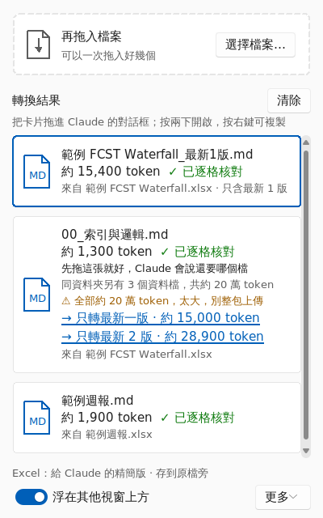
Figure 3 After 只轉最新一版: a new small card with only the newest version appears at the top

7.6 Choosing what to give Claude for each question
Question for Claude | What to give it | Approximate tokens
Which part numbers and brands are there? What is total demand per week? | Just the index card | 1,300
How has the forecast for PN-0012 changed across the 14 versions? | Convert with the keyword filter PN-0012 | 2,700
What is this week's (newest) forecast? | Click 只轉最新一版 | 15,400
Compared with last week, which part numbers changed most? | Click 只轉最新 2 版 | 29,300
A full trend analysis across all 14 versions | Index first, then upload the 2 data files one at a time as Claude asks | 195,000 (in two uploads)
Depending on the question, what you hand Claude from the same file ranges from 195,000 tokens down to a few thousand. The same applies to any other workbook: give the index first, then filter by keyword or upload only the sheets you need.

8. The main window and options
The main window is for converting many files or whole folders at once, and for previewing results.
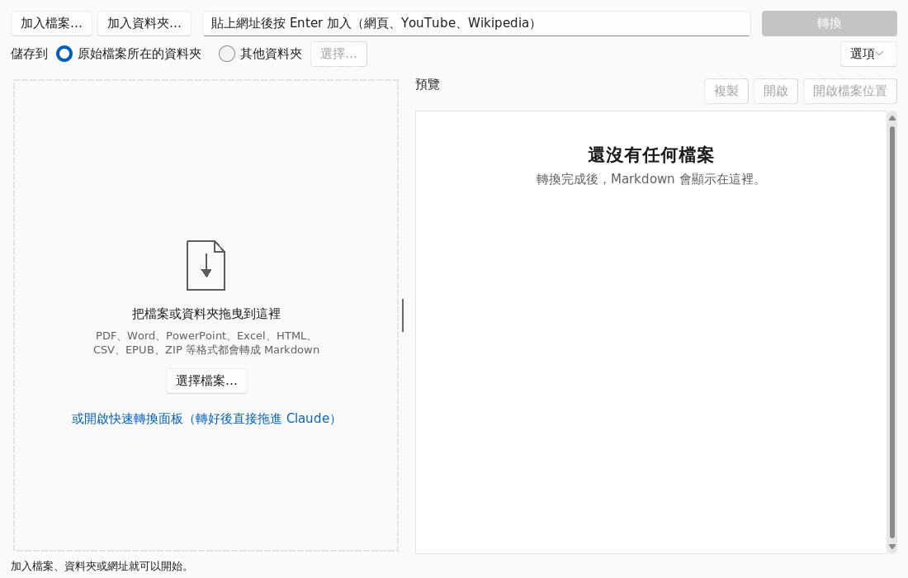
Figure 4 The main window: add files, folders or URLs at the top, then click 轉換 (Convert)
The 「選項」 (Options) menu at the top right of the main window:
Option | What it does
儲存到：原始檔案所在的資料夾／其他資料夾 (Save to: the original's folder / another folder) | Where converted files are saved.
加入資料夾時包含子資料夾 (Include sub-folders when adding a folder) | Also converts files in sub-folders.
略過已經有 .md 的檔案 (Skip files that already have an .md) | When re-running a folder, skips files already converted.
Excel：給 Claude 的精簡版 (compact package for Claude; recommended) | On by default. Turned off, Excel becomes one big readable-table .md: nicer for people, but more tokens.
Excel：只保留含關鍵字的列… (keep only rows containing keywords…) | Enter part numbers, customer names and so on (separated by commas); only rows containing them are written. Header rows are kept, and the index statistics still cover the whole sheet.
Excel：只輸出看得到的工作表、列和欄 (only visible sheets, rows and columns) | Leaves out hidden or filtered-out data, i.e. what Excel shows on screen.
Excel：在每個儲存格的值下方附上公式 (show each cell's formula under its value) | For checking formulas cell by cell. Switches to the readable-table format automatically; the file gets much bigger.
Excel：轉換前先用 Excel 重新計算 (recalculate with Excel first) | Needs Microsoft Excel on your PC. Recalculates formulas and refreshes pivot tables in a copy, then converts it. The original is not changed.
The panel and the main window share the same options.

9. FAQ
Q Windows says "Windows protected your PC" and won't open it.
A Click More info, then Run anyway. The program is not digitally signed, so Windows warns the first time.
Q I can't drag a card into Claude.
A Right-click the card and choose 開啟檔案位置 (Show in folder), then drag the file from File Explorer into Claude; or choose 複製內容 (Copy content) and paste into the conversation.
Q I uploaded all the files and saved hardly any tokens.
A That is expected. Uploading everything costs about as much as the Excel itself. Follow the "upload less" approach in chapter 4.
Q Are the numbers accurate?
A Every cell is checked against the workbook, and the totals and minimums/maximums in the index are computed by the program. Values are the results Excel calculated at the last save; if the file was changed elsewhere and not recalculated, turn on 轉換前先用 Excel 重新計算 (recalculate with Excel first).
Q Why do token counts say 約 (about)?
A They are estimates. Claude models count slightly differently, so the real number can be 10–20% off, which is fine for comparing sizes.
Q A scanned PDF gives no text.
A Scans are images with no text layer, and this tool has no text recognition (OCR).
Q Why do some columns have no name?
A The column has no header in Excel either (for example, one merged cell spans several columns). The program does not invent names; the column's statistics in the index show what it contains.
Q How long does a big file take?
A Usually seconds; a large file with hundreds of thousands of formulas takes a few tens of seconds. You can keep dropping other files in while it works.

10. Advanced: command line
If you are comfortable with the command line, use it from Command Prompt or PowerShell (run markitdown.exe --help for every option):
Command | What it does
markitdown.exe report.xlsx --out-dir output | Convert one file into the folder output
markitdown.exe report.xlsx --xlsx-latest 1 | Keep only the newest version (files with a version column)
markitdown.exe report.xlsx --xlsx-rows-containing PN-0001 | Keep only rows containing this part number (repeatable)
markitdown.exe report.xlsx --xlsx-format readable | Use the readable-table format
markitdown.exe D:\folder -r --out-dir D:\output | A whole folder, including sub-folders
markitdown.exe --panel | Open only the Quick Convert panel

