Information Retrieval HW1

1. Interpolated precision recall curve

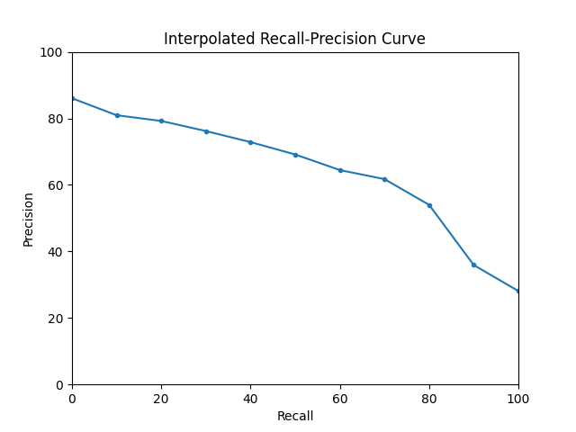

1. Mean average precision  
   mAP = 0.63787315
2. Normalized discounted cumulated gain

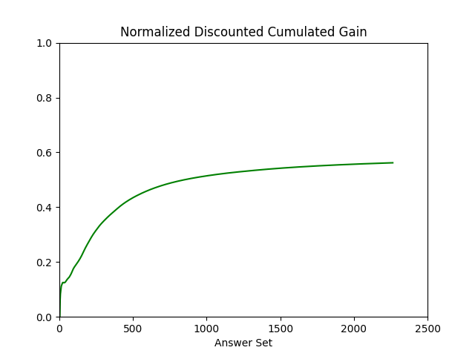

1. Feedback

It is my first time to write code to process such substantial amount of data and output the graphs and answer. Though it was hard for me to finish this homework with little skill in programming, it was an impressive and valuable experience. In the beginning, it seemed difficult and confusing for me to manipulate the knowledge in programming to do the calculation. However, I started to be familiar with it after finishing the first task in this homework and felt confidence in working with the data. It turned out that it was not as difficult as I thought at first. Besides that, I learned more techniques in python from the work, which is rarely taught in general programming class. This homework also makes me get more familiar with the evaluation methods in the information retrieval field. Overall, this homework is interesting and a little challenged for programming beginners.