影像處理 Homework 2

資工112 40847015S 紀軒宇

* Statement

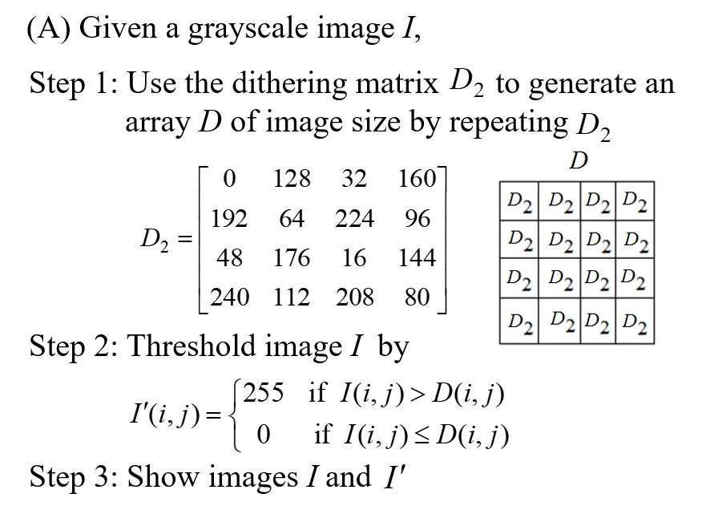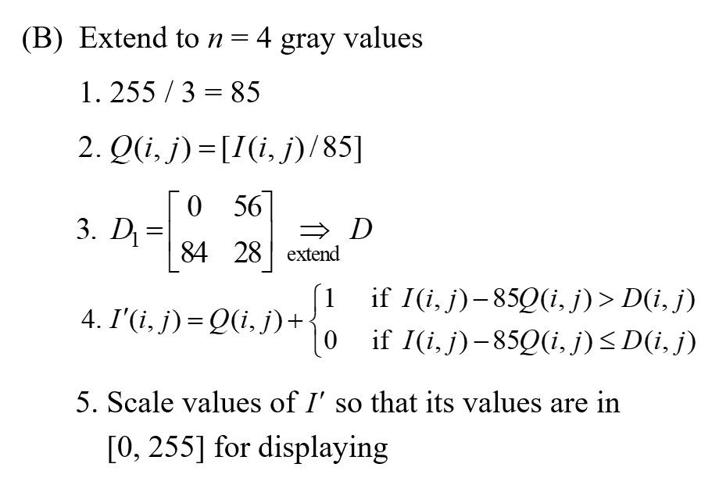

* Code

#import the library

import cv2

import numpy as np

import math

img = cv2.imread('I.jpg', cv2.IMREAD_GRAYSCALE)

y, x = img.shape

# read the image and get the image's shape

# (A)

d2 = np.array([ [ 0, 128, 32, 160,],

[192, 64, 224, 95,],

[ 48, 176, 16, 144,],

[240, 112, 208, 80 ] ])

rx = math.ceil(x/4)

ry = math.ceil(y/4)

d = np.tile(d2, (ry, rx))

# use the dithering matrix d2 to generate an array d of image size by repeating

img_ext = np.zeros([ry*4, rx*4], dtype='uint8')

img_ext[0:y, 0:x] = img.copy()

out = (img_ext>d)[0:y, 0:x]*255

# threshold image I

cv2.imwrite('A.jpg', out) #output the gray image

# (B)

d1 = np.array([ [ 0, 56],

[84, 28] ])

rx = math.ceil(x/2)

ry = math.ceil(y/2)

d = np.tile(d1, (ry, rx))

# use the dithering matrix d2 to generate an array d of image size by repeating

img_ext = np.zeros([ry*2, rx*2], dtype='uint8')

img_ext[0:y, 0:x] = img.copy()

q = (img_ext//85)

out = (q+(img_ext-85*q>d))*85

# scale values of so that its values are in [0, 255] for displaying

cv2.imwrite('B.jpg', out) #output the gray image

* 輸入圖片



* 輸出圖片

(A)

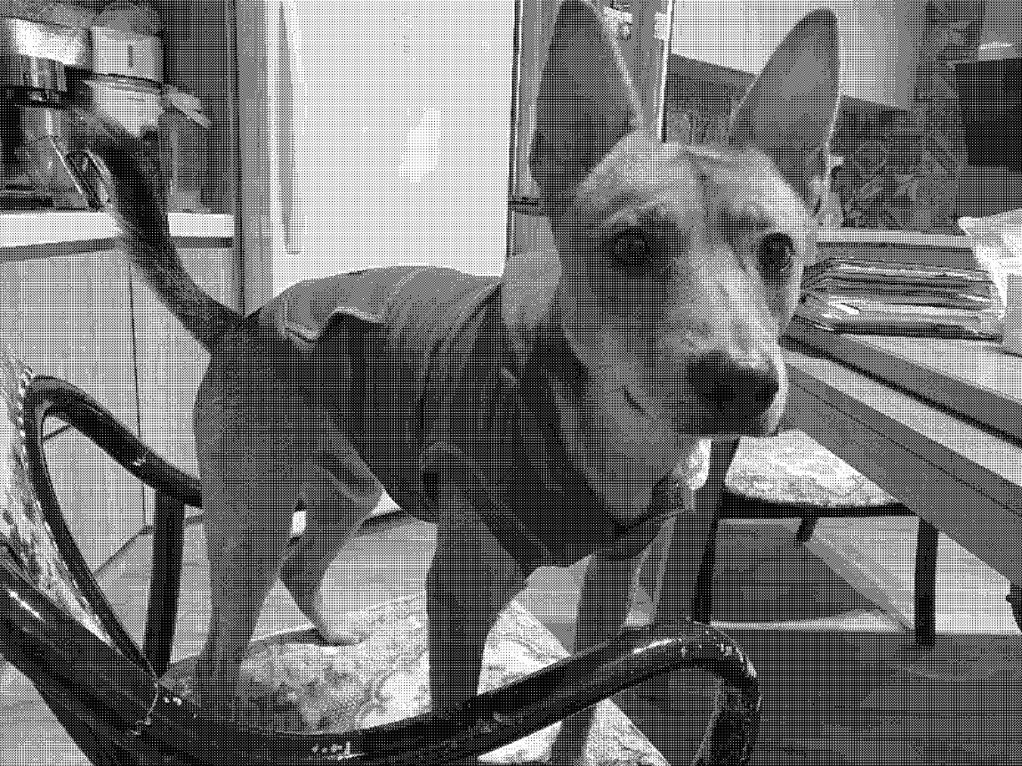

(B)

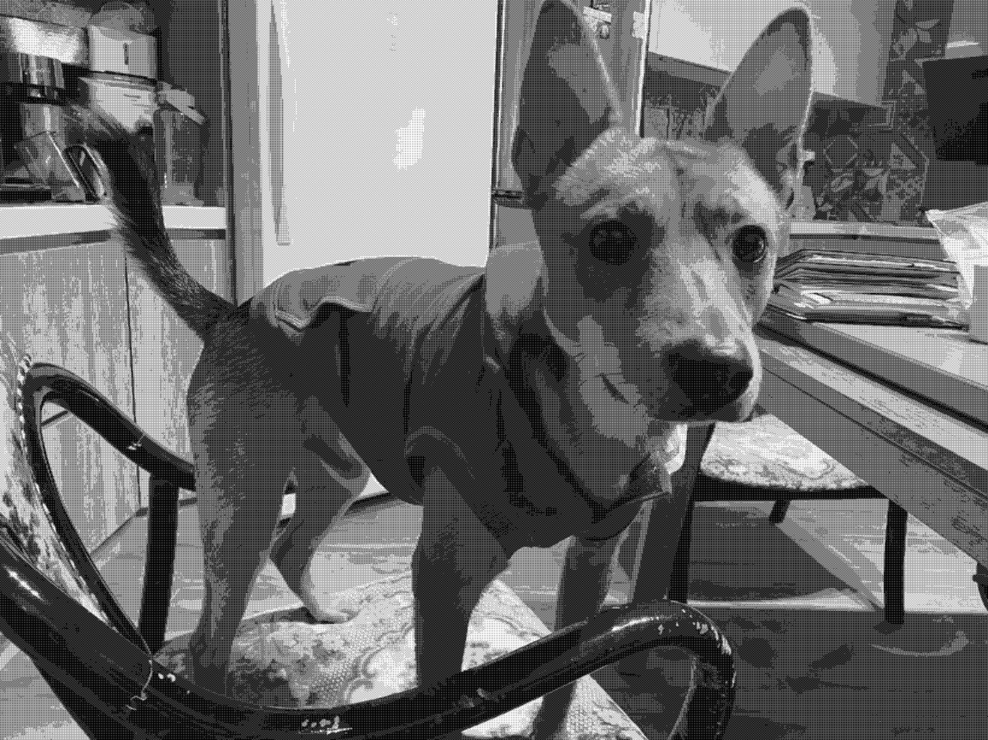

* 心得

這次的dithering實作過程中，了解到即使只有黑白兩種顏色，也可以透過這樣的方式模擬出接近255層灰階的感覺。