影像處理 Homework 6

資工112 40847015S 紀軒宇

* Statement

Implement Otsu’s thresholding method

* Code
* import cv2
* import numpy as np
* import math
* import matplotlib.pyplot as plt
* img = cv2.imread("I.jpg")
* img = cv2.cvtColor(img, cv2.COLOR_BGR2GRAY)
* y, x = img.shape
* his_data_p = np.bincount(img.flatten(), minlength=256)/(x*y)
* mean = 0
* for i in range(256):
* mean += i*his_data_p[i]
* t = 0
* max_out = 0
* for i in range(256-1):
* pa = np.sum(his_data_p[:i+1])
* pb = np.sum(his_data_p[i+1:255])
* if(pa*pb==0):
* continue
* mean_a = 0
* for j in range (i+1):
* mean_a += j*his_data_p[j]
* mean_times_at = mean*pa
* out = ((mean_a-mean_times_at)**2)/(pa*pb)
* if(out>max_out):
* max_out = out
* t = i
* ret1, out1 = cv2.threshold(img, t, 255, cv2.THRESH_BINARY)
* ret2, out2 = cv2.threshold(img,0,255,cv2.THRESH_BINARY+cv2.THRESH_OTSU)
* cv2.imwrite("out1.jpg", out1)
* cv2.imwrite("out2.jpg", out2)
* 輸入圖片

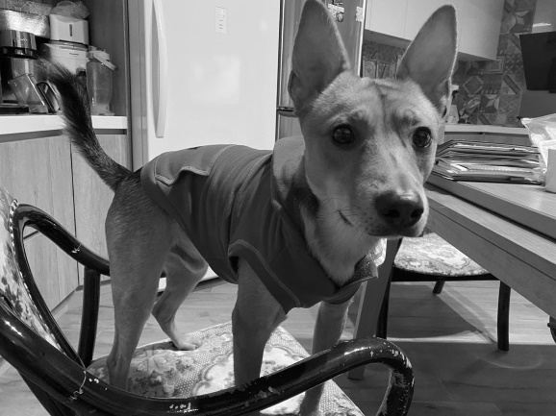

* 輸出圖片

自己實作的圖片

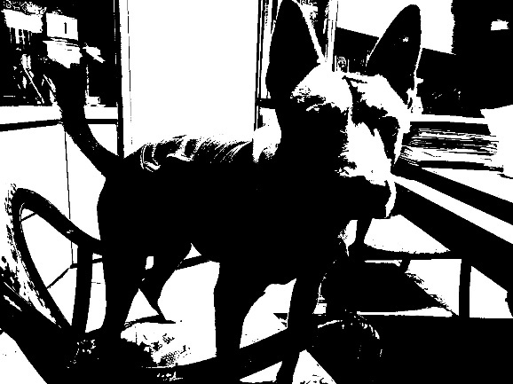

opencv內建function的圖片



* 心得

透過這樣的方法可以將圖片做適當的thresholding，雖相較其他方法，如：Adaptive Thresholding，沒辦法做到最好，不過計算及實作上簡單很多