影像處理 Homework 9

資工112 40847015S 紀軒宇

* Statement

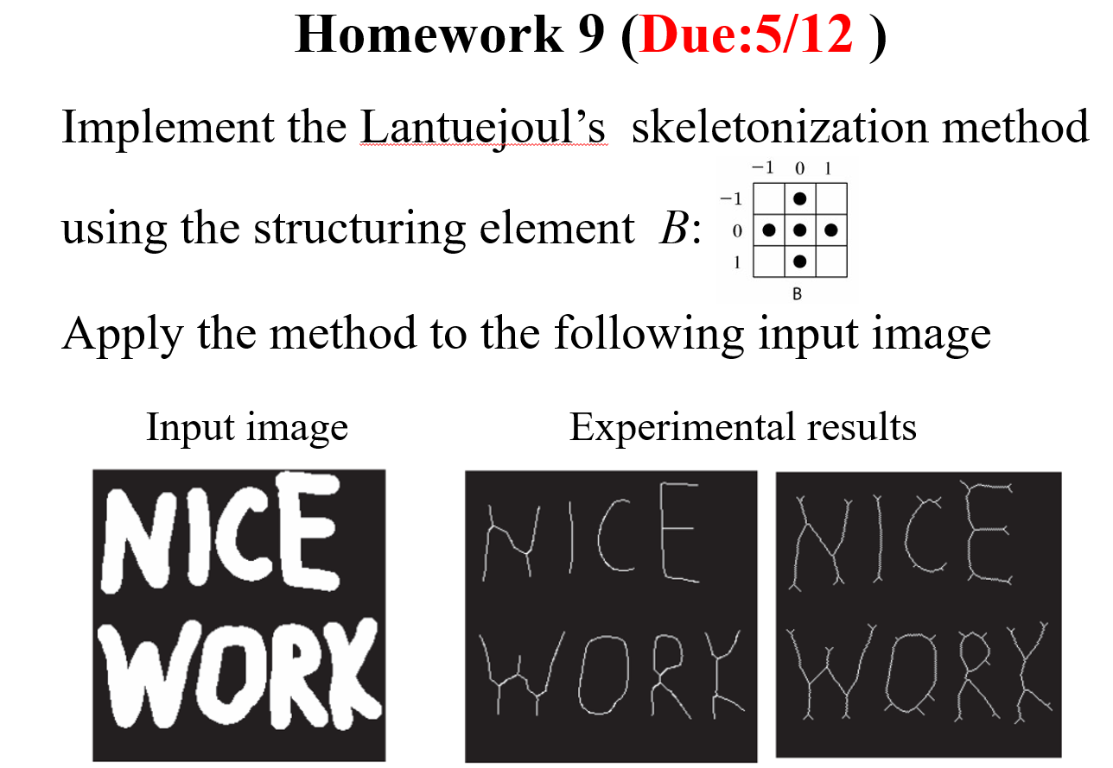

* Code
* #import the library
* import cv2
* import numpy as np
* import math
* img = cv2.imread("input.jpg")
* img = cv2.cvtColor(img, cv2.COLOR_BGR2GRAY)
* ret, img = cv2.threshold(img,127,255,cv2.THRESH_BINARY)
* struct_element = cv2.getStructuringElement(cv2.MORPH_CROSS, (3, 3))
* output = np.zeros(img.shape, dtype="uint8")
* while(1):
* open_img = cv2.morphologyEx(img, cv2.MORPH_OPEN, struct_element)
* if cv2.countNonZero(open_img)==0:
* break
* diff = cv2.subtract(img, open_img)
* output = cv2.bitwise_or(output, diff)
* img = cv2.erode(open_img, struct_element)
* cv2.imshow('ske', output)
* cv2.waitKey(0)
* cv2.imwrite('ske3x3.jpg', output)
* 輸入圖片



* 輸出圖片

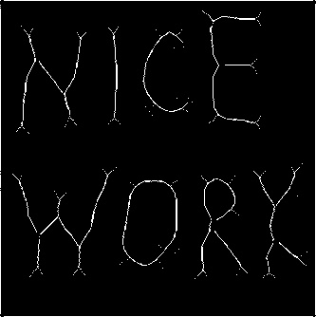　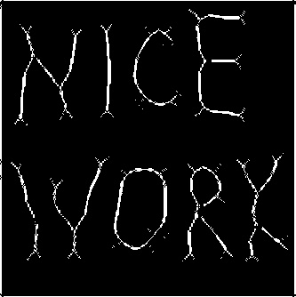　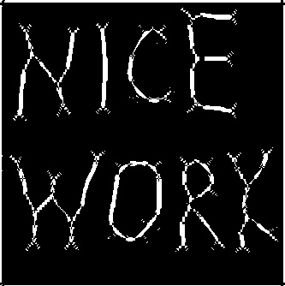

3x3 5x5 7x7

* 心得

實驗部分做了三種實驗，分別使用3x3與5x5及7x7 十字形structure element的做實驗，做出來的結果可以看到隨著structure element的大小做出來的Skeletonization骨架也越粗。