Deep Learning HW1

0851924 許朝鈞

1. 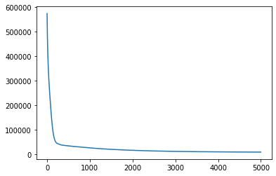Regression

|  |  |
| --- | --- |
| Network architecture | 17 – 8 – ReLU – 1 |
| Selected feature | # Relative Compactness,  Wall Area,  Roof Area,  Overall Height,  Glazing Area |

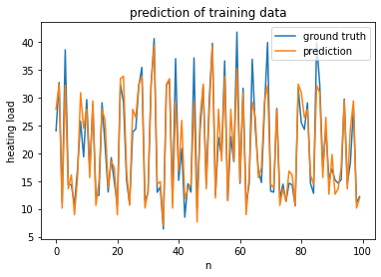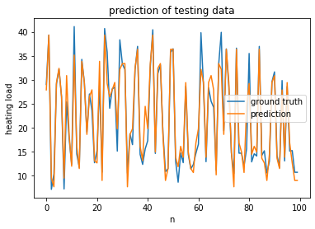

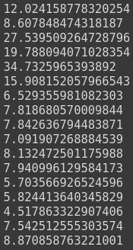 (c) Procedure of choosing different features:

The network has a hidden layer which dimension is 8, so the weights between the input layer and the hidden is (15x8), I added elements in each row, and get 15 values at the right figure, which I thought are the weight if importance of each input feature. Hence, I picked up the first five features.

1. Classification

|  |  |
| --- | --- |
| Network architecture | 35 – 50 – ReLU – 1 |
| Training error rate | 0 / 280 |
| Test error rate | 7 / 71 |

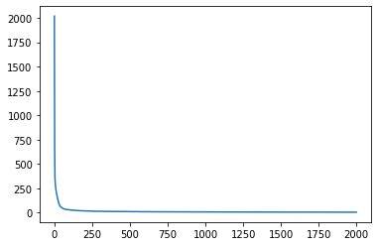

(c)

1. train with one hidden layer, dimension=50

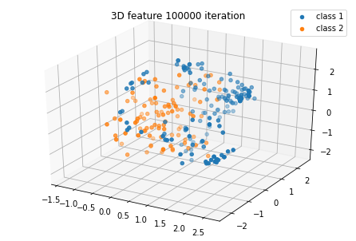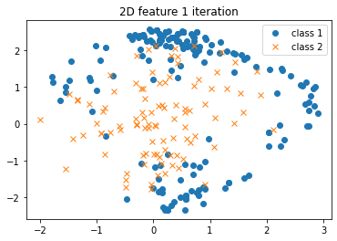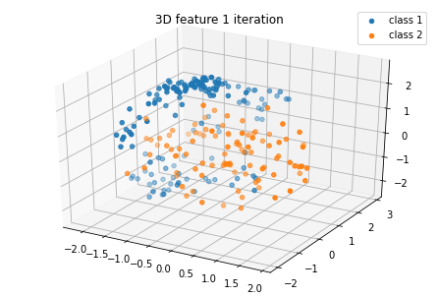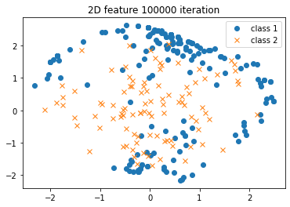

2. train with one hidden layer, dimension=100

