Deep Learning HW4

0851924 許朝鈞

1. Network architecture:

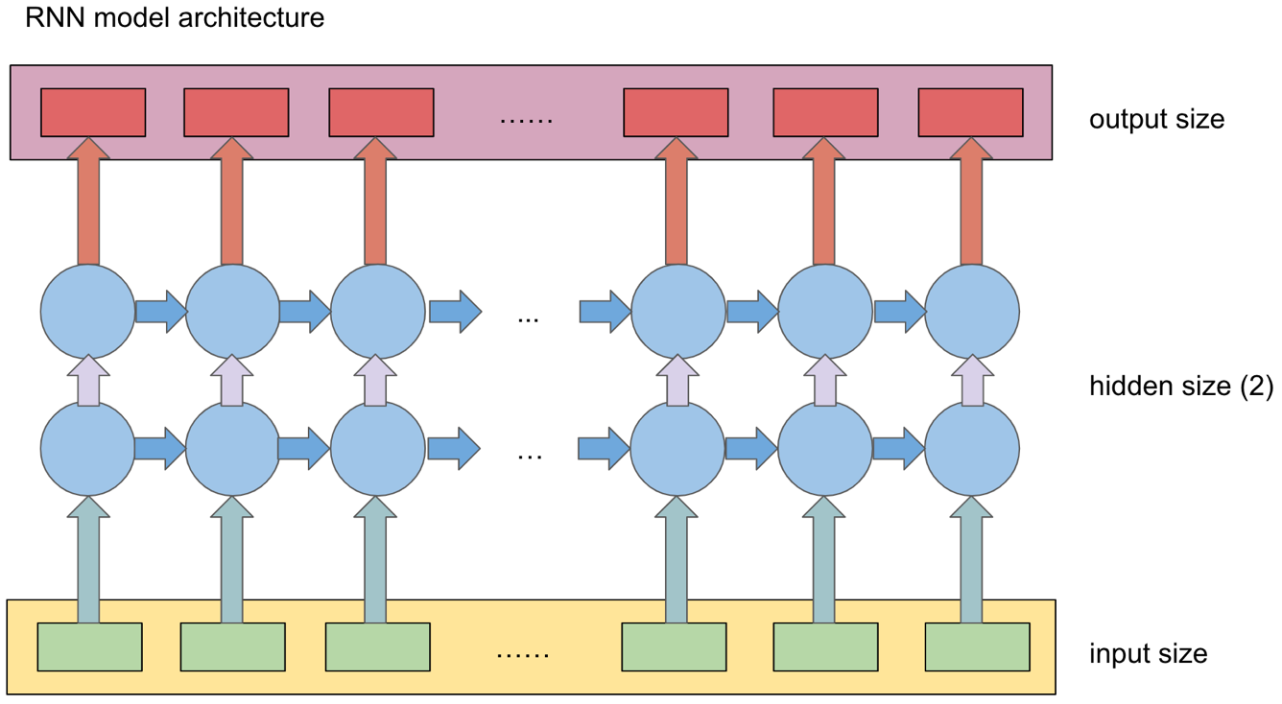

* 1. RNN cell

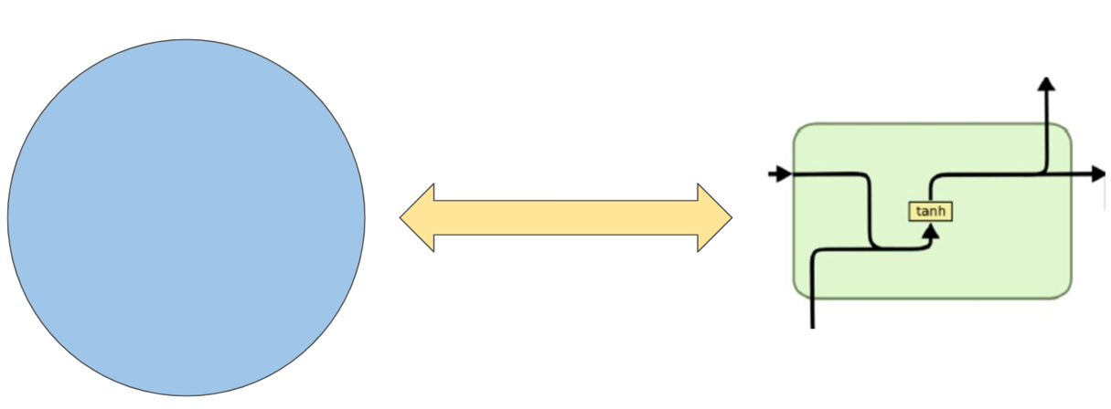

* 1. LSTM cell

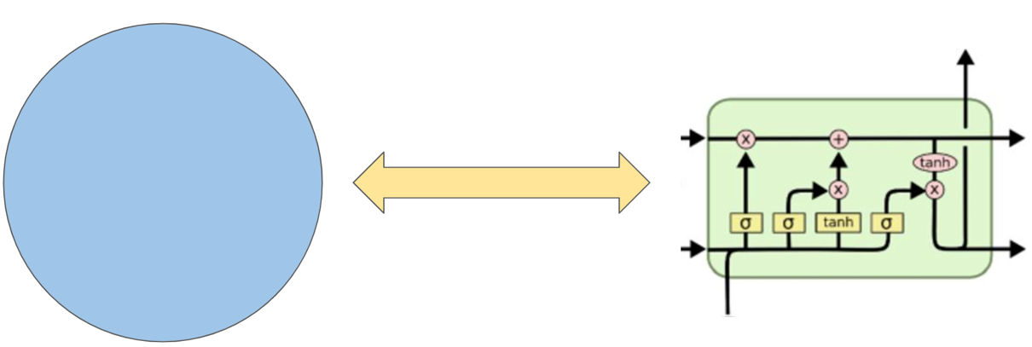

1. RNN learning curve

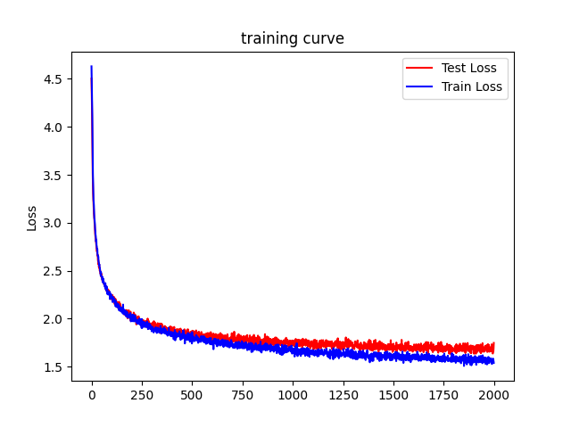

1. LSTM learning curve

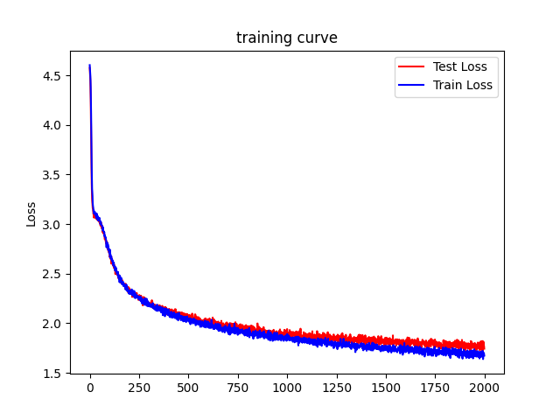

* 1. RNN model with 2000 epoch, hidden size: 150, sequence length: 50  
     (input text: ‘he’)

|  |  |  |  |
| --- | --- | --- | --- |
| Epoch | Train loss | Validation loss | Generate text |
| 400 | 1.8291746520996093 | 1.9136328125 | he poon begorcusts to is i pure to neom the may restive 't store.  krewartion.  duphall, have born.  p |
| 800 | 1.737723388671875 | 1.7780685424804688 | he hearth:  well heren-male ench a speece to sailt blood that that you conting honester will shall glis |
| 1200 | 1.6060601806640624 | 1.727032928466797 | he world's bold desire in more,  and this gentleman, are to the pountend your come her his percure abou |
| 1600 | 1.614979248046875 | 1.6934017944335937 | he artcess.  amerture:  the king, why and crowned and spany water king, with i would marcus charge with |
| 2000 | 1.5397731018066407 | 1.7477688598632812 | her beard in the given in the god unwast of sworn'd as worth  ragone.  edmin:  then i am the king, i am |

* 1. LSTM model with 2000 epoch, hidden size: 150, sequence length: 50  
     (input text: ‘he’)

|  |  |  |  |
| --- | --- | --- | --- |
| Epoch | Train loss | Validation loss | Generate text |
| 400 | 2.139723052978516 | 2.115438690185547 | he fong wall leve me pomgis  a:  but hath  and her by in i as watherd,  to buffer me comes sher the the ha |
| 800 | 1.869774627685547 | 1.9593894958496094 | he!  'cliong:  what a sure stains. hill ies of price an and fister.  i in the let, poffort-  gailding:  p |
| 1200 | 1.7965939331054688 | 1.8652680969238282 | he his the suse sounder cause, to see, could his thus did more to deak  the conder not tweet thou peapt |
| 1600 | 1.7436557006835938 | 1.8143585205078125 | heit; the greeding, fees, sinder slay out dimst brownt, reveade on been no simal so know see see wear |
| 2000 | 1.6740200805664063 | 1.743956298828125 | he worbands,  and me; sir.  ull: ford diving heart somerove  tempory and his nay, is thy did call,  i hav |

* 1. Compare result of different size of hidden state and sequence length

|  |  |  |  |  |
| --- | --- | --- | --- | --- |
| model | epoch | Hidden state size | Sequence length size | Training loss |
| RNN | 2000 | 150 | 50 | 1.5397731018066407 |
| 2000 | 300 | 50 | 1.44021728515625 |
| 2000 | 150 | 100 | 1.5149125671386718 |
| LSTM | 2000 | 150 | 50 | 1.6740200805664063 |
| 2000 | 300 | 50 | 1.5340580749511719 |
| 2000 | 150 | 100 | 1.604589385986328 |

* 1. 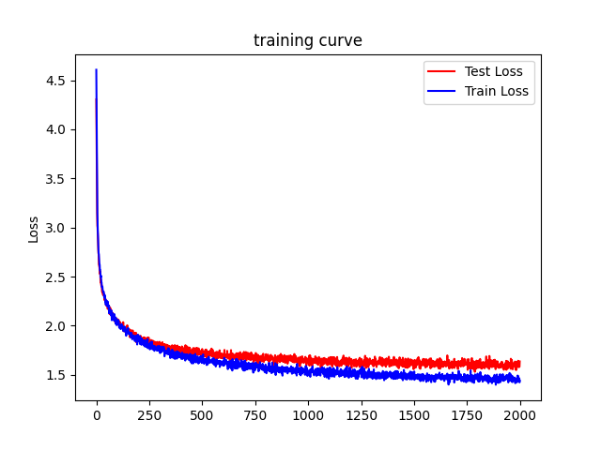Figures
     1. RNN/2000/150/50/1.5397731018066407
     2. RNN/2000/300/50/1.44021728515625



* + 1. RNN/2000/150/100/1.5149125671386718

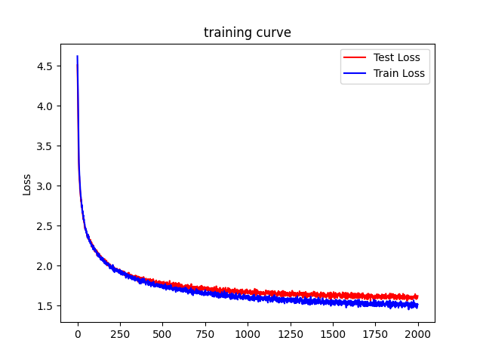

* + 1. LSTM/2000/150/50/1.6740200805664063



* + 1. LSTM /2000/300/50/1.5340580749511719

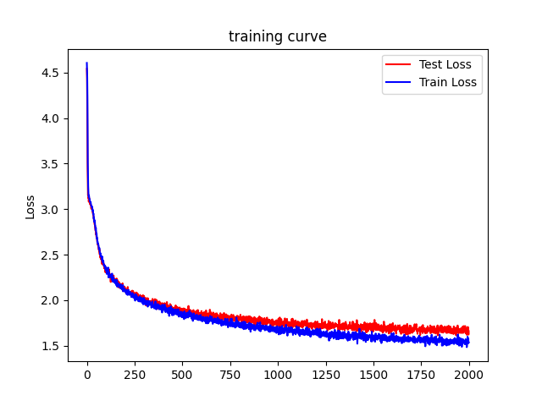

* + 1. LSTM /2000/150/100/1.604589385986328

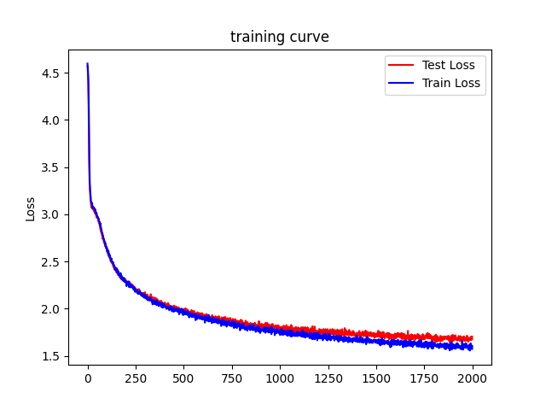

1. Model description: RNN/4000/300/100  
   Prime text: juliet  
     
   output text:   
   juliet:

he's heaven in as wish'd nothing:

and so to write a holy loved up my sacred face?

isabella:

why, then, and cannot be well beaten nothing; i can can be made on

your lates and high

of staring of my bedmatical of your leave may be such traitor, mangled.

alragited:

the cordelia, boyeth valour, of your mother?

mistress quickly:

why, we will have the honour and be become on this sature on

the sungle me: i'll love you

weeping to the name.

rosalind:

that saving him of it.

first comfort:

i said to speak

to the men-conjured thee in my son.

queen margaret:

why, sir, shall hold thee in rest, that your parley of the most precedy. what angelo you should danced, being nearer in the boy why sous.

loder:

are not the days,

to snay for the orting

a chance is own fair of my heart and bloody sound and mark antony.

norfolk:

why, i know not tell them not with you. i'll make no more:

let us but like me in true public else be so,

if your brewd home to this descried of roys:

whilst thou dost thou be a