Computer Vision hw_10

By R01922124 許彥彬

1. Intro of this homework:   
   In this homework we are going to use zero crossing edge detector with different masks. They are “Laplacian”, “Minimum variance”, “Laplacian of Gaussian” and “Difference of Gaussian”.  
   The following are functions and masks that going to be use.  
   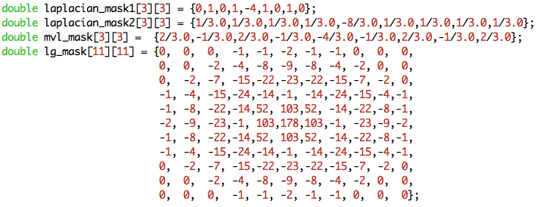
2. Zero Crossing Edge Detectors
   1. Code:  
      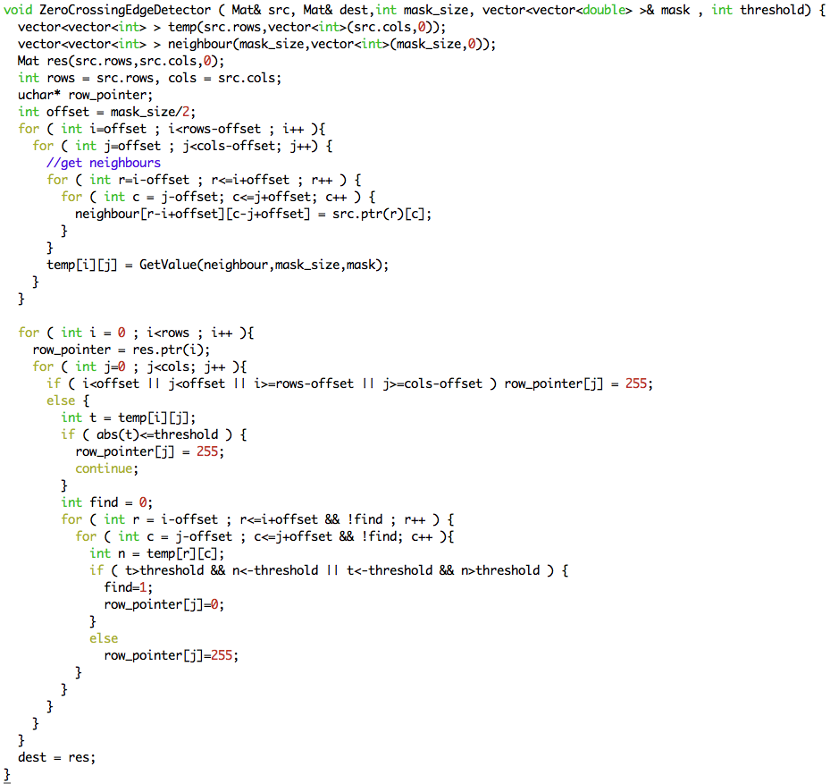
   2. Masks
      1. Laplacian edge detectors with threshold 25 and 16  
         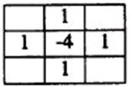 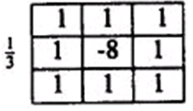
      2. Minimum Variance Laplacian with threshold 12  
         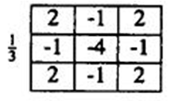
      3. Laplacian of Gaussian with threshold 8000  
         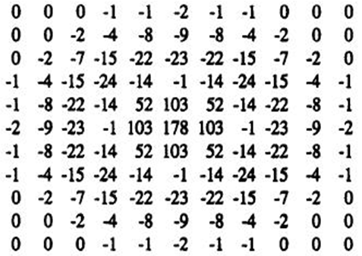
      4. Difference of Gaussian with threshold 7  
         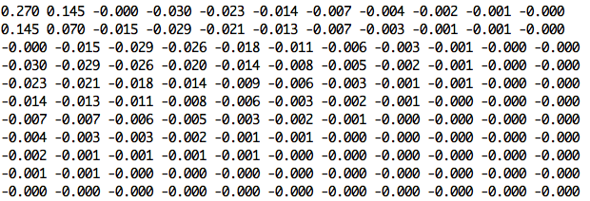
3. Difference of Gaussian operator
   1. Use 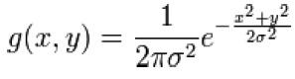 formula to create Gaussian filter and set into “Zero Crossing Edge Detectors” with given threshold.
   2. Code  
      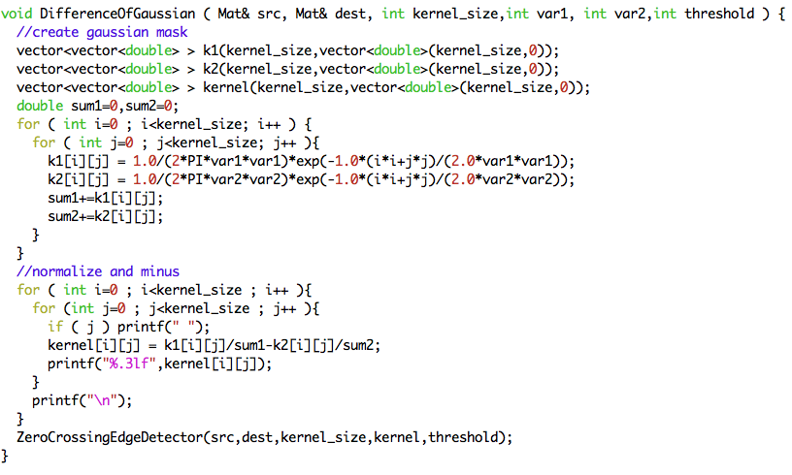
4. “GetValue” function
   1. This function is to get the value calculated by neighbor and a given mask.
   2. Code  
      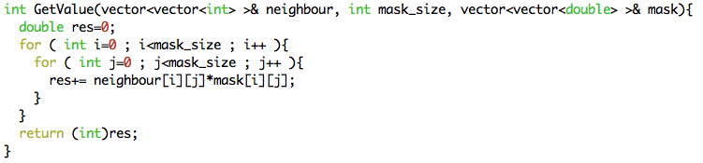
5. Results

|  |  |
| --- | --- |
|  |  |
| lena.bmp | Lap_mask1_25.bmp |
|  |  |
| Lap_mask2_16.bmp | mv_Lap_12.bmp |
|  |  |
| Lap_of_Gaussian_8000 | Diff_of_Gaussian_7.bmp |

1. Appendix
   1. build_all.sh  
      “sh build_all.sh” will automatically compile the code in terminal.
   2. R01922124_HW10.cpp  
      source code
   3. lena.bmp  
      original lena image
   4. Many result images
   5. R01922124_HW10.pdf  
      report