Computer Vision hw_3

By R01922124 許彥彬

1. Histogram Equalization: $s_{k}=255×\sum_{j=0}^{k}{\frac{n_{j}}{n}}$ $k=0 to 255, n_{j}: number of pixels with intensity j$ $n:total number of pixels(rows*cols)$ $for ∀ pixel, if I\left(im, i,j\right)=k then I\left(imhe, i,j\right)=s_{k}$
2. Implementation  
   note: Opencv io function are used.  
    Functions pixel_set, pixet_get are both defined in my first homework.  
   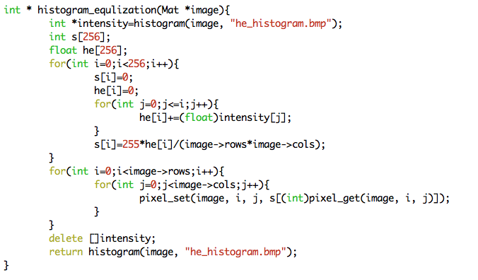
3. Result:
   1. Original Lena.bmp and it’s histogram:  
      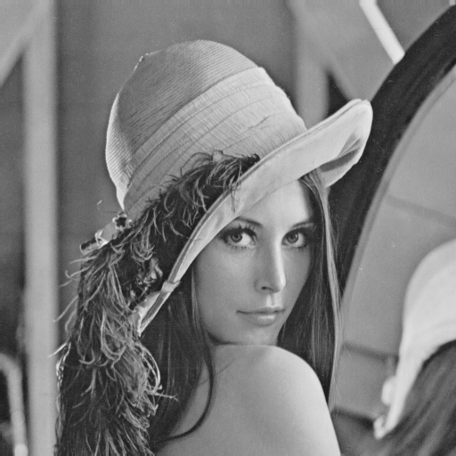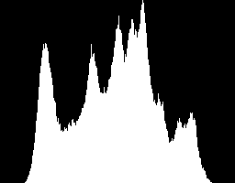
   2. After histogram equalization:  
      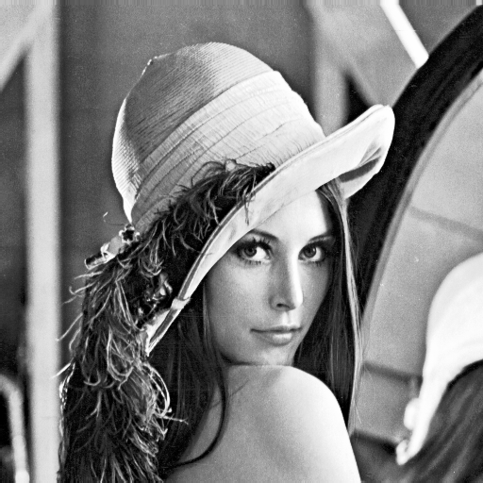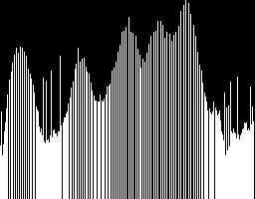
4. Appendix
   1. R01922124_HW3.cpp
   2. R01922124_HW3.pdf
   3. lena.bmp
   4. eq_lena.bmp
   5. histogram.bmp
   6. eq_histogram.bmp
   7. build_all.sh