Computer Vision hw_4

By R01922124 許彥彬

In this part the OpenCV-2.4.2 I/O function was included.

A class “Kernel” is used in this homework to denote a kernel, which used to do erosion and dilation. We use octagon kernel for all except “hit and miss”.

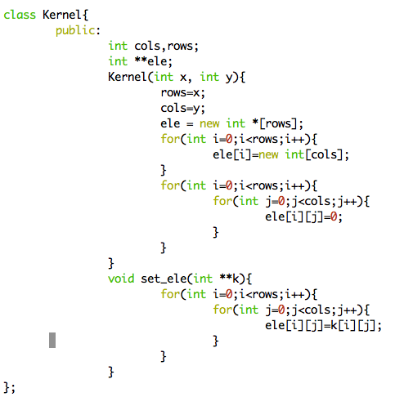

1. Dilation:
   1. First, use functions that wrote in previous homework to transform lena.bmp in to binary image. Search the whole binary image, if a pixel is true, do “di_ele” function to the pixel in order to do the dilation process.
   2. Code:  
      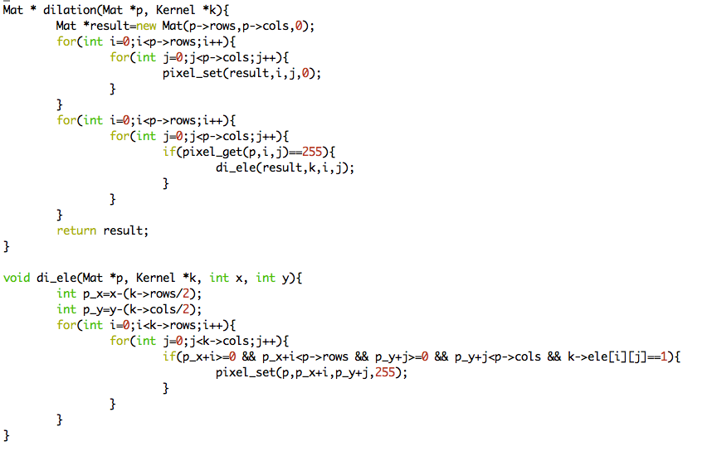
   3. Result:  
      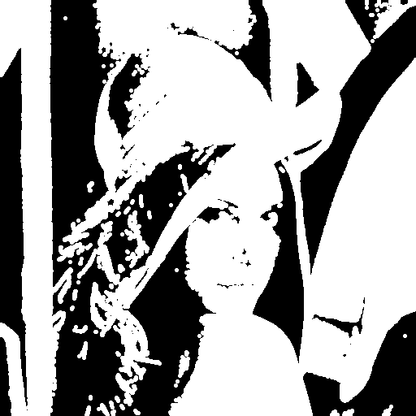
2. Erosion
   1. First, use functions that wrote in previous homework to transform lena.bmp in to binary image. Search the whole binary image, if a pixel is true, do “ero_ele” function to the pixel in order to do the erosion process. If those pixels around the pixel are just like the kernel, return true, else false.
   2. Code:  
      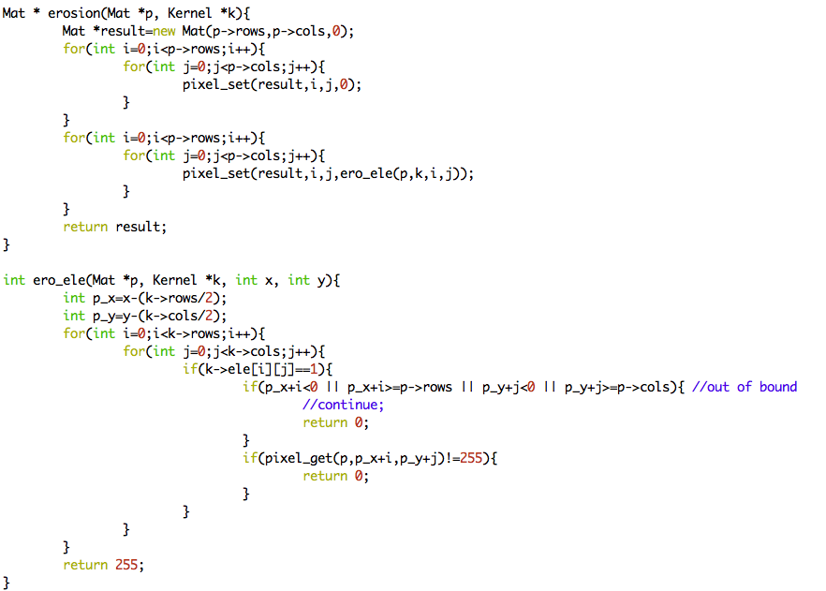
   3. Result:  
      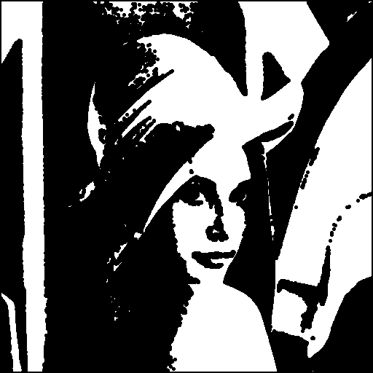
3. Opening
   1. We first do the erosion to lena.bmp, and then do the dilation.
   2. Result:  
      
4. Closing
   1. We first do the dilation to lena.bmp, and then do the erosion.
   2. Result:  
      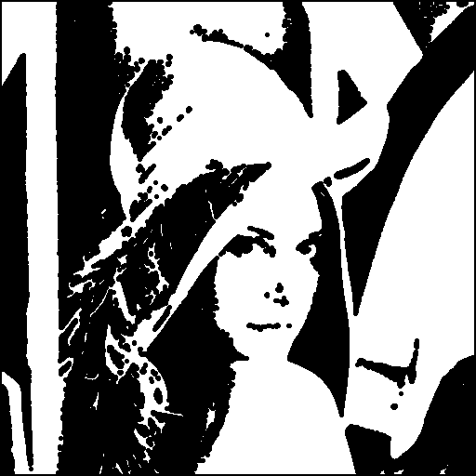
5. Hit and miss:
   1. Kernel:  
      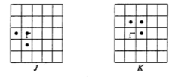
   2. Let A be input picture lena.bmp the formula is:
   3. Code:  
      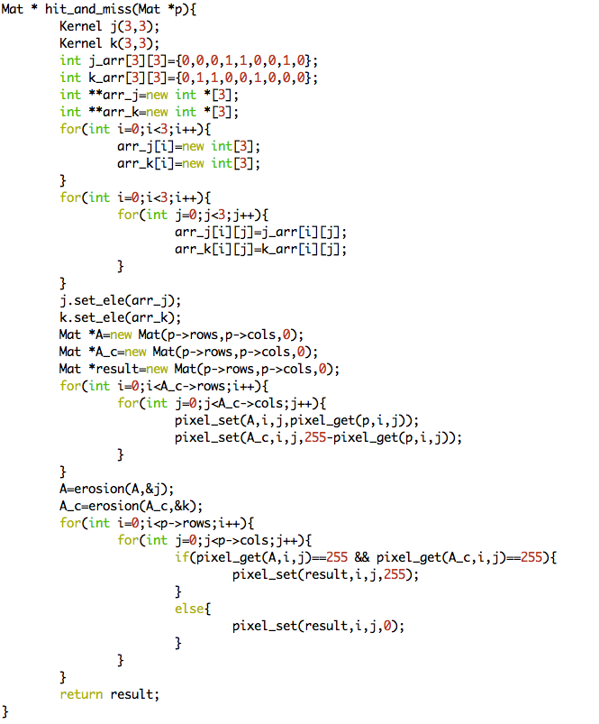
   4. Result:  
      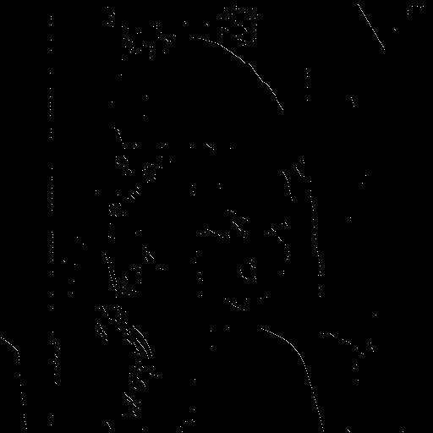
6. Appendix
   1. build_all.sh  
      command: “sh build_all.sh” will automatically compile the code
   2. R01922124_HW4.cpp  
      source code
   3. lena.bmp, di_lena.bmp, ero_lena.bmp, close_ lena.bmp, open_lena.bmp, hit_and_miss_lena.bmp  
      results for this homework
   4. R01922124_HW4.pdf