Computer Vision hw_5

By R01922124 許彥彬

In this part the OpenCV-2.4.2 I/O function was included.

A class “Kernel” is used in this homework to denote a kernel, which used to do erosion and dilation. The octagon kernel is used in this homework.

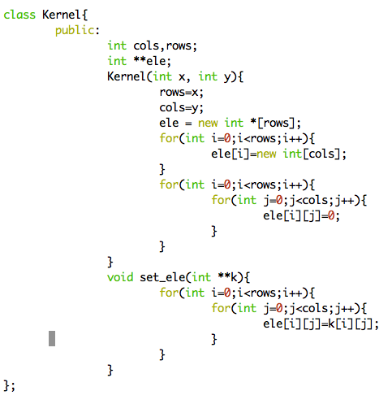

1. Dilation:
   1. First, load the lena.bmp by gray scale. For all pixel in the gray_scale_lena, mask the octagon kernel and set the pixel to the max gray scale value in the kernel.
   2. Code:  
      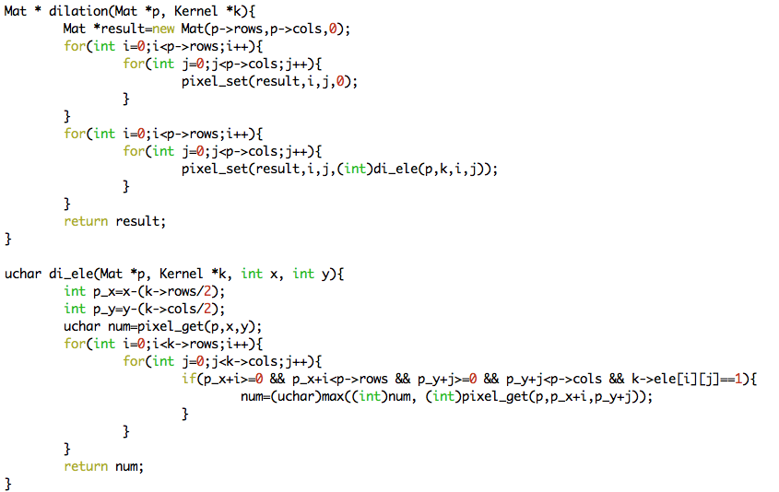
   3. Result:  
      
2. Erosion
   1. First, load the lena.bmp by gray scale. For all pixel in the gray_scale_lena, mask the octagon kernel and set the pixel to the min gray scale value in the kernel.
   2. Code:  
      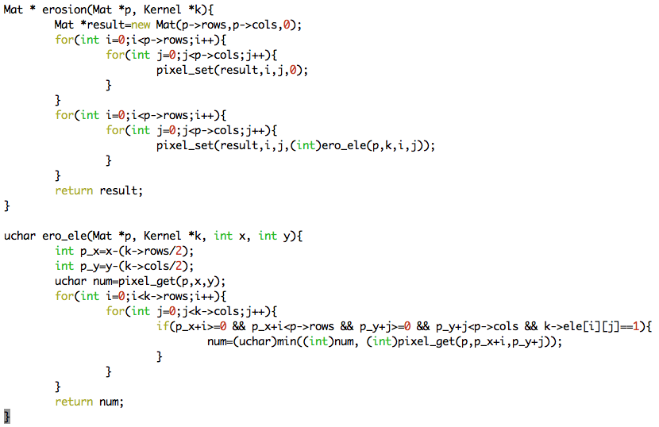
   3. Result:  
      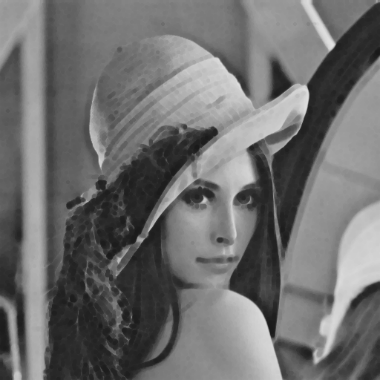
3. Opening
   1. We first do the erosion to lena.bmp, and then do the dilation.
   2. Code:  
      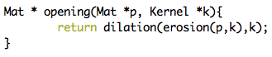
   3. Result:  
      
4. Closing
   1. We first do the dilation to lena.bmp, and then do the erosion.
   2. Code:  
      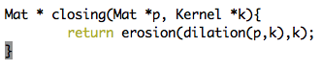
   3. Result:  
      
5. Appendix
   1. build_all.sh  
      command: “sh build_all.sh” will automatically compile the code
   2. R01922124_HW5.cpp  
      source code
   3. lena.bmp, di_lena.bmp, ero_lena.bmp, close_ lena.bmp, open_lena.bmp   
      results for this homework
   4. R01922124_HW5.pdf  
      report