Computer Vision hw_6

By R01922124 許彥彬

Predefine Three parameter Q, R, and S as 1, 0 and 2.

This work includes four new functions and some functions that defined in previous homework.

1. A resize function to resize the lena.bmp. (The default setting in my code is 64x64)  
   codes:  
   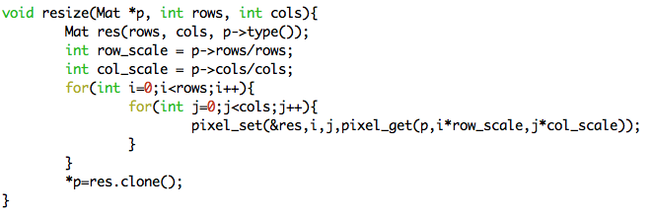
2. 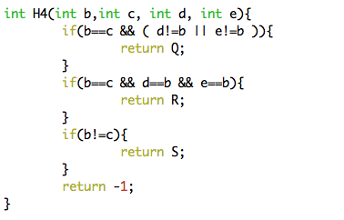Formula 1:  
   Codes:
3. Formula 2: Codes:
4. 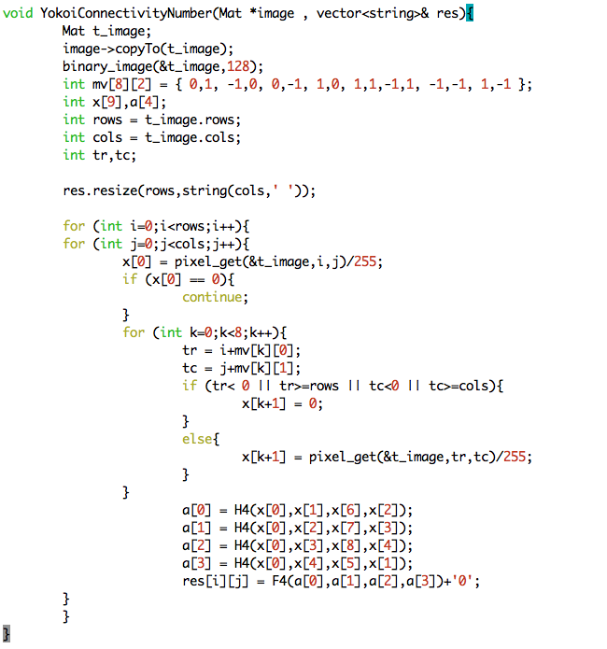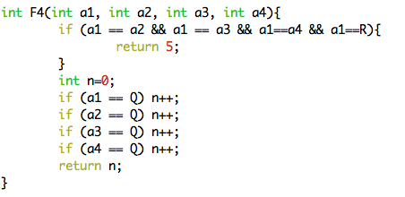Yokoi Connectivity Number  
   idea:  
   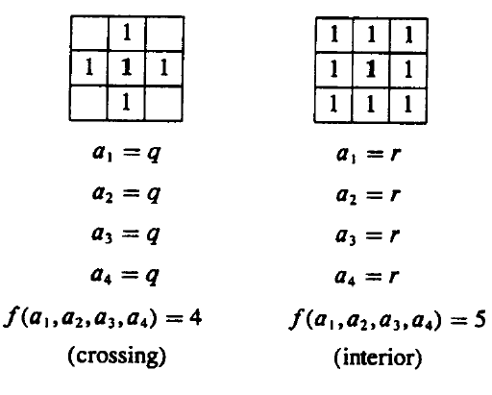 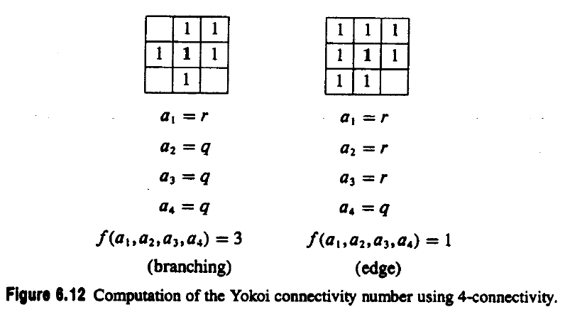  
   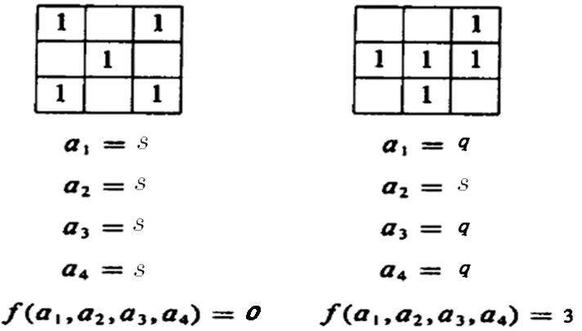  
   Codes:  
     
     
     
     
     
     
     
     
     
     
     
     
     
     
   Result:   
   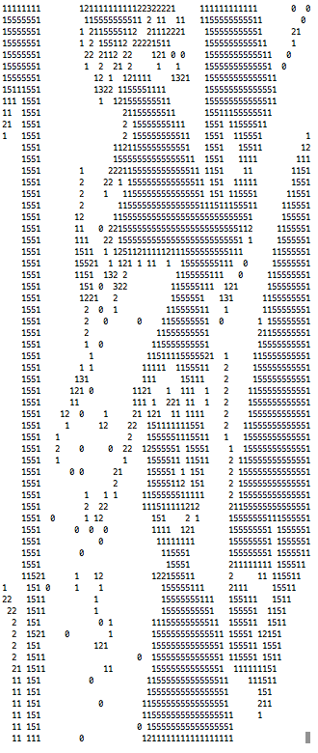
5. Appendix
   1. build_all.sh  
      “sh build_all.sh” will automatically compile the code in terminal.
   2. R01922124_HW6.cpp  
      source code
   3. lena.bmp  
      original lena image
   4. result.txt  
      results for this homework
   5. R01922124_HW6.pdf  
      report