Computer Vision hw_7

By R01922124 許彥彬

1. 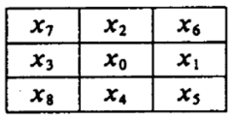Intro of this homework:   
   This assignment is about to do “thining” to “Lena.bmp” with size 64x64. Thining includes three parts of steps, Yokoi connectivity, pair relationship and coneected shrink. I will discuss them in detail respectively. The neighbor is define as the figure shown below.  
     
     
     
     
     
     
     
     
   Last homework I defined three parameters Q, R, and S as 1, 0 and 2. In this homework there are two more parameters, Q_2, P and they are 0 and 1 respectively.  
   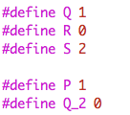  
   This work includes some functions as follows.  
   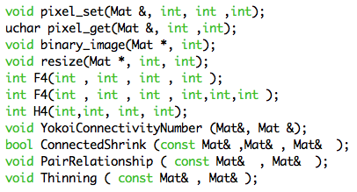
2. Resize
   1. Code:  
      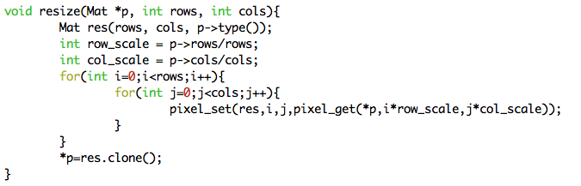
3. Yoikoi connectivity:
   1. Formula: $a_{1}=h\left(x_{o}, x_{1}, x_{6}, x_{2}\right)$ 
      ， $a_{2}=h\left(x_{o}, x_{2}, x_{7}, x_{3}\right)$， $a_{3}=h\left(x_{o}, x_{3}, x_{8}, x_{4}\right)$， $a_{4}=h\left(x_{o}, x_{4}, x_{5}, x_{1}\right)$ $$h\left(b, c, d, e\right)=\left\{\begin{aligned}q, if b=c and \left(d≠b or e≠b\right) \\ r, if b=c and \left(d=b and e=b\right) \\ s, if b≠c \end{aligned}\right. \\ f\left(a_{1}, a_{2, }a_{3}, a_{4}\right)=\left\{\begin{aligned} 5, ifa_{1}=a_{2}=a_{3}=a_{4}=r \\ n, where n=\#\left\{a_{k}|a_{k}=q\right\}, otherwise\end{aligned}\right.$$
   2. Code:  
      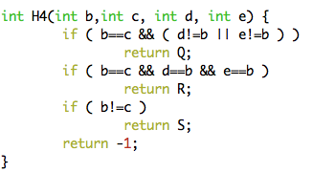  
      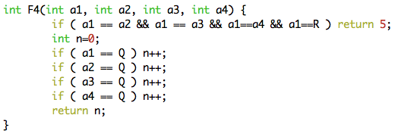  
      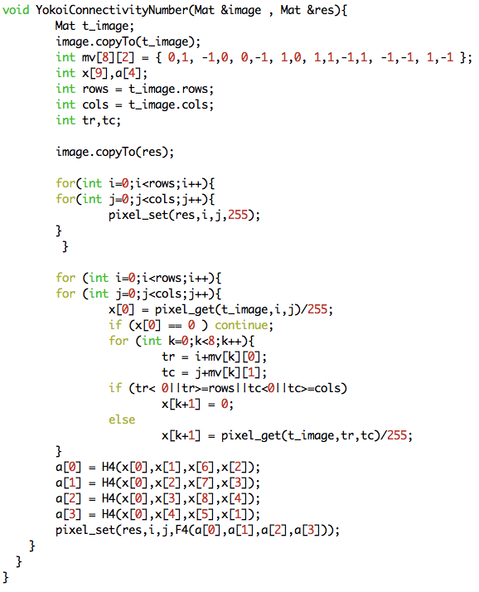
4. Pair relationship:
   1. Formula: $$h\left(a, 1\right)=\left\{\begin{matrix} 1, if a=1 \\ 0, otherwise\end{matrix}\right. \\ y=\left\{\begin{matrix} q, if\sum_{n=1}^{4}{h\left(x_{n}, 1\right)<1 or x_{0}≠1} \\ p, if\sum_{n=1}^{4}{h\left(x_{n}, 1\right)≥1 and x_{0}≠1}\end{matrix}\right.$$
   2. Code: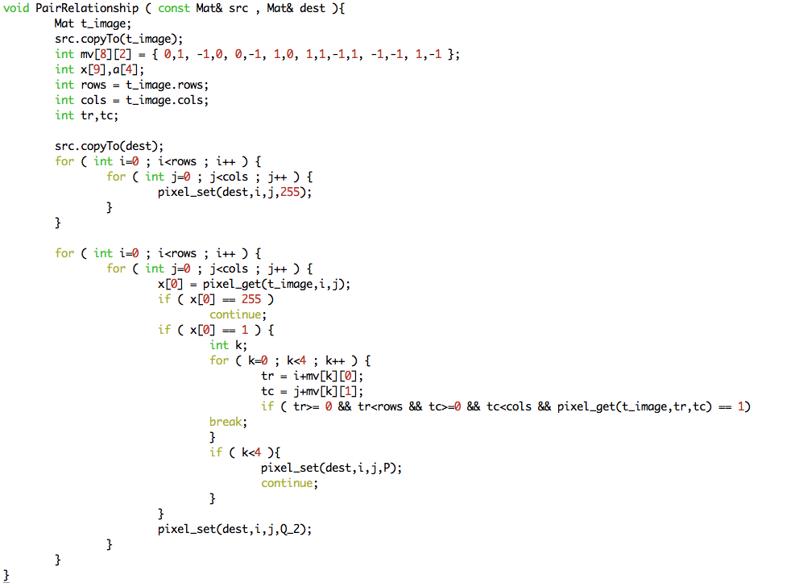Note that there is already a Q in Yokoi connectivity, so I define q in here as Q_2 instead.
5. Connected Shrink
   1. Formula: $$h\left(b, c, d, e\right)=\left\{\begin{matrix} 1, if b=c and \left(d≠b or e≠b\right) \\ 0, otherwise \end{matrix}\right. \\ f\left(a_{1}, a_{2, }a_{3}, a_{4}, x\right)=\left\{\begin{matrix} g, if exactly one of (a_{1}, a_{2, }a_{3}, a_{4})=1 \\ x, otherwise \end{matrix}\right.$$ 
      Note that the h function is very similar to Yokoi connectivity. So I will use the same function and do a little modify. If the return number from H4 is 1 assign 1, else assign 0.
   2. Code:  
      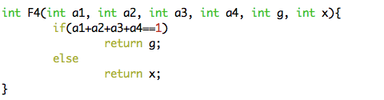  
      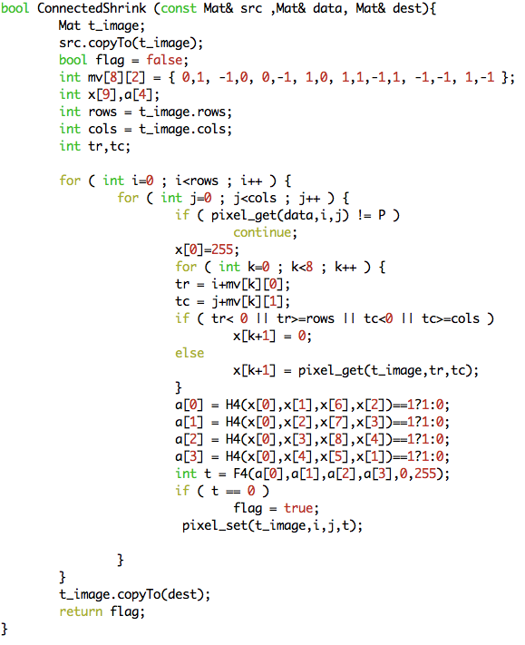
6. Thinning Operator
   1. Idea: Involve the previous three operators.
   2. Code:   
      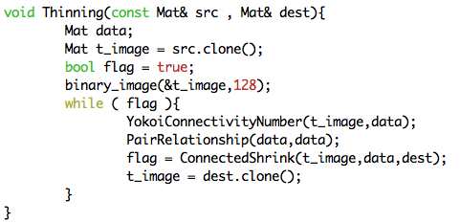
7. Result:  
    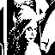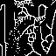
8. Appendix
   1. build_all.sh  
      “sh build_all.sh” will automatically compile the code in terminal.
   2. R01922124_HW7.cpp  
      source code
   3. lena.bmp  
      original lena image
   4. binary_lena.bmp, thinning_lena.bmp  
      results for this homework
   5. R01922124_HW7.pdf  
      report