Computer Vision hw_9

By R01922124 許彥彬

1. Intro of this homework:   
   This homework is to use different edge detectors with different mask, the following are functions that is used in this homework.  
   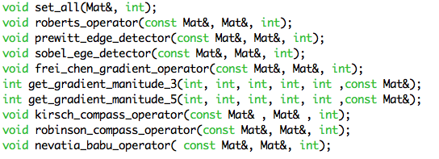
2. Edge detectors in this homework
   1. Robert’s Edge Detector  
      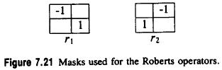  
      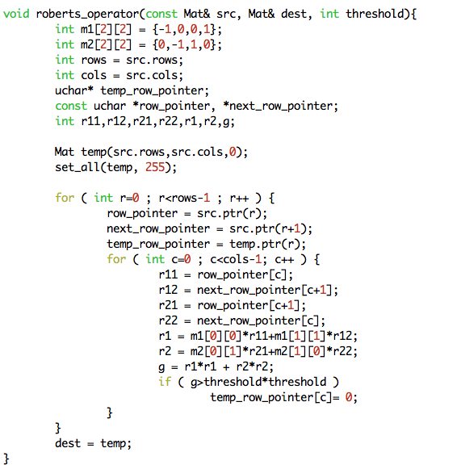
   2. Prewitt’s Edge Detector  
      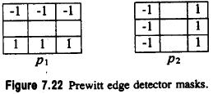  
      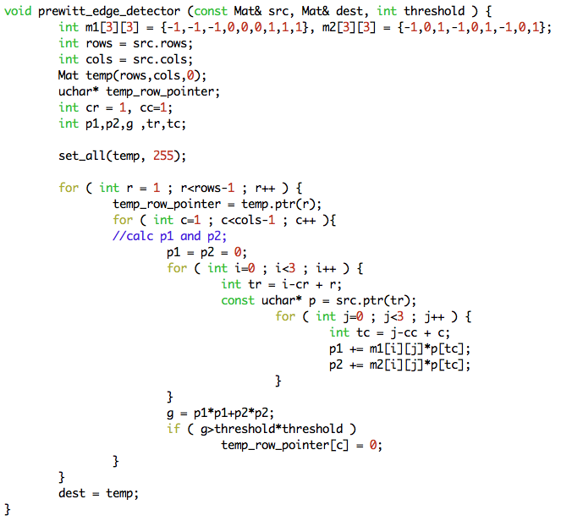
   3. Sobel’s Edge Detector  
      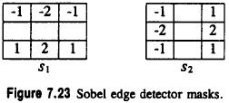  
      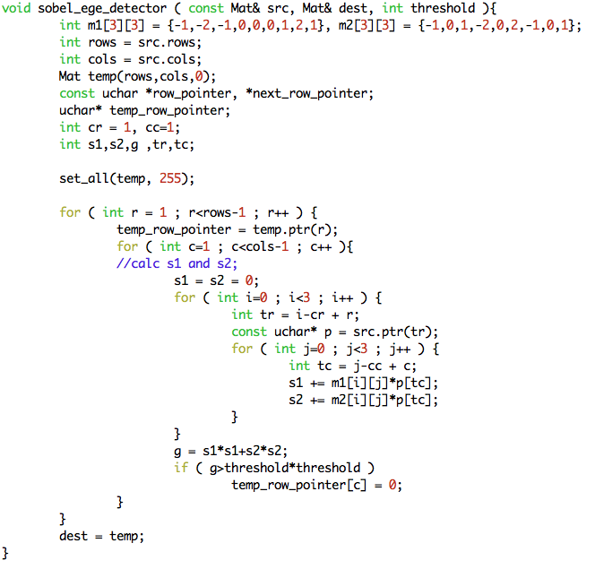
   4. Frei and Chen’s Edge Detector  
      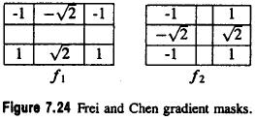  
      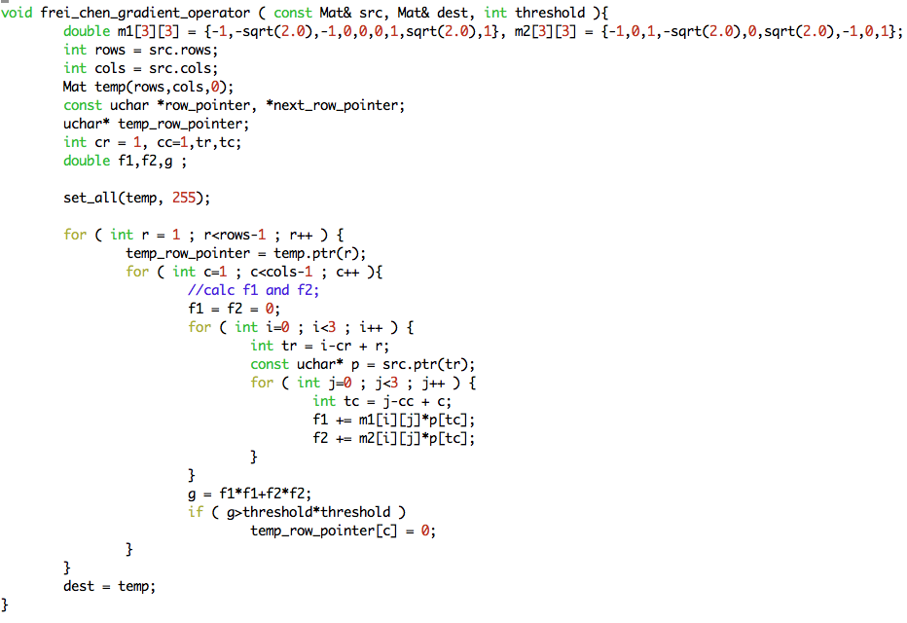
   5. Kirsch’s Edge Detector  
      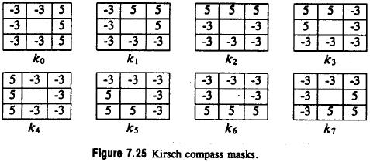  
      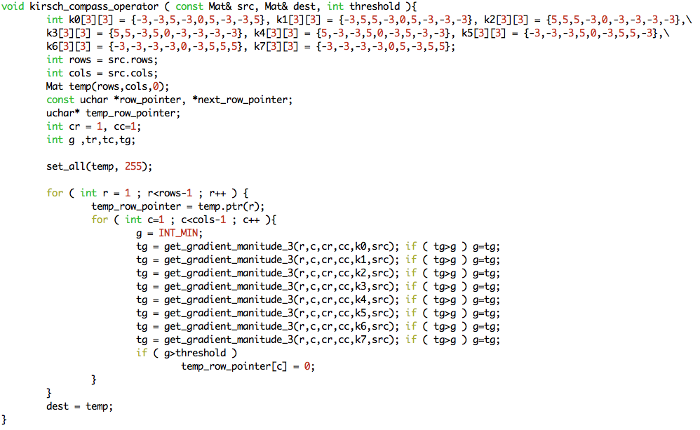
   6. Robinson’s Edge Detector  
      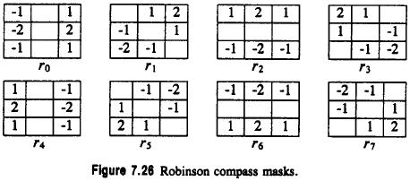  
      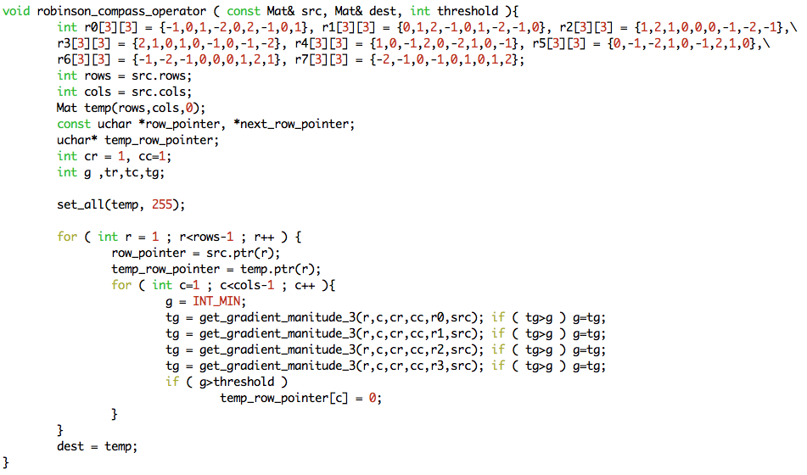
   7. Nevatia-Babu 5x5 Edge Detector  
      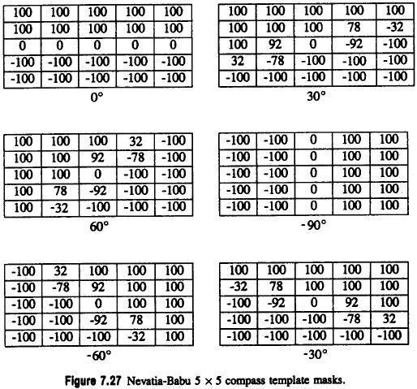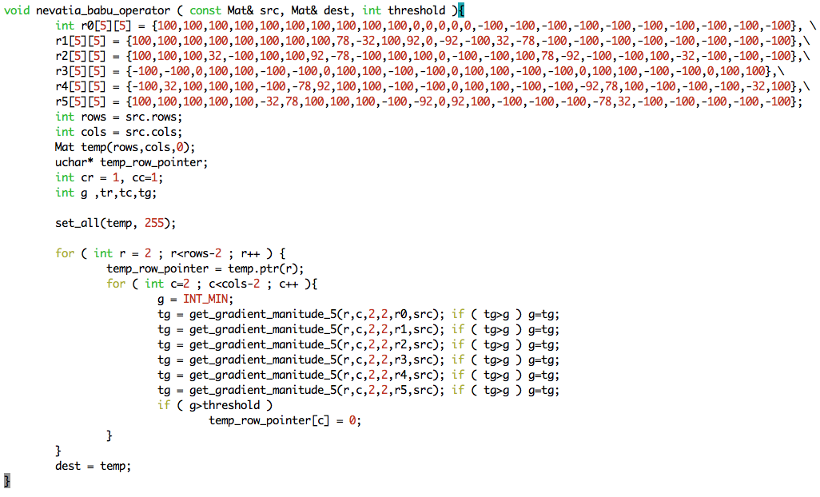
   8. Other functions
      1. set_all: set all pixels of input image to a fixed number   
         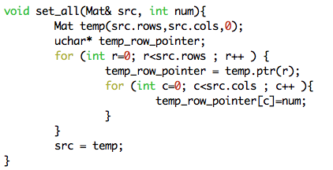
      2. get_gradient_manitude: get the gradient magnitude of size 3 and 5  
         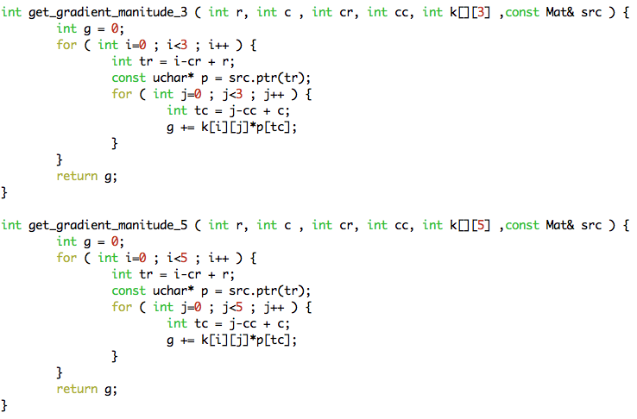
3. Result

|  |  |
| --- | --- |
|  |  |
| lena.bmp | roberts_operator_12.bmp |
|  |  |
| prewitt_edge_detector_24.bmp | sobel_ege_detector_38.bmp |
|  |  |
| frei_chen_gradient_operator_30.bmp | kirsch_compass_operator_135.bmp |
|  |  |
| robinson_compass_operator_43.bmp | nevatia_babu_operator_12500.bmp |

1. Appendix
   1. build_all.sh  
      “sh build_all.sh” will automatically compile the code in terminal.
   2. R01922124_HW9.cpp  
      source code
   3. lena.bmp  
      original lena image
   4. Many result images
   5. R01922124_HW9.pdf  
      report