Ultrasound Lab report

# Introduction:

Ultrasound image processing is widely used in the medical imaging like cardiology, obstetrics, gynaecology and it is popular as the Non-destructive test (NDT) in various field. Ultrasound systems are signal processing intensive. With various imaging modalities and different processing requirements in each modality, digital signal processors (DSP) are finding increasing use in such systems. Various modern technology provides portable and low-cost system without compromising the image quality necessary for clinical applications. The term ultrasound refers to frequencies that are greater than 20 kHz, which is commonly accepted to be the upper frequency limit the human ear can hear.

## Method:

Ultrasound waves are delivered by a transducer, which can both emit ultrasound waves, and in addition identify the ultrasound echoes reflected. As a rule, the dynamic components in ultrasound transducers are made of extraordinary ceramic crystal materials called piezo electrics. These materials can deliver sound waves when an electric field is connected to them, yet can likewise work backward, creating an electric field when a sound wave hits them. At the point when utilized as a part of a ultrasound scanner, the transducer conveys a light emission waves into the body. The sound waves are reflected to the transducer by limits between tissues in the way of the bar (e.g. the limit amongst liquid and delicate tissue or tissue and bone). At the point when these echoes hit the transducer, they produce electrical signs that are sent to the ultrasound scanner. Utilizing the speed of sound and the time of each echo's return, the scanner computes the distance from the transducer to the tissue limit. These separations are then used to create two-dimensional pictures of tissues and organs.

## Results:

Ans 1: Image that rendered from the signal is :

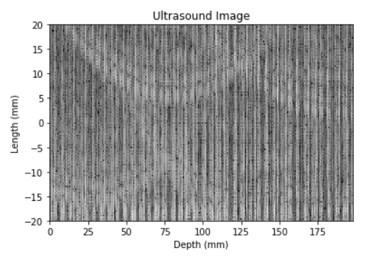

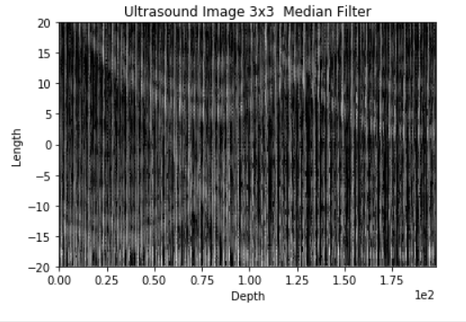

Ans2:

The Index number at max frequency is 398976.

The frequency is 468750.0

the Ultrasound frequency is 4.68 MHz.

Ans3:

By using the formula,

3 = 20 log (V/ 0.00082)

'V' is 0.00011582 and taking down 3 dB gain both sides.

Thus, the bandwidth is from 3.4MHz to 5.5 MHz

Ans4:

The speed of sound in water is 1498 m/sec, so by the formula of the speed of the sound in any medium which is given by

C=(s/p)1/2

Where S= Stiffness of the muscle tissue and P= Density of water, thus by changing the speed of sound. i.e. if we are increasing the speed of sound there will be more reflection from the tissues.

Ans5:

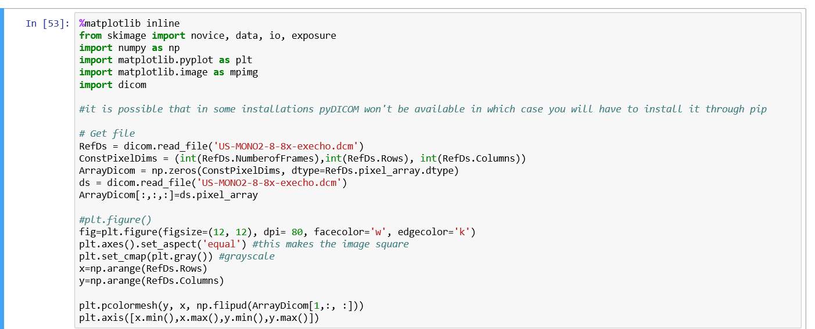

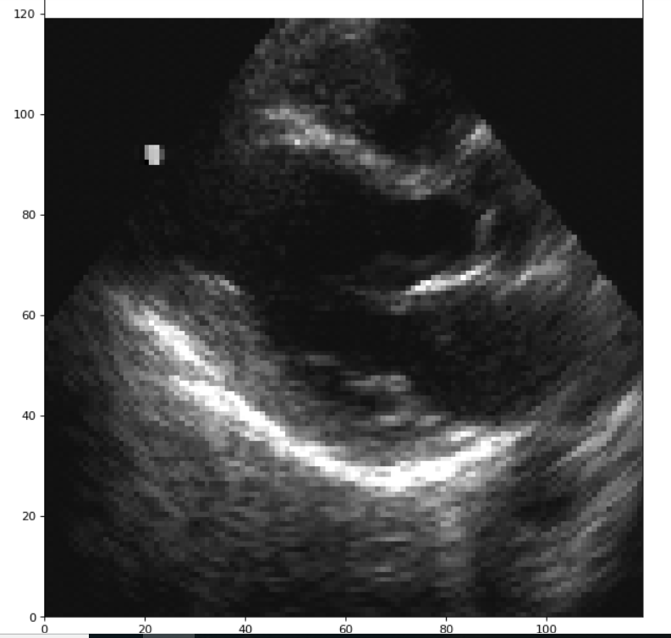

Ans6:

The data we get for the ultrasound is raw signal file and it gives the binary data that will be used to render image. Whereas dicom consists of pixel information where every pixel has a 8 bit data that is used to render the image. Dicom is faster and efficient for that due to its processing.

Ans7:

RAW DICOM corresponds to data on which fewer display processing have been applied. RAW DICOM are encoded on 12bits without compression.

whereas "classic" DICOM images are generally screenshots encoded on 8bits with jpeg lossy compression. That use the image data instead of signal data from that this image is rendered.

## Discussion:

The Ultrasound testing is less complicated than the MRI, but it takes so many manipulations for rendering the final image. The Ultrasound frequency and the scanning tool is more important that how deep we want to scan and how we will choose the parameter while processing the signal.

## References:

* Basics of ultrasound imaging by Vincent Chan and Anahi Perlas .
* Ultrasound system consideration and their impact on front end components by Eberhard Brunner.
* Freudian rich C. “How ultrasound works”. University of Toronto. http://www. physics. utoronto. ca/~ jharlow/teaching/phy138_0708/lec04/ultrasoundx. htm. 2001 Feb 1.