**PyTorch** is a popular open-source machine learning library built by Facebook. It is based on the Torch library and is designed to provide a flexible and efficient way to build and train deep learning models. PyTorch is particularly well-suited for natural language processing (NLP) tasks, such as sentiment analysis, text classification, and machine translation.

Key Features and Advantages:

PyTorch has several key features that make it a popular choice for machine learning and deep learning tasks. Some of its key features include:

1. The dynamic computational graph allows for greater flexibility in building and training models compared to static computational graphs used in other libraries, such as TensorFlow. This dynamic graph enables easy experimentation with different model architectures and training techniques.
2. Tensor computation enables efficient mathematical operations on multi-dimensional data arrays, essential for machine learning tasks.
3. Neural Network Building provides a user-friendly interface to construct and train neural networks. It supports various network architectures, including convolutional neural networks (CNNs), recurrent neural networks (RNNs), and transformers.
4. PyTorch provides a Pythonic interface, making it easy to integrate with other Python libraries and frameworks commonly used in data science and machine learning.

Purpose:

The purpose of PyTorch is to provide a flexible and efficient framework for building and training machine learning models, particularly neural networks. It aims to make it easier for researchers and developers to work with complex data and algorithms by offering features such as dynamic computational graphs, tensor computation, and a rich ecosystem of tools and libraries. PyTorch is widely used for tasks such as natural language processing, computer vision, and other applications involving large-scale data analysis and processing.

Applications:

Real-world applications of PyTorch include:

Healthcare: PyTorch is employed in medical imaging analysis, drug discovery, disease diagnosis, and personalized medicine applications.

1. Medical Imaging Analysis: PyTorch is used for tasks such as image segmentation, disease detection, and medical image classification. For example, it can be employed in the analysis of MRI scans, X-rays, and CT scans to assist in the diagnosis of conditions such as tumors, fractures, and other abnormalities.
2. Drug Discovery: PyTorch is utilized in computational drug discovery to help identify potential drug candidates, predict molecular properties, and simulate molecular interactions. This can aid in the development of new pharmaceuticals and the optimization of drug discovery processes.
3. Disease Diagnosis: PyTorch can be applied in the development of diagnostic tools for various diseases and medical conditions. For instance, it can be used in the analysis of patient data to assist in the early detection and diagnosis of conditions such as cancer, cardiovascular diseases, and neurological disorders.
4. Personalized Medicine: PyTorch is used to analyze patient data and genetic information to develop personalized treatment plans and predict individual responses to specific treatments. This can contribute to the advancement of precision medicine tailored to the unique characteristics of each patient.

Comparison

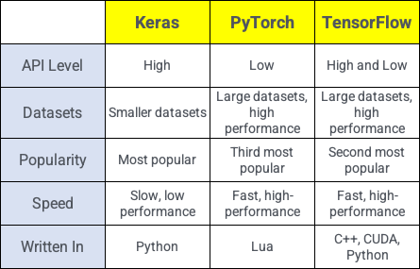

Reference:

Terra J. Aug.23, 2023. Keras vs Tensorflow vs PyTorch: Key Differences Among Deep Learning. Simplilearn.

https://www.simplilearn.com/keras-vs-tensorflow-vs-pytorch-article