Biostat Method Rec 1

HS

9/10/2019

library(tidyverse)

## ── Attaching packages ──────────────────────────────────────────────────────────────────────── tidyverse 1.2.1 ──

## ✔ ggplot2 3.2.1 ✔ purrr 0.3.2  
## ✔ tibble 2.1.3 ✔ dplyr 0.8.3  
## ✔ tidyr 0.8.3 ✔ stringr 1.4.0  
## ✔ readr 1.3.1 ✔ forcats 0.4.0

## ── Conflicts ─────────────────────────────────────────────────────────────────────────── tidyverse_conflicts() ──  
## ✖ dplyr::filter() masks stats::filter()  
## ✖ dplyr::lag() masks stats::lag()

library(arsenal)  
library(dplyr)  
library(goeveg)

## Welcome to the GoeVeg Package

library(readxl)  
#Define get mode function   
getmode <- function(v) {  
 uniqv <- unique(v)  
 uniqv[which.max(tabulate(match(v, uniqv)))]  
}  
  
# Create the vector with numbers.  
#v <- c(2,1,2,3,1,2,3,4,1,5,5,3,2,3)  
  
# Calculate the mode using the user function.  
#result <- getmode(v)  
#print(result)  
  
# Create the vector with characters.  
#charv <- c("o","it","the","it","it")  
  
# Calculate the mode using the user function.  
#result <- getmode(charv)  
#print(result)

## Problem 1

## Problem 2

Twenty-five randomly selected appendectomies lasted for the following lengths of time. Construct a histogram from the following data: 113 118 138 139 157 157 121 123 126 128 130 135 136 137 140 140 142 142 142 142 143 155 158 159 164

timelength_appendectomies = c(113,118,  
138, 139, 157, 157,121, 123, 126, 128, 130, 135, 136, 137, 140, 140, 142, 142, 142, 142, 143, 155, 158, 159, 164)  
  
#Use break to set cat width  
hist(timelength_appendectomies ,   
 main = "Problem 2 Histogram",  
 breaks = 5,  
 xlab = "time length appendectomies",  
 ylab = "Abundance",   
 col = "blue")

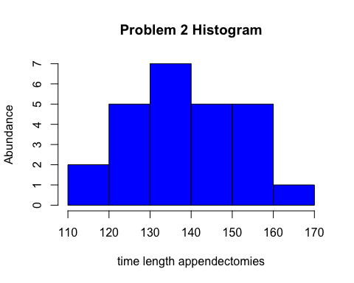

## Problem 3

Heart rates for ten asthmatic patients in a state of respiratory arrest are given below. Find the mean, median, and mode.

165 145 115 110 150 145 38 140 122 155

1. What are the mean, median, and mode?

## [1] "numeric"

The mean is 128.5

The mode is 145

The median is 142.5

1. What is the five-number summary? Make a box-plot using this data. The five-number summary is 38, 115, 142.5, 150, 165

boxplot(Heart_rates_asthmatic_patients,   
 xlab = "Heart_rates_asthmatic_patients",   
 main = "boxplot for problem 3" )

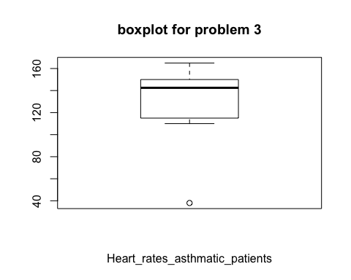

1. What is the Range: The range is38, 165

d.What is the variance? Standard deviation? IQR? The variance is 1325.6111111 The SD is 36.4089427 The IQR is 32

e.What is the coefficient of variation? The coefficient of is 0.2833381

## Problem 4

a.For each variable (other than ID), obtain appropriate descriptive statistics (both numeric and graphic). ##First do the continiouse variable, make a table for these ##Then do the

FEV_DAT <- read_excel("/Users/haosun/Desktop/Columbia\ class/P8130\ -\ BIOSTATISTICAL\ METHODS\ I/Recitation/Rec1/FEV.DAT.xls")  
  
print("the mean is")

## [1] "the mean is"

sapply(select(FEV_DAT,2:4), function(x) mean(as.numeric(x)))

## Age FEV Hgt   
## 9.931193 2.636780 61.143578

print("the mode is")

## [1] "the mode is"

sapply(select(FEV_DAT,2:4), function(x) getmode(as.numeric(x)))

## Age FEV Hgt   
## 9.000 3.082 63.000

print("the five number stat is")

## [1] "the five number stat is"

sapply(select(FEV_DAT,2:4), function(x) fivenum(as.numeric(x)))

## Age FEV Hgt  
## [1,] 3 0.7910 46.0  
## [2,] 8 1.9790 57.0  
## [3,] 10 2.5475 61.5  
## [4,] 12 3.1200 65.5  
## [5,] 19 5.7930 74.0

print("the variance is")

## [1] "the variance is"

sapply(select(FEV_DAT,2:4), function(x) var(as.numeric(x)))

## Age FEV Hgt   
## 8.7257330 0.7517915 32.5300582

print("the sd is")

## [1] "the sd is"

sapply(select(FEV_DAT,2:4), function(x) sd(as.numeric(x)))

## Age FEV Hgt   
## 2.9539352 0.8670591 5.7035128

print("the iqr is")

## [1] "the iqr is"

sapply(select(FEV_DAT,2:4), function(x) IQR(as.numeric(x)))

## Age FEV Hgt   
## 4.0000 1.1375 8.5000

print("the coef of var is")

## [1] "the coef of var is"

sapply(select(FEV_DAT,2:4), function(x) cv(as.numeric(x)))

## Age FEV Hgt   
## 0.29744012 0.32883258 0.09328065

boxplot(select(FEV_DAT,2:4),   
 data=FEV_DAT,   
 xlab = colnames(select(FEV_DAT,2:6)),   
 main = "Boxplot for Q4a" )

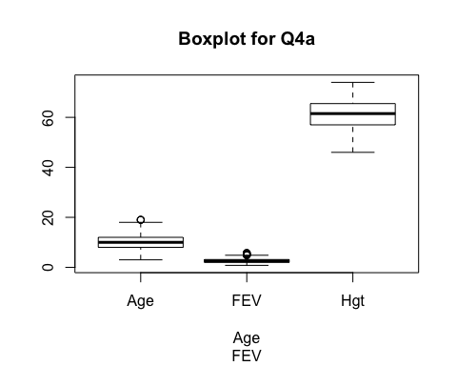

2.24 Use both numeric and graphic measures to assess the relationship of FEB to age, height, and smoking status. (Do this separately for boys and girls.)

(Use Scaltter plot to illustrate the relationship btw continious variable)

Relationship to Smoking

boxplot(FEV~Smoke, FEV_DAT, col=c("blue","red"))

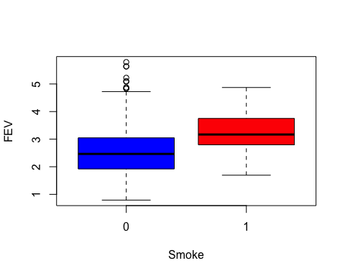

Relationship to age

2.25: Creat regressio line for the FEV and Age for boy and girls

b

?read_excel()  
rm(list=ls())