

Wendall Hsu 300739743

COMP397 – Web Game Programming

Assignment 1

RGB DOOM PORTALS

**Table of Contents**

**Detailed Game Description** 2

Synopsis 2

Overall Description 2

**Overall Mind Map** 3

**Version History** 4

Commit #1 4

Commit #2 4

Commit #3 5

Commit #4 5

Commit #5 5

# **Detailed Game Description**

## Synopsis

You play as Mr. White, an experimental test subject who has been drugged and put into a deep sleep. In your sleep, you dream about waking up in a room that contains three coloured portals - a red one, a green one, and a blue one. You must choose the portal that will lead to your safety, but be wary, for if you choose the wrong, you will suffer a terrible death and will never wake from your sleep. Now...which colour is your favourite?

## Overall Description

In this game, players will get to choose specific paths by clicking on the “PORTAL” buttons. The objective of the game is to get to the pink portal. There is only one path that will lead to the pink portal; any other path that players choose will lead them to a death scenario where they will then be able to reset and start all over again. Each path and its result can be seen on the mind map below.

There will be a total of five different death scenarios. The first three death scenarios (zombies, Mars, and guillotine) will be used for the non-main paths (i.e. not GREEN 🡪 GREEN). Once players get to the room with the purple, orange, and cyan portals, the fourth death scenario (heart attack) will reveal itself if they do not pick the correct portal. Finally, the fifth death scenario will only occur if they choose the brown portal and not the pink portal.

**Project can be found on Windows Azure:** http://comp397-assignment1-hsu.azurewebsites.net

# **Overall Mind Map**

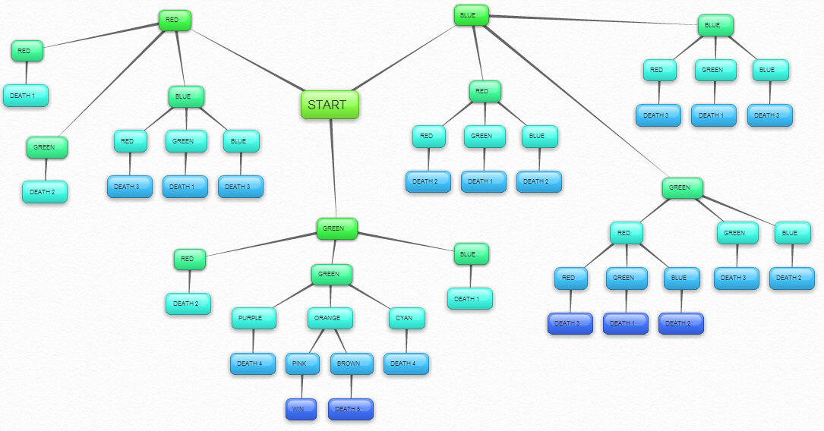

# **Version History**

## Commit #1 (September 28)

* Initial commit onto GitHub to add default .gitIgnore and .gitAttribute files
* Completion of first death path

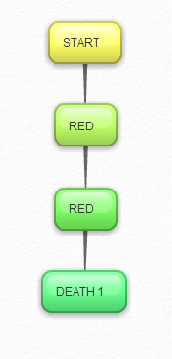

## Commit #2 (September 29)

* Completed full path for initial red portal
* Completed some death scenarios for first green and blue portals

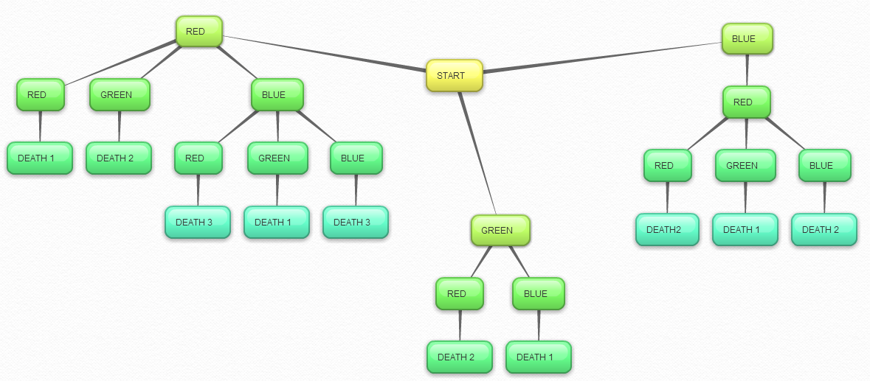

## Commit #3 (October 1)

* Completed all death scenarios except for main path

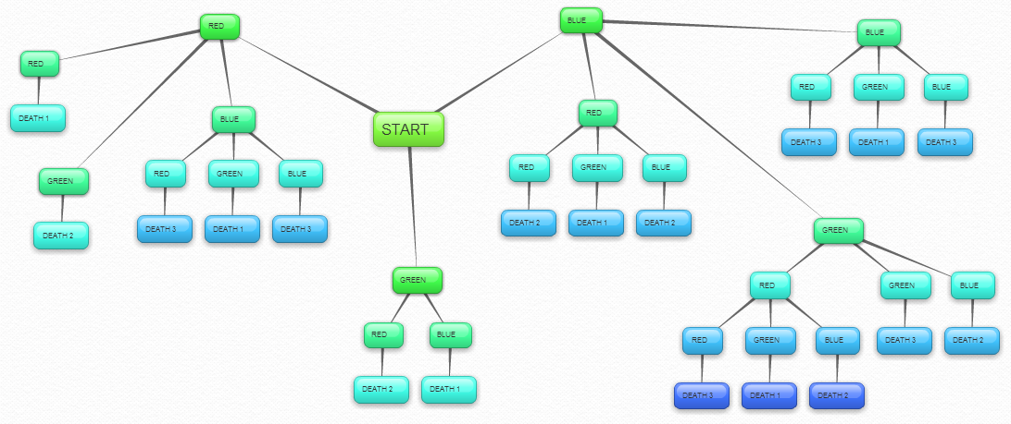

## Commit #4 (October 1)

* Completed full game (refer to overall mind map)

## Commit #5 (October 2)

* Tested and debugged code