LAB SET 1 ASSIGNMENT 1

BY PARUSH(102003404)

Qs1)

#include <iostream>

using namespace std;

int main() {

cout<<"Hello wordl";

return 0;

}

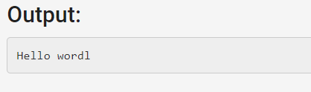

Qs2)

#include <iostream>

using namespace std;

int main() {

cout<<"Oxford's Very Short Introductions series offers concise \n and original introductions to"<<endl<<" a wide range of subjects -- from Islam to Sociology, Politics to Classics, \a and Literary Theory to History. Not simply a textbook of definitions, \r each volume provides trenchant and provocative - yet always balanced - discussions of the central issues in a given topic.";

return 0;

}

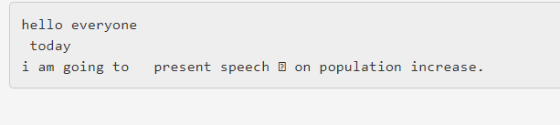

Qs3)

#include <iostream>

using namespace std;

namespace first

{

void func()

{

cout<<"first"<<endl;

}

}

namespace second

{

void func()

{

cout<<"second"<<endl;

}

}

int main ()

{

first::func();

second::func();

return 0;

}

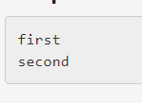

Qs4,5)

#include <iostream>

#include <bits/stdc++.h>

#include <string>

using namespace std;

struct student{

char name[20];

int rollno;

float marks;

public:

void setstudentdata(char \*n,int rollno,float marks)

{

this->rollno=rollno;

this->marks=marks;

strcpy(name,n);

}

void getstudentdata()

{

cout<<name<<" "<<marks<<" "<<rollno<<endl;

}

};

int main() {

student s[3];

char ch[20];

int rollno;

float marks;

for(int i=0;i<3;i++)

{

cin>>ch>>rollno>>marks;

s[i].setstudentdata(ch,rollno,marks);

s[i].getstudentdata();

}

return 0;

}

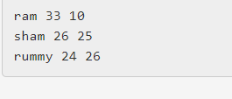

Qs6)

#include <iostream>

#include <bits/stdc++.h>

#include <string>

using namespace std;

class student{

char name[20];

int rollno;

float marks;

public:

void setstudentdata(char \*n,int rollno,float marks)

{

this->rollno=rollno;

this->marks=marks;

strcpy(name,n);

}

void getstudentdata()

{

cout<<name<<" "<<marks<<" "<<rollno<<endl;

}

};

int main() {

student s[3];

char ch[20];

int rollno;

float marks;

for(int i=0;i<3;i++)

{

cin>>ch>>rollno>>marks;

s[i].setstudentdata(ch,rollno,marks);

s[i].getstudentdata();

}

return 0;

}

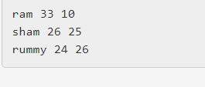

LAB SET 2 ASSIGNMENT 1

Qs1) same qs lab set 1 assignment 1 (top of this page)

Qs2)

#include <iostream>

using namespace std;

bool prime(int no)

{

bool ans=true;

for(int i=2;i<no;i++)

{

if(no%i==0)

ans=false;

}

return ans;

}

int main()

{

for(int i=2;i<=300;i++)

{

if(prime(i))

cout<<i<<" ";

}

return 0;

}



Qs3)

#include<iostream>

using namespace std;

int main()

{

float fahrenheit, celsius;

cout << "Enter the temperature in Celsius : ";

cin >> celsius;

fahrenheit = (celsius \* 9.0) / 5.0 + 32;

cout << "Celsius=" << celsius << endl;

cout << "Fahrenheit=" << fahrenheit << endl;

return 0;

}

Qs4)

#include <iostream>

using namespace std;

int main() {

int a=10;

if(a==0)

cout<<" no is zero"<<endl;

else if(a%2==0)

cout<<"even no";

else

cout<<"odd no";

int p=10,q=20;

char ch;

cin>>ch;

switch(ch)

{

case '+' :

cout<<p+q;

break;

case '-' :

cout<<p-q;

break;

case '\*' :

cout<<p\*q;

break;

case '/' :cout<<p/q;

break;

}

return 0;

}

Qs5)

#include <iostream>

using namespace std;

int main()

{

int ans=0;

while(ans<10)

{

ans++;

cout<<ans<<" ";

++ans;

cout<<ans<<" ";

}

return 0;

}

