1. O

2. O

3. O

4. O

5. O

6. spam(1)

dict[‘key’] = list[index]

7. class OuterClass:

class InnerClass:

pass

pass

8. spam(ham[1], {eggs: 2 }, [ ])

9. 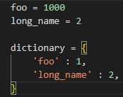

10. 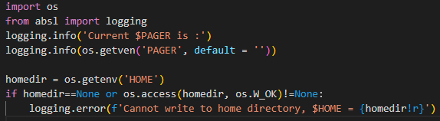

11. ConnectionError