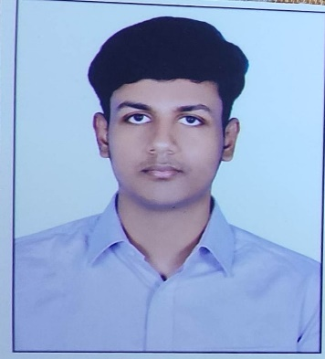

**PRATYUSH KUMAR**

Address: Khajpura, Patna, Bihar - 800014

E-mail: Prabhakar.ppta.pd4@gmail.com

Phone: +91 9155825588

LinkedIn: https://www.linkedin.com/in/pratyush-kumar-70708b121/

**CAREER OBJECTIVE**

To obtain a position in a well-established organization that allows me to utilize my technical skills, problem-solving abilities, and creativity to develop innovative solutions that can positively impact the world

**TECHNICAL COMPETENCIES**

C++ | Java | DSA | HTML | RDBMS | SQL | Adobe Photoshop | Adobe Premiere Pro | M.S. PowerPoint | Data Analytics

**INTERPERSONAL SKILLS**

Team Leadership **|** Management &

Coordination **|** Decision Making **|**

Disciplined **|** Respectful **|** Competitive

**INTERESTS & HOBBIES**

Playing Team games (Football, Basketball, Cricket etc.) **|** Singing **|** Listening Music **|** Travelling

**LANGUAGES KNOWN**

English **|** Hindi **|** Bhojpuri **|** Sanskrit

**PERSONAL DETAILS**

Mother’s Name: Dolly Dubey

Father’s Name: Prabhakar Dubey

DOB: 15th Feb 2003

**EDUCATION**

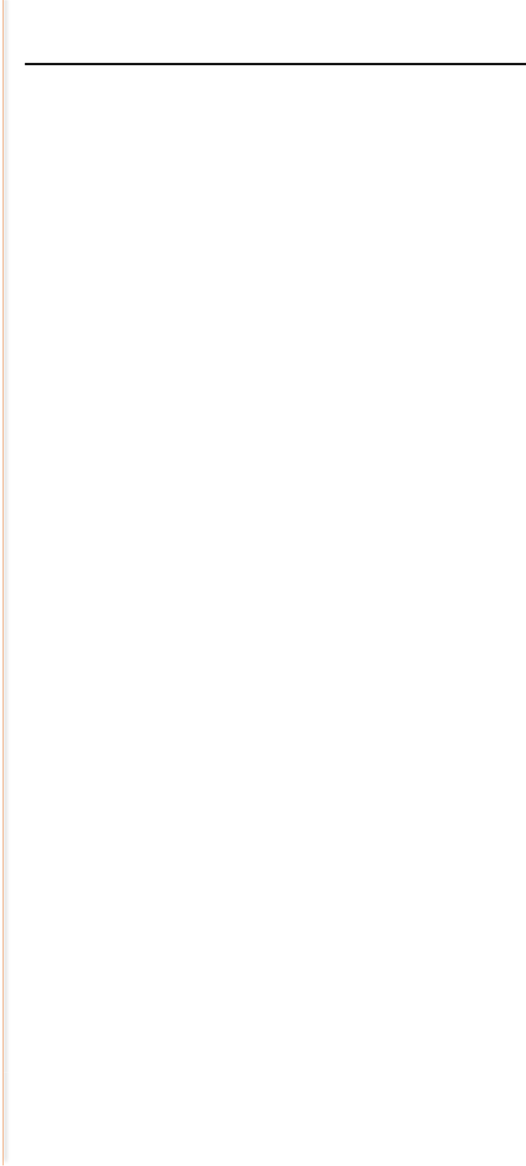

Bachelors in Computer Science Engineering | Chandigarh University, Gharuan, Mohali, Punjab **|** *Session: 2020-2024* **|** *Score: 8.1 CGPA*

Intermediate (C.B.S.E.) **|** D.A.V. Public School, B.S.E.B. Colony, Patna, Bihar **|** *Session: 2018-2020* **|** *Percentage: 82.4%*

Matriculation (C.B.S.E) **|** D.A.V. Public School, B.S.E.B. Colony, Patna, Bihar **|** *Session: 2017-2018* **|** *Percentage: 90.6%*

*SAT Score: 1170 (October 2019)*

**TRAINING & PROJECTS**

**RESEARCH AND DEVELOPMENT INTERNSHIP (NOKIA)**

July 2023- May 2024 (Ongoing)

* Eleven-month internship program in Nokia.
* Learnt development using Java
* Learnt to find solutions to different real time problems using OOP concept in Java.

**ENTERPRISE RESOURCE PLANNING TRAINING**

June 2022- July 2022

* One month training program in Bihar State Power Transmission Company Limited
* Learnt to use SAP ERP software

**CUFOOD APP**

February 2022-June 2022

* Designed a food ordering web application
* A food ordering automation system designed using JSP

**FOOD ORDERING CONSOLE APP**

August 2021-December 2021

* Designed a console based and menu driven program
* CPP was used to design the application

**ACADEMIC ACHIEVEMENTS**

* Scored 1170 Marks in SAT
* Acquired Scholarship from Government of Bihar
* Secured 30% scholarship from Chandigarh University

**CERTIFICATIONS & AWARDS**

* Internshala certificate for Web App development
* Coursera certificate for UX Designing (by Google)
* Coursera certificate for Leadership and Emotional Management
* Coursera certificate for Project Management
* Coursera certificate for Data Analytics in Hadoop

**EXTRA CURRICULAR & CO-CURRICULAR ACHIEVEMENTS**

* Volunteered in largest human image of a waving national flag
* Won Inter Class Cricket Championship 2019
* Won Inter Class Cricket Championship 2011-2013
* Won Badminton Championship 2013