Low dimensional representation of hippocampal population activity during a conditioning task is preserved across environments and across animals

What about:
Conserved neural geometry supports behavioral generalization across contexts
Conserved population geometry supports behavioral generalization

Hannah S Wirtshafter^{1*}, Sara A Solla^{1,2}, John F Disterhoft¹

*Lead contact: hsw@northwestern.edu (HSW)

- Department of Neuroscience, Northwestern University Feinberg School of Medicine, Chicago, IL 60611, USA.
- Department of Physics and Astronomy, Northwestern University, Evanston, IL 60208, USA

Abstract
Learned behaviors often generalize across contexts even though neural representations of different contexts can vary substantially. How the brain preserves task-relevant information across these changing neural representations remains unclear. The hippocampus embodies this problem because hippocampal spatial representations reorganize across environments even when learned behaviors generalize successfully. Here, we recorded hippocampal neuronal activity using calcium imaging while rats performed a conditioning task across multiple distinct spatial contexts. Despite pronounced remapping of spatial representations, the low-dimensional organization of task-related population activity was conserved across contexts. Importantly, preservation reflected conserved relationships among task states, rather than overall similarity in activity patterns. Strikingly, the relational organization of task-related population activity was conserved not only across contexts within individual animals, but also across animals, despite differences in the underlying neural populations and individual experience. These findings identify a conserved population-level organization through which the hippocampus can support behavioral generalization despite contextual remapping and suggest that the neural substrate underlying behavioral generalization may follow shared organizational principles across individuals.

Introduction
Learned behaviors often generalize across contexts even though neural representations of different contexts can vary substantially. How the brain preserves task-relevant information across these changing neural representations remains a central question in neuroscience.
The hippocampus embodies this problem because hippocampal spatial representations¹⁻⁵ reorganize across environments, a phenomenon known as remapping⁶⁻¹⁰, even when learned behaviors generalize successfully⁶⁻⁸.
Because hippocampal activity also encodes nonspatial task-related variables¹¹⁻¹⁶, a major and unresolved question arises: what aspects of task-related population activity are preserved when contextual representations reorganize? A further open question is whether different animals solve this problem using shared population-level strategies or through idiosyncratic and varied neural solutions.

To address these questions, we used in vivo calcium imaging to record hippocampal CA1 activity while rats performed a HPC-dependent conditioning task, trace eyeblink conditioning (tEBC), which is rapidly generalized between spatial contexts^{17,18}. Animals learned the task in one environment and were then tested in a distinct environment in which spatial representations remapped. We compared representations of spatial location and task structure across environments and across animals.
Although spatial representations remapped across environments, task-related population activity preserved a stable low-dimensional structure during behavioral generalization that reflected conserved relationships among task states. Strikingly, this structure was also conserved across animals.
Together, these findings identify a conserved population-level organization of hippocampal task representations that was preserved not only across contexts, but also across individuals. More broadly, these results suggest that neural systems can preserve shared relational task structure even as context-dependent representations reorganize.

Results
We trained five freely moving rats in a conditioning task in one of two distinct environments, labeled A and B; the rats had only been previously familiarized with environment A at the start of conditioning training (Fig. 1a, Fig. S1). Environment A was an unscented rectangular enclosure with wire floor and walls, and white lighting; environment B was a scented ovular enclosure with white solid floor and walls, and red lighting (Fig. 1b). Both environments were located at the same spot in the room relative to external cues (see Methods); animals could see external cues out of the top of both environments, as well as out of the sides of environment A. Animals also reared often, allowing them to see out of the sides of environment B. During training and testing sessions, one session per day, we recorded cellular activity in the hippocampal CA1 region via miniscopes, using GCaMP8m for calcium imaging (CaImg). To perform data analysis, we used both calcium events and calcium traces (see Methods), as indicated when applicable.

Animals easily transfer a conditioning task across environments despite place cell remapping
During the initial phase of our study, freely moving rats (Fig. 1b) underwent training for trace eyeblink conditioning (tEBC) (Fig. S2), a hippocampus dependent classical conditioning task that serves as a robust model for associative memory formation¹⁹⁻²². This paradigm involves presenting a 250ms conditioned stimulus (CS, in the form of a tone) followed by a 500ms trace interval, followed by the 100ms presentation of an unconditioned stimulus (US, an eyelid shock) (Fig. 1c). Both shock and blinking were recorded with wires inserted into the muscle of the eyelid (see Methods). As rats were trained, they exhibited a conditioned blink (CR) in response to the tone; animals were considered to have learned the task after reaching criterion (mean of 20±4.2 training sessions, see Methods; Fig. 1d). After reaching criterion in environment A, the rats were introduced for the first time to environment B, where, after a day of exploration, their ability to perform the tEBC task was assessed without any additional training.
Comparative analysis revealed no significant difference in performance (measured in % CRs) between the last three sessions in environment A and the two test sessions in environment B (mean % CR in environment A last three sessions was 74.75±6.49, mean % CR in environment B test sessions was 77.70±11.68, two-tailed t-test(24)=-0.83, p>0.05) (Fig. 1d), indicating the successful transfer of tEBC learning to a new environment.

Consistent with place cell remapping^{1,8,23,24}, individual hippocampal neurons exhibited distinct spatial representations in environments A and B (Fig. 1e). For each neuron, we identified the spatial location of peak calcium event rate (excluding condition periods¹⁶) and monitored the stability of these peak locations across sessions and environments. Peak activity locations shifted significantly more between environments than between consecutive sessions within the same environment (Fig. 1f), indicating a loss of spatial correspondence across contexts (double-sided t-test, t(1430) = −2.5, p = 0.01). Additional analyses using shuffled controls and population embedding methods yielded results consistent with these findings (Fig. S2–S3).

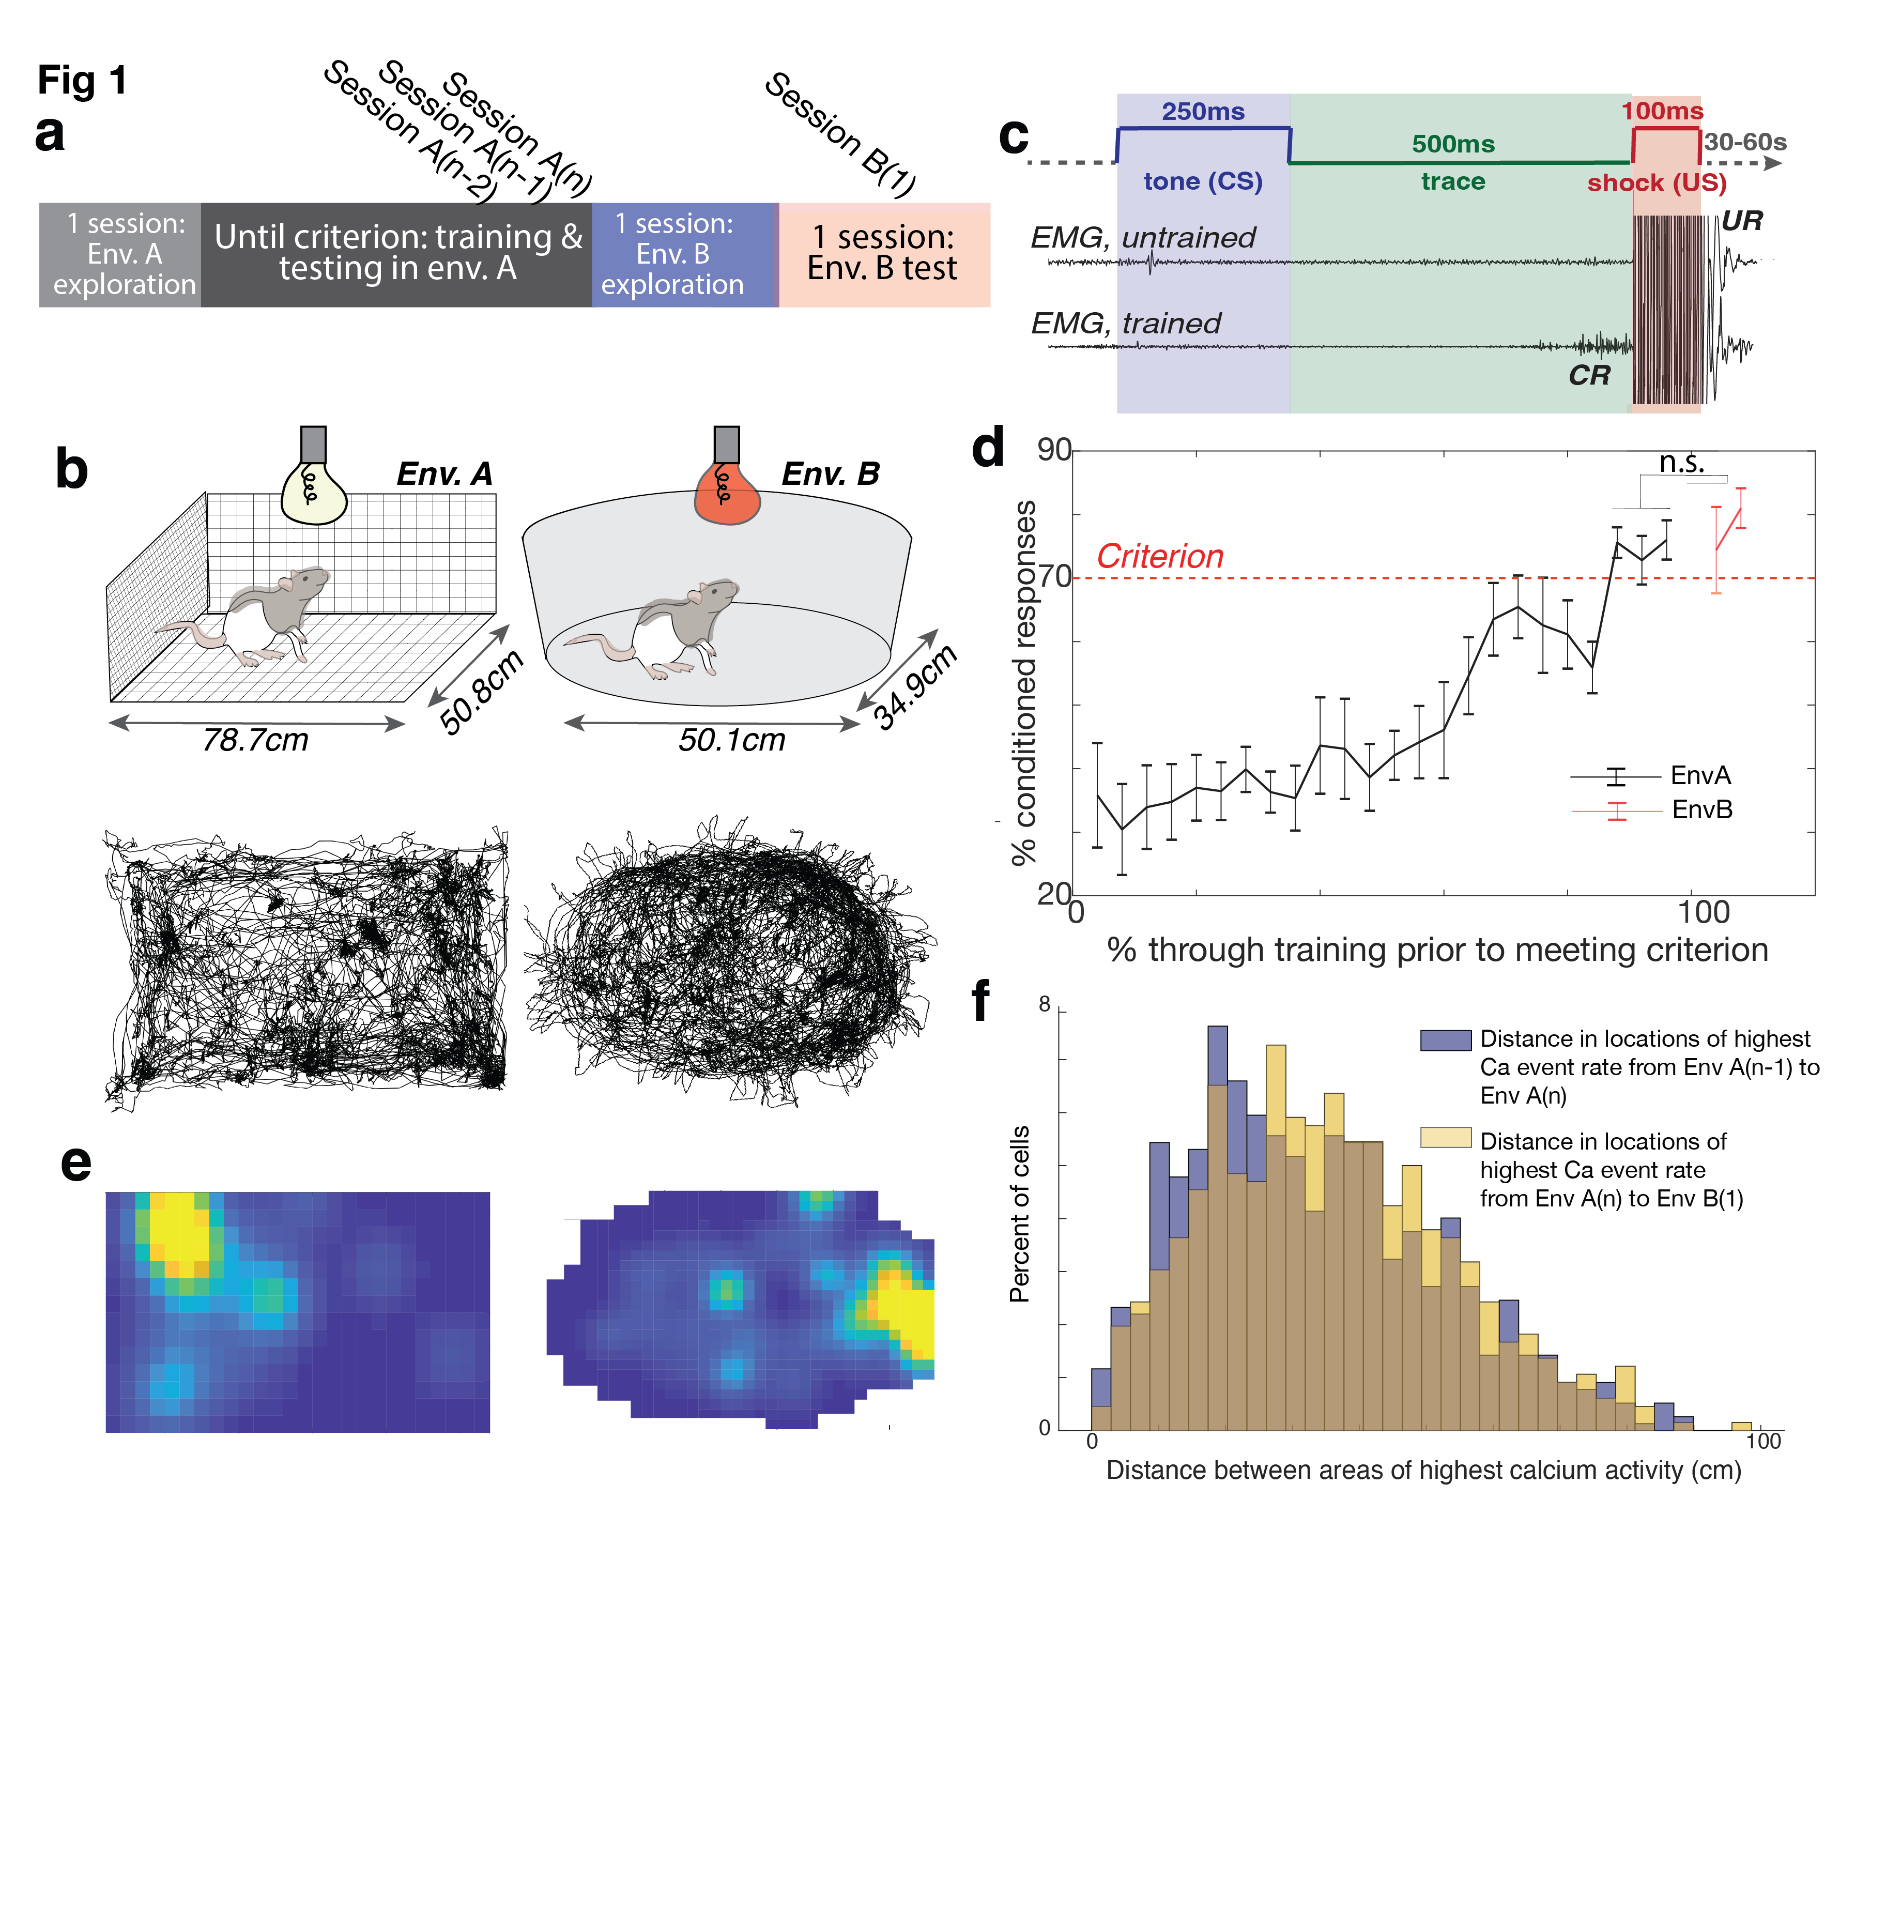

Fig 1. Conditioning is maintained while place cells remap between environment A and environment B.
- Animals explored environment A for one session before undergoing eyeblink conditioning for n sessions until they reached criterion in environment A. Animals were then allowed one session of exploration in environment B, followed by two tEBC test session in environment B, indicated as B(1) and B(2).
- (Top) Schematics of environments A and B. Environment A is a rectangular enclosure with wire walls, floor, and ceiling, lit with white light, and unscented. Environment B is oval-shaped with solid white floors and walls, without a ceiling, lit with red light, and scented with clove oil. Both environments provided distal cues visible from the top and sides. (Bottom) Representantive animal trajectory in environments A and B during a single session, extracted using DeepLabCut.
- Trace eyeblink conditioning (tEBC) paradigm. A 250ms tone (conditioned stimulus, CS) was followed by a 500ms trace interval and a 100ms eyelid shock (unconditioned stimulus, US). Eyelid activity was recorded using an EMG electrode implanted above the eye. Untrained animals only blinked in response to the US (unconditioned response, UR); trained animals began blinking during the trace interval after the CS and before the US (conditioned response, CR).
- Performance of all rats (n=5) in the tEBC task. Animals learned tEBC while freely moving in environment A and successfully transferred this learning to environment B. The dotted line indicates the performance criterion (see panel a legend). No significant difference was found between performance in the criterion sessions in environment A (mean 74.75 ± 6.49%) and the testing sessions in environment B (mean 77.70 ± 11.68%; two-tailed t-test, t(24) = -0.83, p > 0.05). Error bars represent SEM.
- Map of the activity of a single example cell in environments A and B. Yellow indicates the highest activity. This cell exhibited remapping between environments; it shows different place fields relative to external cues in the two contexts.
- Distribution of distances between place field centers (determined by the highest calcium event rate), comparing sessions A(n-1) and A(n) versus sessions A(n) and B(1). Place field centers shifted significantly more when the animal was moved to environment B, compared to shifts between two consecutive sessions in environment A (Wilcoxon rank sum test, p = 0.005; two-sided t-test, t(1430) = -2.5, p = 0.01; two-sample Kolmogorov-Smirnov test, p = 3.0 × 10⁻³). The brown shaded area represents the overlap between the two histograms.

Conditioning task representations are consistent across environments
We then asked whether task-related information could be decoded from population activity across environments. Calcium imaging data from day A(n) were divided into two labeled epochs corresponding to CS and US periods; we refer to this representation as CSUS2 to emphasize the binary segmentation of the task. We used CEBRA²⁵ to generate low-dimensional embeddings of the population activity and trained decoders exclusively on data from session A(n). These decoders successfully generalized to both A(n-1) and B(1), reliably distinguishing CS and US periods in both environments and significantly outperforming shuffled controls (Fig. 2a–c, all two-sided t-tests p<0.001). This result demonstrates that population activity during the conditioning task contains a temporally structured representation that is preserved across across environments despite contextual remapping.

To determine whether finer temporal structure within the conditioning period was similarly preserved, we next trained CEBRA-based decoders using a five period representation of the task (CSUS5): one CS epoch, two trace epochs, and two epochs spanning the US and post-task period (Fig. 2f). Decoders trained only on session A(n) accurately decoded activity from both A(n−1) and B(1) (Fig. 2d–g, all two-sided t-tests p<0.001), demonstrating that detailed temporal organization of the task representation also generalized across environments. Remarkably, for both CSUS2 and CSUS5, the decoding accuracy in B(1) did not differe from decoding accuracy in A(n-1) (two-sided t-tests, both p>0.05) (Fig. 2h).

In contrast, models trained to decode spatial position in environment A did not generalize reliably to environment B, consistent with the remapping of spatial representations (Fig. S4).
Thus, cross-context generalization was selective for task-related temporal structure and did not reflect a generic preservation of hippocampal population activity across environments.

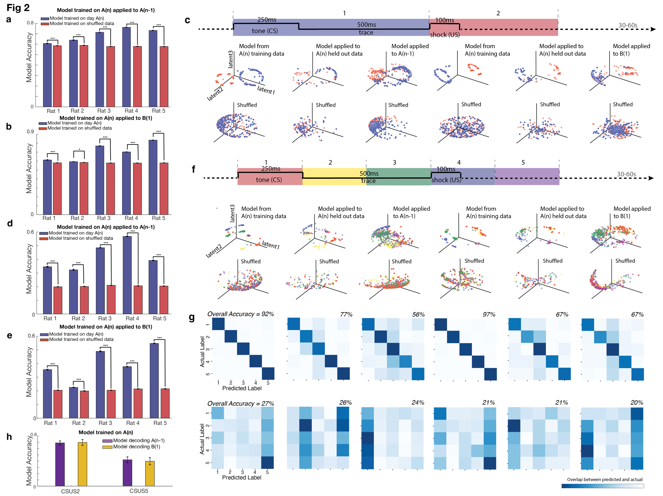

Fig. 2. Models trained in environment A generalize across environments to decode task epochs and fine temporal structure.

- A CEBRA model was trained using calcium imaging data and time-stamped CS/US periods from environment A, using only neurons recorded in both sessions. The model was used to decode whether population activity corresponded to the CS/trace or US/post-US epoch. For all five rats, models trained with data from session A(n) decoded CS vs US in data for session A(n-1) significantly better than shuffled controls (all two-sided t-tests: Rat 1: t(998) = 6.7, p = 2.5 × 10⁻¹¹; Rat 2: t(998) = 16.1, p = 7.4 × 10⁻⁵²; Rat 3: t(998) = 83.5, p = 0; Rat 4: t(998) = 80.1, p = 0; Rat 5: t(998) = 61.0, p = 0). Bars indicate SEM; significance denoted as ***p < 10⁻¹⁰.
- The same models from panel a were epplied to session B(1). These models significantly outperformed shuffled controls (all two-sided t-tests: Rat 1: t(998) = 10.4, p = 2.6 × 10⁻²⁴; Rat 2: t(998) = 2.7, p = 7.6 × 10⁻³; Rat 3: t(998) = 75.3, p = 0; Rat 4: t(998) = 63.7, p = 0; Rat 5: t(998) = 106.3, p = 0). Error bars represent SEM; *p < 10⁻³, ***p < 10⁻¹⁰.

- The tEBC task was divided into two epochs (CSUS2): a CS/trace period (blue) and a US/post-US period (red). Each point represents neural population activity at a single time point projected into the learned latent space. Top row: CEBRA models trained on session A(n) data. Left three panels: models trained using neurons shared between sessions A(n) and A(n−1). Right three panels: models trained using neurons shared between sessions A(n) and B(1). In each set, the first panel shows the training data from A(n), the second panel shows held-out A(n) data (25%), and the third panel shows data from the other session (A(n−1) or B(1)). Separation of CSUS2 epochs was preserved across sessions and environments. Bottom row: Same analyses performed after shuffling task labels. Shuffled controls failed to preserve epoch separation. Decoding performance for models trained on A(n) significantly exceeded shuffled controls for both A(n−1) and B(1) (two-sided t-tests: t(998) = 83.5 and 75.3, respectively; both p ≈ 0).

- A CEBRA model trained on data from environment A to decode fine temporal structure within the conditioning period, divided into five sequential time bins, applied to session A(n-1) in environment A. The model significantly outperformed shuffled controls (all double-sided t-tests for accuracy: Rat 1: t(998) = 41.5, p = 3.3 × 10⁻²²⁰; Rat 2: t(998) = 28.7, p = 7.8 × 10⁻¹³³; Rat 3: t(998) = 122.6, p = 0; Rat 4: t(998) = 118.5, p = 0; Rat 5: t(998) = 62.6, p = 0). Bars indicate SEM; significance denoted as ***p < 10⁻¹⁰.
- The same five models from panel d were now applied to data from session B(1); these models outperformed shuffled controls in decoding the temporal aspects of the CS/US periods, indicating that fine temporal task structure generalized across environments (all two-sided t-tests for accuracy: Rat 1: t(998) = 55.1, p = 4.9 × 10⁻³⁰⁵; Rat 2: t(998) = 9.3, p = 1.1 × 10⁻¹⁹; Rat 3: t(998) = 71.4, p = 0; Rat 4: t(998) = 62.6, p = 0; Rat 5: t(998) = 106.2, p = 0). Bars indicate SEM; significance denoted as ***p < 10⁻¹⁰.
- Cross-environment decoding of fine temporal task structure using CEBRA embeddings (CSUS5 example, Rat 3). The conditioning period was divided into five sequential temporal epochs (CSUS5): one CS epoch (red), two trace epochs (yellow, green), and two epochs spanning the US and post-US periods (blue, purple). Each point represents neural population activity at a single time point projected into the learned latent space.
Top row: CEBRA models trained on session A(n) data and applied to held-out A(n) data, A(n−1), or B(1). Left three panels show models trained using neurons shared between A(n) and A(n−1); right three panels show models trained using neurons shared between A(n) and B(1). Temporal structure was preserved across sessions and environments. Bottom row: Same analyses performed after shuffling task labels. Models trained on true task labels significantly outperformed shuffled controls when decoding both A(n−1) and B(1) (two-sided t-tests: t(998) = 88.9 and 71.4, respectively; both p ≈ 0).

- Confusion matrices (see Methods) show the CEBRA based decoding of five CS/US time bins, as shown in panel f. Top row: Models trained on data from session A(n). Bottom row: Models trained on shuffled data. Darker diagonal values indicate higher decoding accuracy.
- Model accuracy for decoding sessions A(n-1) and B(1) using a model trained on data from session A(n) with CSUS2 and CSUS5 divisions. For both CSUS2 and CSUS5, a model trained in data from session A(n) decoded session B(1) with accuracy comparable to that for session A(n-1) (CSUS2: double-sided t-test, t(8) = -0.13, p > 0.05; CSUS5: t(8) = 0.32, p > 0.05). Bars represent SEM.

While the decoding analyses above demonstrate that task-related information generalizes across environments, successful decoding alone does not establish whether the underlying organization of neural states is preserved. We therefore assessed cross-context similarity at three complementary levels. Consistency refers to the extent to which latent representations learned in one environment support decoding in another (shown prior in figure 2). Geometry preservation refers to preservation of the relational structure among task states, measured using correlations between pairwise distance matrices in latent space. Finally, alignability refers to how closely task trajectories overlap after transformation using Procrustes^{26,27} alignment. Together, these analyses distinguish preservation of relational structure from simple similarity of the underlying neural activity patterns.
To directly test whether tEBC task representations share a conserved population geometry across environments, we compared the structure of task-related activity in the CEBRA embedding space. Task representations were highly consistent across environments A and B, and significantly exceeded shuffled controls across multiple embedding dimensions. This effect was robust when task epochs were divided into both coarse (CSUS2) and fine (CSUS5) temporal segments (Fig. 3a–d). This effect was observed both across rats and within individual animals (Fig. 3), and was also observed in data from individual rats: For CSUS2, all five rats showed significantly greater cross-environment consistency than shuffled controls. This effect remained significant across embeddings containing up to 10 latent dimensions.

To test whether the organization of task-related neural states across successive time bins was preserved across environments, we projected population activity into a two dimensional latent space and compared the resulting trajectories during tEBC across environments. For the CSUS5 analysis, latent trajectories from sessions A(n) and B(1) were averaged across trials within each session. Geometry preservation was quantified by correlating the pairwise Euclidean distance structure among the five task states between A(n) and B(1). This analysis was repeated across 20 independently trained models per session pair. The trajectories corresponding to environments A and B followed similar paths and preserved the structured temporal ordering and relative position of the neural states across successive time bins. Geometry correlations significantly exceeded shuffled controls (calculated after shuffling the points in latent space for day B1; no shuffled value exceeded the observed value in any animal, one-sided permutation p < 0.002; 500 permutations, see Methods) (Fig. 3c).
To visualize this shared structure directly, the average trajectories were then aligned using the Procrustes algorithm^{26,27} (Fig. 3d). A
fter alignment, corresponding task states occupied similar relative positions across environments, indicating preservation of the relational structure among neural states despite substantial changes in the underlying population activity patterns. Consistent with this observation, Procrustes disparity was significantly lower than expected from shuffled controls in all rats (all p < 0.002; Fig. s4), demonstrating that task trajectories were substantially more alignable across contexts than expected by chance. These results indicate that what is preserved across contexts is the temporal relationship among task-related neural states rather than the absolute neural activity patterns themselves.
Together, these results indicate that hippocampal representations of the tEBC task preserve a stable, low dimensional population geometry that preserves the temporal organization of the task despite contextual remapping. This stability across environments is observed in all animals, despite changes in spatial representations.
NOTE FOR ALL GEOMETRY COMPARISIONS (fig 3c,3d,4c,4d,S4) I NEED TO RERUN RAT 2’S MODEL AS I RAN THE WRONG ONE
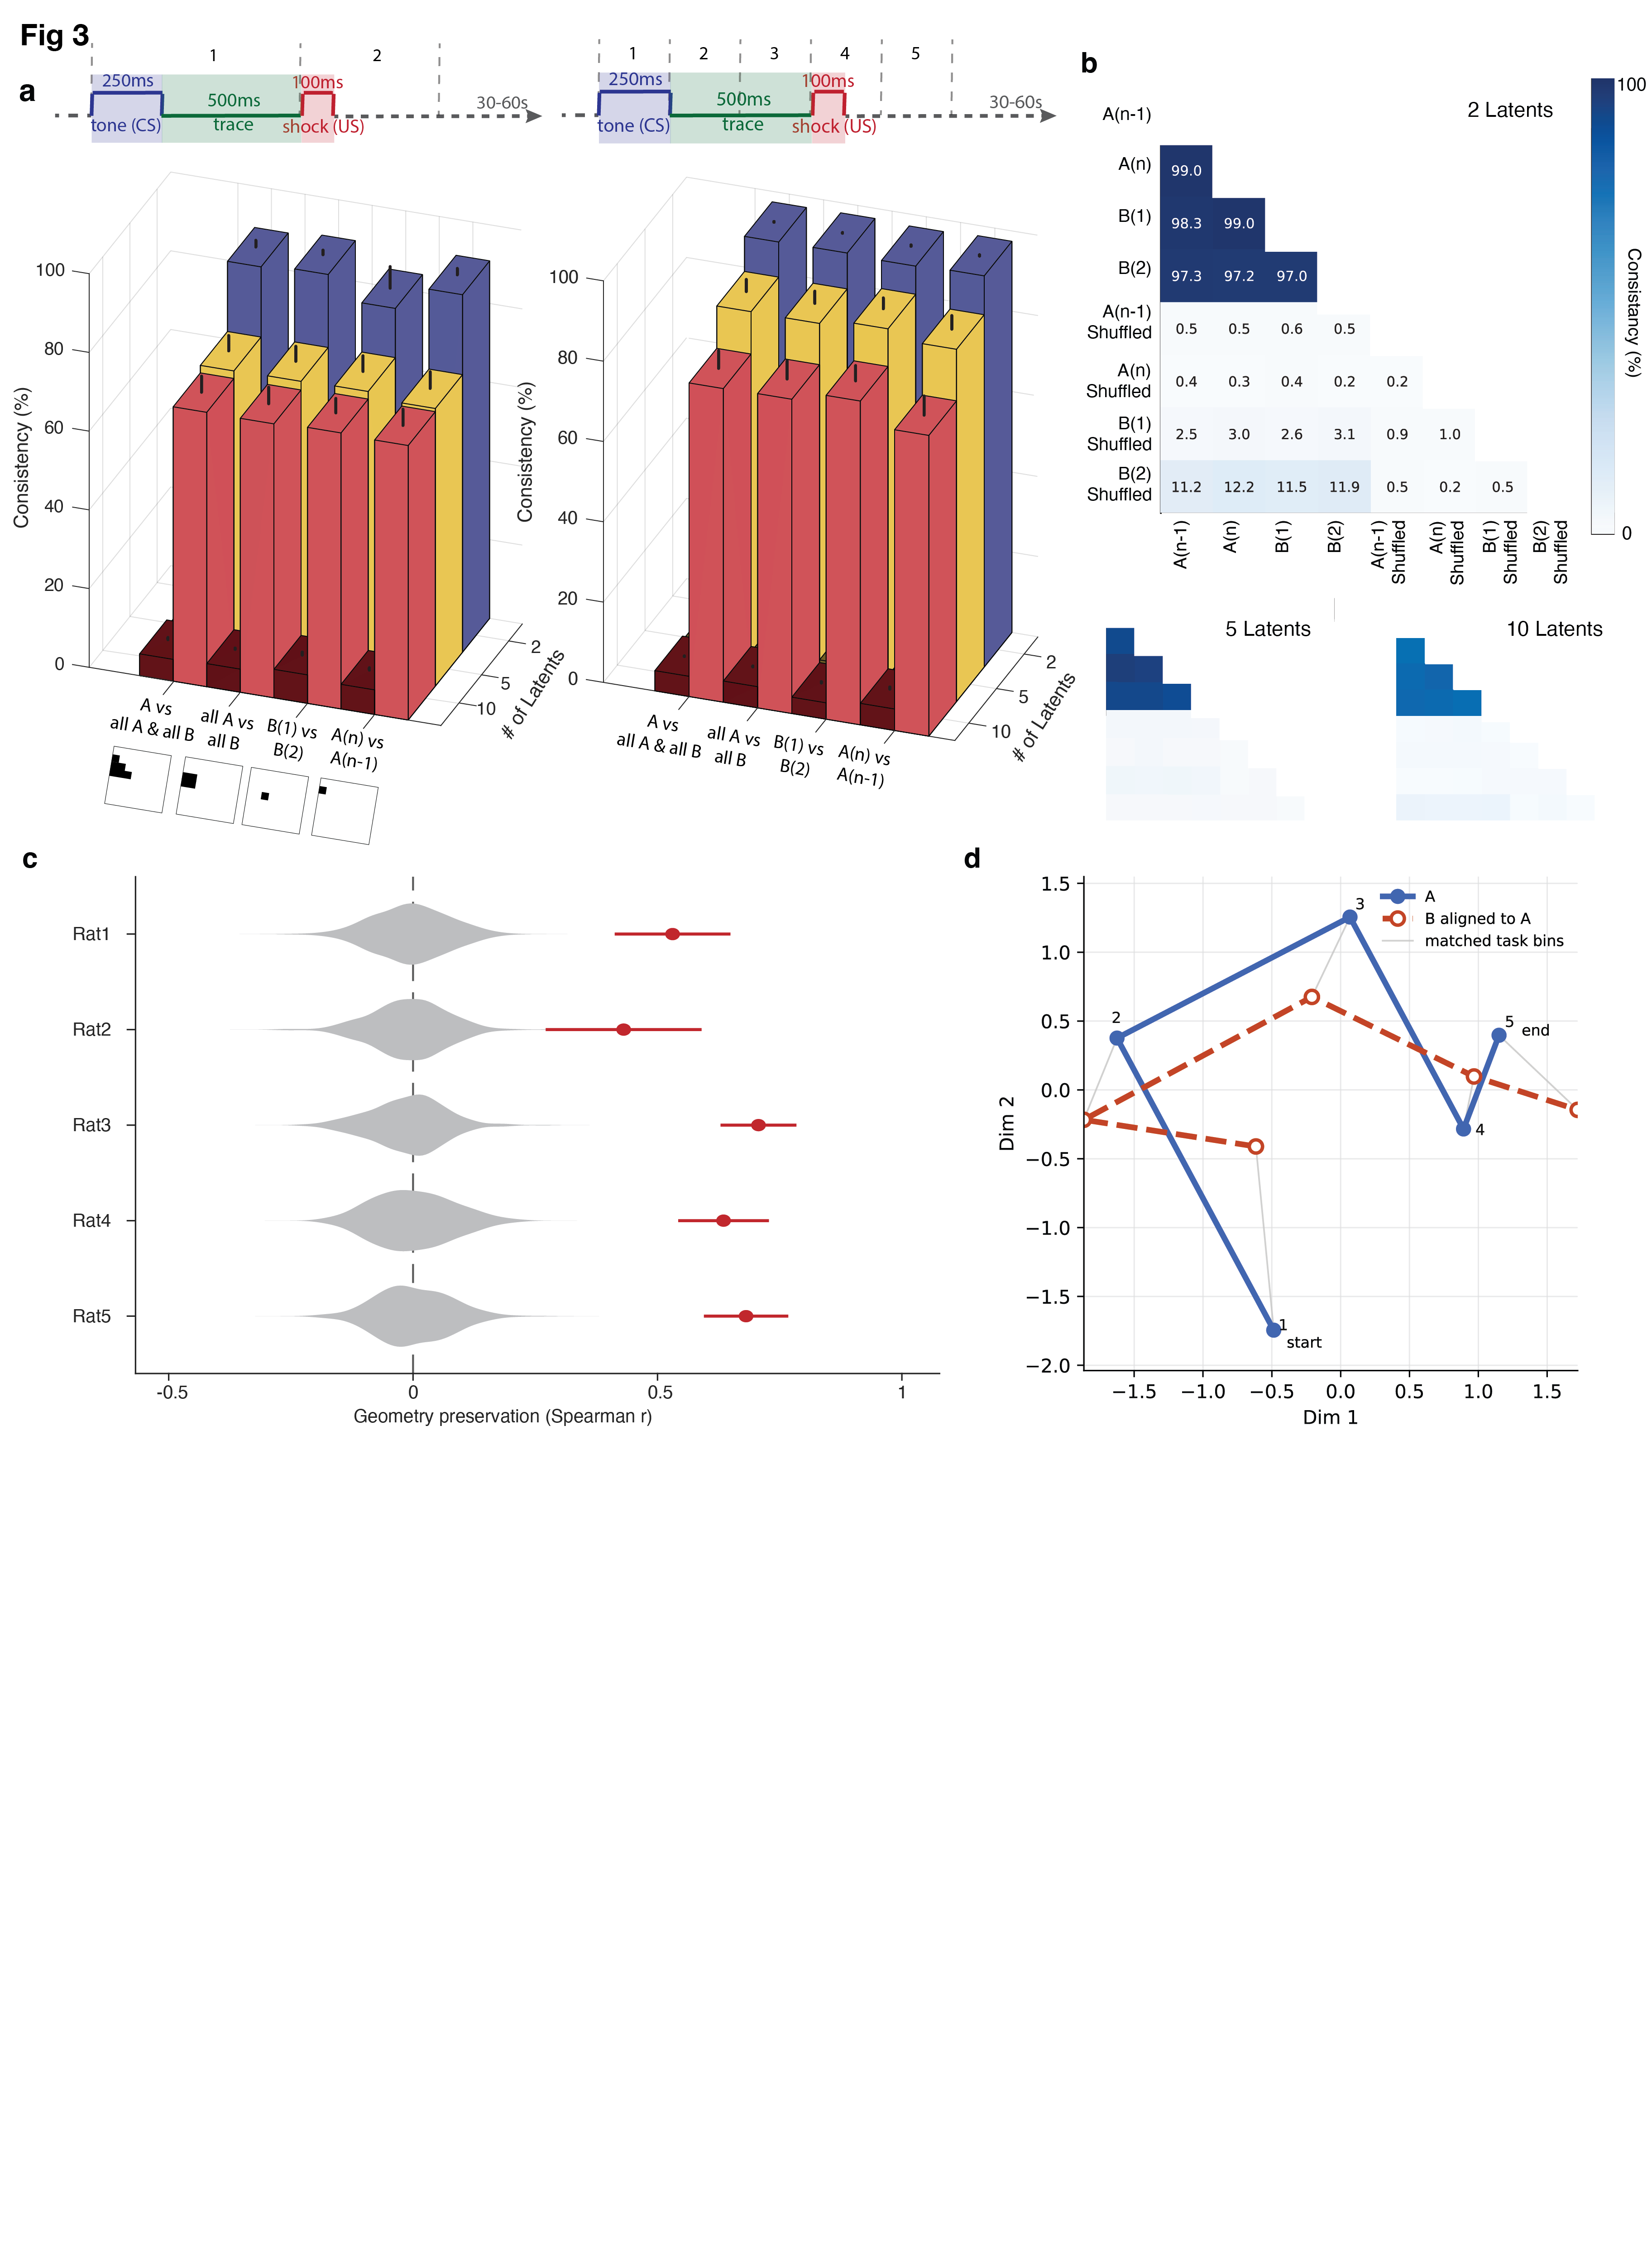
Fig 3. Conserved population geometry of tEBC task representations across environments.
  - Left: Consistency scores averaged across all rats for CSUS2, calculated with 2, 5, and 10 latent dimensions. Lighter bars represent consistency percentage for actual data, while adjacent darker bars represent consistency percentage computed for data where task bins were randomly shuffled. Schematics below the x-axis illustrate the datasets included in each comparison. Bars represent SEM across rats. Consistency scores significantly exceeded shuffled controls across all latent dimensions. (all double-sided t-tests: 2 latents, p < 1 × 10⁻⁵; 5 latents, p < 1 × 10⁻⁵; 10 latents, p < 1 × 10⁻⁴). Right: Same analysis as in the left panel, but for CSUS5, in which the conditioning period was divided into five temporal bins. All five rats showed significantly greater cross-environment consistency than shuffled controls across embeddings containing up to 10 latent dimensions. Bars represent SEM across rats. Significant differences between actual and shuffled data were observed for all latent dimensions (all double-sided t-tests: 2 latents, p < 1 × 10⁻¹²; 5 latents, p < 1 × 10⁻⁶; 10 latents, p < 1 × 10⁻⁵).

  - Example consistency matrices from Rat 3 for CSUS5 using 2, 5, and 10 latent dimensions. Cross-session consistency remained high across environments for true-label data but not shuffled controls.

  - Geometry preservation across contexts within each rat. For each rat, task-state representations were averaged across sessions separately for day A(n) and day B(1). We then computed the pairwise Euclidean distance structure among the five mean task states in latent space for each environment. The 10 unique pairwise distances were correlated across environments to quantify preservation of task geometry across contexts. Gray violins show shuffled-control distributions generated by randomly permuting task-state positions in the B(1) latent space. Red circles indicate the mean geometry-preservation value from the real data, and horizontal lines denote ±SEM across runs. Geometry preservation was significantly greater than expected by chance in all rats; no shuffled value exceeded the observed value in any animal (one-sided permutation p < 0.002; 500 permutations)
  - Example aligned task trajectories from Rat 1 for A(n) (blue) and B(1) (red, aligned to A) shown after Procrustes alignment^{26,27}. Each trajectory represents the trial-averaged latent trajectory for that session. Points correspond to the five task bins (1–5), with “start” and “end” indicating bin #1 and bin #5, respectively. Gray lines connect corresponding bins across environments.

Task-related population geometry is conserved across both animals and contexts

As described above, task representations were highly similar across environments within individual animals. We next asked whether task representations also share a common population-level organization across animals. To address this question, we trained animal-specific CEBRA models using calcium activity and task-epoch labels, and quantified the similarity between models from different animals.
Task-related population representations were highly consistent across animals relative to shuffled controls. This effect was observed both for coarse task segmentation (CSUS2) and for finer temporal segmentation of the task (CSUS5) (Fig. 4a–b).

We next asked whether this similarity reflects a shared structure of task representations. Across all latent dimensionalities, similarity between models trained on different animals was comparable to that observed across sessions within the same animal, with no significant differences for either CSUS2 or CSUS5 (all p > 0.05, two-sided t-tests; Fig. 4b). These results indicate that the latent geometry of task-related population activity is preserved across animals to a similar extent as across sessions within an individual animal. Remarkably, geometry preservation remained high not only when comparing animals within the same environment (A vs A; B vs B), but also when comparing animals across different environments (A vs B). Thus, the relational organization of task-related population activity was conserved across both contextual changes and individual animals.

We next asked whether this consistency reflected preservation of the relationships among task states. To test this, we repeated the geometry-preservation analysis from Fig. 3c–d across animals using mean task trajectories averaged across A(n) and B(1) sessions for each rat. Geometry preservation was significantly greater than chance for all comparison types (Fig. 4c), demonstrating that the relational organization among successive task states during tEBC was conserved across animals.

After alignment, trajectories from different animals preserved both the temporal ordering and relative arrangement of neural states across CSUS5 bins (Fig. 4d). The aligned trajectories revealed a consistent progression of neural population states from task onset through task completion across animals. Consistent with this observation, Procrustes alignment error was significantly lower than expected from shuffled controls for all comparison types (all p < 0.002; Fig. S4), indicating that task trajectories were substantially more alignable across animals than expected by chance.

To further visualize shared task-state organization, we constructed nearest-neighbor graphs from the latent relationships among CSUS5 task states (Fig. 4e). Individual rat graphs consistently preserved the same sequential neighborhood structure among task states (do we want this in supp? It seems pretty clear from fig 4d and the average), and graph similarity across animals was significantly greater than shuffled-label controls. The resulting group-average graph revealed a conserved progression through task states that emerged directly from the latent geometry rather than from imposed temporal ordering.

Together, these results demonstrate that hippocampal representations of the tEBC task exhibit a conserved, low-dimensional population geometry across animals. These results demonstrate that hippocampal representations of the tEBC task exhibit a conserved low-dimensional population geometry across animals despite variability in the recorded neural populations.

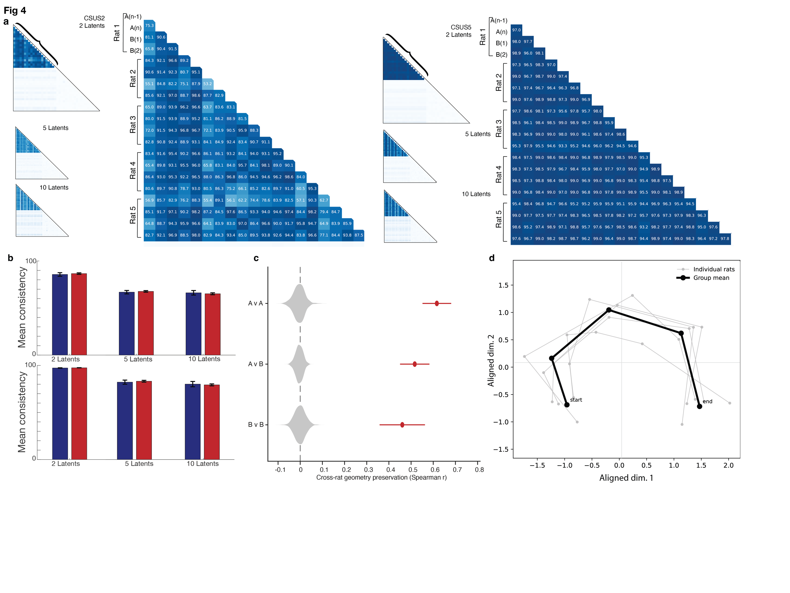

Figure 4. Conserved task-related population geometry across animals

- Cross-animal consistency scores for tEBC representations across temporal resolutions and latent dimensionalities. Left, CSUS2 (two time bins per tEBC period); right, CSUS5 (five time bins per tEBC period). Insets show consistency matrices for increasing latent dimensions (2, 5, and 10), with enlarged views highlighting the two-latent case. High consistency is observed across animals in both coarse (CSUS2) and finer (CSUS5) temporal segmentations of the conditioning task.

- Cross-animal consistency was comparable to within-animal consistency across sessions. Top: CSUS2; bottom: CSUS5. Across all latent dimensionalities, consistency between models trained on different animals (blue) did not differ significantly from consistency across environments within the same animal (red) (all p > 0.05, two-sided t-tests). Error bars indicate mean ± SEM.

- Geometry preservation across rats. Geometry preservation was quantified between pairs of rats by comparing the relational structure of task-state representations in latent space. For five rats, this yielded ten unique rat pairs. For each comparison, task-state representations from the five CSUS5 bins were extracted from two-dimensional latent embeddings derived from sessions A(n) and/or B(1). We then computed the pairwise Euclidean distance structure among the five task states for each rat, yielding 10 unique pairwise distances per embedding. Geometry preservation was quantified as the Spearman correlation between these pairwise distance vectors across rats. Comparisons were performed using A(n) versus A(n) (A v A), B(1) versus B(1) (B v B), or A(n) versus B(1) (A v B) embeddings. Gray violins show shuffled null distributions generated by randomly permuting task-bin identities prior to computing geometry preservation. Red circles indicate the mean geometry-preservation value across all ten rat pairs, and horizontal lines denote ±SEM. Geometry preservation was significantly greater than expected by chance for all comparison types (paired sign-flip permutation tests, p < 0.002 for all comparisons).

- Procrustes-aligned task trajectories across animals. CSUS5 task trajectories for each rat are shown as light gray lines after Procrustes alignment in a shared two-dimensional latent space. Each trajectory represents the average across A(n) and B(1) sessions for that rat. The mean trajectory over all five rats is shown in black. Points correspond to the five task bins (1–5), with “start” and “end” indicating bin #1 and bin #5, respectively.
- Graph-based visualization of shared task-state organization across animals. Top left, sequentially adjacent CSUS5 task states occupied significantly closer positions in latent space than non-adjacent task states (one-sided permutation p < 0.002; 500 permutations). Top right, nearest-neighbor graph structure showed significantly greater agreement across animals than shuffled-label controls ((one-sided permutation p < 0.002; 500 permutations). Bottom left, group-average nearest-neighbor graph derived from latent task-state geometry, illustrating a conserved sequential progression among CSUS5 states. Importantly, individual rat graphs exhibited the same nearest-neighbor progression among task states, despite variability in the precise latent positions of individual states. Bottom right, representative shuffled-label control showing disruption of task-state organization. Graph edges were derived directly from nearest-neighbor relationships among task states in latent space.

Discussion
Our results show that hippocampal population activity associated with a conditioning task exhibits a conserved organization across spatial contexts and across individuals. Although spatial representations in CA1 remap between environments, the relationships among task-related population states were preserved across contexts and animals. Notably, conserved geometry was observed not only across animals within the same environment, but also across animals experiencing different environments, indicating that shared relational organization was maintained despite both contextual remapping and individual variability. These findings suggest that task-relevant information is preserved at the level of population organization, providing a mechanism by which learned behaviors can genreralize despite changing in contextual representations.
Task representations across environments
A central finding of this study is that the relational organization of task-related hippocampal population activity was conserved across distinct spatial environments, even as spatial representations reorganize. This dissociation between spatial remapping and preserved task structure suggests that task-related information is not simply inherited from spatial coding, but instead emerges from population-level organization that remains stable across contexts. Such organization may allow the hippocampus to support behavioral generalization when task demands remain constant across environments.
Our findings support theoretical frameworks proposing that hippocampal representations extend beyond physical space to include relational task structure²⁸. In such frameworks, spatial and task-related variables coexist within a shared representational space, allowing learned behaviors to generalize across environments that differ in contextual or sensory features while preserving common task demands. Our findings provide empirical support for this view by showing that hippocampal population activity preserves task-related structure across environments when task contingencies are unchanged. Importantly, this conservation reflected preservation of the relationships among task-related population states rather than overall similarity in activity patterns. The relative distances between population states during the task were maintained across environments, indicating that the relational structure underlying task activity persisted despite contextual remapping.
Importantly, the conditioning task used here was explicitly designed to remain identical across contexts, enabling us to isolate generalization of task structure from contextual discrimination. Under these conditions, hippocampal population activity maintained a task-related structure across environments, suggesting that the hippocampus can mantain task-relevant information despite changes in surrounding contextual information when such separation is behaviorally appropriate^{29-3155,56}.
Rat 0307 (Rat 2) provides an informative boundary condition for this interpretation. Although task-epoch decoding in this animal remained significantly above shuffled controls in both the within-environment and cross-environment tests, the cross-environment effect was weaker than in the other animals, particularly for the coarse CSUS2 division in environment B(1). This suggests that the conserved task representation is not expressed with identical strength in every individual animal. Such variability could reflect differences in recording quality, the number or identity of cells retained across sessions, behavioral strategy, learning history, or the degree to which contextual remapping interacted with task-period activity. Importantly, the persistence of above-shuffle decoding in Rat 0307 argues against a single-animal exception to the main result; instead, it indicates that the shared task geometry is graded across animals rather than all-or-none.

Population-level organization supports stable non-spatial representations
Our findings suggest that preservation of task structure across contexts emerges at the level of population organization rather than through fixed task-selective neurons. Because many hippocampal neurons encode both spatial and task-related variables^{16,32-34}, preserved task geometry likely reflects distributed population-level organization rather than segregated representations. This organizational principle may allow task-related and contextual variables to coexist within a shared neural population while remaining separable at the level of population structure.

Such population-level organization offers an alternative solution to the proposal of mixed selectivity at the single-cell level³⁵⁻³⁹, allowing task variables and contextual variables to be differentially represented along distinct dimensions within a shared neural population space⁴⁰. Similar organizational principles have been observed in other brain regions, including prefrontal and cingulate cortex⁴¹⁻⁴³, and in artificial neural networks trained on context-dependent tasks⁴⁴. Our findings extend this population-level framework to hippocampal representations of learned tasks across contexts.
Task representations are conserved across animals
One of the most striking findings of this study was that the relational organization of task-related hippocampal population activity was conserved across animals. This observation was unexpected given the substantial variability in hippocampal activity across individuals, including differences in spatial tuning, remapping structure, and the absence of neuron-level correspondence.
This conservation extended beyond overall similarity in activity patterns during the conditioning task period and instead reflected preservation of the relationships among task-related population states, indicating a common geometry in the population representation of the conditioning task across individuals.
Notably, the similarity across animals was comparable to the similarity observed across sessions within individual animals. This unexpected result suggests that hippocampal task representations follow shared organizational principles across animals rather than being entirely idiosyncratically tied to individual experience.
Conservation across animals is particularly notable given the hippocampus’s established role in episodic memory and its sensitivity to individual experience⁴⁵⁻⁴⁹. Prior demonstrates of conserved neural population dynamics across animals have largely involved stereotyped motor or motivational behaviors^{50-5855,57,59,60}. In contrast, hippocampal dependent tasks involve flexible cognitive processes shaped by learning and context⁶¹⁻⁶⁴. The observation that task-related hippocampal population structure was conserved across animals therefore that flexible cognitive functions may rely upon shared population-level organization principles.
Conclusion
Together, our findings indicate that the hippocampus supports behavioral generalization by organizing task-related activity into stable population-level structures that persist across contexts and individuals.
These results add to a growing body of work that emphasizes population-level organization as a fundamental principle of neural computation, and suggest that conserved task representations may support flexible cognition. These findings suggest that behavioral generalization may rely on conserved population-level organizational principles that are shared across individuals despite variability in underlying neural activity and experience.

Citations
1 Schimanski, L. A., Lipa, P. & Barnes, C. A. Tracking the course of hippocampal representations during learning: when is the map required? J Neurosci 33, 3094-3106 (2013). https://doi.org:10.1523/JNEUROSCI.1348-12.2013
2 Gauthier, J. L. & Tank, D. W. A Dedicated Population for Reward Coding in the Hippocampus. Neuron 99, 179-193 e177 (2018). https://doi.org:10.1016/j.neuron.2018.06.008
3 Mamad, O. et al. Place field assembly distribution encodes preferred locations. PLoS Biol 15, e2002365 (2017). https://doi.org:10.1371/journal.pbio.2002365
4 Hok, V. et al. Goal-related activity in hippocampal place cells. J Neurosci 27, 472-482 (2007). https://doi.org:27/3/472 [pii] 10.1523/JNEUROSCI.2864-06.2007
5 Knierim, J. J. Dynamic interactions between local surface cues, distal landmarks, and intrinsic circuitry in hippocampal place cells. J Neurosci 22, 6254-6264 (2002). https://doi.org:20026608
6 Allen, K., Rawlins, J. N., Bannerman, D. M. & Csicsvari, J. Hippocampal place cells can encode multiple trial-dependent features through rate remapping. J Neurosci 32, 14752-14766 (2012). https://doi.org:10.1523/JNEUROSCI.6175-11.2012
7 Jeffery, K. J., Gilbert, A., Burton, S. & Strudwick, A. Preserved performance in a hippocampal-dependent spatial task despite complete place cell remapping. Hippocampus 13, 175-189 (2003). https://doi.org:10.1002/hipo.10047
8 Colgin, L. L., Moser, E.I., May-Britt Moser. Understanding memory through hippocampal remapping. Cell (2008).
9 Fenton, A. A. Remapping revisited: how the hippocampus represents different spaces. Nat Rev Neurosci 25, 428-448 (2024). https://doi.org:10.1038/s41583-024-00817-x
10 Sanders, H., Wilson, M. A. & Gershman, S. J. Hippocampal remapping as hidden state inference. eLife 9 (2020). https://doi.org:10.7554/eLife.51140
11 Christian, K. M. & Thompson, R. F. Neural substrates of eyeblink conditioning: acquisition and retention. Learn Mem 10, 427-455 (2003). https://doi.org:10.1101/lm.59603
12 McEchron, M. D., Tseng, W. & Disterhoft, J. F. Single neurons in CA1 hippocampus encode trace interval duration during trace heart rate (fear) conditioning in rabbit. J Neurosci 23, 1535-1547 (2003).
13 Wirtshafter, H. S. & Wilson, M. A. Locomotor and Hippocampal Processing Converge in the Lateral Septum. Current biology : CB 29, 3177-3192 (2019). https://doi.org:10.1016/j.cub.2019.07.089
14 Berger, T. W., Rinaldi, P. C., Weisz, D. J. & Thompson, R. F. Single-unit analysis of different hippocampal cell types during classical conditioning of rabbit nictitating membrane response. J Neurophysiol 50, 1197-1219 (1983). https://doi.org:10.1152/jn.1983.50.5.1197
15 Wirtshafter, H. S. & Wilson, M. A. Differences in reward biased spatial representations in the lateral septum and hippocampus. eLife 9 (2020). https://doi.org:10.7554/eLife.55252
16 Wirtshafter, H. S., Mehta, M. R., Solla, S. A. & Disterhoft, J. F. Hippocampal trace coding dominates and disrupts place coding. bioRxiv (2026). https://doi.org:10.64898/2026.02.17.706430
17 Bouton, M. E., Nelson, J. B. & Rosas, J. M. Stimulus generalization, context change, and forgetting. Psychological bulletin 125, 171-186 (1999). https://doi.org:10.1037/0033-2909.125.2.171
18 Lovibond, P. F., Preston, G. & Mackintosh, N. Context specificity of conditioning, extinction, and latent inhibition. Journal of Experimental Psychology: Animal Behavior Processes 10, 360 (1984).
19 Moyer, J. R., Jr., Deyo, R. A. & Disterhoft, J. F. Hippocampectomy disrupts trace eye-blink conditioning in rabbits. Behav Neurosci 104, 243-252 (1990).
20 McEchron, M. D. & Disterhoft, J. F. Hippocampal encoding of non-spatial trace conditioning. Hippocampus 9, 385-396 (1999). https://doi.org:10.1002/(SICI)1098-1063(1999)9:4<385::AID-HIPO5>3.0.CO;2-K
21 Woodruff-Pak, D. S. & Disterhoft, J. F. Where is the trace in trace conditioning? Trends Neurosci 31, 105-112 (2008). https://doi.org:10.1016/j.tins.2007.11.006
22 Weiss, C. & Disterhoft, J. F. The impact of hippocampal lesions on trace-eyeblink conditioning and forebrain-cerebellar interactions. Behav Neurosci 129, 512-522 (2015). https://doi.org:10.1037/bne0000061
23 Lenck-Santini, P. P., Rivard, B., Muller, R. U. & Poucet, B. Study of CA1 place cell activity and exploratory behavior following spatial and nonspatial changes in the environment. Hippocampus 15, 356-369 (2005). https://doi.org:10.1002/hipo.20060
24 Plitt, M. H. & Giocomo, L. M. Experience-dependent contextual codes in the hippocampus. Nat Neurosci 24, 705-714 (2021). https://doi.org:10.1038/s41593-021-00816-6
25 Schneider, S., Lee, J. H. & Mathis, M. W. Learnable latent embeddings for joint behavioural and neural analysis. Nature 617, 360-368 (2023). https://doi.org:10.1038/s41586-023-06031-6
26 Schönemann, P. H. A generalized solution of the orthogonal procrustes problem. Psychometrika 31, 1-10 (1966).
27 Virtanen, P. et al. Fundamental algorithms for scientific computing in Python. Nat. Methods 17, 261-272 (2020).
28 Whittington, J. C. R. et al. The Tolman-Eichenbaum Machine: Unifying Space and Relational Memory through Generalization in the Hippocampal Formation. Cell 183, 1249-1263 e1223 (2020). https://doi.org:10.1016/j.cell.2020.10.024
29 Wirtshafter, H. S. & Wilson, M. A. Artificial intelligence insights into hippocampal processing. Front Comput Neurosci 16, 1044659 (2022). https://doi.org:10.3389/fncom.2022.1044659
30 Lehnert, L., Littman, M. L. & Frank, M. J. Reward-predictive representations generalize across tasks in reinforcement learning. PLoS Comput Biol 16, e1008317 (2020). https://doi.org:10.1371/journal.pcbi.1008317
31 Collins, A. G. E. & Frank, M. J. Neural signature of hierarchically structured expectations predicts clustering and transfer of rule sets in reinforcement learning. Cognition 152, 160-169 (2016).
32 Eichenbaum, H., Dudchenko, P., Wood, E., Shapiro, M. & Tanila, H. The hippocampus, memory, and place cells: is it spatial memory or a memory space? Neuron 23, 209-226 (1999). https://doi.org:S0896-6273(00)80773-4 [pii]
33 O'Keefe, J. & Krupic, J. Do hippocampal pyramidal cells respond to nonspatial stimuli? Physiol Rev 101, 1427-1456 (2021). https://doi.org:10.1152/physrev.00014.2020
34 Knierim, J. J. From the GPS to HM: Place cells, grid cells, and memory. Hippocampus 25, 719-725 (2015). https://doi.org:10.1002/hipo.22453
35 Aronov, D., Nevers, R. & Tank, D. W. Mapping of a non-spatial dimension by the hippocampal-entorhinal circuit. Nature 543, 719-722 (2017). https://doi.org:10.1038/nature21692
36 Rigotti, M. et al. The importance of mixed selectivity in complex cognitive tasks. Nature 497, 585-590 (2013). https://doi.org:10.1038/nature12160
37 Leutgeb, S. et al. Independent codes for spatial and episodic memory in hippocampal neuronal ensembles. Science 309, 619-623 (2005). https://doi.org:309/5734/619 [pii]
10.1126/science.1114037
38 Bittner, K. C. et al. Conjunctive input processing drives feature selectivity in hippocampal CA1 neurons. Nat Neurosci 18, 1133-1142 (2015). https://doi.org:10.1038/nn.4062
39 Fusi, S., Miller, E. K. & Rigotti, M. Why neurons mix: high dimensionality for higher cognition. Curr Opin Neurobiol 37, 66-74 (2016). https://doi.org:10.1016/j.conb.2016.01.010
40 Nieh, E. H. et al. Geometry of abstract learned knowledge in the hippocampus. Nature 595, 80-84 (2021).
41 Johnston, W. J., Fine, J. M., Yoo, S. B. M., Ebitz, R. B. & Hayden, B. Y. Semi-orthogonal subspaces for value mediate a binding and generalization trade-off. Nature Neuroscience, 1-13 (2024).
42 Machens, C. K., Romo, R. & Brody, C. D. Functional, but not anatomical, separation of “what” and “when” in prefrontal cortex. Journal of Neuroscience 30, 350-360 (2010).
43 Mante, V., Sussillo, D., Shenoy, K. V. & Newsome, W. T. Context-dependent computation by recurrent dynamics in prefrontal cortex. nature 503, 78-84 (2013).
44 Flesch, T., Juechems, K., Dumbalska, T., Saxe, A. & Summerfield, C. Orthogonal representations for robust context-dependent task performance in brains and neural networks. Neuron 110, 1258-1270. e1211 (2022).
45 Poulter, S., Hartley, T. & Lever, C. The neurobiology of mammalian navigation. Current Biology 28, R1023-R1042 (2018).
46 Tucker, M. A., Ord, T. J. & Rogers, T. L. Evolutionary predictors of mammalian home range size: body mass, diet and the environment. Global Ecology and Biogeography 23, 1105-1114 (2014).
47 Schilder, B. M., Petry, H. M. & Hof, P. R. Evolutionary shifts dramatically reorganized the human hippocampal complex. Journal of Comparative Neurology 528, 3143-3170 (2020).
48 Sherry, D. F., Jacobs, L. F. & Gaulin, S. J. Spatial memory and adaptive specialization of the hippocampus. Trends in neurosciences 15, 298-303 (1992).
49 Pravosudov, V. V. & Roth II, T. C. Cognitive ecology of food hoarding: the evolution of spatial memory and the hippocampus. Annual Review of Ecology, Evolution, and Systematics 44, 173-193 (2013).
50 Safaie, M. et al. Preserved neural dynamics across animals performing similar behaviour. Nature 623, 765-771 (2023). https://doi.org:10.1038/s41586-023-06714-0
51 Gallego, J. A. et al. Cortical population activity within a preserved neural manifold underlies multiple motor behaviors. Nature communications 9, 1-13 (2018).
52 Talpir, I. & Livneh, Y. Stereotyped goal-directed manifold dynamics in the insular cortex. Cell reports 43 (2024).
53 Harris, K. D. & Shepherd, G. M. The neocortical circuit: themes and variations. Nature neuroscience 18, 170-181 (2015).
54 Shmuelof, L. & Krakauer, J. W. Are we ready for a natural history of motor learning? Neuron 72, 469-476 (2011).
55 Manoli, D. S., Meissner, G. W. & Baker, B. S. Blueprints for behavior: genetic specification of neural circuitry for innate behaviors. Trends in neurosciences 29, 444-451 (2006).
56 Tierney, A. Evolutionary implications of neural circuit structure and function. Behavioural processes 35, 173-182 (1995).
57 LeDoux, J. E. As soon as there was life, there was danger: the deep history of survival behaviours and the shallower history of consciousness. Philosophical Transactions of the Royal Society B 377, 20210292 (2022).
58 Martínez-García, F. & Lanuza, E. Evolution of vertebrate survival circuits. Current Opinion in Behavioral Sciences 24, 113-123 (2018).
59 Kogan, E., Lu, J. & Zuo, Y. Cortical circuit dynamics underlying motor skill learning: from rodents to humans. Frontiers in Molecular Neuroscience 16, 1292685 (2023).
60 LeDoux, J. & Daw, N. D. Surviving threats: neural circuit and computational implications of a new taxonomy of defensive behaviour. Nature Reviews Neuroscience 19, 269-282 (2018).
61 Buzsáki, G. & Moser, E. I. Memory, navigation and theta rhythm in the hippocampal-entorhinal system. Nature neuroscience 16, 130-138 (2013).
62 Sweis, B. M., Mau, W., Rabinowitz, S. & Cai, D. J. Dynamic and heterogeneous neural ensembles contribute to a memory engram. Curr Opin Neurobiol 67, 199-206 (2021). https://doi.org:10.1016/j.conb.2020.11.017
63 Davidson, T. J., Kloosterman, F. & Wilson, M. A. Hippocampal replay of extended experience. Neuron 63, 497-507 (2009). https://doi.org:10.1016/j.neuron.2009.07.027 S0896-6273(09)00582-0 [pii]
64 Rubin, R. D., Watson, P. D., Duff, M. C. & Cohen, N. J. The role of the hippocampus in flexible cognition and social behavior. Frontiers in human neuroscience 8, 742 (2014).

Methods
LEAD CONTACT AND MATERIALS AVAILABILITY
Questions and requests for information should be directed to and will be fulfilled by the Lead Contact, Hannah Wirtshafter (hsw@northwestern.edu). This study did not generate new unique reagents. The data that support the findings of this study are available from the corresponding author.

EXPERIMENTAL MODEL AND SUBJECT DETAILS
All procedures were performed within Northwestern Institutional Animal Care and Use Committee and NIH guidelines. Five male Long Evans rats (275–325g) were sourced from Charles River Laboratories, injected with AAV9-GCaMP8m, implanted with a 2mm GRIN lens, and trained and tested on eyeblink conditioning in two apparatuses (Fig. 1). Animals were individually housed in an animal facility with a 12/12h light/dark cycle.

METHOD DETAILS
GCaMP8c injection, lens implantation, EMG implantation
GCaMP8 injection and lens implantation were completed as reported in Wirtshafter and Disterhoft, 2022, Wirtshafter and Disterhoft, 2023, and Wirtshafter et al, 2026¹⁻³. Briefly, rats were anesthetized with isoflurane (induction 4%, maintenance 1-2%) and a craniotomy was performed at stereotaxic coordinates Bregma AP −4.00mm, ML 3.00mm. 0.6$μ$L of GCaMP8m (obtained from AddGene, packaged AAV9 of pGP-AAV-syn-jGCaMP8m-WPRE, lot v175525, titer 1.3E+13GC/mL) was injected over 12 minutes (approximate coordinates Bregma AP −4.00mm, ML 3mm, DV 2.95mm relative to skull); then the syringe was raised 0.2mm and an additional 0.6$μ$L of GCaMP8 was injected. We repeated this process once more and at slightly different coordinates in the craniotomy hole, resulting in 4 total injections.
We then aspirated tissue from the craniotomy site using a vacuum pump and 25 gauge needle. Tissue was aspirated up to and including the horizontal striations of the corpus collosum. A 2mm GRIN lens (obtained from Go!Foton, CLH lens, 2.00mm diameter, 0.448 pitch, working distance 0.30mm, 550nm wavelength) was then inserted into the craniotomy hole and cemented in place using dental acrylic. Animals were given buprenorphine (0.05mg/kg) and 20mL saline, taken off anesthesia, and allowed to recover in a clean cage placed upon a heat pad.
Six to eight weeks after surgery, animals were again anesthetized with isoflurane and checked for GCaMP expression. If expression was seen, baseplates were attached using UV-curing epoxy and dental acrylic. Electrode implantation to record obicularis oculi electromyographic (EMG) activity occurred in the same surgery as baseplate attachment, as described previously^{4,5}. Briefly, a connector containing 5 wires was cemented on the front of the animal’s head: 4 wires were implanted directly above the eye in the surrounding muscle (2 for recording, 2 for electrical stimulation). An additional wire was attached to a connector attached to a ground screw located above the cerebellum; this screw was implanted during lens implantation surgery.

Behavioral environment and training
Two behavioral apparatuses were used in these experiments: Environment A was a 78.7cm x 50.8cm unscented rectangular enclosure with wire floor and walls and white lighting. Environment B was a 50.1cm x 34.9cm scented (with two dabs of clove essential oil on opposite walls) ovular enclosure with white solid floor and walls, and red lighting. Both environments were located at the same spot in the room relative to external cues (see Figures 1b and S1).
A tether containing a plug to relay the EMG activity and to deliver a shock to the rat's eye was attached to the eyeblink connector on the rat's head. The miniscope was plugged into the cemented baseplate. The miniscope and EMG cords were all attached to a commutator for ease of animal movement.
The CS was a 250ms, 85dB free-field tone (5ms rise-fall time). The US was a 100ms shock directed to the left eye. Shock amount varied per session per animal and was calibrated, if needed, at the end of a training session for the next session’s training. Shock level was deemed appropriate when a shock was met with a firm shake of the animal’s head.
The trace interval was 500ms and the intertrial interval (ITI) was randomized between 30s and 60s, with a 45s average. EMG signals were amplified (5000×) and filtered (100Hz to 5kHz), then digitized at 3kHz and stored by computer.
A conditioned response (CR) was identified as an increase in integrated EMG activity that exceeded the baseline mean amplitude by more than four standard deviations, sustained for a minimum duration of 15ms. Baseline mean amplitude was calculated during the 500ms preceding CS onset. Additionally, the response had to commence at least 50ms after the conditioned stimulus (CS) onset and before the unconditioned stimulus (US) onset.
The animal’s first exposure to each environment was a 38min exploration session, in which the animal was able to freely move and explore the environment without any conditioning (Figure 1a). Animals were then trained in one environment per session, with no more than one session per day, and were considered to have learned the task after reaching criterion (70% CRs in 50 trials) on three consecutive training sessions (termed ‘criterion sessions’) or when the previous four training sessions averaged over 70% (in this instance, only the final three of those four sessions were considered ‘criterion sessions’). Following the last session in environment A, the animal was given an exploratory session in environment B. The session after that, the animal was tested on eye blink conditioning in environment B, using the same parameters as used in environment A.

Calcium imaging
Calcium imaging was completed as reported in Wirtshafter and Disterhoft, 2022, Wirtshafter and Disterhoft, 2023, and in Wirtshafter et al, 2026¹⁻³. Briefly, calcium imaging was done using UCLA V4 Miniscopes^{6,7}, assembled with two 3mm diameter, 6mm FL achromat lens used in the objective module and one 4mm diameter, 10mm FL achromat lens used in the emission module.

QUANTIFICATION AND STATISTICAL ANALYSIS
Means are presented as mean+-standard deviation (SEM). All analysis code is available at https://github.com/hsw28/ca_imaging and https://github.com/hsw28/Hannahs-CEBRAs. Code used to create specific figures is available at the former github repository.

Position and speed analysis
Position was sampled by an overhead camera at 30Hz. Position tracking was done post-recording using DeepLabCut⁸. Position was then converted from pixels to cm and smoothed using a Gaussian filter with $σ=$2cm. Speed was calculated by taking the Euclidean distance between two spatial coordinates, one just before and one just after the time of interest.

Video pre-processing and cell identification
Video pre-processing and cell identification were performed as reported in Wirtshafter and Disterhoft, 2022, Wirtshafter and Disterhoft, 2023, and in Wirtshafter et al, 2026¹⁻³. In brief, videos were recorded with Miniscope software at 15frames/second. Video processing was done using CIATAH software⁹. Videos were down sampled in space and normalized by subtracting the mean value of each frame from the frame. Each frame was then normalized using a bandpass FFT filter (70-100cycles/pixel) and motion corrected using TurboReg¹⁰. Videos were then converted to relative florescence (dF/F₀); F₀ was the mean over the entire video.
Cells were automatically identified using CIATAH⁹ using CNMF-E¹¹. Images were filtered with a Gaussian kernel with $σ=$ 2 pixels; neuron diameter was set at a pixel size of 8. The threshold for merging neurons was set at a calcium trace correlation of 0.65; neurons were merged if their distances were smaller than 4 pixels and they had both highly correlated spatial shapes (correlation>0.8) and small temporal correlations (correlation <0.4).
In vivo calcium imaging involves detecting changes in intracellular calcium levels, which
serve as proxies for neuronal activity. Calcium events refer to transient increases in calcium concentration above a threshold level; these crossings putatively correspond to spikes in neuronal firing. These events typically appear as peaks in the data and indicate an active response from the neuron. Calcium traces are continuous recordings of calcium levels over time. Thus, calcium events highlight specific spike-like neuronal activations, while calcium traces provide a full temporal picture of these activations together with baseline activity.
All cells identified using CNMF-E were then scored as neurons or not neurons by a human scorer. Scoring was also done within CIATAH software in a Matlab GUI. Scoring was done while visualizing, and based on the calcium activity trace, average waveform, a montage of the candidate cell’s Ca2+ events, and a maximum projection of all cells on which the candidate cell was highlighted. The local maxima of the relative fluorescence (ΔF/F₀) of each identified cell were identified as calcium events.

Cell cross registration across sessions and within session
Validation and registration were completed as documented in Wirtshafter and Disterhoft². Briefly, videos underwent five rounds of registration using Turboreg image rotation¹⁰ with the CIATAH software^{9,12}. Background noise, axons, and dendrites were removed using an image binarization threshold of 40% of the images’ maximum value. Cells were matched across sessions using a distance threshold of a maximum of five pixels, with a minimum 2-D correlation coefficient of 0.5. Sessions were aligned to session A(n), the last session in environment A.
Calcium imaging (CaImg) enabled the longitudinal monitoring of the same hippocampal cells over multiple sessions in both environments. For criterion and testing sessions, we observed an average of 459.85±265.31 cells per session per animal, with no significant difference between the number of cells recorded in environment A and environment B (two-tailed t-test(24)= -0.56, p>0.05) On average, 132±95 cells were present in both the last criterion session in A and the first testing session in B. This was not a significantly different numbers of cells that were present, on average, in both the semi-final session in A, session A(n-1), and the final session in A, session A(n) (155±115 cells).

Remapping quantification
The place cell center was defined as the occupancy-normalized location with maximum number of calcium events while the animal was moving at 5cm/s or faster. Position was binned into 2.5cm square bins. The place cell centers at environments A and B, as well as at environment A across days and at environment B across days, were used to align each environment across days, as well as to align environment A to environment B.
Population vector correlation was calculated between two environments using calcium event data. Neurons present in both datasets (such as sessions A(n) and A(n-1), or A(n) and B(1)) were identified and their calcium event times were converted to rates using 0.75 second binning. These firing rates were then normalized using z-score normalization across each neuron's activity across time. The mean calcium event rate for each neuron in each environment was then computed. The correlation among population vectors of firing rates in the two environments was cpmputed:

$$population vector correlation= \frac{\sum_{i=1}^{N}{\left(r_{\left\{i,A\right\}}- {\overline{\left\{r\right\}}}_{A}\right)\left(r_{\left\{i,B\right\}}- {\overline{\left\{r\right\}}}_{B}\right)}}{\sqrt{\sum_{i=1}^{N}{{\left(r_{\left\{i,A\right\}}- {\overline{\left\{r\right\}}}_{A}\right)}^{2}}} \sqrt{\sum_{i=1}^{N}{{\left(r_{\left\{i,B\right\}}- {\overline{\left\{r\right\}}}_{B}\right)}^{2}}}}$$

Where:
$r_{\left\{i,A\right\}} and r_{\left\{i,B\right\}}$ = firing rates of neuron i in environments A and B
${\overline{\left\{r\right\}}}_{A} and {\overline{\left\{r\right\}}}_{B}$ = mean firing rates across neurons in environments A and B
The factors in the denominator correspond to the standard deviation of the components of each population vector relative to their mean, computed in each environment.

Use of CEBRA versus alternative methods
We explored multiple different methods before settling on the use of CEBRA for this study. A short summary of each tested method can be found below:

- Principal Component Analysis (PCA)¹³: Principal component analysis (PCA) is a statistical method used to reduce the dimensionality of data while retaining as much variability as possible. This linear technique identifies the axes (principal components) in the dataset that maximize variance. The first principal component explains the most variance, the second explains the second most, and so on. Principal components are combinations of original features and may not always have clear or intuitive meanings. In agreement with previous hippocampal data¹⁴, PCA required upwards of 15-25 components to capture 95% of the variance of the data. In addition, across and within all sessions and representations (spatial and task representations), the manifolds spanned by the largest PCs remained highly similar, with small principal angles in pairwise comparisons. This similarity in the orientation of the leading subspaces suggested that PCA did not distinguish between spatial or behavioral components of the task (Figure S5).
- Independent Component Analysis (ICA)¹⁵: Independent Component Analysis (ICA) is a computational technique used to separate a multivariate signal into additive, independent components. ICA operates under the assumption that observed data are linear mixtures of underlying, independent sources. It aims to find a linear transformation that maximizes the statistical independence of the estimated components. We found that ICA embeddings were unstable throughout the length of the recordings, and also did not clearly map onto behavioral states (Figure S6).
- Isomap¹⁶: Isomap is a manifold learning technique that seeks to capture the intrinsic geometric structure of data. Isomap is useful when linear methods like PCA cannot capture the intrinsic structure of the data, as it preserves the geodesic (curved) distances in the reduced dimensionality space. Unlike linear methods such as PCA, Isomap can capture nonlinear relationships in the data. Interestingly, using Isomap, only about 5 neural modes were required to achieve a residual variance of 5-10%. However, the embedding shape did not relate to any discernable property of neural data or behavior (Figure S7). Dimensionality reduction was achieved, but the resulting representations were not interpretable (Figure S7).
- MIND^{14,17}: MIND is a decoding method designed for integrating multiple data modalities to predict various features, particularly sensory and motor functions. MIND uses recurrent neural networks whose hidden variables provide a memory mechanism for remembering previous inputs; this approach is particularly apt for the analysis of time series data such as neural recordings. While MIND was very robust at distinguishing the different environments, it was not equipped to handle relatively short signals separated in time, such as the conditioning trials separated by intertrial intervals. Our analyses using MIND resulted in poor and unstable embeddings that could not be analyzed (Figure S8).
CEBRA¹⁸ was chosen for this project for its ability to capture nonlinear relationships in the data and to create stable embeddings over short and long time periods. Additionally, spatial separations of components were well isolated and correlated well with observed behaviors.

Use of CEBRA for position decoding
Optimal parameters for decoding the position of each animal from neural activity were determined using an extensive grid search across learning rate, temperature, and number of iterations (Figure S9). Models created to compare different sessions, such as a model trained on data from session A(n) used to decode session B(1), were only trained on cells that occurred in both sessions. Models were trained on spike traces of these cells, labeled with the animal’s (X,Y) position. In all cases, 75% of data was used to train the model while 25% of data was held out for verification. All models were run 500 times. Optimal embeddings were determined based on the minimum median absolute error between the predicted and true positions. The optimal parameters for each rat are as follows:
 | Rat 1 | Rat 2 | Rat 3 | Rat 4 | Rat 5
Model Architecture | ‘Offset10-model’
Batch size | 512
Learning rate | 5.5*10⁻⁵ | 6.22*10⁻⁴ | 5.5*10⁻⁴ | 1.0*10⁻³ | 1.0*10⁻³
Temperature mode | ‘Auto’
Minimum temperature | 1.0*10⁻⁹ | 1.33 | 0.95 | 1.0*10⁻⁹ | 0.15
Output dimensions (# of latents+1) | 3
Max iterations | 25000 | 21000 | 26500 | 30000 | 18000
Distance | ‘Cosine’
Conditional | ‘Time delta’
Number of hidden units | 32
Time offsets | 1

The number of output dimensions was chosen based on the fewest number of dimensions under which all 5 models consistently outperformed shuffled data for both position and conditioning decoding (Figure S10-12).

Use of CEBRA for conditioning decoding
As in position decoding, the optimal parameters for decoding conditioning were determined for each animal using an extensive grid search across learning rate, temperature, and number of iterations (Figure S11). Models created to compare different sessions of neural activity, such as a model trained on data from session A(n) used to decode session B(1), were only trained on cells that occurred in both sessions. Models were trained on spike traces of these cells, with labels corresponding to the CSUS bin during which the signal occurred (either one out of 2 bins or out of 5 bins, see Figures 3c-d). In all cases, 75% of data was used to train the model while 25% of data was held out for verification. All models were run 500 times. Optimal embeddings were determined based on the percent of correctly binned time points. The optimal parameters for each rat are as follows:

 | Rat 1 | Rat 2 | Rat 3 | Rat 4 | Rat 5
Model Architecture | ‘Offset10-model’
Batch size | 512
Learning rate | 3.5*10⁻³ | 2.5*10⁻³ | 3.5*10⁻³ | 7.5*10⁻³ | 9.5*10⁻³
Temperature mode | ‘Constant’ | ‘Constant | ‘Auto’ | ‘Constant’ | ‘Constant’
Minimum temperature | 2.33 | 1.5 | 1.67 | 1.67 | 2.66
Output dimensions (# of latents+1) | 3
Max iterations | 50000 | 30000 | 20000 | 18000 | 25000
Distance | ‘Euclidian’ | ‘Cosine | ‘Cosine’ | ‘Euclidian’ | ‘Cosine’
Conditional | ‘Time delta’
Number of hidden units | 32
Time offsets | 1

The number of output dimension was chosen based on the fewest number of dimensions under which all 5 models consistently outperformed shuffled data for both position and conditioning decoding (Figure S10-12). The parameters listed above were used for decoding into 2 or 5 bins, including the use of 3 output dimensions (# of latents + 1; the third dimension is used for plotting and normalization purposes, per CEBRA¹⁸).
The accuracy of results was computed from the entries in the confusion matrix:

$$Accuracy=\frac{Sum of number of diagonal \left(correct\right) elements}{Sum of number of total elements}$$

±±±

Precisioni=TPiTPi+FPi

TP=true positives
FP=false positives

Precision=1ni=1nPrecisioni

Recalli=TPiTPi+FNi

TP=true positives
FN=false negatives

Recall=1n i=1nRecalli

F1i=2* Precisioni*Recalli Precisioni+Recalli

F1=1n i=1nF1i

AUCi=roc_auc_score(ytrue-bin:,i, ypred-prob :,i)

ROC AUC=1n i=1nAUCi

ytrue-bin=binarized true labels
ypred-prob=predicted probabilities for each class

Geometry Preservation Analysis
To quantify whether CEBRA embeddings preserved task geometry across environments, we created 20 models for each session in each animal. We used these models to compare the pairwise organization of task embeddings between environments A and B. For each rat/session and CEBRA run, embeddings from each environment were first reduced to one embedding per task bin by averaging all time points belonging to the same CSUS bin. CSUS bins were kept in the same order across environments, so corresponding rows represented the same task states.

For each run, embedding dimensions were z-scored separately within each environment. We then computed the pairwise Euclidean distance matrix among task-bin embeddings in environment A and separately in environment B. Because the resulting distance matrices are symmetric, we extracted the unique pairwise distances (excluding self-distances) and correlated these values across environments. The geometry-preservation score was defined as the Spearman correlation between these two distance vectors. Thus, each CEBRA run produced one real geometry-preservation score, reflecting how similarly task states were arranged across environments.

To assess significance, we generated a task-bin correspondence null distribution separately for each rat. For each rat, the observed statistic was a single rat-level value: the mean real geometry-preservation score across the 20 independently trained CEBRA model runs. To generate the null distribution, we repeated the following procedure 500 times. On each null iteration, the B1 task-bin correspondence was randomly permuted separately within each of the 20 model runs. This produced one shuffled geometry-preservation score per model run. The 20 shuffled scores were then averaged, yielding one shuffled rat-level mean for that null iteration. Repeating this procedure 500 times produced a null distribution of 500 shuffled rat-level means. One-sided permutation p-values were calculated as the proportion of shuffled rat-level means greater than or equal to the observed rat-level mean, since higher correlations indicate stronger preservation of representational geometry.

The same general method was used to compare geometry across rats, except the distance matrix was computed across rats using the rat’s mean task trajectories (averaged across A(n) and B(1)), rather than within rat.

Model consistency
Model consistency was computed using a built-in CEBRA function which relies on the function ‘sklearn.metrics.consistency_score’¹⁹. The function compares the embeddings from different models by calculating pairwise consistency scores. This comparison involves measuring the similarity of the embeddings using statistical metrics; i.e. this metric calculates how similar a model’s labels are for similar instances in the data set.
To determine consistency between environments and across animals, the data was fit to each model 20 times. The model with the lowest loss was selected and compared to other models with the lowest loss. Models were created using each individual animal’s optimal parameters (see above).

Procrustes-Aligned Cross-Rat Embedding Visualization
To visualize shared task structure across rats, we generated one representative task trajectory per rat from the binned CEBRA embeddings. For each rat, environment A and B embeddings were first averaged across CEBRA runs to obtain one embedding per task bin in each environment. Embedding dimensions were z-scored separately within each environment. Because the within-rat geometry analysis showed that task geometry was conserved across environments, environment B was Procrustes-aligned^{20,21} to environment A within each rat using corresponding task bins. The aligned B embedding was then averaged with the A embedding to obtain a single representative A/B task trajectory for that rat.
To compare trajectories across rats, each rat’s representative A/B trajectory was Procrustes-aligned to a common reference rat trajectory. Procrustes alignment allowed rotation, reflection, translation, and uniform scaling while preserving relative geometry. The aligned trajectories were plotted in a shared coordinate system, with points corresponding to task bins and lines connecting bins in task order. This visualization was used as a qualitative illustration of the conserved task manifold across rats, complementary to the quantitative cross-rat distance-geometry correlation analysis.

Task-State Graph Preservation
To visualize conserved task-state organization across animals, we constructed graph-based summaries from the same CSUS5 task-state geometry used in the geometry-preservation analysis.
For each rat, CEBRA latent trajectories were summarized by computing the mean latent coordinate for each CSUS5 task bin. The primary graph visualization used the cross-rat Procrustes-aligned mean task trajectories, in which within-rat A/B trajectories were aligned and averaged, then aligned across rats into a shared latent coordinate frame. As in the geometry-preservation analysis, for each rat we computed a 5 × 5 Euclidean distance matrix across the five CSUS5 bin centroids (creating representational dissimilarity matrices). These pairwise distances defined the latent relational structure among CSUS5 task states and served as the basis for graph construction.
Each CSUS5 bin was represented as a graph node, with node colors following task-bin order from bin 1 to bin 5. For each rat, nearest-neighbor graph edges were derived from the pairwise distances among task states using k = 1 nearest neighbor per node. Graph node positions were plotted using the two aligned latent dimensions. A group-average graph was constructed by averaging rat-level distance matrices elementwise and then applying the same nearest-neighbor graph construction procedure.
Shuffle controls were generated by randomly permuting CSUS5 bin labels before graph construction, disrupting the correspondence between task-state identity and latent organization while preserving the underlying distance structure. We generated 500 shuffled-label controls. For nearest-neighbor preservation and graph similarity, p-values were computed as one-sided permutation p-values comparing the real mean score against the shuffled null distribution.

We quantified two complementary graph-preservation metrics. First, nearest-neighbor preservation quantified whether each task state retained the same nearest neighbor across animals. For each rat, nearest-neighbor identities were compared with those obtained from the group-average graph, and preservation was defined as the fraction of task bins whose nearest neighbor matched the group-average nearest neighbor. Second, graph similarity quantified how closely each rat’s nearest-neighbor graph matched the group-average graph. For each rat, nearest-neighbor relationships among task states were converted into a binary graph in which task-state pairs were either connected or unconnected. Graph similarity was then computed as the fraction of task-state pairs for which the rat graph and the group-average graph showed the same connectivity pattern (both connected or both unconnected).

For visualization, the shuffled graph panel shows a representative shuffled-label example selected near the median of the null graph-similarity distribution rather than an extreme or randomly chosen shuffle.

Cross animal decoding

We performed across-animal task-epoch decoding in CEBRA latent space to test whether task-related latent structure learned from one animal could support decoding in another animal without matching neurons across animals. Each rat was embedded independently with its own CEBRA model and neural feature matrix. Transfer between animals was evaluated only after aligning latent spaces, so decoder training and testing never used shared neuron identities.

For each rat, trained independent CEBRA models and save per-sample latent embeddings. The saved models contained 20 independent CEBRA runs per rat, with arrays of shape `model runs × samples × latent dimensions`, separately for the A and B session/environment embeddings. Task labels were the binned CS/US epoch labels (CSUS2 or CSUS5) associated with each time bin.

We evaluated three train/test environment comparisons: A→A, B→B, and A→B. For each comparison, and for each ordered train-rat/test-rat pair, a decoder was trained on the train rat’s CEBRA latent coordinates and evaluated on the test rat’s latent coordinates after alignment into the train rat’s latent coordinate frame.

Before alignment, latent coordinates were z-scored independently within each rat using statistics computed from the alignment subset. This normalization removed differences in latent coordinate scale and variance across rats, allowing alignment to focus on the relative organization of task states rather than absolute embedding magnitude. Latent spaces were aligned using orthogonal Procrustes alignment. Specifically, for each split, task-bin mean latent coordinates were computed from the alignment samples for the train and test rats. The Procrustes transform was estimated from matched task-bin means, with the test-rat alignment means treated as the source points and the train-rat alignment means treated as the target points. The transform was then applied to held-out test-rat samples before decoder evaluation. Orthogonal Procrustes was used to preserve the latent coordinate geometry while estimating a rotation between rat-specific latent spaces.

Samples were randomly divided into non-overlapping alignment and decoding subsets (50% each). Alignment was estimated from task-bin means computed only on the alignment subset, and decoder performance was evaluated on held-out individual samples. Output files include an explicit warning for these sample-level fallback runs.

For decoding, we used multinomial logistic regression with balanced class weights. For each split, the decoder was trained on the train rat’s held-out decoding samples and task labels, then tested on the aligned held-out samples from the test rat.

Shuffle controls were computed by randomly permuting the train-rat labels before decoder training. This preserves the test-rat latent structure and label distribution while destroying the relationship between train-rat latent coordinates and task epoch identity. Shuffle decoding was repeated for each split, and real performance was compared against the corresponding shuffle distribution.

Acknowledgements: This work was supported by an NIA T32 (T32-AG020506/AG/NIA), an NIA R37 (R37-AG008796/AG/NIA), an NINDS R01 (R01 NS113804/NS/NINDS), and a K99 award (K99 MH135062).

This research was supported in part through the computational resources and staff assistance provided by the Quest high performance computing facility at Northwestern University, which is jointly supported by the Office of the Provost, the Office for Research, and Northwestern University Information Technology.

We would like to thank all members of the Disterhoft lab, especially Mackenzie Kneisly. We would like to thank the following individuals for their assistance with CEBRA: Mackenzie Mathis and Steffen Schneider. And additional thank you to David Wirtshafter for his feedback.

Author contributions: Investigation, H.S.W.; Formal Analysis, H.S.W.; Writing –Original Draft, H.S.W.; Writing – Review & Editing, H.S.W., S.A.S., J.F.D.; Funding: H.S.W, J.F.D., Supervision, S.A.S., J.F.D.

Declaration of interests: The authors declare no competing interests.

Additional Information
Supplementary Information is available for this paper.
Correspondence and requests for materials should be addressed to Hannah S Wirtshafter, hsw@northwestern.edu .
Reprints and permissions information is available at www.nature.com/reprints.

Supplementary figures

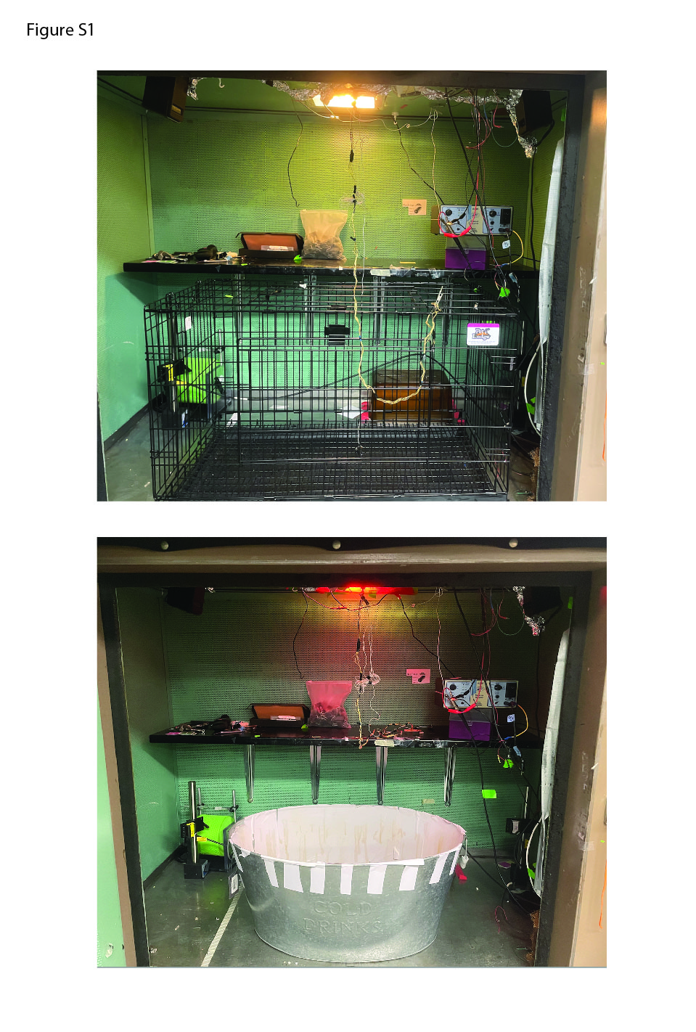
Figure S1. Photos of testing chambers.
Photos of testing chambers. Top: Environment A, an unscented rectangular enclosure with wire floor and walls, and white lighting. Bottom: Environment B, a scented ovular enclosure with white solid floor and walls, and red lighting. Both environments were located at the same spot in the room relative to external cues. The door to the chamber was closed during testing, to accentuate the distinction between the white and red lighting.

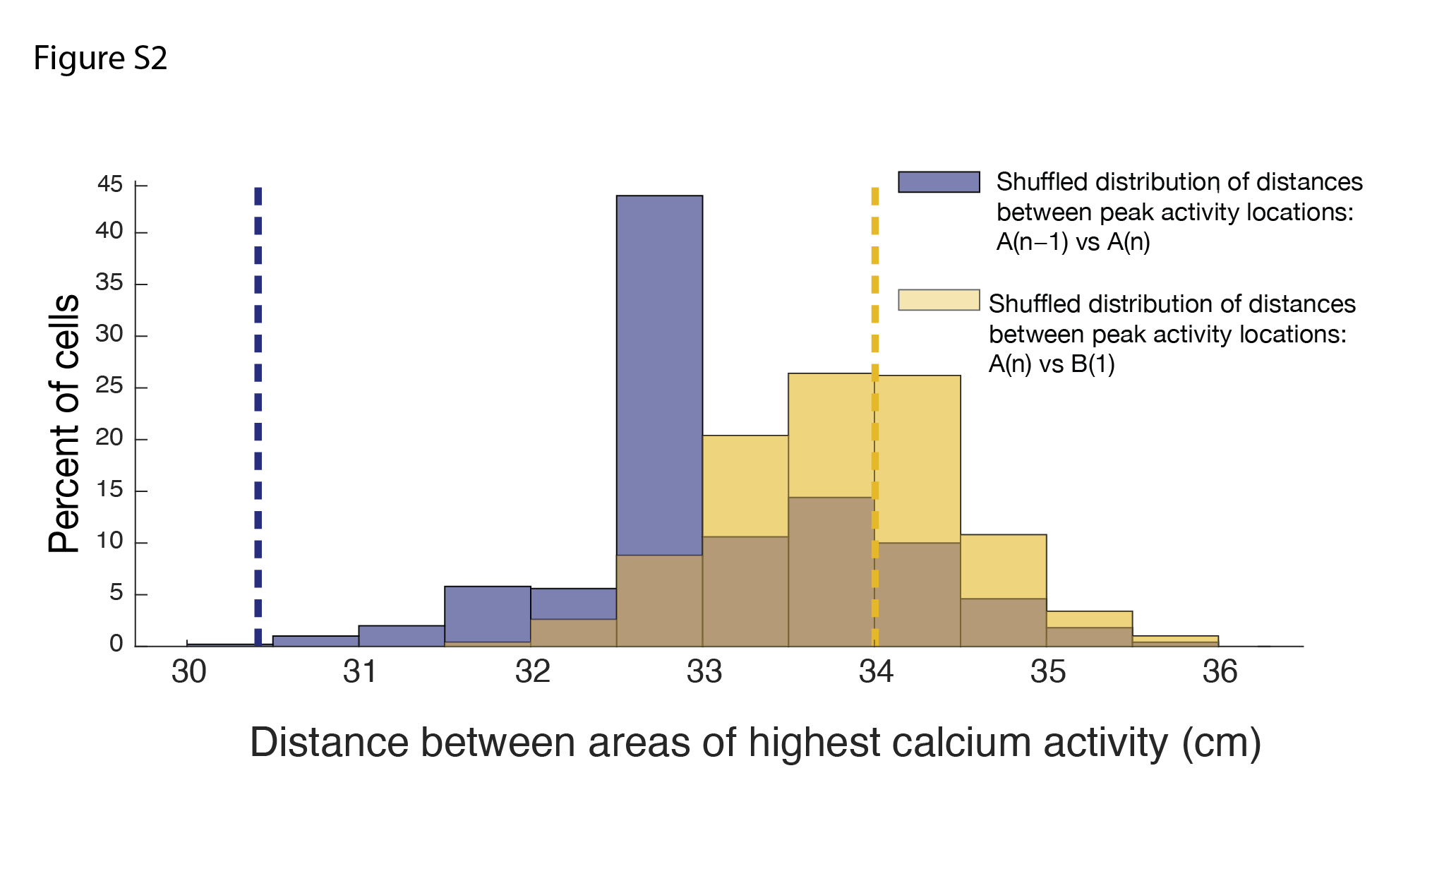
Figure S2. Place cells remap based on comparison to shuffled data.
Distribution of median distances between peak activity locations after randomly shuffling cell identities 500 times. The observed median distance between consecutive sessions in environment A was smaller than nearly all shuffled medians (p = 0.002, dashed blue line), indicating preserved spatial correspondence across sessions. In contrast, the observed median distance between environment A(n) and environment B(1) fell within the shuffled distribution (p = 0.56, dashed yellow line), indicating that peak activity locations were no more spatially aligned across environments than expected by chance. The brown shaded area represents the overlap between shuffled distributions.

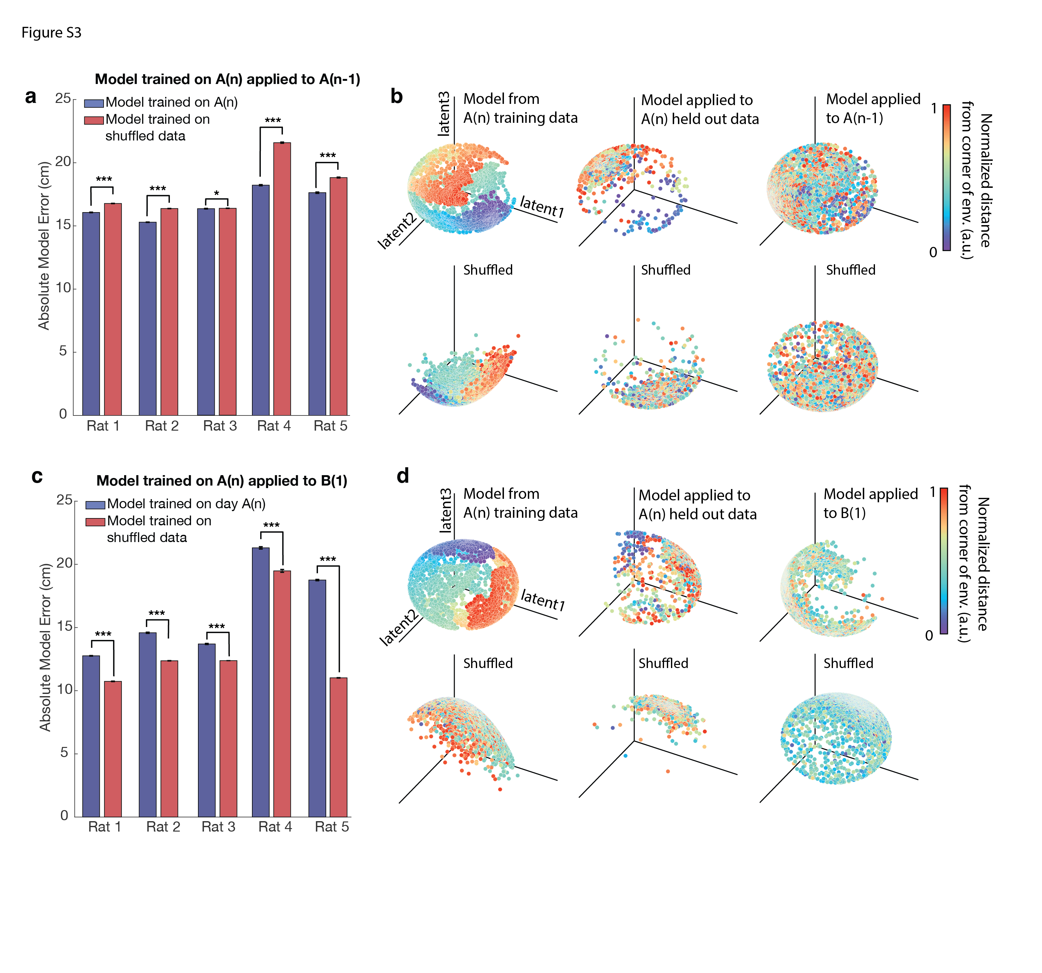

Figure S3. A model trained in environment A can decode positions within environment A but not in environment B.
- A model trained on calcium trace and position data from session A(n), using cells present in both A(n) and A(n-1), predicted positions in environment A(n-1) with significantly greater accuracy than that of a model trained on shuffled position data. The model was run 500 times, and the accuracy of predictions was assessed. The model trained on actual data significantly outperformed the shuffled model across rats (double-sided t-tests: Rat 1: t(998) = -34.3, p = 5.0 × 10⁻¹⁷¹; Rat 2: t(998) = -72.5, p = 0; Rat 3: t(998) = -1.96, p = 0.05; Rat 4: t(998) = -53.7, p = 2.6 × 10⁻²⁹⁹; Rat 5: t(998) = -20.0, p = 4.1 × 10⁻⁷⁵). Error bars represent standard error. A single asterisk (*) indicates p ≤ 0.05, and three asterisks (***) indicate p < 10⁻⁷⁴.
- (Top row) Visualization of model performance for decoding animal position in environment A(n). Left: The trained model demonstrated on the training data from session A(n). Middle: The same model applied to held-out trace data (25%) from session A(n). Right: The model applied to predict animal position in session A(n-1). (Bottom row) The same models trained on shuffled position data. Shown here is the model for Rat 4, where the model trained on real data significantly outperformed model trained on shuffled data for decoding position in session A(n-1) (500 simulations, t(998) = -53.7, p = 2.6 × 10⁻²⁹⁹). For visualization purposes, distance from the corner of the environment is plotted using normalized values in arbitrary units [a.u.].
- A model trained on data from session A(n), using cells present in both A(n) and B(1), was applied to environment B(1). The model's predictions were significantly less accurate than those of a model trained on shuffled position data (double-sided t-tests: Rat 1: t(998) = 84.1, p = 0; Rat 2: t(998) = 18.8, p = 7.4 × 10⁻⁶⁸; Rat 3: t(998) = 74.7, p = 0; Rat 4: t(998) = 13.1, p = 2.0 × 10⁻³⁶; Rat 5: t(998) = 154.4, p = 0). Error bars represent standard error. Three asterisks (***) indicate p < 10⁻³⁵.
- (Top row) Model trained on position and calcium trace data from session A(n), using cells present in both A(n) and B(1). Left: The model demonstrated on the training data from session A(n). Middle: The same model applied to held-out trace data (25%) from session A(n). Right: The model applied to predict the animal position in session B(1). (Bottom row) The same models trained on shuffled position data. Shown here is the model for Rat 4, ßwhere the shuffled model performed significantly better than the model trained on session A(n) for decoding position in session B(1) (500 simulations, t(998) = 13.1, p = 2.0 × 10⁻³⁶). For visualization purposes, distance from the corner of the environment is plotted using normalized values in arbitrary units [a.u.].

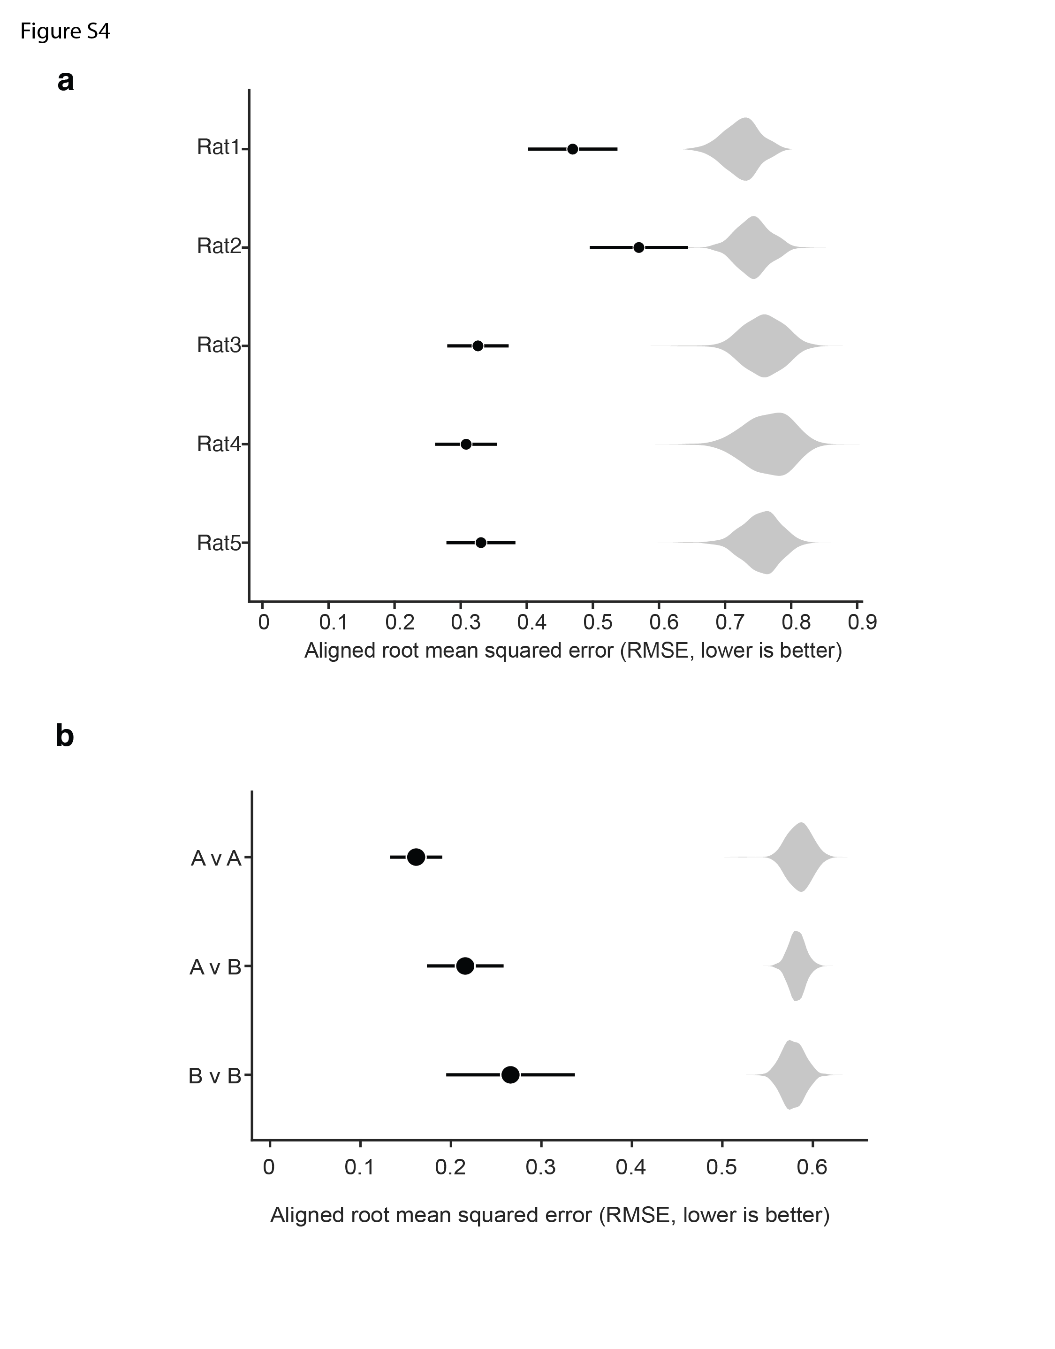
- Procrustes alignment error across contexts within each rat. To quantify direct alignment of task trajectories across contexts, latent trajectories from day A(n) and day B(1) were aligned using the Procrustes algorithm. Alignment quality was quantified as the aligned root mean squared error (RMSE; lower values indicate better alignment). Black circles indicate the mean aligned RMSE across 20 independent CEBRA runs for each rat; horizontal lines denote ±SEM. Gray violins show shuffled null distributions generated by randomly permuting task-bin identities in the B(1) trajectories prior to alignment and averaging the resulting RMSE values across runs. Observed alignment errors were significantly lower than expected by chance in all rats (one-sided permutation p < 0.002; 500 permutations), indicating that task trajectories were substantially more able to be across contexts than expected from shuffled task-state relationships.
- Cross-rat Procrustes alignment error for task trajectories. To quantify alignment of task trajectories across animals, latent trajectories corresponding to the five CSUS5 task states were aligned between pairs of rats using the Procrustes algorithm. Alignment quality was quantified as Procrustes disparity (lower values indicate better alignment). Comparisons were performed using A(n) versus A(n) (A v A), B(1) versus B(1) (B v B), or A(n) versus B(1) (A v B) embeddings across all ten rat pairs. Black circles indicate the mean Procrustes disparity across rat pairs; horizontal lines denote ±SEM. Gray violins show shuffled null distributions generated by randomly permuting task-bin identities prior to alignment. Observed Procrustes disparities were significantly lower than expected by chance for all comparison types (one-sided permutation p < 0.002; 500 permutations), indicating that task trajectories were substantially more alignable across animals than expected from shuffled task-state relationships.

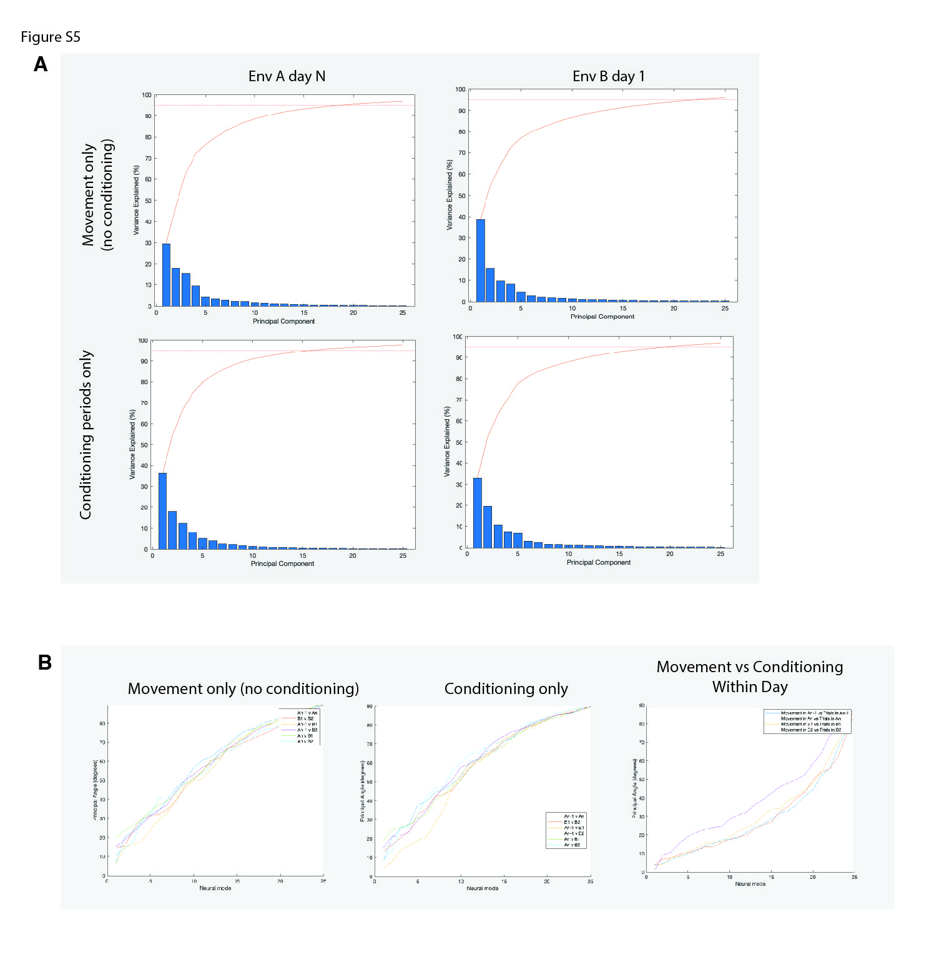
Figure S5. PCA computations for session A(n) and session B(1).
Only cells present in both sessions were used. Principal component analysis (PCA) revealed that approximately 15-25 principal components (PCs) are needed to account for 95% of the variance in the data. When using the complete cell population (not shown), more than 25 PCs are required to achieve the same variance. Across and within all sessions and representations (spatial and task), the principal angles between manifolds remain highly similar.
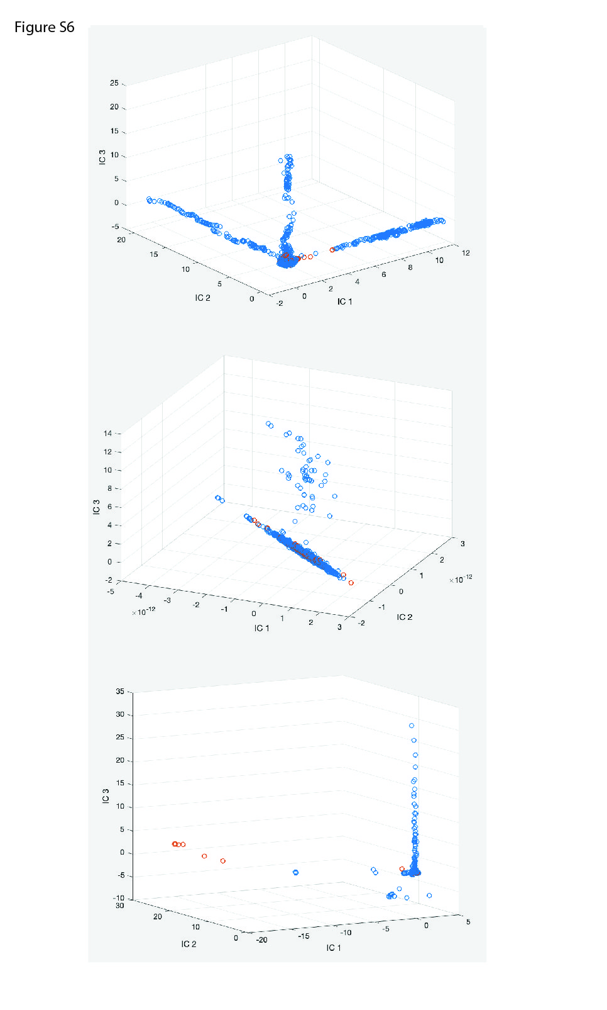
Figure S6. ICA computations across different segments of a session.
Top: Independent component analysis (ICA) was for data over an entire session, using three independent components (ICs). Blue dots represent non-trial times, while red dots represent trial times. Middle: ICA computed over the last two-thirds of the same session shows variability in ICs across segments within a session. Bottom: ICA computed over the second half of the session shows additional variability in the results of the analysis depending on how the session is divided. These results indicate that independent components are highly variable over the course of one session and are sensitive to how the session is partitioned.

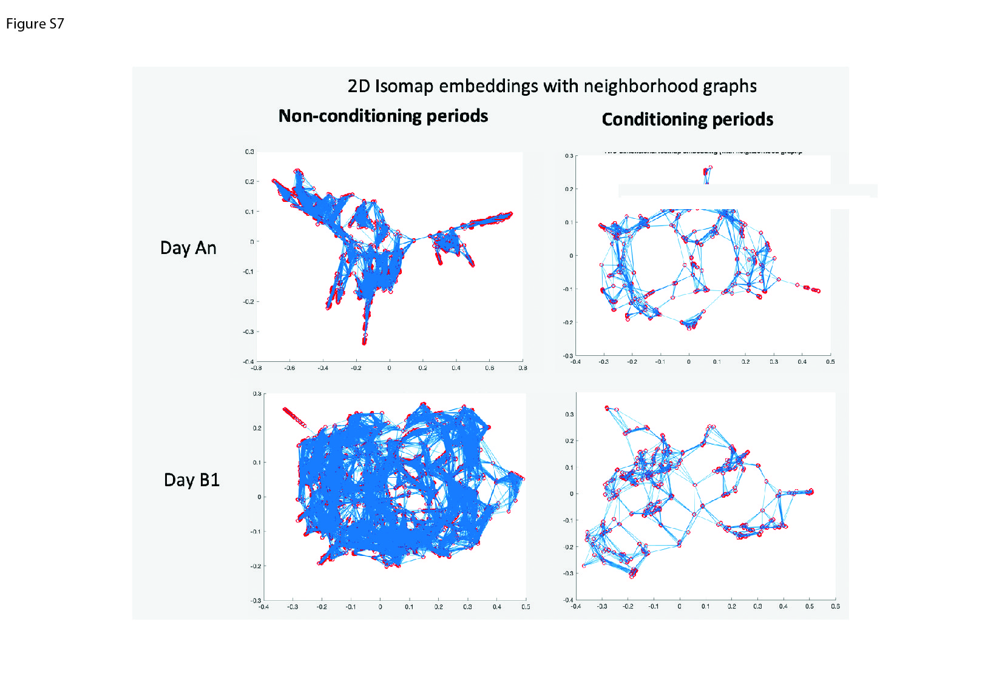
Figure S7. Isomap computations for session A(n) and session B(1).
Isomap computations suggest that approximately five neural modes are sufficient to achieve a residual variance of 5-10%. However, the shape of the Isomap embedding does not correlate with any discernable properties of neural activity or behavior, suggesting limited interpretability of the embedding structure.
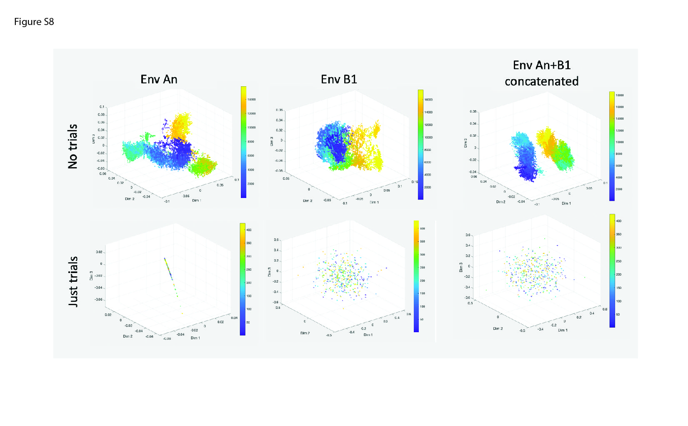
Figure S8. MIND outputs for sessions A(n), B(1), and concatenated sessions.
Top row: MIND embeddings during movement, excluding trial periods, with color bars representing frames. The temporal structure of the data is well captured, with clear separation between A(n) and B(1). Bottom row: MIND embeddings during conditioning periods are highly unstable. Small changes in parameters result in substantial shifts in the embedding structure, transitioning from a linear structure (left) to an undefined, unstable cloud (middle and right).

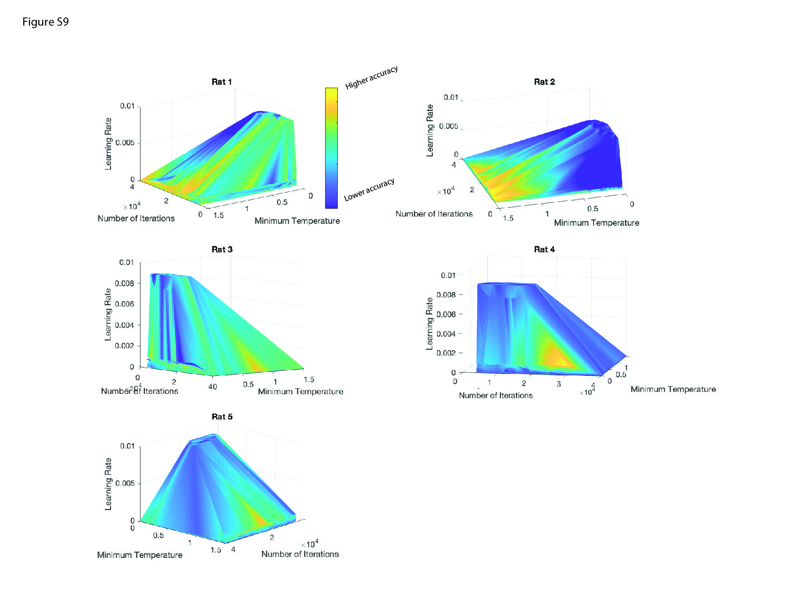
Figure S9. Grid search over decoding parameters for position.
A grid search was performed over three parameters: minimum temperature, learning rate, and number of iterations, for decoding position. Models were trained using cells from session A(n) that also appeared in session A(n-1). The figure shows decoding accuracy for session A(n-1) using the models trained on data from session A(n). Yellow areas indicate higher decoding accuracy.
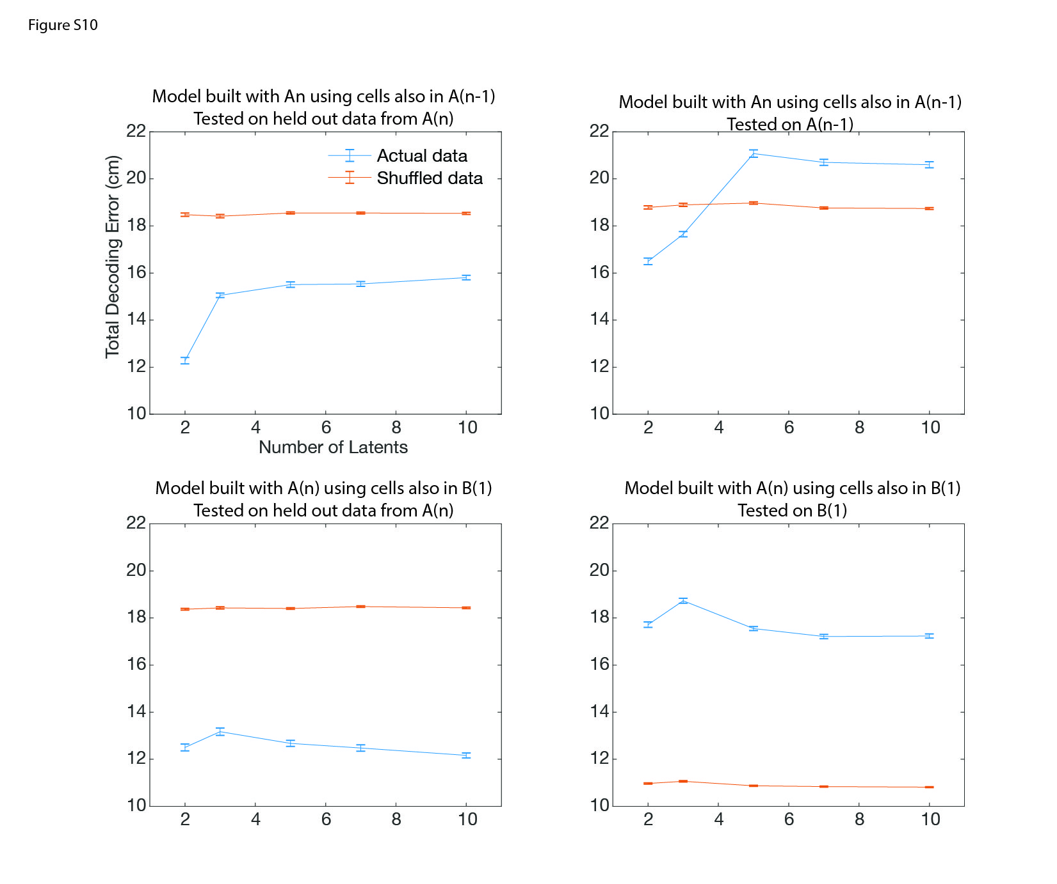
Figure S10. Position decoding error as a function of the number of latents (Rat 5).
This figure shows the decoding error for position as the number of latents increases. Left panels: model trained on data from A(n), tested on held out data from A(n). Upper left panel: As the number of latents increases, the model's ability to decode a different session within the same environment decreases. This effect is not consistent across all rats; see lower left panel. Right panels: model trained on data from A(n), tested on A(n-1) (top) or B(1) (bottom). Performance is particularly bad when the model is tested on a different environment (lower right panel).
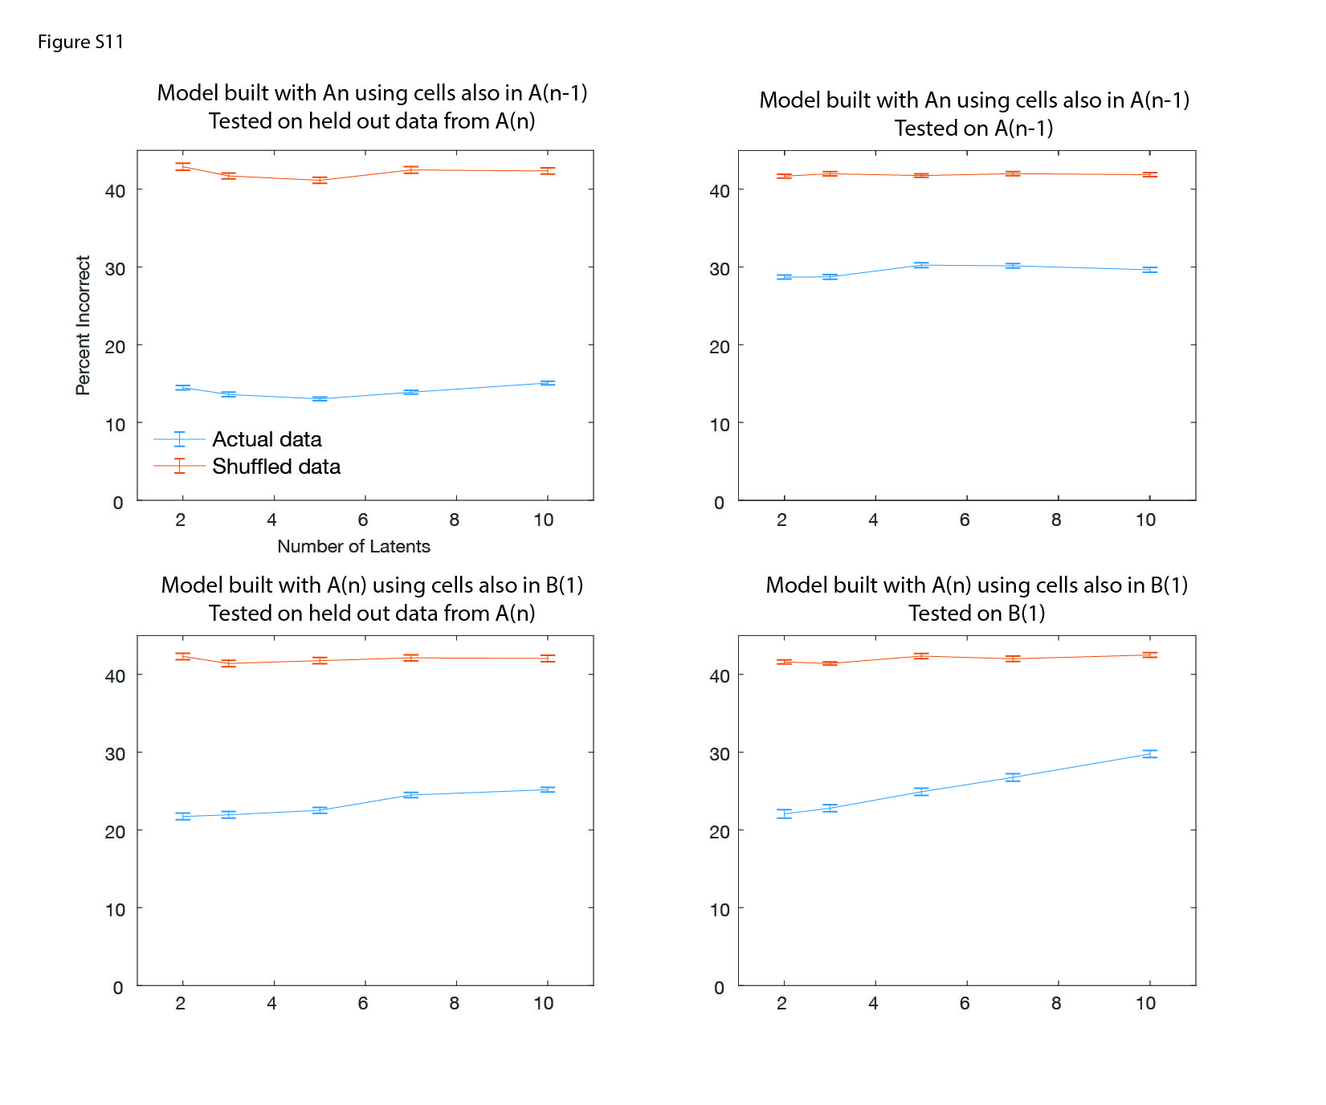
Figure S11. CSUS2 decoding accuracy with increasing number of latents (Rat 3).
Percent of incorrect decoding for the CSUS2 model as the number of latents increases. Left panels: model trained on data from A(n), tested on held out data from A(n). As the number of latents increases, the model's ability to decode a different session within the same environment remains stable or slightly decreases. Right panels: model trained on data from A(n), tested on A(n-1) (top) or B(1) (bottom). Performance remains stable for a different session in the same environment (upper right panel) but deteriorates with increasing number of latents when the model is tested in a different environment (lower right panel). Each model was run 100 times. 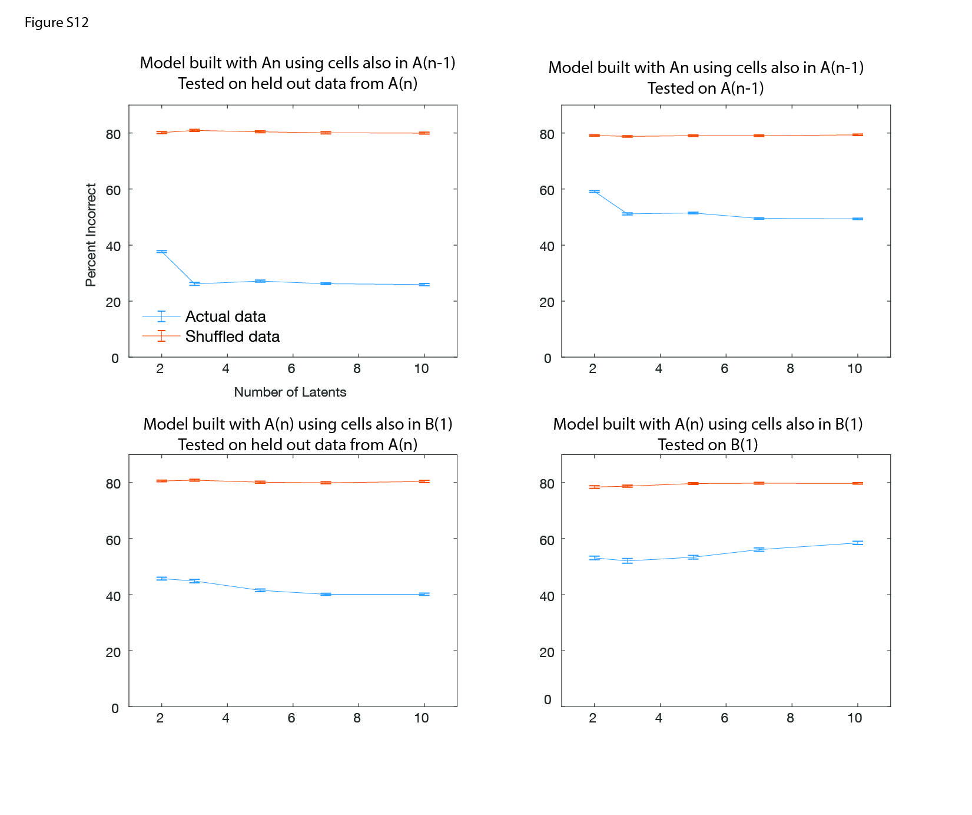Figure S12. CSUS5 decoding accuracy with increasing number of latents (Rat 5).
Same as Figure S11, but for CSUS5; the conditioning period has been divided into five time bins instead of two. The percent of incorrect decoding is shown as the number of latents increases. Left panels: model trained on data from A(n), tested on held out data from A(n). As the number of latents increases, the model's ability to decode a different session within the same environment remains stable or slightly increases. Right panels: model trained on data from A(n), tested on A(n-1) (top) or B(1) (bottom). Performance remains stable for a different session in the same environment (upper right panel) but deteriorates with increasing number of latents when the model is tested in a different environment (lower right panel). Each model was run 100 times.

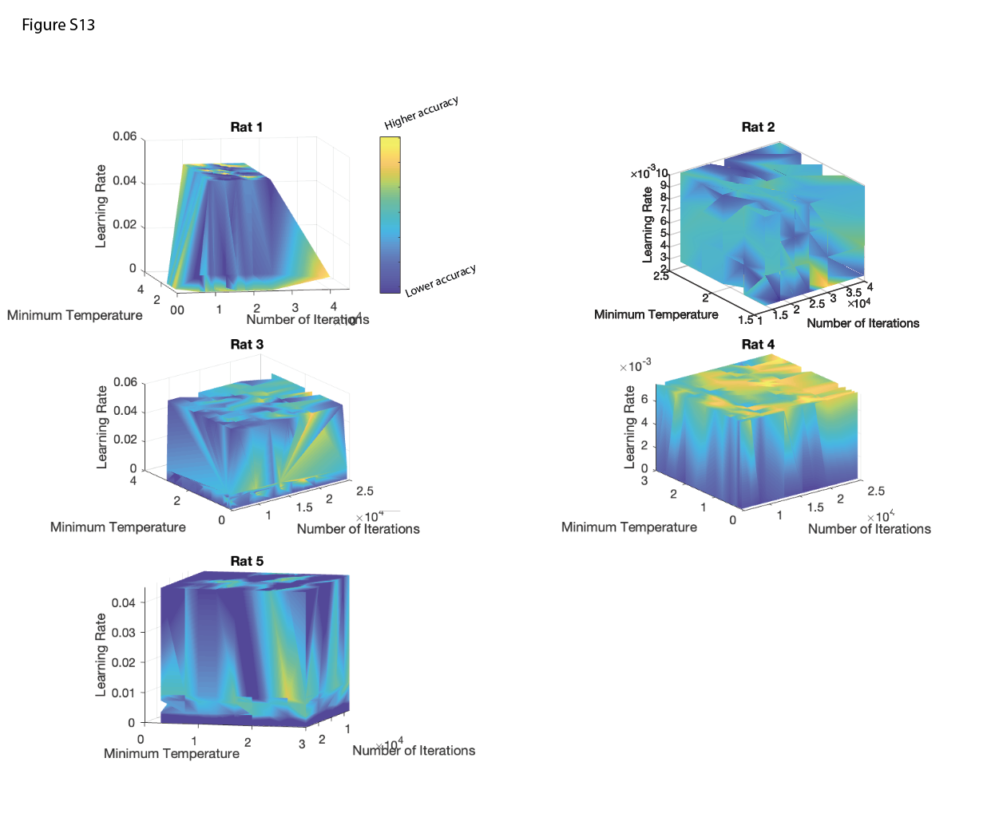
Figure S13. Grid search over decoding parameters for conditioning.
A grid search was performed over three parameters: minimum temperature, learning rate, and number of iterations for conditioning decoding. Models were trained using cells from session A(n) that also appeared in session B(1). The figure shows decoding accuracy for CSUS2 session B(1) using the models trained on data from session A(n). Yellow areas indicate higher decoding accuracy. For Rats 1 and 4, the 'Euclidean' distance with 'constant' temperature mode was used. For Rats 2 and 5, 'cosine' distance with 'constant' temperature mode was used. For Rat 3, 'cosine' distance with 'auto' temperature mode was used.

Methods References

1 Wirtshafter, H. S. & Disterhoft, J. F. Place cells are nonrandomly clustered by field location in CA1 hippocampus. Hippocampus 33, 65-84 (2023). https://doi.org:10.1002/hipo.23489
2 Wirtshafter, H. S. & Disterhoft, J. F. In Vivo Multi-Day Calcium Imaging of CA1 Hippocampus in Freely Moving Rats Reveals a High Preponderance of Place Cells with Consistent Place Fields. J Neurosci (2022). https://doi.org:doi: 10.1523/JNEUROSCI.1750-21.2022
3 Wirtshafter, H. S., Mehta, M. R., Solla, S. A. & Disterhoft, J. F. Hippocampal trace coding dominates and disrupts place coding. bioRxiv, 2026.2002.2017.706430 (2026). https://doi.org:10.64898/2026.02.17.706430
4 Weiss, C. & Thompson, R. F. The effects of age on eyeblink conditioning in the freely moving Fischer-344 rat. Neurobiol Aging 12, 249-254 (1991). https://doi.org:10.1016/0197-4580(91)90105-s
5 Skelton, R. W. Bilateral cerebellar lesions disrupt conditioned eyelid responses in unrestrained rats. Behav Neurosci 102, 586-590 (1988). https://doi.org:10.1037//0735-7044.102.4.586
6 Aharoni, D., Khakh, B. S., Silva, A. J. & Golshani, P. All the light that we can see: a new era in miniaturized microscopy. Nat Methods 16, 11-13 (2019). https://doi.org:10.1038/s41592-018-0266-x
7 Silva, A. J. Miniaturized two-photon microscope: seeing clearer and deeper into the brain. Light: Science & Applications 6, e17104-e17104 (2017).
8 Mathis, A. et al. DeepLabCut: markerless pose estimation of user-defined body parts with deep learning. Nature neuroscience 21, 1281-1289 (2018).
9 Corder, G. et al. An amygdalar neural ensemble that encodes the unpleasantness of pain. Science 363, 276-281 (2019). https://doi.org:10.1126/science.aap8586
10 Thevenaz, P., Ruttimann, U. E. & Unser, M. A pyramid approach to subpixel registration based on intensity. IEEE Trans Image Process 7, 27-41 (1998). https://doi.org:10.1109/83.650848
11 Zhou, P. et al. Efficient and accurate extraction of in vivo calcium signals from microendoscopic video data. eLife 7 (2018). https://doi.org:10.7554/eLife.28728
12 CIAtah: a software package for analyzing one- and two-photon calcium imaging datasets. v. v1.0.0 (Zenodo, 2018).
13 Pearson, K. LIII. On lines and planes of closest fit to systems of points in space. The London, Edinburgh, and Dublin philosophical magazine and journal of science 2, 559-572 (1901).
14 Nieh, E. H. et al. Geometry of abstract learned knowledge in the hippocampus. Nature 595, 80-84 (2021).
15 Ans, B., Hérault, J. & Jutten, C. Architectures neuromimétiques adaptatives: Détection de primitives. Proceedings of Cognitiva 85, 593-597 (1985).
16 Tenenbaum, J. B., Silva, V. d. & Langford, J. C. A global geometric framework for nonlinear dimensionality reduction. science 290, 2319-2323 (2000).
17 Low, R. J., Lewallen, S., Aronov, D., Nevers, R. & Tank, D. W. Probing variability in a cognitive map using manifold inference from neural dynamics. BioRxiv, 418939 (2018).
18 Schneider, S., Lee, J. H. & Mathis, M. W. Learnable latent embeddings for joint behavioural and neural analysis. Nature 617, 360-368 (2023). https://doi.org:10.1038/s41586-023-06031-6
19 Pedregosa, F. et al. Scikit-learn: Machine learning in Python. the Journal of machine Learning research 12, 2825-2830 (2011).
20 Schönemann, P. H. A generalized solution of the orthogonal procrustes problem. Psychometrika 31, 1-10 (1966).
21 Virtanen, P. et al. Fundamental algorithms for scientific computing in Python. Nat. Methods 17, 261-272 (2020).

